Quinzical   
**User Manual**

An in-depth guide on how to play Quinzical

Developed proudly by Shrey Tailor | Jason Wang

Table of Contents

Table of Figures 3

**Introduction** 4

**Installation Instructions** 4

First Time Installation 4

**Main Menu** 5

**Game Module** 6

Starting a Game 6

Game Board 7

International Section 8

Answering Questions 10

Finishing the Game 12

**Practice Module** 13

Selecting Category 13

Answering Questions 14

**Settings** 16

**Statistics** 17

Table of Figures

Figure 1 Main Menu Screen. 5

Figure 2 Selecting Categories For Games Module. 6

Figure 3 Error For Not Selecting Five Categories 6

Figure 4 Displaying Clue Board For Game Module. 7

Figure 5 Confirmation For Resetting The Game. 8

Figure 6 Unlocked International Section. 8

Figure 7 International Section Screen. 9

Figure 8 Answering Clue In Game Module. 10

Figure 9 Correct Answer In Game Module 11

Figure 10 Incorrect Answer In Game Module 11

Figure 11 Game Completion In Game Module. 12

Figure 12 Displaying Categories For Practice Module. 13

Figure 13 Answering Clue For Practice Module. 14

Figure 14 Hint In Practice Module 15

Figure 15 Incorrect Answer In Practice Module. 15

Figure 16 Settings Screen 16

Figure 17 Statistics Screen To See Performance. 17

# **Introduction**

Quinzical is an interactive quiz application that aims to help New Zealanders improve their understanding of Aotearoa. The intended audience for this application is children from 8-12 years old, and it’s developed to be used on Linux.

# **Installation Instructions**

## First Time Installation

1. To get started, first install *festival* and *festlex-oald* text-to-speech dependencies using the commands below.

sudo apt-get install festival

sudo apt-get install festlex-oald

1. Place the *.jar* file, *.run_game.sh* script, and the *QuizBank* folder that contains the question files, into a new directory of your choice.
2. Open the terminal and change the current working directory to the directory created above.

chmod +x run_game.sh

./run_game.sh

1. To run the run, give executable permissions to the script file, and then run the game.

*Note the installation requires assistance of a person with basic knowledge of Linux, and we assume that you are using the VirtualBox image.*

# **Main Menu**

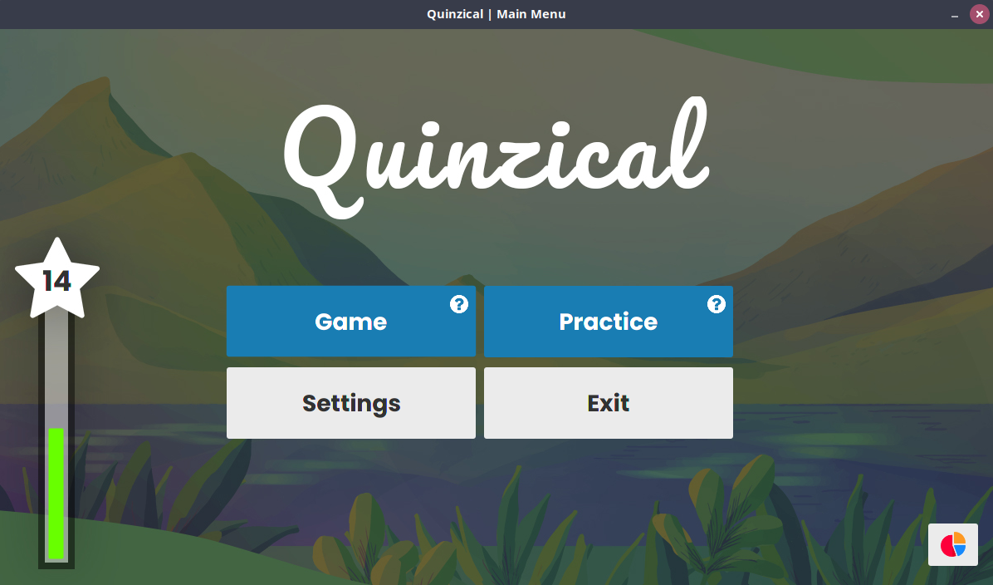

Figure 1 Main Menu Screen.

At the start, you are presented with Main Menu as shown in Figure 1. It shows five buttons which takes you to the main features of Quinzical.

* **Game:** This button opens the Game Module, where you can test your New Zealand knowledge.
* **Practice:** This button takes you to the Practice Module, which can prepare you to play the Game Module.
* **Settings:** This button takes you to Settings.
* **Exit:** This button would exit the game.

The XP bar on the left displays the points earned by answering questions correctly in the Game Module.

The button on the bottom-right corner is to go to Statistics.

# **Game Module**

## Starting a Game

If there is no saved progress (*i.e.* playing the game for the first time, or the game has just been reset), you will be presented to the screen on Figure 2.

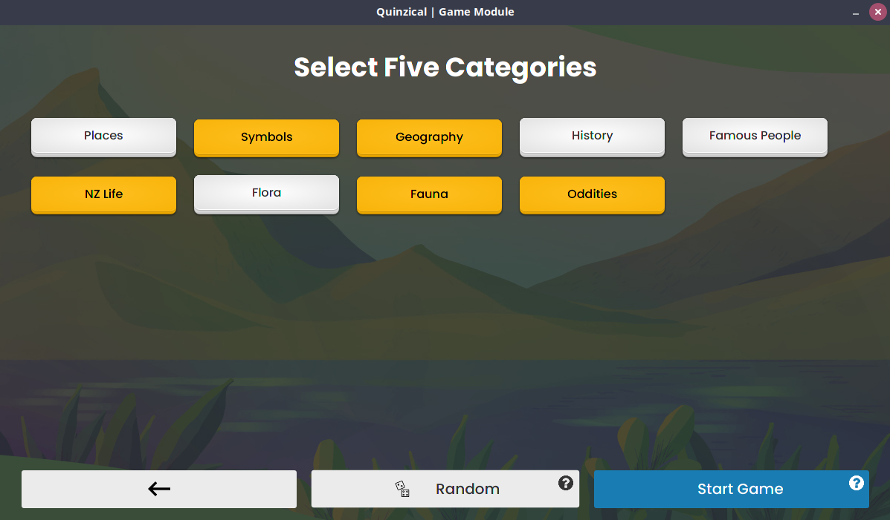

Figure 2 Selecting Categories For Games Module.

You must choose five categories by clicking on the grey category buttons, or you can use the **Random** feature to automatically select the five categories. The selected categories would appear as yellow.

After selecting the categories, you can press the **Start Game** button to start the game. If this button is clicked without selecting five categories, the error message on Figure 3 will be shown.

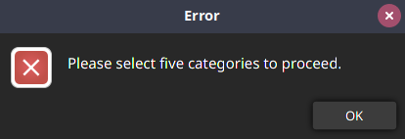

Figure 3 Error For Not Selecting Five Categories

**Game Module (continued)**

## Game Board

When a game is started or loaded, you are shown a screen like Figure 4 that displays the game board.

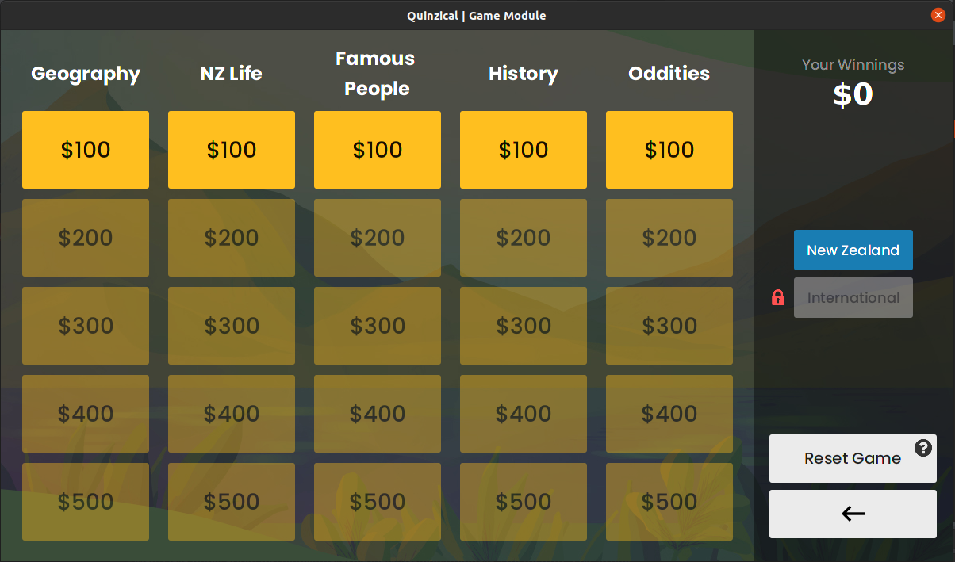

Figure 4 Displaying Clue Board For Game Module.

*For the following, look at Figure 4 above.*

1. **Winnings:** This shows the total amount you have won in Game Module.
2. **Category:** The top of each column contains the name of category.
3. **Active Clue:** The bright yellow buttons represent the clues that are active (i.e. can be asked).
4. **Disabled Clue:** The darker buttons represent the clues which can be unlocked once all the questions before it are attempted.
5. **Reset Game:** This button is used to restart the game. When this button is pressed, an alert will be shown to confirm your decision as shown on Figure 5.

All clue buttons display the worth of the question inside them.

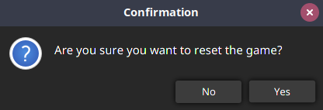

Figure 5 Confirmation For Resetting The Game.

If you press **Yes**, the game will be reset, and you will be presented with the screen to select five categories again.

## International Section

The International Section is initially locked as seen in Figure 4, but it will be unlocked once two categories from New Zealand Section are completed like shown below.

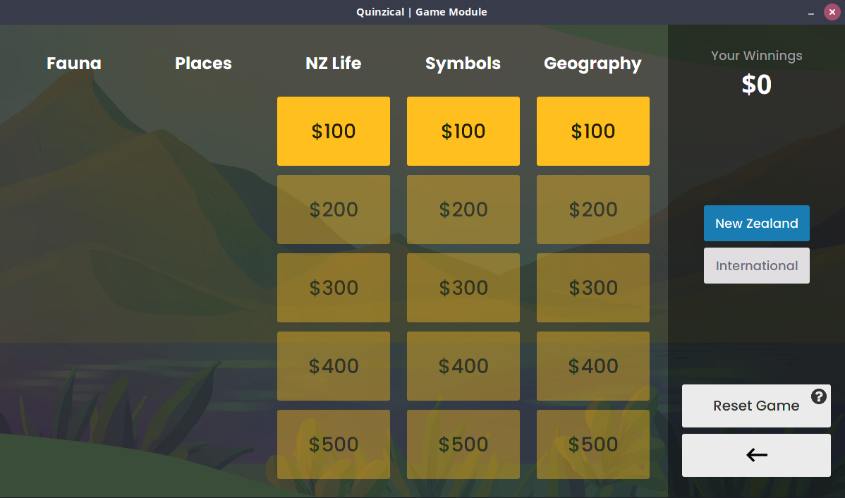

Figure 6 Unlocked International Section.

*For the following, look at Figure 6 above.*

1. After the International Section is unlocked, you can click on the button and it would show the screen like Figure 7.

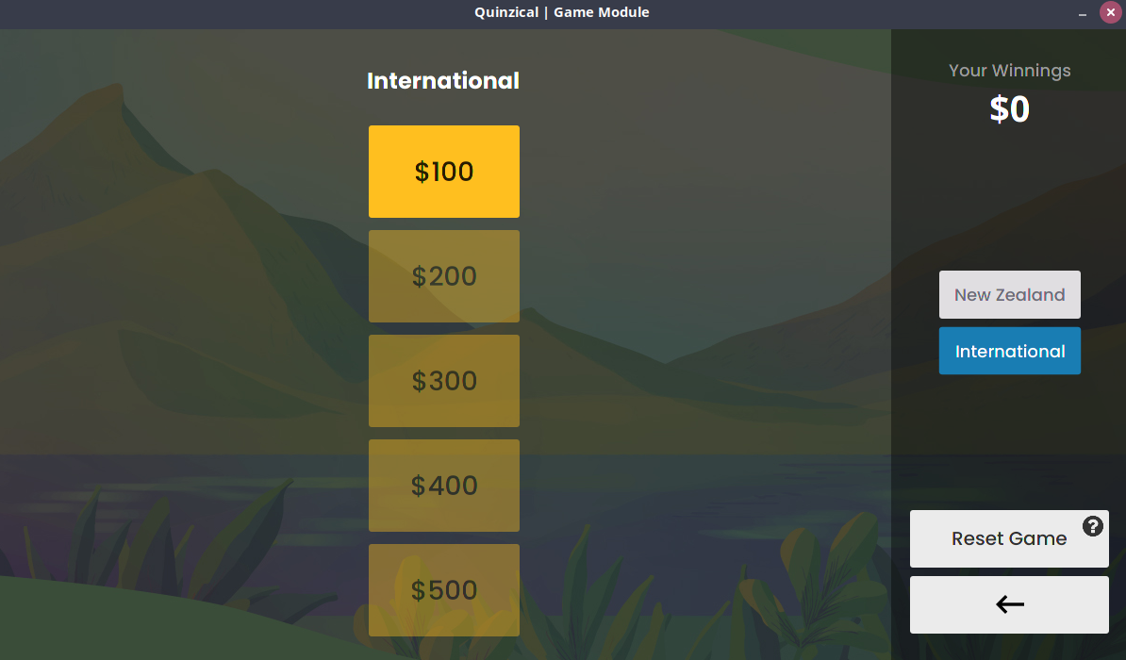

Figure 7 International Section Screen.

The layout for Interational section is really similar to the New Zealand section.

After its unlocked, you can move back and forth between New Zealand and International sections.

**Game Module (continued)**

## Answering Questions

When you click on a clue from the game board, you are presented with the screen like Figure 8, and a voice would automatically start speaking the question.

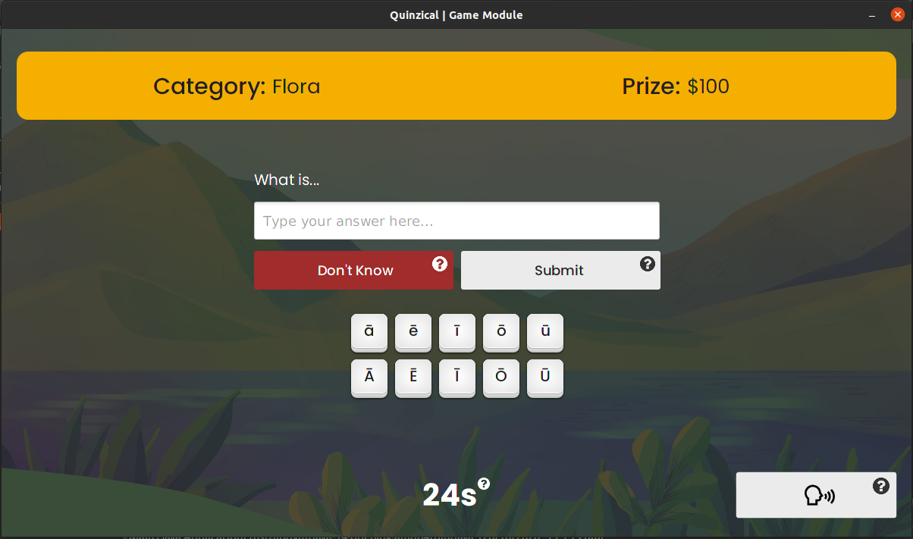

Figure 8 Answering Clue In Game Module.

*For the following, look at Figure 8 above.*

1. **Category:** This shows the name of the question’s category.
2. **Question Worth:** This shows the worth of your question.
3. **Speak Question**: Press this button to hear the question again.
4. **Timer**: This shows the time remaining to answer the question. If it runs out, you automatically get the answer wrong.

A macron keyboard is embedded, because lots of Maori words require them.

You can type the answer in the textbox in the centre, and then press **Submit**. If you don’t know the answer, you can press **Don’t Know**.

If you get the answer correct, you get a certain amount of XP and the worth of the question is added to your winnings, as shown in Figure 9.

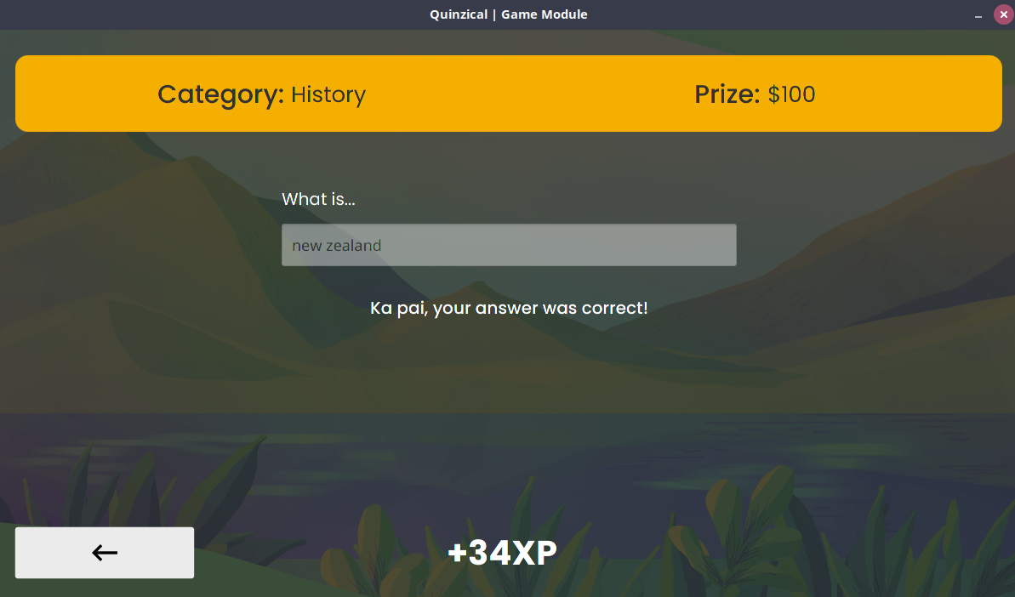

Figure 9 Correct Answer In Game Module

If you get the answer incorrect, you will be shown a screen like Figure 10 that displays and speaks the correct answer. However, you won’t receive any XP points or earnings.

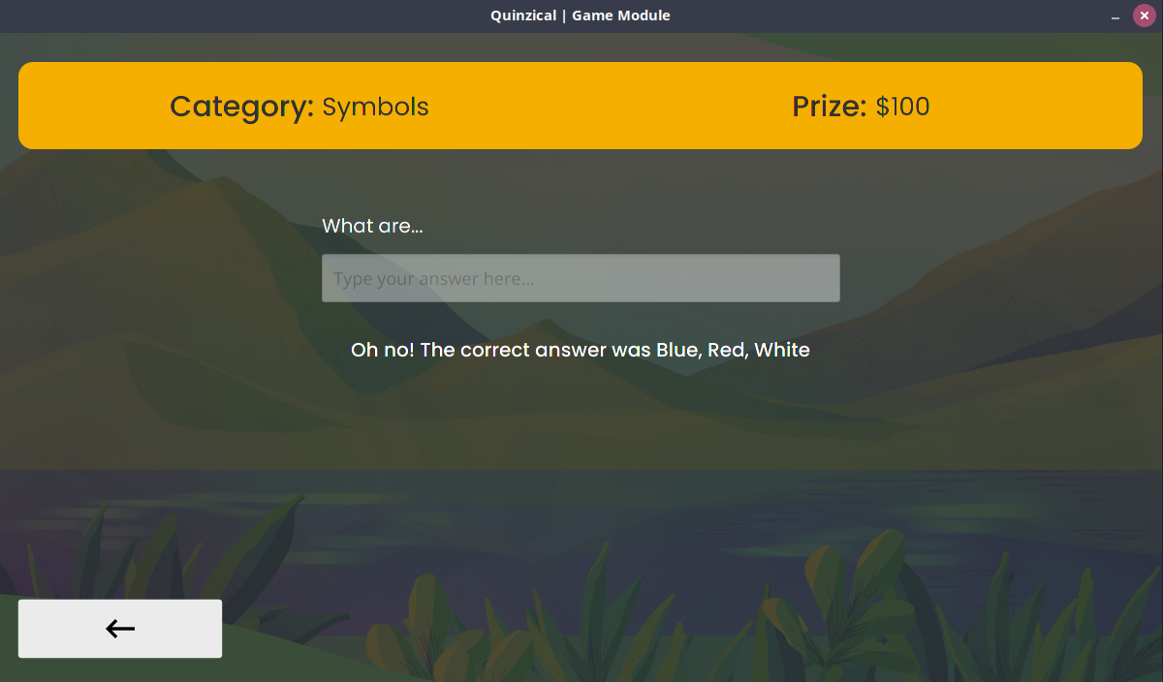

Figure 10 Incorrect Answer In Game Module

**Game Module (continued)**

## Finishing the Game

After completing all the questions from the Game Module, you will be taken to a screen like shown on Figure 11.

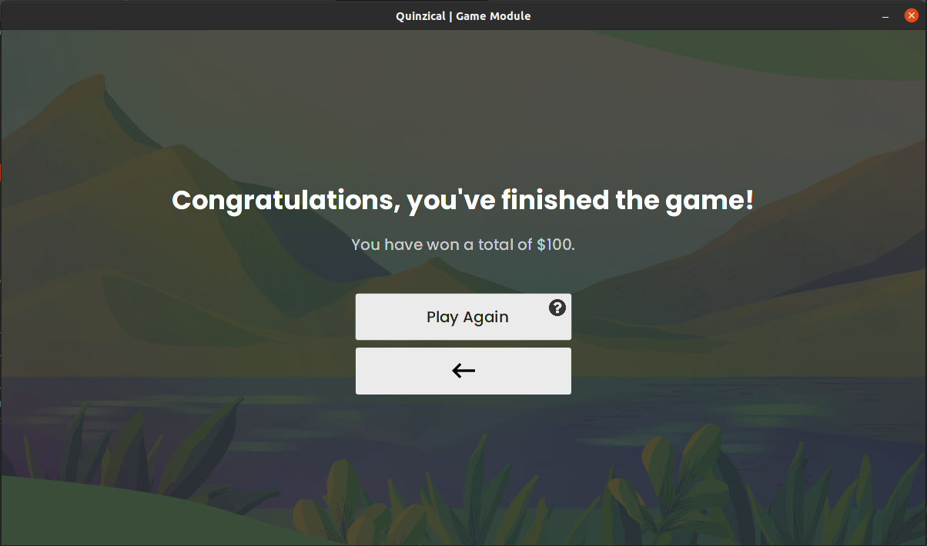

Figure 11 Game Completion In Game Module.

You are informed about the money earned during the game.

You have the option of either starting a new game by pressing the **Play Again** button, or going back to the main menu using the back-arrow button.

# **Practice Module**

## Selecting Category

When you click the Practice button on the main menu, you are taken to a screen like Figure 12. It shows all the categories in the current database as different buttons.

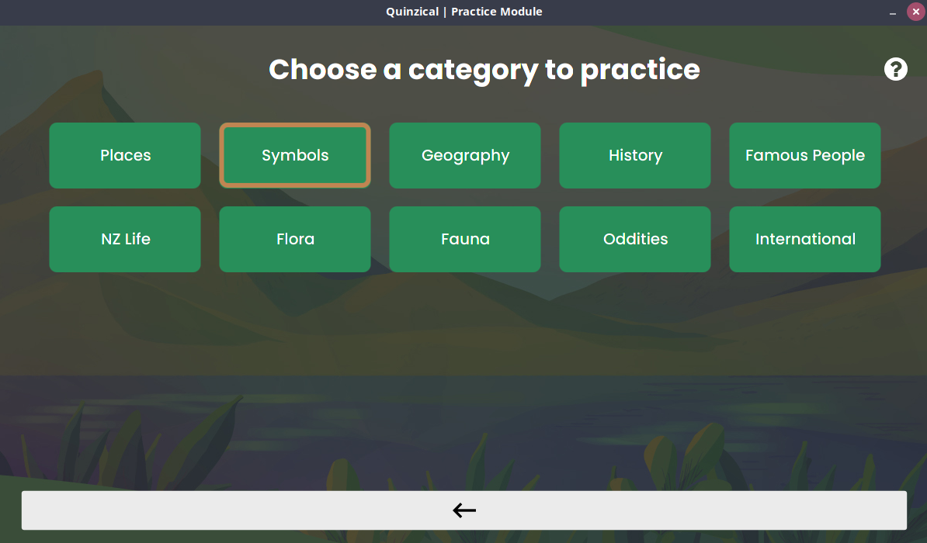

Figure 12 Displaying Categories For Practice Module.

If you want to practice a certain category, you can click its button, and then you will get a random clue from that category to practice.

*For the following, look at Figure 12 above.*

1. **Marked Category**: If you have previously gotten a question wrong from a category in Game Module, that category will be highlighted by a brown border indicating you to practice more for it.

This marking is deleted however after you restart Quinzical.

You also have the option of going back to the main menu by pressing the back-arrow button at the bottom.

**Practice Module (continued)**

## Answering Questions

On selecting a category from Practice Module, you would be taken to the screen on Figure 13, and the voice would automatically say your question.

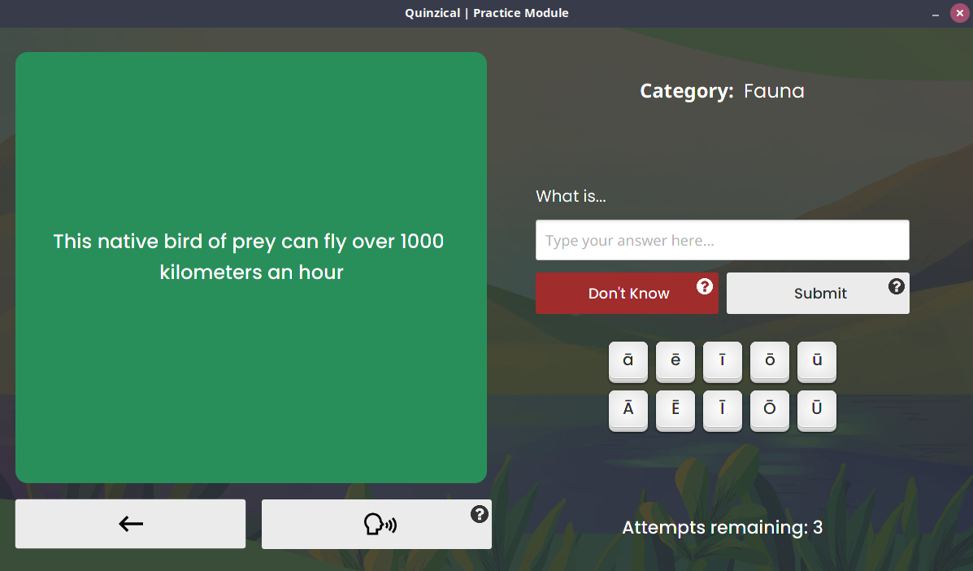

Figure 13 Answering Clue For Practice Module.

*For the following, look at Figure 13.*

1. **Question:** The question will be displayed to you in this section.
2. **Attempts:** In Practice Module, you get three attempts to get the answer correct. After the second attempt, you will get a hint as showed in Figure 14.
3. **Speak Question**: Press this button to hear the question again.

You can type your answer in the textbox and then press the **Submit** button to check your answer. If incorrect, your attempts would decrease as shown in Figure 14. Use the **Don’t Know** button if you don’t know the answer at all.

A macron keyboard is also provided here for some Maori answers. There are no time restrictions to answer in this format.

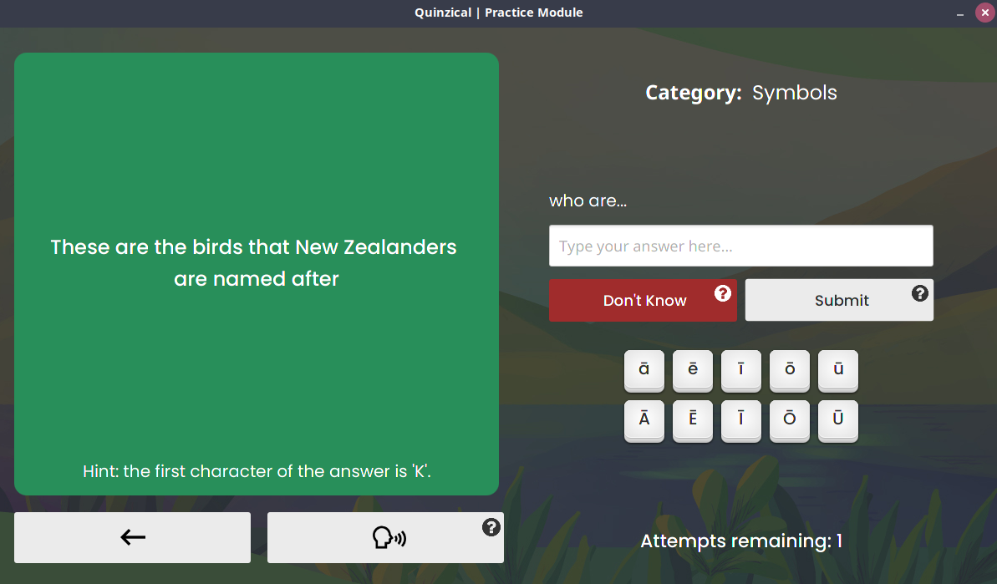

Figure 14 Hint In Practice Module

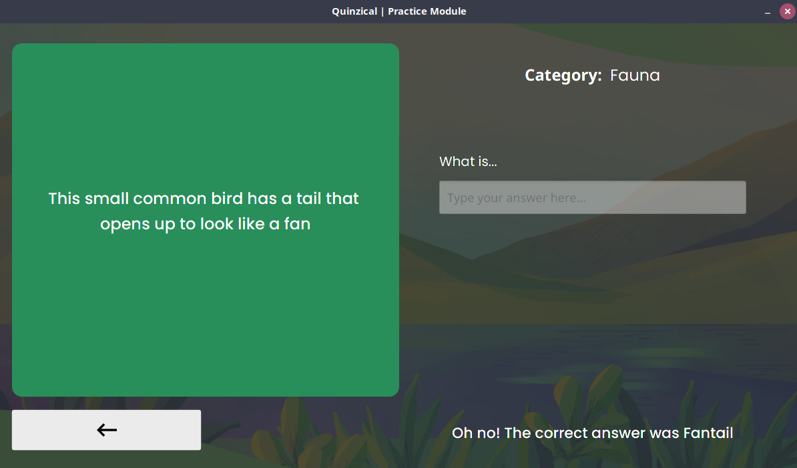

Figure 15 Incorrect Answer In Practice Module.

# **Settings**

The screen on Figure 16 would be shown to the user upon clicking the **Settings** button on the main menu.

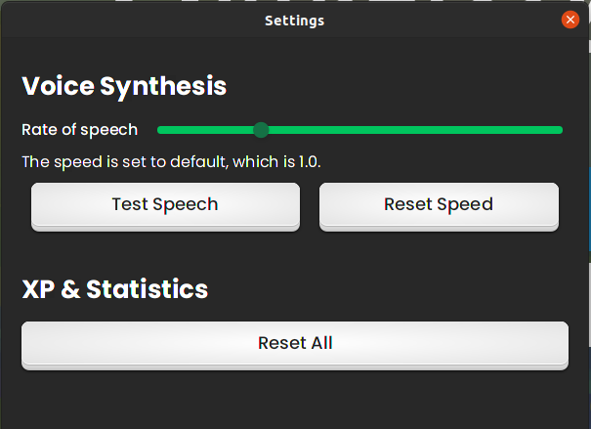

Figure 16 Settings Screen

The options provided for Settings are divided into two main sections.

* **Voice Synthesis**: If you find it difficult to listen to the voice, you can use the slider to change the speed. Taking it right makes it quicker, and left makes it slower. The final speed is shown under the slider.

After changing the speed, the **Test Speech** button can be used to test the new speed. If you want to set it back to normal, press the **Reset Speed** button, and it will go back to 1.0.

* **XP & Statistics:** You have the ability to reset all your statistics like the XP points, and the information on the Statistics screen. Use with caution as the information cannot be retrieved once it’s reset.

# **Statistics**

Upon clicking the button on the bottom-right corner in the main menu, the user would be presented with the screen like Figure 17.

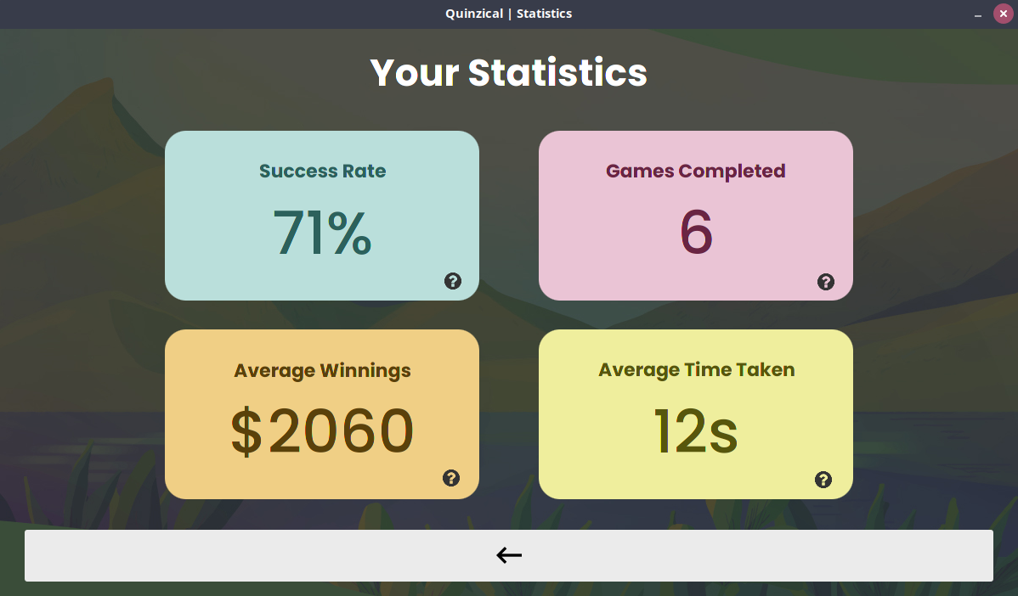

Figure 17 Statistics Screen To See Performance.

On this screen, you see your performance from the Games Module, and possibly compare with your friends and family.

* **Success Rate:** This shows the percentage of the questions from the Game Module that you got correct.
* **Games Completed:** This shows how many games that the user has completed.
* **Average Winnings:** This shows the average winnings across all the completed games.
* **Average Time Taken:** This is the average time taken to answer a question correctly in Game Module.

The *Success Rate* and *Average Time Taken* update after the competition of every question, while *Average Winnings* and *Games Completed* only update after each game is fully finished.

After reading your statistics, you can go back to the main menu using the back-arrow button located at the bottom of the screen.

# **Adding New Questions**

If you want to customize your game and add some new questions to play them in the game, follow the instructions below:

## Adding A Question in New Zealand Database

1. Navigate to the *GameData* folder.
2. Open *Quinzical.txt* file.
3. Having the *Quinzical.txt* file opened, you can now add a question under any category: 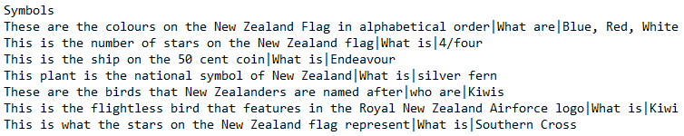

Figure 18 Example of how to add a question to a Category

The question must be in the format:  
QUESTION | PREFIX | ANSWER

1. Save and close the file.

## Adding A Question in New Zealand Database

1. Navigate to the *GameData* folder.
2. Open *International.txt* file.
3. Having the *International.txt* file opened, you can now add a question: 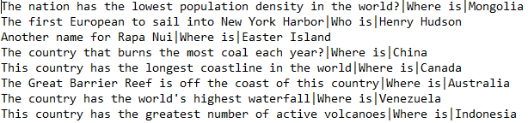

Figure 19 Example of how to add a question in International.txt

The question must be in the format:  
QUESTION | PREFIX | ANSWER

1. Save and close the file.

## Adding A New Category

Similar to adding a question in New Zealand Database, adding a new category requires modifying the *Quinzical.txt*

1. Navigate to the *GameData* folder.
2. Open *Quinzical.txt* file.

# **Adding New Questions (continued)**

1. Add a new Category by writing the name of the category down in a new line.  
   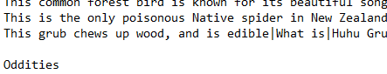

Figure 20 Adding a new category

1. Then, add at least 5 questions under the newly added category.  
   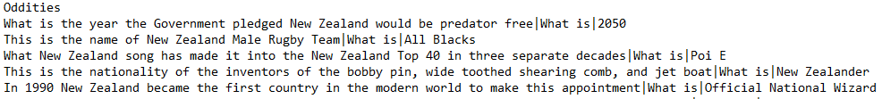

Figure 21 Adding 5 questions to the category

1. Save and close the file.