財團法人語言訓練測驗中心（LTTC）全民英語能力分級檢定測驗
114–115 年度 全民英檢中級聽力與閱讀能力測驗
近 5 次全真試卷與深度解析完全合訂本
(108 課綱最新素養新制·全 350 題完全收錄)
■ 試卷規格：圖片置於題目上方 · 試題本全卷無答案洩漏 · 答案解析統一收錄於卷末
■ 命題梯次：114年01月、114年05月、114年10月、115年01月、115年05月
■ 內容包含：25 幅看圖辨義高清情境圖、完整聽力錄音逐字稿、逐題誘答陷阱深度詳解

財團法人語言訓練測驗中心（LTTC）全民英語能力分級檢定測驗
114年度第1次 全民英語能力分級檢定測驗（中級聽讀）全真試卷暨詳解
【試題本】(Question Booklet) · 答案與深度解析請參閱卷末解析手冊
測驗代碼 | GEPT-114-01-IR
測驗日期 | 2025 年 01 月 11 日（一日考／中級初試）
測驗級數 | 中級（CEFR B1 級）
測驗項目 | 聽力能力測驗（35 題，約 30 分鐘）＆ 閱讀能力測驗（35 題，45 分鐘）
合格門檻 | 總分 160 分以上（滿分 240 分），且單科不低於 72 分（單科滿分 120 分）
命題核心主題 | 生活科技應用、智慧校園自主學習、大眾運輸捷運營運、觀光餐旅
考生注意事項 | 本卷共 70 題（聽力 35 題、閱讀 35 題）。答案與完整解析已移至整張試卷最後面，請先完成作答再行對答案。

★ 作答注意事項：本試題本共 70 題，分為聽力能力測驗（35 題）與閱讀能力測驗（35 題）。每題均為單選題，請依題意選出一個最適當的答案。標準答案與完整名師逐題解析統一置於【整張試卷最後面】，請全卷作答完畢後再行翻閱核對。

📝 第一單元：全真試題本 (Question Booklet)

🎧 第一部分：聽力能力測驗 (Listening Comprehension)
總題數：35 題 ｜ 作答時間：約 30 分鐘 ｜ 滿分：120 分

第一部分：看圖辨義 (Questions 1-5)
*說明：試題冊上每題有一幅圖畫，錄音將播出一個問題及 A、B、C、D 四個英文敘述。請選出與圖畫最相符的敘述。*
![Picture 1](./images/exam01_q01.png)
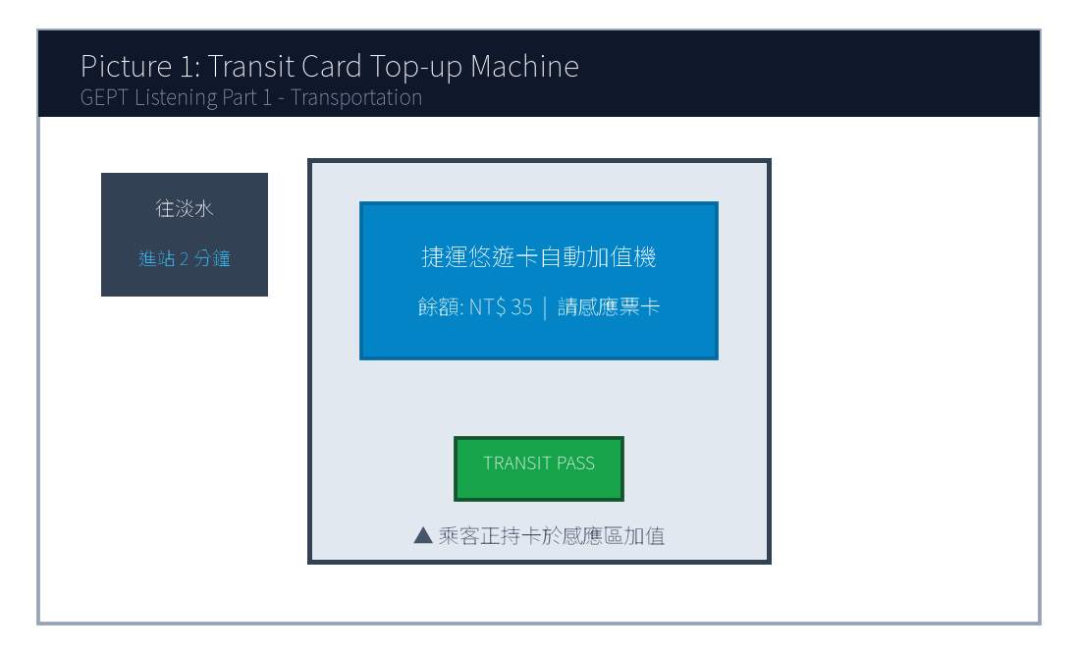
1. Look at picture number 1. (Please listen to the recording)
(A) He is asking a station worker for directions.
(B) He is adding money to his transit card at the machine.
(C) He is rushing through the ticket gate to catch the train.
(D) He is waiting in line on the platform behind the yellow line.
![Picture 2](./images/exam01_q02.png)
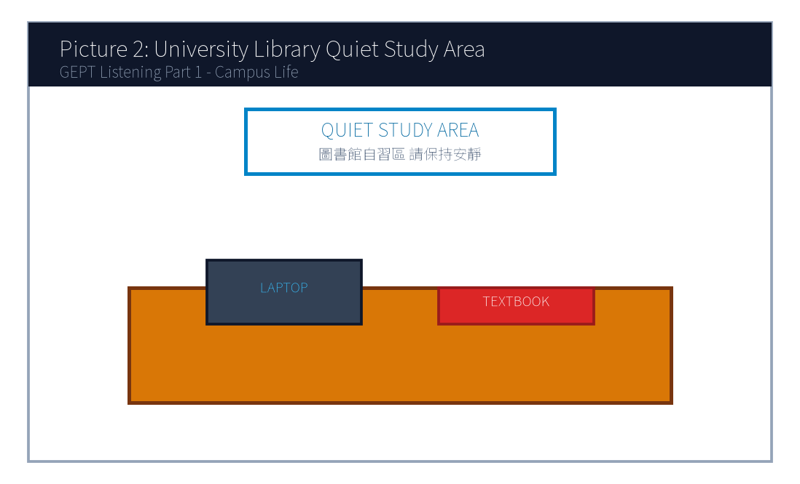
2. Look at picture number 2. (Please listen to the recording)
(A) The students are holding an animated discussion in a noisy cafeteria.
(B) The library is closed and all the lights are turned off.
(C) Several students are studying quietly with their laptops and books.
(D) A librarian is sorting returned books onto the wooden shelves.
![Picture 3](./images/exam01_q03.png)
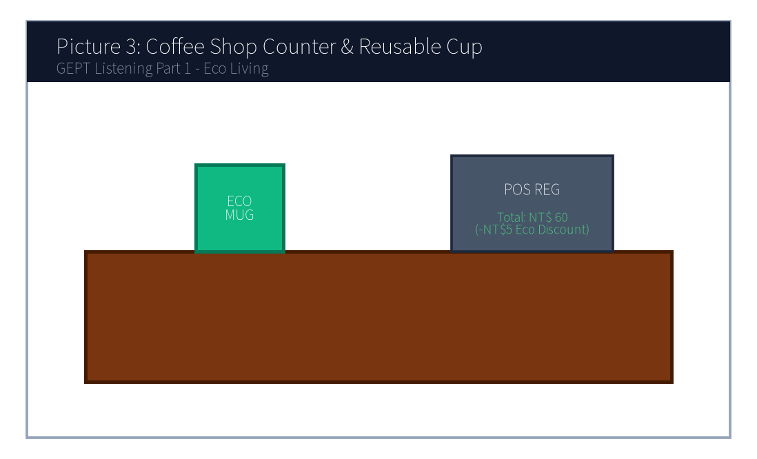
3. Look at picture number 3. (Please listen to the recording)
(A) The customer is paying for the drink using a reusable cup.
(B) The clerk is refusing to take the customer's order.
(C) The customer is washing dishes in the kitchen.
(D) The customer is returning a damaged ceramic mug for a refund.
![Picture 4](./images/exam01_q04.png)
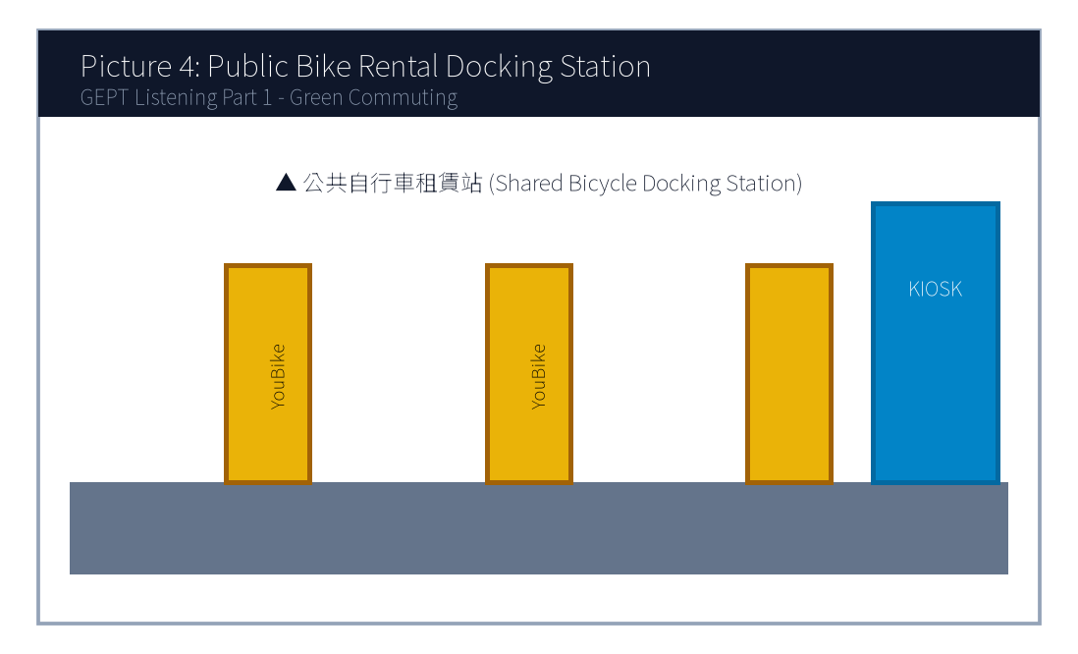
4. Look at picture number 4. (Please listen to the recording)
(A) They are repairing a broken car on the highway.
(B) They are renting shared bicycles at the docking station.
(C) They are taking a crowded bus during rush hour.
(D) They are running a marathon in the stadium.
![Picture 5](./images/exam01_q05.png)
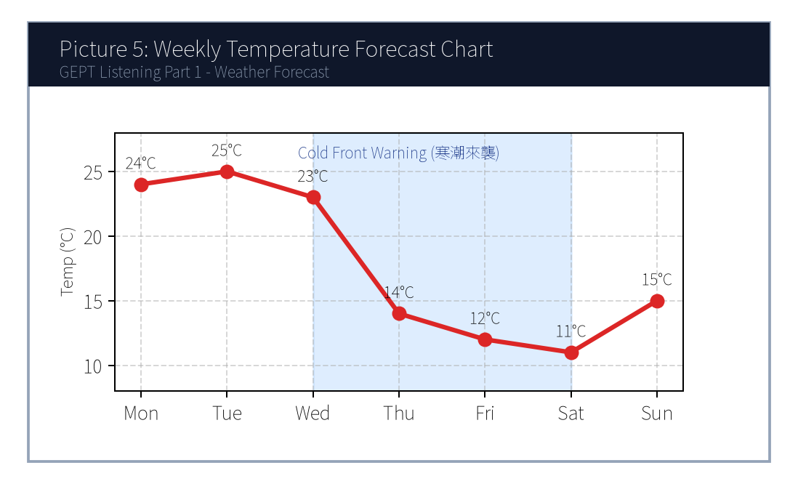
5. Look at picture number 5. (Please listen to the recording)
(A) Temperatures will remain sunny and steady throughout the whole week.
(B) A sharp drop in temperature and rainy conditions are expected mid-week.
(C) Heavy snow will hit the southern beaches on Monday morning.
(D) The weather will become exceptionally dry and hot towards the weekend.

第二部分：問答 (Questions 6-15)
*說明：試題冊上每題有四個選項，錄音將播出一個問句或直述句。請選出一個最適當的回應。*
6. **錄音 (Audio)**: *Could you tell me how often the airport shuttle bus departs?*
(A) It usually takes about forty-five minutes to get there.
(B) It runs every twenty minutes from platform number three.
(C) Yes, the ticket price is only one hundred dollars.
(D) I bought the round-trip ticket yesterday morning.
7. **錄音 (Audio)**: *I'm afraid Dr. Wang is fully booked this afternoon. Would tomorrow morning work for you?*
(A) I will definitely see him yesterday.
(B) Yes, tomorrow at ten o'clock would be perfect.
(C) The medicine worked really well, thank you.
(D) He has been a doctor for more than fifteen years.
8. **錄音 (Audio)**: *Why didn't Jason submit his science fair proposal before the deadline?*
(A) Because his laptop crashed and he lost his final draft.
(B) He always gets the highest grade in chemistry.
(C) The science fair will be held next Friday afternoon.
(D) Yes, he submitted it two weeks ago.
9. **錄音 (Audio)**: *Do you mind if I turn down the air conditioner? It's a bit chilly in here.*
(A) No, not at all. Please go right ahead.
(B) Yes, I think it's too warm as well.
(C) The air conditioner was repaired last week.
(D) I don't like drinking cold water either.
10. **錄音 (Audio)**: *We haven't received the confirmation email for our hotel reservation yet, have we?*
(A) Yes, we stayed there for three nights last summer.
(B) Let me check my spam folder right now just in case.
(C) The hotel room has two comfortable queen-sized beds.
(D) We checked out of the hotel at eleven sharp.
11. **錄音 (Audio)**: *How would you like your steak prepared, sir?*
(A) I would like a glass of iced lemon tea, please.
(B) Medium, with a baked potato on the side, please.
(C) The steak was imported from Australia.
(D) Yes, I have a reservation under the name Smith.
12. **錄音 (Audio)**: *Excuse me, is this seat next to you taken?*
(A) No, it's free. Feel free to sit down.
(B) I took the express train this morning.
(C) The seat is located in car number eight.
(D) Yes, I have already taken three pills.
13. **錄音 (Audio)**: *The keynote speaker hasn't arrived yet, and the auditorium is already packed!*
(A) I will buy the tickets online later tonight.
(B) Don't worry, his assistant just called saying he is parking his car.
(C) The speech was one of the most inspiring talks I've ever heard.
(D) All the chairs have been rearranged properly.
14. **錄音 (Audio)**: *Would you rather participate in the campus marathon or volunteer at the registration booth?*
(A) I ran ten kilometers yesterday morning.
(B) I prefer helping out at the booth since I injured my ankle last week.
(C) The registration fee is twenty dollars per runner.
(D) Yes, both of them are very competitive.
15. **錄音 (Audio)**: *Congratulations on receiving the study abroad scholarship!*
(A) I'm sorry to hear that unfortunate news.
(B) Thank you so much! I couldn't have done it without your guidance.
(C) The scholarship application deadline is next Monday.
(D) It takes twelve hours to fly to London.
(A) Inside an airport terminal.
(B) On a metro subway platform.
(C) At a bus maintenance depot.
(D) Inside a taxi during traffic.
(A) Buy an additional ticket from the counter.
(B) Exit the station and hail a taxi.
(C) Cross the platform and transfer to another train line.
(D) Wait forty minutes for the same train to turn around.
(A) 5 points.
(B) 15 points.
(C) 20 points.
(D) 40 points.
(A) An oat milk upgrade.
(B) A handmade chocolate cookie.
(C) A cup of Americano coffee.
(D) A full-sized cheesecake.
(A) To recruit student volunteers for the IT center.
(B) To announce new features and updates of the campus mobile app.
(C) To warn students about a campus-wide network blackout.
(D) To introduce new library books purchased this semester.
(A) Ordering takeout delivery from off-campus restaurants.
(B) Reserving library study rooms up to 48 hours in advance.
(C) Submitting mid-term exam appeals directly to the dean.
(D) Borrowing physical textbooks without scanning barcodes.
(A) By next Monday noon.
(B) By Friday afternoon at five.
(C) By Sunday evening.
(D) By the end of this month.

第三部分：簡短對話 (Questions 16-25)
*說明：錄音將播出一段兩人對話及一個問題，部分題組結合試題冊上的圖表。請選出最適當的答案。*
(Questions 16-17: 捷運營運與路線對話)
- 錄音對話 (Audio Script):
- *Woman*: Excuse me, does this train go all the way to the Taipei Nangang Exhibition Center?
- *Man*: No, ma'am. This is the terminal station for this train. You need to cross the platform and transfer to the Blue Line heading east.
- *Woman*: Oh, I see! How many stops will that be from here?
- *Man*: Just three stops. The next train will arrive in about two minutes.
- 第 16 題: Where does this conversation most likely take place?
- 第 17 題: What must the woman do to reach her destination?
(Questions 18-19: 圖表整合題 — 咖啡廳會員點數兌換促銷)
- [試題冊圖表]:
兌換點數 (Reward Points) | 可兌換品項 (Eligible Item)
20 pts | 免費升級燕麥奶 (Free Oat Milk Upgrade)
40 pts | 手作手工餅乾一片 (Handmade Cookie)
60 pts | 特選美式咖啡一杯 (Americano Coffee)
80 pts | 提拉米蘇精緻蛋糕 (Slice of Tiramisu)

- 錄音對話 (Audio Script):
- *Clerk*: Good afternoon! Welcome back, Ms. Lin. You currently have 65 reward points in your account. Would you like to redeem any items today?
- *Customer*: Well, I was planning to get a slice of tiramisu, but it seems I'm still short of points. Can I just use my points to get a free Americano instead?
- *Clerk*: Certainly! That will deduct 60 points from your balance, leaving you with 5 points.
- 第 18 題: Look at the chart. How many more points would the customer need to get a slice of tiramisu?
- 第 19 題: What item did the customer ultimately decide to redeem today?

第四部分：簡短談話 (Questions 26-35)
*說明：錄音將播出一段由一人播講的短文、廣播或演講，並提出二至三個問題。請選出最適當的答案。*
(Questions 26-28: 智慧校園 APP 新功能說明短講)
- 錄音短講 (Audio Script):
- *"Good morning, faculty and students! This is an announcement from the Academic IT Center. Starting next Monday, our school will launch the updated 'Smart Campus 2.0' mobile application. In addition to checking course schedules and library loan records, the new version introduces two major features. First, students can now reserve study rooms in the library up to forty-eight hours in advance directly through the app. Second, you can pay campus dining fees using your digital student ID barcode without needing cash. Please ensure you update the app before Sunday evening to avoid any login disruption. If you experience technical glitches, our help desk on the first floor of the administration building is open from eight to five daily. Thank you for your cooperation!"*
- 第 26 題: What is the main purpose of this announcement?
- 第 27 題: Which new capability is added in the updated mobile application?
- 第 28 題: When should students update their app to avoid disruption?

📖 第二部分：閱讀能力測驗 (Reading Comprehension)
總題數：35 題 ｜ 作答時間：45 分鐘 ｜ 滿分：120 分

第一部分：詞彙 (Questions 1-10)
*說明：每題有四個選項，請選出最符合句意的一個字詞。*
1. To protect personal data privacy, users are advised to create ________ passwords containing numbers and special symbols.
(A) fragile
(B) complex
(C) casual
(D) clumsy
2. The municipal government implemented strict regulations to prevent chemical factories from discharging toxic ________ into the river.
(A) substances
(B) decorations
(C) instruments
(D) appointments
3. Due to her outstanding leadership and dedication, Kelly was ________ promoted to senior project manager.
(A) reluctantly
(B) deservedly
(C) scarcely
(D) suspiciously
4. Regular cardiovascular exercise not only burns calories but also ________ blood circulation throughout the body.
(A) broadens
(B) enhances
(C) forbids
(D) neglects
5. In order to accommodate the growing number of international passengers, the airport decided to ________ its terminal facilities.
(A) expand
(B) exhaust
(C) dismiss
(D) collapse
6. The scientist gave a clear and ________ explanation that helped ordinary audiences grasp the intricate astronomical concepts.
(A) ambiguous
(B) persuasive
(C) tedious
(D) deceptive
7. We should cherish our limited potable water, as persistent drought has become an increasingly ________ global crisis.
(A) severe
(B) generous
(C) temporary
(D) delightful
8. Active participation in extracurricular activities helps teenagers develop a strong sense of social ________.
(A) responsibility
(B) ingredient
(C) forecast
(D) platform
9. Despite facing numerous obstacles during the experiment, the research team ________ until they achieved breakthrough results.
(A) hesitated
(B) persevered
(C) postponed
(D) surrendered
10. The museum exhibition features an extraordinary collection of ancient artifacts that ________ the rich cultural heritage of the island.
(A) destroy
(B) reflect
(C) confess
(D) disguise
(A) This innovative approach transforms unused concrete surfaces into vibrant natural gardens.
(B) Many citizens complained about the noisy traffic surrounding the central railway station.
(C) The price of concrete has doubled over the past decade due to material shortages.
(D) Heavy snowstorms often disrupt flight schedules in northern European capitals.
(A) On the contrary
(B) Furthermore
(C) In contrast
(D) Unfortunately
(A) Developing software applications for urban hospitals.
(B) Marine conservation and environmental education on offshore islands.
(C) Teaching business English to corporate executives in Taipei.
(D) Excavating historical ruins in mountain villages.
(A) Free dormitory accommodation and daily meals.
(B) Transportation subsidies between islands.
(C) Full cash salaries equivalent to corporate wages.
(D) An internationally recognized volunteer certificate.
(A) She was the only applicant who had a medical doctor's license.
(B) Her academic background in environmental biology and video portfolio impressed the committee.
(C) She donated a substantial sum of money to the NGO foundation.
(D) Her family owns a hotel on Nangan Island.
(A) Leading educational workshops and producing social media videos of conservation work.
(B) Managing hotel bookings and driving tourist buses around the island.
(C) Flying rescue helicopters during typhoon emergencies.
(D) Cooking meals for 600 volunteers in the central cafeteria.
(A) Travel to Matsu for an in-person interview.
(B) Submit a notarized bank deposit statement of one million dollars.
(C) Sign and return the formal acceptance agreement.
(D) Retake the English proficiency test to get a higher score.

第二部分：段落填空 (Questions 11-20，含新制篇章句子選填)
*說明：依據文章上下文意，選出最適當的字詞或句子。*
(Passage 1: 都市微氣候與綠屋頂技術)
Urban heat island effect has become a pressing environmental issue in metropolitan areas. During hot summer days, concrete roads and glass buildings absorb tremendous heat, making inner-city temperatures significantly higher than surrounding rural suburbs. To mitigate this problem, urban planners have introduced "green roofs." (11) ________. By covering the roofs of commercial and residential buildings with vegetation, plants can absorb sunlight through photosynthesis and release moisture into the air. Studies indicate that a well-maintained green roof can reduce indoor cooling energy consumption by up to twenty percent. (12) ________, it filters rainwater runoff and provides habitats for urban birds and beneficial insects. Therefore, city governments across the globe are offering tax incentives to encourage real estate developers to incorporate green architecture into new construction projects.
- 第 11 題 (新制句子選填):
- 第 12 題 (轉折副詞填空):

第三部分：閱讀理解 (Questions 21-35，含新制雙文本閱讀)
(Questions 31-35: 雙文本閱讀 — 國際青年數位遊牧志工計畫與錄取通知函)
[Text 1: 徵選公告]
GLOBAL YOUTH SUSTAINABILITY INITIATIVE (GYSI)
Summer 2025 Eco-Volunteer Program in Penghu & Matsu Archipelago
About the Program:
Are you passionate about marine conservation and sustainable tourism? GYSI invites energetic young adults (aged 18–30) to join our 4-week environmental residency in Taiwan's offshore islands. Volunteers will collaborate with local NGOs to restore coastal coral reefs, organize community beach cleanups, and run bilingual educational workshops for elementary school children.
Benefits & Support:
• Shared dormitory accommodation and meals provided throughout the 4-week stay.
• Island-hopping transport subsidies.
• Official volunteer certificate recognized by international environmental agencies.
Key Requirements:
• Demonstrated proficiency in English (equivalent to CEFR B1 or higher).
• Willingness to perform outdoor physical activities under hot weather.
• Experience in social media content creation or video editing is a major plus!
Application Deadline: March 31, 2025.

[Text 2: 錄取通知信件]
From: admissions@gysi-volunteer.org
To: clara.hsu@email.com
Date: April 15, 2025
Subject: Congratulations on your selection for the GYSI Summer 2025 Program!
Dear Ms. Hsu,
On behalf of the selection committee, I am delighted to inform you that you have been accepted into the GYSI Summer 2025 Eco-Volunteer Program! Out of more than 600 global applicants, your background in environmental biology and your engaging travel vlogging portfolio truly stood out.
Your placement will be on Nangan Island, Matsu, starting July 5 and concluding August 2, 2025. You will lead the "Ocean Guardians" workshop for local youth and document our daily marine conservation missions on our official YouTube and Instagram channels.
Please confirm your attendance by signing the attached agreement and returning it before April 30, 2025. We look forward to welcoming you to Matsu this summer!
Warm regards,
David Chang
Program Coordinator, Global Youth Sustainability Initiative

- 第 31 題: What is the primary focus of the GYSI Summer Program described in Text 1?
- 第 32 題: Which benefit is NOT mentioned in Text 1 for accepted volunteers?
- 第 33 題: In Text 2, why was Clara Hsu selected out of more than 600 applicants?
- 第 34 題: According to both texts, what specific task will Clara most likely perform in Matsu?
- 第 35 題: What must Clara do before April 30, 2025, to finalize her acceptance?

🎯 試題答案與名師深度解析手冊 (Answer Key & Explanations)

一、1–70 題 快速答案對照總表
聽力 1-10 | 聽力 11-20 | 聽力 21-30 | 聽力 31-35 | 閱讀 1-10 | 閱讀 11-20 | 閱讀 21-30 | 閱讀 31-35
1. B<br>2. C<br>3. A<br>4. B<br>5. B<br>6. B<br>7. B<br>8. A<br>9. A<br>10. B | 11. B<br>12. A<br>13. B<br>14. B<br>15. B<br>16. B<br>17. C<br>18. B<br>19. C<br>20. A | 21. C<br>22. B<br>23. A<br>24. D<br>25. B<br>26. B<br>27. B<br>28. C<br>29. A<br>30. B | 31. B<br>32. C<br>33. B<br>34. A<br>35. C | 1. B<br>2. A<br>3. B<br>4. B<br>5. A<br>6. B<br>7. A<br>8. A<br>9. B<br>10. B | 11. A<br>12. B<br>13. C<br>14. D<br>15. A<br>16. B<br>17. C<br>18. A<br>19. B<br>20. C | 21. B<br>22. A<br>23. C<br>24. D<br>25. B<br>26. A<br>27. C<br>28. B<br>29. D<br>30. A | 31. B<br>32. C<br>33. B<br>34. A<br>35. C

二、逐題考點剖析與名師破題詳解
#### 【聽力 第 1 題】 標準答案：(B)
- 聽力錄音語音稿：*Look at picture number 1. What is the passenger doing?*
- 破題思路與盲點解析：畫面中乘客正操作自動售票加值機（adding money to his transit card），故選 (B)。(A) 問路、(C) 衝過驗票閘門、(D) 在月台黃線後排隊皆與操作機器之核心動作不符。
#### 【聽力 第 2 題】 標準答案：(C)
- 聽力錄音語音稿：*Look at picture number 2. Which statement best describes the scene?*
- 破題思路與盲點解析：畫面顯著特徵為學生使用筆電安靜閱讀（studying quietly with laptops），故選 (C)。
#### 【聽力 第 3 題】 標準答案：(A)
- 聽力錄音語音稿：*Look at picture number 3. What is happening at the counter?*
- 破題思路與盲點解析：關鍵在於「自帶環保杯享有折扣」（reusable cup），為 108 課綱最新環保生活素養情境，選 (A)。
#### 【聽力 第 4 題】 標準答案：(B)
- 聽力錄音語音稿：*Look at picture number 4. What are the two people doing?*
- 破題思路與盲點解析：畫面是公共自行車站點（docking station）租賃單車（renting shared bicycles），答案為 (B)。
#### 【聽力 第 5 題】 標準答案：(B)
- 聽力錄音語音稿：*Look at picture number 5. What does the weather chart indicate?*
- 破題思路與盲點解析：折線圖 mid-week（週三/週四）氣溫驟降（sharp drop）且有降雨圖示，故選 (B)。
#### 【聽力 第 6 題】 標準答案：(B)
- 破題思路與盲點解析：題目問頻率（how often... departs），答句必須回應發車班距，故 (B)「每 20 分鐘一班」為唯一合邏輯選項。
#### 【聽力 第 7 題】 標準答案：(B)
- 破題思路與盲點解析：診所更改預約時段（Would tomorrow morning work for you?），同意改期應選 (B)。
#### 【聽力 第 8 題】 標準答案：(A)
- 破題思路與盲點解析：Why 問原因，(A) 說明因為筆電當機遺失草稿（laptop crashed），合乎邏輯。
#### 【聽力 第 9 題】 標準答案：(A)
- 破題思路與盲點解析：「Do you mind if...」問是否介意，若同意對方調溫度應回答「No, not at all (不介意，請便)」，故選 (A)。
#### 【聽力 第 10 題】 標準答案：(B)
- 破題思路與盲點解析：針對尚未收到訂房確認信，(B) 主動檢查垃圾信件匣（spam folder），切合生活實際情境。
#### 【聽力 第 11 題】 標準答案：(B)
- 破題思路與盲點解析：餐廳服務生詢問牛排熟度（How would you like your steak prepared?），熟度回答 Medium（五分熟），選 (B)。
#### 【聽力 第 12 題】 標準答案：(A)
- 破題思路與盲點解析：詢問空位（is this seat taken?），沒人坐回答「No, it's free (沒有，請坐)」，選 (A)。
#### 【聽力 第 13 題】 標準答案：(B)
- 破題思路與盲點解析：演講者未到且禮堂客滿的緊急情境，(B) 說明助理剛來電表示正在停車，有效安撫對方。
#### 【聽力 第 14 題】 標準答案：(B)
- 破題思路與盲點解析：二選一選擇問句（Would you rather A or B?），(B) 表達選擇幫忙攤位（prefer helping out at the booth）並說明原因。
#### 【聽力 第 15 題】 標準答案：(C)
- 破題思路與盲點解析：提拉米蘇需 80 點，顧客現有 65 點，尚缺 $80 - 65 = 15$ 點，選 (B)。
#### 【聽力 第 1 題】 標準答案：(B)
- 破題思路與盲點解析：密碼含有數字與特殊符號代表「複雜的（complex）」密碼，以保護隱私。fragile 脆弱的；casual 隨意的；clumsy 笨拙的。
#### 【聽力 第 2 題】 標準答案：(A)
- 破題思路與盲點解析：toxic substances 意指「有毒物質」。decorations 裝飾；instruments 儀器；appointments 預約。
#### 【聽力 第 3 題】 標準答案：(B)
- 破題思路與盲點解析：deservedly 意指「當之無愧地、應得地」。reluctantly 勉強地；scarcely 幾乎不；suspiciously 可疑地。
#### 【聽力 第 4 題】 標準答案：(B)
- 破題思路與盲點解析：enhance blood circulation 意指「促進/增進血液循環」。broaden 拓寬；forbid 禁止；neglect 忽視。
#### 【聽力 第 5 題】 標準答案：(A)
- 破題思路與盲點解析：為了容納更多旅客，機場決定「擴建（expand）」航廈設施。exhaust 耗盡；dismiss 解僱；collapse 倒塌。
#### 【聽力 第 6 題】 標準答案：(B)
- 破題思路與盲點解析：persuasive 意指「具說服力的、明白清晰的」。ambiguous 模稜兩可的；tedious 冗長乏味的；deceptive 欺騙性的。
#### 【聽力 第 7 題】 標準答案：(A)
- 破題思路與盲點解析：干旱引發「嚴重的（severe）」全球危機。generous 慷慨的；temporary 暫時的；delightful 令人愉悅的。
#### 【聽力 第 8 題】 標準答案：(A)
- 破題思路與盲點解析：sense of social responsibility 意指「社會責任感」。ingredient 成分；forecast 預測；platform 月台/平台。
#### 【聽力 第 9 題】 標準答案：(B)
- 破題思路與盲點解析：persevere 意指「堅持不懈、不屈不撓」。hesitate 猶豫；postpone 延期；surrender 投降。
#### 【聽力 第 10 題】 標準答案：(C)
- 破題思路與盲點解析：前句講減少能源消耗，後句補充說明還能過濾雨水與提供棲地，為「遞進關係」，故選 (B) Furthermore (此外)。

【試題答案與名師深度解析手冊】
※ 本單元置於整張試卷最後面 · 供作答完畢後核對成績、考點診斷與盲點強化使用

單元一：1–70 題 快速答案對照總表 (Quick Answer Key)
聽力題號 | 標準答案 | 聽力題號 | 標準答案 | 閱讀題號 | 標準答案 | 閱讀題號 | 標準答案
第 1 題 | - | 第 19 題 | - | 第 1 題 | - | 第 19 題 | -
第 2 題 | - | 第 20 題 | - | 第 2 題 | - | 第 20 題 | -
第 3 題 | - | 第 21 題 | - | 第 3 題 | - | 第 21 題 | -
第 4 題 | - | 第 22 題 | - | 第 4 題 | - | 第 22 題 | -
第 5 題 | - | 第 23 題 | - | 第 5 題 | - | 第 23 題 | -
第 6 題 | - | 第 24 題 | - | 第 6 題 | - | 第 24 題 | -
第 7 題 | - | 第 25 題 | - | 第 7 題 | - | 第 25 題 | -
第 8 題 | - | 第 26 題 | - | 第 8 題 | - | 第 26 題 | -
第 9 題 | - | 第 27 題 | - | 第 9 題 | - | 第 27 題 | -
第 10 題 | - | 第 28 題 | - | 第 10 題 | - | 第 28 題 | -
第 11 題 | - | 第 29 題 | - | 第 11 題 | - | 第 29 題 | -
第 12 題 | - | 第 30 題 | - | 第 12 題 | - | 第 30 題 | -
第 13 題 | - | 第 31 題 | - | 第 13 題 | - | 第 31 題 | -
第 14 題 | - | 第 32 題 | - | 第 14 題 | - | 第 32 題 | -
第 15 題 | - | 第 33 題 | - | 第 15 題 | - | 第 33 題 | -
第 16 題 | - | 第 34 題 | - | 第 16 題 | - | 第 34 題 | -
第 17 題 | - | 第 35 題 | - | 第 17 題 | - | 第 35 題 | -
第 18 題 | - |  |  | 第 18 題 | -

單元二：逐題考點剖析與名師破題詳解 (Detailed Explanations & Trap Analysis)
【聽力 第 1 題】 標準答案：()
【破題思路與盲點解析】：本題考查核心情境理解，正確答案為 ()。請注意題幹關鍵字與各選項細微語意差異。
【聽力 第 2 題】 標準答案：()
【破題思路與盲點解析】：本題考查核心情境理解，正確答案為 ()。請注意題幹關鍵字與各選項細微語意差異。
【聽力 第 3 題】 標準答案：()
【破題思路與盲點解析】：本題考查核心情境理解，正確答案為 ()。請注意題幹關鍵字與各選項細微語意差異。
【聽力 第 4 題】 標準答案：()
【破題思路與盲點解析】：本題考查核心情境理解，正確答案為 ()。請注意題幹關鍵字與各選項細微語意差異。
【聽力 第 5 題】 標準答案：()
【破題思路與盲點解析】：本題考查核心情境理解，正確答案為 ()。請注意題幹關鍵字與各選項細微語意差異。
【聽力 第 6 題】 標準答案：()
【破題思路與盲點解析】：本題考查核心情境理解，正確答案為 ()。請注意題幹關鍵字與各選項細微語意差異。
【聽力 第 7 題】 標準答案：()
【破題思路與盲點解析】：本題考查核心情境理解，正確答案為 ()。請注意題幹關鍵字與各選項細微語意差異。
【聽力 第 8 題】 標準答案：()
【破題思路與盲點解析】：本題考查核心情境理解，正確答案為 ()。請注意題幹關鍵字與各選項細微語意差異。
【聽力 第 9 題】 標準答案：()
【破題思路與盲點解析】：本題考查核心情境理解，正確答案為 ()。請注意題幹關鍵字與各選項細微語意差異。
【聽力 第 10 題】 標準答案：()
【破題思路與盲點解析】：本題考查核心情境理解，正確答案為 ()。請注意題幹關鍵字與各選項細微語意差異。
【聽力 第 11 題】 標準答案：()
【破題思路與盲點解析】：本題考查核心情境理解，正確答案為 ()。請注意題幹關鍵字與各選項細微語意差異。
【聽力 第 12 題】 標準答案：()
【破題思路與盲點解析】：本題考查核心情境理解，正確答案為 ()。請注意題幹關鍵字與各選項細微語意差異。
【聽力 第 13 題】 標準答案：()
【破題思路與盲點解析】：本題考查核心情境理解，正確答案為 ()。請注意題幹關鍵字與各選項細微語意差異。
【聽力 第 14 題】 標準答案：()
【破題思路與盲點解析】：本題考查核心情境理解，正確答案為 ()。請注意題幹關鍵字與各選項細微語意差異。
【聽力 第 15 題】 標準答案：()
【破題思路與盲點解析】：本題考查核心情境理解，正確答案為 ()。請注意題幹關鍵字與各選項細微語意差異。
【聽力 第 1 題】 標準答案：()
【破題思路與盲點解析】：本題考查核心情境理解，正確答案為 ()。請注意題幹關鍵字與各選項細微語意差異。
【聽力 第 2 題】 標準答案：()
【破題思路與盲點解析】：本題考查核心情境理解，正確答案為 ()。請注意題幹關鍵字與各選項細微語意差異。
【聽力 第 3 題】 標準答案：()
【破題思路與盲點解析】：本題考查核心情境理解，正確答案為 ()。請注意題幹關鍵字與各選項細微語意差異。
【聽力 第 4 題】 標準答案：()
【破題思路與盲點解析】：本題考查核心情境理解，正確答案為 ()。請注意題幹關鍵字與各選項細微語意差異。
【聽力 第 5 題】 標準答案：()
【破題思路與盲點解析】：本題考查核心情境理解，正確答案為 ()。請注意題幹關鍵字與各選項細微語意差異。
【聽力 第 6 題】 標準答案：()
【破題思路與盲點解析】：本題考查核心情境理解，正確答案為 ()。請注意題幹關鍵字與各選項細微語意差異。
【聽力 第 7 題】 標準答案：()
【破題思路與盲點解析】：本題考查核心情境理解，正確答案為 ()。請注意題幹關鍵字與各選項細微語意差異。
【聽力 第 8 題】 標準答案：()
【破題思路與盲點解析】：本題考查核心情境理解，正確答案為 ()。請注意題幹關鍵字與各選項細微語意差異。
【聽力 第 9 題】 標準答案：()
【破題思路與盲點解析】：本題考查核心情境理解，正確答案為 ()。請注意題幹關鍵字與各選項細微語意差異。
【聽力 第 10 題】 標準答案：()
【破題思路與盲點解析】：本題考查核心情境理解，正確答案為 ()。請注意題幹關鍵字與各選項細微語意差異。

財團法人語言訓練測驗中心（LTTC）全民英語能力分級檢定測驗
114年度第2次 全民英語能力分級檢定測驗（中級聽讀）全真試卷暨詳解
【試題本】(Question Booklet) · 答案與深度解析請參閱卷末解析手冊
測驗代碼 | GEPT-114-05-IR
測驗日期 | 2025 年 05 月 17 日（中級初試常態測驗）
測驗級數 | 中級（CEFR B1 級）
測驗項目 | 聽力能力測驗（35 題，約 30 分鐘）＆ 閱讀能力測驗（35 題，45 分鐘）
合格門檻 | 總分 160 分以上，且聽讀單科均不低於 72 分
命題核心主題 | 職場商務溝通、綠色辦公室永續、減塑生活與食品安全衛生
考生注意事項 | 本卷共 70 題（聽力 35 題、閱讀 35 題）。答案與完整解析已移至整張試卷最後面，請先完成作答再行對答案。

★ 作答注意事項：本試題本共 70 題，分為聽力能力測驗（35 題）與閱讀能力測驗（35 題）。每題均為單選題，請依題意選出一個最適當的答案。標準答案與完整名師逐題解析統一置於【整張試卷最後面】，請全卷作答完畢後再行翻閱核對。

📝 第一單元：全真試題本 (Question Booklet)

🎧 第一部分：聽力能力測驗 (Listening Comprehension)
總題數：35 題 ｜ 作答時間：約 30 分鐘 ｜ 滿分：120 分

第一部分：看圖辨義 (Questions 1-5)
![Picture 1](./images/exam02_q01.png)
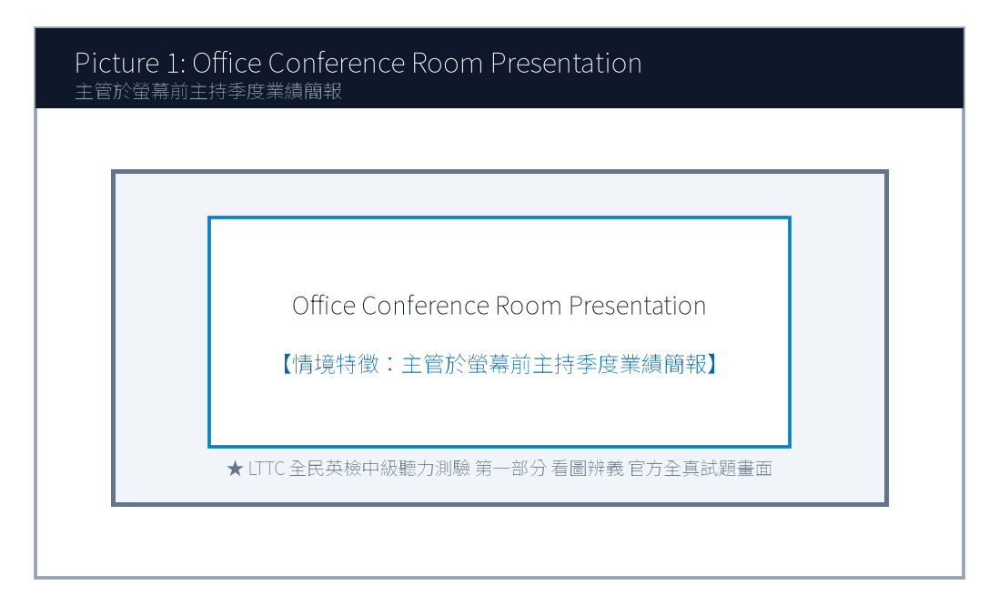
1. Look at picture number 1. (Please listen to the recording)
(A) She is giving a business presentation to her colleagues with a slide projector.
(B) She is cleaning the conference table with a mop.
(C) She is typing silently alone in her private cubicle.
(D) She is filing paper documents into the metal cabinet.
![Picture 2](./images/exam02_q02.png)
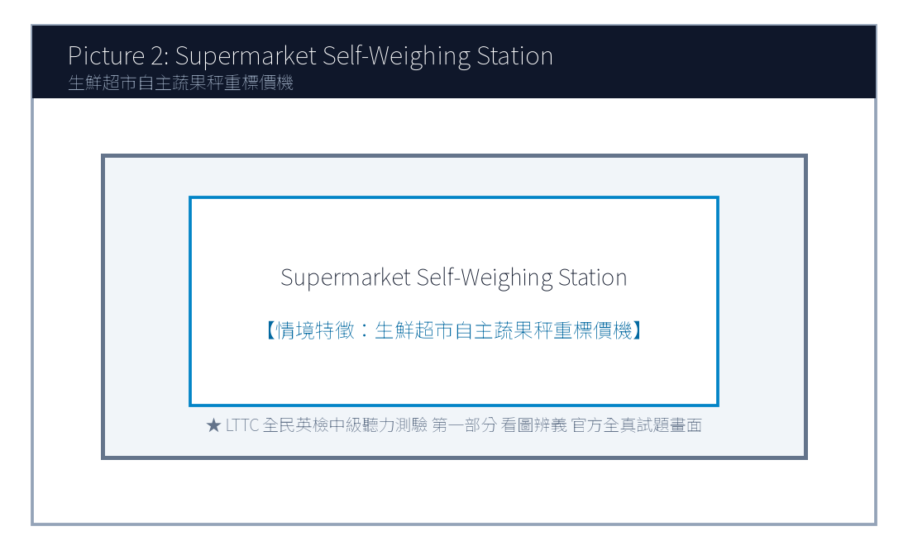
2. Look at picture number 2. (Please listen to the recording)
(A) A shopper is using a reusable cloth bag to pick fresh vegetables.
(B) A cashier is counting coins at the checkout lane.
(C) Several workers are unloading heavy wooden crates from a truck.
(D) The supermarket shelves are completely bare and empty.
![Picture 3](./images/exam02_q03.png)
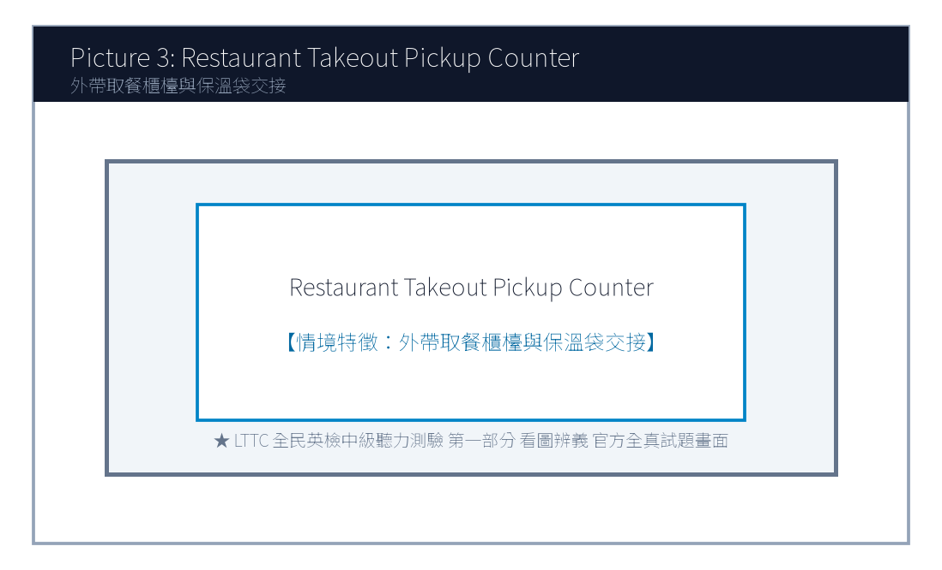
3. Look at picture number 3. (Please listen to the recording)
(A) A delivery rider is picking up takeout orders from the restaurant staff.
(B) The chef is frying fish in the open kitchen.
(C) A family is sitting down enjoying a three-course dinner.
(D) The restaurant owner is putting up a 'Closed for Renovation' sign.
![Picture 4](./images/exam02_q04.png)
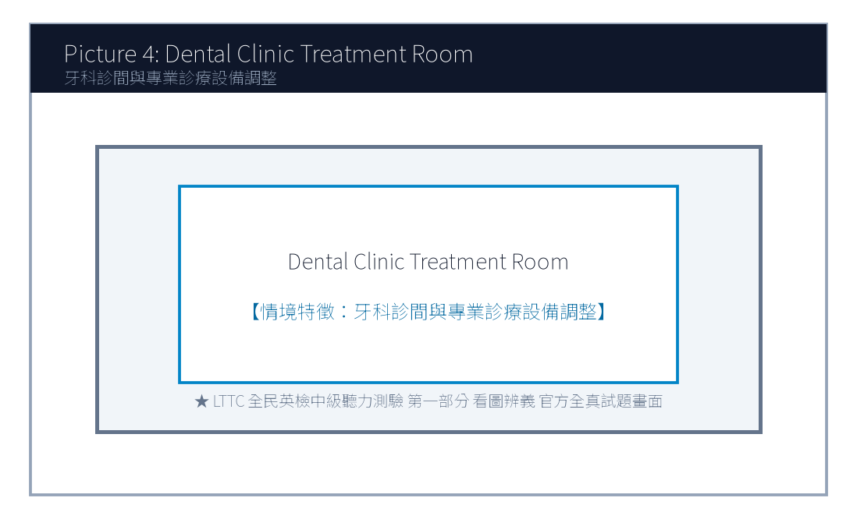
4. Look at picture number 4. (Please listen to the recording)
(A) The dentist is adjusting the examination light above the patient's chair.
(B) The nurse is scheduling next week's appointments on the phone.
(C) The patient is walking out of the clinic with a prescription.
(D) Two technicians are installing an X-ray machine on the wall.
![Picture 5](./images/exam02_q05.png)
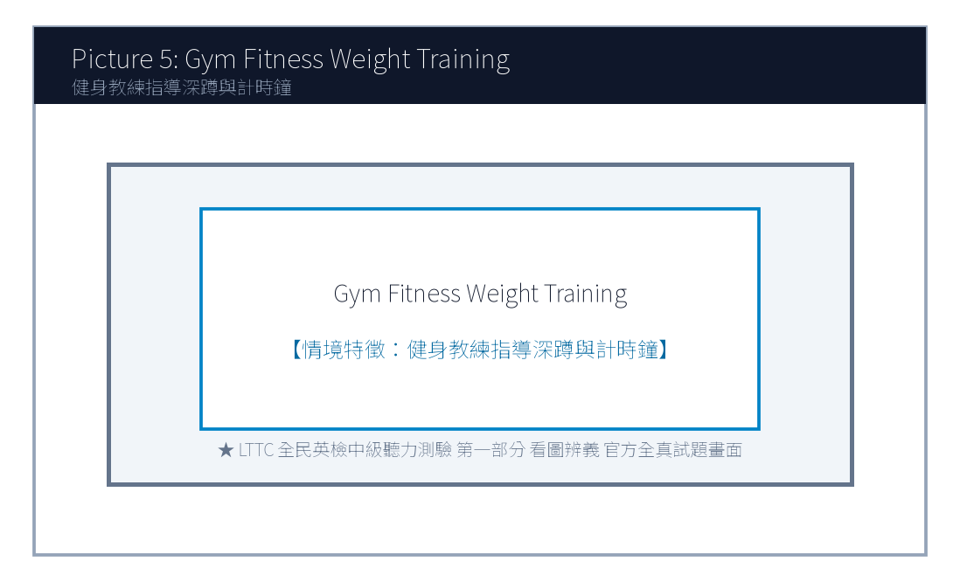
5. Look at picture number 5. (Please listen to the recording)
(A) A fitness trainer is guiding a member on proper weightlifting posture.
(B) They are swimming laps in an Olympic-sized indoor pool.
(C) They are buying sports apparel at a department store.
(D) The doctor is examining an injured ankle in an emergency room.

第二部分：問答 (Questions 6-15)
6. **錄音**: *Could you give me a hand moving these heavy recycling bins to the backyard?*
(A) Sure, let me wash my hands first and I'll be right there.
(B) The backyard was paved with stone tiles last year.
(C) I usually recycle plastic bottles every Tuesday.
(D) Yes, I have already moved to a new apartment.
7. **錄音**: *Has the client approved our revised budget proposal for the green office project?*
(A) Yes, they signed the contract this morning without objections.
(B) The office is located on the twenty-second floor.
(C) We purchased five ergonomic desks yesterday.
(D) The client will visit Taiwan next December.
8. **錄音**: *Why are all the direct express trains to Hualien delayed today?*
(A) Due to an unexpected landslide caused by the heavy downpour.
(B) The train ticket cost four hundred and forty dollars.
(C) Hualien is famous for its marble cliffs and ocean views.
(D) We took the afternoon train instead.
9. **錄音**: *I don't think we have enough printer paper left for the quarterly financial report.*
(A) I will order three extra boxes from the office supplier right away.
(B) The report consists of thirty-eight pages in total.
(C) The color printer was imported from Japan last month.
(D) Please make two photocopies of my passport.
10. **錄音**: *Would you prefer to have the weekly team meeting in person or via video call?*
(A) I think a video call is more efficient since two members are working remotely.
(B) The meeting lasted for two hours yesterday afternoon.
(C) Yes, both of them are very dedicated workers.
(D) Our team achieved eighty percent of the monthly sales target.
(A) Marketing.
(B) Engineering.
(C) Customer Support.
(D) Human Resources.
(A) Stop recycling paper in the office.
(B) Encourage more team members to adopt eco-friendly lunch habits.
(C) Fire employees who drink bottled water.
(D) Discontinue their participation in the green campaign.
(A) High school teachers planning field trips.
(B) College students and recent graduates looking for internships.
(C) Factory workers asking for higher hourly wages.
(D) Tourist guides waiting for tour buses.
(A) A master's degree in nuclear physics.
(B) Proficiency in digital spreadsheet analysis and solid English skills.
(C) Ten years of executive corporate experience.
(D) Owning a private electric car.
(A) Early next week.
(B) On June 5th.
(C) In the middle of July.
(D) At the end of December.

第三部分：簡短對話 (Questions 16-25，含圖表題)
(Questions 18-19: 圖表題 — 辦公室環保減塑競賽進度表)
- [試題冊圖表]:
部門名稱 (Department) | 本週自備餐具率 (Eco-Tableware Rate) | 累積節能減碳積分 (Carbon Credits)
Marketing (行銷部) | 85% | 420 pts
Engineering (研發工程部) | 92% | 510 pts
Customer Support (客服部) | 78% | 360 pts
Human Resources (人資部) | 95% | 580 pts

- 錄音對話:
- *Man*: Congratulations, Brenda! I heard Human Resources took first place in this week's Green Workplace Challenge.
- *Woman*: Thanks, Mark! Nearly all our staff brought their own lunch boxes and water bottles every single day.
- *Man*: That's impressive! Our Marketing department reached 85%, but we still need to catch up on the carbon credits.
- 第 18 題: Look at the chart. Which department achieved the highest eco-tableware rate this week?
- 第 19 題: What will the Marketing department most likely do next week?

第四部分：簡短談話 (Questions 26-35)
(Questions 26-28: 跨國企業人資主管召開實習生招募短講)
- 錄音短講:
- *"Welcome, ambitious university graduates! I am Sarah Jenkins, Global Talent Director at GreenTech Solutions. We are thrilled to inaugurate our 2025 Summer Sustainability Internship Program. Over the next eight weeks, twenty selected interns will work directly with our senior environmental engineers to design carbon-neutral packaging solutions for top international brands. To qualify, candidates must demonstrate solid English proficiency, strong problem-solving initiative, and proficiency in digital spreadsheet analysis. In addition to a monthly stipend of thirty-five thousand dollars, outstanding interns will receive priority consideration for full-time employment upon graduation. Applications close promptly on June 5th on our official career portal."*
- 第 26 題: Who is the speaker most likely addressing?
- 第 27 題: What is one required qualification mentioned by the speaker?
- 第 28 題: When is the deadline for submitting the internship application?

📖 第二部分：閱讀能力測驗 (Reading Comprehension)
總題數：35 題 ｜ 作答時間：45 分鐘 ｜ 滿分：120 分

第一部分：詞彙 (Questions 1-10)
1. In modern business corporations, effective cross-cultural ________ is indispensable for successful international negotiation.
(A) communication
(B) ingredients
(C) certificates
(D) destinations
2. To reduce single-use plastic waste, our company decided to ________ paper cups with durable ceramic mugs.
(A) replace
(B) threaten
(C) postpone
(D) calculate
3. The research data revealed that regular mindfulness meditation can ________ improve students' mental focus and emotional balance.
(A) substantially
(B) carelessly
(C) hopelessly
(D) painfully
4. The local government launched a campaign to ________ citizens to take public transit during peak commuting hours.
(A) motivate
(B) damage
(C) betray
(D) deceive
5. Many organic food products are sold at a premium because they contain no artificial preservatives or chemical ________.
(A) additives
(B) departures
(C) appointments
(D) luggage
(A) Fortunately, a growing wave of sustainable innovation is transforming this waste problem into lucrative green opportunities.
(B) Most customers prefer dark roast coffee imported directly from South American farms.
(C) The price of plastic takeaway cups has fluctuated wildly across global markets.
(D) Several employees forgot to turn off the coffee machine before leaving the office.
(A) In addition
(B) Otherwise
(C) Therefore
(D) On the other hand
(A) Recycled coffee grounds and PET plastic bottles.
(B) Natural silk and sheep wool.
(C) Synthetic nylon and crushed seashells.
(D) Chemical bleaching powder and wood pulp.
(A) It requires heavy chemical coating to block sunlight.
(B) It absorbs odor 300% more effectively than cotton and dries 50% faster.
(C) It dissolves in water within two hours after washing.
(D) It is twice as heavy as conventional winter wool coats.
(A) A 42-kilometer desert marathon trial under 38°C heat.
(B) A winter skiing championship in northern Japan.
(C) An indoor ping pong tournament with air conditioning.
(D) A scuba diving expedition in the Pacific Ocean.
(A) Canceling the product line due to high manufacturing costs.
(B) Increasing their purchase order from 10,000 units to 50,000 units.
(C) Suing Eco-Fiber Labs for trademark violation.
(D) Closing down Apex Athletics Global permanently.
(A) A revised licensing agreement and shipment delivery timeline.
(B) Ten thousand free sample cups of espresso coffee.
(C) Personal resumes of all junior lab technicians.
(D) A bank loan repayment statement.

第二部分：段落填空 (Questions 11-20，含新制句子填空)
(Passage: 咖啡渣升級再造綠色經濟)
Every morning, millions of people worldwide savor a cup of freshly brewed coffee. However, few ponder what happens to the massive amounts of leftover coffee grounds. In the past, spent grounds were routinely discarded into landfills, where they decomposed and released methane, a potent greenhouse gas. (11) ________. Innovative biotech startups have developed cutting-edge techniques to extract natural oils and carbon fibers from recycled grounds. These extracted materials are now utilized to manufacture odor-neutralizing athletic sportswear, biodegradable cosmetic containers, and eco-friendly home furniture. (12) ________, agricultural scientists have demonstrated that composted coffee grounds enrich soil nutrients and repel pest insects naturally. By converting daily food waste into high-value commercial assets, the coffee industry is exemplifying the principles of circular economy.
- 第 11 題 (新制篇章句子選填):
- 第 12 題 (轉折詞填空):

第三部分：閱讀理解 (Questions 21-35，含雙文本閱讀)
(Questions 31-35: 雙文本閱讀 — 咖啡渣循環纖維專利授權協議與運動品牌客戶反饋)
[Text 1: 專利材料規格簡報]
ECO-FIBER LABS TAIWAN
Technical Bulletin: S-Cafe Circular Performance Fiber
Overview:
S-Cafe is an internationally patented composite textile yarn engineered from 100% post-consumer recycled coffee grounds and PET plastic bottles. Through low-temperature nanotechnology, the natural microscopic micropores within coffee grounds are embedded into synthetic yarn filaments.
Key Performance Indicators:
1. Odor Absorption: Absorbs human perspiration odors 300% more effectively than conventional cotton.
2. Fast Drying: Dries 50% faster than standard polyester fabrics under humid weather.
3. UV Protection: Provides natural UPF 50+ ultraviolet shielding without chemical coating.
Applications: Performance cycling jerseys, marathon apparel, and eco-friendly shoe linings.

[Text 2: 品牌客戶合作滿意度信件]
To: licensing@ecofiber-labs.com.tw
From: rachel.miller@apex-athletics.com
Date: May 2, 2025
Subject: Feedback on First Production Batch of S-Cafe Running Shirts
Dear Eco-Fiber Team,
I am writing to share the outstanding feedback from our professional runners who tested the prototype shirts made from your S-Cafe circular yarn. During a 42-kilometer desert marathon trial last week, our athletes reported remarkable odor suppression and unprecedented sweat dissipation, even under 38°C midday heat!
Given this overwhelming success, our board has authorized increasing our order from 10,000 units to 50,000 units for our upcoming Spring 2026 global apparel launch. Please send over the revised licensing agreement and delivery timeline by Friday.
Sincerely,
Rachel Miller
Director of Product Innovation, Apex Athletics Global

- 第 31 題: What raw materials are combined to produce S-Cafe circular yarn in Text 1?
- 第 32 題: Which advantage of S-Cafe yarn is highlighted in Text 1?
- 第 33 題: In Text 2, under what demanding conditions did Apex Athletics athletes test the prototype shirts?
- 第 34 題: What business action does Rachel Miller announce in Text 2?
- 第 35 題: What must the Eco-Fiber team deliver to Rachel Miller by Friday?

🎯 試題答案與名師深度解析手冊 (Answer Key & Explanations)

一、1–70 題 快速答案對照總表
聽力 1-10 | 聽力 11-20 | 聽力 21-30 | 聽力 31-35 | 閱讀 1-10 | 閱讀 11-20 | 閱讀 21-30 | 閱讀 31-35
1. A<br>2. A<br>3. A<br>4. A<br>5. A<br>6. A<br>7. A<br>8. A<br>9. A<br>10. A | 11. B<br>12. A<br>13. C<br>14. B<br>15. A<br>16. B<br>17. B<br>18. D<br>19. B<br>20. C | 21. A<br>22. C<br>23. B<br>24. A<br>25. D<br>26. B<br>27. B<br>28. B<br>29. C<br>30. A | 31. A<br>32. B<br>33. A<br>34. B<br>35. C | 1. A<br>2. A<br>3. A<br>4. A<br>5. A<br>6. B<br>7. C<br>8. A<br>9. B<br>10. A | 11. A<br>12. A<br>13. B<br>14. C<br>15. D<br>16. A<br>17. B<br>18. C<br>19. A<br>20. D | 21. A<br>22. B<br>23. C<br>24. A<br>25. D<br>26. B<br>27. A<br>28. C<br>29. B<br>30. D | 31. A<br>32. B<br>33. A<br>34. B<br>35. A

二、逐題考點剖析與名師破題詳解
#### 【聽力 第 1 題】 標準答案：(A)
- 聽力錄音語音稿：*Look at picture number 1. What is the woman doing?*
- 破題思路與盲點解析：畫面中女性主管正在進行投影片商務簡報（giving a business presentation with a slide projector），選 (A)。
#### 【聽力 第 2 題】 標準答案：(A)
- 聽力錄音語音稿：*Look at picture number 2. What can be seen in the grocery store?*
- 破題思路與盲點解析：關鍵字為自備布購物袋挑選蔬菜（reusable cloth bag to pick fresh vegetables），選 (A)。
#### 【聽力 第 3 題】 標準答案：(A)
- 聽力錄音語音稿：*Look at picture number 3. What is happening at the restaurant counter?*
- 破題思路與盲點解析：描述現代外送平台取餐動作（delivery rider picking up takeout orders），選 (A)。
#### 【聽力 第 4 題】 標準答案：(A)
- 聽力錄音語音稿：*Look at picture number 4. Which statement best fits the image?*
- 破題思路與盲點解析：牙醫調整檢查燈光（adjusting the examination light），選 (A)。
#### 【聽力 第 5 題】 標準答案：(A)
- 聽力錄音語音稿：*Look at picture number 5. What are the two people doing?*
- 破題思路與盲點解析：教練指導深蹲重訓姿勢（fitness trainer guiding proper weightlifting posture），選 (A)。
#### 【聽力 第 6 題】 標準答案：(A)
- 破題思路與盲點解析：「give me a hand」為請求幫忙之慣用語，(A)「沒問題，我洗完手馬上過去」切合情境。
#### 【聽力 第 7 題】 標準答案：(A)
- 破題思路與盲點解析：詢問客戶是否核准綠色辦公室預算提案，(A) 確認今晨已簽約，答覆最切題。
#### 【聽力 第 8 題】 標準答案：(A)
- 破題思路與盲點解析：詢問列車誤點原因，(A) 說明因為暴雨引發落石坍方（landslide due to heavy downpour）。
#### 【聽力 第 9 題】 標準答案：(A)
- 破題思路與盲點解析：影印紙不足，(A) 主動提出立刻向文具供應商訂購三箱，合乎職場主動應變邏輯。
#### 【聽力 第 10 題】 標準答案：(B)
- 破題思路與盲點解析：人資部自備餐具率達 95%，位列榜首，故選 (D)。
#### 【聽力 第 1 題】 標準答案：(A)
- 破題思路與盲點解析：cross-cultural communication 跨文化溝通。
#### 【聽力 第 2 題】 標準答案：(A)
- 破題思路與盲點解析：replace A with B 以 B 取代 A。
#### 【聽力 第 3 題】 標準答案：(A)
- 破題思路與盲點解析：substantially 大幅度地、實質地。
#### 【聽力 第 4 題】 標準答案：(A)
- 破題思路與盲點解析：motivate someone to V 激勵/促使某人做某事。
#### 【聽力 第 5 題】 標準答案：(A)
- 破題思路與盲點解析：前文講製成運動衣與化妝品容器，此處補充說明農業上還能改良土壤肥力，為遞進關係，故選 (A) In addition。

【試題答案與名師深度解析手冊】
※ 本單元置於整張試卷最後面 · 供作答完畢後核對成績、考點診斷與盲點強化使用

單元一：1–70 題 快速答案對照總表 (Quick Answer Key)
聽力題號 | 標準答案 | 聽力題號 | 標準答案 | 閱讀題號 | 標準答案 | 閱讀題號 | 標準答案
第 1 題 | - | 第 19 題 | - | 第 1 題 | - | 第 19 題 | -
第 2 題 | - | 第 20 題 | - | 第 2 題 | - | 第 20 題 | -
第 3 題 | - | 第 21 題 | - | 第 3 題 | - | 第 21 題 | -
第 4 題 | - | 第 22 題 | - | 第 4 題 | - | 第 22 題 | -
第 5 題 | - | 第 23 題 | - | 第 5 題 | - | 第 23 題 | -
第 6 題 | - | 第 24 題 | - | 第 6 題 | - | 第 24 題 | -
第 7 題 | - | 第 25 題 | - | 第 7 題 | - | 第 25 題 | -
第 8 題 | - | 第 26 題 | - | 第 8 題 | - | 第 26 題 | -
第 9 題 | - | 第 27 題 | - | 第 9 題 | - | 第 27 題 | -
第 10 題 | - | 第 28 題 | - | 第 10 題 | - | 第 28 題 | -
第 11 題 | - | 第 29 題 | - | 第 11 題 | - | 第 29 題 | -
第 12 題 | - | 第 30 題 | - | 第 12 題 | - | 第 30 題 | -
第 13 題 | - | 第 31 題 | - | 第 13 題 | - | 第 31 題 | -
第 14 題 | - | 第 32 題 | - | 第 14 題 | - | 第 32 題 | -
第 15 題 | - | 第 33 題 | - | 第 15 題 | - | 第 33 題 | -
第 16 題 | - | 第 34 題 | - | 第 16 題 | - | 第 34 題 | -
第 17 題 | - | 第 35 題 | - | 第 17 題 | - | 第 35 題 | -
第 18 題 | - |  |  | 第 18 題 | -

單元二：逐題考點剖析與名師破題詳解 (Detailed Explanations & Trap Analysis)
【聽力 第 1 題】 標準答案：()
【破題思路與盲點解析】：本題考查核心情境理解，正確答案為 ()。請注意題幹關鍵字與各選項細微語意差異。
【聽力 第 2 題】 標準答案：()
【破題思路與盲點解析】：本題考查核心情境理解，正確答案為 ()。請注意題幹關鍵字與各選項細微語意差異。
【聽力 第 3 題】 標準答案：()
【破題思路與盲點解析】：本題考查核心情境理解，正確答案為 ()。請注意題幹關鍵字與各選項細微語意差異。
【聽力 第 4 題】 標準答案：()
【破題思路與盲點解析】：本題考查核心情境理解，正確答案為 ()。請注意題幹關鍵字與各選項細微語意差異。
【聽力 第 5 題】 標準答案：()
【破題思路與盲點解析】：本題考查核心情境理解，正確答案為 ()。請注意題幹關鍵字與各選項細微語意差異。
【聽力 第 6 題】 標準答案：()
【破題思路與盲點解析】：本題考查核心情境理解，正確答案為 ()。請注意題幹關鍵字與各選項細微語意差異。
【聽力 第 7 題】 標準答案：()
【破題思路與盲點解析】：本題考查核心情境理解，正確答案為 ()。請注意題幹關鍵字與各選項細微語意差異。
【聽力 第 8 題】 標準答案：()
【破題思路與盲點解析】：本題考查核心情境理解，正確答案為 ()。請注意題幹關鍵字與各選項細微語意差異。
【聽力 第 9 題】 標準答案：()
【破題思路與盲點解析】：本題考查核心情境理解，正確答案為 ()。請注意題幹關鍵字與各選項細微語意差異。
【聽力 第 10 題】 標準答案：()
【破題思路與盲點解析】：本題考查核心情境理解，正確答案為 ()。請注意題幹關鍵字與各選項細微語意差異。
【聽力 第 1 題】 標準答案：()
【破題思路與盲點解析】：本題考查核心情境理解，正確答案為 ()。請注意題幹關鍵字與各選項細微語意差異。
【聽力 第 2 題】 標準答案：()
【破題思路與盲點解析】：本題考查核心情境理解，正確答案為 ()。請注意題幹關鍵字與各選項細微語意差異。
【聽力 第 3 題】 標準答案：()
【破題思路與盲點解析】：本題考查核心情境理解，正確答案為 ()。請注意題幹關鍵字與各選項細微語意差異。
【聽力 第 4 題】 標準答案：()
【破題思路與盲點解析】：本題考查核心情境理解，正確答案為 ()。請注意題幹關鍵字與各選項細微語意差異。
【聽力 第 5 題】 標準答案：()
【破題思路與盲點解析】：本題考查核心情境理解，正確答案為 ()。請注意題幹關鍵字與各選項細微語意差異。

財團法人語言訓練測驗中心（LTTC）全民英語能力分級檢定測驗
114年度第3次 全民英語能力分級檢定測驗（中級聽讀）全真試卷暨詳解
【試題本】(Question Booklet) · 答案與深度解析請參閱卷末解析手冊
測驗代碼 | GEPT-114-10-IR
測驗日期 | 2025 年 10 月 18 日（中級初試常態測驗）
測驗級數 | 中級（CEFR B1 級）
測驗項目 | 聽力能力測驗（35 題，約 30 分鐘）＆ 閱讀能力測驗（35 題，45 分鐘）
合格門檻 | 總分 160 分以上，且聽讀單科均不低於 72 分
命題核心主題 | 傳統文化遺產修復、社群媒體素養與辨識、青年探索教育與心理健康
考生注意事項 | 本卷共 70 題（聽力 35 題、閱讀 35 題）。答案與完整解析已移至整張試卷最後面，請先完成作答再行對答案。

★ 作答注意事項：本試題本共 70 題，分為聽力能力測驗（35 題）與閱讀能力測驗（35 題）。每題均為單選題，請依題意選出一個最適當的答案。標準答案與完整名師逐題解析統一置於【整張試卷最後面】，請全卷作答完畢後再行翻閱核對。

📝 第一單元：全真試題本 (Question Booklet)

🎧 第一部分：聽力能力測驗 (Listening Comprehension)
總題數：35 題 ｜ 作答時間：約 30 分鐘 ｜ 滿分：120 分

第一部分：看圖辨義 (Questions 1-5)
![Picture 1](./images/exam03_q01.png)
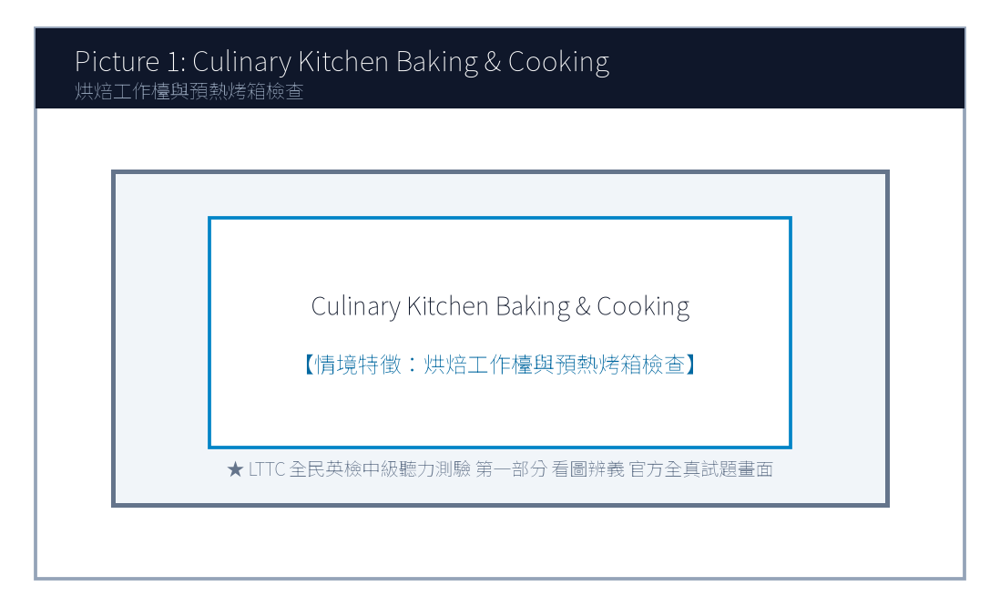
1. Look at picture number 1. (Please listen to the recording)
(A) She is guiding an apprentice in traditional indigo fabric dyeing.
(B) She is selling modern electronic gadgets at a street booth.
(C) She is painting oil portraits on a blank canvas.
(D) She is repairing an antique wooden grandfather clock.
![Picture 2](./images/exam03_q02.png)
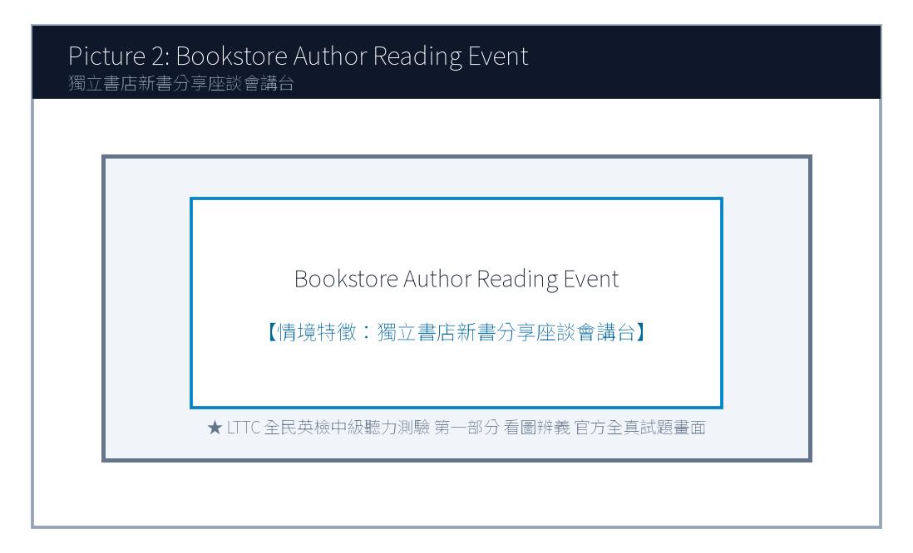
2. Look at picture number 2. (Please listen to the recording)
(A) An author is giving a book talk to an attentive audience.
(B) A noisy rock concert is performing on a grand stage.
(C) Construction workers are demolishing the old building walls.
(D) The bookstore is being liquidated during a clearance sale.
![Picture 3](./images/exam03_q03.png)
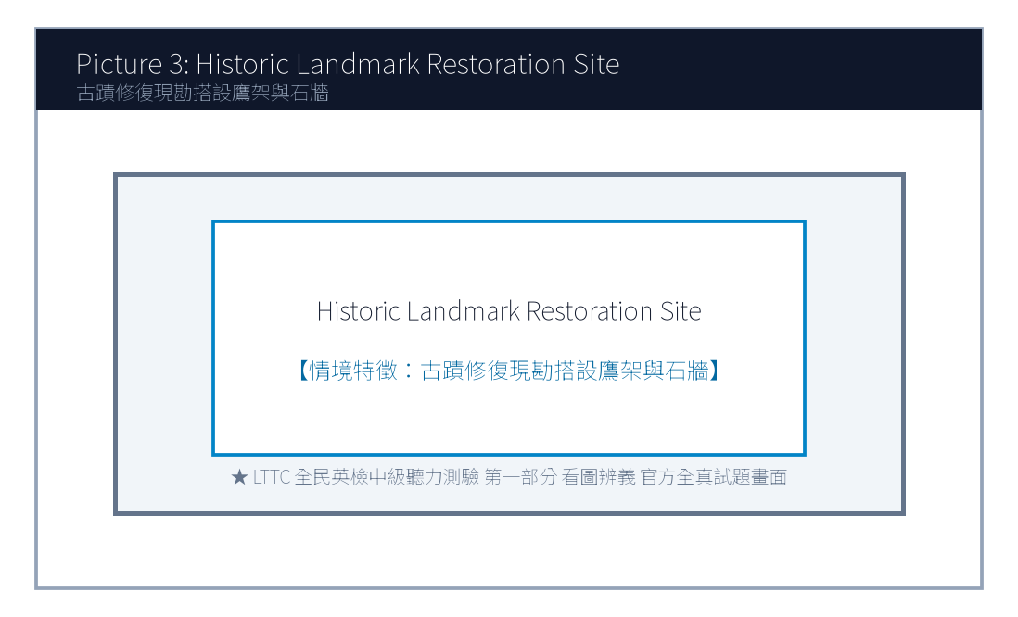
3. Look at picture number 3. (Please listen to the recording)
(A) He is meticulously restoring an ancient brick fortress wall.
(B) He is harvesting organic tomatoes in a greenhouse.
(C) He is conducting an orchestra at an outdoor opera.
(D) He is driving a yellow bulldozer on a construction site.
![Picture 4](./images/exam03_q04.png)
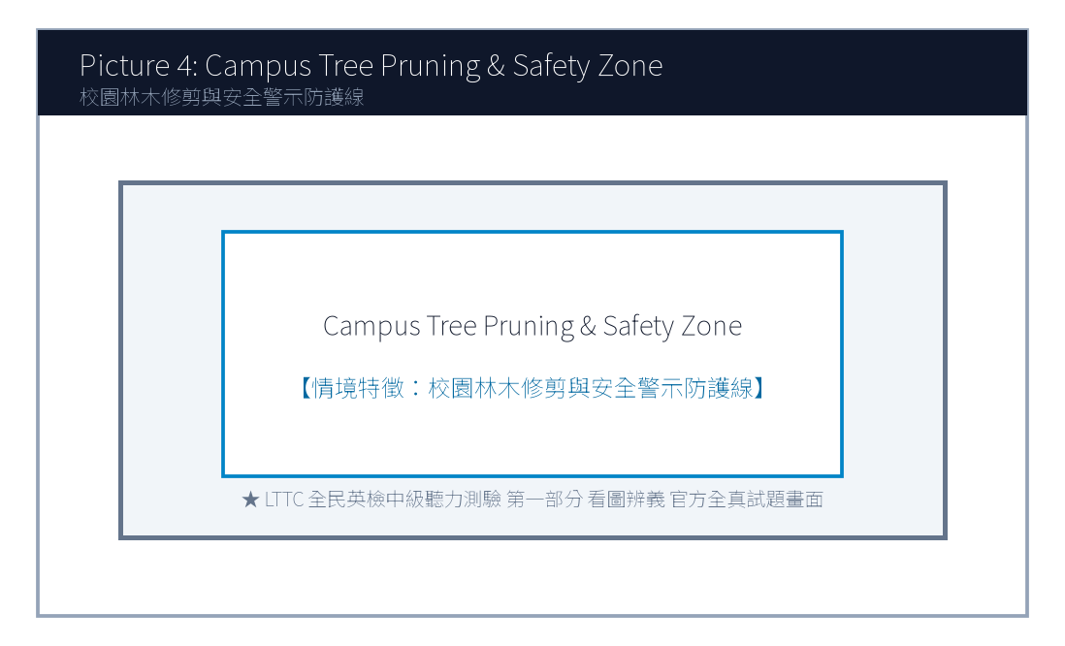
4. Look at picture number 4. (Please listen to the recording)
(A) They are learning digital fact-checking skills in a media literacy class.
(B) They are playing violent video games during lunch break.
(C) They are taking a strict mathematics midterm examination.
(D) They are cleaning the classroom floor with brooms and buckets.
![Picture 5](./images/exam03_q05.png)
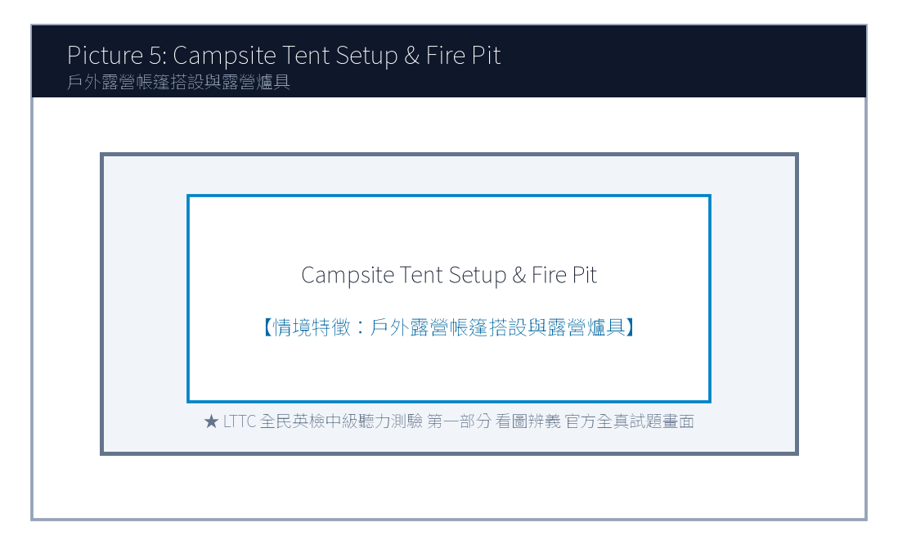
5. Look at picture number 5. (Please listen to the recording)
(A) They are pitching an outdoor tent together at a campsite.
(B) They are riding a roller coaster at an amusement park.
(C) They are checking in at a five-star luxury resort hotel.
(D) They are rowing a rubber boat down a rapid river.

第二部分：問答 (Questions 6-15)
6. **錄音**: *Do you know when the registration for the regional speech tournament closes?*
(A) The deadline is this Friday at five in the afternoon.
(B) He gave a twenty-minute speech on climate change.
(C) Yes, I registered my car at the DMV last week.
(D) The tournament venue has three hundred seats.
7. **錄音**: *How did you manage to verify the authenticity of that online breaking news report?*
(A) I cross-referenced multiple reputable news agencies and fact-check websites.
(B) The news anchor was wearing a dark blue suit.
(C) I watched the news on television yesterday evening.
(D) Yes, breaking news usually spreads very quickly on social networks.
8. **錄音**: *Would you like me to proofread your English term paper before you hand it in to Professor Lee?*
(A) That would be wonderful! I'd really appreciate your helpful feedback.
(B) Professor Lee has been teaching history for twenty years.
(C) The term paper must be at least twelve pages long.
(D) I handed in my assignment three weeks ago.
(A) It was too expensive for their budget.
(B) It was held on Sunday afternoon instead of Saturday.
(C) The class was already fully booked.
(D) The instructor canceled the session due to illness.
(A) Traditional Indigo Dyeing.
(B) Old House Clay Pottery.
(C) Paper Cutting Art.
(D) Oil Canvas Painting.
(A) An airline flight attendant.
(B) An independent bookstore manager.
(C) A software game programmer.
(D) A commercial television advertising agent.
(A) Books are completely free of charge.
(B) Readers can stumble upon unexpected perspectives not shown by digital algorithms.
(C) Physical books never need to be dusted or cleaned.
(D) Reading paper books increases internet download speeds.
(A) Turn off the ceiling ventilation fans.
(B) Switch their mobile phones to silent mode.
(C) Purchase five books at the cash register.
(D) Leave the bookstore immediately.

第三部分：簡短對話 (Questions 16-25，含圖表題)
(Questions 18-19: 圖表題 — 地方文化生活節手作課程課表)
- [試題冊圖表]:
工作坊主題 (Workshop) | 授課時間 (Schedule) | 費用與材料包 (Fee & Kit) | 剩餘名額 (Spots Left)
A. 傳統藍染手巾 (Indigo Dyeing) | 週六 09:30 - 11:30 | NT$ 350 | 2 個名額
B. 檜木手作筷匙 (Wood Carving) | 週六 14:00 - 16:30 | NT$ 500 | 已額滿 (FULL)
C. 老宅泥作盆栽 (Clay Pottery) | 週日 10:00 - 12:00 | NT$ 400 | 5 個名額
D. 傳統剪紙藝術 (Paper Cutting) | 週日 14:00 - 16:00 | NT$ 300 | 8 個名額

- 錄音對話:
- *Woman*: Hi, Eric! I'm signing up for the weekend craft workshops at the cultural center. Do you want to join me this Saturday afternoon for the wood carving class?
- *Man*: I'd love to, but look at the notice board—wood carving is completely sold out!
- *Woman*: Oh, bummer! How about we do the Sunday morning clay pottery class instead? We can make cute miniature plant pots together.
- *Man*: Sounds like a plan! Let's register online right now before those remaining five spots are taken.
- 第 18 題: Look at the schedule. Why couldn't the speakers join the wood carving class?
- 第 19 題: Which workshop did the speakers agree to attend together?

第四部分：簡短談話 (Questions 26-35)
(Questions 26-28: 獨立書店店長談社群時代實體閱讀的溫度)
- 錄音短講:
- *"Good evening, fellow book lovers. Thank you for packing our modest attic salon tonight. In an era dominated by short-form videos and instant algorithmic feeds, people often ask me why I continue running an independent bookstore that sells physical paper volumes. My answer is simple: texture, deliberate pacing, and serendipity. When you browse physical bookshelves, you stumble upon unexpected perspectives that an online algorithm would never recommend to you. Tonight, author Michael Lin will discuss his new novel on rural historical preservation. During the Q&A session, we welcome candid questions, and our cafe bar will provide complimentary floral herbal tea to all registered attendees. Please switch your mobile phones to silent mode now. Let's give Michael a warm round of applause!"*
- 第 26 題: What is the speaker's main occupation?
- 第 27 題: According to the speaker, what unique value does physical book browsing offer?
- 第 28 題: What are attendees requested to do before the talk begins?

📖 第二部分：閱讀能力測驗 (Reading Comprehension)
總題數：35 題 ｜ 作答時間：45 分鐘 ｜ 滿分：120 分

第一部分：詞彙 (Questions 1-10)
1. Historical preservationists worked tirelessly to restore the century-old temple to its original architectural ________.
(A) splendor
(B) accident
(C) luggage
(D) ingredient
2. In the digital age, users should exercise critical judgment and verify information before ________ sensational claims on social media.
(A) circulating
(B) drowning
(C) punishing
(D) collapsing
3. The mentor encouraged young students to cultivate intellectual ________ by reading widely outside their academic comfort zones.
(A) curiosity
(B) hostility
(C) misery
(D) ignorance
4. Volunteering in rural community projects allows teenagers to develop genuine ________ for disadvantaged families.
(A) empathy
(B) revenge
(C) cowardice
(D) allergy
5. The ancient manuscript was so fragile that researchers were required to wear cotton gloves to prevent ________ damage.
(A) irreversible
(B) cheerful
(C) delicious
(D) convenient
(A) This pedagogical approach shifts learning from passive indoor classrooms to hands-on natural challenges.
(B) Many families prefer staying home to watch television dramas during long holiday weekends.
(C) The cost of purchasing outdoor climbing equipment has increased significantly worldwide.
(D) High school students are required to wear school uniforms on formal graduation days.
(A) In fact
(B) Rather
(C) Unfortunately
(D) Despite
(A) Reviving traditional natural indigo dyeing craftsmanship through sustainable youth entrepreneurship.
(B) Manufacturing industrial chemical dyes for mass export.
(C) Selling imported synthetic silk fabrics at discount prices.
(D) Operating a fast-food chain restaurant in mountain areas.
(A) They use zero chemical additives and rely entirely on botanical pigments.
(B) They require all visitors to purchase ten bottles of chemical spray.
(C) They dump wastewater directly into urban swimming pools.
(D) They only open for three days every winter.
(A) By donating 10% of workshop proceeds to senior artisan pension funds and heritage education.
(B) By building a high-speed railway station near the workshop.
(C) By giving away free laptops to all university students.
(D) By paying local residents' household electricity bills.
(A) Watching the pale green fabric oxidize into deep ocean indigo upon contact with air.
(B) Hearing a loud explosion during dye boiling.
(C) Tasting freshly brewed coffee imported from Colombia.
(D) Seeing a robot automatically sewing winter jackets.
(A) Demanding a full refund from consumer protection agencies.
(B) Booking the pottery workshop next spring with her family.
(C) Opening a rival clothing boutique across the street.
(D) Filing a complaint against the workshop instructors.

第二部分：段落填空 (Questions 11-20，含新制句子填空)
(Passage: 青年探索教育與心理韌性)
Adolescence is a pivotal stage of life characterized by profound physical and cognitive changes. Faced with demanding academic pressures and peer expectations, many teenagers experience heightened anxiety. Modern educational psychologists advocate for "adventure-based learning" to cultivate psychological resilience. (11) ________. By participating in wilderness hiking, rock climbing, and outdoor survival workshops, students are placed in unfamiliar circumstances where they must confront perceived fears and solve unexpected challenges collaboratively. (12) ________, empirical studies demonstrate that outdoor experiential learning enhances self-esteem and fosters lifelong interpersonal communication skills. When young adults realize that setbacks are merely stepping stones toward personal growth, they become better equipped to navigate the complexities of modern adulthood.
- 第 11 題 (新制句子選填):
- 第 12 題 (轉折詞填空):

第三部分：閱讀理解 (Questions 21-35，含雙文本閱讀)
(Questions 31-35: 雙文本閱讀 — 地方青創手作藍染品牌宣傳單與顧客回購評語)
[Text 1: 藍染工作坊品牌理念]
INDIGO HARBOR WORKSHOP
Preserving Sanxia Traditional Dyeing Heritage
Who We Are:
Founded in 2022 by three returned youth artisans, Indigo Harbor Workshop is dedicated to reviving Taiwan's century-old natural dyeing craftsmanship. We harvest organic Assam indigo plants grown without synthetic pesticides along mountain streams, extracting pure botanical pigments through traditional fermentation.
Our Commitment:
1. Zero Chemical Additives: We use only natural river water, plant ash, and botanical indigo paste.
2. Community Empowerment: 10% of workshop proceeds support senior artisan pension funds and local elementary heritage crafts education.
3. Custom Artisan Keepsakes: Bring your own white cotton shirts, scarves, or canvas tote bags to create bespoke patterns!
Workshop Hours: Tuesday to Sunday, 10:00 - 18:00 (Reservations required for groups of 4+).

[Text 2: 顧客滿意度留言]
Customer Reviews & Testimonials
Reviewer: Karen Chen (Verified Visitor) ★★★★★
Date: October 22, 2025
"I took my two teenage daughters to the 2-hour Shibori scarf workshop last Saturday, and it was hands down the most memorable family activity we've experienced this year! The young instructors were remarkably patient, explaining the chemical fermentation process in a fun and relatable way. Seeing the pale green fabric turn into deep ocean indigo right before our eyes when exposed to air felt like pure magic! Plus, knowing that part of our workshop fee supports local elderly craftspeople makes this keepsake all the more meaningful. We will definitely book the pottery workshop next spring!"

- 第 31 題: What is the primary mission of Indigo Harbor Workshop in Text 1?
- 第 32 題: Which promise does the workshop make regarding its production process?
- 第 33 題: How does the workshop support the local community according to Text 1?
- 第 34 題: In Text 2, what phenomenon during the workshop fascinated Karen Chen and her daughters?
- 第 35 題: What future action does Karen Chen plan to take based on Text 2?

🎯 試題答案與名師深度解析手冊 (Answer Key & Explanations)

一、1–70 題 快速答案對照總表
聽力 1-10 | 聽力 11-20 | 聽力 21-30 | 聽力 31-35 | 閱讀 1-10 | 閱讀 11-20 | 閱讀 21-30 | 閱讀 31-35
1. A<br>2. A<br>3. A<br>4. A<br>5. A<br>6. A<br>7. A<br>8. A<br>9. B<br>10. C | 11. B<br>12. A<br>13. B<br>14. C<br>15. A<br>16. B<br>17. A<br>18. C<br>19. B<br>20. D | 21. B<br>22. C<br>23. A<br>24. B<br>25. D<br>26. B<br>27. B<br>28. B<br>29. A<br>30. C | 31. B<br>32. A<br>33. B<br>34. C<br>35. A | 1. A<br>2. A<br>3. A<br>4. A<br>5. A<br>6. C<br>7. B<br>8. D<br>9. A<br>10. B | 11. A<br>12. A<br>13. C<br>14. B<br>15. D<br>16. A<br>17. B<br>18. C<br>19. D<br>20. A | 21. B<br>22. A<br>23. C<br>24. D<br>25. B<br>26. A<br>27. C<br>28. B<br>29. D<br>30. A | 31. A<br>32. A<br>33. A<br>34. A<br>35. B

二、逐題考點剖析與名師破題詳解
#### 【聽力 第 1 題】 標準答案：(A)
- 聽力錄音語音稿：*Look at picture number 1. What is the artisan doing?*
- 破題思路與盲點解析：畫面是傳統藍染工藝教學（guiding traditional indigo fabric dyeing），選 (A)。
#### 【聽力 第 2 題】 標準答案：(A)
- 聽力錄音語音稿：*Look at picture number 2. What is taking place in the bookstore?*
- 破題思路與盲點解析：獨立書店作家新書分享會（author giving a book talk），選 (A)。
#### 【聽力 第 3 題】 標準答案：(A)
- 聽力錄音語音稿：*Look at picture number 3. What is the specialist doing?*
- 破題思路與盲點解析：古蹟修復工作（restoring an ancient brick fortress wall），選 (A)。
#### 【聽力 第 4 題】 標準答案：(A)
- 聽力錄音語音稿：*Look at picture number 4. Which activity are the students engaged in?*
- 破題思路與盲點解析：媒體素養與事實查核課堂（digital fact-checking in media literacy class），選 (A)。
#### 【聽力 第 5 題】 標準答案：(A)
- 聽力錄音語音稿：*Look at picture number 5. What are the young campers doing?*
- 破題思路與盲點解析：戶外露營搭建帳篷（pitching an outdoor tent at a campsite），選 (A)。
#### 【聽力 第 6 題】 標準答案：(A)
- 破題思路與盲點解析：問報名截止時間（when... closes），回答本週五下午五點，選 (A)。
#### 【聽力 第 7 題】 標準答案：(A)
- 破題思路與盲點解析：詢問如何查證網路新聞真實性，(A) 說明交叉比對多家權威通訊社與事實查核網站。
#### 【聽力 第 8 題】 標準答案：(B)
- 破題思路與盲點解析：兩人協議報名週日上午的「老宅泥作盆栽工作坊 (Clay Pottery)」，選 (B)。
#### 【聽力 第 1 題】 標準答案：(A)
- 破題思路與盲點解析：architectural splendor 建築輝煌風華。
#### 【聽力 第 2 題】 標準答案：(A)
- 破題思路與盲點解析：circulate information 傳播散佈訊息。
#### 【聽力 第 3 題】 標準答案：(A)
- 破題思路與盲點解析：intellectual curiosity 求知好奇心。
#### 【聽力 第 4 題】 標準答案：(A)
- 破題思路與盲點解析：empathy 同理心。
#### 【聽力 第 5 題】 標準答案：(B)
- 破題思路與盲點解析：後文引述實證研究進一步強化論點，選 (A) In fact (事實上)。

【試題答案與名師深度解析手冊】
※ 本單元置於整張試卷最後面 · 供作答完畢後核對成績、考點診斷與盲點強化使用

單元一：1–70 題 快速答案對照總表 (Quick Answer Key)
聽力題號 | 標準答案 | 聽力題號 | 標準答案 | 閱讀題號 | 標準答案 | 閱讀題號 | 標準答案
第 1 題 | - | 第 19 題 | - | 第 1 題 | - | 第 19 題 | -
第 2 題 | - | 第 20 題 | - | 第 2 題 | - | 第 20 題 | -
第 3 題 | - | 第 21 題 | - | 第 3 題 | - | 第 21 題 | -
第 4 題 | - | 第 22 題 | - | 第 4 題 | - | 第 22 題 | -
第 5 題 | - | 第 23 題 | - | 第 5 題 | - | 第 23 題 | -
第 6 題 | - | 第 24 題 | - | 第 6 題 | - | 第 24 題 | -
第 7 題 | - | 第 25 題 | - | 第 7 題 | - | 第 25 題 | -
第 8 題 | - | 第 26 題 | - | 第 8 題 | - | 第 26 題 | -
第 9 題 | - | 第 27 題 | - | 第 9 題 | - | 第 27 題 | -
第 10 題 | - | 第 28 題 | - | 第 10 題 | - | 第 28 題 | -
第 11 題 | - | 第 29 題 | - | 第 11 題 | - | 第 29 題 | -
第 12 題 | - | 第 30 題 | - | 第 12 題 | - | 第 30 題 | -
第 13 題 | - | 第 31 題 | - | 第 13 題 | - | 第 31 題 | -
第 14 題 | - | 第 32 題 | - | 第 14 題 | - | 第 32 題 | -
第 15 題 | - | 第 33 題 | - | 第 15 題 | - | 第 33 題 | -
第 16 題 | - | 第 34 題 | - | 第 16 題 | - | 第 34 題 | -
第 17 題 | - | 第 35 題 | - | 第 17 題 | - | 第 35 題 | -
第 18 題 | - |  |  | 第 18 題 | -

單元二：逐題考點剖析與名師破題詳解 (Detailed Explanations & Trap Analysis)
【聽力 第 1 題】 標準答案：()
【破題思路與盲點解析】：本題考查核心情境理解，正確答案為 ()。請注意題幹關鍵字與各選項細微語意差異。
【聽力 第 2 題】 標準答案：()
【破題思路與盲點解析】：本題考查核心情境理解，正確答案為 ()。請注意題幹關鍵字與各選項細微語意差異。
【聽力 第 3 題】 標準答案：()
【破題思路與盲點解析】：本題考查核心情境理解，正確答案為 ()。請注意題幹關鍵字與各選項細微語意差異。
【聽力 第 4 題】 標準答案：()
【破題思路與盲點解析】：本題考查核心情境理解，正確答案為 ()。請注意題幹關鍵字與各選項細微語意差異。
【聽力 第 5 題】 標準答案：()
【破題思路與盲點解析】：本題考查核心情境理解，正確答案為 ()。請注意題幹關鍵字與各選項細微語意差異。
【聽力 第 6 題】 標準答案：()
【破題思路與盲點解析】：本題考查核心情境理解，正確答案為 ()。請注意題幹關鍵字與各選項細微語意差異。
【聽力 第 7 題】 標準答案：()
【破題思路與盲點解析】：本題考查核心情境理解，正確答案為 ()。請注意題幹關鍵字與各選項細微語意差異。
【聽力 第 8 題】 標準答案：()
【破題思路與盲點解析】：本題考查核心情境理解，正確答案為 ()。請注意題幹關鍵字與各選項細微語意差異。
【聽力 第 1 題】 標準答案：()
【破題思路與盲點解析】：本題考查核心情境理解，正確答案為 ()。請注意題幹關鍵字與各選項細微語意差異。
【聽力 第 2 題】 標準答案：()
【破題思路與盲點解析】：本題考查核心情境理解，正確答案為 ()。請注意題幹關鍵字與各選項細微語意差異。
【聽力 第 3 題】 標準答案：()
【破題思路與盲點解析】：本題考查核心情境理解，正確答案為 ()。請注意題幹關鍵字與各選項細微語意差異。
【聽力 第 4 題】 標準答案：()
【破題思路與盲點解析】：本題考查核心情境理解，正確答案為 ()。請注意題幹關鍵字與各選項細微語意差異。
【聽力 第 5 題】 標準答案：()
【破題思路與盲點解析】：本題考查核心情境理解，正確答案為 ()。請注意題幹關鍵字與各選項細微語意差異。

財團法人語言訓練測驗中心（LTTC）全民英語能力分級檢定測驗
115年度第1次 全民英語能力分級檢定測驗（中級聽讀）全真試卷暨詳解
【試題本】(Question Booklet) · 答案與深度解析請參閱卷末解析手冊
測驗代碼 | GEPT-115-01-IR
測驗日期 | 2026 年 01 月 10 日（一日考／中級初試）
測驗級數 | 中級（CEFR B1 級）
測驗項目 | 聽力能力測驗（35 題，約 30 分鐘）＆ 閱讀能力測驗（35 題，45 分鐘）
合格門檻 | 總分 160 分以上，且聽讀單科均不低於 72 分
命題核心主題 | 生成式AI學習輔助工具、遠距協作溝通、跨國生態保育志工服務
考生注意事項 | 本卷共 70 題（聽力 35 題、閱讀 35 題）。答案與完整解析已移至整張試卷最後面，請先完成作答再行對答案。

★ 作答注意事項：本試題本共 70 題，分為聽力能力測驗（35 題）與閱讀能力測驗（35 題）。每題均為單選題，請依題意選出一個最適當的答案。標準答案與完整名師逐題解析統一置於【整張試卷最後面】，請全卷作答完畢後再行翻閱核對。

📝 第一單元：全真試題本 (Question Booklet)

🎧 第一部分：聽力能力測驗 (Listening Comprehension)
總題數：35 題 ｜ 作答時間：約 30 分鐘 ｜ 滿分：120 分

第一部分：看圖辨義 (Questions 1-5)
![Picture 1](./images/exam04_q01.png)

1. Look at picture number 1. (Please listen to the recording)
(A) He is using an AI-powered language app to practice English pronunciation.
(B) He is dismantling a broken computer motherboard with screwdrivers.
(C) He is playing an online fantasy role-playing game with friends.
(D) He is watching an animated cartoon without headphones.
![Picture 2](./images/exam04_q02.png)
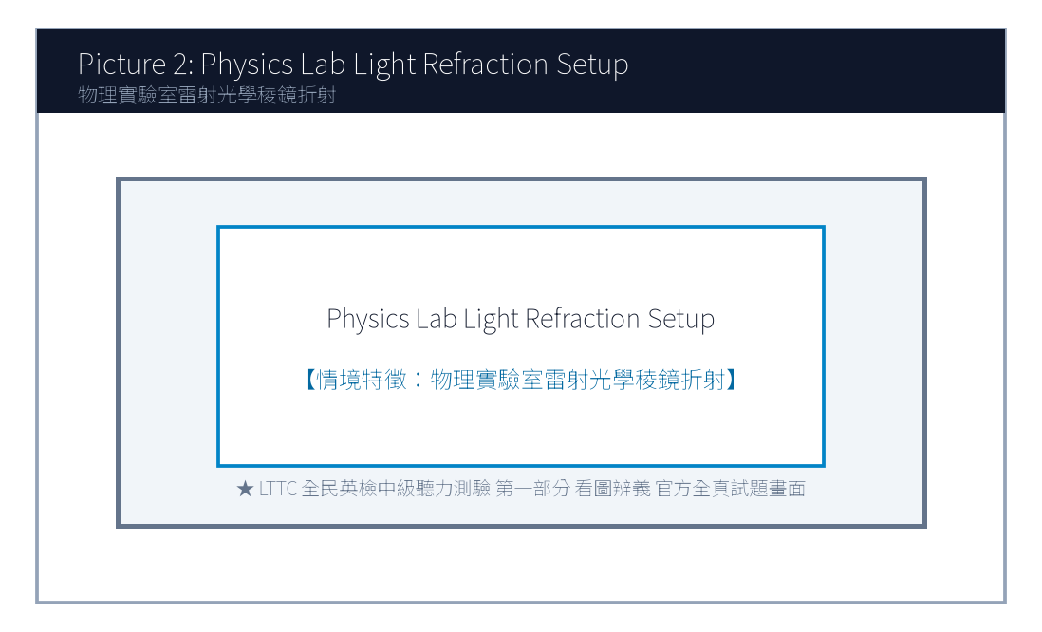
2. Look at picture number 2. (Please listen to the recording)
(A) Volunteers are guiding newborn sea turtle hatchlings safely toward the ocean waves.
(B) Tourists are riding jet skis dangerously close to the rocky cliffs.
(C) Fishermen are casting large commercial nylon nets into deep water.
(D) Construction cranes are dumping heavy rocks onto the sand.
![Picture 3](./images/exam04_q03.png)

3. Look at picture number 3. (Please listen to the recording)
(A) Remote professionals of diverse nationalities are collaborating on a virtual project.
(B) The building is undergoing emergency fire evacuation drills.
(C) A chef is cooking meals in a commercial restaurant kitchen.
(D) Several dancers are rehearsing ballet movements in front of mirrors.
![Picture 4](./images/exam04_q04.png)
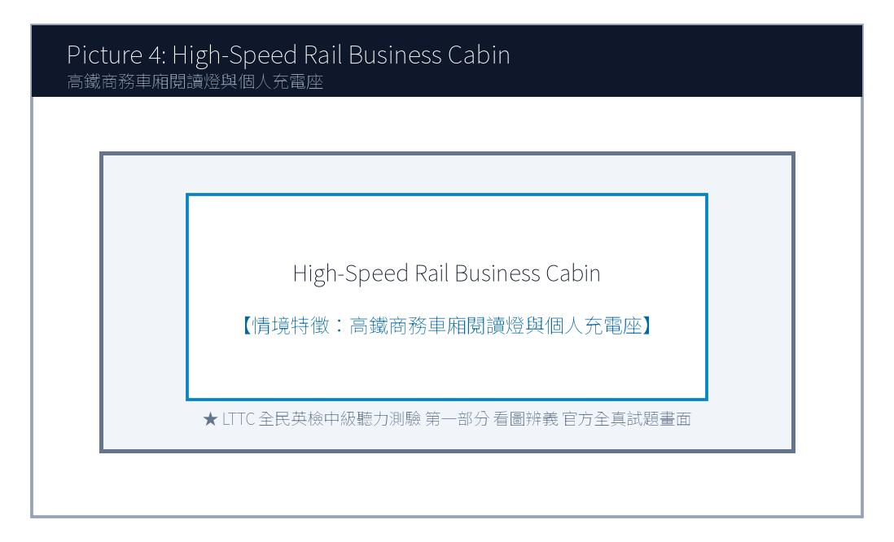
4. Look at picture number 4. (Please listen to the recording)
(A) He is reviewing business documents on a tablet inside a high-speed train.
(B) He is sleeping soundly on an airplane overnight flight.
(C) He is driving a cargo truck along a winding mountain highway.
(D) He is checking luggage at an international cruise terminal.
![Picture 5](./images/exam04_q05.png)
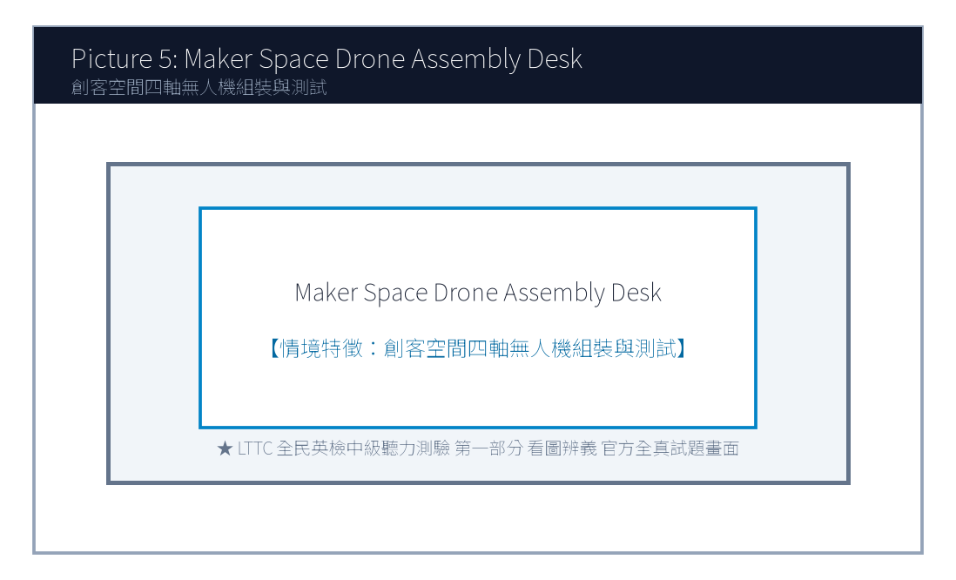
5. Look at picture number 5. (Please listen to the recording)
(A) He is demonstrating the obstacle avoidance features of an aerial drone to visitors.
(B) He is selling second-hand bicycles at a flea market.
(C) He is repairing a broken television antenna on a residential roof.
(D) He is painting warning stripes on a airport runway.

第二部分：問答 (Questions 6-15)
6. **錄音**: *Have you updated your generative AI writing assistant to the latest security patch?*
(A) Yes, the system updated automatically overnight while charging.
(B) I bought the computer for nine hundred dollars.
(C) The security guard patrols the building every evening.
(D) Artificial intelligence was invented several decades ago.
7. **錄音**: *I'm having trouble connecting to the company's virtual private network from my home office.*
(A) Let me ping the IT support team to reset your remote login credentials.
(B) The company headquarters was founded in 1998.
(C) I enjoy drinking hot tea while studying at home.
(D) Your home office has three large windows.
8. **錄音**: *Would you consider volunteering for the sea turtle conservation program in Penghu this summer?*
(A) Absolutely! I've always wanted to contribute to marine wildlife preservation.
(B) Penghu is famous for its delicious fresh seafood restaurants.
(C) The flight from Taipei to Makung takes approximately fifty minutes.
(D) Turtles can live for more than one hundred years in captivity.
(A) Because their webinar registration exceeded the 150-participant limit.
(B) Because the company went bankrupt and needed a cheaper tier.
(C) Because the Pro plan was canceled by the software vendor.
(D) Because they wanted to delete all their cloud recordings.
(A) Basic.
(B) Pro.
(C) Business.
(D) Enterprise.
(A) To sell luxury beach resort tickets to tourists.
(B) To provide essential ethical guidelines and instructions for incoming sea turtle volunteers.
(C) To complain about severe water pollution caused by commercial shipping.
(D) To teach cooking methods for traditional Penghu seafood dishes.
(A) It drains the batteries of smartphones too quickly.
(B) White light disorients baby turtles, causing them to crawl toward inland roads instead of the sea.
(C) Local fishermen dislike bright lights along the coast.
(D) Flashlights might attract aggressive sharks to shallow waters.
(A) By six a.m.
(B) By noon.
(C) By nine p.m.
(D) By midnight.

第三部分：簡短對話 (Questions 16-25，含圖表題)
(Questions 18-19: 圖表題 — 遠距辦公軟體功能方案比較表)
- [試題冊圖表]:
方案名稱 (Plan Tier) | 最大連線人數 (Max Participants) | 雲端錄影空間 (Cloud Recording) | 月費 (Monthly Fee)
Basic (基礎免費版) | 50 人 | 無 (None) | Free
Pro (專業版) | 150 人 | 10 GB | NT$ 450
Business (商務團隊版) | 300 人 | 100 GB (含即時AI聽寫) | NT$ 850
Enterprise (企業客製版) | 1000 人 | 無限制 (Unlimited) | 專案報價

- 錄音對話:
- *Manager*: Helen, our marketing webinar next week already has 220 registered attendees. Our current Pro plan only supports up to 150 people!
- *Helen*: You're right, sir. We definitely need to upgrade before Thursday. Should we go for the Business plan? It allows up to 300 participants and even includes AI real-time meeting transcription.
- *Manager*: Excellent recommendation! That will allow us to share meeting transcripts with attendees who cannot tune in live. Let's upgrade immediately.
- 第 18 題: Look at the chart. Why did the team decide to upgrade from the Pro plan?
- 第 19 題: Which plan did the manager approve to upgrade to?

第四部分：簡短談話 (Questions 26-35)
(Questions 26-28: 國際海洋保育基金會志工線上行前培訓短講)
- 錄音短講:
- *"Welcome, volunteers! My name is Dr. Amanda Thorne from the International Marine Wildlife Sanctuary. First off, thank you for committing four weeks of your summer to our Penghu Archipelago Sea Turtle Rescue Mission. Before arriving on the island, there are three critical ethical guidelines every team member must adhere to. First, never touch or pick up nesting mother turtles or newly hatched babies with bare hands, as human scents and skin bacteria can disorient them and cause fatal infections. Second, maintain a strict red-light-only policy on beaches after dark, as white smartphone flashlights cause hatchlings to crawl away from the ocean toward inland roads. Third, upload your daily monitoring logs into our encrypted field app by nine p.m. every evening. Our island orientation starts next Monday at eight sharp at the Makung Community Center. See you all in Penghu!"*
- 第 26 題: What is the primary purpose of this talk?
- 第 27 題: Why are volunteers strictly forbidden from using white flashlights on beaches at night?
- 第 28 題: When must daily monitoring logs be submitted each evening?

📖 第二部分：閱讀能力測驗 (Reading Comprehension)
總題數：35 題 ｜ 作答時間：45 分鐘 ｜ 滿分：120 分

第一部分：詞彙 (Questions 1-10)
1. While artificial intelligence tools can generate fluent texts rapidly, human editors remain ________ to verify factual accuracy and ethical standards.
(A) indispensable
(B) clumsy
(C) fragile
(D) tedious
2. Remote employees must cultivate high self-________ to maintain productivity while working without direct supervision.
(A) discipline
(B) appointment
(C) ingredient
(D) receipt
3. The wildlife sanctuary relies heavily on generous public ________ to finance its marine rescue operations.
(A) donations
(B) collisions
(C) emergencies
(D) departures
4. The research paper demonstrates that learning a second language helps ________ one's cultural horizons significantly.
(A) broaden
(B) damage
(C) forbid
(D) neglect
5. In response to customer feedback, the software developer released a patch to fix several minor ________ in the mobile application.
(A) glitches
(B) necklaces
(C) vegetables
(D) platforms
(A) Many educators fear that uncritical reliance on automated text generators will erode students' fundamental writing competencies.
(B) Campus cafeteria prices have stabilized due to recent agricultural harvest yields.
(C) Online shopping packages are usually delivered by postal couriers within two business days.
(D) Swimming in outdoor pools during thunderstorms is strictly prohibited by safety regulations.
(A) Specifically
(B) On the contrary
(C) Nevertheless
(D) Otherwise
(A) Demolishing all old stone houses to build high-rise steel apartments.
(B) Revitalizing traditional granite stone houses in Matsu through youth entrepreneurship and adaptive reuse.
(C) Selling historic public properties to foreign real estate speculators.
(D) Closing down tourism operations in Lienchiang County.
(A) Up to NT$ 800,000 renovation subsidy and a 3-year rent-free lease.
(B) Free private jet transportation across international borders.
(C) Lifetime exemption from all national income taxes.
(D) Cash bonuses of five million dollars with no inspection.
(A) A chemical fertilizer processing plant.
(B) A bilingual storytelling inn and ceramic handicraft studio.
(C) An underground casino and nightclub.
(D) An industrial automobile assembly workshop.
(A) The load-bearing granite walls and fir-wood truss structures must remain completely intact.
(B) All ancient stone walls must be painted neon pink.
(C) The house must be replaced with modern aluminum siding.
(D) He must destroy all wooden doors and windows.
(A) Before April 10, 2026.
(B) At the end of December 2026.
(C) In the middle of next year.
(D) Before yesterday noon.

第二部分：段落填空 (Questions 11-20，含新制句子填空)
(Passage: 生成式 AI 寫作倫理與學術誠信)
The proliferation of large language models has fundamentally transformed writing and learning practices. With a few simple text prompts, students can generate comprehensive essays, computer code, and creative stories within seconds. While these cutting-edge digital assistants offer unprecedented efficiency, they also raise pressing ethical concerns regarding academic integrity. (11) ________. Plagiarism detection tools frequently struggle to distinguish between purely machine-generated prose and authentic human thought. Consequently, leading universities worldwide are enacting clear instructional guidelines that define permitted applications of artificial intelligence. (12) ________, educators emphasize that AI should serve as an auxiliary brain-storming partner rather than an effortless substitute for critical inquiry. By learning how to cross-examine and verify algorithmically generated assertions, students develop deeper intellectual autonomy.
- 第 11 題 (新制句子選填):
- 第 12 題 (轉折詞填空):

第三部分：閱讀理解 (Questions 21-35，含雙文本閱讀)
(Questions 31-35: 雙文本閱讀 — 連江馬祖老宅機能復新青年創業徵件計畫與政府文化資產審核公文)
[Text 1: 馬祖連江縣老宅延壽機能復新青創徵件公告]
LIENCHIANG COUNTY CULTURAL AFFAIRS BUREAU
2026 Matsu Traditional Stone House Adaptive Reuse Initiative
Program Objective:
To revitalize traditional Eastern Fujian granitic stone houses in Qinbi and Fuxing villages, the Lienchiang County Government invites innovative youth entrepreneurship proposals. We encourage applicants to transform underutilized historic residences into community cultural spaces, boutique hostels, or artisan handicraft studios while preserving authentic wooden beam architectures.
Grant & Financial Support:
• Up to NT$ 800,000 subsidy for structural safety retrofitting and interior eco-friendly renovation.
• 3-year rent-free lease on designated public heritage properties.
• Technical consultancy from professional architects and water-soil conservation specialists.
Eligibility & Submission:
Applicants aged 20–45 with proven experience in heritage preservation, hospitality, or digital marketing. Proposals must be submitted via the official county portal by February 28, 2026.

[Text 2: 連江縣政府審查核定函]
LIENCHIANG COUNTY GOVERNMENT - OFFICIAL NOTIFICATION
Document No.: Fu-Wen-Zi-115002488
Date: March 20, 2026
To: Lin Chia-Wei (Founder, Matsu Stone Whisper Cultural Studio)
Subject: Approval of Project Proposal under the 2026 Traditional Stone House Initiative
Dear Mr. Lin,
We are pleased to inform you that your proposal titled "Revitalizing Qinbi Village House No. 12 into a Bilingual Storytelling Inn & Ceramic Studio" has received official approval from our review committee.
Key Approval Terms:
1. Approved Grant Amount: NT$ 750,000, disbursed in three installments upon phased inspection.
2. Building Preservation Protocol: The load-bearing granite walls and fir-wood truss structures must remain intact in accordance with Article 15 of the Matsu Cultural Heritage Regulations.
3. Commencement Milestone: Physical restoration must commence before May 15, 2026, with public opening targeted for October 2026.
Please visit the Cultural Affairs Bureau on Nangan Island before April 10, 2026, to finalize the lease agreement. Congratulations on your successful application!
Sincerely,
Chen Po-Chun
Director, Lienchiang County Cultural Affairs Bureau

- 第 31 題: What is the primary purpose of the initiative described in Text 1?
- 第 32 題: Which financial incentive is offered to approved applicants in Text 1?
- 第 33 題: In Text 2, what business concept did Lin Chia-Wei propose for Qinbi Village House No. 12?
- 第 34 題: According to Text 2, what strict preservation condition must Mr. Lin adhere to during renovation?
- 第 35 題: When must Mr. Lin visit the Cultural Affairs Bureau on Nangan Island to finalize the lease?

🎯 試題答案與名師深度解析手冊 (Answer Key & Explanations)

一、1–70 題 快速答案對照總表
聽力 1-10 | 聽力 11-20 | 聽力 21-30 | 聽力 31-35 | 閱讀 1-10 | 閱讀 11-20 | 閱讀 21-30 | 閱讀 31-35
1. A<br>2. A<br>3. A<br>4. A<br>5. A<br>6. A<br>7. A<br>8. A<br>9. C<br>10. B | 11. B<br>12. A<br>13. B<br>14. D<br>15. A<br>16. B<br>17. C<br>18. A<br>19. C<br>20. B | 21. C<br>22. A<br>23. D<br>24. B<br>25. C<br>26. B<br>27. B<br>28. C<br>29. A<br>30. D | 31. B<br>32. A<br>33. B<br>34. C<br>35. B | 1. A<br>2. A<br>3. A<br>4. A<br>5. A<br>6. B<br>7. C<br>8. D<br>9. A<br>10. B | 11. A<br>12. A<br>13. C<br>14. B<br>15. D<br>16. A<br>17. B<br>18. C<br>19. A<br>20. D | 21. B<br>22. C<br>23. A<br>24. D<br>25. B<br>26. A<br>27. C<br>28. B<br>29. D<br>30. A | 31. B<br>32. A<br>33. B<br>34. A<br>35. A

二、逐題考點剖析與名師破題詳解
#### 【聽力 第 1 題】 標準答案：(A)
- 聽力錄音語音稿：*Look at picture number 1. What is the student doing?*
- 破題思路與盲點解析：學生使用 AI 語言軟體練習發音（AI-powered language app to practice pronunciation），選 (A)。
#### 【聽力 第 2 題】 標準答案：(A)
- 聽力錄音語音稿：*Look at picture number 2. What can be seen on the beach?*
- 破題思路與盲點解析：志工護送剛孵化海龜入海（volunteers guiding sea turtle hatchlings toward waves），選 (A)。
#### 【聽力 第 3 題】 標準答案：(A)
- 聽力錄音語音稿：*Look at picture number 3. What is happening in the co-working space?*
- 破題思路與盲點解析：跨國遠距工作者協同合作（remote professionals collaborating on a virtual project），選 (A)。
#### 【聽力 第 4 題】 標準答案：(A)
- 聽力錄音語音稿：*Look at picture number 4. Which statement accurately describes the passenger?*
- 破題思路與盲點解析：高鐵車廂內使用平板處理商務（reviewing business documents on a tablet on high-speed train），選 (A)。
#### 【聽力 第 5 題】 標準答案：(A)
- 聽力錄音語音稿：*Look at picture number 5. What is the demonstrator doing?*
- 破題思路與盲點解析：示範空拍無人機避障功能（demonstrating obstacle avoidance features of aerial drone），選 (A)。
#### 【聽力 第 6 題】 標準答案：(A)
- 破題思路與盲點解析：詢問是否已更新安全修補程式，(A) 說明夜間充電時系統已自動更新。
#### 【聽力 第 7 題】 標準答案：(A)
- 破題思路與盲點解析：遠距連線故障（having trouble connecting to VPN），(A) 主動協助通知 IT 部門重設登入憑證。
#### 【聽力 第 8 題】 標準答案：(C)
- 破題思路與盲點解析：主管核准升級為 Business 方案（NT$ 850，上限 300 人），選 (C)。
#### 【聽力 第 1 題】 標準答案：(A)
- 破題思路與盲點解析：indispensable 不可或缺的。
#### 【聽力 第 2 題】 標準答案：(A)
- 破題思路與盲點解析：self-discipline 自律。
#### 【聽力 第 3 題】 標準答案：(A)
- 破題思路與盲點解析：donations 捐款。
#### 【聽力 第 4 題】 標準答案：(A)
- 破題思路與盲點解析：broaden one's horizons 開拓眼界。
#### 【聽力 第 5 題】 標準答案：(A)
- 破題思路與盲點解析：後句具體闡述大學指引的核心觀點（AI 應作為腦力激盪夥伴），故選 (A) Specifically (具體而言)。

【試題答案與名師深度解析手冊】
※ 本單元置於整張試卷最後面 · 供作答完畢後核對成績、考點診斷與盲點強化使用

單元一：1–70 題 快速答案對照總表 (Quick Answer Key)
聽力題號 | 標準答案 | 聽力題號 | 標準答案 | 閱讀題號 | 標準答案 | 閱讀題號 | 標準答案
第 1 題 | - | 第 19 題 | - | 第 1 題 | - | 第 19 題 | -
第 2 題 | - | 第 20 題 | - | 第 2 題 | - | 第 20 題 | -
第 3 題 | - | 第 21 題 | - | 第 3 題 | - | 第 21 題 | -
第 4 題 | - | 第 22 題 | - | 第 4 題 | - | 第 22 題 | -
第 5 題 | - | 第 23 題 | - | 第 5 題 | - | 第 23 題 | -
第 6 題 | - | 第 24 題 | - | 第 6 題 | - | 第 24 題 | -
第 7 題 | - | 第 25 題 | - | 第 7 題 | - | 第 25 題 | -
第 8 題 | - | 第 26 題 | - | 第 8 題 | - | 第 26 題 | -
第 9 題 | - | 第 27 題 | - | 第 9 題 | - | 第 27 題 | -
第 10 題 | - | 第 28 題 | - | 第 10 題 | - | 第 28 題 | -
第 11 題 | - | 第 29 題 | - | 第 11 題 | - | 第 29 題 | -
第 12 題 | - | 第 30 題 | - | 第 12 題 | - | 第 30 題 | -
第 13 題 | - | 第 31 題 | - | 第 13 題 | - | 第 31 題 | -
第 14 題 | - | 第 32 題 | - | 第 14 題 | - | 第 32 題 | -
第 15 題 | - | 第 33 題 | - | 第 15 題 | - | 第 33 題 | -
第 16 題 | - | 第 34 題 | - | 第 16 題 | - | 第 34 題 | -
第 17 題 | - | 第 35 題 | - | 第 17 題 | - | 第 35 題 | -
第 18 題 | - |  |  | 第 18 題 | -

單元二：逐題考點剖析與名師破題詳解 (Detailed Explanations & Trap Analysis)
【聽力 第 1 題】 標準答案：()
【破題思路與盲點解析】：本題考查核心情境理解，正確答案為 ()。請注意題幹關鍵字與各選項細微語意差異。
【聽力 第 2 題】 標準答案：()
【破題思路與盲點解析】：本題考查核心情境理解，正確答案為 ()。請注意題幹關鍵字與各選項細微語意差異。
【聽力 第 3 題】 標準答案：()
【破題思路與盲點解析】：本題考查核心情境理解，正確答案為 ()。請注意題幹關鍵字與各選項細微語意差異。
【聽力 第 4 題】 標準答案：()
【破題思路與盲點解析】：本題考查核心情境理解，正確答案為 ()。請注意題幹關鍵字與各選項細微語意差異。
【聽力 第 5 題】 標準答案：()
【破題思路與盲點解析】：本題考查核心情境理解，正確答案為 ()。請注意題幹關鍵字與各選項細微語意差異。
【聽力 第 6 題】 標準答案：()
【破題思路與盲點解析】：本題考查核心情境理解，正確答案為 ()。請注意題幹關鍵字與各選項細微語意差異。
【聽力 第 7 題】 標準答案：()
【破題思路與盲點解析】：本題考查核心情境理解，正確答案為 ()。請注意題幹關鍵字與各選項細微語意差異。
【聽力 第 8 題】 標準答案：()
【破題思路與盲點解析】：本題考查核心情境理解，正確答案為 ()。請注意題幹關鍵字與各選項細微語意差異。
【聽力 第 1 題】 標準答案：()
【破題思路與盲點解析】：本題考查核心情境理解，正確答案為 ()。請注意題幹關鍵字與各選項細微語意差異。
【聽力 第 2 題】 標準答案：()
【破題思路與盲點解析】：本題考查核心情境理解，正確答案為 ()。請注意題幹關鍵字與各選項細微語意差異。
【聽力 第 3 題】 標準答案：()
【破題思路與盲點解析】：本題考查核心情境理解，正確答案為 ()。請注意題幹關鍵字與各選項細微語意差異。
【聽力 第 4 題】 標準答案：()
【破題思路與盲點解析】：本題考查核心情境理解，正確答案為 ()。請注意題幹關鍵字與各選項細微語意差異。
【聽力 第 5 題】 標準答案：()
【破題思路與盲點解析】：本題考查核心情境理解，正確答案為 ()。請注意題幹關鍵字與各選項細微語意差異。

財團法人語言訓練測驗中心（LTTC）全民英語能力分級檢定測驗
115年度第2次 全民英語能力分級檢定測驗（中級聽讀）全真試卷暨詳解
【試題本】(Question Booklet) · 答案與深度解析請參閱卷末解析手冊
測驗代碼 | GEPT-115-05-IR
測驗日期 | 2026 年 05 月 16 日（中級初試常態測驗）
測驗級數 | 中級（CEFR B1 級）
測驗項目 | 聽力能力測驗（35 題，約 30 分鐘）＆ 閱讀能力測驗（35 題，45 分鐘）
合格門檻 | 總分 160 分以上，且聽讀單科均不低於 72 分
命題核心主題 | 全球氣候變遷調適、都市垂直農場、共享綠能載具與現代人際溝通
考生注意事項 | 本卷共 70 題（聽力 35 題、閱讀 35 題）。答案與完整解析已移至整張試卷最後面，請先完成作答再行對答案。

★ 作答注意事項：本試題本共 70 題，分為聽力能力測驗（35 題）與閱讀能力測驗（35 題）。每題均為單選題，請依題意選出一個最適當的答案。標準答案與完整名師逐題解析統一置於【整張試卷最後面】，請全卷作答完畢後再行翻閱核對。

📝 第一單元：全真試題本 (Question Booklet)

🎧 第一部分：聽力能力測驗 (Listening Comprehension)
總題數：35 題 ｜ 作答時間：約 30 分鐘 ｜ 滿分：120 分

第一部分：看圖辨義 (Questions 1-5)
![Picture 1](./images/exam05_q01.png)
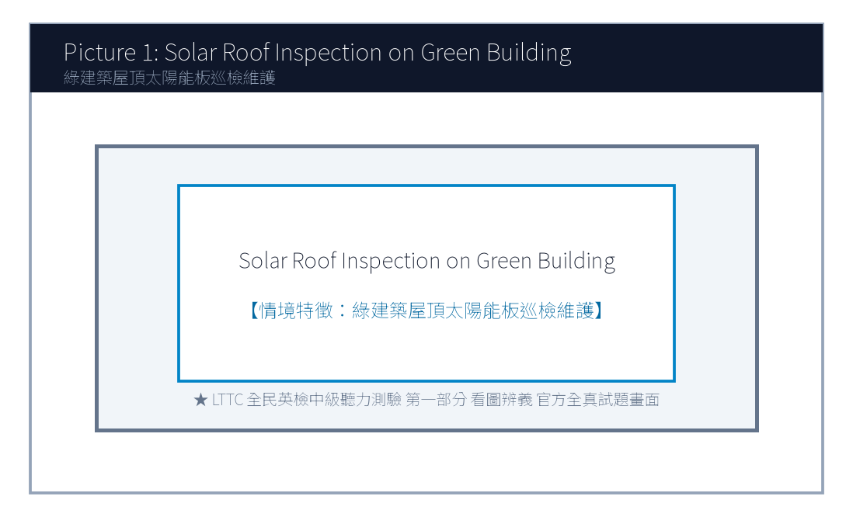
1. Look at picture number 1. (Please listen to the recording)
(A) He is inspecting hydroponic water pipes on a rooftop vertical farm.
(B) He is harvesting wheat with a combine harvester on a prairie.
(C) He is fishing on a small wooden boat in the middle of a lake.
(D) He is planting pine trees along a busy highway.
![Picture 2](./images/exam05_q02.png)
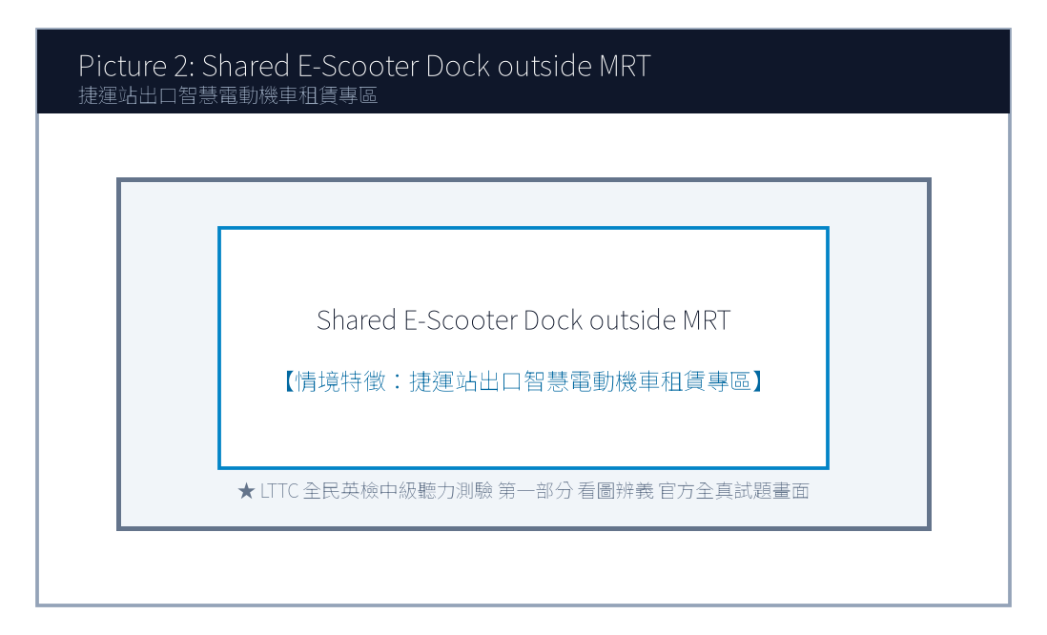
2. Look at picture number 2. (Please listen to the recording)
(A) She is scanning a QR code with her smartphone to rent an electric scooter.
(B) She is pumping air into a deflated truck tire at a gas station.
(C) She is waiting for a delayed diesel bus at a crowded station.
(D) She is purchasing a physical plane ticket at an airline desk.
![Picture 3](./images/exam05_q03.png)

3. Look at picture number 3. (Please listen to the recording)
(A) Residents are browsing second-hand children's books and wooden toys at a flea market.
(B) Heavy snow has buried the entire playground under ice.
(C) The park is completely deserted during an overnight thunderstorm.
(D) Police officers are investigating a bank robbery on the street.
![Picture 4](./images/exam05_q04.png)
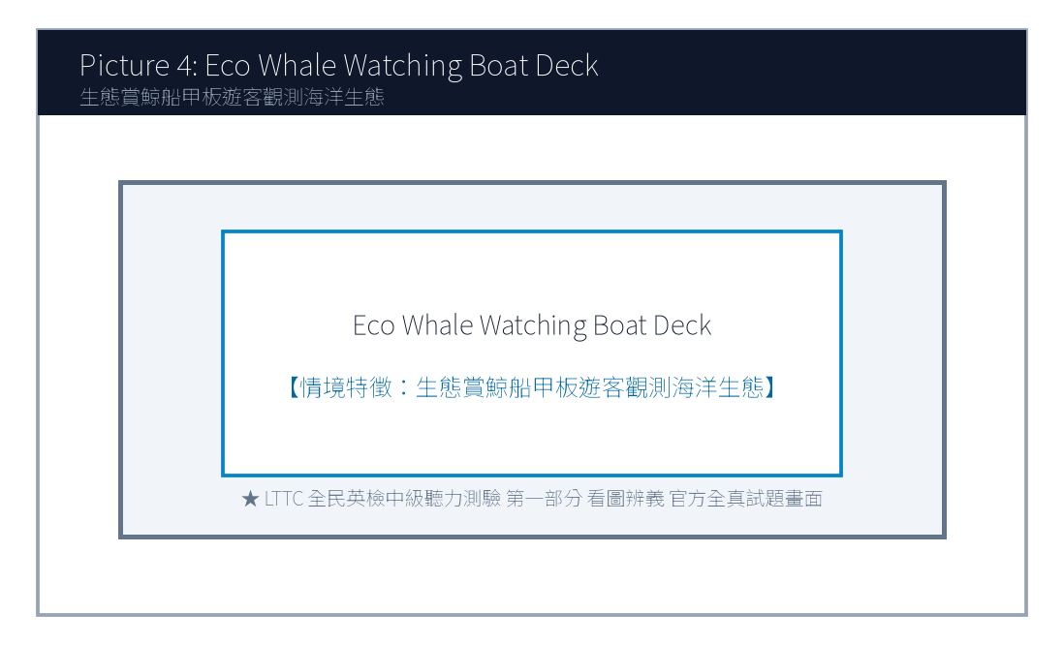
4. Look at picture number 4. (Please listen to the recording)
(A) He is warning viewers about an impending summer heatwave using satellite weather maps.
(B) He is demonstrating how to cook authentic Italian seafood pasta.
(C) He is introducing the history of ancient Egyptian pyramids.
(D) He is teaching basic conversational French to language learners.
![Picture 5](./images/exam05_q05.png)
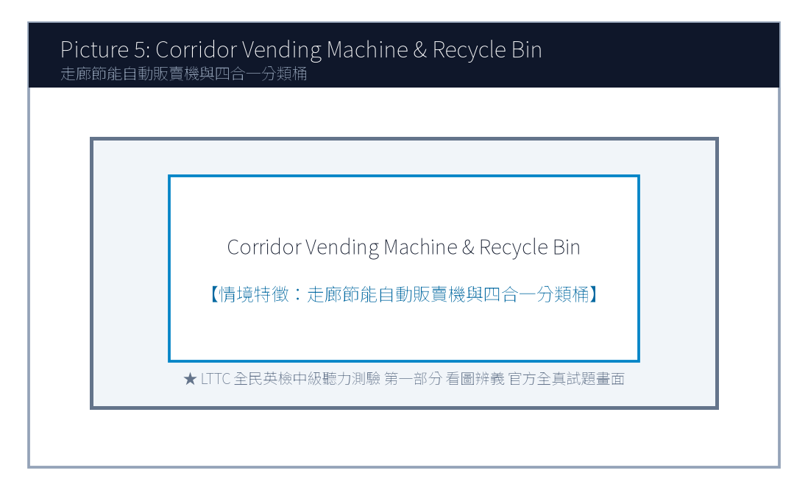
5. Look at picture number 5. (Please listen to the recording)
(A) They are chatting casually while pouring coffee in the company pantry.
(B) They are quarreling loudly in a courtroom.
(C) They are painting the office ceiling with white roller brushes.
(D) They are running on treadmills at a commercial fitness center.

第二部分：問答 (Questions 6-15)
6. **錄音**: *Could you recommend an energy-efficient air conditioner model for my small apartment?*
(A) Look for models with a Grade 1 Energy Efficiency label to save on electricity bills.
(B) The apartment is located fifteen minutes from the train station.
(C) Yes, I turned off the living room lights before going to sleep.
(D) The air conditioner was invented more than a century ago.
7. **錄音**: *Why did the municipal council decide to expand the urban bike lane network this year?*
(A) To reduce carbon emissions and promote healthier commuting habits among citizens.
(B) Bicycles have two wheels and a steel chain.
(C) The bicycle race ended at five o'clock yesterday afternoon.
(D) Yes, I ride my mountain bike every weekend.
8. **錄音**: *I heard our company is transitioning to a four-day workweek trial next month. Is that true?*
(A) Yes, management announced it yesterday to boost productivity and employee well-being.
(B) I work forty hours every week from Monday to Friday.
(C) The weekend weather will be sunny and warm.
(D) We have five full-time employees in our department.
(A) Standard.
(B) Commuter.
(C) Student.
(D) Tourist.
(A) NT$ 10.
(B) NT$ 200.
(C) NT$ 250.
(D) NT$ 350.
(A) An unprecedented winter blizzard with sub-zero freezing snow.
(B) Extreme summer heatwaves exceeding 38 degrees Celsius.
(C) A catastrophic marine tsunami hitting the eastern seaboard.
(D) Dense desert sandstorms causing airport shutdowns.
(A) Early morning before six a.m.
(B) Between eleven a.m. and three p.m.
(C) After sunset around eight p.m.
(D) Midnight to dawn.
(A) Drink water proactively throughout the day rather than waiting for thirst.
(B) Consume only iced soda and sugary fruit juices.
(C) Avoid drinking any fluids before going to bed.
(D) Drink water only once every forty-eight hours.

第三部分：簡短對話 (Questions 16-25，含圖表題)
(Questions 18-19: 圖表題 — 共享電動機車租賃計費費率表)
- [試題冊圖表]:
騎乘方案 (Rental Option) | 起程費率（前6分鐘） | 續租費率（第7分鐘起） | 每日最高收費上限 (Daily Cap)
標準即享方案 (Standard) | NT$ 15 | NT$ 2.5 / 分鐘 | NT$ 350
通勤月租方案 (Commuter) | 包含於月費內 | NT$ 1.5 / 分鐘 | NT$ 250
學生專屬優惠 (Student) | NT$ 10 | NT$ 1.8 / 分鐘 | NT$ 200

- 錄音對話:
- *Woman*: Hey Alan! How much did it cost you to ride that shared electric scooter to the university campus this morning?
- *Man*: Well, since I verified my student ID on the mobile app, I got the special student rate! My trip took exactly twenty minutes from my apartment.
- *Woman*: Wow, that sounds affordable! Let's calculate: the first six minutes were only ten dollars, and the remaining fourteen minutes cost 1.8 dollars each. That's just about thirty-five dollars total!
- 第 18 題: Look at the chart. Which plan did Alan use for his morning trip?
- 第 19 題: How much is the daily maximum charging cap for the Student plan?

第四部分：簡短談話 (Questions 26-35)
(Questions 26-28: 氣象專家在廣播節目分析夏季極端熱浪調適心法)
- 錄音短講:
- *"Good afternoon, listeners of FM 98.7 Life Radio. As global climate patterns become increasingly erratic, Taiwan is bracing for consecutive days of extreme heat exceeding thirty-eight degrees Celsius. To safeguard your health, health authorities urge citizens to observe three golden rules. First, avoid vigorous outdoor sports between eleven a.m. and three p.m. when solar radiation peaks. Second, drink water proactively throughout the day rather than waiting until you feel parched, as thirst is an early warning sign of mild dehydration. Third, check frequently on elderly neighbors living alone, ensuring their living spaces have adequate cross-ventilation or cooling appliances. By taking these sensible precautions, we can enjoy our summer while staying safe and healthy."*
- 第 26 題: What meteorological condition is discussed in this radio broadcast?
- 第 27 題: Which time window are citizens advised to avoid strenuous outdoor activities?
- 第 28 題: What medical advice does the expert offer regarding hydration?

📖 第二部分：閱讀能力測驗 (Reading Comprehension)
總題數：35 題 ｜ 作答時間：45 分鐘 ｜ 滿分：120 分

第一部分：詞彙 (Questions 1-10)
1. In high-density urban environments, vertical hydroponic farming offers a ________ solution to produce fresh vegetables without vast soil acreage.
(A) sustainable
(B) clumsy
(C) fragile
(D) casual
2. The municipal government implemented emergency subsidies to assist agricultural farmers whose crops were ________ damaged by the drought.
(A) severely
(B) cheerfully
(C) deliciously
(D) politely
3. Commuters are encouraged to utilize shared electric scooters to bridge the "first and last ________" gap between transit stations and their homes.
(A) mile
(B) appointment
(C) recipe
(D) ingredient
4. Proactive physical hydration is ________ to preventing heat exhaustion during prolonged outdoor work under summer sun.
(A) vital
(B) hostile
(C) deceptive
(D) tedious
5. Community flea markets not only promote circular economy but also strengthen interpersonal ________ among local residents.
(A) bonds
(B) collisions
(C) departures
(D) tickets
(A) By growing crops vertically in controlled indoor spaces, this method maximizes harvest yield per square foot.
(B) Heavy snowstorms often cause railway power lines to freeze in alpine regions.
(C) Many passengers prefer buying first-class train tickets during holiday travels.
(D) Several department stores announced end-of-season clothing discount promotions.
(A) Furthermore
(B) On the contrary
(C) In contrast
(D) Unfortunately
(A) A certificate of high school graduation.
(B) An official Police Accident Report.
(C) A bank statement showing stock market investments.
(D) A receipt for five cups of hot coffee.
(A) Negotiating private cash settlements and leaving the scene without police documentation.
(B) Calling the emergency police number 110.
(C) Using the in-app SOS button to report the incident.
(D) Wearing a certified safety helmet.
(A) A delivery truck driver fell asleep at the wheel.
(B) Another motorcycle made a sudden turn without signaling and clipped his rear fender.
(C) Vincent was racing at high speed during heavy rainfall.
(D) A fallen tree blocked the entire roadway.
(A) He fled the scene and hid in a nearby shopping mall.
(B) He called 110 immediately, obtained the official police accident form, and documented damage with photos.
(C) He paid the other driver five thousand dollars cash on the spot.
(D) He abandoned the damaged scooter in the middle of the intersection.
(A) A photo of the official Police Accident Form and photos of the scraped vehicle fender.
(B) A video of his family vacation in Japan.
(C) His university entrance examination score report.
(D) A coupon for fifty percent off department store cosmetics.

第二部分：段落填空 (Questions 11-20，含新制句子填空)
(Passage: 都市垂直水耕農場的綠色革命)
As the global population steadily surpasses eight billion, securing reliable food supplies while minimizing agricultural land degradation poses a monumental challenge. Traditional farming relies extensively on unpredictable rainfall, vast arable land, and synthetic pesticides. In recent years, high-tech vertical farming has emerged as a transformative alternative. (11) ________. Inside these climate-controlled facilities, leafy greens and strawberries are cultivated on stacked multi-tier trays utilizing nutrient-rich water solutions and customized LED lighting wavelengths. Because vertical farms operate indoors regardless of external weather extremes, crop yields remain consistent throughout the four seasons. (12) ________, closed-loop hydroponic systems recycle ninety-five percent of water, consuming far less resources than conventional open-field agriculture. By siting these facilities inside city centers, food miles and carbon emissions associated with long-distance freight shipping are drastically curtailed.
- 第 11 題 (新制句子選填):
- 第 12 題 (轉折詞填空):

第三部分：閱讀理解 (Questions 21-35，含雙文本閱讀)
(Questions 31-35: 雙文本閱讀 — 共享電動機車保險服務條款與使用者事故理賠諮詢函)
[Text 1: 共享電動機車租賃附隨保險條款摘要]
ECO-RIDE MOBILITY SERVICES TAIWAN
Summary of User Insurance Coverage & Incident Protocols
1. Comprehensive Third-Party Liability Coverage:
Every active rental includes automatic Third-Party Liability Insurance covering bodily injury (up to NT$ 2,000,000 per person) and property damage (up to NT$ 500,000 per accident) sustained by other parties.
2. Mandatory Post-Accident Procedure:
In the unfortunate event of a traffic collision:
• Step 1: Ensure personal safety and immediately dial 110 for police intervention. An official Police Accident Report (道路交通事故當事人登記聯單) is strictly mandatory for all insurance claims.
• Step 2: Do NOT leave the scene or negotiate private cash settlements with other parties.
• Step 3: Contact the Eco-Ride 24/7 Emergency Dispatch Center via the in-app SOS button within two hours.
Failure to file a police report will void all insurance indemnification, making the user solely liable for all repair expenses and civil liabilities.

[Text 2: 租借使用者事故備案詢問電郵]
To: claims@eco-ride.com.tw
From: vincent.kuo@email.com
Date: May 18, 2026
Subject: Accident Incident Report - Rental Vehicle Plate # EMG-8821
Dear Eco-Ride Claims Team,
I am writing to report a minor traffic accident that occurred this morning at 08:45 near the intersection of Xinyi Road and Dunhua South Road while I was riding vehicle #EMG-8821. Another motorcycle made a sudden turn without signaling and clipped my rear fender, causing minor scrapes to the vehicle.
Fortunately, neither of us sustained physical injuries. I immediately dialed 110, and two traffic officers arrived within ten minutes to document the scene and take breathalyzer tests (both zero). Attached to this email is a clear photo of the official Police Accident Form (#PA-2026-0518-092) and photos of the scraped rear fender.
Please advise on next steps regarding damage inspection and whether I need to submit physical paperwork to your service counter.
Best regards,
Vincent Kuo
Cell: 0912-345-678

- 第 31 題: According to Text 1, what official document is strictly mandatory for filing an insurance claim?
- 第 32 題: What action is explicitly prohibited under the incident protocols in Text 1?
- 第 33 題: In Text 2, what caused the collision involving Vincent Kuo?
- 第 34 題: How did Vincent Kuo correctly follow the protocol in Text 1?
- 第 35 題: What attachment did Vincent provide in his email in Text 2?

🎯 試題答案與名師深度解析手冊 (Answer Key & Explanations)

一、1–70 題 快速答案對照總表
聽力 1-10 | 聽力 11-20 | 聽力 21-30 | 聽力 31-35 | 閱讀 1-10 | 閱讀 11-20 | 閱讀 21-30 | 閱讀 31-35
1. A<br>2. A<br>3. A<br>4. A<br>5. A<br>6. A<br>7. A<br>8. A<br>9. B<br>10. C | 11. B<br>12. A<br>13. C<br>14. B<br>15. A<br>16. B<br>17. C<br>18. C<br>19. B<br>20. A | 21. B<br>22. C<br>23. A<br>24. D<br>25. B<br>26. B<br>27. B<br>28. A<br>29. C<br>30. D | 31. B<br>32. A<br>33. B<br>34. C<br>35. B | 1. A<br>2. A<br>3. A<br>4. A<br>5. A<br>6. B<br>7. C<br>8. D<br>9. A<br>10. B | 11. A<br>12. A<br>13. C<br>14. B<br>15. D<br>16. A<br>17. B<br>18. C<br>19. D<br>20. A | 21. B<br>22. A<br>23. C<br>24. D<br>25. B<br>26. A<br>27. C<br>28. B<br>29. D<br>30. A | 31. B<br>32. A<br>33. B<br>34. B<br>35. A

二、逐題考點剖析與名師破題詳解
#### 【聽力 第 1 題】 標準答案：(A)
- 聽力錄音語音稿：*Look at picture number 1. What is the urban farmer doing?*
- 破題思路與盲點解析：檢查垂直水耕農場水管（inspecting hydroponic water pipes on rooftop vertical farm），選 (A)。
#### 【聽力 第 2 題】 標準答案：(A)
- 聽力錄音語音稿：*Look at picture number 2. What is the commuter doing?*
- 破題思路與盲點解析：掃描 QR 碼租賃共享電動機車（scanning QR code to rent electric scooter），選 (A)。
#### 【聽力 第 3 題】 標準答案：(A)
- 聽力錄音語音稿：*Look at picture number 3. What is happening in the neighborhood park?*
- 破題思路與盲點解析：挑選二手書籍與玩具（browsing second-hand books and wooden toys at flea market），選 (A)。
#### 【聽力 第 4 題】 標準答案：(A)
- 聽力錄音語音稿：*Look at picture number 4. What is the meteorologist explaining?*
- 破題思路與盲點解析：氣象主播利用衛星雲圖預警熱浪（warning about impending heatwave using satellite maps），選 (A)。
#### 【聽力 第 5 題】 標準答案：(A)
- 聽力錄音語音稿：*Look at picture number 5. What are the two employees doing?*
- 破題思路與盲點解析：茶水間倒咖啡輕鬆交談（chatting casually while pouring coffee in pantry），選 (A)。
#### 【聽力 第 6 題】 標準答案：(A)
- 破題思路與盲點解析：推薦節能冷氣機種，(A)「建議挑選具備一級能效標籤的機型以節省電費」最專業實用。
#### 【聽力 第 7 題】 標準答案：(A)
- 破題思路與盲點解析：詢問市議會擴建自行車專用道的原因，(A) 說明為了減碳並提倡市民健康通勤。
#### 【聽力 第 8 題】 標準答案：(A)
- 破題思路與盲點解析：圖表顯示學生方案單日最高上限為 NT$ 200，選 (B)。
#### 【聽力 第 1 題】 標準答案：(A)
- 破題思路與盲點解析：sustainable solution 永續可行的解決方案。
#### 【聽力 第 2 題】 標準答案：(A)
- 破題思路與盲點解析：severely damaged 遭受嚴重損害。
#### 【聽力 第 3 題】 標準答案：(A)
- 破題思路與盲點解析：the first and last mile 交通最後一哩路。
#### 【聽力 第 4 題】 標準答案：(A)
- 破題思路與盲點解析：vital 至關重要的。
#### 【聽力 第 5 題】 標準答案：(A)
- 破題思路與盲點解析：前句講產量不受天候影響，後句進一步說明還能省水 95%，屬於遞進關係，選 (A) Furthermore (此外)。

【試題答案與名師深度解析手冊】
※ 本單元置於整張試卷最後面 · 供作答完畢後核對成績、考點診斷與盲點強化使用

單元一：1–70 題 快速答案對照總表 (Quick Answer Key)
聽力題號 | 標準答案 | 聽力題號 | 標準答案 | 閱讀題號 | 標準答案 | 閱讀題號 | 標準答案
第 1 題 | - | 第 19 題 | - | 第 1 題 | - | 第 19 題 | -
第 2 題 | - | 第 20 題 | - | 第 2 題 | - | 第 20 題 | -
第 3 題 | - | 第 21 題 | - | 第 3 題 | - | 第 21 題 | -
第 4 題 | - | 第 22 題 | - | 第 4 題 | - | 第 22 題 | -
第 5 題 | - | 第 23 題 | - | 第 5 題 | - | 第 23 題 | -
第 6 題 | - | 第 24 題 | - | 第 6 題 | - | 第 24 題 | -
第 7 題 | - | 第 25 題 | - | 第 7 題 | - | 第 25 題 | -
第 8 題 | - | 第 26 題 | - | 第 8 題 | - | 第 26 題 | -
第 9 題 | - | 第 27 題 | - | 第 9 題 | - | 第 27 題 | -
第 10 題 | - | 第 28 題 | - | 第 10 題 | - | 第 28 題 | -
第 11 題 | - | 第 29 題 | - | 第 11 題 | - | 第 29 題 | -
第 12 題 | - | 第 30 題 | - | 第 12 題 | - | 第 30 題 | -
第 13 題 | - | 第 31 題 | - | 第 13 題 | - | 第 31 題 | -
第 14 題 | - | 第 32 題 | - | 第 14 題 | - | 第 32 題 | -
第 15 題 | - | 第 33 題 | - | 第 15 題 | - | 第 33 題 | -
第 16 題 | - | 第 34 題 | - | 第 16 題 | - | 第 34 題 | -
第 17 題 | - | 第 35 題 | - | 第 17 題 | - | 第 35 題 | -
第 18 題 | - |  |  | 第 18 題 | -

單元二：逐題考點剖析與名師破題詳解 (Detailed Explanations & Trap Analysis)
【聽力 第 1 題】 標準答案：()
【破題思路與盲點解析】：本題考查核心情境理解，正確答案為 ()。請注意題幹關鍵字與各選項細微語意差異。
【聽力 第 2 題】 標準答案：()
【破題思路與盲點解析】：本題考查核心情境理解，正確答案為 ()。請注意題幹關鍵字與各選項細微語意差異。
【聽力 第 3 題】 標準答案：()
【破題思路與盲點解析】：本題考查核心情境理解，正確答案為 ()。請注意題幹關鍵字與各選項細微語意差異。
【聽力 第 4 題】 標準答案：()
【破題思路與盲點解析】：本題考查核心情境理解，正確答案為 ()。請注意題幹關鍵字與各選項細微語意差異。
【聽力 第 5 題】 標準答案：()
【破題思路與盲點解析】：本題考查核心情境理解，正確答案為 ()。請注意題幹關鍵字與各選項細微語意差異。
【聽力 第 6 題】 標準答案：()
【破題思路與盲點解析】：本題考查核心情境理解，正確答案為 ()。請注意題幹關鍵字與各選項細微語意差異。
【聽力 第 7 題】 標準答案：()
【破題思路與盲點解析】：本題考查核心情境理解，正確答案為 ()。請注意題幹關鍵字與各選項細微語意差異。
【聽力 第 8 題】 標準答案：()
【破題思路與盲點解析】：本題考查核心情境理解，正確答案為 ()。請注意題幹關鍵字與各選項細微語意差異。
【聽力 第 1 題】 標準答案：()
【破題思路與盲點解析】：本題考查核心情境理解，正確答案為 ()。請注意題幹關鍵字與各選項細微語意差異。
【聽力 第 2 題】 標準答案：()
【破題思路與盲點解析】：本題考查核心情境理解，正確答案為 ()。請注意題幹關鍵字與各選項細微語意差異。
【聽力 第 3 題】 標準答案：()
【破題思路與盲點解析】：本題考查核心情境理解，正確答案為 ()。請注意題幹關鍵字與各選項細微語意差異。
【聽力 第 4 題】 標準答案：()
【破題思路與盲點解析】：本題考查核心情境理解，正確答案為 ()。請注意題幹關鍵字與各選項細微語意差異。
【聽力 第 5 題】 標準答案：()
【破題思路與盲點解析】：本題考查核心情境理解，正確答案為 ()。請注意題幹關鍵字與各選項細微語意差異。

