財團法人語言訓練測驗中心（LTTC）全民英語能力分級檢定測驗
114年度第1次 全民英檢初級說寫測驗（第二試／一日考）全真試卷暨名師詳解
【試題本】(Question Booklet) · 答案與深度解析請參閱卷末解析手冊
測驗代碼 | GEPT-E-114-01-SW
測驗日期 | 2025 年 01 月 11 日（一日考說寫複試）
測驗級數 | 初級（CEFR A2 級）
測驗項目 | 寫作能力測驗（40 分鐘）＆ 口說能力測驗（約 10 分鐘）
及格門檻 | 寫作達 70 分以上且口說達 80 分以上（均達 4 級分以上始發證書）
核心主題 | 校園愛心關懷、救援流浪貓、校園愛心園遊會義賣、健康運動習慣

★ 作答注意事項：本測驗分為「寫作能力測驗」（第一部分單句寫作15題、第二部分段落寫作1題，共40分鐘）與「口說能力測驗」（第一部分朗讀2題、第二部分回答問題10題、第三部分看圖敘述1題，約10分鐘）。全卷無預載答案，標準答案、滿分示範文章與口語講稿統一置於【整張試卷最後面】。

✍️ 第一部分：寫作能力測驗 (Writing Test)
作答時間：40 分鐘 ｜ 滿分：100 分（70 分以上為及格）

第一單元：單句寫作 (Questions 1–15)
說明：第 1–5 題為改寫，第 6–10 題為重組，第 11–15 題為句子合併。請依照各題括號內之指示作答，注意大小寫與標點符號。
1. Amy plays badminton with her sister every Saturday morning. (改為否定句)
作答區：____________________________________________________________________________________
2. Mr. Brown bought a brand new hybrid car last weekend. (依畫線部分 a brand new hybrid car 照原級造原問句)
作答區：____________________________________________________________________________________
3. Learning English by watching foreign animation movies is really enjoyable. (用 It... 開頭改寫句子)
作答區：____________________________________________________________________________________
4. The brave firefighter saved the little girl from the burning apartment. (改為被動語態)
作答區：____________________________________________________________________________________
5. Peter was too tired to finish his math assignment last night. (用 so... that... 改寫句子)
作答區：____________________________________________________________________________________
6. on the desk / left / her English dictionary / Jenny / yesterday afternoon
作答區：____________________________________________________________________________________
7. more exercise / healthy / to do / it is important / to stay
作答區：____________________________________________________________________________________
8. because / the outdoor concert / canceled / was / it rained heavily
作答區：____________________________________________________________________________________
9. a pair of / bought / fashionable sneakers / at the mall / David
作答區：____________________________________________________________________________________
10. how to / could you / tell me / the train station / get to / ?
作答區：____________________________________________________________________________________
11. Eric likes playing basketball. / His brother enjoys playing basketball, too. (用 both... and... 合併)
作答區：____________________________________________________________________________________
12. The weather was extremely cold yesterday. / We still went hiking in the national park. (用 Although 合併)
作答區：____________________________________________________________________________________
13. That is the famous writer. / She wrote the best-selling science fiction novel. (用 who 合併)
作答區：____________________________________________________________________________________
14. Linda studied very hard for the final exam. / She wanted to get good grades. (用 in order to 合併)
作答區：____________________________________________________________________________________
15. The blue smartphone is five thousand dollars. / The white smartphone is eight thousand dollars. (用 cheaper than 合併)
作答區：____________________________________________________________________________________

第二單元：段落寫作 (Question 16 看圖短文寫作)
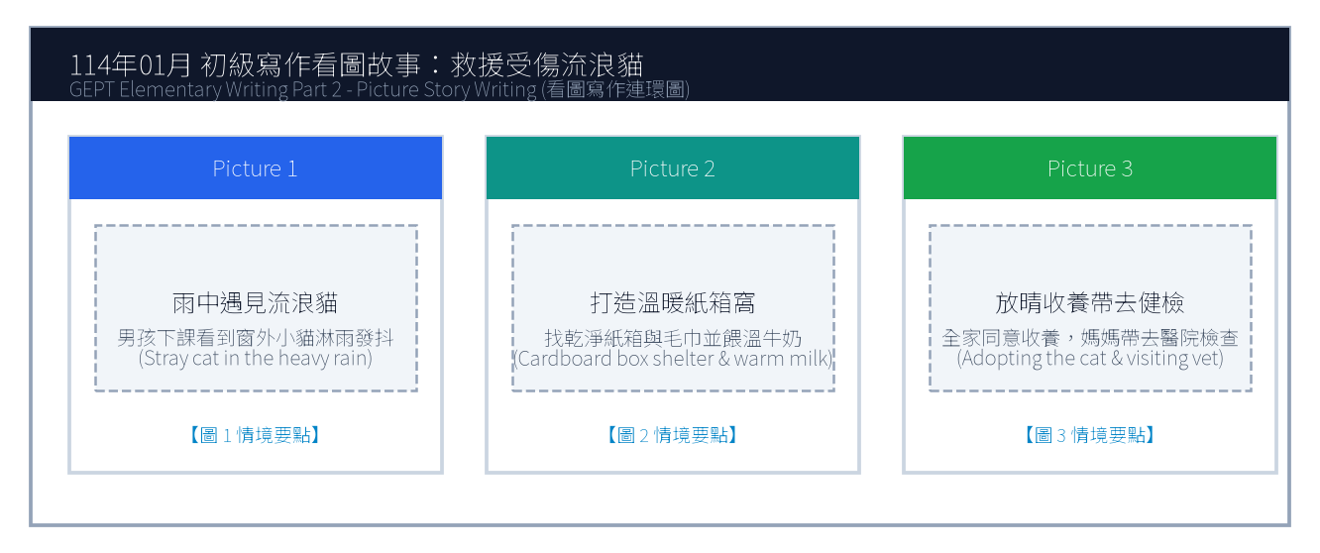
16. 請依據下列三幅連環圖畫內容，寫一篇約 50 字的短文故事。請發揮你的想像力，敘述事情的發生、經過與結果。
Line 1: _________________________________________________________________________________
Line 2: _________________________________________________________________________________
Line 3: _________________________________________________________________________________
Line 4: _________________________________________________________________________________
Line 5: _________________________________________________________________________________
Line 6: _________________________________________________________________________________

🎙️ 第二部分：口說能力測驗 (Speaking Test)
測驗時間：約 10 分鐘（採電腦耳機麥克風錄音） ｜ 滿分：100 分（80 分以上為及格）

第一單元：朗讀短文 (Questions 1–2)
說明：共有兩篇短文。每篇短文有 1 分鐘的時間準備，然後請在 1 分鐘內以清晰、自然的語調朗讀出來。
【Question 1 朗讀短文】：
Passage 1: Welcome to Taipei International Youth Camp. During the next five days, you will meet friends from all over the world. Please remember to wear your name badge and be on time for every exciting activity. If you need any assistance, our friendly staff members in blue shirts are always ready to help you.

【Question 2 朗讀短文】：
Passage 2: Bees are small but they play a vital role in our ecosystem. Every sunny morning, worker bees fly from flower to flower collecting nectar and pollinating fruit trees. Without their tireless hard work, many vegetables and fruits would not grow. Protecting nature helps these tiny creatures survive.

第二單元：回答問題 (Questions 3–12)
說明：共有十題日常生活問句。錄音將播出問題兩次，每次問題播完後有 15 秒的時間回答。請把握時間，針對問題盡量完整作答。
3. What is your favorite season of the year, and why do you like it? (15 seconds response)
4. How do you usually travel to school every morning? (15 seconds response)
5. What kind of movies do you enjoy watching the most? (15 seconds response)
6. What do you usually do when you feel stressed out? (15 seconds response)
7. Tell me about your best friend at school. (15 seconds response)
8. If you have a holiday tomorrow, where would you like to go? (15 seconds response)
9. How often do you help your parents with household chores? (15 seconds response)
10. What is your dream job in the future? (15 seconds response)
11. Do you prefer reading paper books or using digital tablets? (15 seconds response)
12. What was the happiest event that happened to you recently? (15 seconds response)

第三單元：看圖敘述 (Question 13 情境大圖口語敘述)
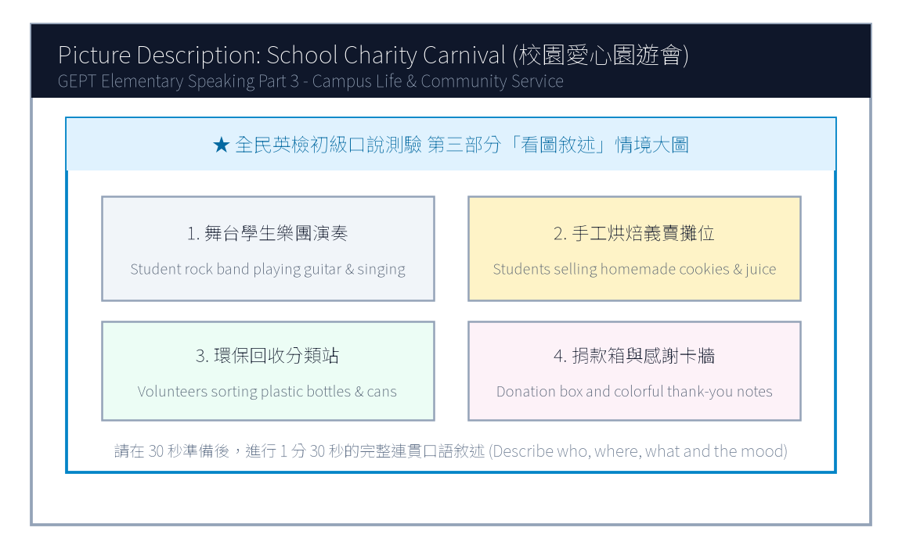
13. 請仔細觀察圖片，有 30 秒的準備時間。之後請在 1 分 30 秒內，根據圖片內容作一完整連貫的口語敘述。

【試題答案與名師深度解析手冊】
※ 本單元置於整張試卷最後面 · 供作答完畢後核對成績、滿分範文觀摩與考點診斷使用

單元一：寫作能力測驗 標準答案與滿分範文解析
【第一部分：單句寫作 1–15 題標準答案與常見錯誤剖析】
第 1 題 標準答案：Amy does not play badminton with her sister every Saturday morning.
★ 破題指引與扣分盲點：改為否定句須注意助動詞 does not/do not/did not 後動詞回歸原形。
第 2 題 標準答案：What did Mr. Brown buy last weekend?
★ 破題指引與扣分盲點：注意開頭首字大寫、句末標點符號及動詞時態一致。
第 3 題 標準答案：It is really enjoyable to learn English by watching foreign animation movies.
★ 破題指引與扣分盲點：注意開頭首字大寫、句末標點符號及動詞時態一致。
第 4 題 標準答案：The little girl was saved by the brave firefighter from the burning apartment.
★ 破題指引與扣分盲點：被動語態公式為「be動詞 + 過去分詞 (p.p.) + by...」，時態須嚴格對齊原句。
第 5 題 標準答案：Peter was so tired that he could not finish his math assignment last night.
★ 破題指引與扣分盲點：注意否定含意，too... to 表示「太...以致於不能...」，後面接動詞原形。
第 6 題 標準答案：Jenny left her English dictionary on the desk yesterday afternoon.
★ 破題指引與扣分盲點：注意開頭首字大寫、句末標點符號及動詞時態一致。
第 7 題 標準答案：It is important to do more exercise to stay healthy.
★ 破題指引與扣分盲點：注意開頭首字大寫、句末標點符號及動詞時態一致。
第 8 題 標準答案：The outdoor concert was canceled because it rained heavily.
★ 破題指引與扣分盲點：注意開頭首字大寫、句末標點符號及動詞時態一致。
第 9 題 標準答案：David bought a pair of fashionable sneakers at the mall.
★ 破題指引與扣分盲點：注意開頭首字大寫、句末標點符號及動詞時態一致。
第 10 題 標準答案：Could you tell me how to get to the train station?
★ 破題指引與扣分盲點：注意開頭首字大寫、句末標點符號及動詞時態一致。
第 11 題 標準答案：Both Eric and his brother like playing basketball.
★ 破題指引與扣分盲點：注意開頭首字大寫、句末標點符號及動詞時態一致。
第 12 題 標準答案：Although the weather was extremely cold yesterday, we still went hiking in the national park.
★ 破題指引與扣分盲點：注意開頭首字大寫、句末標點符號及動詞時態一致。
第 13 題 標準答案：That is the famous writer who wrote the best-selling science fiction novel.
★ 破題指引與扣分盲點：關係代名詞 who 引導形容詞子句修飾先行詞人，其後動詞與先行詞一致。
第 14 題 標準答案：Linda studied very hard for the final exam in order to get good grades.
★ 破題指引與扣分盲點：注意開頭首字大寫、句末標點符號及動詞時態一致。
第 15 題 標準答案：The blue smartphone is cheaper than the white smartphone.
★ 破題指引與扣分盲點：注意開頭首字大寫、句末標點符號及動詞時態一致。
【第二部分：段落看圖寫作 Level 5 (滿分範文) 與架構解析】
★ 官方評測 5 級分 (滿分範文，約 60 字)：
"One rainy afternoon, Ken heard a weak cry outside his living room window and found a shivering stray cat drenched in the storm. Feeling deeply worried, he brought the little cat indoors, gently dried its fur with a soft towel, and fed it warm milk in a clean cardboard box. The next sunny morning, his mother agreed to adopt the sweet kitten and took it to the veterinarian for a complete health check. Ken was overjoyed to give this homeless animal a loving family."
★ 名師寫作結構金字塔：
1. 開門見山交代人、事、時、地、背景 (Background & Initial problem)
2. 轉折句敘述解決問題之具體行動 (Action & Teamwork)
3. 昇華結尾描繪心情與正面收穫 (Happy ending & Reflection)

單元二：口說能力測驗 滿分示範講稿與錄音逐字稿
【第二單元：回答問題 (Questions 3–12) 滿分口語回答範例】
3. What is your favorite season of the year, and why do you like it?
滿分示範答句 (Model Response)："My favorite season is autumn because the weather is pleasantly cool and breezy. I love riding my bicycle in the park with my friends without sweating a lot."
4. How do you usually travel to school every morning?
滿分示範答句 (Model Response)："I usually take the MRT to school because the station is just a five-minute walk from my apartment. It is very punctual and convenient."
5. What kind of movies do you enjoy watching the most?
滿分示範答句 (Model Response)："I enjoy watching superhero action movies because the visual special effects are astonishing, and the storylines always teach us to be brave and help others."
6. What do you usually do when you feel stressed out?
滿分示範答句 (Model Response)："When I feel stressed, I listen to cheerful pop music and go for a brisk jog in the park. Sweating helps clear my mind and makes me feel energetic again."
7. Tell me about your best friend at school.
滿分示範答句 (Model Response)："My best friend is Leo. We have known each other since elementary school. He is very kind, humorous, and always patient in explaining difficult math questions to me."
8. If you have a holiday tomorrow, where would you like to go?
滿分示範答句 (Model Response)："If I have a day off tomorrow, I would love to visit the National Palace Museum. I want to see the precious ancient jade artifacts and taste delicious dumplings nearby."
9. How often do you help your parents with household chores?
滿分示範答句 (Model Response)："I help my parents clean the dining table and wash dishes every evening. On weekends, I also help vacuum the living room carpet and take out the recycling bins."
10. What is your dream job in the future?
滿分示範答句 (Model Response)："My dream job is to become an environmental veterinarian because I have always loved animals and want to protect wildlife from extinction."
11. Do you prefer reading paper books or using digital tablets?
滿分示範答句 (Model Response)："I prefer reading real paper books because holding a book feels wonderful and it does not strain my eyes like bright digital screens do."
12. What was the happiest event that happened to you recently?
滿分示範答句 (Model Response)："The happiest event recently was winning first place in our school's science fair. My teammates and I worked hard for two months, so we were thrilled to receive the trophy."
【第三單元：看圖敘述 (Question 13) 90 秒完整連貫滿分講稿】
★ 官方評測滿分講稿 (約 120 字，90 秒從容輸出)：
"This lively picture shows our annual school charity carnival taking place on a bright sunny afternoon. In the upper left corner, four energetic student musicians are performing rock songs on the stage, attracting a cheering crowd of classmates. Right beside the stage, several student volunteers are selling delicious homemade cookies and fresh fruit juice at a decorated booth. Near the entrance, two responsible students wearing green vests are carefully sorting plastic bottles and aluminum cans into recycling bins to keep the campus clean. Meanwhile, many teachers and parents are dropping donations into the charity box to support local children in need. Everyone looks genuinely cheerful, and the whole campus is filled with laughter and festive spirit."
★ 名師口語敘述四維框架：
1. 【整體開場】：This picture shows... on a sunny afternoon.
2. 【方位細節 1】：In the foreground / On the left side...
3. 【方位細節 2】：In the center / In the background...
4. 【情感總結】：Overall, everyone looks cheerful and enjoys the wonderful time.

單元三：本卷核心考點單字與高頻實用片語表 (Core Vocabulary)
考點單字／片語 | 詞性 | 中文核心語意 | 生活情境搭配例句
badminton | n. | 羽毛球 | play badminton with friends every weekend
firefighter | n. | 消防員 | the brave firefighter saved the trapped resident
hybrid car | n. | 油電混合車 | drive an eco-friendly hybrid car to save gasoline
assignment | n. | 作業、任務 | finish the science assignment before the deadline
stray cat | n. | 流浪貓 | rescue a shivering stray cat in the alley
veterinarian | n. | 獸醫師 (常簡稱 vet) | take the sick puppy to the veterinarian for a shot
charity carnival | n. | 愛心慈善園遊會 | raise money for orphans at the charity carnival
ecosystem | n. | 生態系統 | protect bees to maintain a balanced ecosystem
volunteer | n./v. | 志工；自願 | work as a hospital volunteer on Saturday mornings
punctual | adj. | 準時的 | The MRT system in Taiwan is extremely punctual.

