財團法人語言訓練測驗中心（LTTC）全民英語能力分級檢定測驗
114年度第2次 全民英檢初級說寫測驗（第二試常態初試）全真試卷暨名師詳解
【試題本】(Question Booklet) · 答案與深度解析請參閱卷末解析手冊
測驗代碼 | GEPT-E-114-05-SW
測驗日期 | 2025 年 05 月 17 日（初級複試常態測驗）
測驗級數 | 初級（CEFR A2 級）
測驗項目 | 寫作能力測驗（40 分鐘）＆ 口說能力測驗（約 10 分鐘）
及格門檻 | 寫作達 70 分以上且口說達 80 分以上（均達 4 級分以上始發證書）
核心主題 | 社區環保淨灘、海灘守護行動、假日圖書館閱讀文化、健康生活

★ 作答注意事項：本測驗分為「寫作能力測驗」（第一部分單句寫作15題、第二部分段落寫作1題，共40分鐘）與「口說能力測驗」（第一部分朗讀2題、第二部分回答問題10題、第三部分看圖敘述1題，約10分鐘）。全卷無預載答案，標準答案、滿分示範文章與口語講稿統一置於【整張試卷最後面】。

✍️ 第一部分：寫作能力測驗 (Writing Test)
作答時間：40 分鐘 ｜ 滿分：100 分（70 分以上為及格）

第一單元：單句寫作 (Questions 1–15)
說明：第 1–5 題為改寫，第 6–10 題為重組，第 11–15 題為句子合併。請依照各題括號內之指示作答，注意大小寫與標點符號。
1. Many tourists visit Kenting National Park during summer vacation. (改為否定句)
作答區：____________________________________________________________________________________
2. Susan practices playing the piano for two hours every day. (依畫線部分 for two hours 造原問句)
作答區：____________________________________________________________________________________
3. To sort garbage into different recycling bins is very important. (用 It is... 改寫)
作答區：____________________________________________________________________________________
4. Edison invented the world's first practical electric light bulb. (改為被動語態)
作答區：____________________________________________________________________________________
5. The math puzzle was so difficult that none of the students could solve it. (用 too... to... 改寫)
作答區：____________________________________________________________________________________
6. a clean cloth bag / brought / to the supermarket / Mrs. Lin / yesterday
作答區：____________________________________________________________________________________
7. good for / eating fresh fruits / your health / and vegetables / is
作答區：____________________________________________________________________________________
8. turned off / before leaving / all the computers / the students / the classroom
作答區：____________________________________________________________________________________
9. in the park / saw / three playful puppies / running happily / we
作答區：____________________________________________________________________________________
10. the famous museum / is / from our hotel / how far / ?
作答區：____________________________________________________________________________________
11. Tina woke up early this morning. / She missed the first school bus anyway. (用 Although 合併)
作答區：____________________________________________________________________________________
12. Mark likes drinking green tea. / His father prefers drinking black tea. (用 while 或 but 合併)
作答區：____________________________________________________________________________________
13. The boy won the gold medal in swimming. / He has trained hard for five years. (用 who 合併)
作答區：____________________________________________________________________________________
14. We went to the public library. / We wanted to borrow some travel books. (用 to 或 in order to 合併)
作答區：____________________________________________________________________________________
15. An airplane is faster than a high-speed train. / A high-speed train is faster than a car. (用 fastest 合併)
作答區：____________________________________________________________________________________

第二單元：段落寫作 (Question 16 看圖短文寫作)
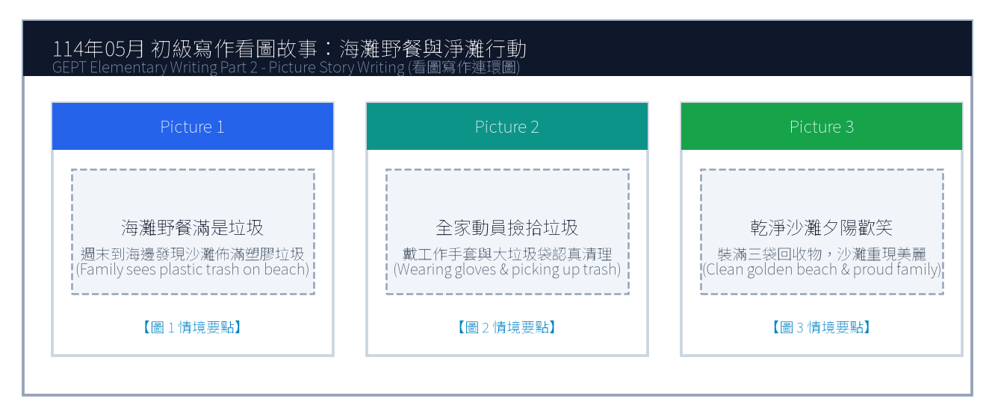
16. 請依據下列三幅海灘淨灘連環圖畫，寫一篇約 50 字的短文故事，敘述全家前往海灘野餐時發現垃圾並主動淨灘的過程。
Line 1: _________________________________________________________________________________
Line 2: _________________________________________________________________________________
Line 3: _________________________________________________________________________________
Line 4: _________________________________________________________________________________
Line 5: _________________________________________________________________________________
Line 6: _________________________________________________________________________________

🎙️ 第二部分：口說能力測驗 (Speaking Test)
測驗時間：約 10 分鐘（採電腦耳機麥克風錄音） ｜ 滿分：100 分（80 分以上為及格）

第一單元：朗讀短文 (Questions 1–2)
說明：共有兩篇短文。每篇短文有 1 分鐘的時間準備，然後請在 1 分鐘內以清晰、自然的語調朗讀出來。
【Question 1 朗讀短文】：
Passage 1: Welcome to the Green Ocean Aquarium. We invite you to explore the fascinating underwater world. Please do not tap on the glass or use flash photography, as bright lights may frighten our sea turtles and penguins. Enjoy your magical journey with our lovely ocean creatures.

【Question 2 朗讀短文】：
Passage 2: Drinking enough water every day is essential for good health. Water helps regulate our body temperature, aids digestion, and keeps our skin hydrated. Health experts suggest carrying a reusable water bottle so you can drink water regularly throughout the busy school day.

第二單元：回答問題 (Questions 3–12)
說明：共有十題日常生活問句。錄音將播出問題兩次，每次問題播完後有 15 秒的時間回答。請把握時間，針對問題盡量完整作答。
3. What kind of breakfast do you usually eat in the morning? (15 seconds response)
4. Where is your favorite place to study? (15 seconds response)
5. How do you usually celebrate your birthday? (15 seconds response)
6. Do you enjoy listening to music while doing homework? (15 seconds response)
7. Tell me about your favorite school teacher. (15 seconds response)
8. What sport do you like to play the most? (15 seconds response)
9. How do you usually spend your Sunday afternoons? (15 seconds response)
10. What would you do if you lost your transit pass? (15 seconds response)
11. Do you like cooking or baking at home? (15 seconds response)
12. What country would you like to travel to in the future? (15 seconds response)

第三單元：看圖敘述 (Question 13 情境大圖口語敘述)
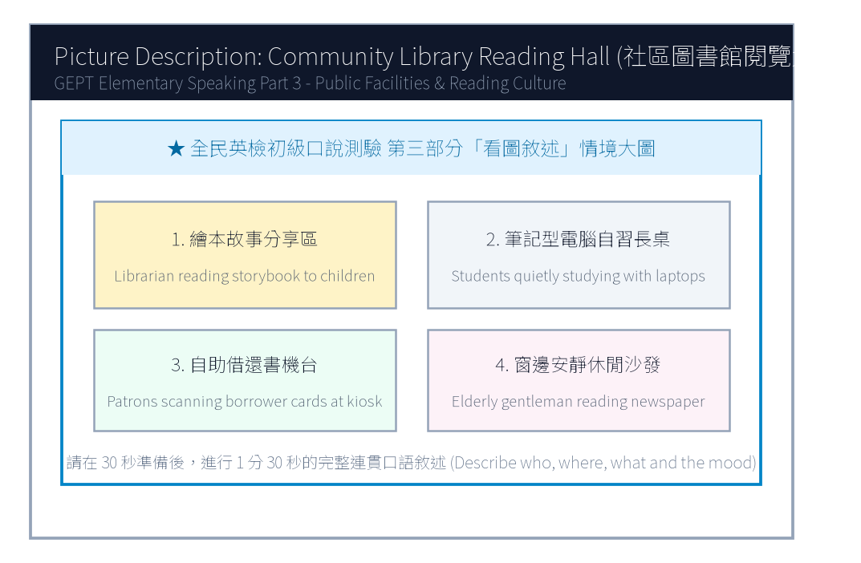
13. 請仔細觀察圖片，有 30 秒的準備時間。之後請在 1 分 30 秒內，根據圖中圖書館閱覽大廳的情境作一完整連貫的口述敘述。

【試題答案與名師深度解析手冊】
※ 本單元置於整張試卷最後面 · 供作答完畢後核對成績、滿分範文觀摩與考點診斷使用

單元一：寫作能力測驗 標準答案與滿分範文解析
【第一部分：單句寫作 1–15 題標準答案與常見錯誤剖析】
第 1 題 標準答案：Many tourists do not visit Kenting National Park during summer vacation.
★ 破題指引與扣分盲點：改為否定句須注意助動詞 does not/do not/did not 後動詞回歸原形。
第 2 題 標準答案：How long does Susan practice playing the piano every day?
★ 破題指引與扣分盲點：注意開頭首字大寫、句末標點符號及動詞時態一致。
第 3 題 標準答案：It is very important to sort garbage into different recycling bins.
★ 破題指引與扣分盲點：注意開頭首字大寫、句末標點符號及動詞時態一致。
第 4 題 標準答案：The world's first practical electric light bulb was invented by Edison.
★ 破題指引與扣分盲點：被動語態公式為「be動詞 + 過去分詞 (p.p.) + by...」，時態須嚴格對齊原句。
第 5 題 標準答案：The math puzzle was too difficult for any of the students to solve.
★ 破題指引與扣分盲點：注意否定含意，too... to 表示「太...以致於不能...」，後面接動詞原形。
第 6 題 標準答案：Mrs. Lin brought a clean cloth bag to the supermarket yesterday.
★ 破題指引與扣分盲點：注意開頭首字大寫、句末標點符號及動詞時態一致。
第 7 題 標準答案：Eating fresh fruits and vegetables is good for your health.
★ 破題指引與扣分盲點：注意開頭首字大寫、句末標點符號及動詞時態一致。
第 8 題 標準答案：The students turned off all the computers before leaving the classroom.
★ 破題指引與扣分盲點：注意開頭首字大寫、句末標點符號及動詞時態一致。
第 9 題 標準答案：We saw three playful puppies running happily in the park.
★ 破題指引與扣分盲點：注意開頭首字大寫、句末標點符號及動詞時態一致。
第 10 題 標準答案：How far is the famous museum from our hotel?
★ 破題指引與扣分盲點：注意開頭首字大寫、句末標點符號及動詞時態一致。
第 11 題 標準答案：Although Tina woke up early this morning, she missed the first school bus anyway.
★ 破題指引與扣分盲點：注意開頭首字大寫、句末標點符號及動詞時態一致。
第 12 題 標準答案：Mark likes drinking green tea, but his father prefers drinking black tea.
★ 破題指引與扣分盲點：注意開頭首字大寫、句末標點符號及動詞時態一致。
第 13 題 標準答案：The boy who has trained hard for five years won the gold medal in swimming.
★ 破題指引與扣分盲點：關係代名詞 who 引導形容詞子句修飾先行詞人，其後動詞與先行詞一致。
第 14 題 標準答案：We went to the public library to borrow some travel books.
★ 破題指引與扣分盲點：注意開頭首字大寫、句末標點符號及動詞時態一致。
第 15 題 標準答案：An airplane is the fastest of the three.
★ 破題指引與扣分盲點：注意開頭首字大寫、句末標點符號及動詞時態一致。
【第二部分：段落看圖寫作 Level 5 (滿分範文) 與架構解析】
★ 官方評測 5 級分 (滿分範文，約 60 字)：
"Last Sunday, Jason and his family went to the seashore for a holiday picnic. To their surprise, the beautiful golden sand was covered with plastic bottles, straws, and food containers left by careless visitors. Instead of merely complaining, they immediately put on sturdy gloves and worked together to collect three large bags of recyclable trash. By sunset, the coastal beach was completely clean and sparkling under the evening breeze. Jason felt proud that their small effort made a huge difference for marine wildlife."
★ 名師寫作結構金字塔：
1. 開門見山交代人、事、時、地、背景 (Background & Initial problem)
2. 轉折句敘述解決問題之具體行動 (Action & Teamwork)
3. 昇華結尾描繪心情與正面收穫 (Happy ending & Reflection)

單元二：口說能力測驗 滿分示範講稿與錄音逐字稿
【第二單元：回答問題 (Questions 3–12) 滿分口語回答範例】
3. What kind of breakfast do you usually eat in the morning?
滿分示範答句 (Model Response)："I usually have a warm toasted ham-and-egg sandwich with a glass of fresh soy milk. It gives me plenty of energy for my morning classes."
4. Where is your favorite place to study?
滿分示範答句 (Model Response)："My favorite place to study is the city library because it is extremely quiet, air-conditioned, and surrounded by helpful reference books."
5. How do you usually celebrate your birthday?
滿分示範答句 (Model Response)："I usually celebrate my birthday at home with my family. My mother bakes a chocolate cake and we enjoy a special dinner together."
6. Do you enjoy listening to music while doing homework?
滿分示範答句 (Model Response)："Yes, I like listening to soft classical piano music because it keeps me calm and focused without distracting my thoughts with lyrics."
7. Tell me about your favorite school teacher.
滿分示範答句 (Model Response)："My favorite teacher is our English teacher, Ms. Lin. She is always energetic, tells hilarious stories, and encourages every student to speak English bravely."
8. What sport do you like to play the most?
滿分示範答句 (Model Response)："I like playing table tennis the most because it sharpens my hand-eye coordination and I can easily play it indoors even on rainy days."
9. How do you usually spend your Sunday afternoons?
滿分示範答句 (Model Response)："I usually ride my bicycle along the riverside park with my cousins and then read mystery novels at a cozy cafe nearby."
10. What would you do if you lost your transit pass?
滿分示範答句 (Model Response)："If I lost my transit pass, I would immediately report it to the MRT station information desk and check if someone turned it in."
11. Do you like cooking or baking at home?
滿分示範答句 (Model Response)："Yes, I love baking chocolate chip cookies with my elder sister on weekends. Sharing warm, freshly baked cookies brings our family great joy."
12. What country would you like to travel to in the future?
滿分示範答句 (Model Response)："I would love to visit New Zealand because of its breathtaking snow-capped mountains, crystal-clear lakes, and unique kiwi birds."
【第三單元：看圖敘述 (Question 13) 90 秒完整連貫滿分講稿】
★ 官方評測滿分講稿 (約 120 字，90 秒從容輸出)：
"This picture captures the peaceful atmosphere inside our community public library on a quiet Saturday morning. In the foreground on the left, an enthusiastic librarian is reading an exciting illustrated fairy tale to a circle of attentive young children. At the center long wooden tables, several diligent high school students are focused on their laptop screens, taking detailed notes for their school projects. Over on the right-hand side, a middle-aged woman is using the modern touchscreen kiosk to return and borrow books automatically. Through the large glass windows in the background, warm sunlight streams across the bookshelf aisles, where people are browsing books in complete silence. The library offers a comfortable and inspiring haven for readers of all ages."
★ 名師口語敘述四維框架：
1. 【整體開場】：This picture shows... on a sunny afternoon.
2. 【方位細節 1】：In the foreground / On the left side...
3. 【方位細節 2】：In the center / In the background...
4. 【情感總結】：Overall, everyone looks cheerful and enjoys the wonderful time.

單元三：本卷核心考點單字與高頻實用片語表 (Core Vocabulary)
考點單字／片語 | 詞性 | 中文核心語意 | 生活情境搭配例句
national park | n. | 國家公園 | explore the wildlife in Kenting National Park
electric light bulb | n. | 電燈泡 | Edison improved the electric light bulb in 1879
recycling bin | n. | 資源回收桶 | put aluminum cans into the designated recycling bin
plastic container | n. | 塑膠容器 | avoid using single-use plastic containers for takeout
marine wildlife | n. | 海洋野生生物 | protect marine wildlife from plastic ingestion
hydrated | adj. | 水分充足的 | drink eight glasses of water to stay well-hydrated
attentive | adj. | 專注的、聚精會神的 | The attentive students listened carefully to the speech.
stream | v./n. | 照進、流出；小溪 | Golden sunlight streamed through the classroom window.
haven | n. | 避風港、寧靜聖地 | The botanical garden is a peaceful haven for city residents.
coastal | adj. | 沿海的、海岸的 | join the volunteer team to clean the coastal beaches

