財團法人語言訓練測驗中心（LTTC）全民英語能力分級檢定測驗
115年度第1次 全民英檢初級說寫測驗（第二試／一日考）全真試卷暨名師詳解
【試題本】(Question Booklet) · 答案與深度解析請參閱卷末解析手冊
測驗代碼 | GEPT-E-115-01-SW
測驗日期 | 2026 年 01 月 10 日（一日考說寫複試）
測驗級數 | 初級（CEFR A2 級）
測驗項目 | 寫作能力測驗（40 分鐘）＆ 口說能力測驗（約 10 分鐘）
及格門檻 | 寫作達 70 分以上且口說達 80 分以上（均達 4 級分以上始發證書）
核心主題 | 家庭溫馨親情、秘密烤蛋糕驚喜慶生、綠能體育運動公園、活力休閒生活

★ 作答注意事項：本測驗分為「寫作能力測驗」（第一部分單句寫作15題、第二部分段落寫作1題，共40分鐘）與「口說能力測驗」（第一部分朗讀2題、第二部分回答問題10題、第三部分看圖敘述1題，約10分鐘）。全卷無預載答案，標準答案、滿分示範文章與口語講稿統一置於【整張試卷最後面】。

✍️ 第一部分：寫作能力測驗 (Writing Test)
作答時間：40 分鐘 ｜ 滿分：100 分（70 分以上為及格）

第一單元：單句寫作 (Questions 1–15)
說明：第 1–5 題為改寫，第 6–10 題為重組，第 11–15 題為句子合併。請依照各題括號內之指示作答，注意大小寫與標點符號。
1. George goes jogging in the community sports park every morning. (改為否定句)
作答區：____________________________________________________________________________________
2. The high school soccer team won five championship matches last year. (依畫線部分 five 造原問句)
作答區：____________________________________________________________________________________
3. To speak English with native speakers requires lots of courage. (用 It takes... 或 It requires... 改寫)
作答區：____________________________________________________________________________________
4. Many curious students visited the newly opened science museum yesterday. (改為被動語態)
作答區：____________________________________________________________________________________
5. The box of antique porcelain was so fragile that nobody dared to move it. (用 too... to... 改寫)
作答區：____________________________________________________________________________________
6. on the blackboard / wrote / an important message / the English teacher
作答區：____________________________________________________________________________________
7. good posture / essential / to maintain / for teenagers / is
作答區：____________________________________________________________________________________
8. a birthday gift / bought / for her younger sister / yesterday / Alice
作答區：____________________________________________________________________________________
9. the baby birds / in their nest / chirping hungrily / we heard
作答區：____________________________________________________________________________________
10. leave / the next express train / will / when / ?
作答區：____________________________________________________________________________________
11. Leo prepared thoroughly for the swimming contest. / He did not win any medals. (用 Although 合併)
作答區：____________________________________________________________________________________
12. You may drink freshly squeezed orange juice. / You may have a cup of hot chocolate. (用 either... or... 合併)
作答區：____________________________________________________________________________________
13. The lady is our school principal. / She delivered an inspiring speech this morning. (用 who 合併)
作答區：____________________________________________________________________________________
14. They traveled to Hualien. / They wanted to admire the magnificent Taroko Gorge. (用 to 或 in order to 合併)
作答區：____________________________________________________________________________________
15. A motorcycle is heavier than a bicycle. / A truck is heavier than a motorcycle. (用 heaviest 合併)
作答區：____________________________________________________________________________________

第二單元：段落寫作 (Question 16 看圖短文寫作)
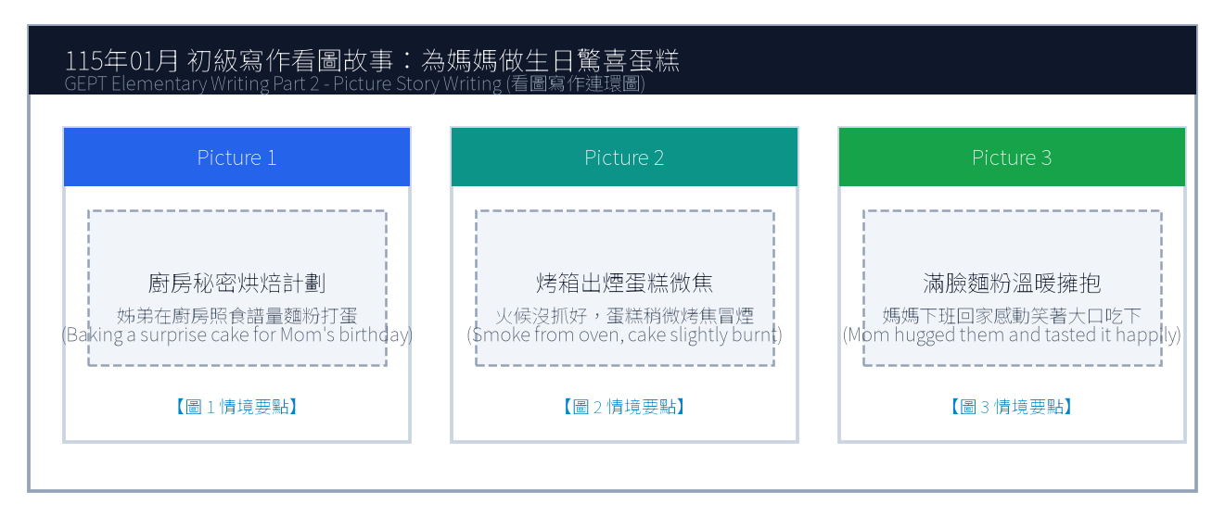
16. 請依據下列三幅連環圖畫內容，寫一篇約 50 字的短文故事，敘述姊弟倆在廚房秘密為媽媽烘焙生日蛋糕，雖然蛋糕烤焦了一角但媽媽依然感動無比的溫馨經過。
Line 1: _________________________________________________________________________________
Line 2: _________________________________________________________________________________
Line 3: _________________________________________________________________________________
Line 4: _________________________________________________________________________________
Line 5: _________________________________________________________________________________
Line 6: _________________________________________________________________________________

🎙️ 第二部分：口說能力測驗 (Speaking Test)
測驗時間：約 10 分鐘（採電腦耳機麥克風錄音） ｜ 滿分：100 分（80 分以上為及格）

第一單元：朗讀短文 (Questions 1–2)
說明：共有兩篇短文。每篇短文有 1 分鐘的時間準備，然後請在 1 分鐘內以清晰、自然的語調朗讀出來。
【Question 1 朗讀短文】：
Passage 1: Good afternoon, passengers. We are now approaching Taichung High Speed Rail Station. Please gather all your personal belongings and check the overhead luggage racks. Do not leave your mobile phones or transit cards on the seats. Thank you for riding with Taiwan High Speed Rail.

【Question 2 朗讀短文】：
Passage 2: Trees are the lungs of our planet. They absorb harmful carbon dioxide from the air and release pure oxygen for humans and animals to breathe. In addition, deep tree roots anchor the soil and prevent destructive landslides during heavy summer typhoons. Planting trees creates a greener world.

第二單元：回答問題 (Questions 3–12)
說明：共有十題日常生活問句。錄音將播出問題兩次，每次問題播完後有 15 秒的時間回答。請把握時間，針對問題盡量完整作答。
3. What is your favorite kind of fruit? (15 seconds response)
4. How do you usually spend your time after finishing homework? (15 seconds response)
5. What kind of pets do you like the most? (15 seconds response)
6. Do you enjoy cooking or helping out in the kitchen? (15 seconds response)
7. Tell me about an interesting place you visited recently. (15 seconds response)
8. How do you celebrate New Year's Eve with your family? (15 seconds response)
9. What subject do you find the most challenging, and why? (15 seconds response)
10. What do you do when you catch a cold? (15 seconds response)
11. Do you prefer watching sports on TV or playing them yourself? (15 seconds response)
12. If you could have any superpower, what would it be? (15 seconds response)

第三單元：看圖敘述 (Question 13 情境大圖口語敘述)
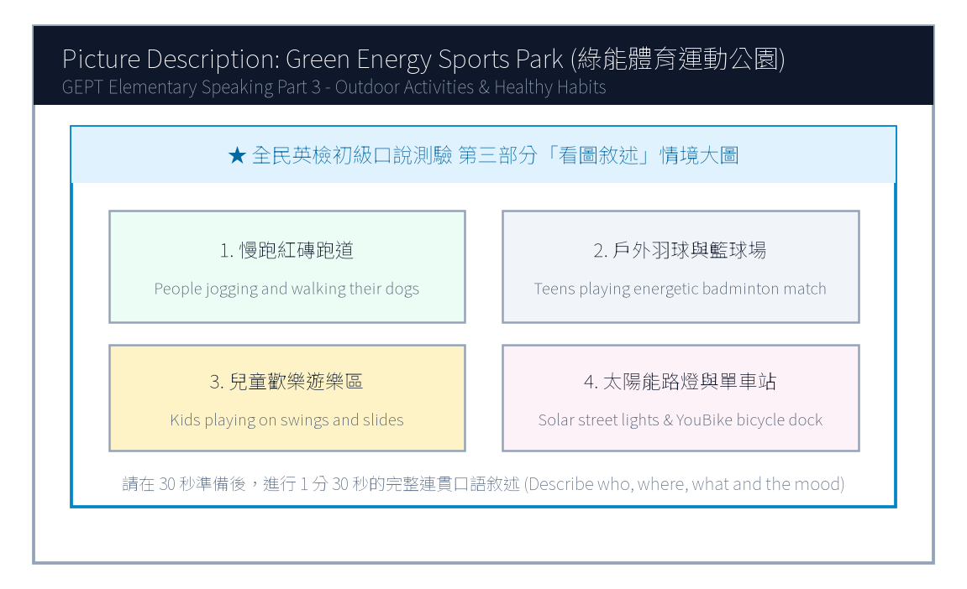
13. 請仔細觀察圖片，有 30 秒的準備時間。之後請在 1 分 30 秒內，根據圖中綠能體育運動公園的情境作一完整連貫的口述敘述。

【試題答案與名師深度解析手冊】
※ 本單元置於整張試卷最後面 · 供作答完畢後核對成績、滿分範文觀摩與考點診斷使用

單元一：寫作能力測驗 標準答案與滿分範文解析
【第一部分：單句寫作 1–15 題標準答案與常見錯誤剖析】
第 1 題 標準答案：George does not go jogging in the community sports park every morning.
★ 破題指引與扣分盲點：改為否定句須注意助動詞 does not/do not/did not 後動詞回歸原形。
第 2 題 標準答案：How many championship matches did the high school soccer team win last year?
★ 破題指引與扣分盲點：注意開頭首字大寫、句末標點符號及動詞時態一致。
第 3 題 標準答案：It takes lots of courage to speak English with native speakers.
★ 破題指引與扣分盲點：注意開頭首字大寫、句末標點符號及動詞時態一致。
第 4 題 標準答案：The newly opened science museum was visited by many curious students yesterday.
★ 破題指引與扣分盲點：被動語態公式為「be動詞 + 過去分詞 (p.p.) + by...」，時態須嚴格對齊原句。
第 5 題 標準答案：The box of antique porcelain was too fragile for anybody to move.
★ 破題指引與扣分盲點：注意否定含意，too... to 表示「太...以致於不能...」，後面接動詞原形。
第 6 題 標準答案：The English teacher wrote an important message on the blackboard.
★ 破題指引與扣分盲點：注意開頭首字大寫、句末標點符號及動詞時態一致。
第 7 題 標準答案：It is essential for teenagers to maintain good posture.
★ 破題指引與扣分盲點：注意開頭首字大寫、句末標點符號及動詞時態一致。
第 8 題 標準答案：Alice bought a birthday gift for her younger sister yesterday.
★ 破題指引與扣分盲點：注意開頭首字大寫、句末標點符號及動詞時態一致。
第 9 題 標準答案：We heard the baby birds chirping hungrily in their nest.
★ 破題指引與扣分盲點：注意開頭首字大寫、句末標點符號及動詞時態一致。
第 10 題 標準答案：When will the next express train leave?
★ 破題指引與扣分盲點：注意開頭首字大寫、句末標點符號及動詞時態一致。
第 11 題 標準答案：Although Leo prepared thoroughly for the swimming contest, he did not win any medals.
★ 破題指引與扣分盲點：注意開頭首字大寫、句末標點符號及動詞時態一致。
第 12 題 標準答案：You may either drink freshly squeezed orange juice or have a cup of hot chocolate.
★ 破題指引與扣分盲點：注意開頭首字大寫、句末標點符號及動詞時態一致。
第 13 題 標準答案：The lady who delivered an inspiring speech this morning is our school principal.
★ 破題指引與扣分盲點：關係代名詞 who 引導形容詞子句修飾先行詞人，其後動詞與先行詞一致。
第 14 題 標準答案：They traveled to Hualien in order to admire the magnificent Taroko Gorge.
★ 破題指引與扣分盲點：注意開頭首字大寫、句末標點符號及動詞時態一致。
第 15 題 標準答案：A truck is the heaviest of the three.
★ 破題指引與扣分盲點：注意開頭首字大寫、句末標點符號及動詞時態一致。
【第二部分：段落看圖寫作 Level 5 (滿分範文) 與架構解析】
★ 官方評測 5 級分 (滿分範文，約 60 字)：
"Yesterday was Mom's birthday, so Cindy and her younger brother decided to bake a surprise strawberry cake before she returned from work. However, because they accidentally set the oven temperature too high, dark smoke poured out and the cake was slightly charred on top. Just as they felt discouraged and messy with flour all over their faces, Mom walked in and understood everything immediately. She embraced them with tears of joy, happily tasting the burnt cake and declaring it the sweetest gift ever."
★ 名師寫作結構金字塔：
1. 開門見山交代人、事、時、地、背景 (Background & Initial problem)
2. 轉折句敘述解決問題之具體行動 (Action & Teamwork)
3. 昇華結尾描繪心情與正面收穫 (Happy ending & Reflection)

單元二：口說能力測驗 滿分示範講稿與錄音逐字稿
【第二單元：回答問題 (Questions 3–12) 滿分口語回答範例】
3. What is your favorite kind of fruit?
滿分示範答句 (Model Response)："My favorite fruit is watermelon because it is extremely juicy, sweet, and refreshing, especially on scorching hot summer days."
4. How do you usually spend your time after finishing homework?
滿分示範答句 (Model Response)："After finishing my homework, I usually practice playing the acoustic guitar for thirty minutes or walk our dog in the neighborhood park."
5. What kind of pets do you like the most?
滿分示範答句 (Model Response)："I like golden retrievers the most because they are exceptionally loyal, gentle with children, and always wag their tails joyfully."
6. Do you enjoy cooking or helping out in the kitchen?
滿分示範答句 (Model Response)："Yes, I really enjoy helping my mother prepare dinner, especially washing fresh vegetables and beating eggs for fried rice."
7. Tell me about an interesting place you visited recently.
滿分示範答句 (Model Response)："Recently, I visited the Taipei Astronomical Museum. The giant 3D planetarium show made me feel like I was floating among distant galaxies."
8. How do you celebrate New Year's Eve with your family?
滿分示範答句 (Model Response)："On New Year's Eve, my family eats hot pot dinner together, watches the festive concert on television, and countdowns to the spectacular 101 fireworks display."
9. What subject do you find the most challenging, and why?
滿分示範答句 (Model Response)："I find history the most challenging because there are so many dynasties, historical figures, and treaty dates that require careful memorization."
10. What do you do when you catch a cold?
滿分示範答句 (Model Response)："When I catch a cold, I visit a clinic immediately, drink plenty of warm lemon water, and sleep early so my body can recover quickly."
11. Do you prefer watching sports on TV or playing them yourself?
滿分示範答句 (Model Response)："I prefer playing sports myself because running on the court and sweating with my classmates is much more thrilling and healthy than watching passively."
12. If you could have any superpower, what would it be?
滿分示範答句 (Model Response)："If I could have a superpower, I would love the ability to fly so I could soar above the clouds and explore every continent without traffic jams."
【第三單元：看圖敘述 (Question 13) 90 秒完整連貫滿分講稿】
★ 官方評測滿分講稿 (約 120 字，90 秒從容輸出)：
"This energetic picture shows a sunny Sunday afternoon at the newly opened city sports park. In the center foreground, several enthusiastic teenagers are playing a fast-paced badminton doubles match, leaping into the air to smash the shuttlecock. Encircling the sports fields is a wide brick-red track where joggers of various ages are running steadily to the rhythm of upbeat music. Over to the right, a joyful playground is filled with small children sliding down bright yellow slides and giggling on swings under their parents' watchful eyes. In the background, modern solar-powered streetlights line the pathways, and a shared bicycle docking station offers green commuting options. The park is vibrant, clean, and full of healthy outdoor vitality."
★ 名師口語敘述四維框架：
1. 【整體開場】：This picture shows... on a sunny afternoon.
2. 【方位細節 1】：In the foreground / On the left side...
3. 【方位細節 2】：In the center / In the background...
4. 【情感總結】：Overall, everyone looks cheerful and enjoys the wonderful time.

單元三：本卷核心考點單字與高頻實用片語表 (Core Vocabulary)
考點單字／片語 | 詞性 | 中文核心語意 | 生活情境搭配例句
charred | adj. | 燒焦的 | The cake was slightly charred on top, but the inside was soft.
discouraged | adj. | 氣餒的、沮喪的 | Don't feel discouraged when facing difficult challenges.
overhead rack | n. | 頭頂行李架 | Place your heavy backpacks on the overhead luggage rack.
carbon dioxide | n. | 二氧化碳 | Green plants absorb carbon dioxide during photosynthesis.
landslide | n. | 土石流、山崩 | Heavy rainfall during typhoons may trigger dangerous landslides.
scorching | adj. | 炙熱的、滾燙的 | drink lots of water on scorching summer afternoons
planetarium | n. | 天文館、天象儀 | watch an immersive 3D show at the science planetarium
vitality | n. | 活力、生機 | The young athletes showed incredible energy and vitality.
shuttlecock | n. | 羽毛球 | hit the shuttlecock over the badminton net with precision
commute | v./n. | 通勤 | Many students commute to school by taking public buses.

