全民英語能力分級檢定測驗（GEPT）模擬練習（依官方題型編製）
115年度第2次 全民英語能力分級檢定測驗（中級聽讀）模擬試題（依官方題型編製）暨詳解
【試題本】(Question Booklet) · 答案與深度解析請參閱卷末解析手冊
測驗代碼 | GEPT-115-05-IR
測驗日期 | 2026 年 05 月 16 日（中級初試常態測驗）
測驗級數 | 中級（CEFR B1 級）
測驗項目 | 聽力能力測驗（35 題，約 30 分鐘）＆ 閱讀能力測驗（35 題，45 分鐘）
合格門檻 | 總分 160 分以上，且聽讀單科均不低於 72 分
命題核心主題 | 全球氣候變遷調適、都市垂直農場、共享綠能載具與現代人際溝通
考生注意事項 | 本卷共 70 題（聽力 35 題、閱讀 35 題）。答案與完整解析已移至整張試卷最後面，請先完成作答再行對答案。

★ 作答注意事項：本試題本共 70 題，分為聽力能力測驗（35 題）與閱讀能力測驗（35 題）。每題均為單選題，請依題意選出一個最適當的答案。標準答案與完整名師逐題解析統一置於【整張試卷最後面】，請全卷作答完畢後再行翻閱核對。

📝 第一單元：模擬試題本 (Question Booklet)

🎧 第一部分：聽力能力測驗 (Listening Comprehension)
總題數：35 題 ｜ 作答時間：約 30 分鐘 ｜ 滿分：120 分

第一部分：看圖辨義 (Questions 1-5)
![Picture 1](./images/exam05_q01.png)
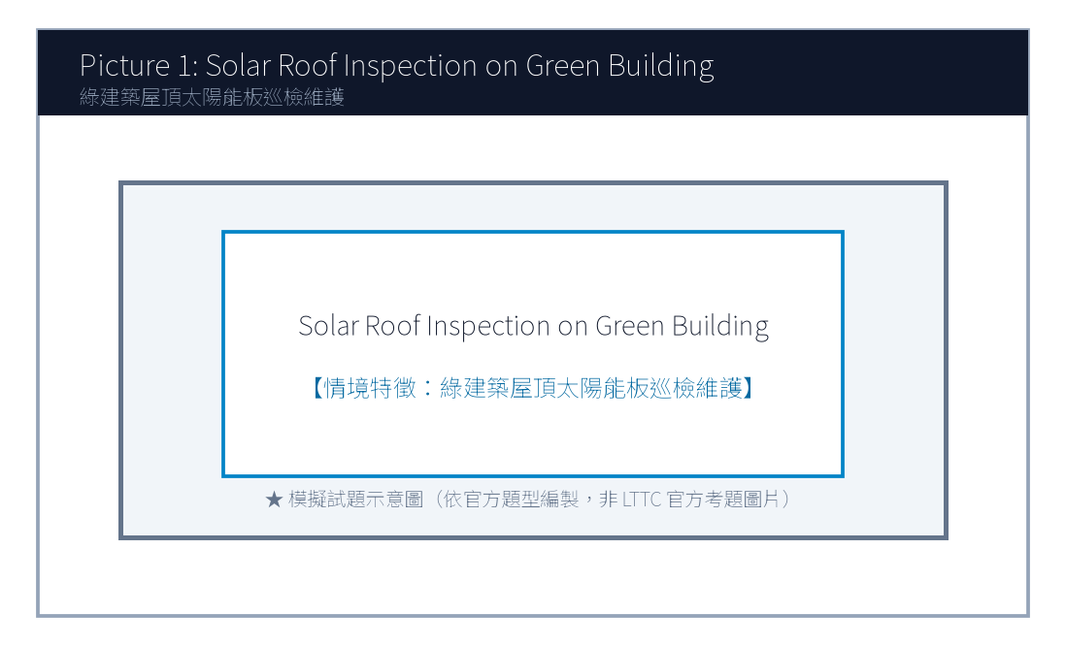
1. Look at picture number 1. (Please listen to the recording)
(A) He is inspecting hydroponic water pipes on a rooftop vertical farm.
(B) He is harvesting wheat with a combine harvester on a prairie.
(C) He is fishing on a small wooden boat in the middle of a lake.
(D) He is planting pine trees along a busy highway.
![Picture 2](./images/exam05_q02.png)
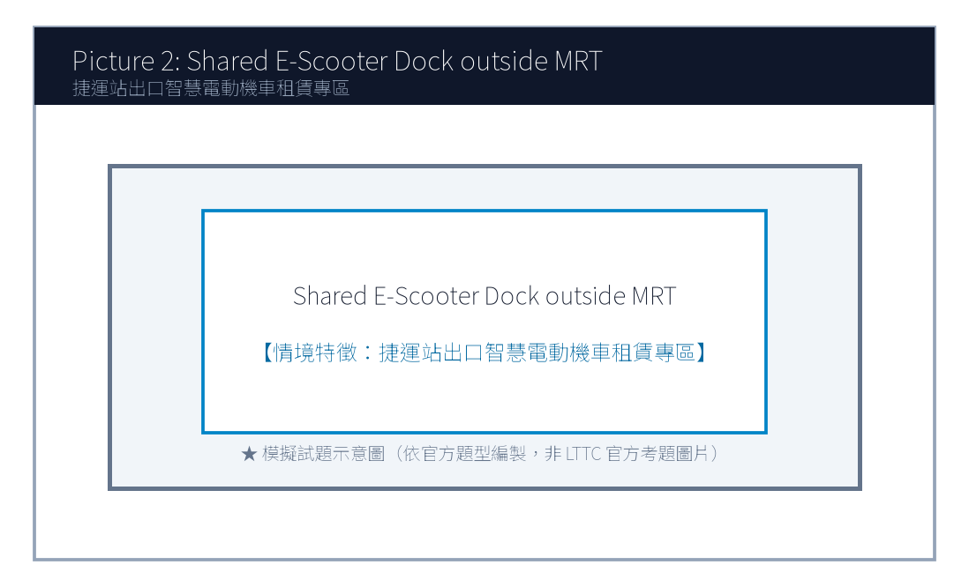
2. Look at picture number 2. (Please listen to the recording)
(A) She is scanning a QR code with her smartphone to rent an electric scooter.
(B) She is pumping air into a deflated truck tire at a gas station.
(C) She is waiting for a delayed diesel bus at a crowded station.
(D) She is purchasing a physical plane ticket at an airline desk.
![Picture 3](./images/exam05_q03.png)

3. Look at picture number 3. (Please listen to the recording)
(A) Residents are browsing second-hand children's books and wooden toys at a flea market.
(B) Heavy snow has buried the entire playground under ice.
(C) The park is completely deserted during an overnight thunderstorm.
(D) Police officers are investigating a bank robbery on the street.
![Picture 4](./images/exam05_q04.png)
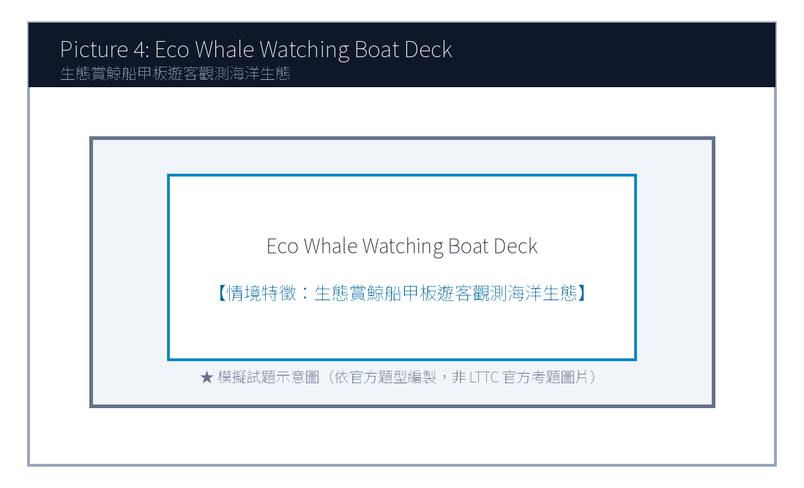
4. Look at picture number 4. (Please listen to the recording)
(A) He is warning viewers about an impending summer heatwave using satellite weather maps.
(B) He is demonstrating how to cook authentic Italian seafood pasta.
(C) He is introducing the history of ancient Egyptian pyramids.
(D) He is teaching basic conversational French to language learners.
![Picture 5](./images/exam05_q05.png)
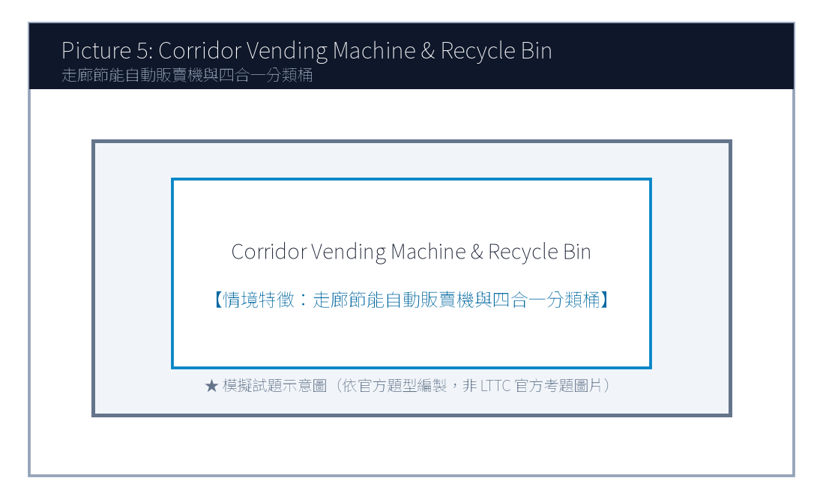
5. Look at picture number 5. (Please listen to the recording)
(A) They are chatting casually while pouring coffee in the company pantry.
(B) They are quarreling loudly in a courtroom.
(C) They are painting the office ceiling with white roller brushes.
(D) They are running on treadmills at a commercial fitness center.

第二部分：問答 (Questions 6-15)
6. **錄音**: *Could you recommend an energy-efficient air conditioner model for my small apartment?*
(A) Look for models with a Grade 1 Energy Efficiency label to save on electricity bills.
(B) The apartment is located fifteen minutes from the train station.
(C) Yes, I turned off the living room lights before going to sleep.
(D) The air conditioner was invented more than a century ago.
7. **錄音**: *Why did the municipal council decide to expand the urban bike lane network this year?*
(A) To reduce carbon emissions and promote healthier commuting habits among citizens.
(B) Bicycles have two wheels and a steel chain.
(C) The bicycle race ended at five o'clock yesterday afternoon.
(D) Yes, I ride my mountain bike every weekend.
8. **錄音**: *I heard our company is transitioning to a four-day workweek trial next month. Is that true?*
(A) Yes, management announced it yesterday to boost productivity and employee well-being.
(B) I work forty hours every week from Monday to Friday.
(C) The weekend weather will be sunny and warm.
(D) We have five full-time employees in our department.
(A) Standard.
(B) Commuter.
(C) Student.
(D) Tourist.
(A) NT$ 10.
(B) NT$ 200.
(C) NT$ 250.
(D) NT$ 350.
(A) An unprecedented winter blizzard with sub-zero freezing snow.
(B) Extreme summer heatwaves exceeding 38 degrees Celsius.
(C) A catastrophic marine tsunami hitting the eastern seaboard.
(D) Dense desert sandstorms causing airport shutdowns.
(A) Early morning before six a.m.
(B) Between eleven a.m. and three p.m.
(C) After sunset around eight p.m.
(D) Midnight to dawn.
(A) Drink water proactively throughout the day rather than waiting for thirst.
(B) Consume only iced soda and sugary fruit juices.
(C) Avoid drinking any fluids before going to bed.
(D) Drink water only once every forty-eight hours.

第三部分：簡短對話 (Questions 16-25，含圖表題)
(Questions 18-19: 圖表題 — 共享電動機車租賃計費費率表)
- [試題冊圖表]:
騎乘方案 (Rental Option) | 起程費率（前6分鐘） | 續租費率（第7分鐘起） | 每日最高收費上限 (Daily Cap)
標準即享方案 (Standard) | NT$ 15 | NT$ 2.5 / 分鐘 | NT$ 350
通勤月租方案 (Commuter) | 包含於月費內 | NT$ 1.5 / 分鐘 | NT$ 250
學生專屬優惠 (Student) | NT$ 10 | NT$ 1.8 / 分鐘 | NT$ 200

- 錄音對話:
- *Woman*: Hey Alan! How much did it cost you to ride that shared electric scooter to the university campus this morning?
- *Man*: Well, since I verified my student ID on the mobile app, I got the special student rate! My trip took exactly twenty minutes from my apartment.
- *Woman*: Wow, that sounds affordable! Let's calculate: the first six minutes were only ten dollars, and the remaining fourteen minutes cost 1.8 dollars each. That's just about thirty-five dollars total!
- 第 18 題: Look at the chart. Which plan did Alan use for his morning trip?
- 第 19 題: How much is the daily maximum charging cap for the Student plan?

第四部分：簡短談話 (Questions 26-35)
(Questions 26-28: 氣象專家在廣播節目分析夏季極端熱浪調適心法)
- 錄音短講:
- *"Good afternoon, listeners of FM 98.7 Life Radio. As global climate patterns become increasingly erratic, Taiwan is bracing for consecutive days of extreme heat exceeding thirty-eight degrees Celsius. To safeguard your health, health authorities urge citizens to observe three golden rules. First, avoid vigorous outdoor sports between eleven a.m. and three p.m. when solar radiation peaks. Second, drink water proactively throughout the day rather than waiting until you feel parched, as thirst is an early warning sign of mild dehydration. Third, check frequently on elderly neighbors living alone, ensuring their living spaces have adequate cross-ventilation or cooling appliances. By taking these sensible precautions, we can enjoy our summer while staying safe and healthy."*
- 第 26 題: What meteorological condition is discussed in this radio broadcast?
- 第 27 題: Which time window are citizens advised to avoid strenuous outdoor activities?
- 第 28 題: What medical advice does the expert offer regarding hydration?

📖 第二部分：閱讀能力測驗 (Reading Comprehension)
總題數：35 題 ｜ 作答時間：45 分鐘 ｜ 滿分：120 分

第一部分：詞彙 (Questions 1-10)
1. In high-density urban environments, vertical hydroponic farming offers a ________ solution to produce fresh vegetables without vast soil acreage.
(A) sustainable
(B) clumsy
(C) fragile
(D) casual
2. The municipal government implemented emergency subsidies to assist agricultural farmers whose crops were ________ damaged by the drought.
(A) severely
(B) cheerfully
(C) deliciously
(D) politely
3. Commuters are encouraged to utilize shared electric scooters to bridge the "first and last ________" gap between transit stations and their homes.
(A) mile
(B) appointment
(C) recipe
(D) ingredient
4. Proactive physical hydration is ________ to preventing heat exhaustion during prolonged outdoor work under summer sun.
(A) vital
(B) hostile
(C) deceptive
(D) tedious
5. Community flea markets not only promote circular economy but also strengthen interpersonal ________ among local residents.
(A) bonds
(B) collisions
(C) departures
(D) tickets
(A) By growing crops vertically in controlled indoor spaces, this method maximizes harvest yield per square foot.
(B) Heavy snowstorms often cause railway power lines to freeze in alpine regions.
(C) Many passengers prefer buying first-class train tickets during holiday travels.
(D) Several department stores announced end-of-season clothing discount promotions.
(A) Furthermore
(B) On the contrary
(C) In contrast
(D) Unfortunately
(A) A certificate of high school graduation.
(B) An official Police Accident Report.
(C) A bank statement showing stock market investments.
(D) A receipt for five cups of hot coffee.
(A) Negotiating private cash settlements and leaving the scene without police documentation.
(B) Calling the emergency police number 110.
(C) Using the in-app SOS button to report the incident.
(D) Wearing a certified safety helmet.
(A) A delivery truck driver fell asleep at the wheel.
(B) Another motorcycle made a sudden turn without signaling and clipped his rear fender.
(C) Vincent was racing at high speed during heavy rainfall.
(D) A fallen tree blocked the entire roadway.
(A) He fled the scene and hid in a nearby shopping mall.
(B) He called 110 immediately, obtained the official police accident form, and documented damage with photos.
(C) He paid the other driver five thousand dollars cash on the spot.
(D) He abandoned the damaged scooter in the middle of the intersection.
(A) A photo of the official Police Accident Form and photos of the scraped vehicle fender.
(B) A video of his family vacation in Japan.
(C) His university entrance examination score report.
(D) A coupon for fifty percent off department store cosmetics.

第二部分：段落填空 (Questions 11-20，含新制句子填空)
(Passage: 都市垂直水耕農場的綠色革命)
As the global population steadily surpasses eight billion, securing reliable food supplies while minimizing agricultural land degradation poses a monumental challenge. Traditional farming relies extensively on unpredictable rainfall, vast arable land, and synthetic pesticides. In recent years, high-tech vertical farming has emerged as a transformative alternative. (11) ________. Inside these climate-controlled facilities, leafy greens and strawberries are cultivated on stacked multi-tier trays utilizing nutrient-rich water solutions and customized LED lighting wavelengths. Because vertical farms operate indoors regardless of external weather extremes, crop yields remain consistent throughout the four seasons. (12) ________, closed-loop hydroponic systems recycle ninety-five percent of water, consuming far less resources than conventional open-field agriculture. By siting these facilities inside city centers, food miles and carbon emissions associated with long-distance freight shipping are drastically curtailed.
- 第 11 題 (新制句子選填):
- 第 12 題 (轉折詞填空):

第三部分：閱讀理解 (Questions 21-35，含雙文本閱讀)
(Questions 31-35: 雙文本閱讀 — 共享電動機車保險服務條款與使用者事故理賠諮詢函)
[Text 1: 共享電動機車租賃附隨保險條款摘要]
ECO-RIDE MOBILITY SERVICES TAIWAN
Summary of User Insurance Coverage & Incident Protocols
1. Comprehensive Third-Party Liability Coverage:
Every active rental includes automatic Third-Party Liability Insurance covering bodily injury (up to NT$ 2,000,000 per person) and property damage (up to NT$ 500,000 per accident) sustained by other parties.
2. Mandatory Post-Accident Procedure:
In the unfortunate event of a traffic collision:
• Step 1: Ensure personal safety and immediately dial 110 for police intervention. An official Police Accident Report (道路交通事故當事人登記聯單) is strictly mandatory for all insurance claims.
• Step 2: Do NOT leave the scene or negotiate private cash settlements with other parties.
• Step 3: Contact the Eco-Ride 24/7 Emergency Dispatch Center via the in-app SOS button within two hours.
Failure to file a police report will void all insurance indemnification, making the user solely liable for all repair expenses and civil liabilities.

[Text 2: 租借使用者事故備案詢問電郵]
To: claims@eco-ride.com.tw
From: vincent.kuo@email.com
Date: May 18, 2026
Subject: Accident Incident Report - Rental Vehicle Plate # EMG-8821
Dear Eco-Ride Claims Team,
I am writing to report a minor traffic accident that occurred this morning at 08:45 near the intersection of Xinyi Road and Dunhua South Road while I was riding vehicle #EMG-8821. Another motorcycle made a sudden turn without signaling and clipped my rear fender, causing minor scrapes to the vehicle.
Fortunately, neither of us sustained physical injuries. I immediately dialed 110, and two traffic officers arrived within ten minutes to document the scene and take breathalyzer tests (both zero). Attached to this email is a clear photo of the official Police Accident Form (#PA-2026-0518-092) and photos of the scraped rear fender.
Please advise on next steps regarding damage inspection and whether I need to submit physical paperwork to your service counter.
Best regards,
Vincent Kuo
Cell: 0912-345-678

- 第 31 題: According to Text 1, what official document is strictly mandatory for filing an insurance claim?
- 第 32 題: What action is explicitly prohibited under the incident protocols in Text 1?
- 第 33 題: In Text 2, what caused the collision involving Vincent Kuo?
- 第 34 題: How did Vincent Kuo correctly follow the protocol in Text 1?
- 第 35 題: What attachment did Vincent provide in his email in Text 2?

🎯 試題答案與名師深度解析手冊 (Answer Key & Explanations)

一、1–70 題 快速答案對照總表
聽力 1-10 | 聽力 11-20 | 聽力 21-30 | 聽力 31-35 | 閱讀 1-10 | 閱讀 11-20 | 閱讀 21-30 | 閱讀 31-35
1. A<br>2. A<br>3. A<br>4. A<br>5. A<br>6. A<br>7. A<br>8. A<br>9. B<br>10. C | 11. B<br>12. A<br>13. C<br>14. B<br>15. A<br>16. B<br>17. C<br>18. C<br>19. B<br>20. A | 21. B<br>22. C<br>23. A<br>24. D<br>25. B<br>26. B<br>27. B<br>28. A<br>29. C<br>30. D | 31. B<br>32. A<br>33. B<br>34. C<br>35. B | 1. A<br>2. A<br>3. A<br>4. A<br>5. A<br>6. B<br>7. C<br>8. D<br>9. A<br>10. B | 11. A<br>12. A<br>13. C<br>14. B<br>15. D<br>16. A<br>17. B<br>18. C<br>19. D<br>20. A | 21. B<br>22. A<br>23. C<br>24. D<br>25. B<br>26. A<br>27. C<br>28. B<br>29. D<br>30. A | 31. B<br>32. A<br>33. B<br>34. B<br>35. A

二、逐題考點剖析與名師破題詳解
#### 【聽力 第 1 題】 標準答案：(A)
- 聽力錄音語音稿：*Look at picture number 1. What is the urban farmer doing?*
- 破題思路與盲點解析：檢查垂直水耕農場水管（inspecting hydroponic water pipes on rooftop vertical farm），選 (A)。
#### 【聽力 第 2 題】 標準答案：(A)
- 聽力錄音語音稿：*Look at picture number 2. What is the commuter doing?*
- 破題思路與盲點解析：掃描 QR 碼租賃共享電動機車（scanning QR code to rent electric scooter），選 (A)。
#### 【聽力 第 3 題】 標準答案：(A)
- 聽力錄音語音稿：*Look at picture number 3. What is happening in the neighborhood park?*
- 破題思路與盲點解析：挑選二手書籍與玩具（browsing second-hand books and wooden toys at flea market），選 (A)。
#### 【聽力 第 4 題】 標準答案：(A)
- 聽力錄音語音稿：*Look at picture number 4. What is the meteorologist explaining?*
- 破題思路與盲點解析：氣象主播利用衛星雲圖預警熱浪（warning about impending heatwave using satellite maps），選 (A)。
#### 【聽力 第 5 題】 標準答案：(A)
- 聽力錄音語音稿：*Look at picture number 5. What are the two employees doing?*
- 破題思路與盲點解析：茶水間倒咖啡輕鬆交談（chatting casually while pouring coffee in pantry），選 (A)。
#### 【聽力 第 6 題】 標準答案：(A)
- 破題思路與盲點解析：推薦節能冷氣機種，(A)「建議挑選具備一級能效標籤的機型以節省電費」最專業實用。
#### 【聽力 第 7 題】 標準答案：(A)
- 破題思路與盲點解析：詢問市議會擴建自行車專用道的原因，(A) 說明為了減碳並提倡市民健康通勤。
#### 【聽力 第 8 題】 標準答案：(A)
- 破題思路與盲點解析：圖表顯示學生方案單日最高上限為 NT$ 200，選 (B)。
#### 【聽力 第 1 題】 標準答案：(A)
- 破題思路與盲點解析：sustainable solution 永續可行的解決方案。
#### 【聽力 第 2 題】 標準答案：(A)
- 破題思路與盲點解析：severely damaged 遭受嚴重損害。
#### 【聽力 第 3 題】 標準答案：(A)
- 破題思路與盲點解析：the first and last mile 交通最後一哩路。
#### 【聽力 第 4 題】 標準答案：(A)
- 破題思路與盲點解析：vital 至關重要的。
#### 【聽力 第 5 題】 標準答案：(A)
- 破題思路與盲點解析：前句講產量不受天候影響，後句進一步說明還能省水 95%，屬於遞進關係，選 (A) Furthermore (此外)。

【試題答案與名師深度解析手冊】
※ 本單元置於整張試卷最後面 · 供作答完畢後核對成績、考點診斷與盲點強化使用

單元一：1–70 題 快速答案對照總表 (Quick Answer Key)
聽力題號 | 標準答案 | 聽力題號 | 標準答案 | 閱讀題號 | 標準答案 | 閱讀題號 | 標準答案
第 1 題 | - | 第 19 題 | - | 第 1 題 | - | 第 19 題 | -
第 2 題 | - | 第 20 題 | - | 第 2 題 | - | 第 20 題 | -
第 3 題 | - | 第 21 題 | - | 第 3 題 | - | 第 21 題 | -
第 4 題 | - | 第 22 題 | - | 第 4 題 | - | 第 22 題 | -
第 5 題 | - | 第 23 題 | - | 第 5 題 | - | 第 23 題 | -
第 6 題 | - | 第 24 題 | - | 第 6 題 | - | 第 24 題 | -
第 7 題 | - | 第 25 題 | - | 第 7 題 | - | 第 25 題 | -
第 8 題 | - | 第 26 題 | - | 第 8 題 | - | 第 26 題 | -
第 9 題 | - | 第 27 題 | - | 第 9 題 | - | 第 27 題 | -
第 10 題 | - | 第 28 題 | - | 第 10 題 | - | 第 28 題 | -
第 11 題 | - | 第 29 題 | - | 第 11 題 | - | 第 29 題 | -
第 12 題 | - | 第 30 題 | - | 第 12 題 | - | 第 30 題 | -
第 13 題 | - | 第 31 題 | - | 第 13 題 | - | 第 31 題 | -
第 14 題 | - | 第 32 題 | - | 第 14 題 | - | 第 32 題 | -
第 15 題 | - | 第 33 題 | - | 第 15 題 | - | 第 33 題 | -
第 16 題 | - | 第 34 題 | - | 第 16 題 | - | 第 34 題 | -
第 17 題 | - | 第 35 題 | - | 第 17 題 | - | 第 35 題 | -
第 18 題 | - |  |  | 第 18 題 | -

單元二：逐題考點剖析與名師破題詳解 (Detailed Explanations & Trap Analysis)
【聽力 第 1 題】 標準答案：()
【破題思路與盲點解析】：本題考查核心情境理解，正確答案為 ()。請注意題幹關鍵字與各選項細微語意差異。
【聽力 第 2 題】 標準答案：()
【破題思路與盲點解析】：本題考查核心情境理解，正確答案為 ()。請注意題幹關鍵字與各選項細微語意差異。
【聽力 第 3 題】 標準答案：()
【破題思路與盲點解析】：本題考查核心情境理解，正確答案為 ()。請注意題幹關鍵字與各選項細微語意差異。
【聽力 第 4 題】 標準答案：()
【破題思路與盲點解析】：本題考查核心情境理解，正確答案為 ()。請注意題幹關鍵字與各選項細微語意差異。
【聽力 第 5 題】 標準答案：()
【破題思路與盲點解析】：本題考查核心情境理解，正確答案為 ()。請注意題幹關鍵字與各選項細微語意差異。
【聽力 第 6 題】 標準答案：()
【破題思路與盲點解析】：本題考查核心情境理解，正確答案為 ()。請注意題幹關鍵字與各選項細微語意差異。
【聽力 第 7 題】 標準答案：()
【破題思路與盲點解析】：本題考查核心情境理解，正確答案為 ()。請注意題幹關鍵字與各選項細微語意差異。
【聽力 第 8 題】 標準答案：()
【破題思路與盲點解析】：本題考查核心情境理解，正確答案為 ()。請注意題幹關鍵字與各選項細微語意差異。
【聽力 第 1 題】 標準答案：()
【破題思路與盲點解析】：本題考查核心情境理解，正確答案為 ()。請注意題幹關鍵字與各選項細微語意差異。
【聽力 第 2 題】 標準答案：()
【破題思路與盲點解析】：本題考查核心情境理解，正確答案為 ()。請注意題幹關鍵字與各選項細微語意差異。
【聽力 第 3 題】 標準答案：()
【破題思路與盲點解析】：本題考查核心情境理解，正確答案為 ()。請注意題幹關鍵字與各選項細微語意差異。
【聽力 第 4 題】 標準答案：()
【破題思路與盲點解析】：本題考查核心情境理解，正確答案為 ()。請注意題幹關鍵字與各選項細微語意差異。
【聽力 第 5 題】 標準答案：()
【破題思路與盲點解析】：本題考查核心情境理解，正確答案為 ()。請注意題幹關鍵字與各選項細微語意差異。

