全民英語能力分級檢定測驗（GEPT）模擬練習（依官方題型編製）
114年度第3次 全民英檢初級說寫測驗（第二試常態初試）模擬試題（依官方題型編製）暨詳解
【試題本】(Question Booklet) · 答案與深度解析請參閱卷末解析手冊
測驗代碼 | GEPT-E-114-11-SW
測驗日期 | 2025 年 11 月 15 日（初級複試常態測驗）
測驗級數 | 初級（CEFR A2 級）
測驗項目 | 寫作能力測驗（40 分鐘）＆ 口說能力測驗（約 10 分鐘）
及格門檻 | 寫作達 70 分以上且口說達 80 分以上（均達 4 級分以上始發證書）
核心主題 | 鄰里互助美德、騎單車上學故障相助、在地農夫市集、均衡飲食與休閒

★ 作答注意事項：本測驗分為「寫作能力測驗」（第一部分單句寫作15題、第二部分段落寫作1題，共40分鐘）與「口說能力測驗」（第一部分朗讀2題、第二部分回答問題10題、第三部分看圖敘述1題，約10分鐘）。全卷無預載答案，標準答案、滿分示範文章與口語講稿統一置於【整張試卷最後面】。

✍️ 第一部分：寫作能力測驗 (Writing Test)
作答時間：40 分鐘 ｜ 滿分：100 分（70 分以上為及格）

第一單元：單句寫作 (Questions 1–15)
說明：第 1–5 題為改寫，第 6–10 題為重組，第 11–15 題為句子合併。請依照各題括號內之指示作答，注意大小寫與標點符號。
1. Henry drinks three cups of black coffee every day. (改為否定句)
作答區：____________________________________________________________________________________
2. The high-speed rail ticket to Kaohsiung costs fifteen hundred dollars. (依畫線部分 fifteen hundred dollars 造原問句)
作答區：____________________________________________________________________________________
3. Making new friends at summer camp is exciting. (用 It is... 改寫)
作答區：____________________________________________________________________________________
4. Thousands of international runners ran the Taipei Marathon yesterday. (改為被動語態)
作答區：____________________________________________________________________________________
5. The suitcase was so heavy that the little boy could not carry it upstairs. (用 too... to... 改寫)
作答區：____________________________________________________________________________________
6. on the subway / left / his black umbrella / Uncle Tom / this morning
作答區：____________________________________________________________________________________
7. healthy habits / essential / to develop / is / for teenagers
作答區：____________________________________________________________________________________
8. in the kitchen / a delicious chocolate cake / baked / Mom and Kelly
作答區：____________________________________________________________________________________
9. a street cat / saw / sleeping peacefully / under the bench / we
作答區：____________________________________________________________________________________
10. start / the basketball match / will / when / ?
作答區：____________________________________________________________________________________
11. Kevin worked hard in the garden all morning. / He did not feel tired at all. (用 Although 合併)
作答區：____________________________________________________________________________________
12. You can take the green bus to the museum. / You can walk there in ten minutes. (用 either... or... 合併)
作答區：____________________________________________________________________________________
13. The girl is my cousin Emily. / She won first prize in the national speech contest. (用 who 合併)
作答區：____________________________________________________________________________________
14. We went to the organic farmers market. / We wanted to purchase fresh vegetables. (用 to 或 in order to 合併)
作答區：____________________________________________________________________________________
15. An elephant is heavier than a horse. / A blue whale is heavier than an elephant. (用 heaviest 合併)
作答區：____________________________________________________________________________________

第二單元：段落寫作 (Question 16 看圖短文寫作)
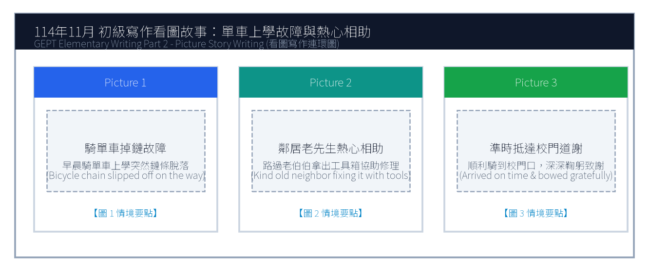
16. 請依據下列三幅連環圖畫內容，寫一篇約 50 字的短文故事，敘述早晨上學途中腳踏車掉鏈故障，獲得鄰居老爺爺熱心相助並準時抵達學校的經歷。
Line 1: _________________________________________________________________________________
Line 2: _________________________________________________________________________________
Line 3: _________________________________________________________________________________
Line 4: _________________________________________________________________________________
Line 5: _________________________________________________________________________________
Line 6: _________________________________________________________________________________

🎙️ 第二部分：口說能力測驗 (Speaking Test)
測驗時間：約 10 分鐘（採電腦耳機麥克風錄音） ｜ 滿分：100 分（80 分以上為及格）

第一單元：朗讀短文 (Questions 1–2)
說明：共有兩篇短文。每篇短文有 1 分鐘的時間準備，然後請在 1 分鐘內以清晰、自然的語調朗讀出來。
【Question 1 朗讀短文】：
Passage 1: Welcome to the Taipei Botanical Garden. We have more than two thousand plant species from tropical and subtropical regions. Please stay on the marked wooden boardwalks and do not pluck flowers or pick fruit. We hope you have an educational and relaxing visit.

【Question 2 朗讀短文】：
Passage 2: Regular exercise is a wonderful way to boost your immune system and elevate your mood. Whether you prefer swimming, cycling, or playing basketball, dedicating thirty minutes three times a week will make your heart stronger and give you boundless energy.

第二單元：回答問題 (Questions 3–12)
說明：共有十題日常生活問句。錄音將播出問題兩次，每次問題播完後有 15 秒的時間回答。請把握時間，針對問題盡量完整作答。
3. What time do you usually wake up on weekdays? (15 seconds response)
4. What is your favorite subject at school? (15 seconds response)
5. Do you prefer eating at home or dining out at restaurants? (15 seconds response)
6. What kind of books do you enjoy reading the most? (15 seconds response)
7. Tell me about your favorite holiday of the year. (15 seconds response)
8. How do you keep in touch with your friends during summer vacation? (15 seconds response)
9. What would you do if it rains heavily on your sports day? (15 seconds response)
10. What musical instrument would you like to learn? (15 seconds response)
11. How do you usually help around the house? (15 seconds response)
12. What was the most memorable trip you have ever taken? (15 seconds response)

第三單元：看圖敘述 (Question 13 情境大圖口語敘述)
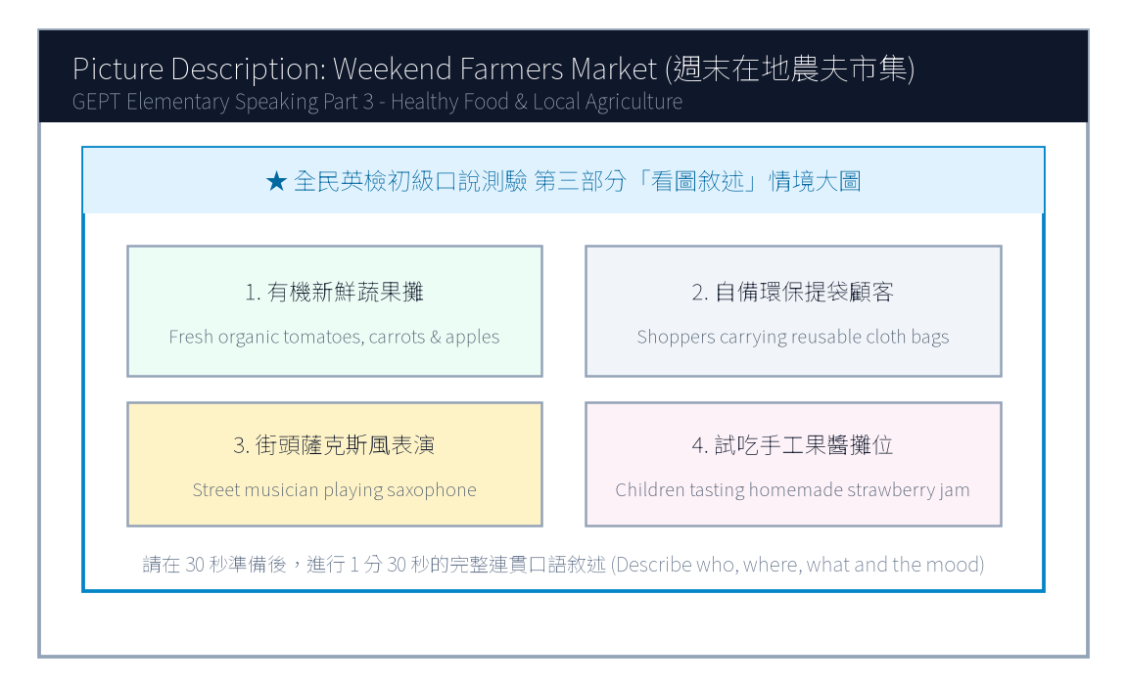
13. 請仔細觀察圖片，有 30 秒的準備時間。之後請在 1 分 30 秒內，根據圖中週末在地農夫市集的情境作一完整連貫的口述敘述。

【試題答案與名師深度解析手冊】
※ 本單元置於整張試卷最後面 · 供作答完畢後核對成績、滿分範文觀摩與考點診斷使用

單元一：寫作能力測驗 標準答案與滿分範文解析
【第一部分：單句寫作 1–15 題標準答案與常見錯誤剖析】
第 1 題 標準答案：Henry does not drink three cups of black coffee every day.
★ 破題指引與扣分盲點：改為否定句須注意助動詞 does not/do not/did not 後動詞回歸原形。
第 2 題 標準答案：How much does the high-speed rail ticket to Kaohsiung cost?
★ 破題指引與扣分盲點：注意開頭首字大寫、句末標點符號及動詞時態一致。
第 3 題 標準答案：It is exciting to make new friends at summer camp.
★ 破題指引與扣分盲點：注意開頭首字大寫、句末標點符號及動詞時態一致。
第 4 題 標準答案：The Taipei Marathon was run by thousands of international runners yesterday.
★ 破題指引與扣分盲點：被動語態公式為「be動詞 + 過去分詞 (p.p.) + by...」，時態須嚴格對齊原句。
第 5 題 標準答案：The suitcase was too heavy for the little boy to carry upstairs.
★ 破題指引與扣分盲點：注意否定含意，too... to 表示「太...以致於不能...」，後面接動詞原形。
第 6 題 標準答案：Uncle Tom left his black umbrella on the subway this morning.
★ 破題指引與扣分盲點：注意開頭首字大寫、句末標點符號及動詞時態一致。
第 7 題 標準答案：It is essential for teenagers to develop healthy habits.
★ 破題指引與扣分盲點：注意開頭首字大寫、句末標點符號及動詞時態一致。
第 8 題 標準答案：Mom and Kelly baked a delicious chocolate cake in the kitchen.
★ 破題指引與扣分盲點：注意開頭首字大寫、句末標點符號及動詞時態一致。
第 9 題 標準答案：We saw a street cat sleeping peacefully under the bench.
★ 破題指引與扣分盲點：注意開頭首字大寫、句末標點符號及動詞時態一致。
第 10 題 標準答案：When will the basketball match start?
★ 破題指引與扣分盲點：注意開頭首字大寫、句末標點符號及動詞時態一致。
第 11 題 標準答案：Although Kevin worked hard in the garden all morning, he did not feel tired at all.
★ 破題指引與扣分盲點：注意開頭首字大寫、句末標點符號及動詞時態一致。
第 12 題 標準答案：You can either take the green bus to the museum or walk there in ten minutes.
★ 破題指引與扣分盲點：注意開頭首字大寫、句末標點符號及動詞時態一致。
第 13 題 標準答案：The girl who won first prize in the national speech contest is my cousin Emily.
★ 破題指引與扣分盲點：關係代名詞 who 引導形容詞子句修飾先行詞人，其後動詞與先行詞一致。
第 14 題 標準答案：We went to the organic farmers market to purchase fresh vegetables.
★ 破題指引與扣分盲點：注意開頭首字大寫、句末標點符號及動詞時態一致。
第 15 題 標準答案：A blue whale is the heaviest of the three.
★ 破題指引與扣分盲點：注意開頭首字大寫、句末標點符號及動詞時態一致。
【第二部分：段落看圖寫作 Level 5 (滿分範文) 與架構解析】
★ 模擬參考 5 級分 (滿分範文，約 60 字)：
"Yesterday morning, Andy was hurriedly riding his bicycle to school when the chain suddenly slipped off, bringing his bike to a complete halt. Just as he felt anxious about being late, a kind elderly neighbor named Mr. Chen noticed his trouble and immediately brought out a heavy metal toolbox. With skilled hands, Mr. Chen helped Andy fix and grease the chain within five minutes. Andy arrived at the school gate just before the bell rang, bowing deeply to thank the warm-hearted gentleman."
★ 名師寫作結構金字塔：
1. 開門見山交代人、事、時、地、背景 (Background & Initial problem)
2. 轉折句敘述解決問題之具體行動 (Action & Teamwork)
3. 昇華結尾描繪心情與正面收穫 (Happy ending & Reflection)

單元二：口說能力測驗 滿分示範講稿與錄音逐字稿
【第二單元：回答問題 (Questions 3–12) 滿分口語回答範例】
3. What time do you usually wake up on weekdays?
滿分示範答句 (Model Response)："I usually wake up at six-thirty on weekday mornings so I have plenty of time to eat a nutritious breakfast and walk to the bus stop."
4. What is your favorite subject at school?
滿分示範答句 (Model Response)："My favorite subject is science because we conduct fascinating experiments in the laboratory, such as testing chemical reactions and observing plant cells."
5. Do you prefer eating at home or dining out at restaurants?
滿分示範答句 (Model Response)："I prefer eating at home because my parents' home-cooked meals are much healthier, less oily, and we can chat leisurely at the dinner table."
6. What kind of books do you enjoy reading the most?
滿分示範答句 (Model Response)："I enjoy reading science-fiction adventure novels because they ignite my imagination about space travel, robots, and futuristic cities."
7. Tell me about your favorite holiday of the year.
滿分示範答句 (Model Response)："My favorite holiday is Lunar New Year because the whole family gathers for a festive reunion dinner, and my grandparents give us lucky red envelopes."
8. How do you keep in touch with your friends during summer vacation?
滿分示範答句 (Model Response)："I usually chat with my friends through instant messaging apps and we often meet up at the community sports center to play basketball."
9. What would you do if it rains heavily on your sports day?
滿分示範答句 (Model Response)："If it rains on sports day, our school will move the relay races and opening ceremony into the indoor gymnasium so we can still have fun."
10. What musical instrument would you like to learn?
滿分示範答句 (Model Response)："I would like to learn to play the acoustic guitar because it is portable and I can play and sing cheerful songs around campfires with friends."
11. How do you usually help around the house?
滿分示範答句 (Model Response)："I help sweep and mop the kitchen floor every weekend, and I water our balcony potted flowers every morning before leaving for school."
12. What was the most memorable trip you have ever taken?
滿分示範答句 (Model Response)："The most memorable trip was visiting Sun Moon Lake with my parents last autumn. We rode bicycles along the lake trail and the misty scenery was breathtaking."
【第三單元：看圖敘述 (Question 13) 90 秒完整連貫滿分講稿】
★ 模擬參考滿分講稿 (約 120 字，90 秒從容輸出)：
"This delightful picture portrays a bustling weekend farmers market held in the town square under the clear blue sky. On the left, several friendly local farmers are displaying neatly arranged wooden crates filled with freshly picked organic tomatoes, crunchy carrots, and red apples. In the center, smiling customers carrying reusable canvas bags are happily chatting with vendors and sampling homemade strawberry jam. Towards the right side, a street musician wearing a stylish hat is playing soothing saxophone melodies, creating a cheerful and relaxed weekend atmosphere. Nearby, young children are laughing as they watch a balloon artist twist colorful animal balloons. The entire square is vibrant, healthy, and filled with community warmth."
★ 名師口語敘述四維框架：
1. 【整體開場】：This picture shows... on a sunny afternoon.
2. 【方位細節 1】：In the foreground / On the left side...
3. 【方位細節 2】：In the center / In the background...
4. 【情感總結】：Overall, everyone looks cheerful and enjoys the wonderful time.

單元三：本卷核心考點單字與高頻實用片語表 (Core Vocabulary)
考點單字／片語 | 詞性 | 中文核心語意 | 生活情境搭配例句
slipped off | phr. | 脫落、滑落 | The bike chain slipped off while riding uphill.
warm-hearted | adj. | 熱心的、好心腸的 | Our warm-hearted neighbors always help each other.
botanical garden | n. | 植物園 | admire exotic orchids at the Taipei Botanical Garden
immune system | n. | 免疫系統 | Eating fresh citrus fruits strengthens your immune system.
organic | adj. | 有機的 | purchase fresh organic vegetables directly from local growers
boardwalk | n. | 木棧道 | Visitors are required to stay on the designated boardwalk.
nutritious | adj. | 有營養的 | A boiled egg and milk make a nutritious breakfast.
crate | n. | 木箱、塑膠簍 | stacked wooden crates of fresh seasonal strawberries
canvas bag | n. | 帆布袋 | bring reusable canvas bags to reduce plastic waste
breathtaking | adj. | 令人屏息的、極為壯麗的 | The sunrise over the mountains was truly breathtaking.

