全民英語能力分級檢定測驗（GEPT）模擬練習（依官方題型編製）
114–115 年度 全民英檢初級說寫測驗（第二試／複試）
近 5 次模擬試題（依官方題型編製）與深度解析完全合訂本
(108 課綱最新素養新制·寫作口說完全收錄)
■ 試卷規格：圖片置於題目上方 · 試題本全卷無答案洩漏 · 答案解析統一收錄於卷末
■ 命題梯次：114年01月(一日考)、114年05月、114年11月、115年01月(一日考)、115年05月
■ 內容包含：10 幅看圖連環圖與大情境圖、寫作單句與滿分範文、口說完整題本與 90 秒示範講稿

全民英語能力分級檢定測驗（GEPT）模擬練習（依官方題型編製）
114年度第1次 全民英檢初級說寫測驗（第二試／一日考）模擬試題（依官方題型編製）暨詳解
【試題本】(Question Booklet) · 答案與深度解析請參閱卷末解析手冊
測驗代碼 | GEPT-E-114-01-SW
測驗日期 | 2025 年 01 月 11 日（一日考說寫複試）
測驗級數 | 初級（CEFR A2 級）
測驗項目 | 寫作能力測驗（40 分鐘）＆ 口說能力測驗（約 10 分鐘）
及格門檻 | 寫作達 70 分以上且口說達 80 分以上（均達 4 級分以上始發證書）
核心主題 | 校園愛心關懷、救援流浪貓、校園愛心園遊會義賣、健康運動習慣

★ 作答注意事項：本測驗分為「寫作能力測驗」（第一部分單句寫作15題、第二部分段落寫作1題，共40分鐘）與「口說能力測驗」（第一部分朗讀2題、第二部分回答問題10題、第三部分看圖敘述1題，約10分鐘）。全卷無預載答案，標準答案、滿分示範文章與口語講稿統一置於【整張試卷最後面】。

✍️ 第一部分：寫作能力測驗 (Writing Test)
作答時間：40 分鐘 ｜ 滿分：100 分（70 分以上為及格）

第一單元：單句寫作 (Questions 1–15)
說明：第 1–5 題為改寫，第 6–10 題為重組，第 11–15 題為句子合併。請依照各題括號內之指示作答，注意大小寫與標點符號。
1. Amy plays badminton with her sister every Saturday morning. (改為否定句)
作答區：____________________________________________________________________________________
2. Mr. Brown bought a brand new hybrid car last weekend. (依畫線部分 a brand new hybrid car 照原級造原問句)
作答區：____________________________________________________________________________________
3. Learning English by watching foreign animation movies is really enjoyable. (用 It... 開頭改寫句子)
作答區：____________________________________________________________________________________
4. The brave firefighter saved the little girl from the burning apartment. (改為被動語態)
作答區：____________________________________________________________________________________
5. Peter was too tired to finish his math assignment last night. (用 so... that... 改寫句子)
作答區：____________________________________________________________________________________
6. on the desk / left / her English dictionary / Jenny / yesterday afternoon
作答區：____________________________________________________________________________________
7. more exercise / healthy / to do / it is important / to stay
作答區：____________________________________________________________________________________
8. because / the outdoor concert / canceled / was / it rained heavily
作答區：____________________________________________________________________________________
9. a pair of / bought / fashionable sneakers / at the mall / David
作答區：____________________________________________________________________________________
10. how to / could you / tell me / the train station / get to / ?
作答區：____________________________________________________________________________________
11. Eric likes playing basketball. / His brother enjoys playing basketball, too. (用 both... and... 合併)
作答區：____________________________________________________________________________________
12. The weather was extremely cold yesterday. / We still went hiking in the national park. (用 Although 合併)
作答區：____________________________________________________________________________________
13. That is the famous writer. / She wrote the best-selling science fiction novel. (用 who 合併)
作答區：____________________________________________________________________________________
14. Linda studied very hard for the final exam. / She wanted to get good grades. (用 in order to 合併)
作答區：____________________________________________________________________________________
15. The blue smartphone is five thousand dollars. / The white smartphone is eight thousand dollars. (用 cheaper than 合併)
作答區：____________________________________________________________________________________

第二單元：段落寫作 (Question 16 看圖短文寫作)
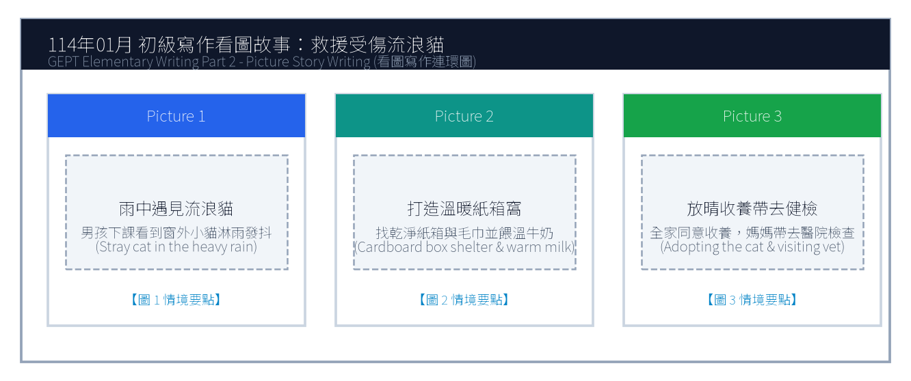
16. 請依據下列三幅連環圖畫內容，寫一篇約 50 字的短文故事。請發揮你的想像力，敘述事情的發生、經過與結果。
Line 1: _________________________________________________________________________________
Line 2: _________________________________________________________________________________
Line 3: _________________________________________________________________________________
Line 4: _________________________________________________________________________________
Line 5: _________________________________________________________________________________
Line 6: _________________________________________________________________________________

🎙️ 第二部分：口說能力測驗 (Speaking Test)
測驗時間：約 10 分鐘（採電腦耳機麥克風錄音） ｜ 滿分：100 分（80 分以上為及格）

第一單元：朗讀短文 (Questions 1–2)
說明：共有兩篇短文。每篇短文有 1 分鐘的時間準備，然後請在 1 分鐘內以清晰、自然的語調朗讀出來。
【Question 1 朗讀短文】：
Passage 1: Welcome to Taipei International Youth Camp. During the next five days, you will meet friends from all over the world. Please remember to wear your name badge and be on time for every exciting activity. If you need any assistance, our friendly staff members in blue shirts are always ready to help you.

【Question 2 朗讀短文】：
Passage 2: Bees are small but they play a vital role in our ecosystem. Every sunny morning, worker bees fly from flower to flower collecting nectar and pollinating fruit trees. Without their tireless hard work, many vegetables and fruits would not grow. Protecting nature helps these tiny creatures survive.

第二單元：回答問題 (Questions 3–12)
說明：共有十題日常生活問句。錄音將播出問題兩次，每次問題播完後有 15 秒的時間回答。請把握時間，針對問題盡量完整作答。
3. What is your favorite season of the year, and why do you like it? (15 seconds response)
4. How do you usually travel to school every morning? (15 seconds response)
5. What kind of movies do you enjoy watching the most? (15 seconds response)
6. What do you usually do when you feel stressed out? (15 seconds response)
7. Tell me about your best friend at school. (15 seconds response)
8. If you have a holiday tomorrow, where would you like to go? (15 seconds response)
9. How often do you help your parents with household chores? (15 seconds response)
10. What is your dream job in the future? (15 seconds response)
11. Do you prefer reading paper books or using digital tablets? (15 seconds response)
12. What was the happiest event that happened to you recently? (15 seconds response)

第三單元：看圖敘述 (Question 13 情境大圖口語敘述)
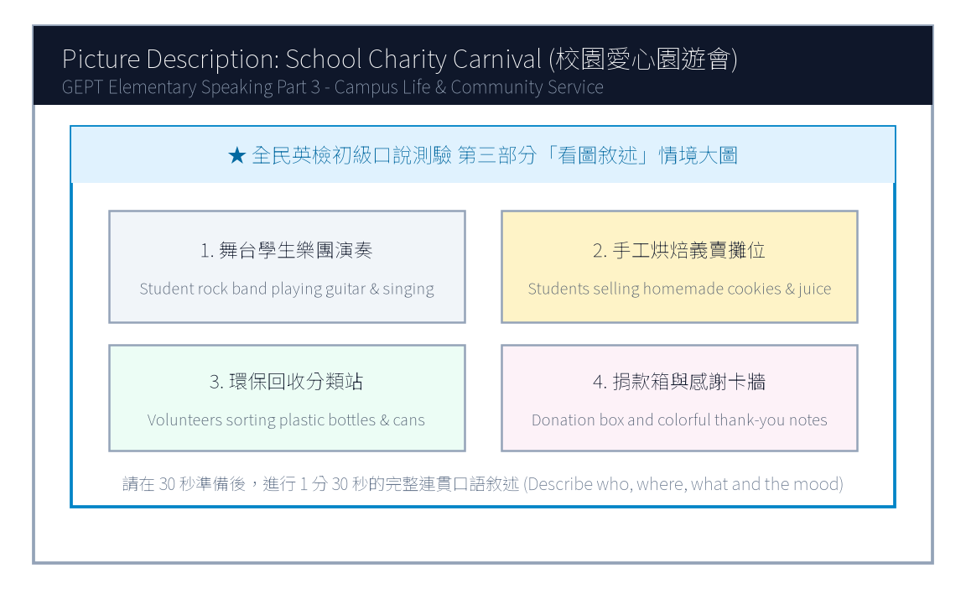
13. 請仔細觀察圖片，有 30 秒的準備時間。之後請在 1 分 30 秒內，根據圖片內容作一完整連貫的口語敘述。

【試題答案與名師深度解析手冊】
※ 本單元置於整張試卷最後面 · 供作答完畢後核對成績、滿分範文觀摩與考點診斷使用

單元一：寫作能力測驗 標準答案與滿分範文解析
【第一部分：單句寫作 1–15 題標準答案與常見錯誤剖析】
第 1 題 標準答案：Amy does not play badminton with her sister every Saturday morning.
★ 破題指引與扣分盲點：改為否定句須注意助動詞 does not/do not/did not 後動詞回歸原形。
第 2 題 標準答案：What did Mr. Brown buy last weekend?
★ 破題指引與扣分盲點：注意開頭首字大寫、句末標點符號及動詞時態一致。
第 3 題 標準答案：It is really enjoyable to learn English by watching foreign animation movies.
★ 破題指引與扣分盲點：注意開頭首字大寫、句末標點符號及動詞時態一致。
第 4 題 標準答案：The little girl was saved by the brave firefighter from the burning apartment.
★ 破題指引與扣分盲點：被動語態公式為「be動詞 + 過去分詞 (p.p.) + by...」，時態須嚴格對齊原句。
第 5 題 標準答案：Peter was so tired that he could not finish his math assignment last night.
★ 破題指引與扣分盲點：注意否定含意，too... to 表示「太...以致於不能...」，後面接動詞原形。
第 6 題 標準答案：Jenny left her English dictionary on the desk yesterday afternoon.
★ 破題指引與扣分盲點：注意開頭首字大寫、句末標點符號及動詞時態一致。
第 7 題 標準答案：It is important to do more exercise to stay healthy.
★ 破題指引與扣分盲點：注意開頭首字大寫、句末標點符號及動詞時態一致。
第 8 題 標準答案：The outdoor concert was canceled because it rained heavily.
★ 破題指引與扣分盲點：注意開頭首字大寫、句末標點符號及動詞時態一致。
第 9 題 標準答案：David bought a pair of fashionable sneakers at the mall.
★ 破題指引與扣分盲點：注意開頭首字大寫、句末標點符號及動詞時態一致。
第 10 題 標準答案：Could you tell me how to get to the train station?
★ 破題指引與扣分盲點：注意開頭首字大寫、句末標點符號及動詞時態一致。
第 11 題 標準答案：Both Eric and his brother like playing basketball.
★ 破題指引與扣分盲點：注意開頭首字大寫、句末標點符號及動詞時態一致。
第 12 題 標準答案：Although the weather was extremely cold yesterday, we still went hiking in the national park.
★ 破題指引與扣分盲點：注意開頭首字大寫、句末標點符號及動詞時態一致。
第 13 題 標準答案：That is the famous writer who wrote the best-selling science fiction novel.
★ 破題指引與扣分盲點：關係代名詞 who 引導形容詞子句修飾先行詞人，其後動詞與先行詞一致。
第 14 題 標準答案：Linda studied very hard for the final exam in order to get good grades.
★ 破題指引與扣分盲點：注意開頭首字大寫、句末標點符號及動詞時態一致。
第 15 題 標準答案：The blue smartphone is cheaper than the white smartphone.
★ 破題指引與扣分盲點：注意開頭首字大寫、句末標點符號及動詞時態一致。
【第二部分：段落看圖寫作 Level 5 (滿分範文) 與架構解析】
★ 模擬參考 5 級分 (滿分範文，約 60 字)：
"One rainy afternoon, Ken heard a weak cry outside his living room window and found a shivering stray cat drenched in the storm. Feeling deeply worried, he brought the little cat indoors, gently dried its fur with a soft towel, and fed it warm milk in a clean cardboard box. The next sunny morning, his mother agreed to adopt the sweet kitten and took it to the veterinarian for a complete health check. Ken was overjoyed to give this homeless animal a loving family."
★ 名師寫作結構金字塔：
1. 開門見山交代人、事、時、地、背景 (Background & Initial problem)
2. 轉折句敘述解決問題之具體行動 (Action & Teamwork)
3. 昇華結尾描繪心情與正面收穫 (Happy ending & Reflection)

單元二：口說能力測驗 滿分示範講稿與錄音逐字稿
【第二單元：回答問題 (Questions 3–12) 滿分口語回答範例】
3. What is your favorite season of the year, and why do you like it?
滿分示範答句 (Model Response)："My favorite season is autumn because the weather is pleasantly cool and breezy. I love riding my bicycle in the park with my friends without sweating a lot."
4. How do you usually travel to school every morning?
滿分示範答句 (Model Response)："I usually take the MRT to school because the station is just a five-minute walk from my apartment. It is very punctual and convenient."
5. What kind of movies do you enjoy watching the most?
滿分示範答句 (Model Response)："I enjoy watching superhero action movies because the visual special effects are astonishing, and the storylines always teach us to be brave and help others."
6. What do you usually do when you feel stressed out?
滿分示範答句 (Model Response)："When I feel stressed, I listen to cheerful pop music and go for a brisk jog in the park. Sweating helps clear my mind and makes me feel energetic again."
7. Tell me about your best friend at school.
滿分示範答句 (Model Response)："My best friend is Leo. We have known each other since elementary school. He is very kind, humorous, and always patient in explaining difficult math questions to me."
8. If you have a holiday tomorrow, where would you like to go?
滿分示範答句 (Model Response)："If I have a day off tomorrow, I would love to visit the National Palace Museum. I want to see the precious ancient jade artifacts and taste delicious dumplings nearby."
9. How often do you help your parents with household chores?
滿分示範答句 (Model Response)："I help my parents clean the dining table and wash dishes every evening. On weekends, I also help vacuum the living room carpet and take out the recycling bins."
10. What is your dream job in the future?
滿分示範答句 (Model Response)："My dream job is to become an environmental veterinarian because I have always loved animals and want to protect wildlife from extinction."
11. Do you prefer reading paper books or using digital tablets?
滿分示範答句 (Model Response)："I prefer reading real paper books because holding a book feels wonderful and it does not strain my eyes like bright digital screens do."
12. What was the happiest event that happened to you recently?
滿分示範答句 (Model Response)："The happiest event recently was winning first place in our school's science fair. My teammates and I worked hard for two months, so we were thrilled to receive the trophy."
【第三單元：看圖敘述 (Question 13) 90 秒完整連貫滿分講稿】
★ 模擬參考滿分講稿 (約 120 字，90 秒從容輸出)：
"This lively picture shows our annual school charity carnival taking place on a bright sunny afternoon. In the upper left corner, four energetic student musicians are performing rock songs on the stage, attracting a cheering crowd of classmates. Right beside the stage, several student volunteers are selling delicious homemade cookies and fresh fruit juice at a decorated booth. Near the entrance, two responsible students wearing green vests are carefully sorting plastic bottles and aluminum cans into recycling bins to keep the campus clean. Meanwhile, many teachers and parents are dropping donations into the charity box to support local children in need. Everyone looks genuinely cheerful, and the whole campus is filled with laughter and festive spirit."
★ 名師口語敘述四維框架：
1. 【整體開場】：This picture shows... on a sunny afternoon.
2. 【方位細節 1】：In the foreground / On the left side...
3. 【方位細節 2】：In the center / In the background...
4. 【情感總結】：Overall, everyone looks cheerful and enjoys the wonderful time.

單元三：本卷核心考點單字與高頻實用片語表 (Core Vocabulary)
考點單字／片語 | 詞性 | 中文核心語意 | 生活情境搭配例句
badminton | n. | 羽毛球 | play badminton with friends every weekend
firefighter | n. | 消防員 | the brave firefighter saved the trapped resident
hybrid car | n. | 油電混合車 | drive an eco-friendly hybrid car to save gasoline
assignment | n. | 作業、任務 | finish the science assignment before the deadline
stray cat | n. | 流浪貓 | rescue a shivering stray cat in the alley
veterinarian | n. | 獸醫師 (常簡稱 vet) | take the sick puppy to the veterinarian for a shot
charity carnival | n. | 愛心慈善園遊會 | raise money for orphans at the charity carnival
ecosystem | n. | 生態系統 | protect bees to maintain a balanced ecosystem
volunteer | n./v. | 志工；自願 | work as a hospital volunteer on Saturday mornings
punctual | adj. | 準時的 | The MRT system in Taiwan is extremely punctual.

全民英語能力分級檢定測驗（GEPT）模擬練習（依官方題型編製）
114年度第2次 全民英檢初級說寫測驗（第二試常態初試）模擬試題（依官方題型編製）暨詳解
【試題本】(Question Booklet) · 答案與深度解析請參閱卷末解析手冊
測驗代碼 | GEPT-E-114-05-SW
測驗日期 | 2025 年 05 月 17 日（初級複試常態測驗）
測驗級數 | 初級（CEFR A2 級）
測驗項目 | 寫作能力測驗（40 分鐘）＆ 口說能力測驗（約 10 分鐘）
及格門檻 | 寫作達 70 分以上且口說達 80 分以上（均達 4 級分以上始發證書）
核心主題 | 社區環保淨灘、海灘守護行動、假日圖書館閱讀文化、健康生活

★ 作答注意事項：本測驗分為「寫作能力測驗」（第一部分單句寫作15題、第二部分段落寫作1題，共40分鐘）與「口說能力測驗」（第一部分朗讀2題、第二部分回答問題10題、第三部分看圖敘述1題，約10分鐘）。全卷無預載答案，標準答案、滿分示範文章與口語講稿統一置於【整張試卷最後面】。

✍️ 第一部分：寫作能力測驗 (Writing Test)
作答時間：40 分鐘 ｜ 滿分：100 分（70 分以上為及格）

第一單元：單句寫作 (Questions 1–15)
說明：第 1–5 題為改寫，第 6–10 題為重組，第 11–15 題為句子合併。請依照各題括號內之指示作答，注意大小寫與標點符號。
1. Many tourists visit Kenting National Park during summer vacation. (改為否定句)
作答區：____________________________________________________________________________________
2. Susan practices playing the piano for two hours every day. (依畫線部分 for two hours 造原問句)
作答區：____________________________________________________________________________________
3. To sort garbage into different recycling bins is very important. (用 It is... 改寫)
作答區：____________________________________________________________________________________
4. Edison invented the world's first practical electric light bulb. (改為被動語態)
作答區：____________________________________________________________________________________
5. The math puzzle was so difficult that none of the students could solve it. (用 too... to... 改寫)
作答區：____________________________________________________________________________________
6. a clean cloth bag / brought / to the supermarket / Mrs. Lin / yesterday
作答區：____________________________________________________________________________________
7. good for / eating fresh fruits / your health / and vegetables / is
作答區：____________________________________________________________________________________
8. turned off / before leaving / all the computers / the students / the classroom
作答區：____________________________________________________________________________________
9. in the park / saw / three playful puppies / running happily / we
作答區：____________________________________________________________________________________
10. the famous museum / is / from our hotel / how far / ?
作答區：____________________________________________________________________________________
11. Tina woke up early this morning. / She missed the first school bus anyway. (用 Although 合併)
作答區：____________________________________________________________________________________
12. Mark likes drinking green tea. / His father prefers drinking black tea. (用 while 或 but 合併)
作答區：____________________________________________________________________________________
13. The boy won the gold medal in swimming. / He has trained hard for five years. (用 who 合併)
作答區：____________________________________________________________________________________
14. We went to the public library. / We wanted to borrow some travel books. (用 to 或 in order to 合併)
作答區：____________________________________________________________________________________
15. An airplane is faster than a high-speed train. / A high-speed train is faster than a car. (用 fastest 合併)
作答區：____________________________________________________________________________________

第二單元：段落寫作 (Question 16 看圖短文寫作)
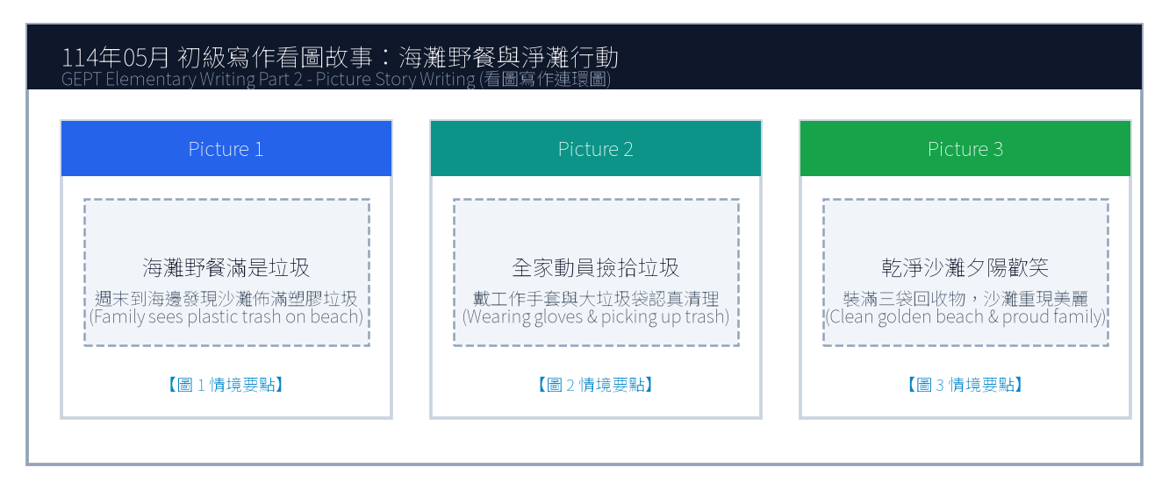
16. 請依據下列三幅海灘淨灘連環圖畫，寫一篇約 50 字的短文故事，敘述全家前往海灘野餐時發現垃圾並主動淨灘的過程。
Line 1: _________________________________________________________________________________
Line 2: _________________________________________________________________________________
Line 3: _________________________________________________________________________________
Line 4: _________________________________________________________________________________
Line 5: _________________________________________________________________________________
Line 6: _________________________________________________________________________________

🎙️ 第二部分：口說能力測驗 (Speaking Test)
測驗時間：約 10 分鐘（採電腦耳機麥克風錄音） ｜ 滿分：100 分（80 分以上為及格）

第一單元：朗讀短文 (Questions 1–2)
說明：共有兩篇短文。每篇短文有 1 分鐘的時間準備，然後請在 1 分鐘內以清晰、自然的語調朗讀出來。
【Question 1 朗讀短文】：
Passage 1: Welcome to the Green Ocean Aquarium. We invite you to explore the fascinating underwater world. Please do not tap on the glass or use flash photography, as bright lights may frighten our sea turtles and penguins. Enjoy your magical journey with our lovely ocean creatures.

【Question 2 朗讀短文】：
Passage 2: Drinking enough water every day is essential for good health. Water helps regulate our body temperature, aids digestion, and keeps our skin hydrated. Health experts suggest carrying a reusable water bottle so you can drink water regularly throughout the busy school day.

第二單元：回答問題 (Questions 3–12)
說明：共有十題日常生活問句。錄音將播出問題兩次，每次問題播完後有 15 秒的時間回答。請把握時間，針對問題盡量完整作答。
3. What kind of breakfast do you usually eat in the morning? (15 seconds response)
4. Where is your favorite place to study? (15 seconds response)
5. How do you usually celebrate your birthday? (15 seconds response)
6. Do you enjoy listening to music while doing homework? (15 seconds response)
7. Tell me about your favorite school teacher. (15 seconds response)
8. What sport do you like to play the most? (15 seconds response)
9. How do you usually spend your Sunday afternoons? (15 seconds response)
10. What would you do if you lost your transit pass? (15 seconds response)
11. Do you like cooking or baking at home? (15 seconds response)
12. What country would you like to travel to in the future? (15 seconds response)

第三單元：看圖敘述 (Question 13 情境大圖口語敘述)
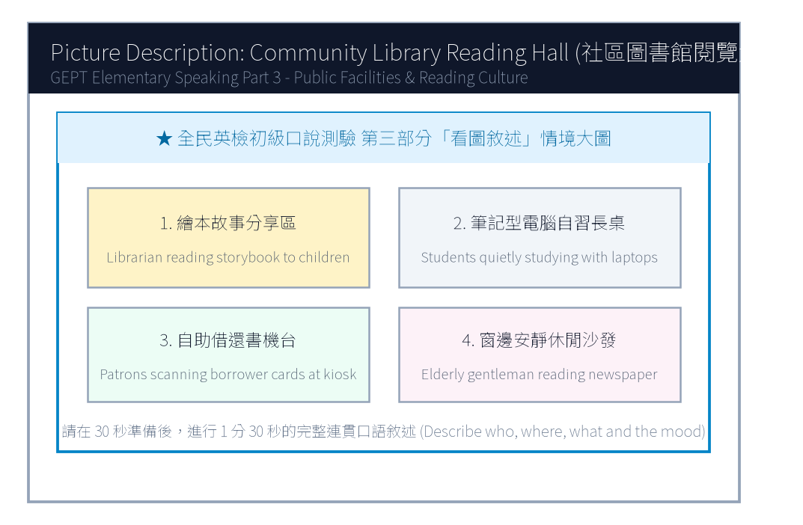
13. 請仔細觀察圖片，有 30 秒的準備時間。之後請在 1 分 30 秒內，根據圖中圖書館閱覽大廳的情境作一完整連貫的口述敘述。

【試題答案與名師深度解析手冊】
※ 本單元置於整張試卷最後面 · 供作答完畢後核對成績、滿分範文觀摩與考點診斷使用

單元一：寫作能力測驗 標準答案與滿分範文解析
【第一部分：單句寫作 1–15 題標準答案與常見錯誤剖析】
第 1 題 標準答案：Many tourists do not visit Kenting National Park during summer vacation.
★ 破題指引與扣分盲點：改為否定句須注意助動詞 does not/do not/did not 後動詞回歸原形。
第 2 題 標準答案：How long does Susan practice playing the piano every day?
★ 破題指引與扣分盲點：注意開頭首字大寫、句末標點符號及動詞時態一致。
第 3 題 標準答案：It is very important to sort garbage into different recycling bins.
★ 破題指引與扣分盲點：注意開頭首字大寫、句末標點符號及動詞時態一致。
第 4 題 標準答案：The world's first practical electric light bulb was invented by Edison.
★ 破題指引與扣分盲點：被動語態公式為「be動詞 + 過去分詞 (p.p.) + by...」，時態須嚴格對齊原句。
第 5 題 標準答案：The math puzzle was too difficult for any of the students to solve.
★ 破題指引與扣分盲點：注意否定含意，too... to 表示「太...以致於不能...」，後面接動詞原形。
第 6 題 標準答案：Mrs. Lin brought a clean cloth bag to the supermarket yesterday.
★ 破題指引與扣分盲點：注意開頭首字大寫、句末標點符號及動詞時態一致。
第 7 題 標準答案：Eating fresh fruits and vegetables is good for your health.
★ 破題指引與扣分盲點：注意開頭首字大寫、句末標點符號及動詞時態一致。
第 8 題 標準答案：The students turned off all the computers before leaving the classroom.
★ 破題指引與扣分盲點：注意開頭首字大寫、句末標點符號及動詞時態一致。
第 9 題 標準答案：We saw three playful puppies running happily in the park.
★ 破題指引與扣分盲點：注意開頭首字大寫、句末標點符號及動詞時態一致。
第 10 題 標準答案：How far is the famous museum from our hotel?
★ 破題指引與扣分盲點：注意開頭首字大寫、句末標點符號及動詞時態一致。
第 11 題 標準答案：Although Tina woke up early this morning, she missed the first school bus anyway.
★ 破題指引與扣分盲點：注意開頭首字大寫、句末標點符號及動詞時態一致。
第 12 題 標準答案：Mark likes drinking green tea, but his father prefers drinking black tea.
★ 破題指引與扣分盲點：注意開頭首字大寫、句末標點符號及動詞時態一致。
第 13 題 標準答案：The boy who has trained hard for five years won the gold medal in swimming.
★ 破題指引與扣分盲點：關係代名詞 who 引導形容詞子句修飾先行詞人，其後動詞與先行詞一致。
第 14 題 標準答案：We went to the public library to borrow some travel books.
★ 破題指引與扣分盲點：注意開頭首字大寫、句末標點符號及動詞時態一致。
第 15 題 標準答案：An airplane is the fastest of the three.
★ 破題指引與扣分盲點：注意開頭首字大寫、句末標點符號及動詞時態一致。
【第二部分：段落看圖寫作 Level 5 (滿分範文) 與架構解析】
★ 模擬參考 5 級分 (滿分範文，約 60 字)：
"Last Sunday, Jason and his family went to the seashore for a holiday picnic. To their surprise, the beautiful golden sand was covered with plastic bottles, straws, and food containers left by careless visitors. Instead of merely complaining, they immediately put on sturdy gloves and worked together to collect three large bags of recyclable trash. By sunset, the coastal beach was completely clean and sparkling under the evening breeze. Jason felt proud that their small effort made a huge difference for marine wildlife."
★ 名師寫作結構金字塔：
1. 開門見山交代人、事、時、地、背景 (Background & Initial problem)
2. 轉折句敘述解決問題之具體行動 (Action & Teamwork)
3. 昇華結尾描繪心情與正面收穫 (Happy ending & Reflection)

單元二：口說能力測驗 滿分示範講稿與錄音逐字稿
【第二單元：回答問題 (Questions 3–12) 滿分口語回答範例】
3. What kind of breakfast do you usually eat in the morning?
滿分示範答句 (Model Response)："I usually have a warm toasted ham-and-egg sandwich with a glass of fresh soy milk. It gives me plenty of energy for my morning classes."
4. Where is your favorite place to study?
滿分示範答句 (Model Response)："My favorite place to study is the city library because it is extremely quiet, air-conditioned, and surrounded by helpful reference books."
5. How do you usually celebrate your birthday?
滿分示範答句 (Model Response)："I usually celebrate my birthday at home with my family. My mother bakes a chocolate cake and we enjoy a special dinner together."
6. Do you enjoy listening to music while doing homework?
滿分示範答句 (Model Response)："Yes, I like listening to soft classical piano music because it keeps me calm and focused without distracting my thoughts with lyrics."
7. Tell me about your favorite school teacher.
滿分示範答句 (Model Response)："My favorite teacher is our English teacher, Ms. Lin. She is always energetic, tells hilarious stories, and encourages every student to speak English bravely."
8. What sport do you like to play the most?
滿分示範答句 (Model Response)："I like playing table tennis the most because it sharpens my hand-eye coordination and I can easily play it indoors even on rainy days."
9. How do you usually spend your Sunday afternoons?
滿分示範答句 (Model Response)："I usually ride my bicycle along the riverside park with my cousins and then read mystery novels at a cozy cafe nearby."
10. What would you do if you lost your transit pass?
滿分示範答句 (Model Response)："If I lost my transit pass, I would immediately report it to the MRT station information desk and check if someone turned it in."
11. Do you like cooking or baking at home?
滿分示範答句 (Model Response)："Yes, I love baking chocolate chip cookies with my elder sister on weekends. Sharing warm, freshly baked cookies brings our family great joy."
12. What country would you like to travel to in the future?
滿分示範答句 (Model Response)："I would love to visit New Zealand because of its breathtaking snow-capped mountains, crystal-clear lakes, and unique kiwi birds."
【第三單元：看圖敘述 (Question 13) 90 秒完整連貫滿分講稿】
★ 模擬參考滿分講稿 (約 120 字，90 秒從容輸出)：
"This picture captures the peaceful atmosphere inside our community public library on a quiet Saturday morning. In the foreground on the left, an enthusiastic librarian is reading an exciting illustrated fairy tale to a circle of attentive young children. At the center long wooden tables, several diligent high school students are focused on their laptop screens, taking detailed notes for their school projects. Over on the right-hand side, a middle-aged woman is using the modern touchscreen kiosk to return and borrow books automatically. Through the large glass windows in the background, warm sunlight streams across the bookshelf aisles, where people are browsing books in complete silence. The library offers a comfortable and inspiring haven for readers of all ages."
★ 名師口語敘述四維框架：
1. 【整體開場】：This picture shows... on a sunny afternoon.
2. 【方位細節 1】：In the foreground / On the left side...
3. 【方位細節 2】：In the center / In the background...
4. 【情感總結】：Overall, everyone looks cheerful and enjoys the wonderful time.

單元三：本卷核心考點單字與高頻實用片語表 (Core Vocabulary)
考點單字／片語 | 詞性 | 中文核心語意 | 生活情境搭配例句
national park | n. | 國家公園 | explore the wildlife in Kenting National Park
electric light bulb | n. | 電燈泡 | Edison improved the electric light bulb in 1879
recycling bin | n. | 資源回收桶 | put aluminum cans into the designated recycling bin
plastic container | n. | 塑膠容器 | avoid using single-use plastic containers for takeout
marine wildlife | n. | 海洋野生生物 | protect marine wildlife from plastic ingestion
hydrated | adj. | 水分充足的 | drink eight glasses of water to stay well-hydrated
attentive | adj. | 專注的、聚精會神的 | The attentive students listened carefully to the speech.
stream | v./n. | 照進、流出；小溪 | Golden sunlight streamed through the classroom window.
haven | n. | 避風港、寧靜聖地 | The botanical garden is a peaceful haven for city residents.
coastal | adj. | 沿海的、海岸的 | join the volunteer team to clean the coastal beaches

全民英語能力分級檢定測驗（GEPT）模擬練習（依官方題型編製）
114年度第3次 全民英檢初級說寫測驗（第二試常態初試）模擬試題（依官方題型編製）暨詳解
【試題本】(Question Booklet) · 答案與深度解析請參閱卷末解析手冊
測驗代碼 | GEPT-E-114-11-SW
測驗日期 | 2025 年 11 月 15 日（初級複試常態測驗）
測驗級數 | 初級（CEFR A2 級）
測驗項目 | 寫作能力測驗（40 分鐘）＆ 口說能力測驗（約 10 分鐘）
及格門檻 | 寫作達 70 分以上且口說達 80 分以上（均達 4 級分以上始發證書）
核心主題 | 鄰里互助美德、騎單車上學故障相助、在地農夫市集、均衡飲食與休閒

★ 作答注意事項：本測驗分為「寫作能力測驗」（第一部分單句寫作15題、第二部分段落寫作1題，共40分鐘）與「口說能力測驗」（第一部分朗讀2題、第二部分回答問題10題、第三部分看圖敘述1題，約10分鐘）。全卷無預載答案，標準答案、滿分示範文章與口語講稿統一置於【整張試卷最後面】。

✍️ 第一部分：寫作能力測驗 (Writing Test)
作答時間：40 分鐘 ｜ 滿分：100 分（70 分以上為及格）

第一單元：單句寫作 (Questions 1–15)
說明：第 1–5 題為改寫，第 6–10 題為重組，第 11–15 題為句子合併。請依照各題括號內之指示作答，注意大小寫與標點符號。
1. Henry drinks three cups of black coffee every day. (改為否定句)
作答區：____________________________________________________________________________________
2. The high-speed rail ticket to Kaohsiung costs fifteen hundred dollars. (依畫線部分 fifteen hundred dollars 造原問句)
作答區：____________________________________________________________________________________
3. Making new friends at summer camp is exciting. (用 It is... 改寫)
作答區：____________________________________________________________________________________
4. Thousands of international runners ran the Taipei Marathon yesterday. (改為被動語態)
作答區：____________________________________________________________________________________
5. The suitcase was so heavy that the little boy could not carry it upstairs. (用 too... to... 改寫)
作答區：____________________________________________________________________________________
6. on the subway / left / his black umbrella / Uncle Tom / this morning
作答區：____________________________________________________________________________________
7. healthy habits / essential / to develop / is / for teenagers
作答區：____________________________________________________________________________________
8. in the kitchen / a delicious chocolate cake / baked / Mom and Kelly
作答區：____________________________________________________________________________________
9. a street cat / saw / sleeping peacefully / under the bench / we
作答區：____________________________________________________________________________________
10. start / the basketball match / will / when / ?
作答區：____________________________________________________________________________________
11. Kevin worked hard in the garden all morning. / He did not feel tired at all. (用 Although 合併)
作答區：____________________________________________________________________________________
12. You can take the green bus to the museum. / You can walk there in ten minutes. (用 either... or... 合併)
作答區：____________________________________________________________________________________
13. The girl is my cousin Emily. / She won first prize in the national speech contest. (用 who 合併)
作答區：____________________________________________________________________________________
14. We went to the organic farmers market. / We wanted to purchase fresh vegetables. (用 to 或 in order to 合併)
作答區：____________________________________________________________________________________
15. An elephant is heavier than a horse. / A blue whale is heavier than an elephant. (用 heaviest 合併)
作答區：____________________________________________________________________________________

第二單元：段落寫作 (Question 16 看圖短文寫作)
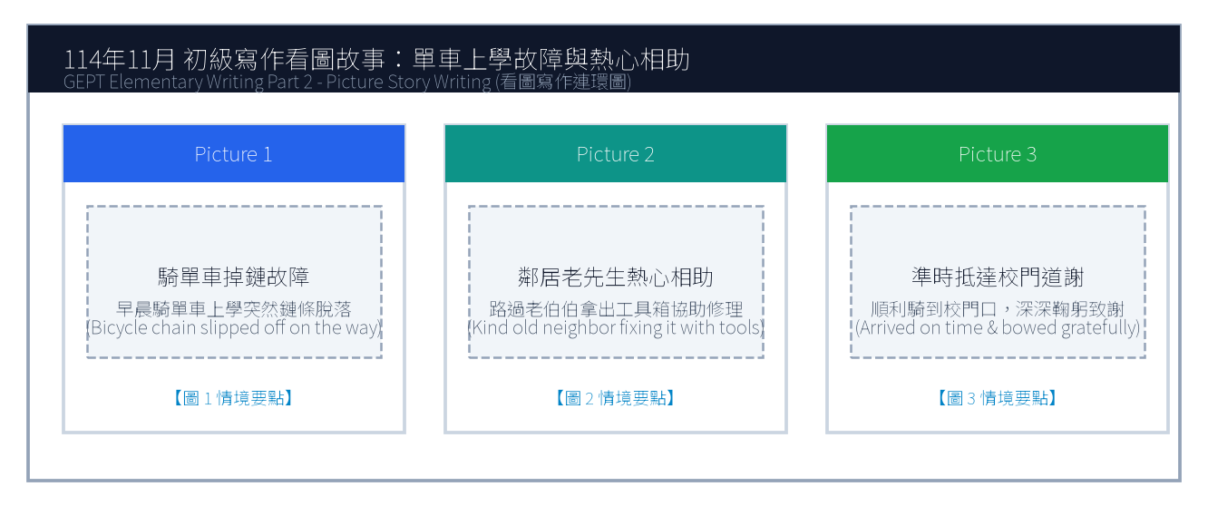
16. 請依據下列三幅連環圖畫內容，寫一篇約 50 字的短文故事，敘述早晨上學途中腳踏車掉鏈故障，獲得鄰居老爺爺熱心相助並準時抵達學校的經歷。
Line 1: _________________________________________________________________________________
Line 2: _________________________________________________________________________________
Line 3: _________________________________________________________________________________
Line 4: _________________________________________________________________________________
Line 5: _________________________________________________________________________________
Line 6: _________________________________________________________________________________

🎙️ 第二部分：口說能力測驗 (Speaking Test)
測驗時間：約 10 分鐘（採電腦耳機麥克風錄音） ｜ 滿分：100 分（80 分以上為及格）

第一單元：朗讀短文 (Questions 1–2)
說明：共有兩篇短文。每篇短文有 1 分鐘的時間準備，然後請在 1 分鐘內以清晰、自然的語調朗讀出來。
【Question 1 朗讀短文】：
Passage 1: Welcome to the Taipei Botanical Garden. We have more than two thousand plant species from tropical and subtropical regions. Please stay on the marked wooden boardwalks and do not pluck flowers or pick fruit. We hope you have an educational and relaxing visit.

【Question 2 朗讀短文】：
Passage 2: Regular exercise is a wonderful way to boost your immune system and elevate your mood. Whether you prefer swimming, cycling, or playing basketball, dedicating thirty minutes three times a week will make your heart stronger and give you boundless energy.

第二單元：回答問題 (Questions 3–12)
說明：共有十題日常生活問句。錄音將播出問題兩次，每次問題播完後有 15 秒的時間回答。請把握時間，針對問題盡量完整作答。
3. What time do you usually wake up on weekdays? (15 seconds response)
4. What is your favorite subject at school? (15 seconds response)
5. Do you prefer eating at home or dining out at restaurants? (15 seconds response)
6. What kind of books do you enjoy reading the most? (15 seconds response)
7. Tell me about your favorite holiday of the year. (15 seconds response)
8. How do you keep in touch with your friends during summer vacation? (15 seconds response)
9. What would you do if it rains heavily on your sports day? (15 seconds response)
10. What musical instrument would you like to learn? (15 seconds response)
11. How do you usually help around the house? (15 seconds response)
12. What was the most memorable trip you have ever taken? (15 seconds response)

第三單元：看圖敘述 (Question 13 情境大圖口語敘述)
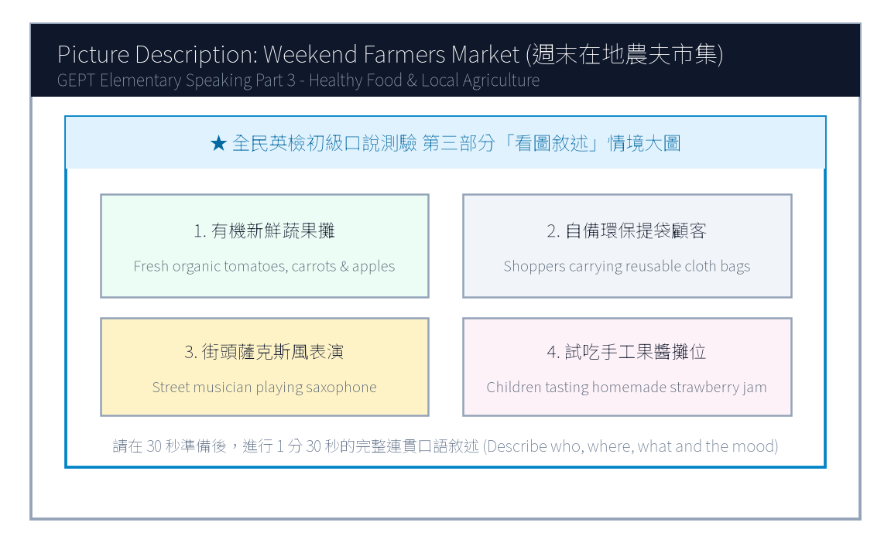
13. 請仔細觀察圖片，有 30 秒的準備時間。之後請在 1 分 30 秒內，根據圖中週末在地農夫市集的情境作一完整連貫的口述敘述。

【試題答案與名師深度解析手冊】
※ 本單元置於整張試卷最後面 · 供作答完畢後核對成績、滿分範文觀摩與考點診斷使用

單元一：寫作能力測驗 標準答案與滿分範文解析
【第一部分：單句寫作 1–15 題標準答案與常見錯誤剖析】
第 1 題 標準答案：Henry does not drink three cups of black coffee every day.
★ 破題指引與扣分盲點：改為否定句須注意助動詞 does not/do not/did not 後動詞回歸原形。
第 2 題 標準答案：How much does the high-speed rail ticket to Kaohsiung cost?
★ 破題指引與扣分盲點：注意開頭首字大寫、句末標點符號及動詞時態一致。
第 3 題 標準答案：It is exciting to make new friends at summer camp.
★ 破題指引與扣分盲點：注意開頭首字大寫、句末標點符號及動詞時態一致。
第 4 題 標準答案：The Taipei Marathon was run by thousands of international runners yesterday.
★ 破題指引與扣分盲點：被動語態公式為「be動詞 + 過去分詞 (p.p.) + by...」，時態須嚴格對齊原句。
第 5 題 標準答案：The suitcase was too heavy for the little boy to carry upstairs.
★ 破題指引與扣分盲點：注意否定含意，too... to 表示「太...以致於不能...」，後面接動詞原形。
第 6 題 標準答案：Uncle Tom left his black umbrella on the subway this morning.
★ 破題指引與扣分盲點：注意開頭首字大寫、句末標點符號及動詞時態一致。
第 7 題 標準答案：It is essential for teenagers to develop healthy habits.
★ 破題指引與扣分盲點：注意開頭首字大寫、句末標點符號及動詞時態一致。
第 8 題 標準答案：Mom and Kelly baked a delicious chocolate cake in the kitchen.
★ 破題指引與扣分盲點：注意開頭首字大寫、句末標點符號及動詞時態一致。
第 9 題 標準答案：We saw a street cat sleeping peacefully under the bench.
★ 破題指引與扣分盲點：注意開頭首字大寫、句末標點符號及動詞時態一致。
第 10 題 標準答案：When will the basketball match start?
★ 破題指引與扣分盲點：注意開頭首字大寫、句末標點符號及動詞時態一致。
第 11 題 標準答案：Although Kevin worked hard in the garden all morning, he did not feel tired at all.
★ 破題指引與扣分盲點：注意開頭首字大寫、句末標點符號及動詞時態一致。
第 12 題 標準答案：You can either take the green bus to the museum or walk there in ten minutes.
★ 破題指引與扣分盲點：注意開頭首字大寫、句末標點符號及動詞時態一致。
第 13 題 標準答案：The girl who won first prize in the national speech contest is my cousin Emily.
★ 破題指引與扣分盲點：關係代名詞 who 引導形容詞子句修飾先行詞人，其後動詞與先行詞一致。
第 14 題 標準答案：We went to the organic farmers market to purchase fresh vegetables.
★ 破題指引與扣分盲點：注意開頭首字大寫、句末標點符號及動詞時態一致。
第 15 題 標準答案：A blue whale is the heaviest of the three.
★ 破題指引與扣分盲點：注意開頭首字大寫、句末標點符號及動詞時態一致。
【第二部分：段落看圖寫作 Level 5 (滿分範文) 與架構解析】
★ 模擬參考 5 級分 (滿分範文，約 60 字)：
"Yesterday morning, Andy was hurriedly riding his bicycle to school when the chain suddenly slipped off, bringing his bike to a complete halt. Just as he felt anxious about being late, a kind elderly neighbor named Mr. Chen noticed his trouble and immediately brought out a heavy metal toolbox. With skilled hands, Mr. Chen helped Andy fix and grease the chain within five minutes. Andy arrived at the school gate just before the bell rang, bowing deeply to thank the warm-hearted gentleman."
★ 名師寫作結構金字塔：
1. 開門見山交代人、事、時、地、背景 (Background & Initial problem)
2. 轉折句敘述解決問題之具體行動 (Action & Teamwork)
3. 昇華結尾描繪心情與正面收穫 (Happy ending & Reflection)

單元二：口說能力測驗 滿分示範講稿與錄音逐字稿
【第二單元：回答問題 (Questions 3–12) 滿分口語回答範例】
3. What time do you usually wake up on weekdays?
滿分示範答句 (Model Response)："I usually wake up at six-thirty on weekday mornings so I have plenty of time to eat a nutritious breakfast and walk to the bus stop."
4. What is your favorite subject at school?
滿分示範答句 (Model Response)："My favorite subject is science because we conduct fascinating experiments in the laboratory, such as testing chemical reactions and observing plant cells."
5. Do you prefer eating at home or dining out at restaurants?
滿分示範答句 (Model Response)："I prefer eating at home because my parents' home-cooked meals are much healthier, less oily, and we can chat leisurely at the dinner table."
6. What kind of books do you enjoy reading the most?
滿分示範答句 (Model Response)："I enjoy reading science-fiction adventure novels because they ignite my imagination about space travel, robots, and futuristic cities."
7. Tell me about your favorite holiday of the year.
滿分示範答句 (Model Response)："My favorite holiday is Lunar New Year because the whole family gathers for a festive reunion dinner, and my grandparents give us lucky red envelopes."
8. How do you keep in touch with your friends during summer vacation?
滿分示範答句 (Model Response)："I usually chat with my friends through instant messaging apps and we often meet up at the community sports center to play basketball."
9. What would you do if it rains heavily on your sports day?
滿分示範答句 (Model Response)："If it rains on sports day, our school will move the relay races and opening ceremony into the indoor gymnasium so we can still have fun."
10. What musical instrument would you like to learn?
滿分示範答句 (Model Response)："I would like to learn to play the acoustic guitar because it is portable and I can play and sing cheerful songs around campfires with friends."
11. How do you usually help around the house?
滿分示範答句 (Model Response)："I help sweep and mop the kitchen floor every weekend, and I water our balcony potted flowers every morning before leaving for school."
12. What was the most memorable trip you have ever taken?
滿分示範答句 (Model Response)："The most memorable trip was visiting Sun Moon Lake with my parents last autumn. We rode bicycles along the lake trail and the misty scenery was breathtaking."
【第三單元：看圖敘述 (Question 13) 90 秒完整連貫滿分講稿】
★ 模擬參考滿分講稿 (約 120 字，90 秒從容輸出)：
"This delightful picture portrays a bustling weekend farmers market held in the town square under the clear blue sky. On the left, several friendly local farmers are displaying neatly arranged wooden crates filled with freshly picked organic tomatoes, crunchy carrots, and red apples. In the center, smiling customers carrying reusable canvas bags are happily chatting with vendors and sampling homemade strawberry jam. Towards the right side, a street musician wearing a stylish hat is playing soothing saxophone melodies, creating a cheerful and relaxed weekend atmosphere. Nearby, young children are laughing as they watch a balloon artist twist colorful animal balloons. The entire square is vibrant, healthy, and filled with community warmth."
★ 名師口語敘述四維框架：
1. 【整體開場】：This picture shows... on a sunny afternoon.
2. 【方位細節 1】：In the foreground / On the left side...
3. 【方位細節 2】：In the center / In the background...
4. 【情感總結】：Overall, everyone looks cheerful and enjoys the wonderful time.

單元三：本卷核心考點單字與高頻實用片語表 (Core Vocabulary)
考點單字／片語 | 詞性 | 中文核心語意 | 生活情境搭配例句
slipped off | phr. | 脫落、滑落 | The bike chain slipped off while riding uphill.
warm-hearted | adj. | 熱心的、好心腸的 | Our warm-hearted neighbors always help each other.
botanical garden | n. | 植物園 | admire exotic orchids at the Taipei Botanical Garden
immune system | n. | 免疫系統 | Eating fresh citrus fruits strengthens your immune system.
organic | adj. | 有機的 | purchase fresh organic vegetables directly from local growers
boardwalk | n. | 木棧道 | Visitors are required to stay on the designated boardwalk.
nutritious | adj. | 有營養的 | A boiled egg and milk make a nutritious breakfast.
crate | n. | 木箱、塑膠簍 | stacked wooden crates of fresh seasonal strawberries
canvas bag | n. | 帆布袋 | bring reusable canvas bags to reduce plastic waste
breathtaking | adj. | 令人屏息的、極為壯麗的 | The sunrise over the mountains was truly breathtaking.

全民英語能力分級檢定測驗（GEPT）模擬練習（依官方題型編製）
115年度第1次 全民英檢初級說寫測驗（第二試／一日考）模擬試題（依官方題型編製）暨詳解
【試題本】(Question Booklet) · 答案與深度解析請參閱卷末解析手冊
測驗代碼 | GEPT-E-115-01-SW
測驗日期 | 2026 年 01 月 10 日（一日考說寫複試）
測驗級數 | 初級（CEFR A2 級）
測驗項目 | 寫作能力測驗（40 分鐘）＆ 口說能力測驗（約 10 分鐘）
及格門檻 | 寫作達 70 分以上且口說達 80 分以上（均達 4 級分以上始發證書）
核心主題 | 家庭溫馨親情、秘密烤蛋糕驚喜慶生、綠能體育運動公園、活力休閒生活

★ 作答注意事項：本測驗分為「寫作能力測驗」（第一部分單句寫作15題、第二部分段落寫作1題，共40分鐘）與「口說能力測驗」（第一部分朗讀2題、第二部分回答問題10題、第三部分看圖敘述1題，約10分鐘）。全卷無預載答案，標準答案、滿分示範文章與口語講稿統一置於【整張試卷最後面】。

✍️ 第一部分：寫作能力測驗 (Writing Test)
作答時間：40 分鐘 ｜ 滿分：100 分（70 分以上為及格）

第一單元：單句寫作 (Questions 1–15)
說明：第 1–5 題為改寫，第 6–10 題為重組，第 11–15 題為句子合併。請依照各題括號內之指示作答，注意大小寫與標點符號。
1. George goes jogging in the community sports park every morning. (改為否定句)
作答區：____________________________________________________________________________________
2. The high school soccer team won five championship matches last year. (依畫線部分 five 造原問句)
作答區：____________________________________________________________________________________
3. To speak English with native speakers requires lots of courage. (用 It takes... 或 It requires... 改寫)
作答區：____________________________________________________________________________________
4. Many curious students visited the newly opened science museum yesterday. (改為被動語態)
作答區：____________________________________________________________________________________
5. The box of antique porcelain was so fragile that nobody dared to move it. (用 too... to... 改寫)
作答區：____________________________________________________________________________________
6. on the blackboard / wrote / an important message / the English teacher
作答區：____________________________________________________________________________________
7. good posture / essential / to maintain / for teenagers / is
作答區：____________________________________________________________________________________
8. a birthday gift / bought / for her younger sister / yesterday / Alice
作答區：____________________________________________________________________________________
9. the baby birds / in their nest / chirping hungrily / we heard
作答區：____________________________________________________________________________________
10. leave / the next express train / will / when / ?
作答區：____________________________________________________________________________________
11. Leo prepared thoroughly for the swimming contest. / He did not win any medals. (用 Although 合併)
作答區：____________________________________________________________________________________
12. You may drink freshly squeezed orange juice. / You may have a cup of hot chocolate. (用 either... or... 合併)
作答區：____________________________________________________________________________________
13. The lady is our school principal. / She delivered an inspiring speech this morning. (用 who 合併)
作答區：____________________________________________________________________________________
14. They traveled to Hualien. / They wanted to admire the magnificent Taroko Gorge. (用 to 或 in order to 合併)
作答區：____________________________________________________________________________________
15. A motorcycle is heavier than a bicycle. / A truck is heavier than a motorcycle. (用 heaviest 合併)
作答區：____________________________________________________________________________________

第二單元：段落寫作 (Question 16 看圖短文寫作)
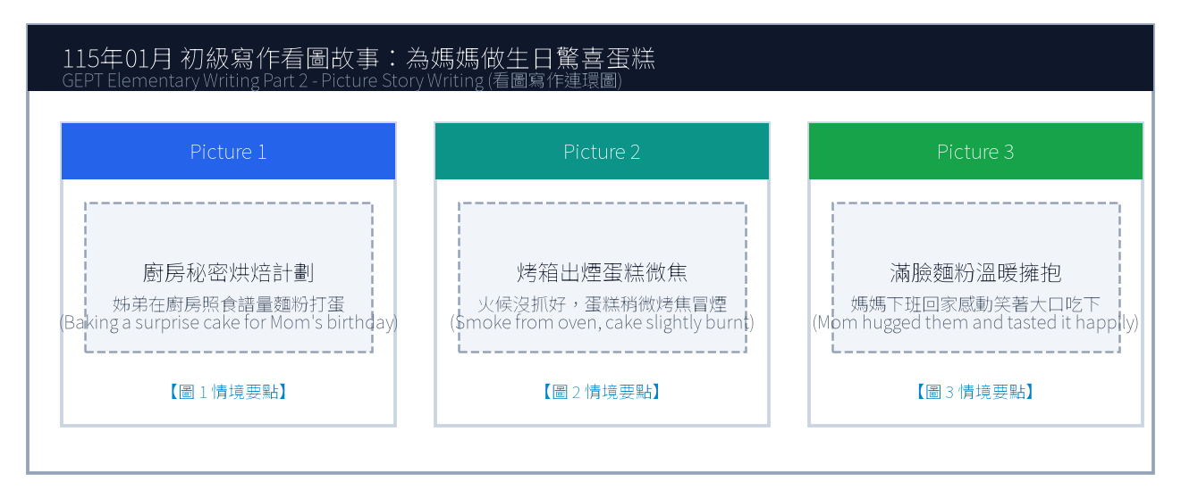
16. 請依據下列三幅連環圖畫內容，寫一篇約 50 字的短文故事，敘述姊弟倆在廚房秘密為媽媽烘焙生日蛋糕，雖然蛋糕烤焦了一角但媽媽依然感動無比的溫馨經過。
Line 1: _________________________________________________________________________________
Line 2: _________________________________________________________________________________
Line 3: _________________________________________________________________________________
Line 4: _________________________________________________________________________________
Line 5: _________________________________________________________________________________
Line 6: _________________________________________________________________________________

🎙️ 第二部分：口說能力測驗 (Speaking Test)
測驗時間：約 10 分鐘（採電腦耳機麥克風錄音） ｜ 滿分：100 分（80 分以上為及格）

第一單元：朗讀短文 (Questions 1–2)
說明：共有兩篇短文。每篇短文有 1 分鐘的時間準備，然後請在 1 分鐘內以清晰、自然的語調朗讀出來。
【Question 1 朗讀短文】：
Passage 1: Good afternoon, passengers. We are now approaching Taichung High Speed Rail Station. Please gather all your personal belongings and check the overhead luggage racks. Do not leave your mobile phones or transit cards on the seats. Thank you for riding with Taiwan High Speed Rail.

【Question 2 朗讀短文】：
Passage 2: Trees are the lungs of our planet. They absorb harmful carbon dioxide from the air and release pure oxygen for humans and animals to breathe. In addition, deep tree roots anchor the soil and prevent destructive landslides during heavy summer typhoons. Planting trees creates a greener world.

第二單元：回答問題 (Questions 3–12)
說明：共有十題日常生活問句。錄音將播出問題兩次，每次問題播完後有 15 秒的時間回答。請把握時間，針對問題盡量完整作答。
3. What is your favorite kind of fruit? (15 seconds response)
4. How do you usually spend your time after finishing homework? (15 seconds response)
5. What kind of pets do you like the most? (15 seconds response)
6. Do you enjoy cooking or helping out in the kitchen? (15 seconds response)
7. Tell me about an interesting place you visited recently. (15 seconds response)
8. How do you celebrate New Year's Eve with your family? (15 seconds response)
9. What subject do you find the most challenging, and why? (15 seconds response)
10. What do you do when you catch a cold? (15 seconds response)
11. Do you prefer watching sports on TV or playing them yourself? (15 seconds response)
12. If you could have any superpower, what would it be? (15 seconds response)

第三單元：看圖敘述 (Question 13 情境大圖口語敘述)
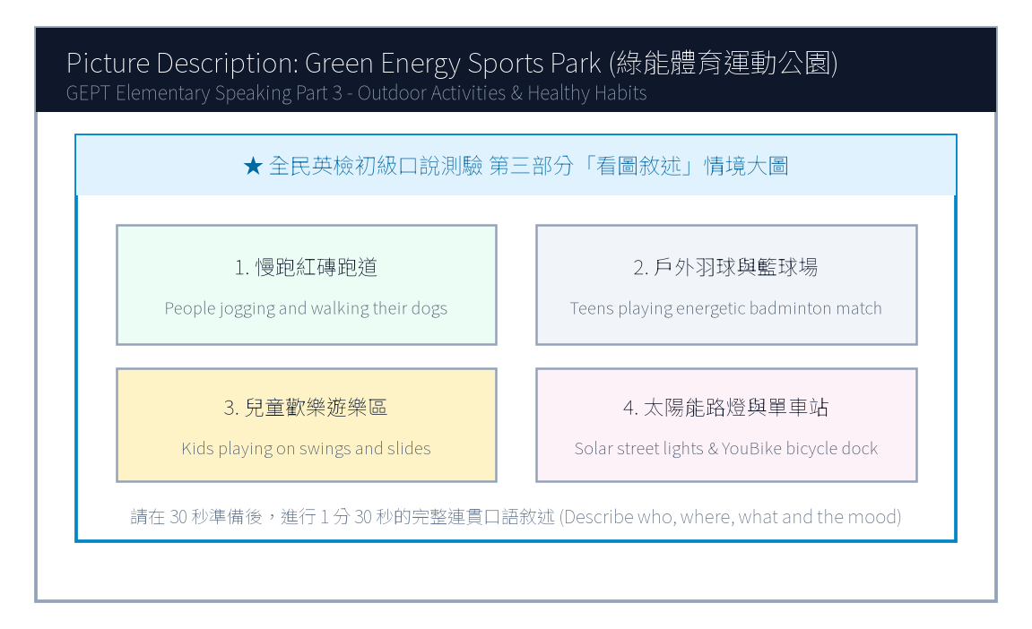
13. 請仔細觀察圖片，有 30 秒的準備時間。之後請在 1 分 30 秒內，根據圖中綠能體育運動公園的情境作一完整連貫的口述敘述。

【試題答案與名師深度解析手冊】
※ 本單元置於整張試卷最後面 · 供作答完畢後核對成績、滿分範文觀摩與考點診斷使用

單元一：寫作能力測驗 標準答案與滿分範文解析
【第一部分：單句寫作 1–15 題標準答案與常見錯誤剖析】
第 1 題 標準答案：George does not go jogging in the community sports park every morning.
★ 破題指引與扣分盲點：改為否定句須注意助動詞 does not/do not/did not 後動詞回歸原形。
第 2 題 標準答案：How many championship matches did the high school soccer team win last year?
★ 破題指引與扣分盲點：注意開頭首字大寫、句末標點符號及動詞時態一致。
第 3 題 標準答案：It takes lots of courage to speak English with native speakers.
★ 破題指引與扣分盲點：注意開頭首字大寫、句末標點符號及動詞時態一致。
第 4 題 標準答案：The newly opened science museum was visited by many curious students yesterday.
★ 破題指引與扣分盲點：被動語態公式為「be動詞 + 過去分詞 (p.p.) + by...」，時態須嚴格對齊原句。
第 5 題 標準答案：The box of antique porcelain was too fragile for anybody to move.
★ 破題指引與扣分盲點：注意否定含意，too... to 表示「太...以致於不能...」，後面接動詞原形。
第 6 題 標準答案：The English teacher wrote an important message on the blackboard.
★ 破題指引與扣分盲點：注意開頭首字大寫、句末標點符號及動詞時態一致。
第 7 題 標準答案：It is essential for teenagers to maintain good posture.
★ 破題指引與扣分盲點：注意開頭首字大寫、句末標點符號及動詞時態一致。
第 8 題 標準答案：Alice bought a birthday gift for her younger sister yesterday.
★ 破題指引與扣分盲點：注意開頭首字大寫、句末標點符號及動詞時態一致。
第 9 題 標準答案：We heard the baby birds chirping hungrily in their nest.
★ 破題指引與扣分盲點：注意開頭首字大寫、句末標點符號及動詞時態一致。
第 10 題 標準答案：When will the next express train leave?
★ 破題指引與扣分盲點：注意開頭首字大寫、句末標點符號及動詞時態一致。
第 11 題 標準答案：Although Leo prepared thoroughly for the swimming contest, he did not win any medals.
★ 破題指引與扣分盲點：注意開頭首字大寫、句末標點符號及動詞時態一致。
第 12 題 標準答案：You may either drink freshly squeezed orange juice or have a cup of hot chocolate.
★ 破題指引與扣分盲點：注意開頭首字大寫、句末標點符號及動詞時態一致。
第 13 題 標準答案：The lady who delivered an inspiring speech this morning is our school principal.
★ 破題指引與扣分盲點：關係代名詞 who 引導形容詞子句修飾先行詞人，其後動詞與先行詞一致。
第 14 題 標準答案：They traveled to Hualien in order to admire the magnificent Taroko Gorge.
★ 破題指引與扣分盲點：注意開頭首字大寫、句末標點符號及動詞時態一致。
第 15 題 標準答案：A truck is the heaviest of the three.
★ 破題指引與扣分盲點：注意開頭首字大寫、句末標點符號及動詞時態一致。
【第二部分：段落看圖寫作 Level 5 (滿分範文) 與架構解析】
★ 模擬參考 5 級分 (滿分範文，約 60 字)：
"Yesterday was Mom's birthday, so Cindy and her younger brother decided to bake a surprise strawberry cake before she returned from work. However, because they accidentally set the oven temperature too high, dark smoke poured out and the cake was slightly charred on top. Just as they felt discouraged and messy with flour all over their faces, Mom walked in and understood everything immediately. She embraced them with tears of joy, happily tasting the burnt cake and declaring it the sweetest gift ever."
★ 名師寫作結構金字塔：
1. 開門見山交代人、事、時、地、背景 (Background & Initial problem)
2. 轉折句敘述解決問題之具體行動 (Action & Teamwork)
3. 昇華結尾描繪心情與正面收穫 (Happy ending & Reflection)

單元二：口說能力測驗 滿分示範講稿與錄音逐字稿
【第二單元：回答問題 (Questions 3–12) 滿分口語回答範例】
3. What is your favorite kind of fruit?
滿分示範答句 (Model Response)："My favorite fruit is watermelon because it is extremely juicy, sweet, and refreshing, especially on scorching hot summer days."
4. How do you usually spend your time after finishing homework?
滿分示範答句 (Model Response)："After finishing my homework, I usually practice playing the acoustic guitar for thirty minutes or walk our dog in the neighborhood park."
5. What kind of pets do you like the most?
滿分示範答句 (Model Response)："I like golden retrievers the most because they are exceptionally loyal, gentle with children, and always wag their tails joyfully."
6. Do you enjoy cooking or helping out in the kitchen?
滿分示範答句 (Model Response)："Yes, I really enjoy helping my mother prepare dinner, especially washing fresh vegetables and beating eggs for fried rice."
7. Tell me about an interesting place you visited recently.
滿分示範答句 (Model Response)："Recently, I visited the Taipei Astronomical Museum. The giant 3D planetarium show made me feel like I was floating among distant galaxies."
8. How do you celebrate New Year's Eve with your family?
滿分示範答句 (Model Response)："On New Year's Eve, my family eats hot pot dinner together, watches the festive concert on television, and countdowns to the spectacular 101 fireworks display."
9. What subject do you find the most challenging, and why?
滿分示範答句 (Model Response)："I find history the most challenging because there are so many dynasties, historical figures, and treaty dates that require careful memorization."
10. What do you do when you catch a cold?
滿分示範答句 (Model Response)："When I catch a cold, I visit a clinic immediately, drink plenty of warm lemon water, and sleep early so my body can recover quickly."
11. Do you prefer watching sports on TV or playing them yourself?
滿分示範答句 (Model Response)："I prefer playing sports myself because running on the court and sweating with my classmates is much more thrilling and healthy than watching passively."
12. If you could have any superpower, what would it be?
滿分示範答句 (Model Response)："If I could have a superpower, I would love the ability to fly so I could soar above the clouds and explore every continent without traffic jams."
【第三單元：看圖敘述 (Question 13) 90 秒完整連貫滿分講稿】
★ 模擬參考滿分講稿 (約 120 字，90 秒從容輸出)：
"This energetic picture shows a sunny Sunday afternoon at the newly opened city sports park. In the center foreground, several enthusiastic teenagers are playing a fast-paced badminton doubles match, leaping into the air to smash the shuttlecock. Encircling the sports fields is a wide brick-red track where joggers of various ages are running steadily to the rhythm of upbeat music. Over to the right, a joyful playground is filled with small children sliding down bright yellow slides and giggling on swings under their parents' watchful eyes. In the background, modern solar-powered streetlights line the pathways, and a shared bicycle docking station offers green commuting options. The park is vibrant, clean, and full of healthy outdoor vitality."
★ 名師口語敘述四維框架：
1. 【整體開場】：This picture shows... on a sunny afternoon.
2. 【方位細節 1】：In the foreground / On the left side...
3. 【方位細節 2】：In the center / In the background...
4. 【情感總結】：Overall, everyone looks cheerful and enjoys the wonderful time.

單元三：本卷核心考點單字與高頻實用片語表 (Core Vocabulary)
考點單字／片語 | 詞性 | 中文核心語意 | 生活情境搭配例句
charred | adj. | 燒焦的 | The cake was slightly charred on top, but the inside was soft.
discouraged | adj. | 氣餒的、沮喪的 | Don't feel discouraged when facing difficult challenges.
overhead rack | n. | 頭頂行李架 | Place your heavy backpacks on the overhead luggage rack.
carbon dioxide | n. | 二氧化碳 | Green plants absorb carbon dioxide during photosynthesis.
landslide | n. | 土石流、山崩 | Heavy rainfall during typhoons may trigger dangerous landslides.
scorching | adj. | 炙熱的、滾燙的 | drink lots of water on scorching summer afternoons
planetarium | n. | 天文館、天象儀 | watch an immersive 3D show at the science planetarium
vitality | n. | 活力、生機 | The young athletes showed incredible energy and vitality.
shuttlecock | n. | 羽毛球 | hit the shuttlecock over the badminton net with precision
commute | v./n. | 通勤 | Many students commute to school by taking public buses.

全民英語能力分級檢定測驗（GEPT）模擬練習（依官方題型編製）
115年度第2次 全民英檢初級說寫測驗（第二試常態初試）模擬試題（依官方題型編製）暨詳解
【試題本】(Question Booklet) · 答案與深度解析請參閱卷末解析手冊
測驗代碼 | GEPT-E-115-05-SW
測驗日期 | 2026 年 05 月 16 日（初級複試常態測驗）
測驗級數 | 初級（CEFR A2 級）
測驗項目 | 寫作能力測驗（40 分鐘）＆ 口說能力測驗（約 10 分鐘）
及格門檻 | 寫作達 70 分以上且口說達 80 分以上（均達 4 級分以上始發證書）
核心主題 | 拾金不昧公民道德、公車掉皮夾物歸原主、中央捷運轉運通勤、公眾交通安全

★ 作答注意事項：本測驗分為「寫作能力測驗」（第一部分單句寫作15題、第二部分段落寫作1題，共40分鐘）與「口說能力測驗」（第一部分朗讀2題、第二部分回答問題10題、第三部分看圖敘述1題，約10分鐘）。全卷無預載答案，標準答案、滿分示範文章與口語講稿統一置於【整張試卷最後面】。

✍️ 第一部分：寫作能力測驗 (Writing Test)
作答時間：40 分鐘 ｜ 滿分：100 分（70 分以上為及格）

第一單元：單句寫作 (Questions 1–15)
說明：第 1–5 題為改寫，第 6–10 題為重組，第 11–15 題為句子合併。請依照各題括號內之指示作答，注意大小寫與標點符號。
1. Many passengers take the rapid transit system during rush hour. (改為否定句)
作答區：____________________________________________________________________________________
2. The high school volleyball team practices three times a week. (依畫線部分 three times a week 造原問句)
作答區：____________________________________________________________________________________
3. Wearing a safety helmet when riding a scooter is required by law. (用 It is... 改寫)
作答區：____________________________________________________________________________________
4. An honest schoolboy handed the lost smartphone to the police officer. (改為被動語態)
作答區：____________________________________________________________________________________
5. The English reading passage was so complicated that none of us could comprehend it. (用 too... to... 改寫)
作答區：____________________________________________________________________________________
6. on the library shelf / returned / the science magazines / the student
作答區：____________________________________________________________________________________
7. traffic regulations / vital / to obey / for pedestrians / is
作答區：____________________________________________________________________________________
8. a brand new backpack / bought / for the new semester / Kevin
作答區：____________________________________________________________________________________
9. in the distance / heard / thunder rumbling / we / this afternoon
作答區：____________________________________________________________________________________
10. the next bus / arrive / at the bus stop / will / when / ?
作答區：____________________________________________________________________________________
11. Grace was feeling nervous before the English speech. / She spoke fluently on stage. (用 Although 合併)
作答區：____________________________________________________________________________________
12. You can take the circular bus to the hospital. / You can take the metro train. (用 either... or... 合併)
作答區：____________________________________________________________________________________
13. The police officer was praised by the mayor. / He helped an elderly woman find her lost grandson. (用 who 合併)
作答區：____________________________________________________________________________________
14. Mr. Wang exercised daily. / He wanted to lower his blood pressure and stay healthy. (用 to 或 in order to 合併)
作答區：____________________________________________________________________________________
15. A bicycle is slower than a scooter. / A pedestrian is slower than a bicycle. (用 slowest 合併)
作答區：____________________________________________________________________________________

第二單元：段落寫作 (Question 16 看圖短文寫作)
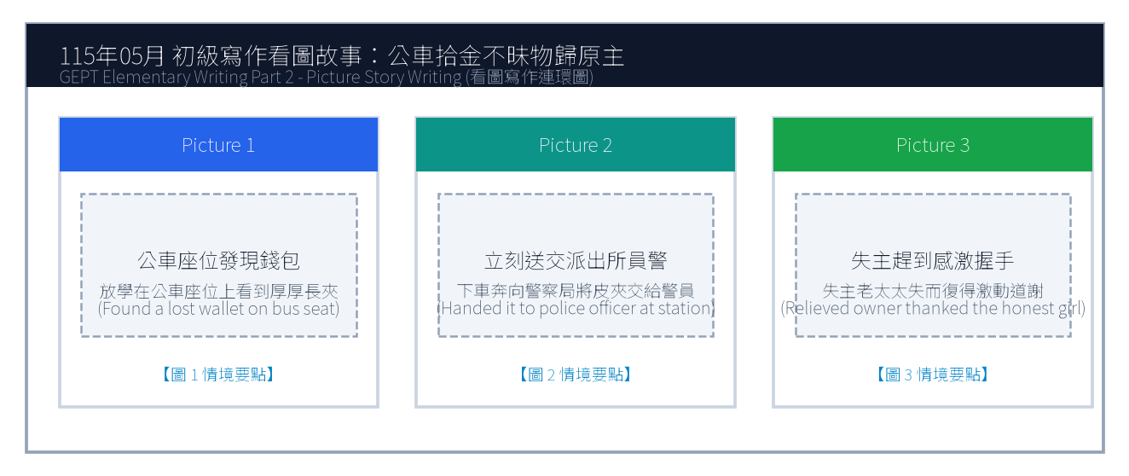
16. 請依據下列三幅連環圖畫內容，寫一篇約 50 字的短文故事，敘述女孩在公車座位上發現一個掉落的長夾，下車後立刻送至派出所交給員警，失主老太太失而復得激動感謝的拾金不昧經過。
Line 1: _________________________________________________________________________________
Line 2: _________________________________________________________________________________
Line 3: _________________________________________________________________________________
Line 4: _________________________________________________________________________________
Line 5: _________________________________________________________________________________
Line 6: _________________________________________________________________________________

🎙️ 第二部分：口說能力測驗 (Speaking Test)
測驗時間：約 10 分鐘（採電腦耳機麥克風錄音） ｜ 滿分：100 分（80 分以上為及格）

第一單元：朗讀短文 (Questions 1–2)
說明：共有兩篇短文。每篇短文有 1 分鐘的時間準備，然後請在 1 分鐘內以清晰、自然的語調朗讀出來。
【Question 1 朗讀短文】：
Passage 1: Attention all passengers. The airport express train bound for Taoyuan International Airport is now boarding at platform two. Please stand behind the yellow safety line until the train comes to a complete stop. Mind the platform gap when boarding and keep your luggage secure.

【Question 2 朗讀短文】：
Passage 2: The habit of reading broadens our horizons and enhances our understanding of the diverse world. When we read biographical memoirs or historical fiction, we experience extraordinary adventures and develop empathy for people from different cultural backgrounds. Reading is a lifelong treasure.

第二單元：回答問題 (Questions 3–12)
說明：共有十題日常生活問句。錄音將播出問題兩次，每次問題播完後有 15 秒的時間回答。請把握時間，針對問題盡量完整作答。
3. What time do you usually eat dinner on weekdays? (15 seconds response)
4. Where do you like to buy your school supplies? (15 seconds response)
5. What is your favorite outdoor sport, and how often do you play it? (15 seconds response)
6. Do you enjoy taking public transportation such as buses and trains? (15 seconds response)
7. Tell me about your favorite family holiday tradition. (15 seconds response)
8. What would you do if someone dropped their wallet in front of you? (15 seconds response)
9. How do you prepare for an important English examination? (15 seconds response)
10. What kind of music helps you relax after a tiring day? (15 seconds response)
11. Do you prefer living in a bustling city or a quiet countryside? (15 seconds response)
12. What is a goal you hope to achieve this year? (15 seconds response)

第三單元：看圖敘述 (Question 13 情境大圖口語敘述)
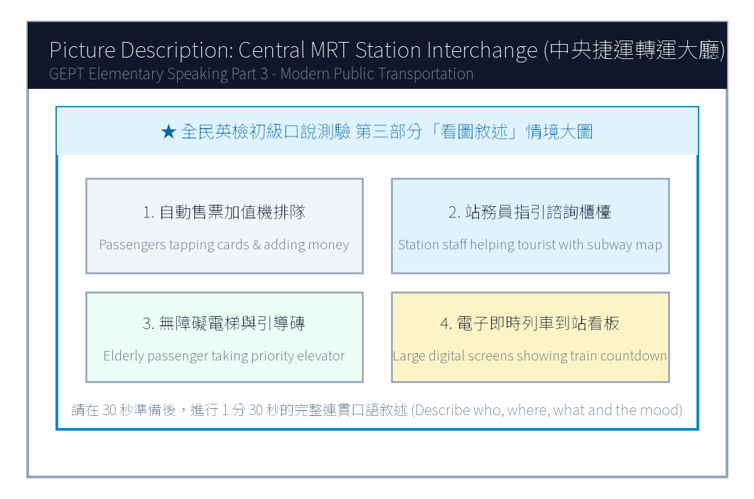
13. 請仔細觀察圖片，有 30 秒的準備時間。之後請在 1 分 30 秒內，根據圖中繁忙的中央捷運轉運大廳情境作一完整連貫的口述敘述。

【試題答案與名師深度解析手冊】
※ 本單元置於整張試卷最後面 · 供作答完畢後核對成績、滿分範文觀摩與考點診斷使用

單元一：寫作能力測驗 標準答案與滿分範文解析
【第一部分：單句寫作 1–15 題標準答案與常見錯誤剖析】
第 1 題 標準答案：Many passengers do not take the rapid transit system during rush hour.
★ 破題指引與扣分盲點：改為否定句須注意助動詞 does not/do not/did not 後動詞回歸原形。
第 2 題 標準答案：How often does the high school volleyball team practice?
★ 破題指引與扣分盲點：注意開頭首字大寫、句末標點符號及動詞時態一致。
第 3 題 標準答案：It is required by law to wear a safety helmet when riding a scooter.
★ 破題指引與扣分盲點：注意開頭首字大寫、句末標點符號及動詞時態一致。
第 4 題 標準答案：The lost smartphone was handed to the police officer by an honest schoolboy.
★ 破題指引與扣分盲點：被動語態公式為「be動詞 + 過去分詞 (p.p.) + by...」，時態須嚴格對齊原句。
第 5 題 標準答案：The English reading passage was too complicated for any of us to comprehend.
★ 破題指引與扣分盲點：注意否定含意，too... to 表示「太...以致於不能...」，後面接動詞原形。
第 6 題 標準答案：The student returned the science magazines on the library shelf.
★ 破題指引與扣分盲點：注意開頭首字大寫、句末標點符號及動詞時態一致。
第 7 題 標準答案：It is vital for pedestrians to obey traffic regulations.
★ 破題指引與扣分盲點：注意開頭首字大寫、句末標點符號及動詞時態一致。
第 8 題 標準答案：Kevin bought a brand new backpack for the new semester.
★ 破題指引與扣分盲點：注意開頭首字大寫、句末標點符號及動詞時態一致。
第 9 題 標準答案：We heard thunder rumbling in the distance this afternoon.
★ 破題指引與扣分盲點：注意開頭首字大寫、句末標點符號及動詞時態一致。
第 10 題 標準答案：When will the next bus arrive at the bus stop?
★ 破題指引與扣分盲點：注意開頭首字大寫、句末標點符號及動詞時態一致。
第 11 題 標準答案：Although Grace was feeling nervous before the English speech, she spoke fluently on stage.
★ 破題指引與扣分盲點：注意開頭首字大寫、句末標點符號及動詞時態一致。
第 12 題 標準答案：You can either take the circular bus to the hospital or take the metro train.
★ 破題指引與扣分盲點：注意開頭首字大寫、句末標點符號及動詞時態一致。
第 13 題 標準答案：The police officer who helped an elderly woman find her lost grandson was praised by the mayor.
★ 破題指引與扣分盲點：關係代名詞 who 引導形容詞子句修飾先行詞人，其後動詞與先行詞一致。
第 14 題 標準答案：Mr. Wang exercised daily in order to lower his blood pressure and stay healthy.
★ 破題指引與扣分盲點：注意開頭首字大寫、句末標點符號及動詞時態一致。
第 15 題 標準答案：A pedestrian is the slowest of the three.
★ 破題指引與扣分盲點：注意開頭首字大寫、句末標點符號及動詞時態一致。
【第二部分：段落看圖寫作 Level 5 (滿分範文) 與架構解析】
★ 模擬參考 5 級分 (滿分範文，約 60 字)：
"While riding the public bus home yesterday, Brenda spotted a thick leather wallet forgotten on an empty seat. Knowing the owner must be frantic, she resisted any selfish temptation, immediately got off at the next stop, and carried the wallet directly to the nearby police station. Within an hour, a tearful elderly woman arrived and was immensely relieved to recover her identification documents and pension money. The grateful grandmother thanked Brenda with warm hugs, praising her as a shining example of honesty."
★ 名師寫作結構金字塔：
1. 開門見山交代人、事、時、地、背景 (Background & Initial problem)
2. 轉折句敘述解決問題之具體行動 (Action & Teamwork)
3. 昇華結尾描繪心情與正面收穫 (Happy ending & Reflection)

單元二：口說能力測驗 滿分示範講稿與錄音逐字稿
【第二單元：回答問題 (Questions 3–12) 滿分口語回答範例】
3. What time do you usually eat dinner on weekdays?
滿分示範答句 (Model Response)："I usually eat dinner at seven o'clock with my parents after everyone finishes work and classes. We enjoy delicious hot soup and share stories about our day."
4. Where do you like to buy your school supplies?
滿分示範答句 (Model Response)："I like buying my stationery at a large bookstore near our school because they have an enormous variety of colorful gel pens, notebooks, and stickers."
5. What is your favorite outdoor sport, and how often do you play it?
滿分示範答句 (Model Response)："My favorite outdoor sport is basketball. I play full-court games with my classmates twice a week at the school playground."
6. Do you enjoy taking public transportation such as buses and trains?
滿分示範答句 (Model Response)："Yes, I really enjoy taking the MRT because the train cabins are immaculately clean, comfortable, and never get stuck in frustrating traffic jams."
7. Tell me about your favorite family holiday tradition.
滿分示範答句 (Model Response)："Every Mid-Autumn Festival, our family gathers on our apartment rooftop to barbecue seafood, peel sweet pomelos, and admire the bright harvest moon."
8. What would you do if someone dropped their wallet in front of you?
滿分示範答句 (Model Response)："I would instantly call out to the person and return the wallet to them. If they walked away too fast, I would hand it to the nearest police officer."
9. How do you prepare for an important English examination?
滿分示範答句 (Model Response)："I review vocabulary flashcards daily, listen to English radio podcasts during my commute, and practice writing short essays to reinforce grammar."
10. What kind of music helps you relax after a tiring day?
滿分示範答句 (Model Response)："Soft acoustic guitar music and gentle piano melodies help me relax the most, as they soothe my tired nerves and help me fall asleep peacefully."
11. Do you prefer living in a bustling city or a quiet countryside?
滿分示範答句 (Model Response)："I prefer living in a bustling city because everything is convenient; libraries, convenience stores, and train stations are all within walking distance."
12. What is a goal you hope to achieve this year?
滿分示範答句 (Model Response)："My main goal this year is to pass the GEPT Elementary test with high scores and improve my spoken English so I can communicate confidently with foreign tourists."
【第三單元：看圖敘述 (Question 13) 90 秒完整連貫滿分講稿】
★ 模擬參考滿分講稿 (約 120 字，90 秒從容輸出)：
"This bustling illustration depicts the main concourse of a central metro interchange station during the busy afternoon commute. In the center, travelers carrying rolling suitcases are standing in orderly lines before automatic ticket machines, topping up transit cards or buying tokens. Over to the left near the information counter, a polite station worker in uniform is pointing at an electronic subway map to guide a lost foreign traveler. In the background on the right, passengers are stepping onto modern escalators, while an elderly person in a wheelchair is using the priority elevator with ease. Huge electronic screens hanging overhead clearly display upcoming train arrivals and transfer gates. The station is exceptionally bright, spotless, and running with impressive efficiency."
★ 名師口語敘述四維框架：
1. 【整體開場】：This picture shows... on a sunny afternoon.
2. 【方位細節 1】：In the foreground / On the left side...
3. 【方位細節 2】：In the center / In the background...
4. 【情感總結】：Overall, everyone looks cheerful and enjoys the wonderful time.

單元三：本卷核心考點單字與高頻實用片語表 (Core Vocabulary)
考點單字／片語 | 詞性 | 中文核心語意 | 生活情境搭配例句
frantic | adj. | 極度焦急的、心急如焚的 | The mother was frantic when her toddler wandered away.
pension | n. | 退休金、養老金 | Many retirees rely on their monthly government pension.
concourse | n. | 中央大廳、轉運大廳 | The grand concourse of the station was filled with commuters.
pedestrian | n. | 行人 | Drivers must yield the right of way to pedestrians at crosswalks.
empathy | adj. | 同理心 | Reading stories about diverse cultures fosters deep empathy.
spotless | adj. | 一塵不染的、極為乾淨的 | The hotel lobby and metro station were completely spotless.
stationery | n. | 文具 | buy colorful highlighters and notebooks at the stationery store
pomelo | n. | 柚子、文旦 | eating sweet pomelos during the Mid-Autumn Festival
soothe | v. | 撫慰、使平靜 | Soft ambient music helped soothe the stressed patient.
efficiency | n. | 效率 | Taiwan's high-speed rail operates with remarkable efficiency.

