**Box2D Installation**

10/19/2021  pwb

I mostly used the instruction here: <https://www.youtube.com/watch?v=TR3CcqG4Oes&ab_channel=Gamefromscratch>

* 1. Go to site: <https://github.com/erincatto/box2d>
  2. Press the green "Code" button and down load the zip file:

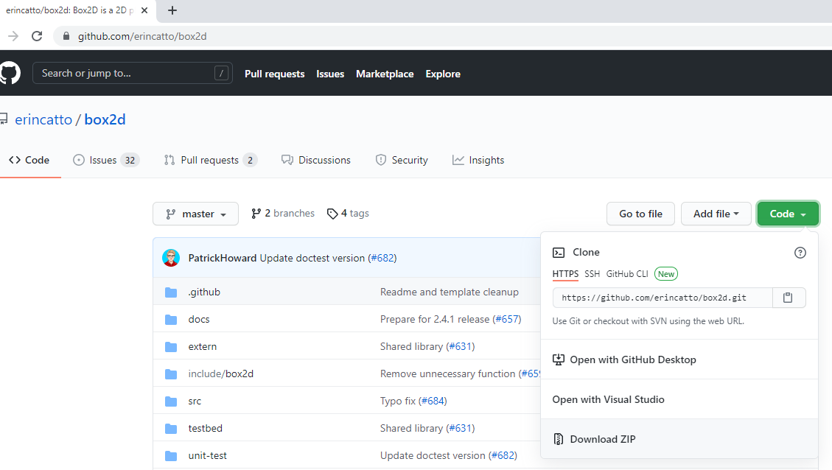

* 1. Unzip to D:\Box2DLib\box2d-2.4.1. Then I moved content folders up a couple levels so it looks like this, and moved the box2d-master.zip file into directory (just to keep zip with directories it unzipped).

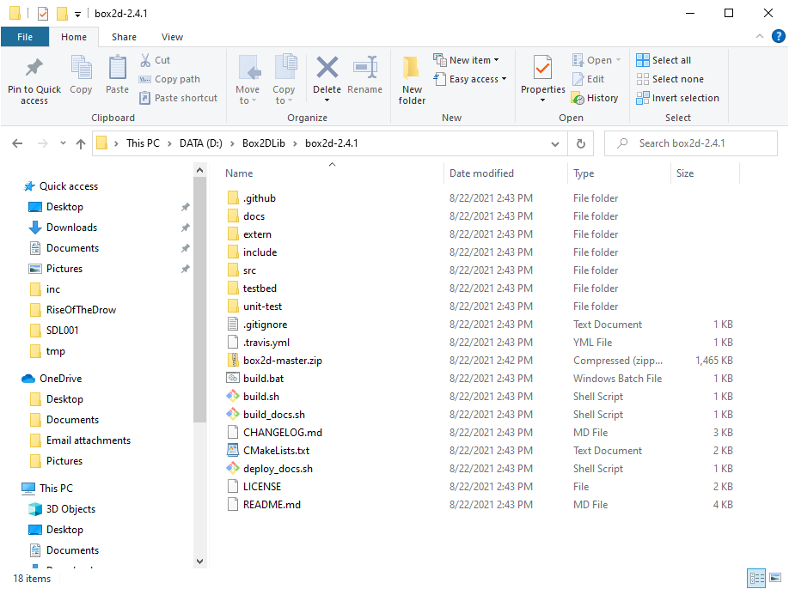

* 1. Press the "windows key", and typed in "command prompt for v" and selected "Developer Command Prompt for VS" as shown below (in my case the "… 2019 (2)" is VS Community version.

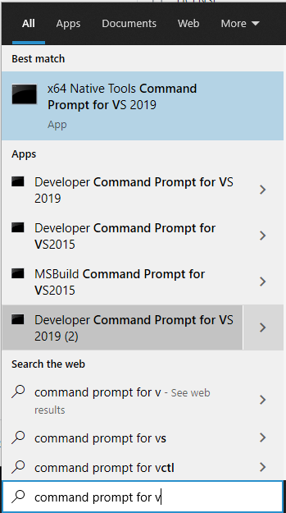

* 1. I got a command window that looks like this …

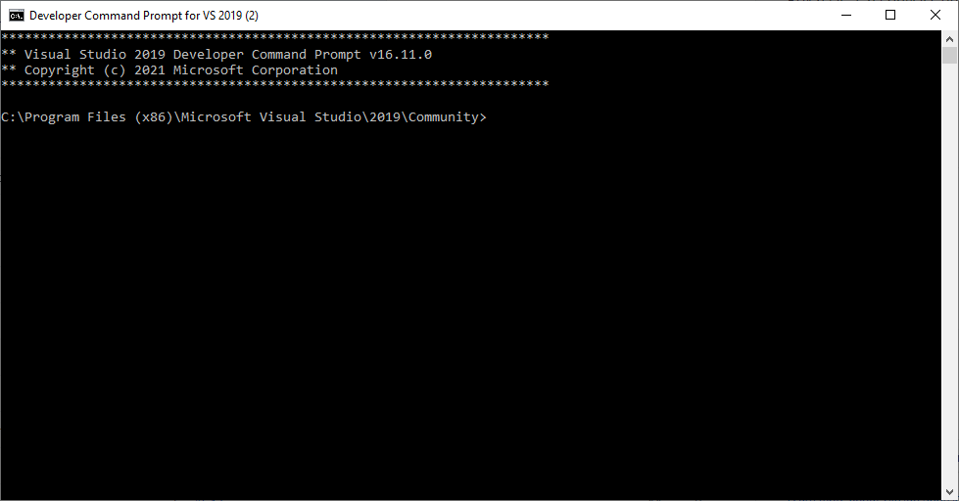

* 1. I changed directory to D:\Box2DLib\box2d-2.4.1, and typed "build" as follows …

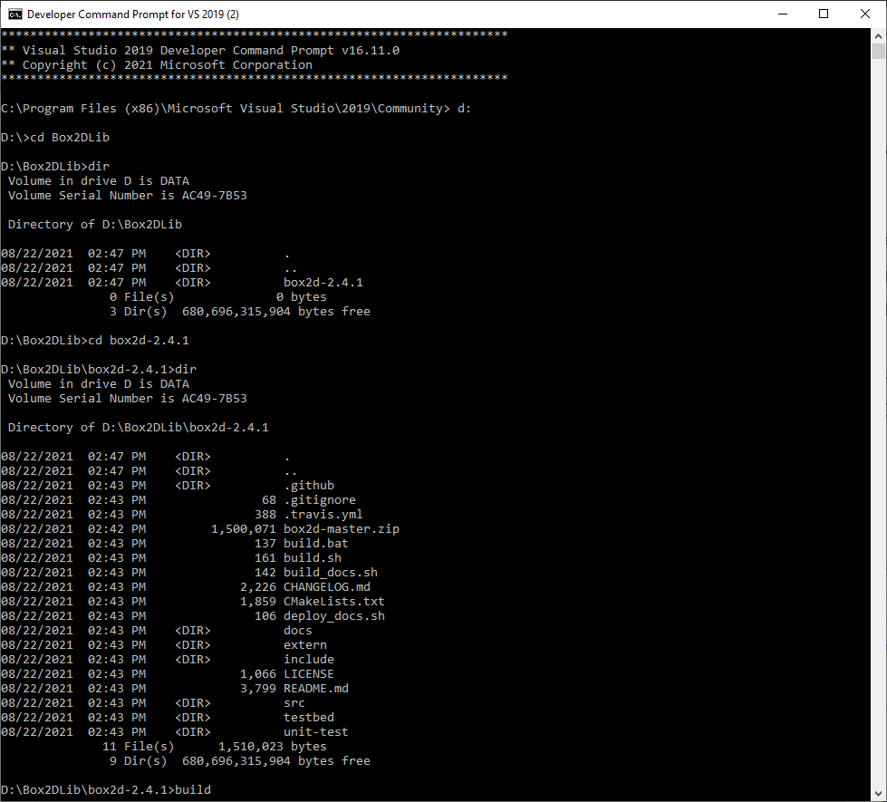

* 1. The build process seemed to work fine.
  2. I opened the VS solution at D:\Box2DLib\box2d-2.4.1\build\**box2d.sln** using VS Community.

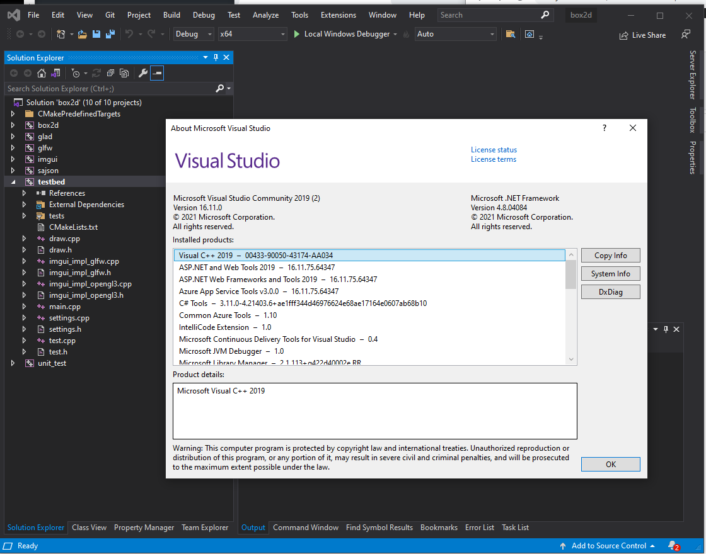

* 1. I selected the testbed project, pressed "F5" to run and it ran fine …

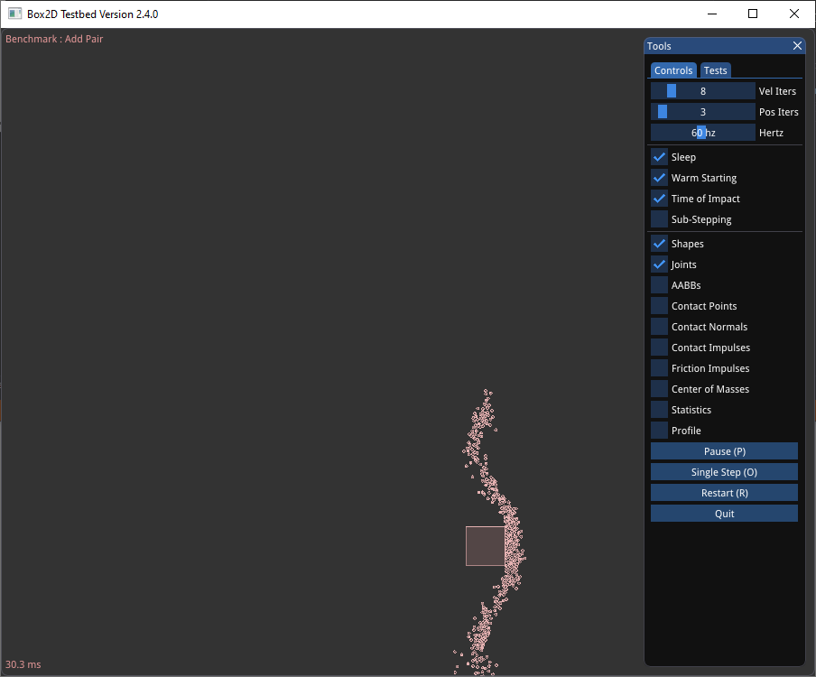

* 1. I selected the "Tests" tab in the upper left, and the instructions are on the upper left …

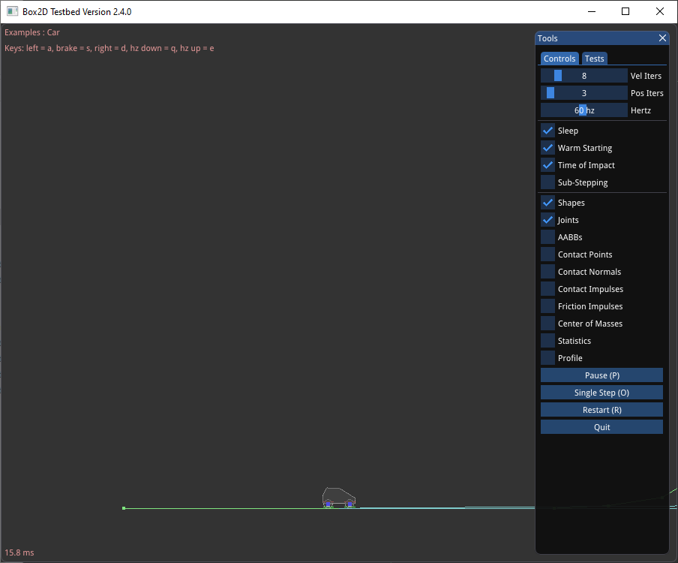

* 1. <the end>