Main Install Instructions for C++ Graphics Libraries

10/19/2021 pwb

These are instructions for installing the C++ based graphics libraries SDL, FreeGlut, and Box2D collision detection. FYI: SDL has sound support too.

**Note:** Instructions use the driver letter D:, but can be any drive letter as long as all references to D: are changed appropriately.

You need the files stored I stored in my GitHub repository at <https://github.com/pwbolton77/SdlBox2DInstallInstructions> including:

* + CppSDLLib.zip
  + Box2d-master.zip
  + Main.cpp

* 1. Install Box2D as per **Box2dInstallNotes.docx**
  2. Unzip the CppSDLLibs.zip into D:\CppSDLLibs as follow:

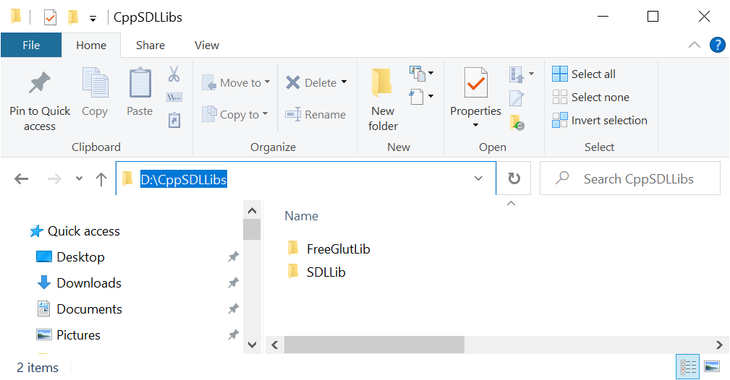

* 1. Boost is not necessary, but otherwise setup the other three "Bolt" system environment as follows:

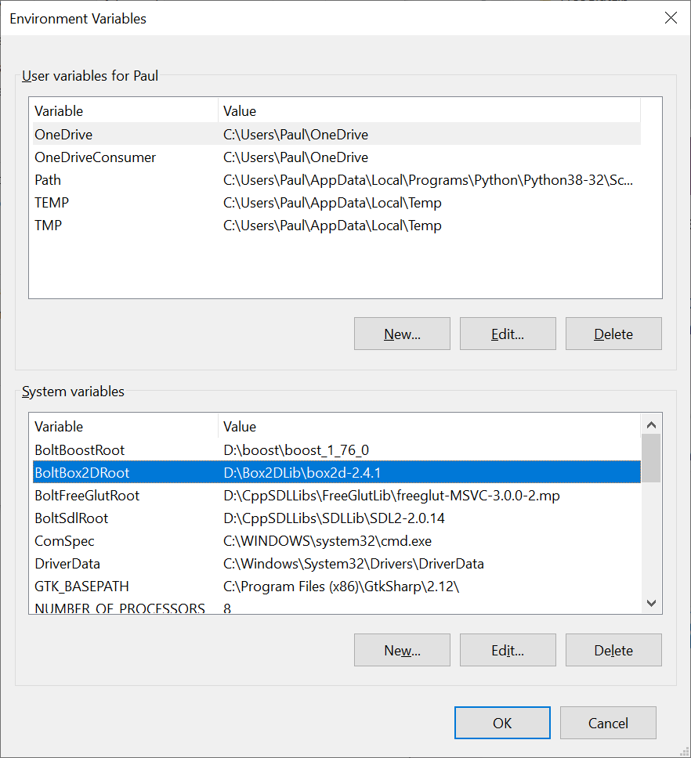

* 1. Create a new and empty C++ project.
  2. Set target as x64 Debug.
  3. Create at least one cpp file (e.g. Main.cpp). You probably want to use the Main.cpp at my GitHub site to test.
  4. In VS 2019 right click on the project to change the property settings.

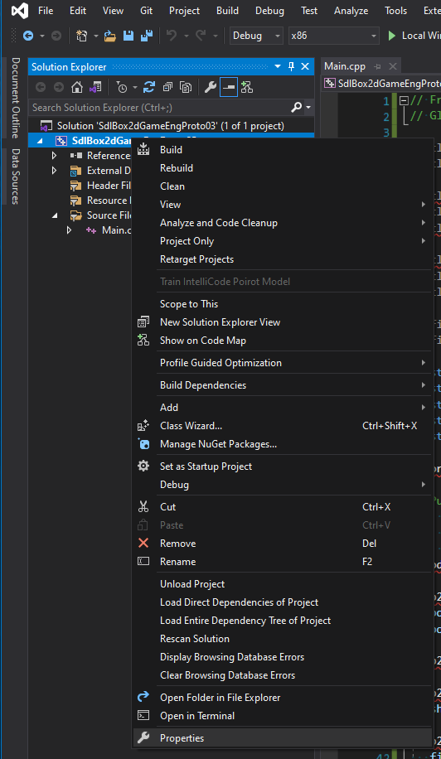

* 1. Go to "C/C++ General" and:
     1. Change "Configuration:" to "All Configurations".
     2. Make sure "Platform" is set to x64.
     3. Change Include Directories to:

**"%BoltSdlRoot%\include;%BoltBox2DRoot%\include;%BoltFreeGlutRoot%\freeglut\include;%(AdditionalIncludeDirectories)"**

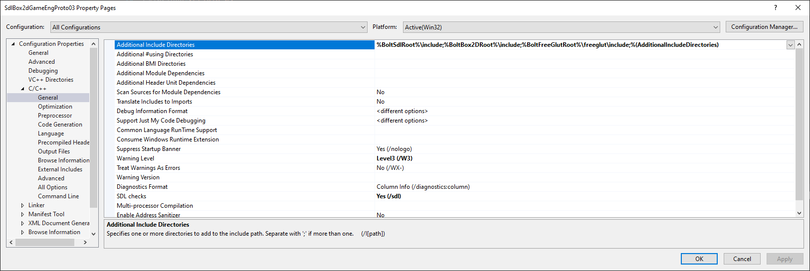

* 1. Go to "Linker", select "**General**" and set "Additional **Library Directories**" to:

**"%BoltSdlRoot%\lib\x64;%BoltFreeGlutRoot%\freeglut\lib\x64;%(AdditionalLibraryDirectories)"**

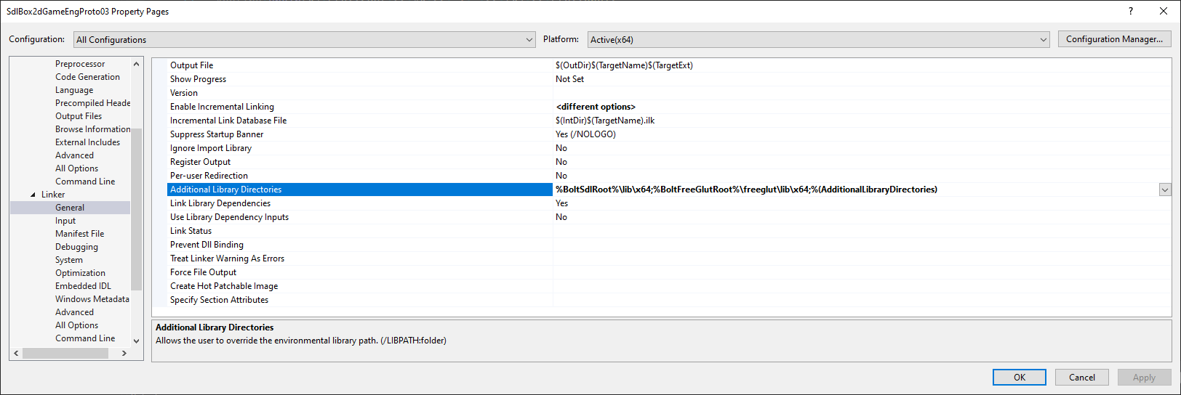

* 1. Go to "Linker", select "**All Options**" and set "Additional **Dependencies**" to:

**"SDL2.lib;Sdl2main.lib;%BoltBox2DRoot%\build\bin\Debug\box2d.lib;OpenGL32.lib;freeglut.lib;%(AdditionalDependencies)"**

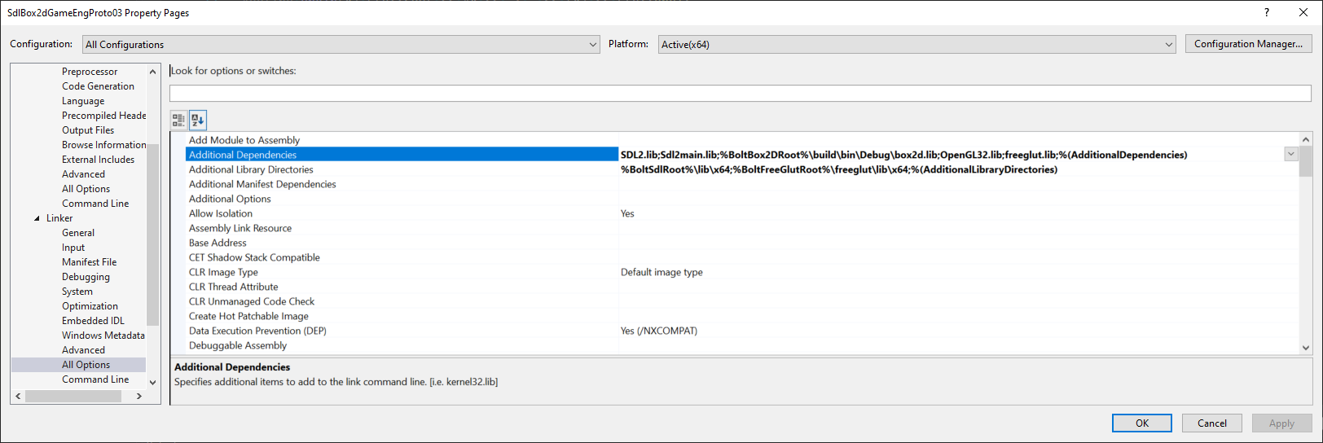

* 1. Do a full Rebuild the project.
  2. Run the application. If you used the Main.cpp in my GitHub then you should be able to click anywhere in the application window and it will make blocks that fall.
  3. <The End>