**OpenGL FreeGlut Install for SDL**

Pwb 9/6/2021

Things often change on the internet so the “Brief Instructions” should work unless/until things change. The other sections are more detailed, so hopefully if/when things change, we can trouble shoot the “Brief Instructions”

# Brief Instructions

1. I did this for x64 Visual Studio 2019 Community
2. Go to this link: <https://www.transmissionzero.co.uk/software/freeglut-devel/>
3. Find this link: [Download freeglut 3.0.0 for MSVC](https://www.transmissionzero.co.uk/files/software/development/GLUT/freeglut-MSVC.zip) which will down load a zip file: freeglut-MSVC-3.0.0-2.zip
4. Unzip the so directories look like the following …

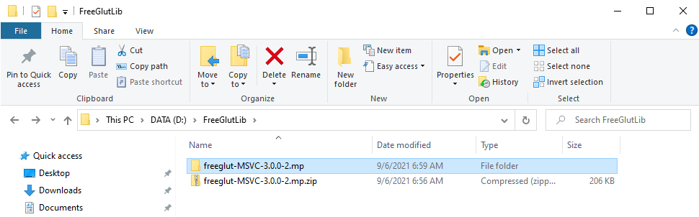

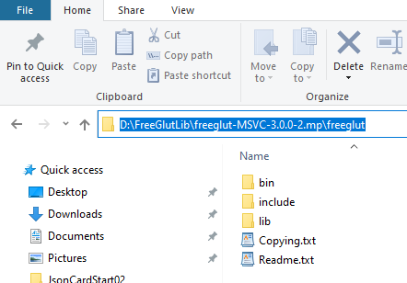

================================

As per: <https://lazyfoo.net/tutorials/OpenGL/01_hello_opengl/windows/msvsnet2010u/index.php>

**Note:** I make a few changes from the instructions:

1. to use the x64 versions of the library, and
2. added to the Path environmental variable the location of the x64 version of the freeglut.dll.

I found a link to the "Martain Payne's binaries…" prepackaged Windows release on this page: <http://freeglut.sourceforge.net/index.php#download>

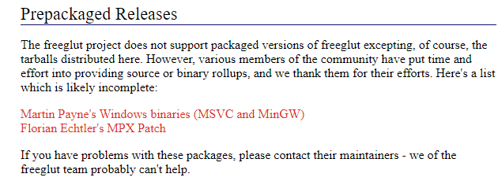

From the link above, I found the "Download freeglut …" link here …

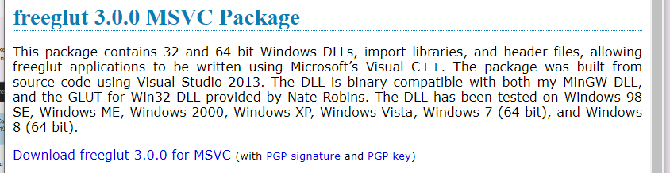

I downloaded the zip file from the link above, and created a D:\FreeGlutLib where I unzipped the contents …



Drilling down a couple directories …



I started a new C++ project and setup, and set it up for Debug and x64 …

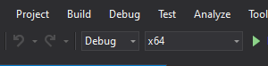

Then I setup the include directory and the **library** path for the project.

**Note: I setup library path for x64.**

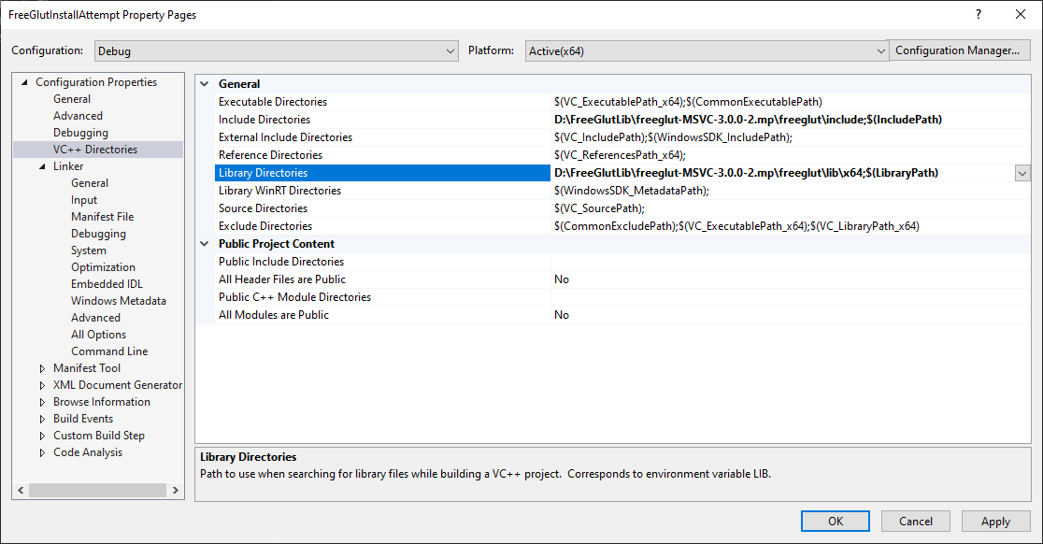

D:\FreeGlutLib\freeglut-MSVC-3.0.0-2.mp\freeglut\include;$(IncludePath)

D:\FreeGlutLib\freeglut-MSVC-3.0.0-2.mp\freeglut\lib\x64;$(LibraryPath)

Setup the Linker Input …

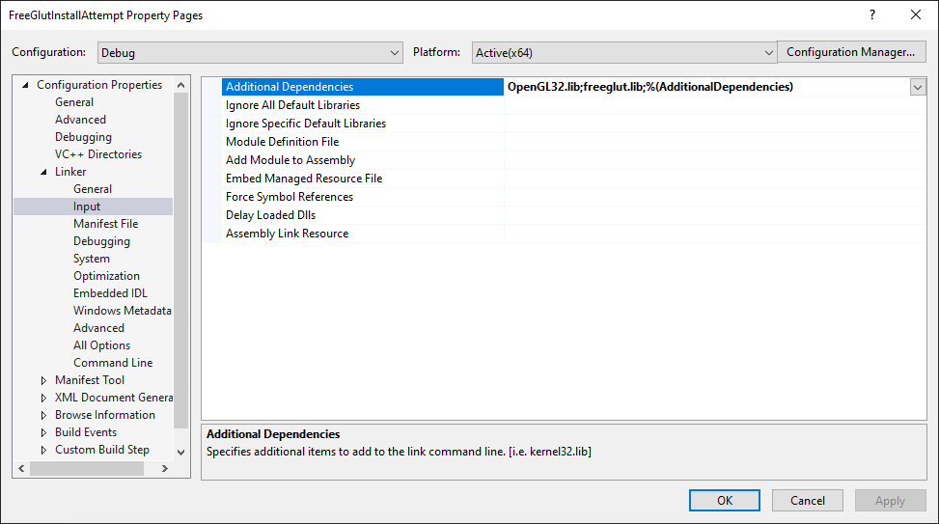

OpenGL32.lib;freeglut.lib;%(AdditionalDependencies)

I left the "System" to "Console" …

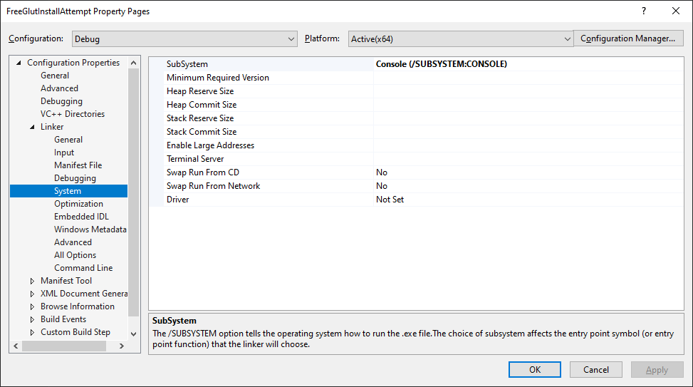

Then I added the following directory to the Path environmental variable …

D:\FreeGlutLib\freeglut-MSVC-3.0.0-2.mp\freeglut\bin\x64

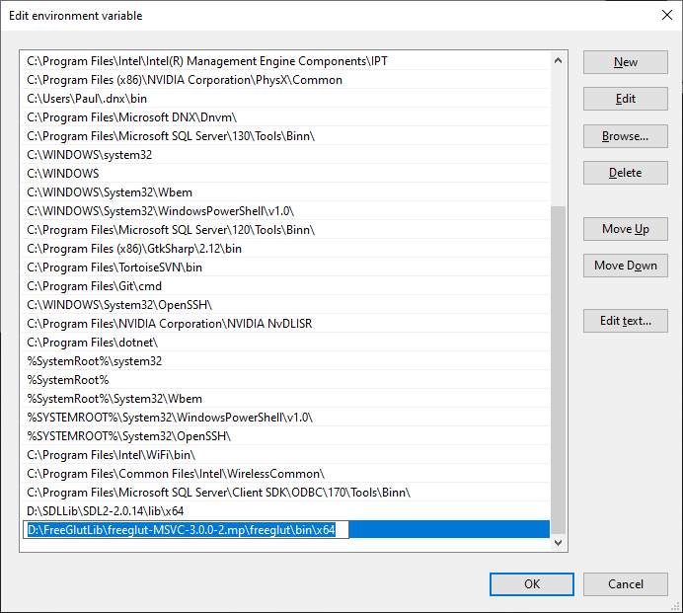

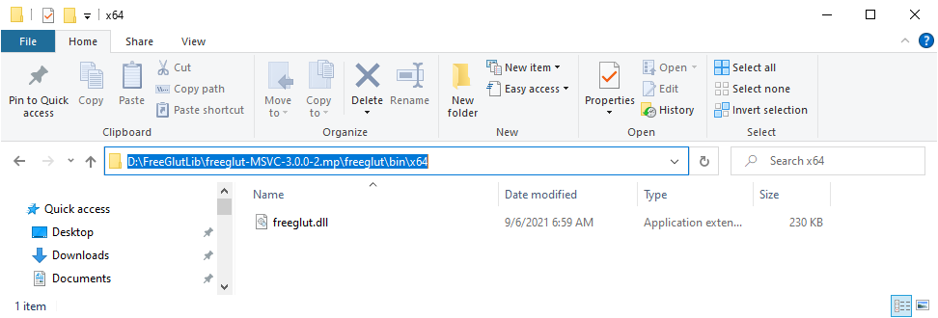

**I reopened the Visual Studio project.**

Then I downloaded the tutorial source as per link that follow in the next comments …

"Now go download the [source for lesson 01](https://lazyfoo.net/tutorials/OpenGL/01_hello_opengl/01_hello_freeglut.zip). Add the source files inside to your project."

I added the files to the project (and kept the "#pragma once" commands in the headers) …

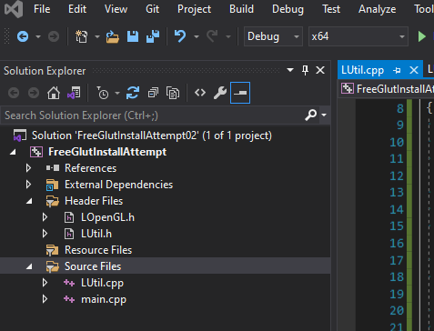

**Rebuilt and ran, and everything seemed to work !!**