Patrick Capps

CSE 5544 Assignment 2

Effective Example: Figure 1a from

Jeffrey Heer, Michael Bostock, Vadim Ogievetsky (2010), A Tour through the Visualization Zoo, Communications of the ACM, vol. 53, no. 6, pp. 59-67, 2010.

Figure 1a. Time-Series Data: Index chart of selected technology stocks, 2000–2010.

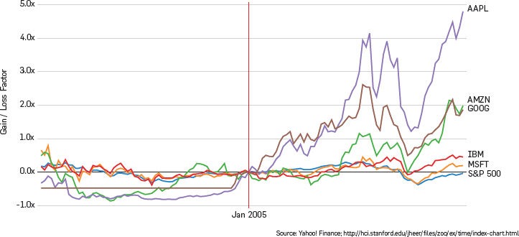

I find this visualization to be an effective one because it allows for easy comparison of the given companies’ stock changes. This index chart makes trends very obvious so we can see how Apple, Amazon, and Google have all seen rising stocks since 2005. The most noticeable elements of this graph are the line notating January 2005 and the large changes in stock after this point. These later trends are the most important part of the visualization I think, so having them stand out works well. The index chart has all of the essential information. It is meant to compare trends, so having specific stock values is not necessary. The chart is very simple, so has little clutter and no elements with no information. The chosen colors allow each company to stand out from each other even though their trendlines are very close around the Jan 2005 mark, which is also effectively highlighted with color since it is the index point. One misperception that the visualization could encourage is that Apple has much higher stock prices than the other companies by the end of the timeline. However, the chart is showing growth and not price so the label and scale of the y-axis is critical to dispel this assumption. The goal of the index chart is to show percentage growth and allow for meaningful comparison, so I think the y-axis scale could be improved by changing it to actual percentage points with more gridlines for more accurate comparison instead of 1x vs. 5x.

Ineffective Example: Figure 3d from same article

Figure 3d. Maps: Dorling cartogram of obesity in the U.S., 2008.

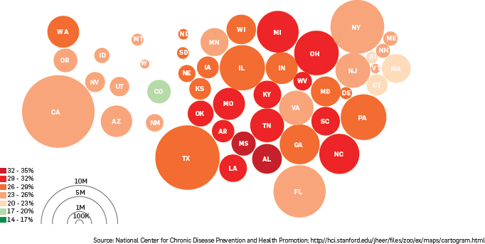

I think this visualization is ineffective because it relies heavily on using area and color to convey the information. According to the description, the size of the circles represents the total obese population in that state, while color as can be seen from the scale represents percentage. The circles are also placed geographically, but this is somewhat problematic as you can see the New York circle above Massachusetts and Maryland is above Pennsylvania. However, what I think is a bigger problem is that comparing circle size is difficult in this placement, since Texas and New York seem to be similarly sized circles but are too far apart to compare well, and the population scale only shows half a circle which makes comparison more difficult. Also Colorado is the only green circle, which jumps out as being either very low or very high until you check the legend. It being the only green state makes it one of the more noticeable elements, along with clusters of red circles and the larger circles like California and Texas. I would argue that Texas and California’s obese population is not important comparatively since they have the largest total populations anyway. The cluster of red circles around Mississippi and Alabama could be important since it shows a large obese population in that geographical region. Although Colorado is the least obese state, I don’t think it should be such a different color. The legends for this cartogram are missing labels making it unclear what the radius is conveying. Also, Alaska and Hawaii are not included in this dataset. The visualization is simple, so everything conveys some information. As mentioned, I do not think the color scale is well done because Colorado stands out too much and it is a bit difficult to differentiate the maroon from the red. Depending on whether the viewer focuses on size or color, one could come to the conclusion that Texas and California are very obese states when in fact they have middle percentages of obese people. For this type of data, the percent of the population that is obese is the more important statistic, so I think it would be better to just use a colored map instead of the circles.