**Calculator**

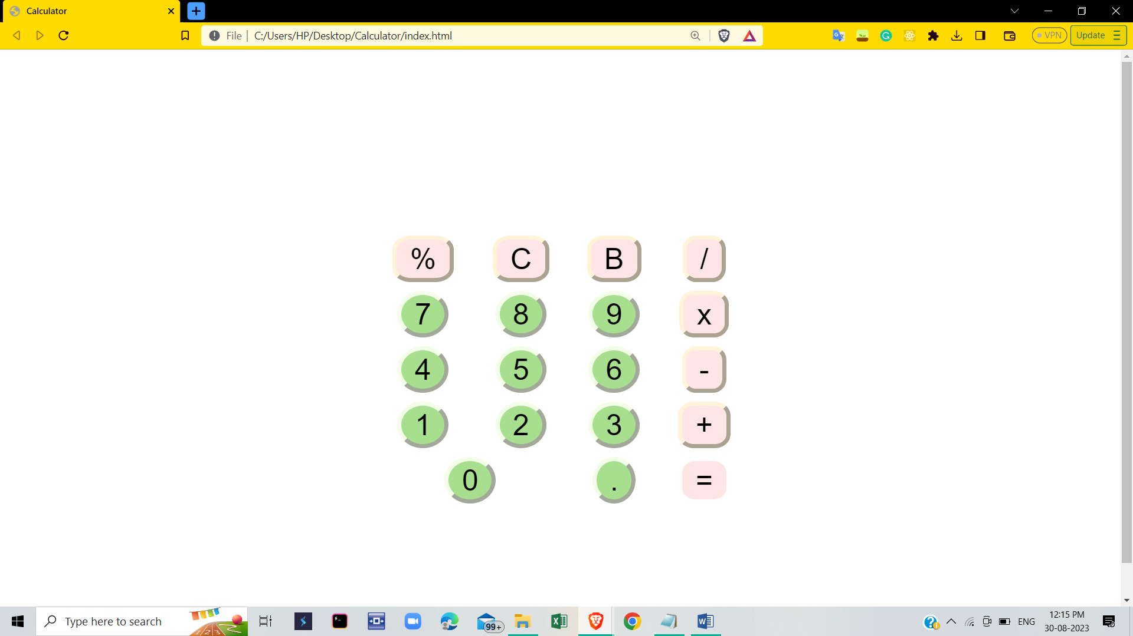

HTML file

<html>

<head>

<title>Calculator</title>

<link rel="stylesheet" href="myStyle.css">

</head>

<body>

<div class="table-container">

<table cell-spacing="10" class="tle">

<tr>

<td colspan="4" ><input type="text" id="result" ></td>

</tr>

<tr>

<td ><input type="button" value="%" onclick="Solve('%')" class="operator"></td>

<td ><input type="button" value="C" onclick="Clear()" class="operator"></td>

<td ><input type="button" value="B" onclick="Back()" class="operator"></td>

<td ><input type="button" value="/" onclick="Solve('/')" class="operator"></td>

</tr>

<tr>

<td ><input type="button" value="7" onclick="Solve('7')" class="number"></td>

<td ><input type="button" value="8" onclick="Solve('8')" class="number"></td>

<td ><input type="button" value="9" onclick="Solve('9')" class="number"></td>

<td ><input type="button" value="x" onclick="Solve('*')" class="operator"></td>

</tr>

<tr>

<td ><input type="button" value="4" onclick="Solve('4')" class="number"></td>

<td ><input type="button" value="5" onclick="Solve('5')" class="number"></td>

<td ><input type="button" value="6" onclick="Solve('6')" class="number"></td>

<td ><input type="button" value="-" onclick="Solve('-')" class="operator"></td>

</tr>

<tr>

<td ><input type="button" value="1" onclick="Solve('1')" class="number"></td>

<td><input type="button" value="2" onclick="Solve('2')" class="number"></td>

<td ><input type="button" value="3" onclick="Solve('3')" class="number"></td>

<td ><input type="button" value="+" onclick="Solve('+')" class="operator"></td>

</tr>

<tr>

<td colspan="2"><input type="button" value="0" onclick="Solve('0')" class="number"></td>

<td ><input type="button" value="." onclick="Solve('.')" class="number"></td>

<td ><input type="button" value="=" onclick="Result()" id = "result" class="operator" ></td>

</tr>

</table>

</div>

<script>

function Solve(val) {

var v = document.getElementById('result');

v.value += val;

}

function Result(){

var num1 = document.getElementById('result').value;

var num2 = eval(num1);

document.getElementById('result').value = num2;

}

function Clear() {

var inp = document.getElementById('result');

inp.value = '';

}

function Back() {

var del = document.getElementById('result');

del.value = del.value.slice(0,-1);

}

</script>

</body>

</html>

CSS file

body{

font-family: 'Source Sans Pro';

text-align: right;

}

.table-container{

display: flex;

justify-content: center;

align-items: center;

height: 100vh;

}

table{

text-align: center;

}

.number{

background-color: #A8DF8E;

border-radius: 50%;

border-color: #F3FDE8;

}

.operator{

background-color: #FFE5E5;

border-radius: 30%;

border-color: #FFF3DA;

}

#result{

border-bottom: #F6635C;

border-top: none;

border-left: none;

border-right: none;

}

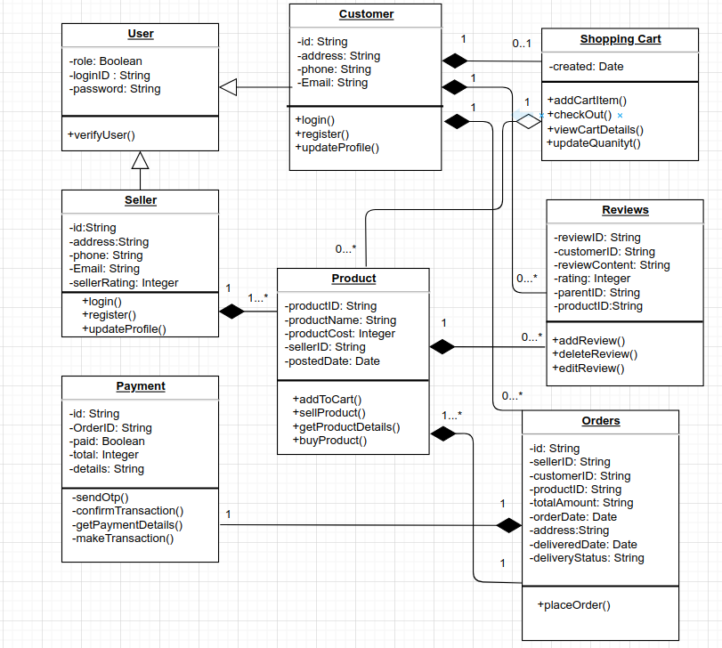

**Code for the above uml diagram without implementation:**

using System;

using System.Collections.Generic;

class User

{

public bool Role;

public string LoginID;

public string Password;

public bool VerifyUser()

{

Console.WriteLine("Verified");

}

}

class Customer : User

{

public string Id;

public string Address;

public string Phone;

public string Email;

public ShoppingCart ShoppingCart;

public List<Reviews> Reviews;

public List<Orders> Orders;

public void Login()

{

Console.WriteLine("Customer login");

}

public void Register()

{

Console.WriteLine("Customer registered");

}

public void UpdateProfile()

{

Console.WriteLine("Customer profile updated");

}

}

class Seller : User

{

public string Id;

public string Address;

public string Phone;

public string Email;

public int SellerRating;

public List<Product> Products;

public void Login()

{

Console.WriteLine("Seller login");

}

public void Register()

{

Console.WriteLine("Seller registered");

}

public void UpdateProfile()

{

Console.WriteLine("Seller profile updated");

}

}

class Product

{

public string ProductID;

public string ProductName;

public int ProductCost;

public string SellerID;

public DateTime PostedDate;

public List<Reviews> Reviews;

public List<Orders> Orders;

public void AddToCart()

{

Console.WriteLine("Product added to cart");

}

public void SellProduct()

{

Console.WriteLine("Product sold");

}

public void GetProductDetails()

{

Console.WriteLine("Product details");

}

public void BuyProduct()

{

Console.WriteLine("Product bought");

}

}

class Reviews

{

public string ReviewID;

public string CustomerID;

public string ReviewContent;

public int Rating;

public string ParentID;

public string ProductID;

public void AddReview()

{

Console.WriteLine("Review added");

}

public void DeleteReview()

{

Console.WriteLine("Review deleted");

}

public void EditReview()

{

Console.WriteLine("Review edited");

}

}

class Orders

{

public string Id;

public string SellerID;

public string CustomerID;

public string ProductID;

public string TotalAmount;

public DateTime OrderDate;

public string Address;

public DateTime DeliveryDate;

public string DeliveryStatus;

public Payment Payment;

public void PlaceOrder()

{

Console.WriteLine("Order placed");

}

}

class Payment

{

public string Id;

public string OrderID;

public bool Paid;

public int Total;

public string Details;

public void SendOtp()

{

Console.WriteLine("OTP sent");

}

}

class ShoppingCart

{

public DateTime Created;

public List<Product> CartItems;

public void AddCartItem()

{

Console.WriteLine("Cart item added");

}

public void CheckOut()

{

Console.WriteLine("Checkout completed");

}

public void ViewCartDetails()

{

Console.WriteLine("Cart details viewed");

}

public void UpdateQuantity()

{

Console.WriteLine("Quantity updated");

}

}

class Program

{

static void Main(string[] args)

{

// User user = new User();

// user.VerifyUser();

// Console.WriteLine("You are successfully login to the E_commerce.\n");

// bool ch = true;

// while (ch)

// {

// Console.WriteLine("Please choose below categories by their index number: \n" +

// "\n1. Customer Details 1" +

// "\n2. Seller Details 2" +

// "\n3. Shopping Cart 3" +

// "\n4. Orders 4" +

// "\n5. Product Details 5" +

// "\n6. Reviews 6" +

// "\n7. Payment Details 7" +

// "\n8. Exit the E_Commerce 8");

// int choose = Convert.ToInt32(Console.ReadLine());

// if (choose == 1)

// {

// Customer customer = new Customer();

// customer.Login();

// customer.Register();

// customer.UpdateProfile();

// Console.WriteLine("\n");

// }

// else if (choose == 2)

// {

// Seller seller = new Seller();

// seller.Login();

// seller.Register();

// seller.UpdateProfile();

// Console.WriteLine("\n");

// }

// else if (choose == 3)

// {

// ShoppingCart cart = new ShoppingCart();

// cart.AddCartItem();

// cart.CheckOut();

// cart.ViewCartDetails();

// cart.UpdateQuantity();

// Console.WriteLine("\n");

// }

// else if (choose == 4)

// {

// Orders orders = new Orders();

// orders.PlaceOrder();

// Console.WriteLine("\n");

// }

// else if (choose == 5)

// {

// Product product = new Product();

// product.AddToCart();

// product.SellProduct();

// product.GetProductDetails();

// product.BuyProduct();

// Console.WriteLine("\n");

// }

// else if (choose == 6)

// {

// Reviews reviews = new Reviews();

// reviews.AddReview();

// reviews.DeleteReview();

// reviews.EditReview();

// Console.WriteLine("\n");

// }

// else if (choose == 7)

// {

// Payment payment = new Payment();

// payment.SendOtp();

// Console.WriteLine("\n");

// }

// else if (choose == 8)

// {

// Console.WriteLine("Thank You for using our E_Commerce site" +

// " for your daily requierments.\nYou are logout from our site now, " +

// "We hope that you are enjoying our products and services." +

// ".\nVisit again, have a good day.\nThank You.");

// ch = false;

}

}

}

}