**ASSIGNMENT 1**

<!DOCTYPE html>

<html lang="en">

<head>

   <style>

      *{

         padding: 0;

         margin: 0;

         font-family: 'poppins', sans-serif;

      }

      body{

         background-color: white;

         display: grid;

         height: 100vh;

         place-items: center;

      }

      .main{

         width: 400px;

         height: 450px;

         background-color: white;

         position: absolute;

         border: 5px solid black;

         border-radius: 6px;

      }

      .main input[type='text'] {

         width: 88%;

         position: relative;

         height: 80px;

         top: 10px;

         text-align: right;

         padding: 3px 6px;

         outline: none;

         font-size: 40px;

         border: 2px solid black;

         display: flex;

         margin: auto;

         border-radius: 6px;

         color: black;

      }

      .btn input[type='button']{

         width:90px;

         padding: 2px;

         margin: 2px 0px;

         position: relative;

         left: 13px;

         top: 20px;

         height: 60px;

         cursor: pointer;

         font-size: 18px;

         transition: 0.5s;

         background-color: gainsboro;

         border-radius: 6px;

         color: black;

      }

   </style>

   <script>

      function Solve(val) {

         var v = document.getElementById('res');

         v.value += val;

      }

      function Result() {

         var num1 = document.getElementById('res').value;

         var num2 = eval(num1);

         document.getElementById('res').value = num2;

      }

      function Clear() {

         var inp = document.getElementById('res');

         inp.value = '';

      }

      function Back() {

         var ev = document.getElementById('res');

         ev.value = ev.value.slice(0,-1);

      }

   </script>

   <title>Calculator</title>

</head>

<body>

   <div class="main">

      <input type="text" id = 'res' placeholder="0">

      <div class="btn">

         <input type="button" value = 'C' onclick = "Clear()">

         <input type="button" value = '%' onclick = "Solve('%')">

         <input type="button" value = '←' onclick ="Back('←')">

         <input type="button" value = '/' onclick = "Solve('/')">

         <br>

         <input type="button" value = '7' onclick = "Solve('7')">

         <input type="button" value = '8' onclick = "Solve('8')">

         <input type="button" value = '9' onclick = "Solve('9')">

         <input type="button" value = 'x' onclick = "Solve('*')">

         <br>

         <input type="button" value = '4' onclick = "Solve('4')">

         <input type="button" value = '5' onclick = "Solve('5')">

         <input type="button" value = '6' onclick = "Solve('6')">

         <input type="button" value = '-' onclick = "Solve('-')">

         <br>

         <input type="button" value = '1' onclick = "Solve('1')">

         <input type="button" value = '2' onclick = "Solve('2')">

         <input type="button" value = '3' onclick = "Solve('3')">

         <input type="button" value = '+' onclick = "Solve('+')">

         <br>

         <input type="button" value = '00'onclick = "Solve('00')">

         <input type="button" value = '0' onclick = "Solve('0')">

         <input type="button" value = '.' onclick = "Solve('.')">

         <input type="button" value = '=' onclick = "Result()" style="background-color:darkblue; color: whitesmoke;">

      </div>

   </div>

</body>

</html>

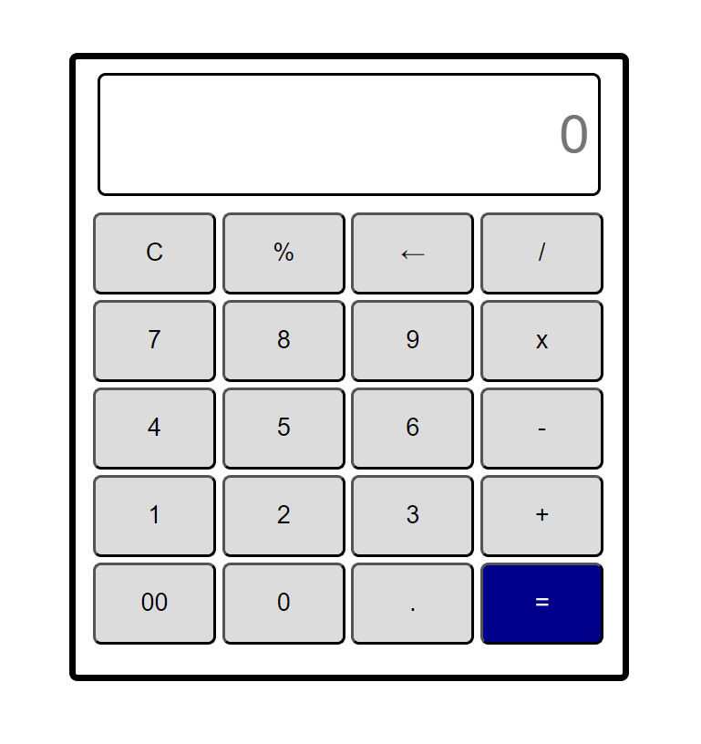

**ASSIGNMENT 2**

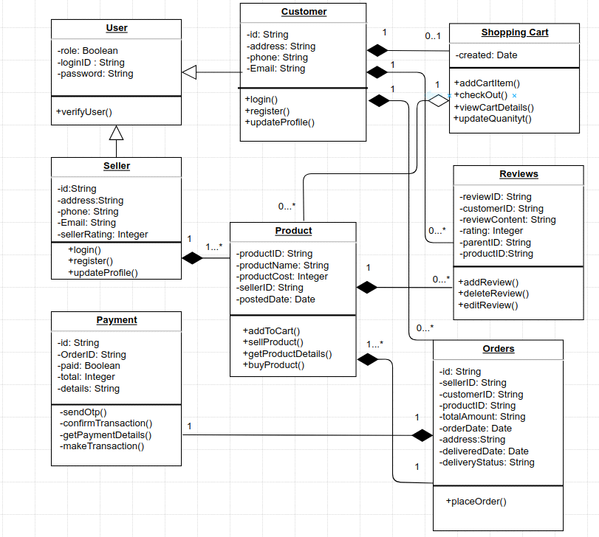

**User.java**

public class User {

private boolean role;

private String loginID;

private String password;

// Constructor

public User(boolean role, String loginID, String password) {

this.role = role;

this.loginID = loginID;

this.password = password;

}

// Getters and Setters

public boolean isRole() {

return role;

}

public void setRole(boolean role) {

this.role = role;

}

public String getLoginID() {

return loginID;

}

public void setLoginID(String loginID) {

this.loginID = loginID;

}

public String getPassword() {

return password;

}

public void setPassword(String password) {

this.password = password;

}

public void verifyUser() {

// Code to verify user

System.out.println("The user is verified successfully!!!");

}

}

**Customer.java**

public class Customer extends User {

private String id;

private String address;

private String phone;

private String email;

// Constructor

public Customer(String id, String address, String phone, String email) {

this.id = id;

this.address = address;

this.phone = phone;

this.email = email;

}

// Getters and Setters

public String getId() {

return id;

}

public void setId(String id) {

this.id = id;

}

public String getAddress() {

return address;

}

public void setAddress(String address) {

this.address = address;

}

public String getPhone() {

return phone;

}

public void setPhone(String phone) {

this.phone = phone;

}

public String getEmail() {

return email;

}

public void setEmail(String email) {

this.email = email;

}

public void login() {

// Code for customer login functionality

System.out.println("Logged in successfully!");

}

public void register() {

// Code for customer registration functionality

System.out.println("User registered Successfully!");

}

public void updateProfile() {

// Code for updating customer profile

System.out.println("Profile updated successfully!");

}

}

**Seller.java**

public class Seller extends User {

private String id;

private String address;

private String phone;

private String email;

private int sellerRating;

// Constructor

public Seller(String id, String address, String phone, String email, int sellerRating) {

this.id = id;

this.address = address;

this.phone = phone;

this.email = email;

this.sellerRating = sellerRating;

}

// Getters and Setters

public String getId() {

return id;

}

public void setId(String id) {

this.id = id;

}

public String getAddress() {

return address;

}

public void setAddress(String address) {

this.address = address;

}

public String getPhone() {

return phone;

}

public void setPhone(String phone) {

this.phone = phone;

}

public String getEmail() {

return email;

}

public void setEmail(String email) {

this.email = email;

}

public int getSellerRating() {

return sellerRating;

}

public void setSellerRating(int sellerRating) {

this.sellerRating = sellerRating;

}

public void login() {

// Code for customer login functionality

System.out.println("Logged in successfully!");

}

public void register() {

// Code for customer registration functionality

System.out.println("User registered Successfully!");

}

public void updateProfile() {

// Code for updating customer profile

System.out.println("Profile updated successfully!");

}

}

**ShoppingCart.java**

import.java.util.Date;

class ShoppingCart extends Customer {

public void c() {

Customer c = new Customer(); // Composition

c.login();

}

private Date created;

public Date getCreated() {

return created;

}

public void setCreated(Date created) {

this.created = created;

}

public void addCartItem() {

// Code to add an item to the shopping cart

System.out.println("Item added successfully!");

}

public void checkOut() {

// Code to process the checkout of the shopping cart

System.out.println("Let's checkout!");

}

public void viewCartDetails() {

// Code to display the details of the shopping cart

System.out.println("Let's view the cart details!");

}

public void updateQuantity() {

// Code to update the quantity of an item in the shopping cart

System.out.println("Let's update the quantity!");

}

}

**Product.java**

import.java.util.Date;

class Product extends Seller {

public void l() {

Seller l = new Seller(); // Composition

l.login();

}

private String productID;

private String productName;

private int productCost;

private String sellerID;

private Date postedDate;

// Getters and Setters

public String getProductID() {

return productID;

}

public void setProductID(String productID) {

this.productID = productID;

}

public String getProductName() {

return productName;

}

public void setProductName(String productName) {

this.productName = productName;

}

public int getProductCost() {

return productCost;

}

public void setProductCost(int productCost) {

this.productCost = productCost;

}

public String getSellerID() {

return sellerID;

}

public void setSellerID(String sellerID) {

this.sellerID = sellerID;

}

public Date getPostedDate() {

return postedDate;

}

public void setPostedDate(Date postedDate) {

this.postedDate = postedDate;

}

public void addToCart() {

// Add the product to the cart

System.out.println("Added to cart successfully!");

}

public void sellProduct() {

// Sell the product

System.out.println("The product is being sold successfully!");

}

public void getProductDetails() {

// Retrieve and display the product details

System.out.println("Product details fetched successfully!");

}

public void buyProduct() {

// Buy the product

System.out.println("Product bought successfully!");

}

}

**Reviews.java**

class Reviews extends Customer {

public void u() {

Customer u = new Customer(); // Composition

u.updateProfile();

}

private String reviewID;

private String customerID;

private String reviewContent;

private int rating;

private String parentID;

private String productID;

// Getters and Setters

public String getReviewID() {

return reviewID;

}

public void setReviewID(String reviewID) {

this.ReviewID = reviewID;

}

public String getCustomerID() {

return customerID;

}

public void setCustomerID(String customerID) {

this.customerID = customerID;

}

public String getReviewContent() {

return reviewContent;

}

public void setReviewContent(String reviewContent) {

this.reviewContent = reviewContent;

}

public int getRating() {

return rating;

}

public void setRating(int rating) {

this.rating = rating;

}

public String getParentID() {

return parentID;

}

public void setParentID(String parentID) {

this.parentID = parentID;

}

public String getProductID() {

return productID;

}

public void setProductID(String productID) {

this.productID = productID;

}

public void addReview() {

// Code to add a review

System.out.println("Review added successfully!");

}

public void deleteReview() {

// Code to delete a review

System.out.println("Review deleted successfully!");

}

public void editReview() {

// Code to edit a review

System.out.println("Review edited successfully!");

}

}

**Payment.java**

class Payment extends Orders {

public void u() {

Customer u = new Customer(); // Composition

u.updateProfile();

}

private String id;

private String orderID;

private boolean paid;

private int total;

private String details;

// Getters and Setters

public String getId() {

return id;

}

public void setId(String id) {

this.id = id;

}

public String getOrderID() {

return orderID;

}

public void setOrderID(String orderID) {

this.orderID = orderID;

}

public boolean isPaid() {

return paid;

}

public void setPaid(boolean paid) {

this.paid = paid;

}

public int getTotal() {

return total;

}

public void setTotal(int total) {

this.total = total;

}

public String getDetails() {

return details;

}

public void setDetails(String details) {

this.details = details;

}

public void sendOTP() {

// Code for sending OTP

System.out.println("OTP sent successfully!");

}

public void confirmTransaction() {

// Code for confirming the transaction

System.out.println("Transaction confirmed!");

}

public void getPaymentDetails() {

// Code for retrieving payment details

System.out.println("Payment details fetched successfully!");

}

public void makeTransaction() {

// Code for making the transaction

System.out.println("Transaction done successfully!");

}

}

**Orders.java**

class Orders extends Customer {

public void p() {

Payment p = new Payment(); // Composition

p.placeOrder();

}

private String id;

private String sellerID;

private String customerID;

private String productID;

private String totalAmount;

private Date orderDate;

private String address;

private Date deliveredDate;

private String deliveryStatus;

// Getters and Setters

public String getId() {

return id;

}

public void setId(String id) {

this.id = id;

}

public String getSellerID() {

return sellerID;

}

public void setSellerID(String sellerID) {

this.sellerID = sellerID;

}

public String getCustomerID() {

return customerID;

}

public void setCustomerID(String customerID) {

this.customerID = customerID;

}

public String getProductID() {

return productID;

}

public void setProductID(String productID) {

this.productID = productID;

}

public String getTotalAmount() {

return totalAmount;

}

public void setTotalAmount(String totalAmount) {

this.totalAmount = totalAmount;

}

public Date getOrderDate() {

return orderDate;

}

public void setOrderDate(Date orderDate) {

this.orderDate = orderDate;

}

public String getAddress() {

return address;

}

public void setAddress(String address) {

this.address = address;

}

public Date getDeliveredDate() {

return deliveredDate;

}

public void setDeliveredDate(Date deliveredDate) {

this.deliveredDate = deliveredDate;

}

public String getDeliveryStatus() {

return deliveryStatus;

}

public void setDeliveryStatus(String deliveryStatus) {

this.deliveryStatus = deliveryStatus;

}

public void placeOrder() {

// Code to place an order

System.out.println("Order placed successfully!");

}

}

**Submitted by:**

Liza Susan  
PwC | Specialist | Advisory  
Mobile: +91 81389 51685  
Email: [liza.chandy@pwc.com](mailto:liza.chandy@pwc.com)  
PricewaterhouseCoopers Private Limited