Sakshi Sandip More  
Email: [sakshi.more@pwc.com](file:///C:\Users\smore032\Desktop\sakshi.more@pwc.com)  
PricewaterhouseCoopers Private Limited

ASSIGNMENT 01:

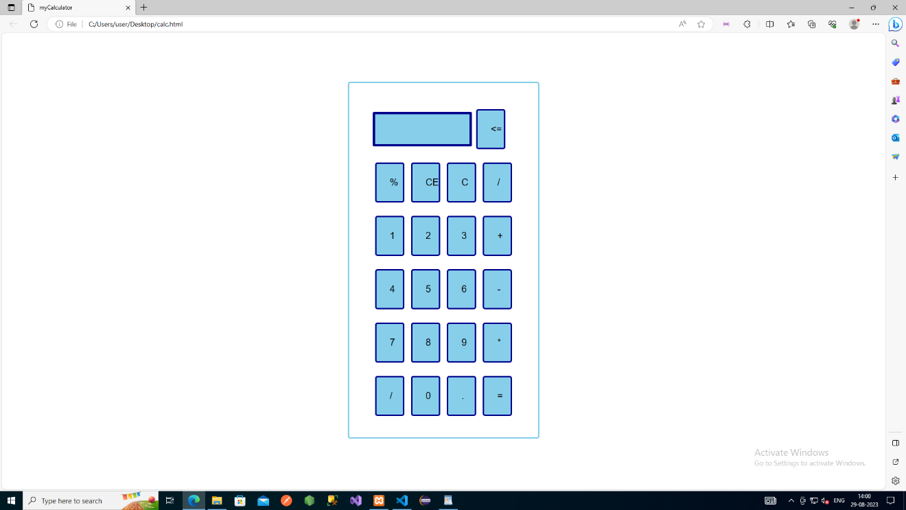

<!DOCTYPE html>

<html lang = "en">

<head>

<title> myCalculator </title>

<style>

h1 {

text-align: center;

padding: 30px;

background-color: g;

color: black;

}

.formstyle

{

width: 300px;

height: 650px;

margin: auto;

border: 3px solid skyblue;

border-radius: 5px;

padding: 50px;

}

input

{

width: 20px;

background-color: skyblue;

color: black;

border: 3px solid darkblue;

border-radius: 5px;

padding: 28px;

margin: 5px;

font-size: 20px;

}

#calc{

width: 160px;

border: 5px solid darkblue;

border-radius: 3px;

padding: 20px;

margin: auto;

}

</style>

</head>

<body>

<h1> </h1>

<div class= "formstyle">

<form name = "form1">

<!-- This input box shows the button pressed by the user in calculator. -->

<input id = "calc" type ="text" name = "answer">

<input type = "button" value = "<=" onclick = "form1.answer.value = form1.answer.value.slice(0, -1)" > <br> <br>

<!-- Display the calculator button on the screen. -->

<!-- onclick() function display the number prsses by the user. -->

<!-- display() function displays the value of clicked button -->

<input type = "button" value = "%" onclick = "form1.answer.value += '%' ">

<input type = "button" value = "CE" onclick = "form1.answer.value = ' ' " id= "clear" >

<input type = "button" value = "C" onclick = "form1.answer.value = ' ' " id= "clear" >

<input type = "button" value = "/" onclick = "form1.answer.value += '/' ">

<br> <br>

<input type = "button" value = "1" onclick = "form1.answer.value += '1' ">

<input type = "button" value = "2" onclick = "form1.answer.value += '2' ">

<input type = "button" value = "3" onclick = "form1.answer.value += '3' ">

<input type = "button" value = "+" onclick = "form1.answer.value += '+' ">

<br> <br>

<input type = "button" value = "4" onclick = "form1.answer.value += '4' ">

<input type = "button" value = "5" onclick = "form1.answer.value += '5' ">

<input type = "button" value = "6" onclick = "form1.answer.value += '6' ">

<input type = "button" value = "-" onclick = "form1.answer.value += '-' ">

<br> <br>

<input type = "button" value = "7" onclick = "form1.answer.value += '7' ">

<input type = "button" value = "8" onclick = "form1.answer.value += '8' ">

<input type = "button" value = "9" onclick = "form1.answer.value += '9' ">

<input type = "button" value = "\*" onclick = "form1.answer.value += '\*' ">

<br> <br>

<input type = "button" value = "/" onclick = "form1.answer.value += '/' ">

<input type = "button" value = "0" onclick = "form1.answer.value += '0' ">

<input type = "button" value = "." onclick = "form1.answer.value += '.' ">

<!-- When we click on the '=' button, the onclick() shows the sum results on the calculator screen. -->

<input type = "button" value = "=" onclick = "form1.answer.value = eval(form1.answer.value) ">

<br>

<!-- Display the Cancel button and erase all data entered by the user. -->

<!-- <input type = "button" value = "Clear All" onclick = "form1.answer.value = ' ' " id= "clear" >

<br> -->

</form>

</div>

</body>

</html>

ASSIGNMENT 02:

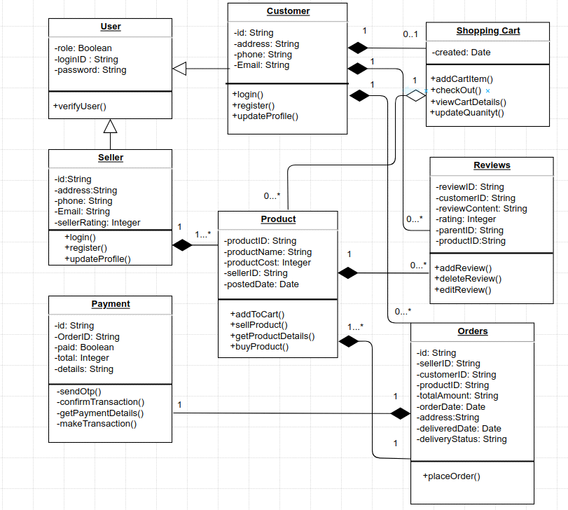

public class User {

private boolean role;

private String loginID;

private String password;

// Constructor

public User(boolean role, String loginID, String password) {

this.role = role;

this.loginID = loginID;

this.password = password;

}

// Getters and Setters

public boolean isRole() {

return role;

}

public void setRole(boolean role) {

this.role = role;

}

public String getLoginID() {

return loginID;

}

public void setLoginID(String loginID) {

this.loginID = loginID;

}

public String getPassword() {

return password;

}

public void setPassword(String password) {

this.password = password;

}

public void verifyUser() {

// Code to verify user

System.out.println("The user is verified successfully!!!");

}

}

public class Customer extends User {

private String id;

private String address;

private String phone;

private String email;

// Constructor

public Customer(String id, String address, String phone, String email) {

this.id = id;

this.address = address;

this.phone = phone;

this.email = email;

}

// Getters and Setters

public String getId() {

return id;

}

public void setId(String id) {

this.id = id;

}

public String getAddress() {

return address;

}

public void setAddress(String address) {

this.address = address;

}

public String getPhone() {

return phone;

}

public void setPhone(String phone) {

this.phone = phone;

}

public String getEmail() {

return email;

}

public void setEmail(String email) {

this.email = email;

}

public void login() {

// Code for customer login functionality

System.out.println("Logged in successfully!");

}

public void register() {

// Code for customer registration functionality

System.out.println("User registered Successfully!");

}

public void updateProfile() {

// Code for updating customer profile

System.out.println("Profile updated successfully!");

}

}

public class Seller extends User {

private String id;

private String address;

private String phone;

private String email;

private int sellerRating;

// Constructor

public Seller(String id, String address, String phone, String email, int sellerRating) {

this.id = id;

this.address = address;

this.phone = phone;

this.email = email;

this.sellerRating = sellerRating;

}

// Getters and Setters

public String getId() {

return id;

}

public void setId(String id) {

this.id = id;

}

public String getAddress() {

return address;

}

public void setAddress(String address) {

this.address = address;

}

public String getPhone() {

return phone;

}

public void setPhone(String phone) {

this.phone = phone;

}

public String getEmail() {

return email;

}

public void setEmail(String email) {

this.email = email;

}

public int getSellerRating() {

return sellerRating;

}

public void setSellerRating(int sellerRating) {

this.sellerRating = sellerRating;

}

public void login() {

// Code for customer login functionality

System.out.println("Logged in successfully!");

}

public void register() {

// Code for customer registration functionality

System.out.println("User registered Successfully!");

}

public void updateProfile() {

// Code for updating customer profile

System.out.println("Profile updated successfully!");

}

}

import.java.util.Date;

class ShoppingCart extends Customer {

public void c() {

Customer c = new Customer(); // Composition

c.login();

}

private Date created;

public Date getCreated() {

return created;

}

public void setCreated(Date created) {

this.created = created;

}

public void addCartItem() {

// Code to add an item to the shopping cart

System.out.println("Item added successfully!");

}

public void checkOut() {

// Code to process the checkout of the shopping cart

System.out.println("Let's checkout!");

}

public void viewCartDetails() {

// Code to display the details of the shopping cart

System.out.println("Let's view the cart details!");

}

public void updateQuantity() {

// Code to update the quantity of an item in the shopping cart

System.out.println("Let's update the quantity!");

}

}

import.java.util.Date;

class Product extends Seller {

public void l() {

Seller l = new Seller(); // Composition

l.login();

}

private String productID;

private String productName;

private int productCost;

private String sellerID;

private Date postedDate;

// Getters and Setters

public String getProductID() {

return productID;

}

public void setProductID(String productID) {

this.productID = productID;

}

public String getProductName() {

return productName;

}

public void setProductName(String productName) {

this.productName = productName;

}

public int getProductCost() {

return productCost;

}

public void setProductCost(int productCost) {

this.productCost = productCost;

}

public String getSellerID() {

return sellerID;

}

public void setSellerID(String sellerID) {

this.sellerID = sellerID;

}

public Date getPostedDate() {

return postedDate;

}

public void setPostedDate(Date postedDate) {

this.postedDate = postedDate;

}

public void addToCart() {

// Add the product to the cart

System.out.println("Added to cart successfully!");

}

public void sellProduct() {

// Sell the product

System.out.println("The product is being sold successfully!");

}

public void getProductDetails() {

// Retrieve and display the product details

System.out.println("Product details fetched successfully!");

}

public void buyProduct() {

// Buy the product

System.out.println("Product bought successfully!");

}

}

class Reviews extends Customer {

public void u() {

Customer u = new Customer(); // Composition

u.updateProfile();

}

private String reviewID;

private String customerID;

private String reviewContent;

private int rating;

private String parentID;

private String productID;

// Getters and Setters

public String getReviewID() {

return reviewID;

}

public void setReviewID(String reviewID) {

this.ReviewID = reviewID;

}

public String getCustomerID() {

return customerID;

}

public void setCustomerID(String customerID) {

this.customerID = customerID;

}

public String getReviewContent() {

return reviewContent;

}

public void setReviewContent(String reviewContent) {

this.reviewContent = reviewContent;

}

public int getRating() {

return rating;

}

public void setRating(int rating) {

this.rating = rating;

}

public String getParentID() {

return parentID;

}

public void setParentID(String parentID) {

this.parentID = parentID;

}

public String getProductID() {

return productID;

}

public void setProductID(String productID) {

this.productID = productID;

}

public void addReview() {

// Code to add a review

System.out.println("Review added successfully!");

}

public void deleteReview() {

// Code to delete a review

System.out.println("Review deleted successfully!");

}

public void editReview() {

// Code to edit a review

System.out.println("Review edited successfully!");

}

}

class Payment extends Orders {

public void u() {

Customer u = new Customer(); // Composition

u.updateProfile();

}

private String id;

private String orderID;

private boolean paid;

private int total;

private String details;

// Getters and Setters

public String getId() {

return id;

}

public void setId(String id) {

this.id = id;

}

public String getOrderID() {

return orderID;

}

public void setOrderID(String orderID) {

this.orderID = orderID;

}

public boolean isPaid() {

return paid;

}

public void setPaid(boolean paid) {

this.paid = paid;

}

public int getTotal() {

return total;

}

public void setTotal(int total) {

this.total = total;

}

public String getDetails() {

return details;

}

public void setDetails(String details) {

this.details = details;

}

public void sendOTP() {

// Code for sending OTP

System.out.println("OTP sent successfully!");

}

public void confirmTransaction() {

// Code for confirming the transaction

System.out.println("Transaction confirmed!");

}

public void getPaymentDetails() {

// Code for retrieving payment details

System.out.println("Payment details fetched successfully!");

}

public void makeTransaction() {

// Code for making the transaction

System.out.println("Transaction done successfully!");

}

}

class Orders extends Customer {

public void p() {

Payment p = new Payment(); // Composition

p.placeOrder();

}

private String id;

private String sellerID;

private String customerID;

private String productID;

private String totalAmount;

private Date orderDate;

private String address;

private Date deliveredDate;

private String deliveryStatus;

// Getters and Setters

public String getId() {

return id;

}

public void setId(String id) {

this.id = id;

}

public String getSellerID() {

return sellerID;

}

public void setSellerID(String sellerID) {

this.sellerID = sellerID;

}

public String getCustomerID() {

return customerID;

}

public void setCustomerID(String customerID) {

this.customerID = customerID;

}

public String getProductID() {

return productID;

}

public void setProductID(String productID) {

this.productID = productID;

}

public String getTotalAmount() {

return totalAmount;

}

public void setTotalAmount(String totalAmount) {

this.totalAmount = totalAmount;

}

public Date getOrderDate() {

return orderDate;

}

public void setOrderDate(Date orderDate) {

this.orderDate = orderDate;

}

public String getAddress() {

return address;

}

public void setAddress(String address) {

this.address = address;

}

public Date getDeliveredDate() {

return deliveredDate;

}

public void setDeliveredDate(Date deliveredDate) {

this.deliveredDate = deliveredDate;

}

public String getDeliveryStatus() {

return deliveryStatus;

}

public void setDeliveryStatus(String deliveryStatus) {

this.deliveryStatus = deliveryStatus;

}

public void placeOrder() {

// Code to place an order

System.out.println("Order placed successfully!");

}

}