**Name: Tejas Shinde**

**Email: tejas.shinde@pwc.com**

**Assignment 1: Calculator**

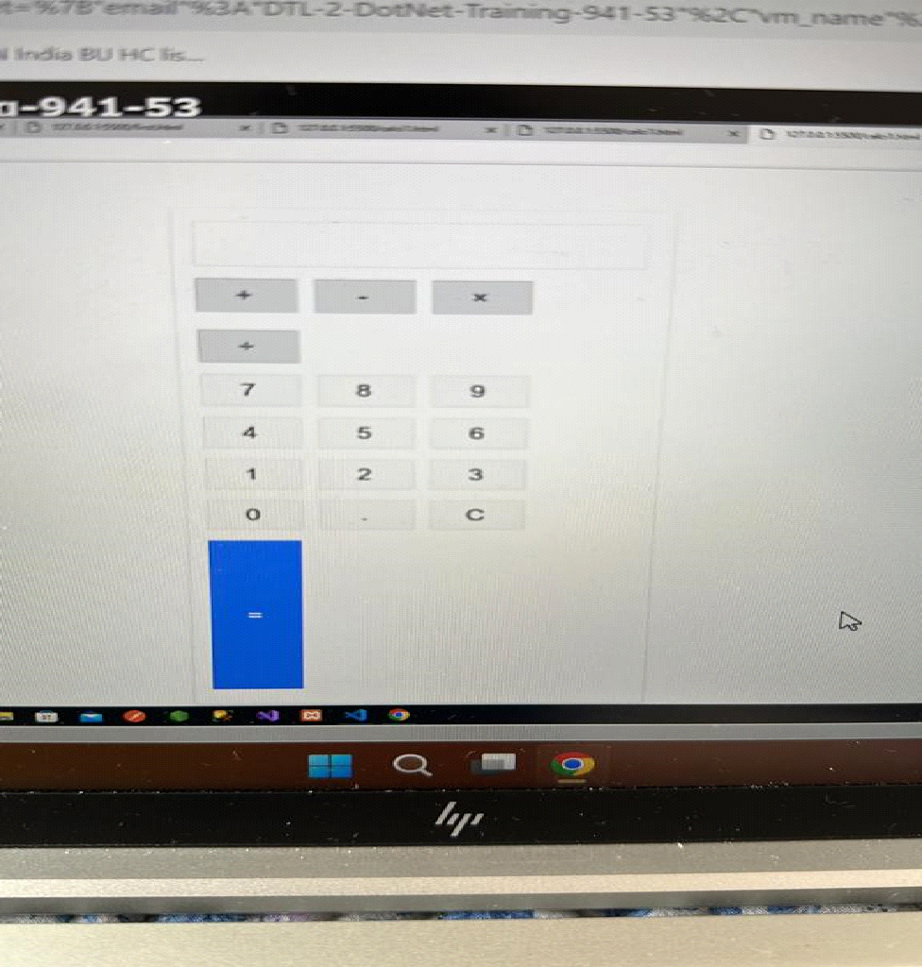

Code:

**HTML code:**

| <!DOCTYPE html> <html lang="en"> <head>  <link rel="stylesheet" href="calci2.css">  <title>Calulator</title> </head> <body>  <div class="main">  <input type="text" id = 'res'>  <div class="btn">  <input type="button" value = 'C' onclick = "Clear()">  <input type="button" value = '%' onclick = "Solve('%')">  <input type="button" value = '←' onclick ="Back('←')">  <input type="button" value = '/' onclick = "Solve('/')">  <br>  <input type="button" value = '7' onclick = "Solve('7')">  <input type="button" value = '8' onclick = "Solve('8')">  <input type="button" value = '9' onclick = "Solve('9')">  <input type="button" value = 'x' onclick = "Solve('*')">  <br>  <input type="button" value = '4' onclick = "Solve('4')">  <input type="button" value = '5' onclick = "Solve('5')">  <input type="button" value = '6' onclick = "Solve('6')">  <input type="button" value = '-' onclick = "Solve('-')">  <br>  <input type="button" value = '1' onclick = "Solve('1')">  <input type="button" value = '2' onclick = "Solve('2')">  <input type="button" value = '3' onclick = "Solve('3')">  <input type="button" value = '+' onclick = "Solve('+')">  <br>  <input type="button" value = '00'onclick = "Solve('00')">  <input type="button" value = '0' onclick = "Solve('0')">  <input type="button" value = '.' onclick = "Solve('.')">  <input type="button" value = '=' onclick = "Result()">  </div>  </div>  <script src = 'calci3.js' ></script> </body> </html> |
| --- |

**CSS Code:**

| *{  padding: 0;  margin: 0;  font-family: 'poppins', sans-serif; } body{  background-color: *#495250;*  display: grid;  height: 100vh;  place-items: center; } .main{  width: 400px;  height: 450px;  background-color: white;  position: absolute;  border: 5px solid black;  border-radius: 6px;  } .main input[type='text'] {  width: 88%;  position: relative;  height: 80px;  top: 5px;  text-align: right;  padding: 3px 6px;  outline: none;  font-size: 40px;  border: 5px solid black;  display: flex;  margin: auto;  border-radius: 6px;  color: black; } .btn input[type='button']{  width:90px;  padding: 2px;  margin: 2px 0px;  position: relative;  left: 13px;  top: 20px;  height: 60px;  cursor: pointer;  font-size: 18px;  transition: 0.5s;  background-color: *#495250;*  border-radius: 6px;  color: white; } .btn input[type='button']:hover{  background-color: black;  color: white; } |
| --- |

**JS Code:**

| function Solve(val) {  var v = document.getElementById('res');  v.value += val; } function Result() {  var num1 = document.getElementById('res').value;  var num2 = eval(num1);  document.getElementById('res').value = num2; } function Clear() {  var inp = document.getElementById('res');  inp.value = ''; } function Back() {  var ev = document.getElementById('res');  ev.value = ev.value.slice(0,-1); }` |
| --- |

**Assignment 2 :**

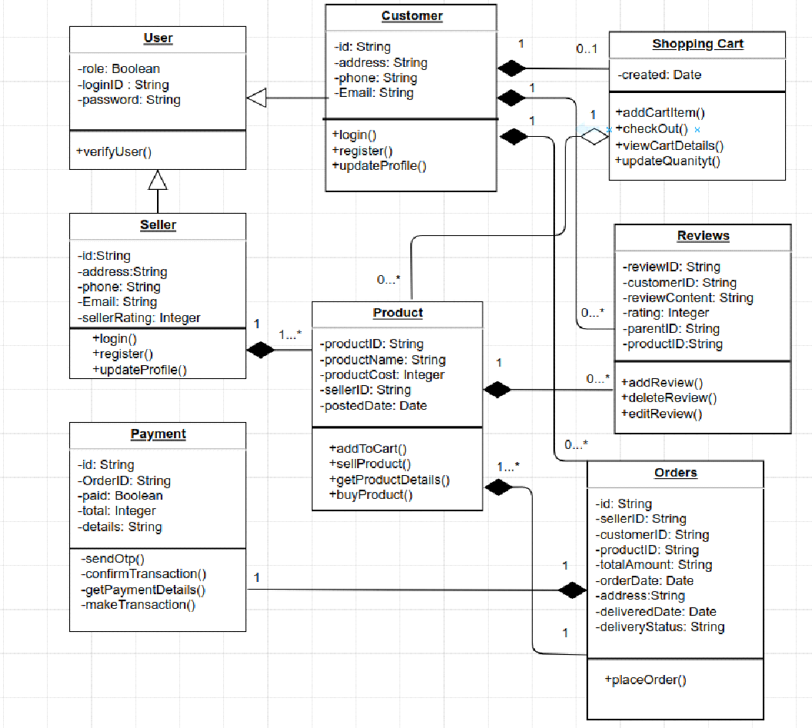

| User.java public **class** **User** {  **private** **boolean** **role**;  **private** **String** **loginID**;  **private** **String** **password**;    // **Constructor**  **public** **User**(boolean role, String loginID, String password) {  **this**.**role** = **role**;  **this**.**loginID** = **loginID**;  **this**.**password** = **password**;  }    // **Getters** **and** **Setters**  **public** **boolean** **isRole**() {  **return** **role**;  }   **public** **void** **setRole**(boolean role) {  **this**.**role** = **role**;  }   **public** **String** **getLoginID**() {  **return** **loginID**;  }   **public** **void** **setLoginID**(String loginID) {  **this**.**loginID** = **loginID**;  }   **public** **String** **getPassword**() {  **return** **password**;  }   **public** **void** **setPassword**(String password) {  **this**.**password** = **password**;  }   **public** **void** **verifyUser**() {  // **Code** **to** **verify** **user**  **System**.**out**.**println**("The user is verified successfully!!!");  } } **Customer**.**java** **public** **class** **Customer** **extends** **User** {  **private** **String** **id**;  **private** **String** **address**;  **private** **String** **phone**;  **private** **String** **email**;    // **Constructor**  **public** **Customer**(String id, String address, String phone, String email) {  **this**.**id** = **id**;  **this**.**address** = **address**;  **this**.**phone** = **phone**;  **this**.**email** = **email**;  }    // **Getters** **and** **Setters**  **public** **String** **getId**() {  **return** **id**;  }    **public** **void** **setId**(String id) {  **this**.**id** = **id**;  }    **public** **String** **getAddress**() {  **return** **address**;  }    **public** **void** **setAddress**(String address) {  **this**.**address** = **address**;  }    **public** **String** **getPhone**() {  **return** **phone**;  }    **public** **void** **setPhone**(String phone) {  **this**.**phone** = **phone**;  }    **public** **String** **getEmail**() {  **return** **email**;  }    **public** **void** **setEmail**(String email) {  **this**.**email** = **email**;  }   **public** **void** **login**() {  // **Code** **for** **customer** **login** **functionality**  **System**.**out**.**println**("Logged in successfully!");  }   **public** **void** **register**() {  // **Code** **for** **customer** **registration** **functionality**  **System**.**out**.**println**("User registered Successfully!");  }   **public** **void** **updateProfile**() {  // **Code** **for** **updating** **customer** **profile**  **System**.**out**.**println**("Profile updated successfully!");  } } **Seller**.**java** **public** **class** **Seller** **extends** **User** {  **private** **String** **id**;  **private** **String** **address**;  **private** **String** **phone**;  **private** **String** **email**;  **private** **int** **sellerRating**;    // **Constructor**  **public** **Seller**(String id, String address, String phone, String email, int sellerRating) {  **this**.**id** = **id**;  **this**.**address** = **address**;  **this**.**phone** = **phone**;  **this**.**email** = **email**;  **this**.**sellerRating** = **sellerRating**;  }    // **Getters** **and** **Setters**  **public** **String** **getId**() {  **return** **id**;  }    **public** **void** **setId**(String id) {  **this**.**id** = **id**;  }    **public** **String** **getAddress**() {  **return** **address**;  }    **public** **void** **setAddress**(String address) {  **this**.**address** = **address**;  }    **public** **String** **getPhone**() {  **return** **phone**;  }    **public** **void** **setPhone**(String phone) {  **this**.**phone** = **phone**;  }    **public** **String** **getEmail**() {  **return** **email**;  }    **public** **void** **setEmail**(String email) {  **this**.**email** = **email**;  }   **public** **int** **getSellerRating**() {  **return** **sellerRating**;  }    **public** **void** **setSellerRating**(int sellerRating) {  **this**.**sellerRating** = **sellerRating**;  }   **public** **void** **login**() {  // **Code** **for** **customer** **login** **functionality**  **System**.**out**.**println**("Logged in successfully!");  }   **public** **void** **register**() {  // **Code** **for** **customer** **registration** **functionality**  **System**.**out**.**println**("User registered Successfully!");  }   **public** **void** **updateProfile**() {  // **Code** **for** **updating** **customer** **profile**  **System**.**out**.**println**("Profile updated successfully!");  } } **ShoppingCart**.**java** **import**.**java**.**util**.**Date**;  **class** **ShoppingCart** **extends** **Customer** {   **public** **void** **c**() {  **Customer** **c** = **new** **Customer**(); // **Composition**  **c**.**login**();  }   **private** **Date** **created**;   **public** **Date** **getCreated**() {  **return** **created**;  }   **public** **void** **setCreated**(Date created) {  **this**.**created** = **created**;  }   **public** **void** **addCartItem**() {  // **Code** **to** **add** **an** **item** **to** **the** **shopping** **cart**  **System**.**out**.**println**("Item added successfully!");  }   **public** **void** **checkOut**() {  // **Code** **to** **process** **the** **checkout** **of** **the** **shopping** **cart**  **System**.**out**.**println**("Let's checkout!");  }   **public** **void** **viewCartDetails**() {  // **Code** **to** **display** **the** **details** **of** **the** **shopping** **cart**  **System**.**out**.**println**("Let's view the cart details!");  }   **public** **void** **updateQuantity**() {  // **Code** **to** **update** **the** **quantity** **of** **an** **item** **in** **the** **shopping** **cart**  **System**.**out**.**println**("Let's update the quantity!");  } } **Product**.**java** **import**.**java**.**util**.**Date**;  **class** **Product** **extends** **Seller** {   **public** **void** **l**() {  **Seller** **l** = **new** **Seller**(); // **Composition**  **l**.**login**();  }   **private** **String** **productID**;  **private** **String** **productName**;  **private** **int** **productCost**;  **private** **String** **sellerID**;  **private** **Date** **postedDate**;   // **Getters** **and** **Setters**  **public** **String** **getProductID**() {  **return** **productID**;  }    **public** **void** **setProductID**(String productID) {  **this**.**productID** = **productID**;  }    **public** **String** **getProductName**() {  **return** **productName**;  }    **public** **void** **setProductName**(String productName) {  **this**.**productName** = **productName**;  }    **public** **int** **getProductCost**() {  **return** **productCost**;  }    **public** **void** **setProductCost**(int productCost) {  **this**.**productCost** = **productCost**;  }   **public** **String** **getSellerID**() {  **return** **sellerID**;  }    **public** **void** **setSellerID**(String sellerID) {  **this**.**sellerID** = **sellerID**;  }    **public** **Date** **getPostedDate**() {  **return** **postedDate**;  }    **public** **void** **setPostedDate**(Date postedDate) {  **this**.**postedDate** = **postedDate**;  }   **public** **void** **addToCart**() {  // **Add** **the** **product** **to** **the** **cart**  **System**.**out**.**println**("Added to cart successfully!");  }   **public** **void** **sellProduct**() {  // **Sell** **the** **product**  **System**.**out**.**println**("The product is being sold successfully!");  }   **public** **void** **getProductDetails**() {  // **Retrieve** **and** **display** **the** **product** **details**  **System**.**out**.**println**("Product details fetched successfully!");  }   **public** **void** **buyProduct**() {  // **Buy** **the** **product**  **System**.**out**.**println**("Product bought successfully!");  } } **Reviews**.**java** **class** **Reviews** **extends** **Customer** {   **public** **void** **u**() {  **Customer** **u** = **new** **Customer**(); // **Composition**  **u**.**updateProfile**();  }   **private** **String** **reviewID**;  **private** **String** **customerID**;  **private** **String** **reviewContent**;  **private** **int** **rating**;  **private** **String** **parentID**;  **private** **String** **productID**;   // **Getters** **and** **Setters**  **public** **String** **getReviewID**() {  **return** **reviewID**;  }   **public** **void** **setReviewID**(String reviewID) {  **this**.**ReviewID** = **reviewID**;  }   **public** **String** **getCustomerID**() {  **return** **customerID**;  }   **public** **void** **setCustomerID**(String customerID) {  **this**.**customerID** = **customerID**;  }   **public** **String** **getReviewContent**() {  **return** **reviewContent**;  }   **public** **void** **setReviewContent**(String reviewContent) {  **this**.**reviewContent** = **reviewContent**;  }   **public** **int** **getRating**() {  **return** **rating**;  }   **public** **void** **setRating**(int rating) {  **this**.**rating** = **rating**;  }   **public** **String** **getParentID**() {  **return** **parentID**;  }   **public** **void** **setParentID**(String parentID) {  **this**.**parentID** = **parentID**;  }   **public** **String** **getProductID**() {  **return** **productID**;  }   **public** **void** **setProductID**(String productID) {  **this**.**productID** = **productID**;  }   **public** **void** **addReview**() {  // **Code** **to** **add** **a** **review**  **System**.**out**.**println**("Review added successfully!");  }   **public** **void** **deleteReview**() {  // **Code** **to** **delete** **a** **review**  **System**.**out**.**println**("Review deleted successfully!");  }   **public** **void** **editReview**() {  // **Code** **to** **edit** **a** **review**  **System**.**out**.**println**("Review edited successfully!");  } } **Payment**.**java** **class** **Payment** **extends** **Orders** {   **public** **void** **u**() {  **Customer** **u** = **new** **Customer**(); // **Composition**  **u**.**updateProfile**();  }   **private** **String** **id**;  **private** **String** **orderID**;  **private** **boolean** **paid**;  **private** **int** **total**;  **private** **String** **details**;   // **Getters** **and** **Setters**  **public** **String** **getId**() {  **return** **id**;  }    **public** **void** **setId**(String id) {  **this**.**id** = **id**;  }   **public** **String** **getOrderID**() {  **return** **orderID**;  }   **public** **void** **setOrderID**(String orderID) {  **this**.**orderID** = **orderID**;  }   **public** **boolean** **isPaid**() {  **return** **paid**;  }   **public** **void** **setPaid**(boolean paid) {  **this**.**paid** = **paid**;  }   **public** **int** **getTotal**() {  **return** **total**;  }   **public** **void** **setTotal**(int total) {  **this**.**total** = **total**;  }   **public** **String** **getDetails**() {  **return** **details**;  }   **public** **void** **setDetails**(String details) {  **this**.**details** = **details**;  }   **public** **void** **sendOTP**() {  // **Code** **for** **sending** **OTP**  **System**.**out**.**println**("OTP sent successfully!");  }   **public** **void** **confirmTransaction**() {  // **Code** **for** **confirming** **the** **transaction**  **System**.**out**.**println**("Transaction confirmed!");  }   **public** **void** **getPaymentDetails**() {  // **Code** **for** **retrieving** **payment** **details**  **System**.**out**.**println**("Payment details fetched successfully!");  }   **public** **void** **makeTransaction**() {  // **Code** **for** **making** **the** **transaction**  **System**.**out**.**println**("Transaction done successfully!");  } } **Orders**.**java** **class** **Orders** **extends** **Customer** {   **public** **void** **p**() {  **Payment** **p** = **new** **Payment**(); // **Composition**  **p**.**placeOrder**();  }   **private** **String** **id**;  **private** **String** **sellerID**;  **private** **String** **customerID**;  **private** **String** **productID**;  **private** **String** **totalAmount**;  **private** **Date** **orderDate**;  **private** **String** **address**;  **private** **Date** **deliveredDate**;  **private** **String** **deliveryStatus**;   // **Getters** **and** **Setters**  **public** **String** **getId**() {  **return** **id**;  }    **public** **void** **setId**(String id) {  **this**.**id** = **id**;  }   **public** **String** **getSellerID**() {  **return** **sellerID**;  }   **public** **void** **setSellerID**(String sellerID) {  **this**.**sellerID** = **sellerID**;  }   **public** **String** **getCustomerID**() {  **return** **customerID**;  }   **public** **void** **setCustomerID**(String customerID) {  **this**.**customerID** = **customerID**;  }    **public** **String** **getProductID**() {  **return** **productID**;  }   **public** **void** **setProductID**(String productID) {  **this**.**productID** = **productID**;  }   **public** **String** **getTotalAmount**() {  **return** **totalAmount**;  }   **public** **void** **setTotalAmount**(String totalAmount) {  **this**.**totalAmount** = **totalAmount**;  }   **public** **Date** **getOrderDate**() {  **return** **orderDate**;  }   **public** **void** **setOrderDate**(Date orderDate) {  **this**.**orderDate** = **orderDate**;  }   **public** **String** **getAddress**() {  **return** **address**;  }   **public** **void** **setAddress**(String address) {  **this**.**address** = **address**;  }   **public** **Date** **getDeliveredDate**() {  **return** **deliveredDate**;  }   **public** **void** **setDeliveredDate**(Date deliveredDate) {  **this**.**deliveredDate** = **deliveredDate**;  }   **public** **String** **getDeliveryStatus**() {  **return** **deliveryStatus**;  }   **public** **void** **setDeliveryStatus**(String deliveryStatus) {  **this**.**deliveryStatus** = **deliveryStatus**;  }   **public** **void** **placeOrder**() {  // **Code** **to** **place** **an** **order**  **System**.**out**.**println**("Order placed successfully!");  } } |
| --- |