**ASSIGNMENT 2**

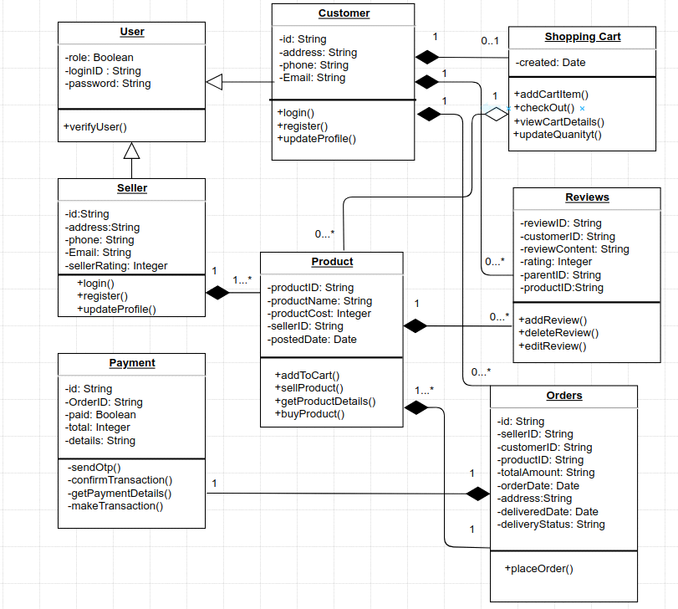

**User.java**

public class User

{

private boolean role;

private String loginID;

private String password;

// Constructor

public User(boolean role, String loginID, String password)

{

this.role = role;

this.loginID = loginID;

this.password = password;

}

// Getters and Setters

public boolean isRole()

{

return role;

}

public void setRole(boolean role)

{

this.role = role;

}

public String getLoginID()

{

return loginID;

}

public void setLoginID(String loginID)

{

this.loginID = loginID;

}

public String getPassword()

{

return password;

}

public void setPassword(String password)

{

this.password = password;

}

public void verifyUser()

{

// Code is used to verify the user

System.out.println("Successful user verification");

}

}

**Customer.java**

public class Customer extends User

{

private String id;

private String address;

private String phone;

private String email;

// Constructor

public Customer(String id, String address, String phone, String email)

{

this.id = id;

this.address = address;

this.phone = phone;

this.email = email;

}

// Getters and Setters

public String getId()

{

return id;

}

public void setId(String id)

{

this.id = id;

}

public String getAddress()

{

return address;

}

public void setAddress(String address)

{

this.address = address;

}

public String getPhone()

{

return phone;

}

public void setPhone(String phone)

{

this.phone = phone;

}

public String getEmail()

{

return email;

}

public void setEmail(String email)

{

this.email = email;

}

public void login()

{

// Login functionality for customer

System.out.println("Logged in successfully!");

}

public void register()

{

// Registration functionality for customer

System.out.println("User registered Successfully!");

}

public void updateProfile()

{

// Code for updating customer profile

System.out.println("Profile updated successfully!");

}

}

**Seller.java**

public class Seller extends User

{

private String id;

private String address;

private String phone;

private String email;

private int sellerRating;

// Constructor

public Seller(String id, String address, String phone, String email, int sellerRating)

{

this.id = id;

this.address = address;

this.phone = phone;

this.email = email;

this.sellerRating = sellerRating;

}

// Getters and Setters

public String getId()

{

return id;

}

public void setId(String id)

{

this.id = id;

}

public String getAddress()

{

return address;

}

public void setAddress(String address)

{

this.address = address;

}

public String getPhone() {

return phone;

}

public void setPhone(String phone)

{

this.phone = phone;

}

public String getEmail()

{

return email;

}

public void setEmail(String email)

{

this.email = email;

}

public int getSellerRating()

{

return sellerRating;

}

public void setSellerRating(int sellerRating)

{

this.sellerRating = sellerRating;

}

public void login()

{

// customer login functionality

System.out.println("Logged in successfully!");

}

public void register()

{

// customer registration functionality

System.out.println("User registered Successfully!");

}

public void updateProfile()

{

// customer profile updation

System.out.println("updation of profile done successfully!");

}

}

**ShoppingCart.java**

import.java.util.Date;

class ShoppingCart extends Customer

{

public void c()

{

Customer c = new Customer(); // Composition

c.login();

}

private Date created;

public Date getCreated() {

return created;

}

public void setCreated(Date created)

{

this.created = created;

}

public void addCartItem()

{

// add an item to the shopping cart

System.out.println("Item added successfully!");

}

public void checkOut()

{

// processing the checkout of the shopping cart

System.out.println("Let's checkout!");

}

public void viewCartDetails()

{

// displaying the details of the shopping cart

System.out.println("Let's view the cart details!");

}

public void updateQuantity()

{

// updating the quantity of an item in the shopping cart

System.out.println("Let's update the quantity!");

}

}

**Product.java**

import.java.util.Date;

class Product extends Seller

{

public void l()

{

Seller l = new Seller(); // Composition

l.login();

}

private String productID;

private String productName;

private int productCost;

private String sellerID;

private Date postedDate;

// Getters and Setters

public String getProductID()

{

return productID;

}

public void setProductID(String productID)

{

this.productID = productID;

}

public String getProductName()

{

return productName;

}

public void setProductName(String productName)

{

this.productName = productName;

}

public int getProductCost()

{

return productCost;

}

public void setProductCost(int productCost)

{

this.productCost = productCost;

}

public String getSellerID()

{

return sellerID;

}

public void setSellerID(String sellerID)

{

this.sellerID = sellerID;

}

public Date getPostedDate()

{

return postedDate;

}

public void setPostedDate(Date postedDate)

{

this.postedDate = postedDate;

}

public void addToCart()

{

// Adding product to the cart

System.out.println("Added to cart successfully!");

}

public void sellProduct()

{

// Selling the product

System.out.println("The product is being sold successfully!");

}

public void getProductDetails()

{

// Retrieving and displaying product details

System.out.println("Product details fetched successfully!");

}

public void buyProduct()

{

// Buy the product

System.out.println("Product bought successfully!");

}

}

**Reviews.java**

class Reviews extends Customer

{

public void u()

{

Customer u = new Customer(); // Composition

u.updateProfile();

}

private String reviewID;

private String customerID;

private String reviewContent;

private int rating;

private String parentID;

private String productID;

// Getters and Setters

public String getReviewID()

{

return reviewID;

}

public void setReviewID(String reviewID)

{

this.ReviewID = reviewID;

}

public String getCustomerID()

{

return customerID;

}

public void setCustomerID(String customerID)

{

this.customerID = customerID;

}

public String getReviewContent()

{

return reviewContent;

}

public void setReviewContent(String reviewContent)

{

this.reviewContent = reviewContent;

}

public int getRating()

{

return rating;

}

public void setRating(int rating)

{

this.rating = rating;

}

public String getParentID()

{

return parentID;

}

public void setParentID(String parentID)

{

this.parentID = parentID;

}

public String getProductID()

{

return productID;

}

public void setProductID(String productID)

{

this.productID = productID;

}

public void addReview()

{

// adding a review

System.out.println("Review added successfully!");

}

public void deleteReview()

{

// deleting a review

System.out.println("Review deleted successfully!");

}

public void editReview()

{

// editing a review

System.out.println("Review edited successfully!");

}

}

**Payment.java**

class Payment extends Orders

{

public void u()

{

Customer u = new Customer(); // Composition

u.updateProfile();

}

private String id;

private String orderID;

private boolean paid;

private int total;

private String details;

// Getters and Setters

public String getId()

{

return id;

}

public void setId(String id)

{

this.id = id;

}

public String getOrderID()

{

return orderID;

}

public void setOrderID(String orderID)

{

this.orderID = orderID;

}

public boolean isPaid()

{

return paid;

}

public void setPaid(boolean paid)

{

this.paid = paid;

}

public int getTotal()

{

return total;

}

public void setTotal(int total)

{

this.total = total;

}

public String getDetails()

{

return details;

}

public void setDetails(String details)

{

this.details = details;

}

public void sendOTP()

{

// sending OTP

System.out.println("OTP sent successfully!");

}

public void confirmTransaction()

{

// confirming the transaction

System.out.println("Transaction confirmed!");

}

public void getPaymentDetails()

{

// retrieving payment details

System.out.println("Payment details fetched successfully!");

}

public void makeTransaction()

{

// making the transaction

System.out.println("Transaction done successfully!");

}

}

**Orders.java**

class Orders extends Customer

{

public void p()

{

Payment p = new Payment(); // Composition

p.placeOrder();

}

private String id;

private String sellerID;

private String customerID;

private String productID;

private String totalAmount;

private Date orderDate;

private String address;

private Date deliveredDate;

private String deliveryStatus;

// Getters and Setters

public String getId()

{

return id;

}

public void setId(String id)

{

this.id = id;

}

public String getSellerID()

{

return sellerID;

}

public void setSellerID(String sellerID)

{

this.sellerID = sellerID;

}

public String getCustomerID()

{

return customerID;

}

public void setCustomerID(String customerID)

{

this.customerID = customerID;

}

public String getProductID()

{

return productID;

}

public void setProductID(String productID)

{

this.productID = productID;

}

public String getTotalAmount()

{

return totalAmount;

}

public void setTotalAmount(String totalAmount)

{

this.totalAmount = totalAmount;

}

public Date getOrderDate()

{

return orderDate;

}

public void setOrderDate(Date orderDate)

{

this.orderDate = orderDate;

}

public String getAddress()

{

return address;

}

public void setAddress(String address)

{

this.address = address;

}

public Date getDeliveredDate()

{

return deliveredDate;

}

public void setDeliveredDate(Date deliveredDate)

{

this.deliveredDate = deliveredDate;

}

public String getDeliveryStatus()

{

return deliveryStatus;

}

public void setDeliveryStatus(String deliveryStatus)

{

this.deliveryStatus = deliveryStatus;

}

public void placeOrder()

{

// placing order

System.out.println("Order placed successfully!");

}

}

**Submitted by:**

Gourab Nag  
PwC | Advisory  
Mobile: 7278580166  
Email: gourab.nag@pwc.com  
PricewaterhouseCoopers Private Limited