Plug-In SDK

Date | Version | Information | Author
2012-3-22 | 1.0 | create | ybk
2012-4-12 | 1.1 | Add tuner control | ybk
2012-5-22 | 1.2 | Change Compile script | chris

1 Introduction 5
2 Managing Projects 5
3 Building 5
4 Running 6
5 STB and Plug-in 7
5.1 Communication between Plug-in and STB 8
5.2 Plug-in Running Process 9
5.3 Plug-in GUI Running Process 10
5.4 The Important Function of Plug-in 11
6 GUI 12
6.1 Basic Concepts 12
6.2 A Simple GUI Program 12
6.3 Window System and Window 19
6.3.1 Concept of Window 19
6.3.2 Creating Window and Window Type 20
6.3.3 Window Style 20
6.3.4 Destroying Main Window 21
6.4 Important Window Function 21
6.4.1 YWGUI_DestroyMainWindow 21
6.4.2 YWGUI_SetWinProc 21
6.4.3 YWGUI_ShowWindow 21
6.4.4 YWGUI_UpdateShapeState 21
6.4.5 YWGUI_UpdateWindow 22
6.4.6 YWGUI_MoveWindow 22
6.4.7 YWGUI_EnableWindow 22
6.4.8 YWGUI_InvalidateRect 22
6.4.9 YWGUI_Invalidate 22
6.4.10 YWGUI_GetActiveMainHWnd 23
6.4.11 YWGUI_IsWindowVisible 23
6.4.12 YWGUI_IsWindowEnabled 23
6.4.13 YWGUI_GetMainWinById 23
6.4.14 YWGUI_GetMainWinId 23
6.4.15 YWGUI_SetFocus 23
6.4.16 YWGUI_GetFocus 23
6.4.17 YWGUI_GetHosting 24
6.4.18 YWGUI_SetWindowText 24
6.4.19 YWGUI_GetWindowTextLength 24
6.4.20 YWGUI_GetWindowText 24
6.4.21 YWGUI_SetTimer 24
6.4.22 YWGUI_KillTimer 24
6.4.23 YWGUI_ResetTimer 24
6.4.24 YWGUI_CreateDialog 25
6.4.25 YWGUI_DefaultDialogProc 25
6.4.26 YWGUI_GetDlgItem 25
6.4.27 YWGUI_GetDlgCtrlID 25
6.4.28 YWGUI_GetWindowRectInScreen 25
6.4.29 YWGUI_GetWindowRectInParent 25
6.4.30 YWGUI_GetWindowRect 25
6.4.31 YWGUI_PostMessage 26
6.4.32 YWGUI_SendMessage 26
6.5 Message and Message Handling 26
6.5.1 Message Type 26
6.5.2 Sending and Posting Message 27
6.6 Timer 28
7 Control 30
7.1 Control and Control Class 30
7.2 Topics Involved in Control Programming 30
7.3 Static Control 31
7.3.1 Style of Static Control 31
7.3.2 Function of Static Control 32
7.4 Picture Control 32
7.5 Button Control 32
7.5.1 Style of Button Control 33
7.5.2 Notification Codes of Button 33
7.5.3 Function of Button Control 33
7.6 List Table Control 33
7.6.1 Types and Styles of List Table 34
7.6.2 Notification Codes of List Table 34
7.6.3 Functions of List Table 34
8 Resource 36
8.1 String 36
8.1.1 The location of Strings 36
8.1.2 The Function of String 36
8.2 Image 37
8.2.1 Load and Unload Image 37
8.2.2 Show Image in Picture Control 37
9 Internet TV 37
9.1 Needed Resource 38
9.2 Play Process 38
9.3 The Important Function 39
93.1 YW_ErrorType_T YWNATIVE_Init(void) 39
9.3.2 YW_ErrorType_T YWNATIVE_Term(void) 39
9.3.3 YW_ErrorType_T YWNATIVE_GetFreeHandle(S8* pcType, U32* puIndetifer) 39
9.3.4 YW_ErrorType_T YWNATIVE_ReleaseHandle(U32 identifier) 39
9.3.5 YW_ErrorType_T YWNATIVE_AvPLay(U32 Identifier, U8 * url, U16* videoPId, U16 * audioPid, U16 * pcrPid, U32 * pos, U32* speed, U8 *videoCodec, U8 * audioCodec, U8 * container) 39
9.3.6 YW_ErrorType_T YWNATIVE_AvStop(U32 identifier) 42
9.3.7 YW_ErrorType_T YWNATIVE_AvPause(U32 identifier); 42
9.3.8 YW_ErrorType_T YWNATIVE_AvResume(U32 identifier); 42
9.3.9 YW_ErrorType_T YWNATIVE_AvGetDuration(U32 identifier, U32* duration); 43
9.3.10 YW_ErrorType_T YWNATIVE_AvGetState(U32 identifier, S32* state); 43
9.3.11 YW_ErrorType_T YWNATIVE_AvGetPos(U32 identifier, U32* pos); 43
9.3.12 YW_ErrorType_T YWNATIVE_AvSetPos(U32 identifier, U32 pos); 43
9.3.13 YW_ErrorType_T YWNATIVE_AvSetWin(U32 identifier, S16 x, S16 y, S16 w, S16 h); 44
9.3.14 YW_ErrorType_T YWNATIVE_AvSetVol(U32 identifier, U8 vol); 44
9.3.15 YW_ErrorType_T YWNATIVE_AvGetVol(U32 identifier, U8 * vol); 44
9.3.16 YW_ErrorType_T YWNATIVE_AvSetSpeed(U32 identifier, S32 speed); 44
9.3.17 YW_ErrorType_T YWNATIVE_AvGetSpeed(U32 identifier, S32 *speed); 44
9.3.18 YW_ErrorType_T YWNATIVE_AvMute(U32 identifier, BOOL bMute); 44
9.4 Checking play state 45
10 Tuner Control 47
11 Others API Function 47
12 Tools 47

1 Introduction
Plug-in SDK provides the environment for developing plug-in on SPARK platform, including the GUI system and variety of API functions. Using these, you can develop applications based on Linux DVB API, internet TV, and applications based on Linux standard devices.
This file focuses on how to use the plug-in SDK to develop plug-in applications, introduces the description of the SDK tree, the program development and operation, the GUI system, the API functions, the interaction between SPARK STB and plug-in etc.

2 Managing Projects
Projects act as containers for storing things such as code and resource files. The SDK tools expect your project to follow a specific structure so it can compile your application correctly. The following directories and files comprise a plug-in project.
1, app/
Contains the program initialization file: main.c, GUI initialization file: gui.c, public control files: general_info.c, rename.c, public control template files: res_layout.c, and the application source code directory, such as camconfig.
2, inc/
The system header files in the SDK.
3, lib/
The library files, including the GUI library, the XML library, etc.
4, src/
Contains the SDK source code files.
5, tool/
The SDK tools file.
6, other files
Contains the makefile, setenv.sh, make.sh, clean.sh plugin.mak, which are used to compile the project, and generate the required executable file.

3 Building
1, Set the environment for applications.
Open plugin.mak file, and find “CROSS_COMPILE”:
CROSS_COMPILE = /opt/STM/STLinux-2.3/devkit/sh4/bin/sh4-linux-

CC = $(CROSS_COMPILE)gcc
CXX = $(CROSS_COMPILE)g++
STRIP = $(CROSS_COMPILE)strip
AR = $(CROSS_COMPILE)ar
The above variables define the location of the compiler. Give the various options the correct path.
2, Write source code
Create you own project directory under app/, for example camconfig, and then accomplish source code files in the new folder.
3, Write the makefile file
include $(PLUGINROOT)/plugin.mak

TARGET = camconfig.a

####################OBJS##############################

OBJS = camcfg.o camcfg_layout.o

$(TARGET):$(OBJS)
$(BUILD_LIBRARY)

clean:
$(echo) " RM $(wildcard *.o *.d *.a*~)"
$(Q)$(RM) $(wildcard *.o *.d *.bak *.a *~)
Add makefile files to the new directory for the project. According to these files, the compiler can compile the project correctly in the directory. An example is given above.
4, Execute the script
. make.sh camconfig
Run the script file make.sh in the SDK directory to build the application. If anything is ok, you will get the desired target file. The script of make.sh needs the project name (camconfig) as the parameter. The target’s name is like plugin_xxx.

4 Running
1, Get the target binary file, copy it to the set-top-box. The path is:
/root/plugin/var/bin
Copy the picture files to the above path.
/root/plugin/var/
2, Run the plug-in from the set-top-box
Using the remoter to come to the Plug in menu on STB, you will see the new added plug-in file. Choose the file, and press OK button to run the program. After the plug-in is running, you can see the state of the current item is changed.
3, Open the plug-in GUI menu
If the plug-in program realizes the GUI menu, and at same time, it is running, you can use the red button of the remoter to open the GUI menu.
4, Exit from the plug-in GUI menu
Using the exit key to exit plug-in GUI menu, return to the list menu of Plug in.
5, Exit running state
Highlight the item, and then press ok button, the running plug-in will be killed to stop state. You can see the state icon is changed.

5 STB and Plug-in
STB and plug-in programs communicate with each other through FIFO. For the FIFO has been half duplex, the STB and the plug-in application both create a FIFO, shown as below:
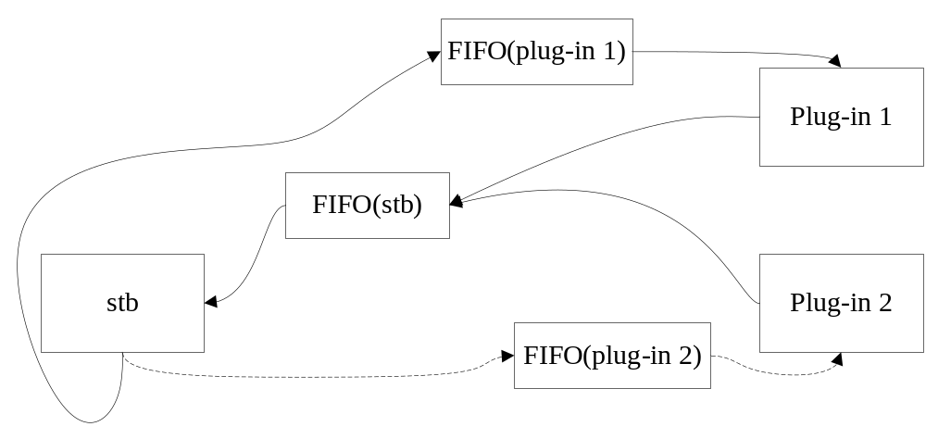
FIFO (stb): waiting for message from plug-in programs.
FIFO (plug-in): waiting for message from STB.
STB start a plug-in using “system” function, and stop the program using “kill” command.

5.1 Communication between Plug-in and STB
The communication between Plug-in and STB is shown as below:
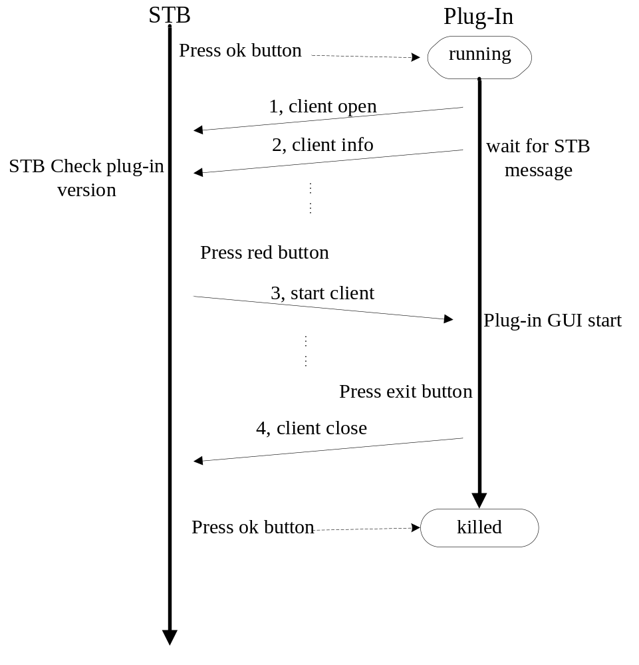
In order to communicate with plug-in, the STB creates a well-know STB FIFO when start up, waiting for message from the plug-in. After running, the plug-in program write messages to the STB FIFO, and create a plug-in FIFO with is name to receive message from STB. So the STB and plug-in both know the two FIFO, through which, the can communicate with each other.
Detail process is shown as above:
1, the user press ok button in Plug-in menu, if the selected plug-in is running, which will be killed, otherwise, the plug-in is started by STB.
2, the plug-in program send message (CLIENT_OPEN) to STB after running.
3, the plug-in program send message (CLIENT_INFO) to STB.
4, the plug-in program runs into a circulation, waiting for message from STB.
5, if the STB receives the version of the plug-in, it will check whether it is valid. If receives an illegal version, the STB will give an error message, prompt the users the wrong version.
6, if the version is valid, STB will send start message (SER_START_CLIENT) to plug-in when user press red button. And if the plug-in realizes GUI system, the GUI menu will be shown.
7, if the user press exit key to exit plug-in GUI menu, plug-in will send close message (CLIENT_CLOSE) to STB to notify the plug-in GUI has stopped.
8, now, if the user press red button, continue with step 6, else if the user press OK button, the STB kill the process of the plug-in to stop the program. For again run the plug-in, go to step 1.

5.2 Plug-in Running Process
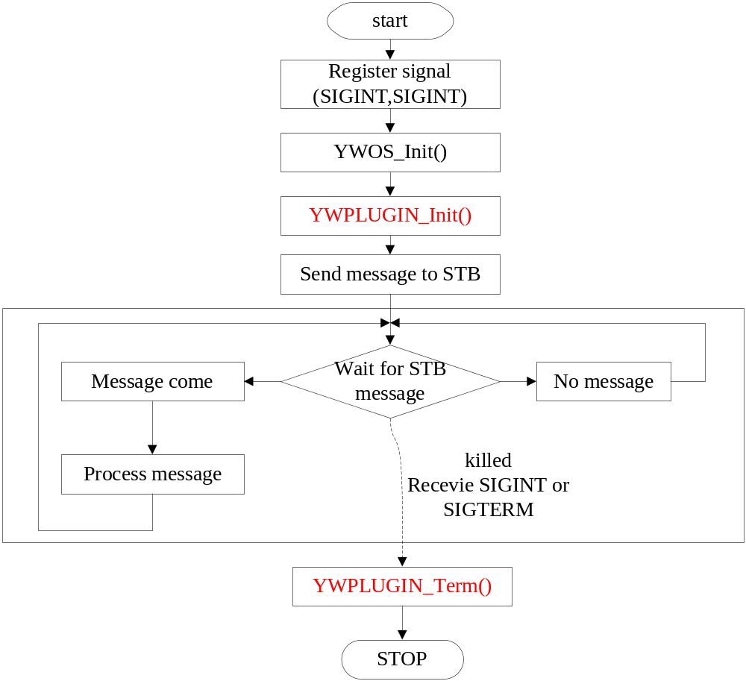
Firstly, the plug-in program does initialization when the program starts to run, Then, it will call the YWPLUGIN_init() function. Finally it will maintain a loop, waiting for messages form the STB.
If the plug-in receive a message, then handle the message, else, continue to wait until it be killed. One of important messages is SER_START_CLIENT, which is to notify plug-in to start the GUI system.
In plug-in menu of STB, when the user press OK button to stop the plug-in, the plug-in will receive the SIGTERM signal, causing the execution of clear function.
The Process is shown as follows:
1, register signal SIGINT and SIGTERM, listen to whether the current plug-in program terminates. If the signal is received, then do clear process.
2, do OS initialization.
3, call function YWPLUGIN_Init(). This is a standard function, filled by the user. Initialization source code of the plug-in can write here.
4, send message to STB to notify the plug-in program is running.
5, wait for the STB messages until it be killed.
6, if program receive signal SIGINT or SIGTERM, indicate that the program terminated. Then call signal processing functions. At this time, the function YWPLUGIN_Term() is called, it same as the function YWPLUGIN_Init(), should be accomplished by user. The release of resources can write here.

5.3 Plug-in GUI Running Process
After initialization of GUI, the system will call standard predefined functions to create the first main window. Then, come into a message loop. The process is as shown below:
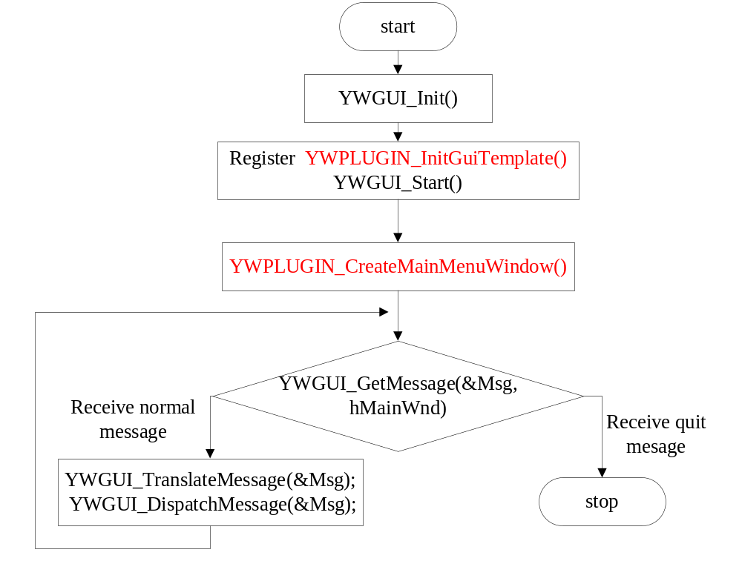

Plug-in start GUI when receive SER_START_CLIENT message. Then the GUI system creates a message queue to wait messages until exit to GUI system.
1, GUI system initialization.
2, call YWGUI_Start() function, it will use YWPLUGIN_InitGuiTemplate() function to register window templates.
3, create the first main window using YWPLUGIN_CreateMainMenuWindow() function.
4, come into a message loop. If receive message, send the message to corresponding window procedure.
5, if receive quit message, exit the GUI system.

5.4 The Important Function of Plug-in
Using the plug-in system, user should complete the following standard predefined functions.
1, plug-in initialization function.
void YWPLUGIN_Init(void)
Write the initialization source code in this function, it will be called when plug-in initialization is completed.

2, terminative function
void YWPLUGIN_Term(void)

Called before the stop of the plug-in, perform the clean-up task.

3, GUI template registration function
void YWPLUGIN_InitGuiTemplate(void)
If the plug-in realizes the GUI system, put template registration functions here.

4, Create the first main window
YWGUI_HWnd_T YWPLUGIN_CreateMainMenuWindow(void)
User should use this function to create the first main window. The function is called when plug-in GUI system initialization is completed

5，Obtain the current version
S8* YWPLUGIN_GetVersion(void)
Return the current version of the plug-in program.

6 GUI

6.1 Basic Concepts
GUI is a graphics user interface support system, and general GUI programming concepts are all suitable for plug-in GUI programming, such as window and event driven programming etc.
In the GUI graphics system model, actions of remoter generate events that are continuously checked by application. These events are generally sent to the focused window, and are transferred by application to procedures related to this window for handling. These window procedures are generally defined by application, or one of some standard procedures. Operating system, event-handling procedure of other windows, and application all can generate events.
Application can require redrawing the whole or part of the window by calling some system functions, which are usually handled by window procedures.
In order to maintain the design of the user interface separately from the source code that defines the application’s behavior, the window template is defined in xxx_layout.c files. The window procedures will not contain the layout using views. In this way, the code will be more clear, and easy to modify.
The window procedures handle the action of event, and the logical processing. The style defines the window’s position, size, shape, and controls. In GUI system, each window and control has an ID which is distinctive with each other. According the ID, you can find the corresponding window or control easily.

6.2 A Simple GUI Program
1) Create a project directory named camconfig under app/, and create two c files and correspond header files in the new directory. Now, you have four files: camcfg_layout.c, camcfg.c, camcfg_layout.h, camcfg.h.
camcfg.c is used to store window procedures, and the camcfg_layout.c file is used to store window templates.

2) In camcfg_layout.c file:
#include "ywgui_ext.h"
#include "res_layout.h"
#include "camcfg_layout.h"
The three header files included in the beginning of camcfg_layout.c.
  - ywgui_ext.h Includes definitions of global and general interface functions and miscellaneous functions.
  - res_layout.h Includes definitions of general data structure of style.
  - camcfg_layout.h Includes definitions of window templates and window ID of camcfg_layout.c.

3) The window template definition, in camcfg_layout.c
const YWGUI_DlgTemplate_T g_template_netclntcfg =
{
IDD_NET_CLIENT_CONFIG, /*window ID*/
YWGUI_WS_VISIBLE,
YWGUI_WS_EX_NONE,
300, /*pos_x*/
112, /*pos_y*/
1320, /*width*/
856, /*height*/
-1,
YWGUI_ARRAY_SIZE(g_ctrl_template_netclntcfg), /*control windows*/
g_ctrl_template_netclntcfg,
0,
NULL
};
  - IDD_NET_CLIENT_CONFIG The window ID, which is defined in camcfg_layout.h.
  - YWGUI_WS_VISIBLE The initial window is visible.
  - 300，112，1320，856 The window size.
  - -1 No title.
  - g_ctrl_template_netclntcfg The control windows.

4) The control windows, in camcfg_layout.c

static YWGUI_CtrlTemplate_T g_ctrl_template_netclntcfg[] =
{

/*title text*/
{
(const S8*)YWGUI_CTRL_STATIC,
YWGUI_WS_VISIBLE|YWGUI_SS_CENTER|YWGUI_SS_VCENTER,
YWGUI_WS_EX_TRANSPARENT|YWGUI_WS_EX_TITLECTRL,
(YWPUBLIC_COMM_DLG_W-400)/2, 36, 400, 52,
IDC_TXT_NET_CFG_TITLE,
STR_EMPTY,
0,
0
},
/*button*/
{
(const S8*)YWGUI_CTRL_BUTTON,
YWGUI_WS_VISIBLE|YWGUI_BS_CENTER|YWGUI_BS_VCENTER,
YWGUI_WS_EX_NONE |YWGUI_WS_EX_NOTIFY,
_PIC_START_X, _PIC_START_Y, _BTN_W_, CTRL_COMMON_HIGH,
IDC_BTN_NET_CFG_OSCAM,
0,
0,
&g_tButtonShapeInfo
},
};

The above definition includes a static control and a button control. The template defines the control ID, size, type etc.

  - YWGUI_CTRL_STATIC: static control.
  - YWGUI_CTRL_BUTTON: button control.
  - YWGUI_WS_VISIBLE|YWGUI_SS_CENTER|YWGUI_SS_VCENTER: creating initially visible and center-aligned control.
  - YWGUI_WS_EX_TRANSPARENT|YWGUI_WS_EX_TITLECTRL: creating initially transparent control which is drawn on the frame.
  - (YWPUBLIC_COMM_DLG_W-400)/2, 36, 400, 52, the control position and size.
  - IDC_TXT_NET_CFG_TITLE: static control ID.
  - STR_EMPTY: default string ID of static control.
  - g_tButtonShapeInfo: the shape definition of button, it describes four states (normal, disable, active focus, inactive focus) of the control.

- in camcfg.c:
#include "ywgui_ext.h"
#include "res_layout.h"
#include "camcfg_layout.h"
#include "gui.h"
#include "ywos.h"
#include "ywlib.h"
#include "camcfg.h"
  - ywgui_ext.h: Includes definitions of global and general interface funxtions and miscellaneous functions.
  - res_layout.h: Includes definitions of general data structure of style.
  - camcfg_layout.h: Includes definitions of window templates and window ID of camcfg_layout.c.
  - gui.h: Includes definition of button, and general window processing functions.
  - ywos.h: Includes definition of general macro.
  - ywlib.h: Includes definition of general library functions.
  - camcfg.h: Includes definition of data structure and functions of the application.

6) The window procedure, in camcfig.c.
Defined the template of the window, then you can use the style to create window directly through the window ID.
First, the window templates need to be registered to the GUI window manager.
void YWPLUGIN_InitGuiTemplate(void)
{
YWGUI_AddTempletNode(&g_template_netclntcfg);
......
}
YWPLUGIN_InitGuiTemplate is a standard predefined function which is required for users to fill. GUI initialization will call this function.
Within the function, fill in the predefined templates, such as g_template_netclntcfg, and use YWGUI_AddTempletNode function to register to the system.
Second, create a window instance:
YWGUI_HWnd_T YWPLUGIN_CreateMainMenuWindow(void)
{
YWGUI_HWnd_T hNetClientCfg = YWGUI_NULL_HANDLE;
YW_ErrorType_T Error = YW_NO_ERROR;

Error = YWGUI_CreateDialog(IDD_NET_CLIENT_CONFIG,
YWGUI_NULL_HANDLE, YWNetClientCfgi_WndProc, 0, &hNetClientCfg);

return (YW_NO_ERROR == Error) ? hNetClientCfg : YWGUI_NULL_HANDLE;
}
The above function YWGUI_CreateDialog creates a main window according to the ID specified in the template (IDD_NET_CLIENT_CONFIG), therefore, the GUI window management knows how to draw the window, and then the window can be shown as you define before.
A function pointer is passed when creating windows. This function is procedure of the window which is used to process the event of various messages.
The function YWPLUGIN_CreateMainMenuWindow is another standard predefined function, which is used to create the initial main window for the application.
Finally, write the window procedure.
static S32 YWNetClientCfgi_WndProc(YWGUI_HWnd_T hWnd, S32 message, WPARAM wParam,LPARAM lParam)
{
switch (message)
{
case YWGUI_MSG_NCCREATE:
{
YWGUI_SetWEColor(hWnd, YWGUI_MAINWND_BGC, Color_black);
YWGUI_SetWEShapeState(hWnd, YWGUI_STATUS_NORMAL, &g_tSubMenuFrameShapeState);
break;
}
case YWGUI_MSG_PAINT:
{
YWGUI_HDc_T hdc;
YWGUI_Pixel_T OldColor;
hdc = YWGUI_BeginPaint(hWnd);
YWGUI_SetBrushColor(hdc, Color_gray, OldColor);
YWGUI_FillBox(hdc, 0, 610, 1220,4);
YWGUI_EndPaint(hWnd,hdc);
break;
}
case YWGUI_MSG_KEYDOWN:
{
U16 scancode=YWGUI_LOWORD(wParam);
switch(scancode)
{
case YWGUI_SCANCODE_EXIT:
YWGUI_SendMessage(hWnd, YWGUI_MSG_CLOSE, 0, 0);
break;
default:
break;
}
}
break;
case YWGUI_MSG_CLOSE:
break;
default:
break;
}
return YWGUI_DefaultDialogProc(hWnd,message,wParam,lParam);
}
A, window procedure function
Window procedure function is the main body of GUI program. The most work of an application happens in the window procedure function actually, because the main task of GUI program is to receive and handle various messages received by the window.
The window procedure is the function named as YWNetClientCfgi_WndProc in the camcfig.c. program. Programs may name the window procedure fuction arbitrarily.
The window procedure function always has the following prototype:
static S32 YWNetClientCfgi_WndProc(YWGUI_HWnd_T hWnd, S32 message, WPARAM wParam,LPARAM lParam)
The first argument hWnd is the handle of the window to receive messages, which is same with the return value of YWGUI_CreateDialog function and indicates the specific window to receive the message.
The second argument is an integer value indicating the received message.
The last two arguments are both 32-bit message parameters, which provide special information related to the message.

  - YWGUI_MSG_NCCREATE, this message is sent to window procedure during GUI creates a main window. You can modify the window style during the message.
  - YWGUI_SetWEColor(hWnd, YWGUI_MAINWND_BGC, Color_black)，set back color for the window background.
  - YWGUI_SetWEShapeState(), set the window display style when it is in the normal state. In this case, the function adds a framework to the window.
  - YWGUI_MSG_PAINT, this message is sent to the window procedure when the window needs to be repainted.
  - YWGUI_MSG_KEYDOWN，this message is sent to the window procedure when the application received key event. The low part of parameter wParam is the key code used to indicate key information.
  - YWGUI_SCANCODE_EXIT，exit key.
  - YWGUI_SendMessage(hWnd, YWGUI_MSG_CLOSE, 0, 0), send a message to a window. In this case, it sends a YWGUI_MSG_CLOSE message to itself. The window will be destroyed when receive this message.
  - YWGUI_DefaultDialogProc(hWnd,message,wParam,lParam), the default message handler. The message which the procedure is not processing should be passed to this function.
When the main window display on the screen, it is time to go into the message loop. The GUI maintains a message queue. After an event happens, GUI transforms the event into a message, and put the message into the message queue of the target window. Then the task of the application is to get the message from the message queue continuously and handle them.

B, Screen Output
The program executes screen output when responding to the YWGUI_MSG_PAINT message. The application gets the device context handle first by calling YWGUI_BeginPaint function, and uses it to call GDI functions to execute drawing operations. The application calls YWGUI_EndPaint function to release the device context handle after the drawing is completed.

C, Exit of the Program
The application will call YWGUI_DestroyWidgetWindow function to destroy the main window when it receives the YWGUI_MSG_CLOSE message.

6.3 Window System and Window

6.3.1 Concept of Window
A window is a rectangle region on the screen. In traditional windowing system model, the vision part is comprised of one or more windows. Each window represents one drawing region on the screen, and the window system controls the mapping of the drawing region to the actual screen, that is, to control the position, size, and vision of the window. Each window is allocated a screen drawing screen region to display part or whole of the window, even if it is not allocated screen region at all (this window is overlapped and hidden by other overlap windows).

Overlapping windows on the screen generally has the following relationship:
- Windows are generally organized in the form of hierarchy (or form of tree structure).
- All the other windows have parent windows except the root window, and each window may have child windows, brother windows, ancestor windows, or descendant windows etc.
- A child window is contained in a parent window, and the child windows of the same parent window are regarded as windows of the same level.
- The visibility of overlapped windows depends on their relationship. A window is visible only when its parent window is visible, and its parent window can clip a child window.
- Windows of the same level can be overlapped, but only one window can be outputted to the overlapped region at a time.
- A frame window/main window comprises a usable client region and a decorate region (also referred as “non client region”) managed by the windowing system.
- Windows have subordinate relationship, that is, their owner determines the life cycle and visibility of some windows. A parent window generally owns their child windows.

An application window usually includes the following parts:
- A visible border.
- A window ID, which is used by programs to operate the window and is referred as “window handle” in GUI.
- Some other characteristics, such as, height, width and background color etc.
- Additional window elements such as menu and scrollbars may exist.

The relationship between child controls and window:
- If the child controls are draw on the frame, its position is the distance which between the frame.
- If the child controls are draw on the client area, its position is the distance which between the client area.

Window state：
- normal.
- disable.
- focus and activity.
- focus but not activity.

6.3.2 Creating Window and Window Type
GUI has three window types: main window, dialog box, and control window (child window). Each GUI application generally creates a main window, which is used as the main interface or start interface of the application. The main window generally includes some child windows, and these child windows are generally control windows. A dialog box is actually a main window, and has two types: modal or modeless dialog.
YW_ErrorType_T YWGUI_CreateDialog(S32 id,
YWGUI_HWnd_T hOwner, YWGUI_WindowProc_P DlgProc, LPARAM lParam,YWGUI_HWnd_T*phDlg);
Main windows are created by the above function.
  - id: Window ID, must comparable to the window templates.
  - hOnwer: the parent window.
  - DlgPorc：the procedure of the window.
  - lParma: the parameter which can be obtained by “lparam” when receive message “YWGUI_MSG_INITDIALOG”.
  - phDlg：return the window’s handle.

6.3.3 Window Style
Window Style is used to control some appearances and behaviors of windows, such as border type of window, visibility of window, and usability of window etc. In GUI, window styles can be divided to normal style and extended style.
1, Common styles of a window
YWGUI_WS_VISIBLE: creating initially visible window
YWGUI_WS_DISABLED: creating initially disabled window
YWGUI_WS_NONE: no any style
2，Extended styles
YWGUI_WS_EX_TRANSPARENT: creating initially transparent window
YWGUI_WS_EX_NONE: no any style

6.3.4 Destroying Main Window
Application destroys a main window when receiving YWGUI_MSG_CLOSE message in main window procedure.

6.4 Important Window Function

6.4.1 YWGUI_DestroyMainWindow
YW_ErrorType_T YWGUI_DestroyMainWindow(YWGUI_HWnd_T hWnd);
Destroy main window.

6.4.2 YWGUI_SetWinProc
YWGUI_WindowProc_P YWGUI_SetWinProc (YWGUI_HWnd_T hWnd, YWGUI_WindowProc_P pfNewProc);
Set the Window（hWnd）processing function。

6.4.3 YWGUI_ShowWindow
YW_ErrorType_T YWGUI_ShowWindow (YWGUI_HWnd_T hWnd, S32 iCmdShow);
Show or hide a window(hWnd).

6.4.4 YWGUI_UpdateShapeState
YW_ErrorType_T YWGUI_UpdateShapeState(YWGUI_HWnd_T hWnd, YWGUI_WesItem_E item, YWGUI_ShapeState_T* ptShapeState);
Change the window’s style, it always be used when receive “YWGUI_MSG_NCCREATE” message.
The “item” should be one of the follow states.
typedef enum YWGUI_WesItem_e
{
YWGUI_STATUS_NORMAL=0,
YWGUI_STATUS_DISABLED,
YWGUI_STATUS_AFOCUS,
YWGUI_STATUS_SFOCUS,

YWGUI_WES_STATUS_NUM
}YWGUI_WesItem_E;

6.4.5 YWGUI_UpdateWindow
void YWGUI_UpdateWindow (YWGUI_HWnd_T hWnd);
Redraw the window(hWnd), include both client area and none client area.

6.4.6 YWGUI_MoveWindow
YW_ErrorType_T YWGUI_MoveWindow (YWGUI_HWnd_T hWnd, S32 x, S32 y, S32 w, S32 h, BOOL bPaint,YWGUI_ShapeInfo_T *ptShapeInfo);
Move window or child window.

6.4.7 YWGUI_EnableWindow
BOOL YWGUI_EnableWindow (YWGUI_HWnd_T hWnd, BOOL bEnable);

Enable or disable the window.

6.4.8 YWGUI_InvalidateRect
YW_ErrorType_T YWGUI_Invalidate (YWGUI_HWnd_T hWnd, BOOL bEraseBkgnd);

Invalidate client area.

6.4.9 YWGUI_Invalidate
YW_ErrorType_T YWGUI_Invalidate (YWGUI_HWnd_T hWnd, BOOL bEraseBkgnd);
Invalidate the whole window.

6.4.10 YWGUI_GetActiveMainHWnd
YWGUI_HWnd_T YWGUI_GetActiveMainHWnd(void);
Get the current activity main window.

6.4.11 YWGUI_IsWindowVisible
BOOL YWGUI_IsWindowVisible (YWGUI_HWnd_T hWnd);

6.4.12 YWGUI_IsWindowEnabled
BOOL YWGUI_IsWindowEnabled (YWGUI_HWnd_T hWnd);

6.4.13 YWGUI_GetMainWinById
YWGUI_HWnd_T YWGUI_GetMainWinById(U16 id);

6.4.14 YWGUI_GetMainWinId
U16 YWGUI_GetMainWinId(YWGUI_HWnd_T hWnd);

6.4.15 YWGUI_SetFocus
YWGUI_HWnd_T YWGUI_SetFocus(YWGUI_HWnd_T hWnd);

6.4.16 YWGUI_GetFocus
YWGUI_HWnd_T YWGUI_GetFocus(YWGUI_HWnd_T hParent);

6.4.17 YWGUI_GetHosting
YWGUI_HWnd_T YWGUI_GetHosting (YWGUI_HWnd_T hWnd);

6.4.18 YWGUI_SetWindowText
YW_ErrorType_T YWGUI_SetWindowText (YWGUI_HWnd_T hWnd, const YWGUI_Char_T* spString);

6.4.19 YWGUI_GetWindowTextLength
S32 YWGUI_GetWindowTextLength (YWGUI_HWnd_T hWnd);

6.4.20 YWGUI_GetWindowText
S32 YWGUI_GetWindowText(YWGUI_HWnd_T hWnd, YWGUI_Char_T* textBuf, U32 buf_size);

6.4.21 YWGUI_SetTimer
YW_ErrorType_T YWGUI_SetTimer (YWGUI_HWnd_T hWnd, S32 idTimer, U32 elapse);

6.4.22 YWGUI_KillTimer
YW_ErrorType_T YWGUI_KillTimer(YWGUI_HWnd_T hWnd, S32 idTimer);

6.4.23 YWGUI_ResetTimer
YW_ErrorType_T YWGUI_ResetTimer(YWGUI_HWnd_T hWnd, S32 idTimer, U32 elapse);

6.4.24 YWGUI_CreateDialog
YW_ErrorType_T YWGUI_CreateDialog(S32 id, YWGUI_HWnd_T hOwner, YWGUI_WindowProc_P DlgProc, LPARAM lParam,YWGUI_HWnd_T*phDlg);

6.4.25 YWGUI_DefaultDialogProc
S32 YWGUI_DefaultDialogProc (YWGUI_HWnd_T hWnd, S32 message,WPARAM wParam, LPARAM lParam);

6.4.26 YWGUI_GetDlgItem
YWGUI_HWnd_T YWGUI_GetDlgItem (YWGUI_HWnd_T hDlg, S32 nIDDlgItem);

6.4.27 YWGUI_GetDlgCtrlID
U16 YWGUI_GetDlgCtrlID (YWGUI_HWnd_T hCtrl);

6.4.28 YWGUI_GetWindowRectInScreen
YW_ErrorType_T YWGUI_GetWindowRectInScreen (YWGUI_HWnd_T hWnd, YWGUI_Rect_T* pRect);

6.4.29 YWGUI_GetWindowRectInParent
YW_ErrorType_T YWGUI_GetWindowRectInParent(YWGUI_HWnd_T hWnd, YWGUI_Rect_T* pRect);

6.4.30 YWGUI_GetWindowRect
YW_ErrorType_T YWGUI_GetWindowRect (YWGUI_HWnd_T hWnd, YWGUI_Rect_T* pRect);

6.4.31 YWGUI_PostMessage
YW_ErrorType_T YWGUI_PostMessage (YWGUI_HWnd_T hWnd, S32 iMsg, WPARAM wParam, LPARAM lParam);

6.4.32 YWGUI_SendMessage
S32 YWGUI_SendMessage (YWGUI_HWnd_T hWnd, S32 iMsg, WPARAM wParam, LPARAM lParam);

6.5 Message and Message Handling
GUI application communicates with the outside by receiving messages. Messages are generated by the system or the application itself. The system generates messages for input events, and also generates message for corresponding to applications. Application can complete a certain task or communicate with other windows by sending message. Generally speaking, GUI is a message driven system, in which all the operations are performed around messages.
System sends messages to the window procedure of the application. Window procedure has four arguments: window handle, message identifier and two 32-bit message parameters. Window handle determines the target window to which messages are sent, through which GUI determines to which window procedure the massages are sent. Message identifier is an integer constant, which identifies the type of a message. If window procedure receives a message, it determines the type of the message and how to handle it according to the message identifier. Message parameters give further description of the message contents, meaning of which usually depends on the message itself. It can be an integer, a flag or a point to a data structure. For different message types, wParam and lParam have different definition. Applications usually need to check message parameters to determine how to handle the message.

6.5.1 Message Type
The predefined general messages of GUI have the following types:
- Window painting message YWGUI_MSG_PAINT.
- Window creating and destroying messages：include YWGUI_MSG_NCCREATE, YWGUI_MSG_INITDIALOG, YWGUI_MSG_DESTROY, YWGUI_MSG_CLOSE etc.
- Remoter event messages: include YWGUI_MSG_KEYDOWN、YWGUI_MSG_CHAR etc.
- Other message： YWGUI_MSG_SETFOCUS、YWGUI_MSG_TIMER、YWGUI_NONE_CODE etc.
You can define messages yourself, and define the meaning of wParm and lParam. To let users be able to define message themselves, GUI defines YWGUI_MSG_USER macro, and application can define its own messages as follow:
#define YWGUI_MSG_MYMESSAGE1 (YWGUI_MSG_USER + 1)
#define YWGUI_MSG_MYMESSAGE2 (YWGUI_MSG_USER + 2)
You can use the user-defined message in your programs, and transfer data by using you customized message.

6.5.2 Sending and Posting Message
Posting (mailing) a message is to copy the message into message queue, and sending a message is to send the message to window procedure function.
Several important message handing functions in GUI are listed below.
S32 YWGUI_SendMessage (YWGUI_HWnd_T hWnd, S32 iMsg, WPARAM wParam, LPARAM lParam);
YW_ErrorType_T YWGUI_PostMessage (YWGUI_HWnd_T hWnd, S32 iMsg, WPARAM wParam, LPARAM lParam);
YWGUI_PostMessage：This function posts a message to the message queue of a specific window and then returns immediately. This form is called “posting message”. If the posting message buffer of the message queue is full, the function will return an error value. The window will not handle the message until YWGUI_GetMessage function gets the message. PostMessage is usually used for posting some non-key messages.
YWGUI_SendMessage：Application usually informs the window procedure to complete a certain task immediately by sending a message. This function is different from YWGUI_PostMessage function in that it sends a message to the window procedure of a specific window and will not return until the window procedure handles the message. When it needs to know the handling result of a certain message, you should use this function to send the message, and then perform handing according to the return value of the function. If the thread to send messages is not the same as the thread to receive messages, the sender thread will be blocked and wait the handling result of another thread, and then continue to run; if the thread sender is the same as the receiver thread, the window procedure function of the window which receives message is called directly.
The meaning of each parameter in YWGUI_SendMessage is as follows：
- hWnd: The window handle passed when sending message.
- iMsg: The type of the timer.
- wParam, lParam: The parameters of the message.

6.6 Timer
GUI application can call function YWGUI_SetTimer to create a timer. When the created timer is expired, the target window will receive message YWGUI_MSG_TIMER, the identifier of the timer, and the system tick value that the timer is triggered. When the time is not needed, application program can call YWGUI_KillTimer to delete the timer. YWGUI_ResetTimer used to reset a timer.The prototypes are as follow:
YW_ErrorType_T YWGUI_SetTimer (YWGUI_HWnd_T hWnd, S32 idTimer, U32 elapse);
YW_ErrorType_T YWGUI_KillTimer(YWGUI_HWnd_T hWnd, S32 idTimer);
YW_ErrorType_T YWGUI_ResetTimer(YWGUI_HWnd_T hWnd, S32 idTimer, U32 elapse);
The meaning of each parameter in YWGUI_SetTimer is as follows：
- The window handle passed when creating the timer.
- The timer ID.
- The system tick value that the timer is triggered.
#define _ID_TIMER 100

static int TaskBarWinProc(YWGUI_HWnd_T hWnd, S32 message, WPARAM wParam, LPARAM lParam)
{
switch (message)
{
case YWGUI_MSG_INITDIALOG:
{
/* Create a timer with interval being one second.
* Its identifier is _ID_TIMER, target window is hWnd.
*/
YWGUI_SetTimer (hWnd, _ID_TIMER, 100);
break;
}
case YWGUI_MSG_TIMER:
{
/* Received a message of MSG_TIMER。
* Application should determine whether wParam is _ID_TIMER.
*/
switch((S32)wParam)
{
case _ID_TIMER:
/*add code here*/
break;
default:
break;
}
break;
}
case YWGUI_MSG_CLOSE:
/* Delete the timer */
YWGUI_KillTimer (hWnd, _ID_TIMER);
break;
return YWGUI_DefaultDialogProc(hWnd, message, wParam, lParam);
}
}
It is necessary to explain that the third argument of YWGUI_SetTimer is used to specify the interval of timer. The default unit is milliseconds.
Application can also call YWGUI_ResetTimer to reset interval of a timer. The usage of the function is similar to YWGUI_SetTimer.

7 Control
There are predefined controls in a relatively complex GUI system, and they are the main elements for the human-machine interaction. This chapter will illustrate what is the control and control class, and briefly introduce the predefined control classes in GUI.

7.1 Control and Control Class
The concept of controls is well known. The control can be interpreted as the child window in the main window. The behaviors of these child windows, as well as that of the main window, both can accept the exterior input such as the keyboard, and can output in their own regions - but all the actions are restricted within the main window. We also support child windows, and can create nested child windows in the child window. We refer to all the child windows in GUI as controls.
Here lists the predefined control classes and the corresponding class names in GUI.

Control Class | Class Name | C Macro for  Control Name
Static | “STATIC” | YWGUI_CTRL_STATIC
Picture | "PICTURE" | YWGUI_CTRL_PICTURE
Button | “BUTTON” | YWGUI_CTRL_BUTTON
List Table | “LISTTABLE” | YWGUI_CTRL_LISTTABLE

7.2 Topics Involved in Control Programming
We define Controls in window template file.
The control has its own window style definition. You need to specify the needed style when creating the control. Different styles will result in different appearance and behavior.
In addition, the general functions for windows are usually suitable for the controls, such as YWGUI_ShowWindow, YWGUI_MoveWindow, YWGUI_EnableWindow, etc.
Informing the parent window by notification messages when a certain event happens in the control. Notification messages are generally sent by YWGUI_MSG_COMMAND messages. WParam parameter of this message consists of the window identifier and the notification code, and lParam includes the handle of the control sending the notification messages. If the window procedure of the parent window needs to know this change, the notification message should be handled in the window procedure of the parent window as follows:
case YWGUI_MSG_COMMAND:
{
unsigned short id = (unsigned short)YWGUI_LOWORD(wParam);
unsigned short notifyCode = (unsigned short)YWGUI_HIWORD(wParam);

switch(notifyCode)
{
case YWGUI_NONE_CODE:
{
//the user press the button
//do something
}

default:
break;
}
break;
}

7.3 Static Control
A static control is used to display information, such as text and digits, in the specified position of a window, and can also be used to display some static image information, such as corporation logos, product brands, etc. As suggested by its name, the behavior of a static box cannot respond dynamically to the user input. The existence of the control is basically for displaying some information, and does not receive any input from the keyboard or the mouse.

7.3.1 Style of Static Control
By setting the style of a static control to be one of YWGUI_SS_CENTER, YWGUI_SS_LEFT, YWGUI_SS_RIGHT, YWGUI_SS_VCENTER, YWGUI_SS_TOP, YWGUI_SS_BOTTOM, you can create a static control displaying text. The displayed content thereof is specified by the string ID. The follow program defines a static control.
{
(const S8*)YWGUI_CTRL_STATIC,
YWGUI_WS_VISIBLE|YWGUI_SS_CENTER|YWGUI_SS_VCENTER,
YWGUI_WS_EX_TRANSPARENT|YWGUI_WS_EX_TITLECTRL,
(YWPUBLIC_COMM_DLG_W-400)/2, 36, 400, 52,
IDC_TXT_NET_CFG_TITLE, /*static control ID*/
STR_EMPTY, /*display content*/
0,
0
}

7.3.2 Function of Static Control
YWGUI_SetWindowText.
YWGUI_StaticSetXOffset
YWGUI_StaticSetYOffset
The display content can be changed by calling YWGUI_SetWindowText.

7.4 Picture Control
A picture control displays a bitmap or an icon in the control. It is needed to set a pointer to a bitmap object to be displayed when the control is created, and the picture can be changed by calling function YWGUI_SetPicture.
{
(const S8*)YWGUI_CTRL_PICTURE,
YWGUI_WS_VISIBLE,
YWGUI_WS_EX_TRANSPARENT,
CH_SEL_X + 25, CH_SEL_Y - 20 - 30 , 1100, 10,
IDC_CH_SEL_PIC_TOP, /*the ID of the control*/
0,
(DWORD)&g_aGraphCellArray[YWCELL_PB_BLUE_LINE_1012], /*point to a bitmap*/
0
}

7.5 Button Control
Button control is the most frequently used control besides the static control. A button is usually used to provide switch selection for the user. The user’s input will make a button generating notification messages, and an application can also send messages to a button to change the status of it.

7.5.1 Style of Button Control
A button is a rectangle, in which the window caption passed through string ID is displayed. You can use YWGUI_BS_CENTER, YWGUI_BS_LEFT, YWGUI_BS_RIGHT, YWGUI_BS_VCENTER, YWGUI_BS_TOP, YWGUI_BS_BOTTOM to define the Control.
A push button control is mainly used to trigger an action.
{
(const S8*)YWGUI_CTRL_BUTTON,
YWGUI_WS_VISIBLE|YWGUI_BS_CENTER|YWGUI_BS_VCENTER,
YWGUI_WS_EX_NONE |YWGUI_WS_EX_NOTIFY,
_PIC_START_X, _PIC_START_Y, _BTN_W_, CTRL_COMMON_HIGH,
IDC_BTN_NET_CFG_OSCAM, /*button ID*/
STR_CHANGE_ITEM, /* display content */
0,
&g_tButtonShapeInfo
},

7.5.2 Notification Codes of Button
YWGUI_MSG_COMMAND message will be received when you press the button control. The notification code is YWGUI_NONE_CODE.

7.5.3 Function of Button Control
YWGUI_SetWindowText.
YWGUI_ButtonSetXOffset
YWGUI_ButtonSetYOffset

7.6 List Table Control
A list table generally provides a series of options, which are shown in a scroll window. The user can select one or more items with the remoter. The selected items are usually highlighted.

7.6.1 Types and Styles of List Table
- YWGUI_LTS_MARK
List table supports multiple-selection using this style. The list table can show a picture when you select one item, and when the item was unselected, the picture will be hided.
- YWGUI_LTS_DISAB
The List table can not get focus with the style.
- YWGUI_LTS_ROLLDISP
When the item content is too long to show, the content will roll with the style.

7.6.2 Notification Codes of List Table
- YWGUI_LTN_NEEDDATA
Notify the user to add data to the list table. It needs one page data every time. lParam parameter of this message consists of the start index and the end index. Calling function YWGUI_LTSetItemInfo to add the data.
- YWGUI_LTN_CURCHANGE
Notify the focus line is changed. lParam parameter indicate the current focus line.

7.6.3 Functions of List Table
YW_ErrorType_T YWGUI_LTSetTotalLine(YWGUI_HWnd_T hCtrl, U16 LineNum, U16 CurLine);
Set total line num and the first highlight line to the list table.
U16 YWGUI_LTGetTotalLine(YWGUI_HWnd_T hCtrl);
Get total line num of the list.
YW_ErrorType_T YWGUI_LTSetItemInfo(YWGUI_HWnd_T hCtrl, U16 Line, U16 Col, const YWGUI_LTItemInfo_T *pItemInfo);
Add one item to the list, usually used when receive YWGUI_LTN_NEEDDATA message.
YW_ErrorType_T YWGUI_LTScrollPage(YWGUI_HWnd_T hCtrl, BOOL IsPageDown);
Turn to the next page or previous page.
YW_ErrorType_T YWGUI_LTSetCurLine(YWGUI_HWnd_T hCtrl, U16 LineNum);
Set current highlight line for the list.
S32 YWGUI_LTGetCurLine(YWGUI_HWnd_T hCtrl);
Get current highlight line num of the list.
YW_ErrorType_T YWGUI_LTMarkLine(YWGUI_HWnd_T hCtrl, U16 LineNum, BOOL IsMark);
Select or unselect one item, the list should have the style of YWGUI_LTS_MARK.
YW_ErrorType_T YWGUI_LTMarkAll(YWGUI_HWnd_T hCtrl, BOOL IsMark);
Select or unselect all items, the list should have the style of YWGUI_LTS_MARK.
YW_ErrorType_T YWGUI_LTSwitchAllMark(YWGUI_HWnd_T hCtrl);
Reversed the selected items.
BOOL YWGUI_LTGetMarkState(YWGUI_HWnd_T hCtrl, U16 LineNum);
Get the line selected state.
YW_ErrorType_T YWGUI_LTGetFirstMarkLine(YWGUI_HWnd_T hCtrl, S32 *pLine);
Get the first line which was selected.
YW_ErrorType_T YWGUI_LTGetNextMarkLine(YWGUI_HWnd_T hCtrl, S32 *pLine);
Get the next line which was selected.
YW_ErrorType_T YWGUI_LTGetLastMarkLine(YWGUI_HWnd_T hCtrl, S32 *pLine);
Get the last line which was selected.
YW_ErrorType_T YWGUI_LTGetPrevMarkLine(YWGUI_HWnd_T hCtrl, S32 *pLine);
Get the previous line which was selected.
YW_ErrorType_T YWGUI_LTGetTotalMarkLineNum(YWGUI_HWnd_T hCtrl, S32 *pNum);
Get the number of the selected lines.
YW_ErrorType_T YWGUI_LTRefreshCurPageData(YWGUI_HWnd_T hCtrl);
Refresh the current page of the list, it will send YWGUI_LTN_NEEDDATA message to the window.
YW_ErrorType_T YWGUI_LTDisableLine(YWGUI_HWnd_T hCtrl, U16 LineNum, BOOL IsDisable);
Disable one line.
YW_ErrorType_T YWGUI_LTDisableAll(YWGUI_HWnd_T hCtrl, BOOL IsDisable);
Disable all lines.
YW_ErrorType_T YWGUI_LTGetViewLineNum(YWGUI_HWnd_T hCtrl, S32 *pViewLineNum);
Get the viewable line number.

8 Resource

8.1 String
The strings using UNICODE16 code in plug-in GUI system. Each string has a unique enumeration value (ID). If you need to use a string, function YWSTR_GetSting() will find the contents through the string’s ID.
Using ID to identify the string, it can easily support multiple languages. In the GUI system, the same string but different language has the same ID. You need to set the system language before using strings.

8.1.1 The location of Strings
1) The enumeration values of the all defined strings in the file: ‘app/ywst_id.h’.
2) The directory ‘app/string’ contains the strings resource file.
- strings_all.txt: original string file.
- ywstr_xxx.h: the coded string file for different language.

8.1.2 The Function of String
void YWSTR_InitString()
Init function for string.
S32 YWSTR_SetLanguage(YWRES_Language_T stLanguage)
Get the current menu language.
YWRES_Language_T YWSTR_GetLanguage(void)
Set the current menu language.
YWGUI_Char_T *YWSTR_GetMenuLangString(YWRES_Language_T stLanguage)
Get langue string.
YWGUI_Char_T *YWSTR_GetString(S32 id)
Get the string whose id is ‘id’.

8.2 Image
Plug-in GUI system support load and display the image of PNG format.

8.2.1 Load and Unload Image
YW_ErrorType_T YWIMG_LoadDiBitmap(YWMID_DibitmapData_T *pstDiBmp, const U8 *psFileName);
Load a picture from a path, the picture format should be png.
void YWIMG_UnLoadDiBitmap(YWMID_DibitmapData_T *pstDiBmp);
Unload a picture from memory.

8.2.2 Show Image in Picture Control
YWIMG_LoadDiBitmap(&g_bmp_struct_POP, (const U8*)"pop.png");

YWGUI_GraphCell_T GaphCell = {{YWMID_DIBMP_OP_MODE_ALPHA|YWMID_DIBMP_COLOR_KEY_MODE_NONE|YWMID_DIBMP_OUTPUT_MODE_CENTER, {0,0,0,0},{0,0,0,0}},NULL};

GaphCell.ptBmp = &g_bmp_struct_POP;

YWGUI_SetPicture(YWGUI_GetDlgItem(hWnd, IDC_PIC_GENERAL_TIPINFO), &GaphCell, TRUE);

YWIMG_UnLoadDiBitmap(&g_bmp_struct_POP）;
- Load a picture to memory.
- Construct a structure use the picture.
- Show the picture in a picture control.
- Unload the picture.

9 Internet TV
Plug-in SDK provides the interface functions for playing videos and audios. Through these interfaces, local or network video and audio player can be developed.

9.1 Needed Resource
1, libywnative.so: a dynamic library file of the interface functions.
2, ywnative.h: contains the definitions of functions and data structure.

9.2 Play Process
Here is a simple example to play the local file (/mnt/nfs/movie/360p.mp4).
int main(int argc, char * argv[])
{
int handle = 0;
int state = 0;
YW_ErrorType_T Error = 0;

Error = YWNATIVE_Init();
if(YW_NO_ERROR != Error)
{
printf("native init error.\n");
YWNATIVE_Term();
return 0;
}

YWNATIVE_AddVodEventListener(callback);
Error = YWNATIVE_GetFreeHandle("Vod", &handle);
if(YW_NO_ERROR != Error)
{
printf("get free handle error.\n");
YWNATIVE_Term();
return 0;
}
Error = YWNATIVE_AvPLay(handle, "/mnt/nfs/movie/360p.mp4", NULL, NULL, NULL, "0", "100", NULL, NULL, "mp4");
if(YW_NO_ERROR != Error)
{
printf("av play error.\n");
YWNATIVE_Term();
return 0;
}
while(1)
{
printf("%d wait to stop\n", __LINE__);
Error = YWNATIVE_AvGetState(handle, &state);
if((YW_NO_ERROR != Error) || (5 == state))
{
break;
}
sleep(2);
}
YWNATIVE_AvStop(handle);
YWNATIVE_ReleaseHandle(handle);
YWNATIVE_Term();
return 0;
}
1, call YWNATIVE_Init() function to initialize the environment.
2, call YWNATIVE_GetFreeHandle() to obtain a handle. The handle is the identifier of the play, which is used to operate the play process.
3, call YWNATIVE_AvPLay() to stat playing, you need to pass the handle of player, file path, file format, etc.
4, call YWNATIVE_AvGetState() to get current play state. If the state is 5, indicate that the player has been completed.
5, call YWNATIVE_AvStop() to stop a player, release the resources.
6, if you do not need playing, call YWNATIVE_ReleaseHandle() function to release play handle.
7, finally, call YWNATIVE_Term() to release resources.

9.3 The Important Function

93.1 YW_ErrorType_T YWNATIVE_Init(void)
Initialize the environment. If the function returns error, the play is failed.

9.3.2 YW_ErrorType_T YWNATIVE_Term(void)
Release play resources, it is called when the end of playback.

9.3.3 YW_ErrorType_T YWNATIVE_GetFreeHandle(S8* pcType, U32* puIndetifer)
Obtain the player handle.
- pcType: must be “Vod”
- puIndetifer: return the player handle for the process.

9.3.4 YW_ErrorType_T YWNATIVE_ReleaseHandle(U32 identifier)
Release player handle.

9.3.5 YW_ErrorType_T YWNATIVE_AvPLay(U32 Identifier, U8 * url, U16* videoPId, U16 * audioPid, U16 * pcrPid, U32 * pos, U32* speed, U8 *videoCodec, U8 * audioCodec, U8 * container)
Play function.
1, Identifier: the player handle.
2, url: the file path. The path is either local file or internet file. The local path format is “file://...”, and the internet file format is “http:// ...”.
3, videoPId, audioPid, pcrPid: the PID of the file.
4, Pos: the beginning position of the file.
5, Speed: the speed of the player. The value can be 50, 100, 200. 50 is half normal speed, 100 is normal speed, and 200 is double normal speed.
6, videoCodec, audioCodec: the code type of the video and audio.
The value should be:

static S8 *g_stream_str[]=
{
"NULL",
"MPEG1_VIDEO",
"MPEG2_VIDEO",
"MPEG4_VIDEO",
"MPEG1 LAYER I",
"MPEG1 LAYER II",
"MP4_AUDIO",
"PES_TTX",
"PES_SUBTITLE",
"PCR",
"AC3",
"H264",
"MPEG4 PART II",
"VC1",
"AAC",
"HEAAC",
"WMA",
"DDPLUS",
"DTS",
"MMV",
"MMA",
"AVS",
"MP1A_AD",
"MP2A_AD",
"AC3_AD",
"HEAAC",

"LPCM",
"MP1A_AUX",
"MP2A_AUX",
"MP4A_AUX",
"AC3_AUX",
"AAC_AUX",
"HEAAC_AUX",
"WMA_AUX",
"DDPLUS_AUX",
"DTS_AUX",
"LPCM_AUX",
};
7, container: the container of the player.
The value should be:
static S8* g_Container_str[] =
{
"avi",
"asf",
"mov",
"mpeg",
"mpegts",
"mpegvideo",
"flv",
"mkv",
"mp3",
"ac3",
"wav",
"lpcm",
"cdxa",
"ogg",
"flac",
"aac",
"pdcf",
"dcf",
"mpls",
"mp4",
"webm",
"3gp",
};

9.3.6 YW_ErrorType_T YWNATIVE_AvStop(U32 identifier)
Stop playing.
Identifier: the player handle.

9.3.7 YW_ErrorType_T YWNATIVE_AvPause(U32 identifier);
Pause playing.
Identifier: the player handle.

9.3.8 YW_ErrorType_T YWNATIVE_AvResume(U32 identifier);
Resume playing.
Identifier: the player handle.

9.3.9 YW_ErrorType_T YWNATIVE_AvGetDuration(U32 identifier, U32* duration);
Get the total time of the file.
Identifier: the player handle.
Duration: the unit is milliseconds.

9.3.10 YW_ErrorType_T YWNATIVE_AvGetState(U32 identifier, S32* state);
Get the current play state.
Identifier: the player handle.
The state cod of the Vod:
0 - stopped; user (or script) has stopped playback of the current media, or playback has not yet started. This is the initial play state of the A/V object.
1 - playing; the current media pointed to by data is currently playing
2 - paused; the current media pointed to by data has been paused.
3 - connecting; connecting to media server, i.e. waiting for connection to media server to be established, upon first connection or after the connection was lost.
4 - buffering; the presentation buffer is being filled in order to have sufficient data avail-able to initiate or continue playback. In this state, playback is stalled due to insufficient data in the buffer to continue playback. The buffering play state is an intermediate state to reach play state 1 (‘playing’). Hence, if the play state is 0 (‘stopped’) or 2 (‘paused’), there is no state transition to 4 (‘buffered’), unless the play() method has been called.
5 - finished; the playback of the current media has reached the end of the media
6 - error; an error occurred during media playback, preventing the current media to start/continue playing.

9.3.11 YW_ErrorType_T YWNATIVE_AvGetPos(U32 identifier, U32* pos);
Get the current position of the player.
Identifier: the player handle.
Pos: the unit is milliseconds.

9.3.12 YW_ErrorType_T YWNATIVE_AvSetPos(U32 identifier, U32 pos);
Set the current position of the player.
Identifier: the player handle.
Pos: the unit is milliseconds.

9.3.13 YW_ErrorType_T YWNATIVE_AvSetWin(U32 identifier, S16 x, S16 y, S16 w, S16 h);
Set size of the viewable window
Identifier: the player handle.
x, y, w, h, the object the window.

9.3.14 YW_ErrorType_T YWNATIVE_AvSetVol(U32 identifier, U8 vol);
Set volume for player.
Identifier: the player handle.
vol: 0~255

9.3.15 YW_ErrorType_T YWNATIVE_AvGetVol(U32 identifier, U8 * vol);
Set volume for player.
Identifier: the player handle.
vol: return volume

9.3.16 YW_ErrorType_T YWNATIVE_AvSetSpeed(U32 identifier, S32 speed);
Set play speed.
Identifier: the player handle.
speed: 50, half normal speed; 100, full speed; 200, double speed; negative value represents back up.

9.3.17 YW_ErrorType_T YWNATIVE_AvGetSpeed(U32 identifier, S32 *speed);
Get play speed.
Identifier: the player handle.
speed, return the play speed.

9.3.18 YW_ErrorType_T YWNATIVE_AvMute(U32 identifier, BOOL bMute);
Set mute or cancel mute.
Identifier: the player handle.
bMute: true for mute, and false for unmute.

9.4 Checking play state
Checking play state is necessary during the playback. Through the state, you will know errors about the process, and you will get a notification when the playback completed. In doing this, you should register a function before the playback, the function will be called when the playback state changes.

void YWNATIVE_AddVodEventListener(void* listener)
typedef void (vodListener)(VodEvent event, VodEventInfo *info, VodHandle id);
listenr: a pointer to a function, the type is vodListener.
event: the current event type, the value is shown as below. Now we only support VOD_EVENT_PLAY_STATE_CHANGED which means “vod” playback state changes.
typedef enum {
/** This event corresponds to the onPlaySpeedChanged event defined in CEA-2014-A req 5.7.1.f */
VOD_EVENT_PLAY_STATE_CHANGED = 0,
/** This event corresponds to the onFullScreenChanged event defined in CEA-2014-A req 5.7.1.g */
VOD_EVENT_FULL_SCREEN_CHANGED = 1,
/** This event corresponds to the onPlaySpeedChanged event defined in DAE 7.14.3 */
VOD_EVENT_PLAY_SPEED_CHANGED = 2,
/** This event corresponds to the onPlayPositionChanged event defined in DAE 7.14.3 */
VOD_EVENT_PLAY_POSITION_CHANGED = 3,
/** This event corresponds to the onDRMRightsError event defined in DAE 7.14.6 */
VOD_EVENT_DRM_RIGHTS_ERROR = 4
} VodEvent;
Usually, you can only check VOD_EVENT_PLAY_STATE_CHANGED.
VodEventInfo: general the value is NULL.
Id, the play handle. It identifies the play process.
This function will notify the player state has chanted. At this time, you should call YWNATIVE_AvGetState () to get the real state.
static void callback(U32 event, void *info, U32 handle)
{
YW_ErrorType_T error = YW_NO_ERROR;
S32 state = 0;

switch(event)
{
case 0: /* VOD_EVENT_PLAY_STATE_CHANGED */
{
error = YWNATIVE_AvGetState(handle, &state);
if(error != YW_NO_ERROR)
{
return;
}
switch(state)
{
case 0: /*stop*/
break;
case 1: /*playing*/
break;
case 2: /*pause*/
break;
case 3: /*connect*/
break;
case 4: /*buffering*/
break;
case 5: /*finish*/
break;
case 6: /*error*/
break;
default:
break;
}
break;
}
case 1:
case 2:
case 3:
case 4:
break;
default:
break;
}
}

10 Tuner Control
Spark 7162 platform provides tuner control for plug-in applications. Using the Linux DVB API about frontend, you can set parameters to the peripheral devices such as 22K, Diseqc, Power etc., and can lock the signal easily. Spark 7111 does not support this function.
For the 7162 platform has more than one tuner, you can decide which tuner belongs to Spark application, and which belongs to plug-in application according to the Spark/Main menu/Install/tuner configuration menu.
Before using the tuner, you should call the following function to know whether the specify tuner is valid.
BOOL YWPUBLIC_isTunerAllow(int u32TunerIdx)
If the tuner is not allowed, you should not use it.
If the box has three tuners:
  - u32TunerIdx = 0, the frontend0, the left tuner.
  - u32TunerIdx = 1, the frontend1, the middle tuner.
  - u32TunerIdx = 2, the frontend2, the right tuner (Cable or Terrestrial tuner).

11 Others API Function
11.1 Get the STBID
void YWPublic_GetSystemInfo(char *name, char *value, int value_len)

12 Tools
12.1 String Tool
String tool is used for transformation of the strings, which can convert code to UNICODE16 encoding automatically, and generate string ID files. The tool can only be used under the Windows.
1) Using the Microsoft office Excel to open the strings_all.ext file.
2) Fill the ID column with string ID, and fill the language column with string contents. When fill is complete, save and exit.
3) Run the script “Str_Maker.bat”, ywstr_id.h and ywstr_xxx.h files are generated in the current directory.
4) Copy ywst_id.h to app/ directory.
5) Copy ywstr_xxx.h and strings_all.ext to app/string/ directory.

