AI for Good Sandbox Hackathon – IKSP Record Pipeline
Team leader: Paul Alvarez
Team members: Paul Alvarez
Contact details: pevalvarez@gmail.com
Github link: https://github.com/pwdrkg/ITUAIIP

1. Introduction
Indigenous knowledge systems and practices (IKSP) sustain how Indigenous communities in the Philippines farm, govern themselves and respond to hazards, and they can make public programmes better. But accounts recorded from a few voices, cut from their context or changed in translation can misrepresent communities in decisions that last. Communities have the right to control their knowledge (IPRA s32–s35).
We propose an AI pipeline for community-directed IKSP records. It records accounts from many knowledge holders in their own languages, reads written documents, cross-checks the accounts, flags one-sided ones for human review, and reads the result back so holders can correct it, with every correction logged. Records are released only for uses the community permits: a community archive, school materials, disaster and climate planning, ancestral domain recognition, or protection against appropriation. AI agents playing the government institutions involved test the pipeline against step-by-step error scenarios, and every decision is logged with its reasoning and the clause it relies on.
The solution follows the ITU-T Y.3172 pipeline, reflects the ITU AI Readiness Framework 2.0, adheres to Philippine law, and maps each domain gap to a global policy example.

2. Description of the use case
IKSP sustain livelihoods and customary governance: Kalanguya farming knowledge in Tinoc, Ifugao was documented with community-selected knowledge holders and validated with them (Daguitan et al., 2016), and the Kalinga bodong supported cooperation in the Chico River Dam struggle (Göransson, 2022). Documented IKSP can also improve public programmes: the IPCC (2022) links inclusive planning with Indigenous knowledge to avoiding maladaptation, and RA 10121 s2(j) requires disaster measures to be sensitive to indigenous knowledge systems. Yet practices are declining (UNESCO Decision 19.COM 6.A.4 on the Subanen Buklog, 2024), data gaps persist (World Bank, 2024), and accounts cut from context or changed in translation can misrepresent communities in lasting decisions. IPRA s32–s35 gives communities control of their knowledge.
Research problem. Under what conditions can AI support community-directed documentation of IKSP that sustains knowledge transmission and gives a sound basis for authorised educational or policy use?
Gaps in current practice:
- Documentation is often led from outside; knowledge holders rarely examine how their accounts are represented before the record is used.
- Accounts can rest on a few voices, such as appointed representatives, while women, youth and remote members are left out, even though NCIP's IKSP guidelines (AO 1, s.2012) give the community the choice of knowledge holders.
- Transcription and translation across many languages can change meaning, and nothing routinely measures or corrects that change.
- Records get detached from their context: who spoke, where, on what occasion, about which practice.
- Individual data-privacy consent and collective community authorisation are handled separately, or not at all, and a record's permitted use is rarely written down.
- Indigenous people are largely invisible in national data: the main income, labour, poverty and health surveys have no ethnicity questions (World Bank, 2024).
How our solution closes them:
- Select and record. The community chooses its knowledge holders through its own process; we add many voices, including women, youth and members from each settlement. Each person speaks in a separate session, in their own language, after individual consent and the community's authorisation are recorded. Each teller names their own group (self-identification).
- Read and translate. A voice reader (speech-to-text) handles recordings; a text reader (OCR) handles written accounts, maps and genealogies. Originals are kept; terms that do not translate stay in the original language with a gloss; community translators check both.
- Cross-check. Extract places, practices, events and family lines, then link them across tellers and documents, with an agreement score for each account.
- Check for bias. Flag accounts given by only one teller, or only by representatives, for human review. Nothing is rejected automatically.
- Read back and review. Knowledge holders hear the summary and its translation, then confirm or correct it; every correction goes into a meaning-change log.
- Release by permitted use. The community sets each record's permitted use. Records leave the private store only for approved uses, such as a community archive, school materials, a local disaster plan, or an ancestral domain recognition dossier (demo output; a real filing needs sworn, signed statements).
Use cases. A. Community archive and transmission (RA 11961 cultural mapping). B. Education (DepEd IPEd orders). C. Disaster and climate planning (RA 10121 s2(j)). D. Ancestral domain recognition (IPRA s52(d); only 22% of approved CADTs fully registered by early 2023). E. Protection against appropriation (IPOPHL–NCIP AO 1, s.2016). Scenarios test D and C.
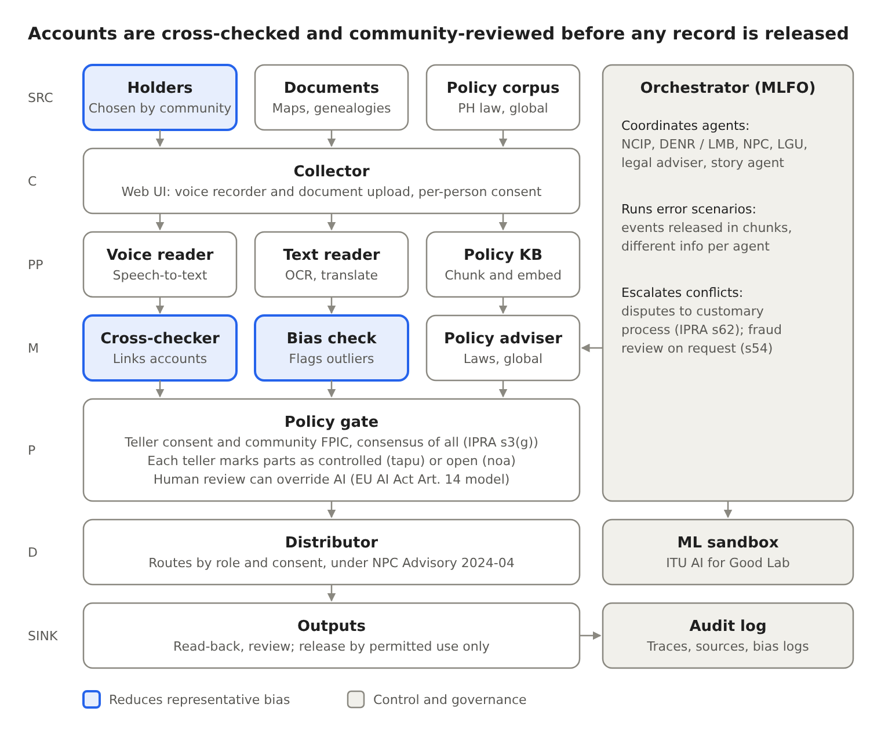
Figure 1. Y.3172 pipeline with orchestrator, sandbox and audit log
The pipeline follows Y.3172 from source (SRC) to output (SINK). A voice reader and a text reader feed the same cross-checker, so written documents are checked against spoken accounts. The orchestrator (MLFO) runs the agents and scenarios, and every step writes to the audit log.

3. Use case requirement
Each node of the pipeline is associated with requirements. Targets below are our design choices for the demo.
- SRC (sources). Knowledge holders chosen by the community, plus at least 20 tellers per topic, including women, youth and members from each settlement. Each teller self-identifies their group. Documents are linked where they exist (domain recognition needs at least one, s52(d)).
- C (collector). Recording works offline on a phone and uploads when there is signal, since about 37% of indigenous people live in geographically isolated and disadvantaged areas (GIDAs). Consent is explained in the teller's language before recording, given separately for each purpose, and can be withdrawn as easily as it was given (NPC Circular 2023-04).
- PP (preprocessor). Speech-to-text and OCR output is checked by community translators. Text is translated into Filipino and English, keeping the original.
- M (models). Every match and flag points to the exact tellers and documents behind it. Agents cite the clause they rely on.
- P (policy). Each teller marks parts of their story as controlled (tapu, restricted) or open (noa, shareable), following Te Mana Raraunga. Every use follows the record's permitted use and community consent, defined in IPRA s3(g) as the consensus of all members. A human can override any AI output.
- D (distributor). Private community data never enters the open knowledge base. Outputs go only to roles the community has approved.
- SINK (outputs). Every step is written to a tamper-evident audit log with sources and reasoning.

4. Mapping with ITU-T Y.3172 Readiness 2.0 Report, and domain-specific policies
 | Use case (public services: IKSP records) | Readiness 2.0 Report | Documents (policies, strategies, AI innovative regulations)
SRC | Stories from many members; community documents; policy corpus | Data/model marketplace; AI for inclusion | IPRA s51, s52(d); Data Privacy Act (RA 10173) on consent; World Bank (2024) on self-identification
C | Web and phone recorder, offline-first; separate sessions | Digital infrastructure; Human interface | Data Privacy Act; NPC Circular 2023-04 on consent; NCIP AO 1 s.2012 on researching and documenting indigenous knowledge systems and practices (IKSP); National Cybersecurity Plan 2023–2028 (EO 58); World Bank (2024) on isolated areas
PP | Voice reader, text reader (OCR), translation, entity extraction; policy knowledge base built with the ITU reference code | Contextualization and regional impact; Generated content marketplace | NPC Advisory 2024-04 (accuracy, bias); IPRA s52(g) on translation into the native language
M | Story matcher, bias check, policy adviser and institutional agents | Cross-domain correlation analysis; Level of integration of AI in workflows | NPC Advisory 2024-04; Delgamuukw (Canada) on oral evidence; EU AI Act Art. 14
P | Consent, controlled (tapu) or open (noa) marks, permitted use per record, human review and override | AI and policies; Collaboration with AI; Impacts of humans in AI integration | IPRA s3(g), s34; CARE Principles; Te Mana Raraunga; EU AI Act Art. 14
D | Routes outputs by role and consent; keeps private data out of the open knowledge base | Strategy alignment | IPRA s34 and s45; NPC Advisory 2024-04; National AI Strategy Roadmap 2.0
SINK | Consensus read-back, sample dossier, multi-agent simulation with a simulated timeline | AI and policies (policy sandbox); Granular priorities | IPRA s52(d), s52(k), s54, s59, s62; NCIP AO 4 s.2012 (delineation); Mining Act s16; UNDRIP Art. 32(2)

Country documents also mapped: Mining Act (economic), IP Code (intellectual property), UNDRIP and the Convention on Biological Diversity (treaties), and World Bank (2024) data on labour and isolated areas. Full mapping and Readiness perspectives are in the full report.
Knowledge base. Built with the ITU reference code (docling parsing, 256-word chunks, nomic-embed-text, ChromaDB). It adds 106 sources in eight folders (Philippine laws, NCIP rules, data privacy, strategies, jurisprudence, context data, IKSP publications, global practice), 49 of them from the team's IKSP reference register; each chunk tagged with source, issuer, year and section numbers, plus 25 key clauses, 16 key figures and 17 gaps stored one per chunk for exact citation. A 32-question retrieval test must return the expected source in the top five. Community stories stay in a separate private store and are never published.

5. Error scenarios
Agents: story agent, NCIP, DENR (land and mining permits), National Privacy Commission, local government and a legal adviser. The main script tests use case D; a policy reuse request tests use case C. The orchestrator releases events one at a time over 40 simulated days, each only to the agents that would receive it in real life.
Scenario 1: mining overlap (use case D), released over 40 simulated days.
- Step-1 (day 0): A community files a petition. 40 members are recorded; most name a river and a ridge as the boundary. Released to: Story agent, NCIP agent. Expected handling: Story agent drafts a boundary from the matched stories. NCIP opens delineation (IPRA s52(b)–(c)).
- Step-2 (day 20): A mining company applies for an exploration permit over part of the claimed area. Released to: DENR agent only. Expected handling: DENR must get NCIP certification that the area does not overlap an ancestral domain (Certification Precondition, IPRA s59) before granting. Test: does DENR ask NCIP?.
- Step-3 (day 25): Two appointed representatives change their accounts: the ridge is no longer the boundary. Released to: Story agent only. Expected handling: Bias check flags a change made only by representatives. Nothing changes automatically; it goes to human review.
- Step-4 (day 30): A recording describing a sacred site leaks online. Released to: NPC agent, LGU agent. Expected handling: NPC runs breach response under the Data Privacy Act; illegal access is a crime under the Cybercrime Prevention Act. The audit log shows the file was marked private and who accessed it.
- Step-5 (day 35): A neighbouring community claims the same river as its boundary. Released to: NCIP agent. Expected handling: Customary laws and practices come first (s62, s66); NCIP's Ancestral Domains Office helps the parties reach a preliminary resolution (s52(h)); unresolved disputes go to NCIP adjudication under its 2018 Rules of Procedure.
- Step-6 (day 40): Escalation: the company offers benefits through the appointed representatives, in exchange for consent. Released to: All agents. Expected handling: Legal adviser: consent must be the consensus of all members, free of manipulation (s3(g)); Mining Act s16; UNDRIP Art. 32(2). No new permit while a CADT application is pending (s59).
Scenario 2: policy reuse request (use case C). The municipal disaster risk reduction office asks to use recorded flood and landslide stories for its hazard map. Expected handling: the records' permitted-use field is checked; NCIP's AO 1, s.2012 and community FPIC apply; only records approved for policy use are shared, with context and the original language kept; the request and decision are logged. This tests RA 10121 s2(j) against community control (IPRA s32–s35).
Step 6 turns a permit issue into a consent and ethics breach. Corrective actions follow rules agreed before the simulation, not ad hoc choices. Every agent step is written to a hash-chained audit log with the sources, reasoning steps and clauses it relied on.
Where it gets controversial. Flagging the representatives' changed accounts may look like distrust of traditional leaders. The response: flags go only to the community council and NCIP, are never published, and never reject testimony on their own. Elders can explain the change, and that explanation is recorded.

6. Policy gaps and standards gaps derived from the mapping exercise
Gap | Type | Global example
IPRA sets no minimum number or mix of tellers (s52(d)) | Legislative | Canada, Delgamuukw (1997): oral history treated as equal to other evidence
No rules for AI-processed evidence | Standards | EU AI Act Art. 14: humans can monitor and override high-risk AI (Annex III from 2 December 2027)
No shared live register of pending CADT applications for DENR to check (s59) | Unclear responsibility; coordination | Australia: public, mapped Register of Native Title Claims
Only 55 of 257 approved CADTs registered by early 2023 (World Bank, 2024) | Coordination | Australia's shared claims register
National income, labour, poverty and health surveys have no ethnicity questions (World Bank, 2024) | Data | World Bank (2024): standard ethnicity variables, self-identification, FPIC in local languages
Only NCIP has a mandate for indigenous data; efforts are uncoordinated (World Bank, 2024) | Unclear responsibility | CARE Principles
Public NCIP research data (s45) versus community control of knowledge (s34) | Conflict between objectives | CARE Principles; Canada's OCAP®
Recording sacred knowledge | Standards | New Zealand, Te Mana Raraunga: Māori decide which data are controlled (tapu) or open (noa)
Mining Act "prior consent" (s16) versus IPRA consensus of all members (s3(g)) | Conflict between objectives | UNDRIP Art. 32(2)
Traditional knowledge in stories could be patented by others | Legislative | WIPO Treaty on IP, Genetic Resources and Associated Traditional Knowledge (2024; not yet in force)
No structured way to compare evidence in boundary disputes (s62) | Coordination | Australia, Native Title Act: court-managed mediation; overlapping claims heard together (s67)
IPRA s16 requires indigenous representation in local councils; the Local Government Code s41(c) makes it only one option for a sectoral seat | Conflict between objectives | Kenya, Community Land Act 2016: land decisions by an assembly of all adult members
37% of indigenous people live in isolated areas (World Bank, 2024) | Technology | Offline-first design
RA 10121 s2(j) requires sensitivity to indigenous knowledge but no process to document, validate or authorise IKSP for disaster plans | Coordination; standards | IPCC AR6 WGII (2022): inclusive planning with Indigenous knowledge helps avoid maladaptation

Gaps on tellers, the register of pending applications, sacred content, boundary disputes and local representation are our reading of the law, not findings of a court or agency. IPRA s54 lets NCIP review and cancel fraudulently acquired titles on the community's written request; our bias check can support such reviews.
Sources: World Bank (2024); IPRA; NPC Advisory 2024-04; ITU reference code. Global example sources are listed in the full report.

