Ancestral Land Story Pipeline
Concept paper · ITU AI for Good Sandbox Hackathon · Public services (ancestral land rights), Philippines

Summary
An AI pipeline that helps indigenous communities prove ancestral land claims by recording stories from many members, not just appointed representatives. It reads their documents, matches the accounts, flags one-sided claims for human review, and reads the consensus story back to the community to confirm. AI agents playing the government institutions involved test it against realistic, step-by-step error scenarios, with every decision logged and traced to the law.

The problem
Under IPRA (RA 8371) s52(d), a claim needs sworn testimony of elders or the community plus at least one authentic document. Testimony can rest mainly on a few appointed representatives who may be biased, spans many languages, and is hard to verify. Women, youth and remote members risk being left out.
The scale. The 2020 census counted 9.46 million indigenous people, about 8.7% of the population (8.21 million IPs plus 1.25 million counted as both IP and Muslim); the census classified 228 of 268 ethnic groups as indigenous; NCIP estimates more than 15 million. By early 2023, 257 ancestral domains had approved CADTs, but only 55 (22%) were fully registered. CADTs cover about 20.5% of the country's land, and conflict can increase when titling is delayed. About 37% of indigenous people (2.9 million) live in geographically isolated areas (World Bank, 2024). The Philippine Statistics Authority reports 9.84 million from the same 2020 census, and a 2025 government–World Bank workshop cited NCIP's database of 222 indigenous groups and 110 languages.

The idea
- Record. Each member tells their story in a separate session, in their own language, after consent is explained in that language. Each teller names their own group (self-identification).
- Read and translate. A voice reader (speech-to-text) handles recordings; a text reader (OCR) handles written accounts, maps and genealogies. Both are translated and checked by community translators.
- Match. Extract places, landmarks, events and family lines, then link them across tellers and documents.
- Check for bias. Flag claims made by only one teller, or only by representatives, for human review. Nothing is rejected automatically.
- Read back. The model retells the consensus story to the community, which confirms or corrects it.
- Dossier. Package the verified story, agreement scores and sources as a sample dossier structured like the s52(d) proof requirements. It is a demo output; a real filing still needs sworn, signed statements.

How it works
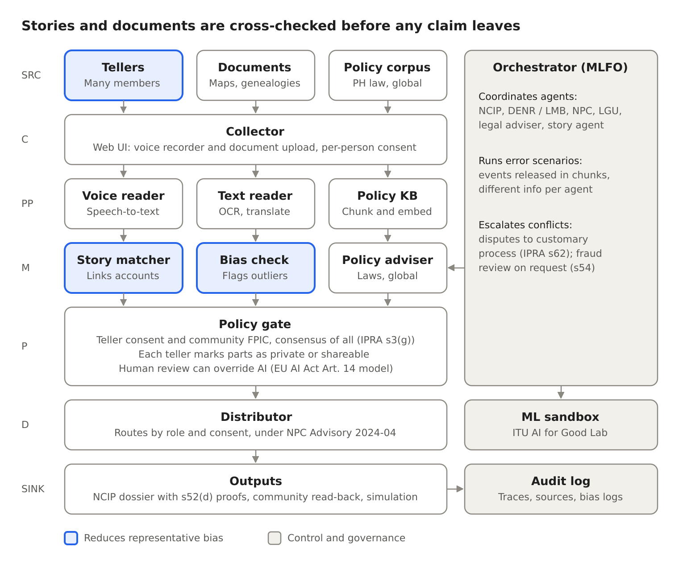
Figure 1. The pipeline follows ITU-T Y.3172 from sources to outputs
The pipeline follows Y.3172 from source (SRC) to output (SINK). A voice reader and a text reader feed the same matcher, so written proofs under IPRA s52(d) are checked against the stories. The orchestrator (MLFO) runs the agents and scenarios, and every step writes to the audit log.

What makes it different
- Many voices, not a few. Separate sessions with many members reduce the influence of any one representative.
- Cross-checked evidence. Stories are linked to each other and to written proofs, with an agreement score for each claim.
- Policy-tested before use. Institutional agents (NCIP, DENR, NPC, LGU, legal adviser) respond to a 40-day scenario where information arrives unevenly, such as a mining permit overlapping the claim.
- Transparent by design. Every agent step records what it knew, the sources it retrieved, its reasoning and the clause it relied on.

Policy fit
The solution is grounded in Philippine law and maps each gap to a global example:
- Philippine law and strategy: IPRA (proof, consent, registration, disputes, fraud review); Data Privacy Act and NPC Advisory 2024-04 on AI; Mining Act s16; National AI Strategy Roadmap 2.0; National Cybersecurity Plan 2023–2028.
- Key gaps: no minimum number or mix of tellers; no rules for AI-processed evidence; only 22% of approved CADTs fully registered; no ethnicity questions in national surveys; tension between public NCIP data and community control.
- Global examples: Canada's Delgamuukw ruling on oral history; EU AI Act Article 14 on human oversight; CARE Principles and OCAP® on indigenous data; New Zealand's Te Mana Raraunga; Australia's Register of Native Title Claims; UNDRIP Article 32(2); WIPO's 2024 treaty on traditional knowledge.

Alignment with ITU
The architecture follows the Y.3172 pipeline (SRC, C, PP, M, P, D, SINK) with an orchestrator, sandbox and audit log. The knowledge base is built with the ITU reference code. It addresses the AI Readiness perspectives, including open data (open policy base, private community data), contextualization (222 indigenous groups and 110 languages in NCIP's database), human supervision (override at the policy gate), social inclusion (women, youth, remote members) and infrastructure (offline-first recording).

Safeguards
- AI assists, people decide. NCIP and the community decide every claim.
- Consent first. Consent is explained in the teller's language; each teller can withdraw. Using the stories for a claim follows community FPIC, which IPRA defines as the consensus of all members under customary law (s3(g)).
- Equal partners. Community members work as recorders and translators at every stage, as the World Bank (2024) recommends for indigenous data collection.
- Sacred content. Tellers can mark parts as private; those parts are never shared.
- Audit log. Every transcript, match and recommendation is traced to its source and policy clause.
- Conflicts escalate. Competing claims go to human mediation, never automatic rejection.

Next steps
- Load Philippine and global documents into the knowledge base with the ITU reference code and pass the retrieval test.
- Fine-tune speech-to-text for Filipino and one target indigenous language with consented recordings.
- Build the agents and run the mining-overlap scenario end to end, with the audit log.
- Record the demo and finalise the technical report.
Main data source: World Bank (2024), No Data, No Story: Indigenous Peoples in the Philippines.

