AI for Good Sandbox Hackathon – Ancestral Land Story Pipeline
Team leader: [name]
Team members: Paul Alvarez, Kahlil de Silva
Contact details: [email]
GitHub link: github.com/pwdrkg/ITUAIIP
Domain: Public services (ancestral land rights). Country: Philippines.

1. Introduction
Indigenous communities in the Philippines prove ancestral land claims largely through oral testimony. That testimony can rest mainly on a few appointed representatives, who may be biased, and it spans many languages.
We propose an AI pipeline that records stories from many community members, reads their written documents, matches the accounts, and returns a consensus story for the community to confirm. A team of AI agents, each playing a government institution, tests the solution against realistic error scenarios released step by step. Every agent decision is logged with its reasoning and the clause it relies on.
The solution follows the ITU-T Y.3172 pipeline, reflects the ITU AI Readiness Framework 2.0, adheres to Philippine law, and maps each domain gap to a global policy example.

2. Description of the use case
Under IPRA (RA 8371) s52(d), a claim for a Certificate of Ancestral Domain Title must include sworn testimony of elders or the community, plus at least one authentic document such as maps, genealogies or landmark histories.
The scale. The 2020 census counted 9.46 million indigenous people, about 8.7% of the population (8.21 million IPs plus 1.25 million counted as both IP and Muslim); the census classified 228 of 268 ethnic groups as indigenous; NCIP estimates more than 15 million. By early 2023, 257 ancestral domains had approved CADTs, but only 55 (22%) were fully registered. CADTs cover about 20.5% of the country's land, and conflict can increase when titling is delayed. About 37% of indigenous people (2.9 million) live in geographically isolated areas (World Bank, 2024). The Philippine Statistics Authority reports 9.84 million from the same 2020 census, and a 2025 government–World Bank workshop cited NCIP's database of 222 indigenous groups and 110 languages.
Gaps in the current process:
- Testimony can rest on a few representatives, so private agendas could shape the claim.
- Women, youth and remote members risk being left out.
- Recording, translating and checking testimony across many languages is slow and hard to verify.
- Nothing links what different tellers say, or checks stories against the documents.
- Indigenous people are largely invisible in national data: the main income, labour, poverty and health surveys have no ethnicity questions (World Bank, 2024).
How our solution closes them:
- Record. Each member tells their story in a separate session, in their own language, after consent is explained in that language. Each teller names their own group (self-identification).
- Read and translate. A voice reader (speech-to-text) handles recordings; a text reader (OCR) handles written accounts, maps and genealogies. Both are translated and checked by community translators.
- Match. Extract places, landmarks, events and family lines, then link them across tellers and documents.
- Check for bias. Flag claims made by only one teller, or only by representatives, for human review. Nothing is rejected automatically.
- Read back. The model retells the consensus story to the community, which confirms or corrects it.
- Dossier. Package the verified story, agreement scores and sources as a sample dossier structured like the s52(d) proof requirements. It is a demo output; a real filing still needs sworn, signed statements.
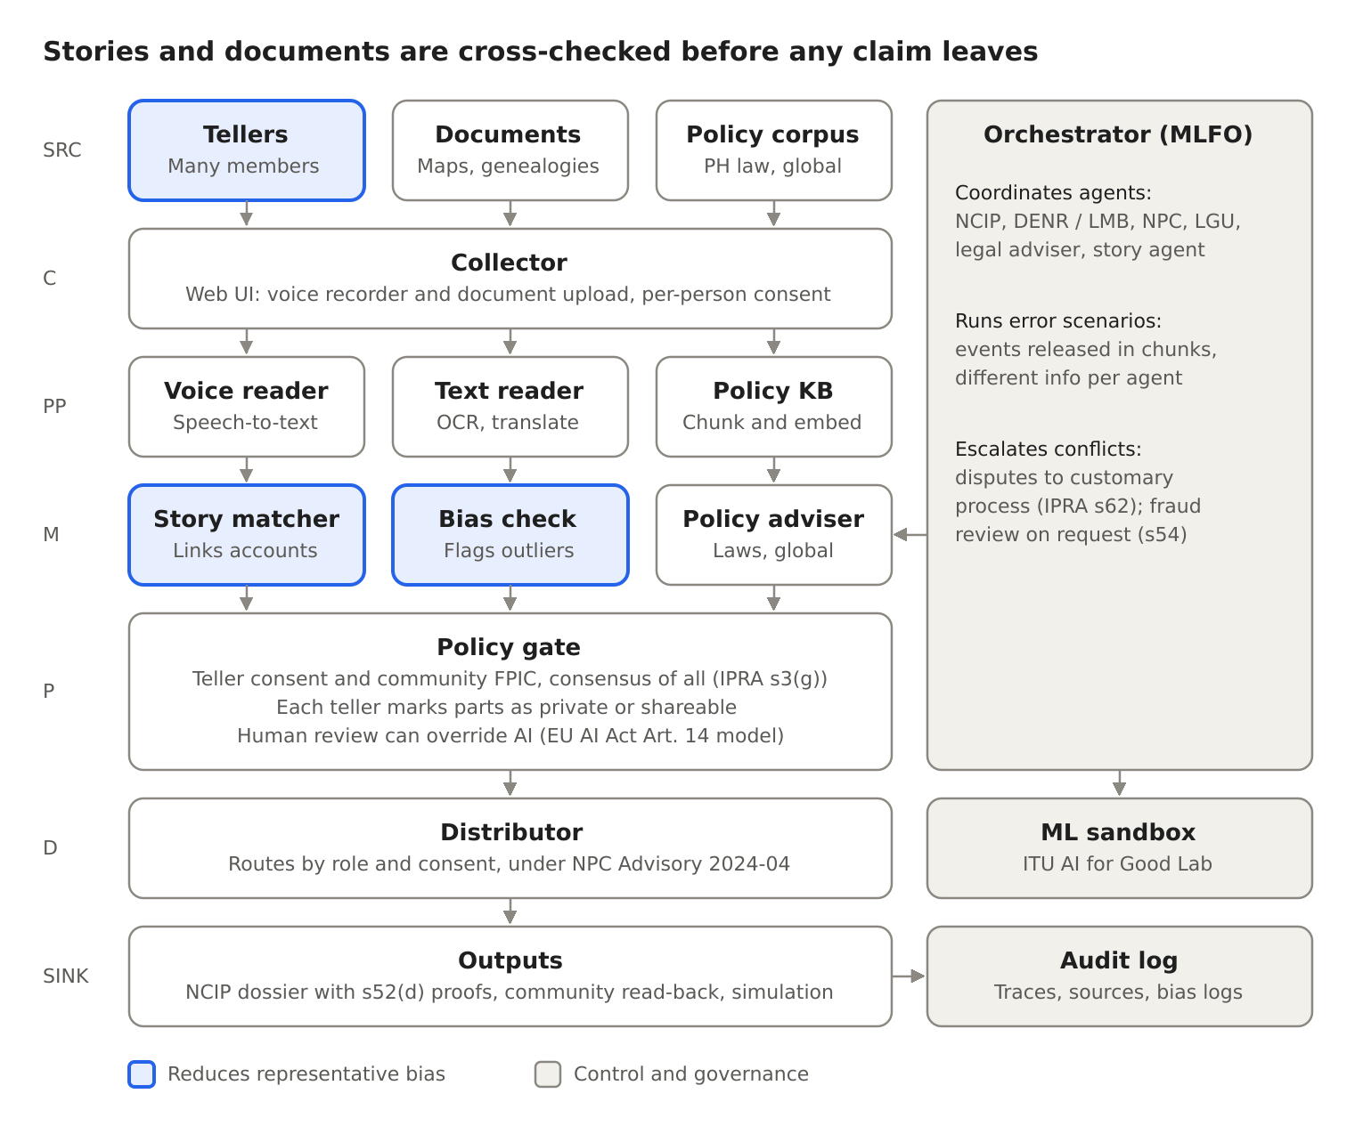
Figure 1. Y.3172 pipeline with orchestrator, sandbox and audit log
The pipeline follows Y.3172 from source (SRC) to output (SINK). A voice reader and a text reader feed the same matcher, so written proofs under IPRA s52(d) are checked against the stories. The orchestrator (MLFO) runs the agents and scenarios, and every step writes to the audit log.

3. Use case requirements
Targets below are our design choices for the demo.
- SRC (sources). At least 20 tellers per claim, including women, youth and members from each settlement. Each teller self-identifies their group. At least one authentic document per claim, as s52(d) requires.
- C (collector). Recording works offline on a phone and uploads when there is signal, since about 37% of indigenous people live in isolated areas. Consent is explained in the teller's language before recording, given separately for each purpose, and can be withdrawn as easily as it was given (NPC Circular 2023-04).
- PP (preprocessor). Speech-to-text and OCR output is checked by community translators. Text is translated into Filipino and English, keeping the original.
- M (models). Every match and flag points to the exact tellers and documents behind it. Agents cite the clause they rely on.
- P (policy). Each teller marks parts of their story as private or shareable. Use for a claim follows community consent, defined in IPRA s3(g) as the consensus of all members. A human can override any AI output.
- D (distributor). Private community data never enters the open knowledge base. Outputs go only to roles the community has approved.
- SINK (outputs). Every step is written to a tamper-evident audit log with sources and reasoning.

4. Mapping with ITU-T Y.3172, Readiness 2.0 Report, and domain-specific policies
Node | Use case (public services: ancestral land rights) | Readiness 2.0 dimension | Documents
SRC | Stories from many members; community documents; policy corpus | Data/model marketplace; AI for inclusion | IPRA s51, s52(d); Data Privacy Act (RA 10173) on consent; World Bank (2024) on self-identification
C | Web and phone recorder, offline-first; separate sessions | Digital infrastructure; Human interface | Data Privacy Act; NPC Circular 2023-04 on consent; NCIP AO 1 s.2012 on documenting indigenous knowledge; National Cybersecurity Plan 2023–2028 (EO 58); World Bank (2024) on isolated areas
PP | Voice reader, text reader (OCR), translation, entity extraction; policy knowledge base built with the ITU reference code | Contextualization and regional impact; Generated content marketplace | NPC Advisory 2024-04 (accuracy, bias); IPRA s52(g) on translation into the native language
M | Story matcher, bias check, policy adviser and institutional agents | Cross-domain correlation analysis; Level of integration of AI in workflows | NPC Advisory 2024-04; Delgamuukw (Canada) on oral evidence; EU AI Act Art. 14
P | Consent, private or shareable marks, human review and override | AI and policies; Collaboration with AI; Impacts of humans in AI integration | IPRA s3(g), s34; CARE Principles; Te Mana Raraunga; EU AI Act Art. 14
D | Routes outputs by role and consent; keeps private data out of the open knowledge base | Strategy alignment | IPRA s34 and s45; NPC Advisory 2024-04; National AI Strategy Roadmap 2.0
SINK | Consensus read-back, sample dossier, multi-agent simulation with a simulated timeline | AI and policies (policy sandbox); Granular priorities | IPRA s52(d), s52(k), s54, s59, s62; NCIP AO 4 s.2012 (delineation); Mining Act s16; UNDRIP Art. 32(2)

Country documents also mapped: Mining Act (economic), IP Code (intellectual property), UNDRIP and the Convention on Biological Diversity (treaties), and World Bank (2024) data on labour and isolated areas. Full mapping and Readiness perspectives are in the full report.
Knowledge base. Built with the ITU reference code (docling parsing, 256-word chunks, nomic-embed-text, ChromaDB). It adds 50 checked sources in seven folders (Philippine laws, NCIP rules, data privacy, strategies, jurisprudence, context data, global practice), each chunk tagged with source, issuer, year and section numbers, plus 25 key clauses, 16 key figures and 13 gaps stored one per chunk for exact citation. A 27-question retrieval test must return the expected source in the top five. Community stories stay in a separate private store and are never published.

5. Error scenarios
Agents: story agent, NCIP, DENR (land and mining permits), National Privacy Commission, local government and a legal adviser. The orchestrator releases events one at a time over 40 simulated days, each only to the agents that would receive it in real life.
Step | Day | Event | Released to | Expected handling
1 | 0 | A community files a petition. 40 members are recorded; most name a river and a ridge as the boundary | Story agent, NCIP agent | Story agent drafts a boundary from the matched stories. NCIP opens delineation (IPRA s52(b)–(c))
2 | 20 | A mining company applies for an exploration permit over part of the claimed area | DENR agent only | DENR must get NCIP certification of no overlap before granting (IPRA s59). Test: does DENR ask NCIP?
3 | 25 | Two appointed representatives change their accounts: the ridge is no longer the boundary | Story agent only | Bias check flags a change made only by representatives. Nothing changes automatically; it goes to human review
4 | 30 | A recording describing a sacred site leaks online | NPC agent, LGU agent | NPC runs breach response under the Data Privacy Act; illegal access is a crime under the Cybercrime Prevention Act. The audit log shows the file was marked private and who accessed it
5 | 35 | A neighbouring community claims the same river as its boundary | NCIP agent | Customary process comes first (s62, s66); NCIP's Ancestral Domains Office helps the parties reach a preliminary resolution (s52(h)); unresolved disputes go to NCIP adjudication under its 2018 Rules of Procedure
6 | 40 | Escalation: the company offers benefits through the appointed representatives, in exchange for consent | All agents | Legal adviser: consent must be the consensus of all members, free of manipulation (s3(g)); Mining Act s16; UNDRIP Art. 32(2). No new permit while a CADT application is pending (s59)

Step 6 turns a permit issue into a consent and ethics breach. Corrective actions follow rules agreed before the simulation, not ad hoc choices. Every agent step is written to a hash-chained audit log with the sources, reasoning steps and clauses it relied on.
Where it gets controversial. Flagging the representatives' changed accounts may look like distrust of traditional leaders. The response: flags go only to the community council and NCIP, are never published, and never reject testimony on their own. Elders can explain the change, and that explanation is recorded.

6. Policy gaps and standards gaps
Gap | Type | Global example
IPRA sets no minimum number or mix of tellers (s52(d)) | Legislative | Canada, Delgamuukw (1997): oral history treated as equal to other evidence
No rules for AI-processed evidence | Standards | EU AI Act Art. 14: humans can monitor and override high-risk AI (Annex III from 2 December 2027)
No shared live register of pending claims for DENR to check (s59) | Unclear responsibility; coordination | Australia: public, mapped Register of Native Title Claims
Only 55 of 257 approved CADTs registered by early 2023 (World Bank, 2024) | Coordination | Australia's shared claims register
National income, labour, poverty and health surveys have no ethnicity questions (World Bank, 2024) | Data | World Bank (2024): standard ethnicity variables, self-identification, FPIC in local languages
Only NCIP has a mandate for indigenous data; efforts are uncoordinated (World Bank, 2024) | Unclear responsibility | CARE Principles
Public NCIP research data (s45) versus community control of knowledge (s34) | Conflict between objectives | CARE Principles; Canada's OCAP®
Recording sacred knowledge | Standards | New Zealand, Te Mana Raraunga: Māori decide what stays private
Mining Act "prior consent" (s16) versus IPRA consensus of all members (s3(g)) | Conflict between objectives | UNDRIP Art. 32(2)
Traditional knowledge in stories could be patented by others | Legislative | WIPO Treaty on IP, Genetic Resources and Associated Traditional Knowledge (2024; not yet in force)
No structured way to compare evidence in boundary disputes (s62) | Coordination | Australia, Native Title Act: court-managed mediation; overlapping claims heard together (s67)
IPRA s16 requires indigenous representation in local councils; the Local Government Code s41(c) makes it only one option for a sectoral seat | Conflict between objectives | Kenya, Community Land Act 2016: land decisions by an assembly of all adult members
37% of indigenous people live in isolated areas (World Bank, 2024) | Technology | Offline-first design

Gaps on tellers, the claims register, sacred content, boundary disputes and local representation are our reading of the law, not findings of a court or agency. IPRA s54 lets NCIP review and cancel fraudulently acquired claims on the community's written request; our bias check can support such reviews.
Sources: World Bank (2024); IPRA; NPC Advisory 2024-04; ITU reference code. Global example sources are listed in the full report.

