Deployment Demonstration
Network Anomaly Detection — FastAPI Service
Step 8 deliverable — running application walkthrough

1. Overview
The best model from this project (a Random Forest achieving 0.974 recall and 0.989 PR-AUC on the held-out test set) is deployed as a REST service using FastAPI. The service loads the fitted preprocessing pipeline and the trained model once at start-up and exposes a prediction endpoint plus a lightweight web interface. This document walks through the running application with screenshots.
Framework | FastAPI (Python), served by Uvicorn
Model served | Random Forest (best_model.joblib) — switchable to XGBoost via env var
Endpoints | / (UI), /predict, /health, /model-info, /docs (Swagger)
Container | Dockerfile provided; configurable via MODEL_NAME, THRESHOLD, MODEL_DIR

2. Running the service
Locally, the service starts with a single command and is then available in the browser:
pip install -r requirements.txt
uvicorn app.main:app --port 8000
# open http://localhost:8000
Or as a container:
docker build -t nad-detector .
docker run -p 8000:8000 nad-detector

3. The web interface
The interface accepts a network connection as JSON, lets the analyst adjust the decision threshold, and returns an attack probability with a clear verdict. Two real connections from the UNSW-NB15 test set are provided as one-click examples.
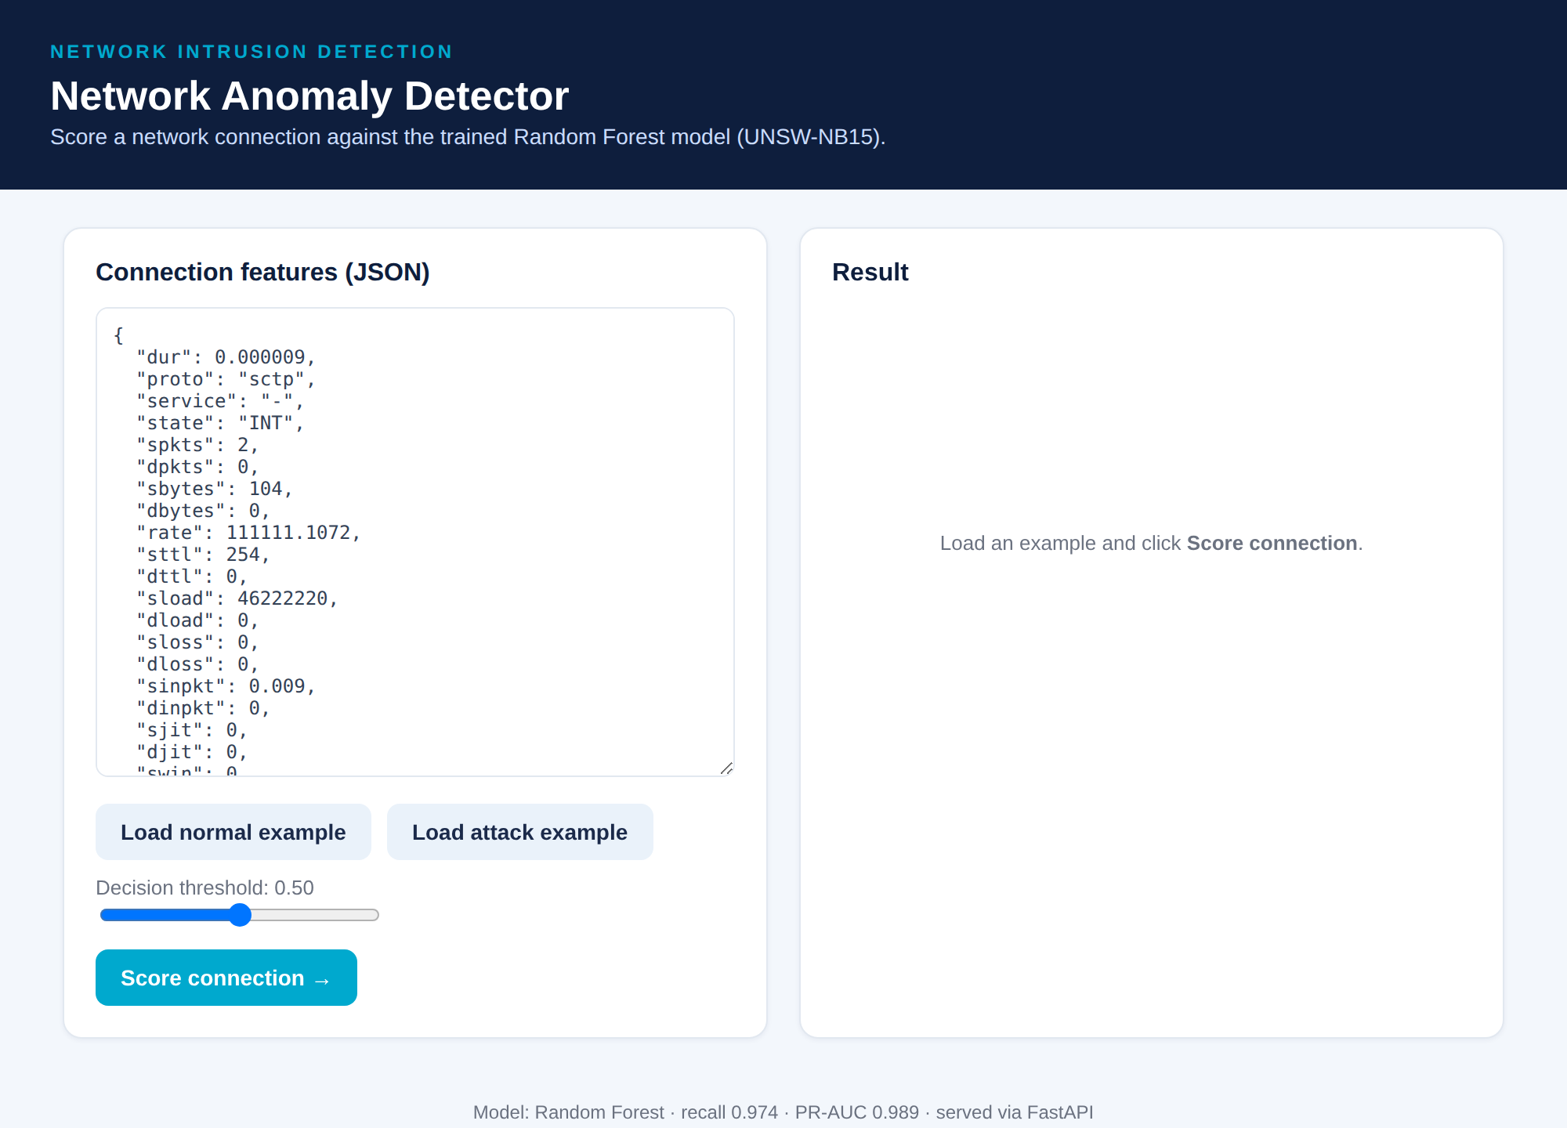
Figure 1 — Landing page. A connection is entered as JSON (left); the threshold slider and example loaders sit beneath. The result panel (right) awaits input.

4. Scoring an attack
Loading the attack example and clicking “Score connection” sends the record to the /predict endpoint. The model returns a 98.0% attack probability, and the interface renders a clear ATTACK verdict with a red probability gauge.
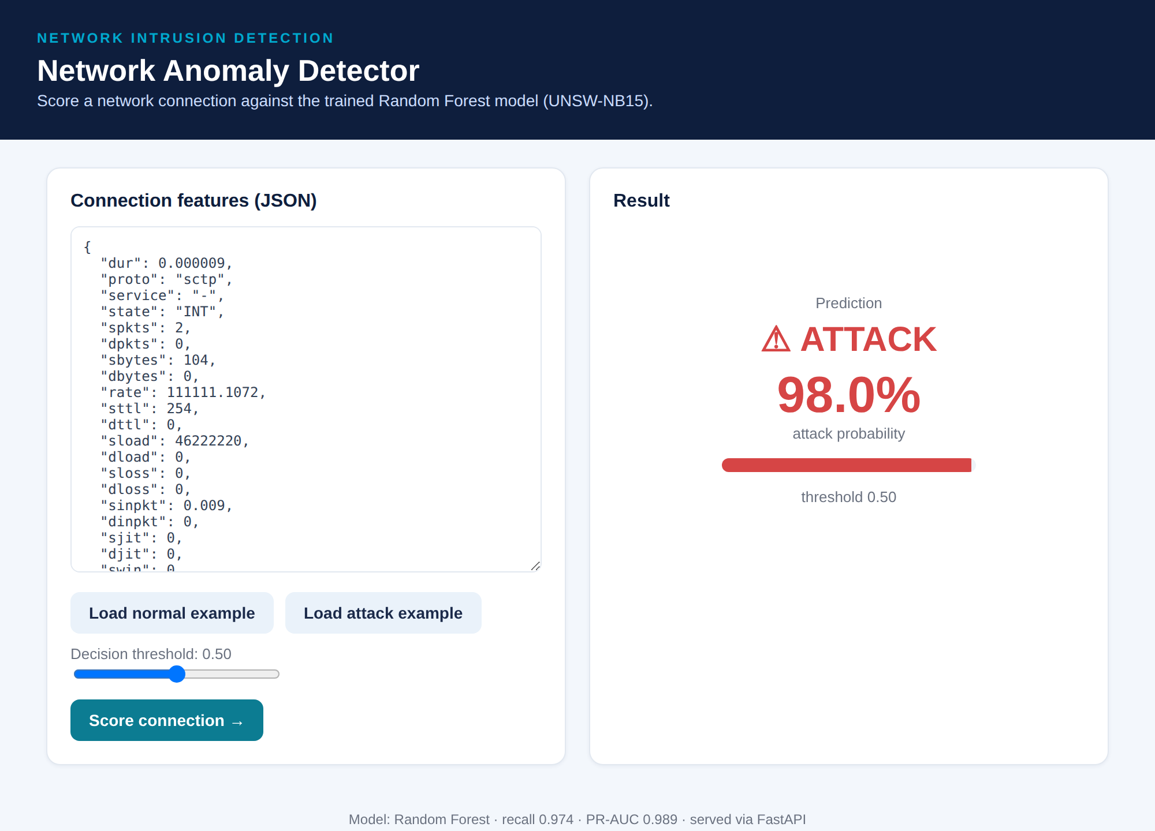
Figure 2 — An attack connection scored at 98.0% → ATTACK. The verdict, probability, and gauge update in place.

5. Scoring a normal connection
Loading the normal example and re-scoring returns a 0.0% attack probability and a green NORMAL verdict — demonstrating the model cleanly separates the two examples.
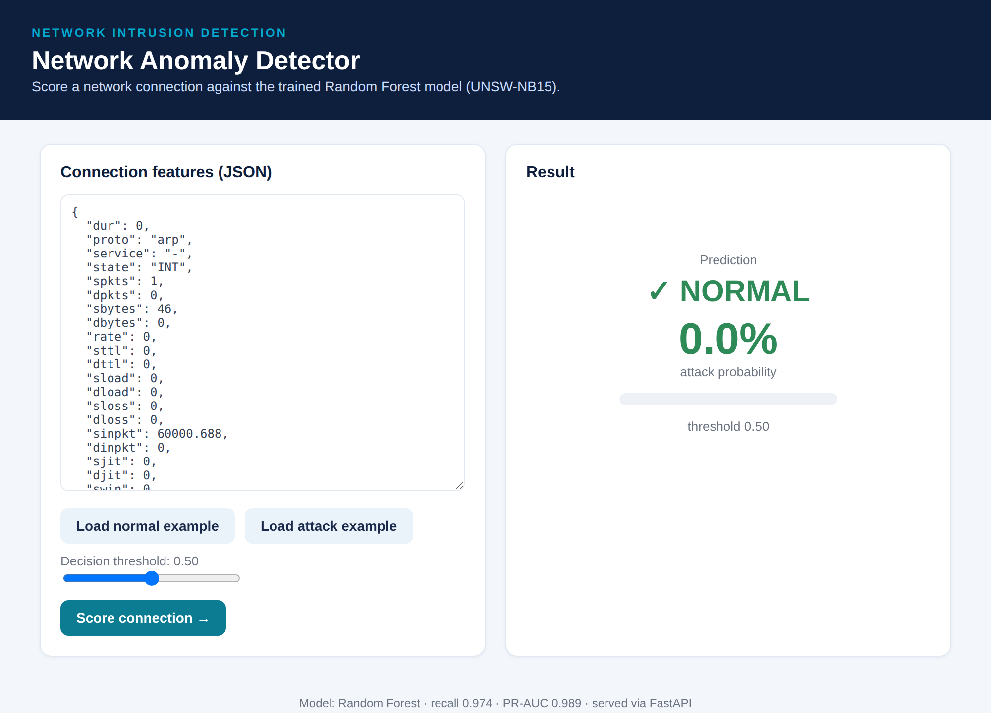
Figure 3 — A normal connection scored at 0.0% → NORMAL.

6. The API directly
The same functionality is available programmatically. A POST to /predict returns a compact JSON verdict; the threshold can be overridden per request.
curl -X POST "http://localhost:8000/predict?threshold=0.5" \
-H "Content-Type: application/json" \
-d '{"proto":"sctp","state":"INT","sbytes":104,"sttl":254,
"sload":46222220,"rate":111111.1,"smean":52,"spkts":2,
"ct_state_ttl":2,"ct_dst_src_ltm":2,"sinpkt":0.009}'
# -> {"attack_probability":0.9803,"prediction":1,
# "label":"attack","threshold":0.5}
Health and metadata endpoints support monitoring and automated checks:
GET /health -> {"status":"ok","model_loaded":true, ...}
GET /model-info -> {"model":"best_model","n_features":69,
"reported_test_recall":0.974, ...}

7. Quality & operations
- Tests: a pytest suite (tests/test_api.py) covers health, metadata, and both attack and normal predictions — all passing.
- CI: a GitHub Actions workflow runs linting (ruff) and the test suite on every push and pull request.
- Configuration: model, threshold, and paths are environment-driven (config.yaml documents the defaults), so the same image runs unchanged locally and in the cloud.
- Monitoring & rollback: PSI-based drift monitoring on connection-counter features triggers retraining; models are versioned artifacts, so rollback is simply redeploying the previous best_model.joblib with its matching preprocessor.
Full instructions are in DEPLOYMENT.md in the repository.

