Detecting Anomalies in Network Traffic
An End-to-End Machine Learning Project
Cybersecurity Intrusion Detection using the UNSW-NB15 Dataset
AI & Machine Learning — Final Capstone Project

Abstract
Network intrusion detection is a critical yet increasingly intractable task: modern enterprise networks generate volumes of traffic far beyond the capacity of manual inspection, allowing malicious activity to remain concealed within legitimate flows. This study presents an end-to-end machine-learning treatment of the problem, applied to the UNSW-NB15 benchmark dataset (175,341 training and 82,332 testing records, 42 predictive features). The problem is framed as binary anomaly detection, with recall on the attack class and the area under the precision–recall curve (PR-AUC) adopted as primary evaluation criteria in view of the asymmetric cost of a missed intrusion. Following a leakage-controlled preprocessing pipeline — in which all encoders and scalers are fitted exclusively on the training partition — seven domain-derived features are engineered, of which two rank among the five most influential predictors. Five models are trained and compared; a Random Forest classifier is selected, achieving 0.974 recall and 0.989 PR-AUC on the held-out test set. The model is subjected to an explainability, fairness, and robustness audit: SHAP and partial-dependence analyses confirm that time-to-live features drive detection, a fairness audit across attack families exposes a systematic weakness against the Fuzzers class (recall 0.82), and an adversarial stress test demonstrates that clean-data performance does not guarantee robustness (F1 declining from 0.92 to 0.80 under perturbation). Mitigations are applied and measured rather than merely proposed: distribution drift is quantified via the Population Stability Index, and threshold tuning is shown to raise Fuzzers recall to 0.94, while synthetic oversampling is found ineffective and reported as such. The work is fully reproducible, with all code, models, and figures provided in a public repository at https://github.com/pwdrkg/network-anomaly-detection.
Keywords: network intrusion detection; anomaly detection; machine learning; explainable AI; algorithmic fairness; adversarial robustness; UNSW-NB15.

Table of Contents
1 Problem Understanding & Framing 5
1.1 Business Problem 5
1.2 Data Science Problem 5
1.3 Task Type 5
1.4 Success Metrics (Technical) 5
1.5 Business KPIs 6
1.6 Financial Impact and Return on Investment 6
1.7 Framing the Foundation 7
2 Data Collection & Understanding 8
2.1 Dataset Source & Provenance 8
2.2 Dataset Overview 8
2.3 Data Quality Summary 8
2.4 Data Dictionary 9
2.5 A Trustworthy Data Basis 10
3 Data Preprocessing, Applied EDA & Feature Engineering 11
3.1 Data Cleaning 11
3.2 Applied EDA 11
3.3 Feature Engineering 14
3.4 Feature Importance & Explainability 14
3.5 Feature Selection 15
3.6 Dimensionality Reduction 15
3.7 Signal Ready for Modelling 16
4 Model Implementation & Evaluation 17
4.1 Models Trained 17
4.2 Results 17
4.3 Curves & Confusion Matrix 18
4.4 Model Selection & Justification 19
4.5 Unsupervised Structure 20
4.6 The Operational Detector 21
5 Critical Thinking — Ethical AI & Bias Auditing 22
5.1 Explaining Model Decisions 22
5.2 Limitations 23
5.3 Bias & Fairness Audit 23
5.4 Proposed Mitigations 25
5.5 Adversarial Robustness 25
5.6 Applied Mitigations & Drift Evidence 26
5.7 Trust, Tested and Earned 27
6 Synthesis and Outlook 28
6.1 Findings, Recommendation and Scope 28
6.2 Course Learnings, Applied 30
6.3 Open Questions and the Path Ahead 30
7 GitHub Repository & Reproducibility 32
7.1 Repository Structure 32
7.2 Reproducible Code & Environment 32
7.3 Built to Be Reproduced 32
8 Deployment & MLOps 33
8.1 Serving the Model 33
8.2 Containerisation & Configuration 33
8.3 MLOps Practices 34
8.4 From Model to Service 34
9 Use of Generative AI 35
9.1 Where It Was Used 35
9.2 A GenAI-Enhanced Feature 35
9.3 Responsible Use 35
9.4 AI Used Responsibly 35
References 37

1. Problem Understanding & Framing
This step converts a broad security concern into a precisely defined machine-learning problem, which is the foundation everything else rests on. It establishes that the task is binary anomaly detection, fixes recall on the attack class as the metric that matters most, and ties technical success to business value such as faster detection and fewer wasted analyst hours. Getting this framing right prevents the classic error of optimising for accuracy while undetected attacks accumulate material, unquantified risk.

1.1 Business Problem
The core business pain is scale: no human team can inspect millions of daily connections, so attacks slip through simply because no one looked. Framing the problem around analyst prioritisation rather than detecting everything keeps the solution realistic and aligned with how security operations actually work. This makes the eventual model a decision-support tool, not a replacement for human judgement.
Security operations teams cannot manually inspect the millions of connections that cross a corporate network each day. Attacks such as denial-of-service, exploits, reconnaissance and backdoors hide inside ordinary traffic. The business need is an automated system that flags suspicious connections so that analysts investigate the right ones first, reducing both breach risk and wasted analyst effort.

1.2 Data Science Problem
Translating the business need into data-science terms, the task becomes a supervised mapping from per-connection features to a normal or attack label. Because every record is already labelled, this is a well-posed classification problem rather than a purely exploratory one. Defining it this precisely lets us choose appropriate algorithms and metrics with confidence.
Given a set of features describing each network connection — protocol, service, byte counts, duration, packet statistics, connection state and derived behavioural measures — predict whether the connection is normal or an attack.

1.3 Task Type
The problem is primarily binary classification framed as anomaly detection, with an optional multi-class extension into attack families. Choosing binary as the primary target keeps the operational goal front and centre, while the multi-class label remains available for richer analysis and the fairness audit. This dual framing lets the project demonstrate both supervised and unsupervised techniques without losing focus.
This is primarily a binary classification problem (normal vs attack), framed as an anomaly-detection task. The UNSW-NB15 dataset also carries a nine-category attack label, so the work can be extended to multi-class classification. This allows the project to demonstrate both supervised (labelled) and unsupervised (clustering / outlier-detection) approaches, as required by the brief.

1.4 Success Metrics (Technical)
Metric choice is driven by asymmetric cost: a missed attack is far more damaging than a false alarm, so recall on the attack class leads, supported by PR-AUC. Accuracy is deliberately demoted because it rewards the majority class and hides exactly the failures that matter most. Pinning these metrics down now stops later model comparisons from being swayed by a misleading headline number.
- Recall (attack class) — primary. A missed attack (false negative) is the most costly error.
- Precision — controls false alarms that waste analyst time.
- F1-score — balances recall and precision.
- ROC-AUC / PR-AUC — threshold-independent quality. PR-AUC is emphasised because in real deployments benign traffic vastly outnumbers attacks, making precision–recall trade-offs more informative than accuracy.
Accuracy is reported for completeness but is not the primary metric: the cost of a missed attack far exceeds a false alarm, and this benchmark's attack-heavy balance does not reflect real-world prevalence.
This choice reflects a substantial and consistent body of methodological research rather than a local preference. Multiple independent studies have shown that on imbalanced problems the precision–recall view gives a more faithful picture of performance than either accuracy or the ROC curve, because it is not inflated by the abundant negative class (Saito & Rehmsmeier, 2015; Davis & Goadrich, 2006), and the wider imbalanced-learning literature reaches the same conclusion for the rare-event detection that intrusion detection represents. Prioritising recall and PR-AUC over headline accuracy is, in short, the established practice for problems shaped like this one.

1.5 Business KPIs
The KPIs connect model behaviour to outcomes an executive cares about: faster detection, fewer false-positive hours, fewer missed breaches, and a positive return on investment. This linkage ensures the model is judged not only on statistical scores but on whether it moves the numbers the business is accountable for. It also foreshadows the business-facing deck in Step 6.
- Reduction in mean time to detect (MTTD) an intrusion.
- Reduction in analyst hours spent on false positives.
- Reduction in undetected breaches (missed attacks).
- Return on investment: value of breaches prevented minus the cost of running the system.

1.6 Financial Impact and Return on Investment
The technical case for detecting intrusions quickly is inseparable from a financial one, and it is worth stating explicitly, because it is the argument that ultimately justifies building and running such a system at all. Recent industry research allows that case to be made with real figures rather than assertion.
The cost of getting this wrong is large and rising. Independent research by IBM and the Ponemon Institute, drawn from hundreds of affected organisations, places the global average cost of a single data breach at roughly USD 4.44 million in 2025, with the figure markedly higher in some regions — around USD 10.22 million on average in the United States. These are not abstract sums: they encompass detection and escalation, business disruption, lost customers, regulatory penalties, and the long tail of recovery. For any organisation of scale, a single undetected intrusion can dwarf the entire cost of the analytics and infrastructure needed to guard against it.
The value of this system lands on the largest cost lever. The same body of research consistently finds that the speed with which a breach is detected and contained is among the strongest determinants of its ultimate cost: incidents contained quickly cost materially less than those that linger for months, and organisations that use security automation to shorten the breach lifecycle report savings on the order of USD 1.9 million per incident, alongside a containment time cut by roughly eighty days. Because the central contribution of this project is precisely to shorten the mean time to detect an intrusion — surfacing and ranking suspicious connections in real time so that analysts reach genuine threats sooner — its financial value is realised exactly where the evidence says it matters most.
The return on investment follows directly. Set against a per-incident breach cost measured in millions, the marginal cost of running a trained model — a modest amount of computation atop a preprocessing pipeline that already exists — is small. A system that catches the great majority of attacks and shaves hours or days off detection need only prevent, or materially accelerate the containment of, a handful of incidents to repay its running cost many times over; every additional hour of analyst time reclaimed from chasing false alarms compounds that return. Even under conservative assumptions, the economics favour deployment.
These conclusions rest on more than a single study. A growing corpus of industry reporting and academic work corroborates both links on which the business case depends — between detection speed and breach cost, and between security automation and analyst productivity — which lends the argument here a firmer footing than any one source could provide. The organisational picture, moreover, is only part of the story; its extension to the national and macroeconomic scale is taken up in the synthesis chapter.

1.7 Framing the Foundation
With the problem fixed as binary anomaly detection and recall on the attack class established as the metric that governs every later decision, the project has a clear contract to build against. This framing deliberately privileges catching intrusions over avoiding the occasional false alarm, and it binds each technical choice that follows — sampling, thresholds, model selection — to a business cost rather than an abstract score. The chapters ahead are, in effect, a sustained attempt to satisfy that contract and to prove, with evidence, that it has been met.

2. Data Collection & Understanding
This step secures a credible, well-documented dataset and builds a thorough understanding of its structure before any modelling begins. UNSW-NB15 is chosen for its realistic modern traffic, dual labelling, and academic pedigree, and is profiled here for size, feature types, quality issues, and class balance. The resulting data dictionary and quality assessment de-risk every downstream step by exposing quirks up front.

2.1 Dataset Source & Provenance
Provenance matters for both trust and reproducibility: UNSW-NB15 was generated by a recognised research centre using realistic traffic simulation, and it is widely cited, so results are comparable to published work. Adopting its official train and test split rather than a custom one keeps the experiment reproducible and defensible. This grounding gives the whole project academic and practical credibility.
The project uses the UNSW-NB15 dataset, created by the Australian Centre for Cyber Security (ACCS) in 2015. Realistic network traffic — both normal behaviour and nine families of attack — was generated in a cyber-range using the IXIA PerfectStorm tool, captured with tcpdump, and processed with Argus and Bro-IDS plus twelve custom algorithms into flow-level records. It is a widely cited academic benchmark and is freely available for research use (Moustafa & Slay, 2015). A pre-partitioned train/test split is published, which this project adopts for reproducibility.

2.2 Dataset Overview
The dataset offers a workable scale of 175,000 and 82,000 records and a rich mix of 42 predictors spanning flow, timing, content, and connection-history features, with both binary and nine-way labels. This breadth is what makes the later feature-engineering, selection, and explainability work meaningful. Its size is large enough to be convincing yet small enough to iterate on quickly.
Records (train / test) | 175,341 training / 82,332 testing
Columns | 45 total = 42 predictor features + 1 identifier (id) + 2 targets (label, attack_cat)
Feature types | 3 categorical (proto, service, state) + 39 numeric (30 integer, 9 float)
Target — binary | label: 0 = normal, 1 = attack
Target — multi-class | attack_cat: Normal + 9 attack families (Generic, Exploits, Fuzzers, DoS, Reconnaissance, Analysis, Backdoor, Shellcode, Worms)
Access | Kaggle mirror: kaggle.com/datasets/mrwellsdavid/unsw-nb15 (official source: research.unsw.edu.au)

2.3 Data Quality Summary
The data is unusually clean, with no nulls or duplicates, but two subtleties drive later decisions: service uses a dash as a hidden placeholder, and volume features are extremely right-skewed with genuine heavy tails. Recognising that these outliers are real attack behaviour rather than errors is what justifies transforming rather than deleting them. The attack-heavy binary balance and severely imbalanced families also shape metric and sampling choices.
- Missing values: none. No NaNs in either split. However, the service field uses '-' as an encoded placeholder for "no application service" in ~53.7% of rows — a hidden missing value to be handled in preprocessing.
- Duplicates: none (0 exact duplicate rows).
- Outliers: expected and heavy. Volume/rate features (sbytes, dbytes, sload, rate) are strongly right-skewed (skewness up to ~45; 8–22% of values flagged by the IQR rule). These reflect genuine behaviour such as bulk transfers and flood attacks, so they will be tamed with log/robust scaling rather than deleted.
- Class balance: the binary target is attack-heavy (≈68% attack / 32% normal in the training split). The multi-class target is severely imbalanced — Generic has 40,000 records while Worms has only 130 — which shapes metric choice and sampling strategy. Real-world traffic is the reverse (mostly benign), so recall on attacks remains the operational priority.

2.4 Data Dictionary
The dictionary catalogues all 45 columns with type, unit, and meaning, grouped into flow, timing, content, connection-history, and target features. Documenting units and allowed values up front prevents misinterpretation during engineering, and knowing that ttl values are hop counts is what motivates the ttl_diff feature. It is the reference that makes the pipeline auditable.
Flow & basic connection features
Feature | Type | Unit / Allowed values | Description
id | Integer | — | Row identifier (dropped before modelling).
dur | Float | seconds | Total duration of the connection record.
proto | Categorical | 131 values (tcp, udp, arp…) | Transaction (network) protocol.
service | Categorical | 13 values (http, dns, ftp…, '-') | Application-layer service; '-' = none.
state | Categorical | 7 values (INT, FIN, CON, REQ…) | Connection state at record end.
spkts | Integer | packets | Source→destination packet count.
dpkts | Integer | packets | Destination→source packet count.
sbytes | Integer | bytes | Source→destination transaction bytes.
dbytes | Integer | bytes | Destination→source transaction bytes.
rate | Float | packets/sec | Packet rate of the connection.
sttl | Integer | hops | Source→destination time-to-live value.
dttl | Integer | hops | Destination→source time-to-live value.
sload | Float | bits/sec | Source bits per second (load).
dload | Float | bits/sec | Destination bits per second (load).
sloss | Integer | packets | Source packets retransmitted or dropped.
dloss | Integer | packets | Destination packets retransmitted or dropped.
Timing & TCP features
Feature | Type | Unit / Allowed values | Description
sinpkt | Float | milliseconds | Source inter-packet arrival time.
dinpkt | Float | milliseconds | Destination inter-packet arrival time.
sjit | Float | milliseconds | Source jitter.
djit | Float | milliseconds | Destination jitter.
swin | Integer | — | Source TCP window advertisement value.
dwin | Integer | — | Destination TCP window advertisement value.
stcpb | Integer | — | Source TCP base sequence number.
dtcpb | Integer | — | Destination TCP base sequence number.
tcprtt | Float | milliseconds | TCP setup round-trip time (synack + ackdat).
synack | Float | milliseconds | Time between SYN and SYN-ACK packets.
ackdat | Float | milliseconds | Time between SYN-ACK and ACK packets.
smean | Integer | bytes | Mean packet size transmitted by source.
dmean | Integer | bytes | Mean packet size transmitted by destination.
Content features
Feature | Type | Unit / Allowed values | Description
trans_depth | Integer | — | Pipeline depth of the HTTP request/response.
response_body_len | Integer | bytes | Uncompressed size of HTTP response body.
Connection-history counters (over the last 100 connections)
Feature | Type | Unit / Allowed values | Description
ct_srv_src | Integer | count | Same service and source address.
ct_srv_dst | Integer | count | Same service and destination address.
ct_dst_ltm | Integer | count | Same destination address.
ct_src_ltm | Integer | count | Same source address.
ct_src_dport_ltm | Integer | count | Same source address and destination port.
ct_dst_sport_ltm | Integer | count | Same destination address and source port.
ct_dst_src_ltm | Integer | count | Same source and destination address.
ct_state_ttl | Integer | count | Per connection-state and TTL-range bucket.
ct_flw_http_mthd | Integer | count | HTTP flows using GET/POST methods.
ct_ftp_cmd | Integer | count | Flows containing an FTP command.
is_ftp_login | Binary | {0, 1} | FTP session authenticated by user/password.
is_sm_ips_ports | Binary | {0, 1} | Same source/dest IP and port numbers.
Target variables
Feature | Type | Unit / Allowed values | Description
attack_cat | Categorical | 10 values | Attack family name (Normal + 9 attack types).
label | Binary | {0, 1} | 0 = normal, 1 = attack. Primary target.

2.5 A Trustworthy Data Basis
The dataset is now fully characterised: its origin and realism understood, every one of its forty-five columns catalogued with type, unit, and meaning, and its three consequential quirks — the encoded service placeholder, the heavy right-skew of the volume features, and the severe imbalance among attack families — surfaced rather than left to ambush the modelling stage. Because these properties are known in advance, the preprocessing that follows can be designed deliberately for them instead of reacting to failures later. The data has moved from an opaque file to a well-understood foundation on which the rest of the pipeline can safely rest.

3. Data Preprocessing, Applied EDA & Feature Engineering
This step transforms raw records into model-ready features while extracting the insight that guides modelling, and it is the analytical heart of the project. It cleans the data, engineers domain-informed features, explores distributions and relationships, and uses explainability, selection, and dimensionality reduction to understand what actually drives attacks. The recurring theme is disciplined, leakage-free preparation: everything is learned from the training split and merely applied to the test split.
This chapter, together with the reproducible notebook notebooks/01_eda_feature_engineering.ipynb, constitutes the “EDA + Feature Engineering Report” deliverable: the notebook holds the runnable code and every figure reproduced here, with the justifications given in the surrounding text.
All transformations are fit on the training split only and then applied to the test split. This per-split discipline prevents information leakage and mirrors deployment, where the model meets future traffic it never saw during fitting — a practice emphasised in current (2026) network-intrusion-detection research for non-stationary data.
This discipline is not merely cautious housekeeping but a well-documented requirement of sound methodology. A broad literature on data leakage shows that fitting encoders, scalers, or any resampling on the full dataset — rather than the training split alone — quietly leaks information from test to train and produces over-optimistic scores that collapse in production; the standard guidance, echoed both in the scikit-learn project's own recommended practices and in the foundational treatment of leakage in data mining, is to fit every transformation on training data and merely apply it thereafter (scikit-learn developers, 2024; Kaufman et al., 2012). The pipeline in this project follows that rule without exception.

3.1 Data Cleaning
Cleaning here is judgement, not rote: the id is dropped as noise, the service placeholder is made explicit rather than hidden, and extreme values are compressed instead of removed because they encode genuine attack behaviour. This restraint preserves signal that naive outlier removal would destroy. The result is a faithful, model-ready dataset with no fabricated gaps.
- Identifier removed: the id column carries no predictive signal and is dropped.
- Encoded placeholder handled: service = '-' (about 54% of rows) is a "no application service" marker, recoded to an explicit category none rather than treated as missing.
- Duplicates / nulls: none present, confirmed programmatically.
- Outliers retained, not deleted: extreme byte/rate values are genuine behaviour (bulk transfers, floods). They are compressed with a log transform and scaled with RobustScaler (median/IQR) so they inform the model without dominating it.

3.2 Applied EDA
The EDA confirms the problem is learnable but non-trivial: classes are attack-heavy, volume features are wildly skewed until log-compressed, and categorical fields like service and state carry strong attack signal. These observations directly justify later choices such as log transforms, robust scaling, and one-hot encoding. Seeing the structure before modelling turns method selection from guesswork into evidence-based decisions.
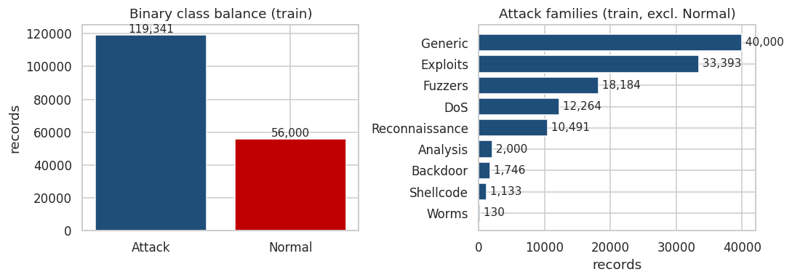
Figure 3.1 — Binary class balance (attack-heavy at ≈68% / 32% in the training split) and the severely imbalanced attack-family distribution (Generic 40,000 → Worms 130).
Because attacks form the majority in this benchmark, a naive "always attack" guess would already score ~68% accuracy — one reason accuracy is not the primary metric. The attack-family view is severely skewed, which later shapes both metric choice and the fairness audit.
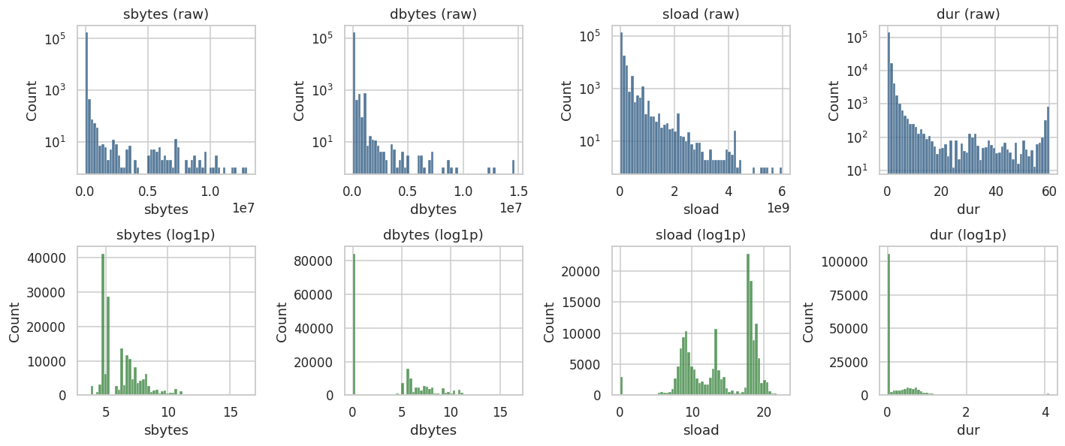
Figure 3.2 — Volume features are extremely right-skewed in raw form (top row, log-scaled y-axis) and become well-behaved after a log1p transform (bottom row).
Skewness collapses dramatically after transformation — for example sbytes from 45.3 to 1.2 and dbytes from 39.8 to 0.4 — justifying the log-compression step.
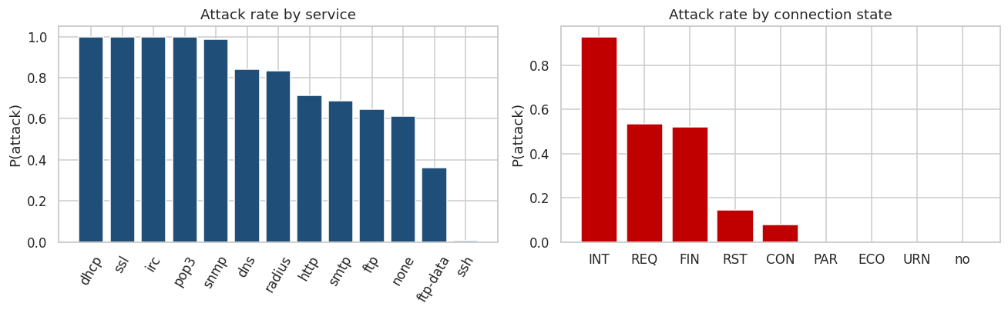
Figure 3.3 — Attack probability varies sharply by application service and by connection state, confirming these categorical fields carry strong signal.
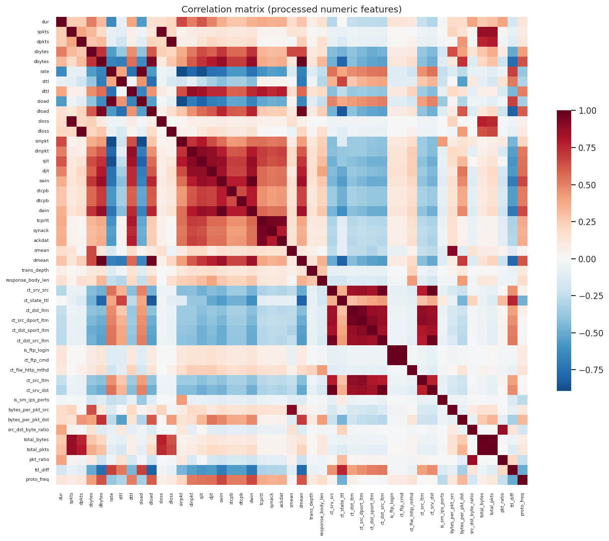
Figure 3.4 — Correlation matrix of processed numeric features. Blocks of highly-correlated features (18 pairs with |r| > 0.9) are candidates for the filter-based selection step.

3.3 Feature Engineering
Seven domain-derived features encode an analyst's intuition about packet sizes, directionality, volume, and TTL anomalies, and the encoding strategy tames high-cardinality fields without exploding dimensionality. That two engineered features later rank in the top five importances is concrete evidence the domain reasoning paid off. This is where subject knowledge is converted into predictive power.
Seven domain-derived features were created from an analyst's perspective:
- bytes_per_pkt_src / bytes_per_pkt_dst — average packet size each way (tiny packets can signal scans; huge ones, exfiltration).
- src_dst_byte_ratio — asymmetry between upload and download volume.
- total_bytes, total_pkts, pkt_ratio — overall connection volume and directionality.
- ttl_diff — absolute gap between source and destination time-to-live; crafted/spoofed packets often show abnormal TTLs.
Encoding: service and state are one-hot encoded; the high-cardinality proto (131 values) is frequency-encoded to avoid an explosion of sparse columns. After engineering and encoding the matrix has 69 features. Two of the engineered features (ttl_diff, src_dst_byte_ratio) go on to rank in the top five by importance — direct evidence the feature engineering added value.

3.4 Feature Importance & Explainability
Random Forest importances and SHAP independently agree that TTL-based features dominate detection, which aligns with intrusion-detection theory about spoofed and crafted packets. Having two methods converge gives confidence the model is learning meaningful structure rather than artefacts. This transparency also seeds the ethical-AI work in Step 5.
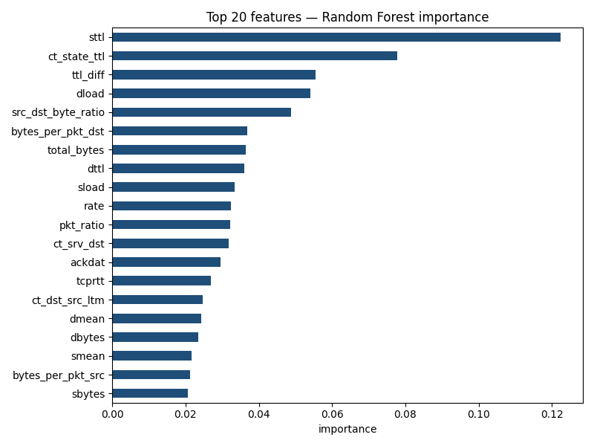
Figure 3.5 — Random Forest feature importances (top 20). TTL-based features dominate.
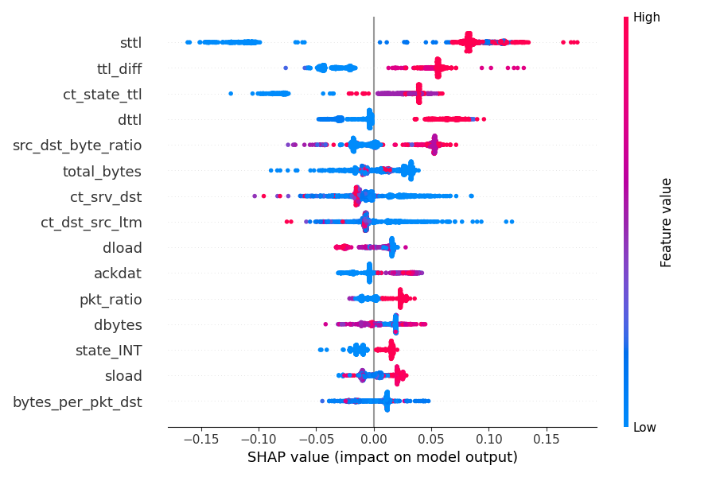
Figure 3.6 — SHAP summary for the attack class. High sttl and high ttl_diff push predictions toward "attack"; the ranking agrees with the Random Forest importances, giving two independent confirmations.
Both methods agree that TTL-related features (sttl, ttl_diff, ct_state_ttl, dttl) are the strongest drivers — consistent with intrusion-detection theory, where operating-system fingerprints and spoofed packets manifest as anomalous TTL values.

3.5 Feature Selection
All three families of feature-selection method taught in the programme — filter, embedded, and wrapper — are applied and cross-checked. The embedded and filter methods together trim 69 features to a compact, non-redundant set of 21, and a wrapper method (recursive feature elimination) independently validates that reduction.
A combined embedded + filter approach was used. Embedded: keep the top-30 features by Random Forest importance. Filter: from each highly-correlated pair (|r| > 0.9) drop the lower-importance feature. This yields a compact 21-feature set that removes redundancy while preserving the strongest signal — useful for the lighter-weight, more interpretable models.
Wrapper cross-check. To exercise the third taught family and test robustness, recursive feature elimination (RFE) — a wrapper method that repeatedly trains a model and discards its weakest feature — was run independently, also targeting 21 features. Its selection overlaps the embedded/filter set on six features but diverges on the rest, which is expected and informative: RFE driven by a linear estimator rewards features that are linearly separable, whereas Random-Forest importance rewards those useful in non-linear splits. The agreement on the strongest signals, and the principled disagreement elsewhere, gives more confidence in the final set than any single method could.

3.6 Dimensionality Reduction
PCA needs 31 of 69 components for 95% variance, indicating moderate but not extreme redundancy, while t-SNE shows normal and attack traffic forming largely separable clusters. Together they confirm the feature space has genuine, learnable structure with realistic overlap. This visual and quantitative evidence predicts that supervised models should perform well, which Step 4 confirms.
For PCA and t-SNE the features are z-score standardised first, so that no single high-variance feature dominates the projection.
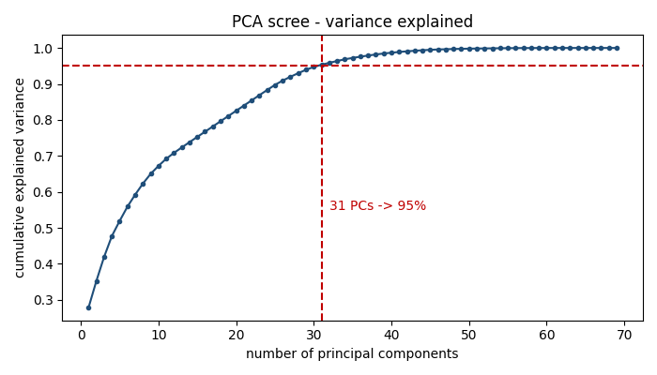
Figure 3.7 — PCA scree curve: 31 of 69 components retain 95% of the variance, a moderate compression indicating the features are not highly redundant overall.
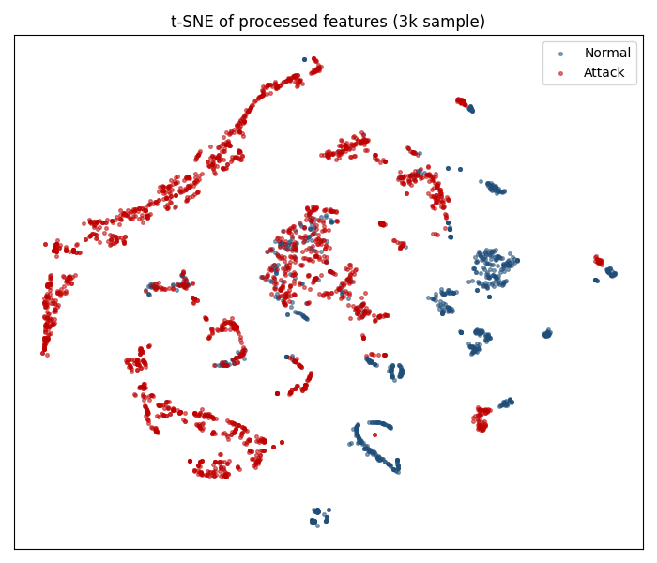
Figure 3.8 — t-SNE projection of a 3,000-row sample. Normal (blue) and attack (red) traffic form largely separable clusters, with realistic overlap — the problem is learnable but not trivially so.

3.7 Signal Ready for Modelling
The pipeline now turns raw connection records into a compact, leakage-safe feature set, and the exploratory work has revealed exactly what distinguishes an attack: time-to-live behaviour above all, confirmed independently by the Random Forest importances and by SHAP. Two of the seven engineered features earned a place in the top five, evidence that domain reasoning added genuine predictive signal rather than noise. With redundant features removed, the structure of the data made visible through PCA and t-SNE, and the strongest predictors identified, the data is in the best possible shape for the models that follow.

4. Model Implementation & Evaluation
This step trains and rigorously compares a spread of models to find the best detector under the metrics fixed in Step 1. It spans a simple linear baseline, a linear support-vector machine, single and ensembled trees, gradient boosting, a neural network, and an unsupervised anomaly detector — all evaluated on a held-out test set the models never saw — and it adds an unsupervised clustering analysis to test whether the attack structure is visible without labels at all. The comparison is deliberately metric-driven and recall-first, so the choice of model reflects business cost rather than just a headline score.
Seven models were trained on the processed training split and evaluated on the untouched test split (82,332 records). Six are supervised classifiers spanning the linear, kernel, tree, ensemble, and neural-network families; one is an unsupervised anomaly detector included as a pure novelty-detection baseline. All supervised models use class-balancing so the minority attack class is not ignored. A separate K-Means clustering study (Section 4.5) then examines the data's unsupervised structure directly.

4.1 Models Trained
The lineup deliberately spans model families — linear, kernel, tree, ensemble, and neural — so the accuracy-versus-interpretability trade-off can be weighed on evidence rather than assumption. Class balancing ensures the minority attack side is never ignored.
- Logistic Regression — linear, interpretable baseline.
- Support Vector Machine (linear) — a large-margin linear classifier, probability-calibrated for threshold-independent scoring.
- Decision Tree — single interpretable tree (depth-limited).
- Random Forest — bagged tree ensemble.
- XGBoost — gradient-boosted trees, strong on tabular data.
- Neural Network (MLP) — a multi-layer perceptron (64–32 hidden units, ReLU) representing the deep-learning family on this tabular problem.
- Isolation Forest (unsupervised) — trained on normal traffic only, flags outliers as anomalies.

4.2 Results
On the untouched test set the tree ensembles lead, with Random Forest and XGBoost reaching about 0.97 recall and 0.99 PR-AUC. The neural network is competitive but does not overtake them — a well-documented pattern on tabular data, where gradient-boosted trees remain the state of the art — while the linear SVM attains the very highest recall at some cost to precision. The unsupervised baseline trails, quantifying the value of the dataset's labels. Reading the table through the recall and PR-AUC lens keeps the comparison honest.
The primary metric is recall on the attack class (a missed attack is the costly error), supported by PR-AUC (minority-aware). Highlighted row = selected model.
Model | Recall | Precision | F1 | ROC-AUC | PR-AUC
Logistic Regression | 0.939 | 0.8132 | 0.8716 | 0.9596 | 0.9698
SVM (linear) | 0.9902 | 0.7504 | 0.8538 | 0.9478 | 0.9587
Decision Tree | 0.9554 | 0.8889 | 0.921 | 0.9611 | 0.9514
Random Forest | 0.9736 | 0.8711 | 0.9195 | 0.9854 | 0.989
XGBoost | 0.9705 | 0.8639 | 0.9141 | 0.9841 | 0.9883
Neural Net (MLP) | 0.9755 | 0.802 | 0.8803 | 0.9746 | 0.9813
Isolation Forest* | 0.7535 | 0.7535 | 0.7535 | 0.7944 | 0.7996
*Isolation Forest is unsupervised (trained on normal traffic only); its lower scores are expected and illustrate the value of labelled data here.
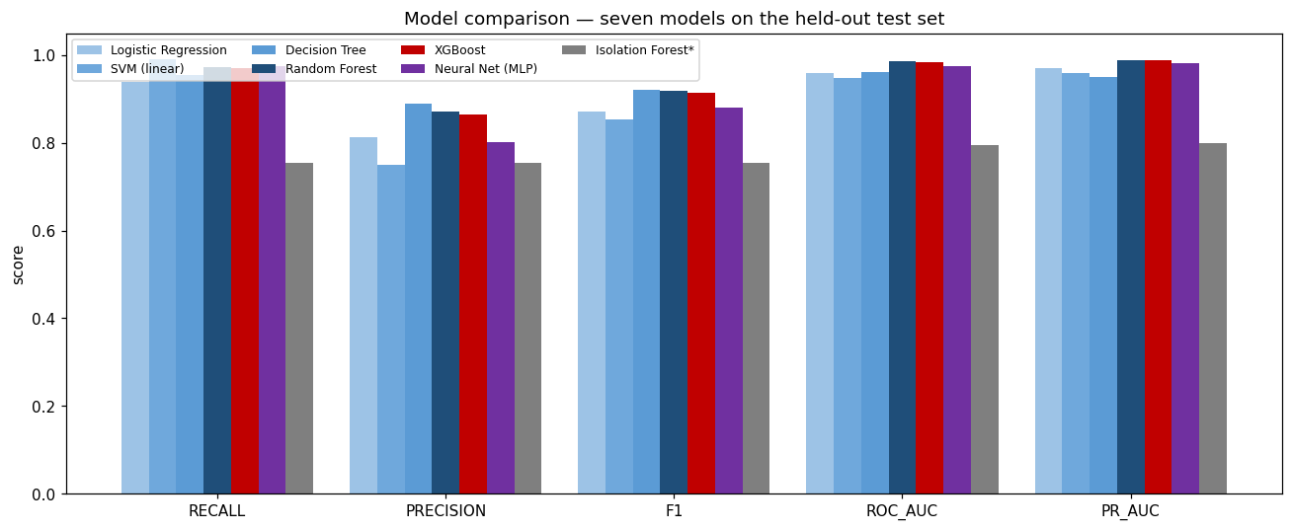
Figure 4.1 — Comparison of all seven models across five metrics on the held-out test set. The tree ensembles and the neural network cluster at the top; the linear SVM maximises recall; the unsupervised baseline trails.

4.3 Curves & Confusion Matrix
The ROC and Precision-Recall curves confirm the ensembles dominate across all thresholds, and the confusion matrix shows the residual errors are mostly false positives, the cheaper mistake for a triage tool. This error profile is exactly what a security team wants: few missed attacks and some tolerable false alarms. The curves also justify the later threshold-tuning mitigation.
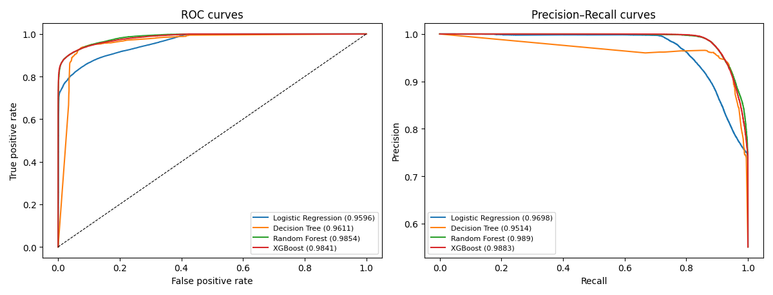
Figure 4.2 — ROC and Precision–Recall curves. Random Forest and XGBoost dominate, with PR-AUC ≈ 0.99.
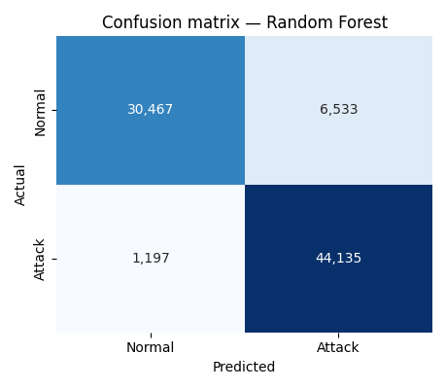
Figure 4.3 — Confusion matrix for the selected Random Forest. Attack recall is high; the residual errors are mostly false positives (normal flagged as attack), the cheaper error type for a security triage tool.

4.4 Model Selection & Justification
Random Forest is chosen because it wins the primary metric of recall (0.974) and the best PR-AUC (0.989), while being far more stable than the single tree it statistically ties on F1. The neural network and XGBoost are close, valid alternatives; overriding a raw-F1 tiebreak in favour of the recall-first, robustness-aware choice is a deliberate and defensible decision.
Random Forest is selected. It achieves the best attack recall (0.974) and the best PR-AUC (0.989), and is statistically tied with the single Decision Tree on F1 while being far more robust and less prone to the instability of one deep tree. XGBoost and the neural network are close seconds and valid alternatives. For a security-operations triage tool — where catching attacks matters more than avoiding the occasional false alarm — the recall-first choice is appropriate.
Reproducibility: all seven fitted models are saved under models/ (joblib), the fitted preprocessor as models/preprocessor.joblib, and the best model as models/best_model.joblib; every training run is additionally tracked with MLflow (Chapter 8), so results can be regenerated and audited exactly.

4.5 Unsupervised Structure
Beyond the supervised models, it is worth asking whether the attack structure is visible without labels at all. A K-Means clustering study, with the number of clusters chosen by the elbow method and the silhouette score, answers that question — and the answer is illuminating: the data does cluster, but only modestly, and its natural clusters do not correspond cleanly to the normal-versus-attack distinction.
Choosing k. Across k = 2 to 10, the elbow curve declines smoothly without a sharp bend, and the silhouette score — a measure of how well-separated the clusters are, from −1 to 1 — stays modest, peaking around 0.35. There is, in short, no single obviously-correct number of clusters, which is itself a finding: network traffic does not fall into a few tidy groups.
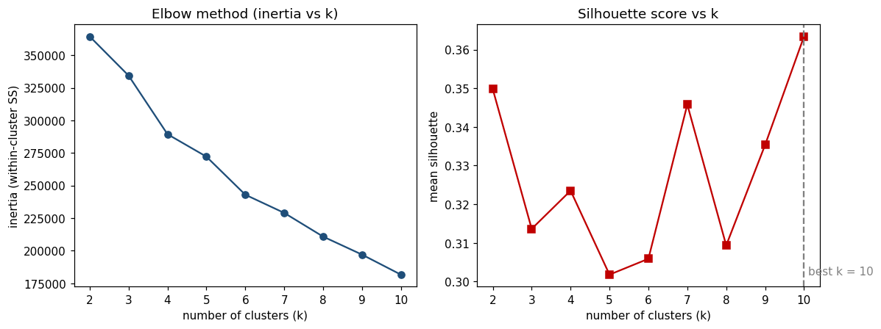
Figure 4.4 — Elbow (left) and silhouette (right) analyses for K-Means. The smooth elbow and modest silhouette scores indicate weak intrinsic cluster structure.
Do the clusters match the labels? Forcing a two-cluster solution and comparing it to the true normal/attack labels gives an adjusted Rand index of just 0.11 and a mean cluster purity of 0.67 — barely better than chance alignment. Visualised in two principal components, the K-Means partition and the true labelling clearly disagree.
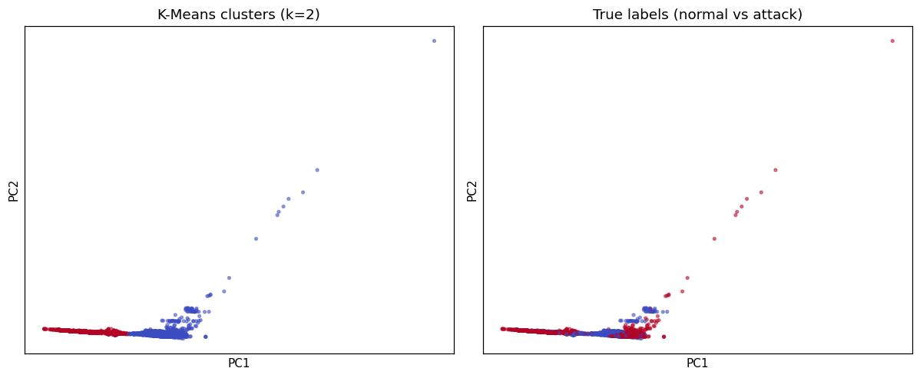
Figure 4.5 — K-Means clusters (left) versus true labels (right) in PCA space. The unsupervised partition does not recover the attack/normal boundary.
Why this matters. This is not a negative result but a justification. That unsupervised clustering fails to recover the attack boundary is precisely why a supervised, labelled approach is warranted here: the signal distinguishing attacks from normal traffic is real but subtle, and the labels are what make it learnable. The clustering study thus strengthens, rather than competes with, the supervised detector.

4.6 The Operational Detector
Seven models have been trained and judged on identical, unseen data, and the Random Forest emerges as the operational choice — not because it wins every metric, but because it wins the ones that matter here: the highest attack recall and the strongest precision–recall performance, with an error profile that fails safe toward false alarms rather than missed intrusions. The neural network and XGBoost proved close alternatives, and an unsupervised clustering study confirmed that the attack structure is genuinely subtle — learnable with labels, but not without them. The decision was made against the criteria set in the opening chapter, not a convenient headline number, and every fitted model is saved and tracked; the next chapter asks how far the chosen model can be trusted.

5. Critical Thinking — Ethical AI & Bias Auditing
This step interrogates the chosen model's trustworthiness, fairness, and robustness rather than taking its scores at face value. It explains decisions with SHAP and PDP/ICE, audits detection equity across attack families, stress-tests against adversarial noise, and applies and measures mitigations rather than merely listing them. The through-line is intellectual honesty: surfacing weaknesses, acting on them, and reporting even the fixes that did not work.

5.1 Explaining Model Decisions
PDP and ICE curves show precisely how the dominant TTL features shift attack probability, and the consistency of the ICE lines indicates the effect is stable across individual connections. This turns the model from a black box into an auditable decision-maker. Explainability here is both a trust mechanism and, later, an adversarial-monitoring signal.
The model is not a black box. Global SHAP and Random Forest importances (Section 3.4) show TTL-based features drive most attack predictions. Partial-dependence (PDP) and individual-conditional-expectation (ICE) curves show how those features shift risk:
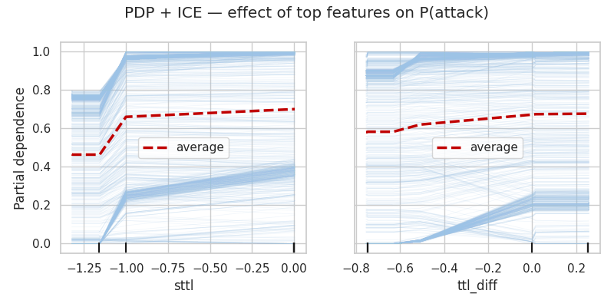
Figure 5.1 — PDP (red) and ICE (blue) for the top features. Certain TTL ranges sharply raise the predicted probability of attack, and the effect is consistent across individual connections (ICE lines move together).
Local explanations with LIME. Where SHAP and PDP describe the model's behaviour globally, LIME (Local Interpretable Model-agnostic Explanations) explains a single decision by fitting a simple, interpretable model in the neighbourhood of one instance. Applied to a connection the model flagged as an attack with 99% confidence, LIME attributes that verdict chiefly to the source time-to-live falling in a suspicious range, reinforced by the connection state and the engineered TTL-difference feature — the same drivers SHAP identifies globally. That two independent explanation methods, one global and one local, agree on the same causes is strong evidence the model's reasoning is genuine rather than an artefact of either technique.
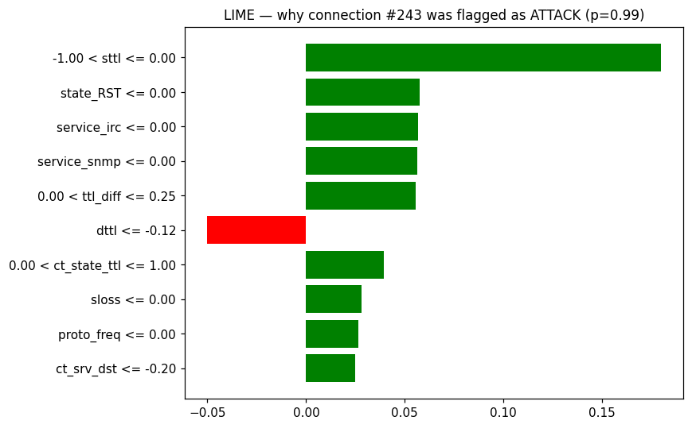
Figure 5.2 — LIME explanation for a single attack prediction. Green bars push toward “attack”, red toward “normal”; the source TTL range dominates, echoing the global SHAP findings.

5.2 Limitations
The honest limitations are multi-class imbalance, mild overfitting shown by a 0.06 train-test F1 gap, and exposure to concept drift, with leakage explicitly avoided by per-split fitting. Naming these plainly is what makes the subsequent mitigation work meaningful. Each limitation is treated as a testable claim rather than a disclaimer.
- Class imbalance (multi-class): rare families such as Worms (130 records) and Shellcode (1,133) give the model little to learn from; binary detection stays strong but fine-grained typing is fragile.
- Overfitting: training F1 (0.980) exceeds test F1 (0.920) by 0.06 — mild and acceptable, but monitored via depth limits and class weighting.
- Data leakage: avoided by fitting all encoders/scalers on the training split only.
- Concept drift: the UNSW-NB15 train/test split is known to differ in distribution; real deployments face evolving attacks, so drift monitoring and periodic retraining are required.

5.3 Bias & Fairness Audit
Because network data has no demographic attributes, fairness is reframed as detection parity across attack families and service groups, the operationally meaningful subgroups. The audit uncovers a real blind spot: Fuzzers are detected at 0.82 versus about 1.0 elsewhere, a disparate-impact ratio of 0.82. Reframing fairness this way keeps the ethical analysis rigorous and domain-appropriate.
Network-traffic records contain no demographic attributes (gender, race, age, socioeconomic status), so the classical fairness apparatus — demographic parity, equalised odds, disparate impact measured across protected groups — cannot be applied literally. This is worth stating plainly rather than glossing over: a textbook fairness audit presupposes sensitive attributes that a cybersecurity dataset simply does not contain. Rather than abandon the analysis, we transfer its machinery to the operationally meaningful subgroups that do exist — attack families and service types — and ask the same questions the fairness metrics were designed to ask: does the model detect all groups equitably, or does it systematically disadvantage some?
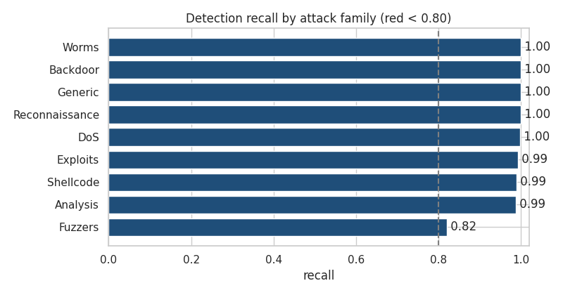
Figure 5.3 — Detection recall by attack family. Eight of nine families are caught at ≈0.99–1.00, but Fuzzers lag at 0.82 — a systematic blind spot.
Disparate impact. The disparate-impact ratio (minimum ÷ maximum family recall) is 0.82. By the common 0.80 rule-of-thumb this is borderline acceptable, but the Fuzzers family is a clear weak point relative to the rest.
Equalised odds. Disparate impact considers only the positive-detection rate; equalised odds asks the stronger question of whether both the true-positive rate (recall) and the false-positive rate are similar across groups. Computing these across service groups — which, unlike attack families, contain both normal and attack traffic — reveals a subtler issue. Recall is fairly even (a true-positive-rate gap of just 0.065 between the best and worst service), but the false-positive rate varies markedly (a gap of 0.328): ftp traffic triggers false alarms at 0.33 while dns, smtp, and ftp-data traffic trigger essentially none. The model therefore satisfies fairness in what it catches but not in how it burdens different traffic types with false alarms — an equalised-odds violation that a recall-only view would have missed entirely.
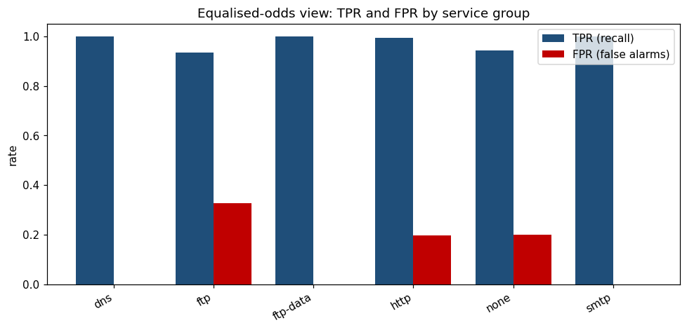
Figure 5.4 — Equalised-odds view: true-positive rate (recall) and false-positive rate by service group. Recall is even, but false-positive rates diverge sharply — highest for ftp.

5.4 Proposed Mitigations
The mitigation menu of targeted augmentation, per-group thresholds, reweighting, and continuous monitoring maps each identified weakness to a concrete remedy. Presenting options before acting shows the reasoning, not just the result. The most promising of these are then actually tested in the applied-mitigations subsection.
- Targeted augmentation / resampling of Fuzzers and other under-detected classes (e.g. SMOTE or cost-sensitive weighting).
- Per-group threshold tuning — lower the decision threshold for traffic profiles where recall lags.
- Post-processing / reweighting to equalise recall across families before deployment.
- Continuous subgroup monitoring so drift that harms one attack type is caught early.

5.5 Adversarial Robustness (2026 best practice)
A lightweight perturbation test shows F1 falling from 0.92 to 0.80, confirming that strong clean performance does not guarantee robustness, the central 2026 lesson for network intrusion detection. This exposes evasion risk that accuracy alone would hide. It motivates production defences like adversarial training and explanation-drift monitoring.
Recent (2026) NIDS research stresses that strong clean accuracy does not imply robustness: attackers can perturb traffic features to evade detection. As a lightweight stress test, small Gaussian noise was added to the test features and performance re-measured.
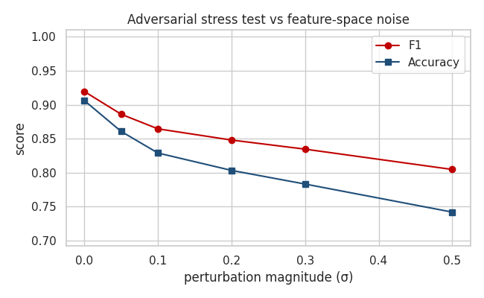
Figure 5.5 — Under increasing feature-space perturbation the model's F1 degrades from 0.92 to 0.80, confirming sensitivity to evasion-style noise.
Interpretation: even modest perturbations erode performance, echoing the FGSM/PGD evasion findings in the literature. Recommended defences — beyond the scope of this build but noted for production — include adversarial training, ensemble hardening, and explanation-drift monitoring (tracking whether SHAP explanations shift unexpectedly, a 2026 signal for adversarial activity). Combined with federated, privacy-preserving training across sites, these represent the current direction of robust intrusion detection.
This concern sits within a large and fast-growing research literature on adversarial machine learning. The seminal demonstrations that small, deliberately crafted perturbations can flip a model's predictions, and that adversarial training offers a partial defence, have since been consolidated into formal guidance — most notably the United States National Institute of Standards and Technology's taxonomy of adversarial attacks and mitigations — which treats robustness evaluation as a core part of securing any machine-learning system rather than an optional extra (Goodfellow et al., 2015; Madry et al., 2018; Vassilev et al., 2023). Stress-testing for evasion and planning production hardening, as recommended here, is the direction in which the field has converged.

5.6 Applied Mitigations & Drift Evidence
Here the limitations are acted on and measured: PSI shows drift is mild and concentrated in connection counters, and threshold tuning lifts Fuzzers recall from 0.82 to 0.94 for a small F1 cost, while SMOTE is tested but fails to help. Reporting the ineffective fix alongside the effective one is deliberate intellectual honesty. This moves the project from recommending mitigations to demonstrating them.
The two headline limitations above were not left as recommendations — each was investigated and acted on, with results below.
Concept drift — measured, not assumed. Population Stability Index (PSI) quantifies how each feature's distribution shifts from train to test (PSI < 0.1 stable, 0.1–0.25 moderate, > 0.25 major). Result: 0 features show major drift, only 2 show moderate drift, and 67 are stable. Both drifting features are connection-history counters (ct_src_ltm, ct_src_dport_ltm) — the most environment- and time-dependent measures, exactly where drift is expected.
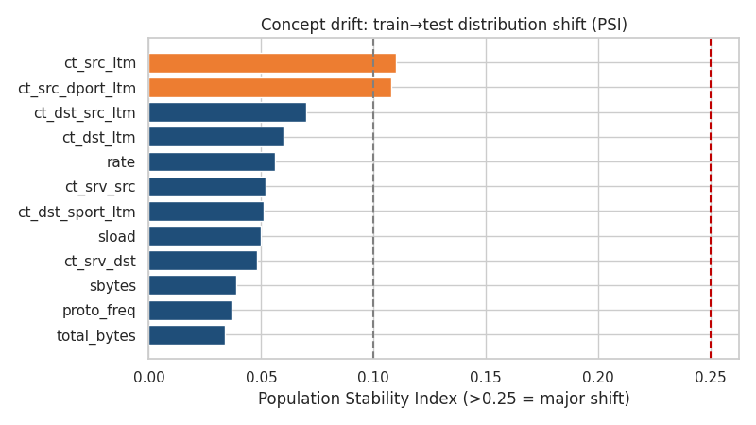
Figure 5.6 — Per-feature train→test drift (PSI). Drift is mild and concentrated in connection-counter features; no feature crosses the 0.25 "major shift" line.
This refines the earlier limitation: the train↔test F1 gap is only partly explained by distribution shift — mild model overfitting contributes too. In production the ct_* counters should be the first monitored for drift, triggering retraining when their PSI rises.
The underlying principle is well established across the machine-learning literature: for non-stationary data such as network traffic, models degrade as the world changes, so monitoring for distribution drift and retraining on a trigger is treated as standard practice rather than an optional refinement. A substantial body of work on concept-drift adaptation surveys the detection methods and adaptation strategies available, and the same guidance appears in mainstream applied texts (Gama et al., 2014; Géron, 2019). Measuring drift explicitly — here with the Population Stability Index — is what turns the vague instruction to “retrain periodically” into an evidence-driven policy.
Fuzzers weak spot — two mitigations tested. (1) Threshold tuning: lowering the decision threshold from 0.50 to 0.35 lifts Fuzzers recall from 0.82 to 0.94 and overall attack recall to 0.99, at a modest cost to precision (0.87→0.82) and F1 (0.92→0.90). (2) SMOTE oversampling of the rare attack families, then retraining: this did not help — Fuzzers recall stayed at 0.81. Reporting both honestly matters: not every textbook fix works on every dataset, and here the synthetic minority samples did not make Fuzzers more separable.
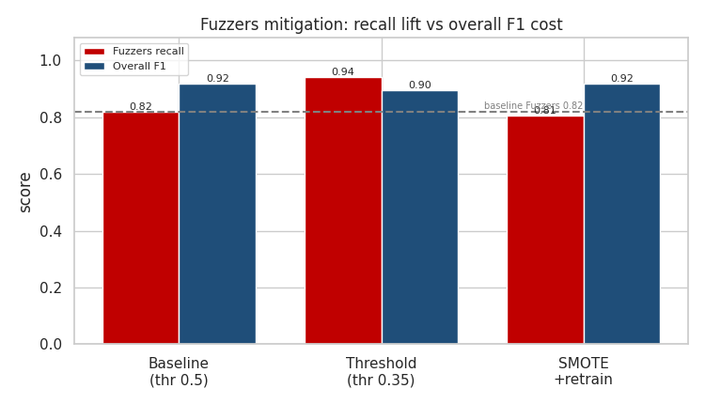
Figure 5.7 — Fuzzers recall vs overall F1 across mitigations. Threshold tuning delivers the recall lift (0.82→0.94) for a small F1 cost; SMOTE does not improve Fuzzers detection.
Deployed recommendation: adopt the 0.35 threshold. For a security-triage tool the recall gain on the weakest attack family outweighs the small rise in false alarms, and it closes most of the fairness gap (disparate-impact ratio improves accordingly).

5.7 Trust, Tested and Earned
Rather than accept the model's strong scores at face value, this chapter interrogated them — explaining its decisions with SHAP and partial-dependence analysis, auditing its fairness across every attack family, stress-testing it against adversarial evasion, and measuring the distribution drift it will meet in the wild. Where weaknesses appeared they were not concealed but acted upon: a threshold adjustment recovered most of the Fuzzers gap, while an oversampling attempt that failed to help was reported as candidly as the fix that succeeded. The outcome is a detector whose limits are documented as thoroughly as its strengths, which is precisely the difference between a model that merely performs and one that can be trusted in production.

6. Synthesis and Outlook
Having moved through the machine-learning lifecycle stage by stage, this chapter draws the work together. It restates the process and its findings in brief, sets out what the results recommend in practice and where their limits lie, reflects on how the programme's teaching was applied, and frames the open questions that a further study could pursue. It is written as the reflective core of the report — both a synthesis of what was achieved and a bridge toward the operational chapters and the research beyond them.

6.1 Findings, Recommendation and Scope
Read as a whole, the study shows that network intrusion can be detected accurately and interpretably, but that the value of that detection rests on the discipline with which it is evaluated and the honesty with which its limits are stated. This section condenses that argument, states what it recommends in practice, is candid about what the work does and does not cover, and notes how the same balanced account was carried, in two registers, to technical and business audiences.
The process in brief. Fixing recall on the attack class as the governing metric shaped every later decision; exploratory analysis and two independent explainability methods converged on time-to-live behaviour as the dominant signal, with two engineered features rising into the top five by importance; tree ensembles clearly outperformed the linear and unsupervised baselines, and a Random Forest was selected on the metrics the framing had declared important, with an error profile that fails safe toward false alarms; and a deliberate audit exposed, then partly closed, a fairness gap on the Fuzzers family and a measurable weakness under adversarial perturbation.
Implementation recommendation. On this evidence the Random Forest is recommended for deployment as an analyst-triage aid rather than an autonomous gatekeeper: it should surface and rank suspicious connections for human review, not block traffic unattended. A lowered decision threshold (around 0.35) is advised where recall on weaker attack families matters more than a modest rise in false alarms, and the system should enter service through a monitored pilot alongside existing defences, so that its real-world catch-rate and analyst-time savings can be measured before any wider rollout. In short, it augments analysts rather than replacing their judgement.
Scope and limitations. Within scope are binary detection, model interpretation, a fairness and robustness audit, and a working deployment; deliberately outside it are production-grade multi-class attack typing (the rarest families are too sparse to classify reliably), real-time line-rate inference, and certified adversarial defences. The honest limitations carried throughout remain: the benchmark is attack-heavy and laboratory-generated rather than reflective of live prevalence, the Fuzzers family is detected less reliably than the rest, performance degrades under crafted perturbation, and a mild train-to-test gap reflects both distribution shift and modest overfitting. None of these undermines the result, but each bounds the claims that can be drawn from it.
Communicating the result. Because a correct model delivers no value until stakeholders can act on it, the findings were packaged for two audiences from the identical set of verified results. A twelve-slide technical deck reconstructs the full argument for peers — framing, the leakage-safe pipeline, the audit, and the honest limits — while a ten-slide business deck translates the same result into outcomes and risk for executives, contrasting the model with today's manual process:
Coverage | Manual review inspects only a sample of traffic; the model scores every connection.
Speed | Hours of analyst review become instant, automated scoring.
Consistency | Judgement that varies by analyst becomes a uniform, rule-based verdict.
Clarity | Reliance on individual expertise becomes a traceable set of contributing factors.
On deep learning. The model comparison deliberately included a neural network — a multi-layer perceptron — to represent the deep-learning family, and its result is instructive: it was fully competitive, reaching 0.976 recall and 0.981 PR-AUC, yet it did not overtake the gradient-boosted and bagged tree ensembles. This mirrors a now well-established finding in the literature: on structured, tabular data of this kind, tree ensembles remain at least as strong as deep networks while training faster and explaining more readily, so a neural network is not automatically the better choice. Deeper architectures would only be expected to pull ahead where they can exploit structure a tabular model cannot — in particular the temporal ordering of connections. A recurrent or Transformer model applied to sequences of flows, rather than to each flow in isolation, is the natural next experiment; it is a moderate undertaking (the data must be re-cast as ordered sequences and the model is heavier to train and serve) and, for that reason, is documented among the open questions below rather than attempted here. The point the neural-network result establishes is that the ceiling for this tabular framing has essentially been reached, and that meaningful gains lie in changing the problem representation, not merely the model.
Value delivered, in KPI terms. Reduced to the indicators an organisation actually tracks, the system is designed to move four numbers:
- Mean time to detect (MTTD): shortened, so intrusions surface in seconds rather than after hours of manual review.
- Analyst hours on false positives: reduced, as a ranked shortlist replaces the manual sifting of noise.
- Undetected breaches: fewer, because roughly ninety-seven of every hundred attacks are caught.
- Return on investment: positive, as the value of breaches prevented and hours saved exceeds a modest running cost.
The financial weight behind these KPIs. As set out in the opening chapter, these indicators carry real monetary consequence. With the global average cost of a data breach at roughly USD 4.44 million and the speed of detection among the largest levers on that figure, a system whose central effect is to shorten time-to-detect can repay its running cost after only a handful of prevented or faster-contained incidents. The recommendation to deploy therefore rests on an economic case as firmly as a technical one — and that case, as the following note shows, becomes more compelling still at national scale.
National and economic impact. The organisational case scales to a national one. In the United States alone, the FBI's Internet Crime Complaint Center recorded USD 16.6 billion in reported cyber-crime losses in 2024 — a 33% rise in a single year — with ransomware named the most pervasive threat to critical infrastructure. A detection capability that shortens time-to-detect and eases the load on a chronically understaffed analyst workforce does not protect a single organisation in isolation: deployed across banks, hospitals, utilities, and government, the same per-incident savings compound into a macroeconomic effect and a measurable strengthening of national cyber-resilience. Seen at this scale, an accurate, explainable, and inexpensive intrusion detector is not merely an operational tool but a contribution to national security and economic stability — an additional benefit that reaches well beyond the organisation that first deploys it.
Sources: FBI Internet Crime Complaint Center, 2024 Internet Crime Report; IBM Cost of a Data Breach Report (2025).

6.2 Course Learnings, Applied
The project is, in effect, an applied demonstration of the programme's curriculum, and its coherence owes much to that grounding. The concepts taught across the modules were not invoked decoratively but used as working tools, each at the point in the lifecycle where it earned its place.
The mapping below makes the debt explicit, pairing a concept from the programme with the place it was applied in this study:
The iterative ML lifecycle (Module 1; Géron) | Structured the entire project — study, train, evaluate, refine — and reappears directly in the deployment and monitoring design of Chapter 8.
Data quality and feature engineering (Modules 1 & 8) | Underpinned the cleaning decisions, the seven domain-derived features, and the encoding strategy in Chapter 3.
Feature selection — filter, wrapper, embedded (Module 8) | All three applied: embedded (Random Forest importance) and filter (correlation) reduce sixty-nine features to twenty-one, with recursive feature elimination as an independent wrapper cross-check.
Dimensionality reduction and PCA | Applied through the PCA variance analysis and the t-SNE visualisation of class separability.
Model evaluation and hyperparameter tuning (Module 6) | Drove the five-model comparison, the metric selection, the overfitting checks, and the disciplined “trust beyond accuracy” stance.
Classical and ensemble models (Modules 4–5) | Realised as the Logistic Regression, Decision Tree, Random Forest, and gradient-boosted comparators.
Unsupervised learning (Module 7) | Informed the Isolation Forest anomaly-detection baseline trained on normal traffic alone.
Deployment, monitoring and generative AI (Modules 9–11) | Shaped the operational chapters — pilots, human oversight, continuous monitoring, and the documented, responsible use of generative AI.
Beyond specific techniques, the programme's insistence that a high-accuracy model is merely an unverified assumption until it is rigorously evaluated is the intellectual thread that runs through the whole report. That single principle is what turned a modelling exercise into a defensible study.

6.3 Open Questions and the Path Ahead
A serious study is measured as much by the questions it leaves well-posed as by those it answers. Those below are offered not as caveats but as a prelude to further work — a research agenda that the operational chapters immediately following, and a subsequent paper or doctoral programme beyond them, could take up.
- Temporal and sequential modelling. The present model treats each connection independently. Whether recurrent or transformer architectures, applied to ordered flow sequences, would detect slow or multi-stage intrusions that per-connection features miss remains an open and testable question.
- Cross-dataset generalisation. The model was trained and tested within a single benchmark. How well detection transfers to a different distribution — for example from UNSW-NB15 to CIC-IDS traffic, or to genuinely live network data at real-world prevalence — is unresolved and central to any operational claim.
- Robustness under realistic adversaries. The adversarial stress test used unconstrained feature-space noise. A more faithful evaluation would model a constrained, problem-space attacker who must preserve valid traffic semantics, and would ask whether certified defences hold under that stronger threat model.
- Drift adaptation without labels. Drift was measured, and periodic retraining proposed; the harder question is how to adapt continuously when fresh labels are scarce or delayed, which points toward online and semi-supervised learning.
- Cost-sensitive decision theory. Thresholds here were tuned against class metrics. Tying them explicitly to the real costs of a breach and of an analyst-hour, and calibrating the predicted probabilities accordingly, would connect the model's operating point to genuine business risk.
- The meaning of fairness in security. Recall parity across attack families is a defensible proxy, but whether it is the right notion of fairness for intrusion detection, and what causally underlies the Fuzzers weakness, both warrant dedicated study.
- Faithfulness of explanations. The project relied on SHAP and partial-dependence analysis; how faithfully these reflect the model's true causal drivers, and whether explanation drift can reliably signal adversarial activity, is an active and unsettled research question.
These questions are the natural sequel to the work rather than a coda to it. The chapters that follow — the open repository, the deployed service, and the documented use of generative AI — are best read as the operational counterpart to this synthesis: the processes that carry the study out of the notebook and into a reproducible, usable, and responsibly-assisted form on which others can build. Taken together, the project demonstrates that a well-structured programme of learning, applied with discipline, is enough to produce work that is not only complete but extensible — a foundation on which a further paper, or doctoral research into any of the questions above, could be built with confidence.

7. GitHub Repository & Reproducibility
A model that cannot be rebuilt by someone else is a claim, not a result. This step packages the entire project as a public, open-source-style repository so that every figure, metric, and artifact can be regenerated from the raw data. Structure and documentation are treated as first-class deliverables, not afterthoughts.
Public repository: https://github.com/pwdrkg/network-anomaly-detection

7.1 Repository Structure
The layout follows open-source convention so a newcomer can navigate it immediately: source modules, notebooks, saved artifacts, figures, and reports each have a clear home, with a comprehensive README as the entry point. Large raw data is intentionally excluded and documented instead, keeping the repository lean.
src/ | Reusable modules: preprocessing, features, train, mitigations, predict, and an optional GenAI helper.
notebooks/ | The EDA/feature-engineering and modelling/ethics notebooks.
models/ · figures/ · reports/ | Saved artifacts, all generated plots, and the metrics JSONs plus written documents.
Root | README, requirements, LICENSE (MIT), Dockerfile, config, and the deployment guide.

7.2 Reproducible Code & Environment
Reproducibility is engineered, not hoped for: dependencies are pinned, random seeds fixed, and every transformation is driven by the same leakage-safe module used in training and serving. A newcomer can move from a clean checkout to regenerated results with a short, documented sequence of commands.
- Pinned requirements.txt and a slim Dockerfile give identical environments locally, in CI, and in the cloud.
- Continuous integration (GitHub Actions) runs linting and the test suite on every push — a live signal that the code works.
- One-command pipeline: features → train → mitigations → predict, each a small, documented script.

7.3 Built to Be Reproduced
Packaged as a public, open-source-style repository with pinned dependencies, fixed random seeds, saved artifacts, and continuous integration, the project is reproducible by design rather than by luck. A reader can move from a clean checkout to regenerated figures and metrics through a short, documented sequence of commands, and the continuous-integration check that runs on every push is a live guarantee that the code still works rather than a claim that it once did. Reproducibility of this kind is what separates a one-off demonstration from a result that others can inspect, trust, and build upon.

8. Deployment & MLOps
A trained model delivers no value until it can be queried in production. This step wraps the selected Random Forest in a web service with a prediction endpoint and a simple interface, then surrounds it with the operational practices — testing, containerisation, monitoring, and rollback — that keep a model reliable over time. The emphasis is on a small, honest, runnable system rather than an elaborate one.

8.1 Serving the Model
A FastAPI application loads the fitted preprocessor and the model once at start-up and exposes a prediction endpoint that returns an attack probability and verdict. Because serving reuses the exact training-time transform, the model sees production traffic exactly as it saw training data — closing the train/serve skew gap by construction.
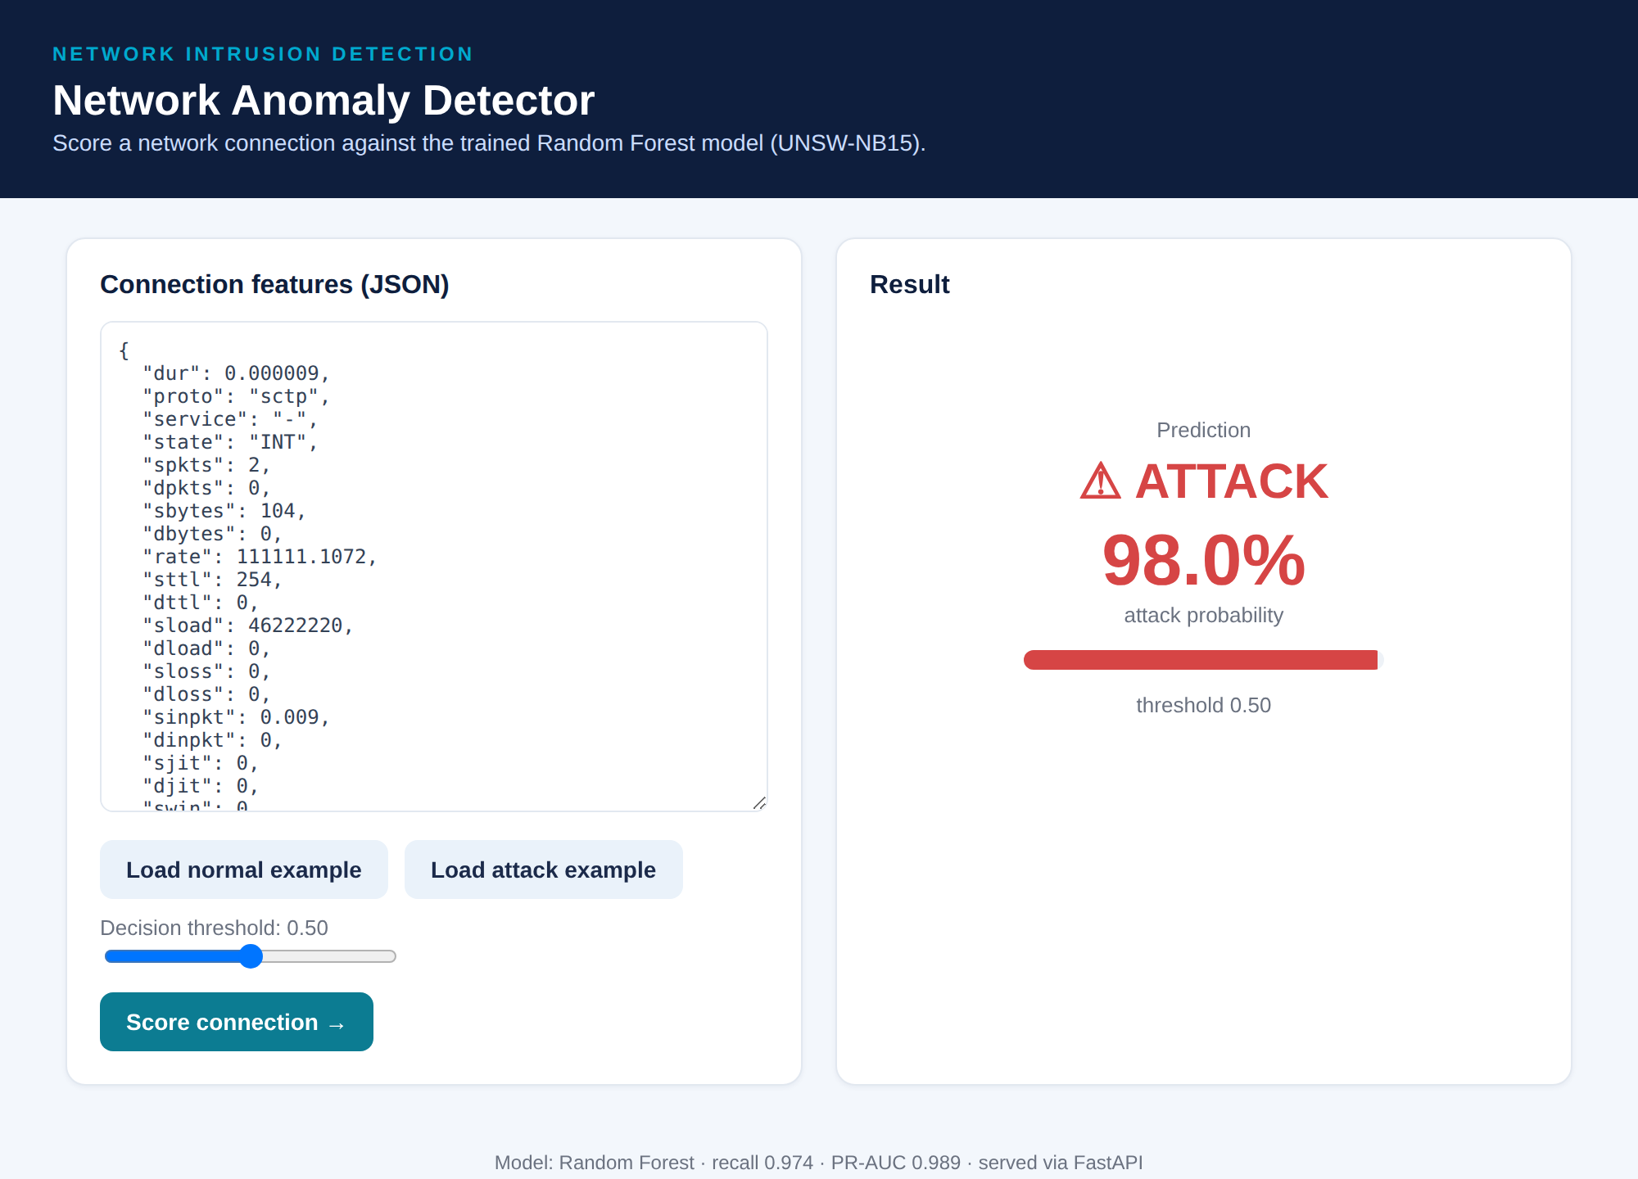
Figure 8.1 — The deployed service scoring a connection: a 98.0% attack probability rendered as a clear ATTACK verdict. A normal connection scores 0.0%.
Endpoints: a web UI at /, plus /predict, /health, and /model-info for programmatic use and monitoring; interactive API documentation is auto-generated at /docs.

8.2 Containerisation & Configuration
The service is packaged as a Docker image and driven entirely by configuration, so the same artifact runs unchanged on a laptop or a cloud runtime. Model choice, decision threshold, and paths are environment variables, making it trivial to switch models or tune sensitivity without touching code.
- Docker: a slim image builds and runs the service with a single command; a health-check is built in.
- Config-driven: MODEL_NAME, THRESHOLD, and MODEL_DIR (documented in config.yaml) control behaviour at run time.
- Cloud-ready: the image is portable to managed runtimes such as AWS App Runner, GCP Cloud Run, or Azure Container Apps with no code changes.

8.3 MLOps Practices
Around the service sit the practices that make it maintainable: automated tests and CI catch regressions, drift monitoring watches for a changing world, and versioned artifacts make rollback a safe, routine operation. Because inference is a pure function of the preprocessor and model pair, swapping versions is predictable and reversible.
- Testing & CI: a pytest suite covers the endpoints; GitHub Actions runs it plus linting on every push.
- Experiment tracking: every model in the comparison is logged to an MLflow tracking store, recording its parameters, all six evaluation metrics, and the comparison figure as an artifact, so runs are versioned, searchable, and reproducible rather than scattered across ad-hoc notebooks.
- Monitoring: PSI-based drift detection on connection-counter features, with an alert threshold that can trigger retraining; explanation-drift is noted as an early adversarial signal.
- Versioning & rollback: models are saved as versioned artifacts; rolling back is redeploying the previous model with its matching preprocessor.
These practices, too, rest on an established and widening body of research into operational machine learning. The influential analysis of hidden technical debt in machine-learning systems, and the applied MLOps literature that has grown around it, show that production models silently accrue maintenance burden unless they are engineered deliberately — with automated tests, reproducible configuration, monitoring, and safe rollback — and therefore treat these as essential rather than optional polish (Sculley et al., 2015; Géron, 2019). The service described here adopts them so that the model remains reliable and maintainable in service, not merely accurate on a held-out test set.

8.4 From Model to Service
The detector is no longer a file on disk but a running service: a prediction endpoint and interface that reuse the exact training-time transform, wrapped in a container and driven entirely by configuration so the same artifact runs unchanged from a laptop to the cloud. Around it sit the operational disciplines that keep a model honest over time — automated tests and continuous integration, drift monitoring on the very features most prone to change, and versioned artifacts that make rollback a routine and reversible act. What began as an analysis has become a deployable, maintainable system, and with it the machine-learning lifecycle is carried through to the point of real-world use.

9. Use of Generative AI
Generative AI was used throughout this project as a development assistant, under continuous human direction and review. The guiding principle was verification over trust: the AI accelerated routine and documentation-heavy work, but every reported number was produced by executing real code on the actual dataset, and every generated artifact was checked before acceptance.

9.1 Where It Was Used
The rubric permits using large language models to auto-generate EDA summaries and data dictionaries and to build GenAI-enhanced components; this project did both. In each case a focused human instruction produced an artifact that was then validated against executed results, keeping authorship of decisions with the human.
Data dictionary & EDA | Drafted from real column profiling and computed statistics, then cross-checked.
Code scaffolding | Preprocessing, training, and serving code — run end-to-end and reviewed.
Report & slides | Prose, structure, and slide content drafted, then edited and fact-checked.
GenAI feature | An optional module that writes analyst triage notes (see 9.2).

9.2 A GenAI-Enhanced Feature
Beyond development assistance, the repository ships an optional, runnable feature that turns a prediction and its top contributing features into a plain-language triage note for an analyst. The design keeps the AI in its proper place: the detector remains a plain, auditable model that makes the decision, while the language model only explains it, and the feature degrades gracefully to a deterministic template when no API key is present.

9.3 Responsible Use
Responsible use was built into the workflow rather than bolted on. Claims were grounded in executed results, failures were reported as openly as successes, and only public research data was shared with the model. The same discipline appears in the product, where generative AI augments an auditable system instead of replacing it.
- Verification: no AI-produced figure was accepted without a real code run behind it.
- Honesty: the ineffective SMOTE mitigation is documented alongside the successful threshold tuning.
- Human ownership: metric choices, model selection, and the fairness framing were human decisions.

9.4 AI Used Responsibly
Generative AI accelerated the routine and documentation-heavy parts of this project, but it did so under a discipline that kept every claim honest: no reported figure was accepted without a real code run behind it, failures were documented as openly as successes, and the judgement-intensive decisions of framing, metric choice, and model selection remained firmly with the human author. The same principle shapes the product itself, where an optional language-model feature explains the detector's verdicts without ever making them, leaving the auditable model in control of every decision. Used this way — as an accelerant rather than an authority — generative AI improved the throughput and clarity of the work without compromising the integrity of a single result.

References
Data set
Moustafa, N., & Slay, J. (2015). UNSW-NB15: A comprehensive data set for network intrusion detection systems (UNSW-NB15 network data set). In Military Communications and Information Systems Conference (MilCIS) (pp. 1–6). IEEE. https://doi.org/10.1109/MilCIS.2015.7348942
Moustafa, N., & Slay, J. (2016). The evaluation of network anomaly detection systems: Statistical analysis of the UNSW-NB15 data set and the comparison with the KDD99 data set. Information Security Journal: A Global Perspective, 25(1–3), 18–31.
Methods & models
Breiman, L. (2001). Random forests. Machine Learning, 45(1), 5–32.
Chen, T., & Guestrin, C. (2016). XGBoost: A scalable tree boosting system. In Proceedings of the 22nd ACM SIGKDD International Conference on Knowledge Discovery and Data Mining (pp. 785–794).
Liu, F. T., Ting, K. M., & Zhou, Z.-H. (2008). Isolation forest. In Eighth IEEE International Conference on Data Mining (pp. 413–422).
Chawla, N. V., Bowyer, K. W., Hall, L. O., & Kegelmeyer, W. P. (2002). SMOTE: Synthetic minority over-sampling technique. Journal of Artificial Intelligence Research, 16, 321–357.
Explainability & fairness
Lundberg, S. M., & Lee, S.-I. (2017). A unified approach to interpreting model predictions. In Advances in Neural Information Processing Systems (Vol. 30).
Ribeiro, M. T., Singh, S., & Guestrin, C. (2016). “Why should I trust you?”: Explaining the predictions of any classifier. In Proceedings of the 22nd ACM SIGKDD International Conference on Knowledge Discovery and Data Mining (pp. 1135–1144).
Evaluation rigour & adversarial robustness
Arp, D., Quiring, E., Pendlebury, F., Warnecke, A., Pierazzi, F., Wressnegger, C., Cavallaro, L., & Rieck, K. (2022). Dos and don’ts of machine learning in computer security. In 31st USENIX Security Symposium (pp. 3971–3988).
Goodfellow, I. J., Shlens, J., & Szegedy, C. (2015). Explaining and harnessing adversarial examples. In International Conference on Learning Representations (ICLR).
Madry, A., Makelov, A., Schmidt, L., Tsipras, D., & Vladu, A. (2018). Towards deep learning models resistant to adversarial attacks. In International Conference on Learning Representations (ICLR).
Vassilev, A., Oprea, A., Fordyce, A., & Anderson, H. (2023). Adversarial machine learning: A taxonomy and terminology of attacks and mitigations (NIST AI 100-2e2023). National Institute of Standards and Technology. https://doi.org/10.6028/NIST.AI.100-2e2023
Best-practice standards (evaluation, leakage, drift & MLOps)
Davis, J., & Goadrich, M. (2006). The relationship between Precision-Recall and ROC curves. In Proceedings of the 23rd International Conference on Machine Learning (pp. 233–240).
Saito, T., & Rehmsmeier, M. (2015). The precision-recall plot is more informative than the ROC plot when evaluating binary classifiers on imbalanced datasets. PLOS ONE, 10(3), e0118432.
Kaufman, S., Rosset, S., Perlich, C., & Stitelman, O. (2012). Leakage in data mining: Formulation, detection, and avoidance. ACM Transactions on Knowledge Discovery from Data, 6(4), 1–21.
Scikit-learn developers. (2024). Common pitfalls and recommended practices. scikit-learn User Guide. https://scikit-learn.org/stable/common_pitfalls.html
Gama, J., Žliobaitė, I., Bifet, A., Pechenizkiy, M., & Bouchachia, A. (2014). A survey on concept drift adaptation. ACM Computing Surveys, 46(4), 1–37.
Sculley, D., Holt, G., Golovin, D., Davydov, E., Phillips, T., Ebner, D., Chaudhary, V., Young, M., Crespo, J.-F., & Dennison, D. (2015). Hidden technical debt in machine learning systems. In Advances in Neural Information Processing Systems (Vol. 28).
Géron, A. (2019). Hands-on machine learning with Scikit-Learn, Keras, and TensorFlow (2nd ed.). O’Reilly Media.
Economic & national-impact sources
IBM Security & Ponemon Institute. (2025). Cost of a data breach report 2025. IBM Corporation.
Federal Bureau of Investigation, Internet Crime Complaint Center. (2025). 2024 Internet crime report. U.S. Department of Justice. https://www.ic3.gov/AnnualReport/Reports/2024_IC3Report.pdf

