Conj
- in particular,
- no longer
- not only
- but
- however
Addition
- In addition /in addition to+N
- Similarly
- Likewise
- Compared to
- Besides
- Apart from
- Furthermore
- Moreover
---------
Contrast
- On the other hand
- In contrast
- On contrasy
- however
- despite
- in spite of
- even though/though/although
----------------
As adj as
The same n as

vocab
- huge/tremendous巨大的
- workforce勞動力
- rear後部的
- paychecks工資
- opt to 選擇
- well-known/famous/popular/renowned/prominent 著名的
- well-known/popular/prevalent流行的
- urgent緊急的
- specific/particular/special/unique
- perceived/opine/claim/realize認為
- reductant多餘
- fragrance
- novice
- fruity
- stemmed
- thorns
- plop down
- gtocery
- availability
- various
- nearly/approximately
- significantly

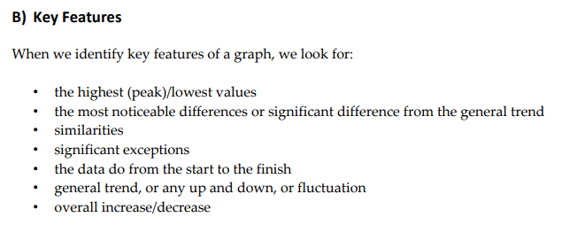
instructions.
paraphrase the question
signposting
describe change.
planning
tense
mistakes.

task2:
Write in an academic or semi-formal/neutral style. •
Write complete sentences and paragraphs.
Present a clear, relevant and well-organised argument.
Give evidence or examples to support ideas. •
Use language accurately.
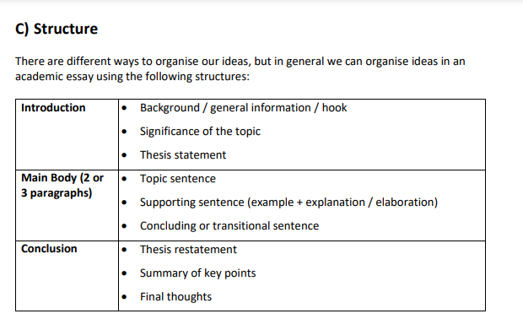

The pie chart and table illustrate the destination of Anthropology graduates after graduation from the university and income of those people in work after a 5 year period respectively.

In general,it was obvious to see that full-time work was the most popular choice for the graduates.In addition,most of the graduates could get high salaries,whereas only few of them gained low salaries.

Regarding the pie chart,52% of graduates had full-time work,which dominated the half of the chart.It is evident to see that full-time works were the most prevalent among the graduates.Compared to it,less than one-tenth people chose part-time as their recent jobs or postgrad study,which was a staggering fact.

In the salaries table,a wide range of graduates,who had worked for at least 5 years,could retrieve more than 100000 dollars for salaries,in particular the income from the government sector.In stark contrast,in the same aspect,
only 5% of them earned between 25000 and 49999 dollars,which was no more than 50 thousand dollars.
(176)
In some cultures,the young are often convinced that they can achieve anything if they attempt with enough effort,by someone,such as their parents and teachers.In this issue,there exist both of the benefits and drawbacks to give children to understand the message.

For the positive aspect,it is beneficial for the children to try a lot and to feel a sense of achievement.In fact,people are always vulnerable to give up to do some work just like doing sports or can do some jobs consistently within 3 minutes only,owing to fear of failure.As long as those people believed the messages when they were young,they would try hard enough to achieve their goals without caring the opportunities of failing.For example,children who are
less self-esteem,care about the height to play basketball.Without a try,they just remain less confident.However,if they have a good try and attempt to play basketball regularly,the height of them will be strengthened and the sense of accomplishment will be received after doing that sports with a successful start.It is indispensable for humans to nurture diligent habits when they are young.

However,every coin has two sides.It also causes some disadvantageous consequences to some children.Children are curious about the world and want to attempt anything after receiving the message.It is probable for them to go astray just like to try some cigarettes and even some illegal activities such as robberies and bargains in that they realise that they can do anything successfully and well and truly.

In conclusion,children can gain some positive impacts and detrimental influences from that message.
(278)

sample
In general,the line chart illustrates the changing rates of crime in various areas in Panama City between 2010 and 2019.
First of all,in 2010,there had happened approximately 3500 cases of burglary,which was the most huge crime in that year.By contrast,there had been nearly 600 cases of robbery in that year.

This graph illustrates how crime rates altered in Panama City during the period 2010-2019. (paraphrase)
We can see immediately that the greatest change occurred in the number of burglaries, while incidents of theft remained low but steady.(overview)
In 2010, we can see that burglary was the most common crime, with approximately 3,400 reported cases. The figure rose to around 3,700 in 2011, but then there was a downward trend until 2015. At this point the figure stood at just over 1,000 incidents. This rose slightly in 2016, then continued to fluctuate for the remaining period.
In 2010, the number of cars being stolen stood at around 2,800 and followed a similar trend to burglary until 2013. At this point the number rose, standing at around 2,200 in 2014. There was a marginal decrease in the following year, but from then on, the trend was generally upwards.
Finally, robbery has always been a fairly minor problem for Panama City. The number of offences committed changed little over nine years. It is interesting to note that the figure of approximately 700 in 2010 is the same figure for 2019.
The 2 pie charts below illustrates contribution to the economy of Turkey by sector betwenn 2000 and 2016

In 1950,the children spent less than 1 hour per day to watch television.It was obvious and evident to see a markedly increasing trend between 1950 and 1980.In the middle between 1990 and 2000,it reached the maximum point.It means that children always watch television and almost use 4 hours per day to do that things in this period.

From 2000 to 2010,it had a marginal decrease and became steady declining slope.In 2010,children just nearly 3.5 hours per day to watch television.

the diagram shows the information about steel rods are manufactured and produced in the furniture industry in the nowadays
the bar chart illustrates the divorce rates in FINLAND AND SWEDEN between 2011 and 2015
sweden’s divorce rate was about 45% in 2011,being higher than Finland’s rate by approximately 8%

The bar chart illustrates how many car journeys into the city centre were made by residents and non-residents respectively from 1996 to 2005.Although both of data had similar fluctuations,overall,the number of car journeys,which was created by residents,dramatically declined,while the number of car journeys which was made by non-residents marginally decreased.
In the year 1996,for residents,there were around 10000 car journeys per day,being equal to 2 times data of non-residents in the same period.When

The chart illustrates the sites visited by various people living in Canada.Overall,the vast majority of residents in Canada went to the cinema,while the minority of residents went to the theatre.
First of all,cinema was a popular place for people to travel.Nearly 70% of people who were born in Canada went to the cinema.Then,
Besides,around half of and almost a quarter of new migrants born in English-speaking countries visited the zoo and theatre respectively.
Finally,approximately 55% new migrants born in other countries went to library.

The chart gives information about the kinds of leisure activity engaged in by three distinct groups: native Canadians, recently arrived immigrants from English-speaking countries and new migrants for whom English is not the first language in their country.
The cinema is by far the most popular free-time activity listed in the chart for those with English as their first language — 70% of non-migrants and 65% of English-speaking migrants. Half the migrants from non-English-speaking countries also go to see a film but interestingly, 5% more of this group prefer the library to the cinema. Roughly 40% of the other two groups say they visit the library.
Zoos are visited most by half of the English-speaking migrants compared to just over 40% of those born in Canada and approximately 35% of the migrants born where English is not widely spoken. The theatre is least popular for all concerned, with only 10% of non-English-speaking migrants attending, while double the number of native Canadians go to see a play. A quarter of those born in English-speaking countries are theatre-goers.

seriously
while/whilst
gradually
significantly
vary/erratic
p13-14

ielts
speaking→ listening→ reading→ writing

kellymok119@hotmail.com
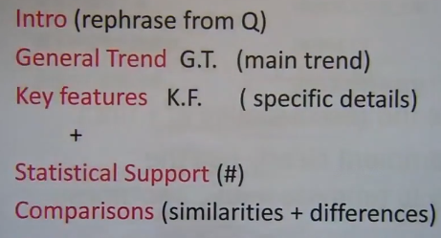
wheras=while→ compare
on the other hand
in contrast/however/on the other hand
the figure for
the line chart illustrates the proportion of car ownership in Great Britain according to household from 1961 to 2001,measured in ten-year periods.

overall,there were signifcant increases in the percentages of household with 1 car or 2 or more cars,while there was drastically decline in the percentages of household with no car during this period.

In 1961,only around 10% of households had 2 or more cars,compared with almost 30% with 1 car.Decade later,the proportion of car ownerships had risen to 30% (1 car) and around 38% (2 or more cars) respectively and separately.Eventually,in 2001,the figure for household with 2 or more cars had risen to 48%,having overtaken the figure for household with 1 car around 10%.

on the other hand,the household with no car had reached the peak of 70% in 1961,while it had declined sharply in 1971,and gradually become 10% in year 2001.

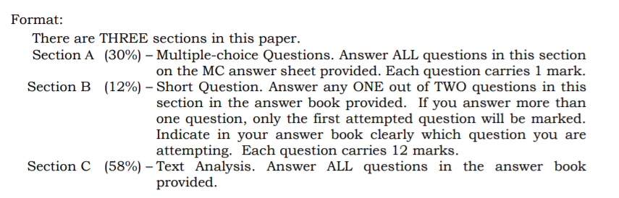

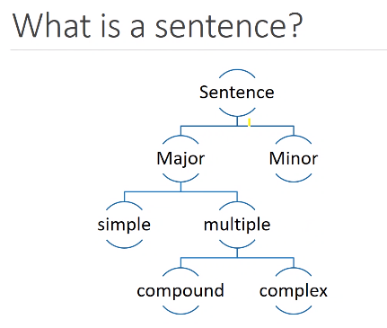

FVG
Modality:probability/usuality
obligation(command)/inclination(willing)
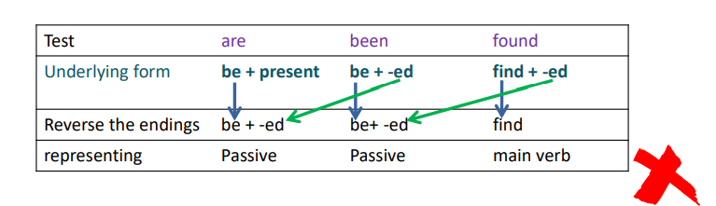
finite function: | non-finite:
- sensing  - saying  - action  - relating  - existing | - as representing things  - as modifying things  - as completing the meaning(FVG)

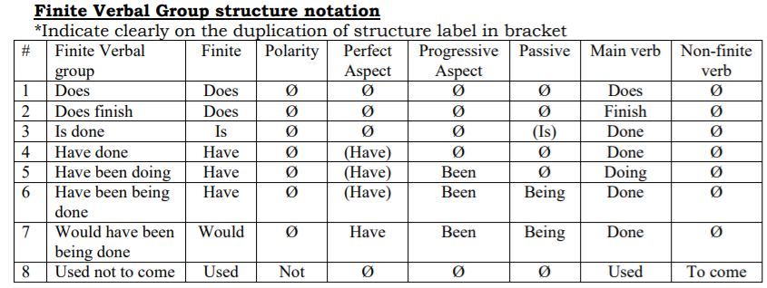

nominal group
post determiner=量
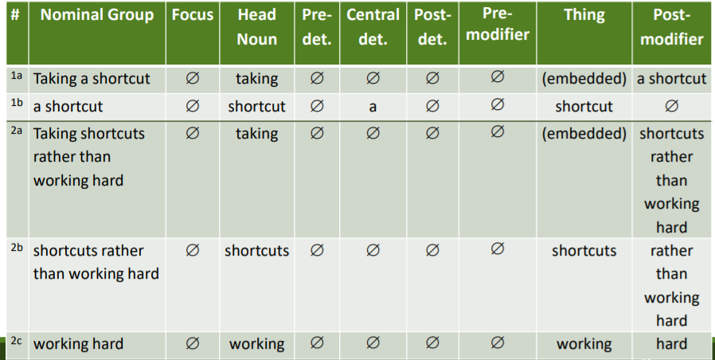
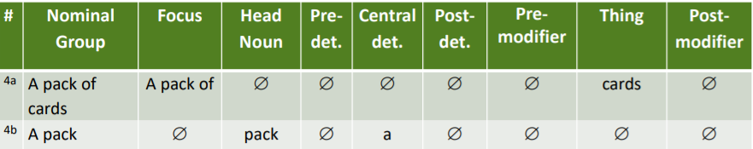Week 10 Prepositional Groups
Functions
- Adjectival Element (postmodifier of Nominal Groups)
- Adverbial Element (adverbials of Sentence Components)
Sentence Hierarchy
- Major vs Minor Sentence
- Simple vs Multiple Sentence
- Compound vs Complex Sentence
Sentence Types
- Declaratives
- Interrogatives
- Imperatives
- Exclamatives
genre
