Team Members

Matt Baldree

Paul Widhalm

Brandon Hill

Proposal

We propose to develop an index of a segment of the cryptocurrency market as a tool for investors and financial managers. This tool could be used to measure investments against the market while also showing the strength of the cryptocurrency market. Considerations for the index include the following: purpose, segment, membership, algorithm, rebalancing, data, adoption, etc.

Problem

The cryptocurrency market started in 2009 with the bitcoin network and in 2010, the first bitcoin exchange opened. As of September 7, 2017, there are 5,475 cryptocurrency exchanges according to Coin Market Cap and the total market capitalization is $164 billion for 867 currencies. For comparison, this market capitalization represents 20% of Apple’s market cap.

The market is growing exponentially. For instance, the number two cryptocurrency in market capitalization, Ethereum, grew 4,100% in eight months. The Standard and Poor’s 500 Index which is made up of 500 of the most widely traded US stocks took over 40 years to achieve the same kind of growth. The cryptocurrency market is currently in its infancy and to enable it to grow into maturity will require solid measurements by which investors can rely upon.

With so much growth in an industry, many people want to get involved in the opportunity but don’t have the knowledge or background to comfortably invest. A rapidly expanding market has enormous opportunities. But, it also has major risks. One of these risk is price fluctuation or price volatility. As of September 9, 2017, the total market capitalization is $147 billion. That is a 10% slide in the market in two days. Bitcoin makes up 47% of the cap, so its price fluctuation probably drives the market. The challenge for investors today is navigating this young, volatile new market.

Our belief is that an appropriately designed index would help investors and financial managers describe the market and determine if it was up or down. This new index could then be used to compare returns on specific investments. In addition, exchange-traded funds (ETF) could be developed to follow the index or try and beat it.

Notes

Considerations

Rebalancing

Algorithm

Market cap, price, weight, etc.

Purpose which dictates membership of index

Track top players, ICO’s, altcoins, bitcoin, market, etc.

Current research

DOW Jones Industrial Average (DJIA)

Most famous stock market barometer

30 largest and most influential companies

ETF’s that track the DOW

SPDR Dow Jones Industrial Average ETF (DIA)

Invests in all stocks of the DOW and weights them in a manner similar to the weights in the underlying index

Elements Dow Jones High Yield Select 10 Total Return Index (DOD)

Only ten stocks based on Dogs of the DOW

Rebalancing based on dividend yield (companies with highest dividend yield)

ProShares Ultra DOW30 (DDM)

Aim is to beat the DOW by seeking 2x daily performance of that index.

<http://www.investopedia.com/terms/d/djia.asp?ad=dirN&qo=investopediaSiteSearch&qsrc=0&o=40186>

price-weighted average of 30 significant stocks traded on NYSE and NASDAW

invested by Charles Dow in 1896

one of the oldest, single most-watched indices in the world and includes companies such as GE, Walt Disney, Exxon Mobil, Microsoft, etc.

Market is up or down refers to the DOW

Design to serve as a proxy for the broader US economy

GE is the only company part of the original DOW

Composition of index changes over time based on company performance or shifts in economy

It is price-weighted index which means stocks with higher share prices are given a greater weight in the index

Originally, it was calculated average by adding the prices of the 12 dow component stocks and dividing by 12

Additions/subtractions, mergers, stock splits must be accounted for in the index to its value does not become affected

It grew to 30 in 1928 and has changed components 51x

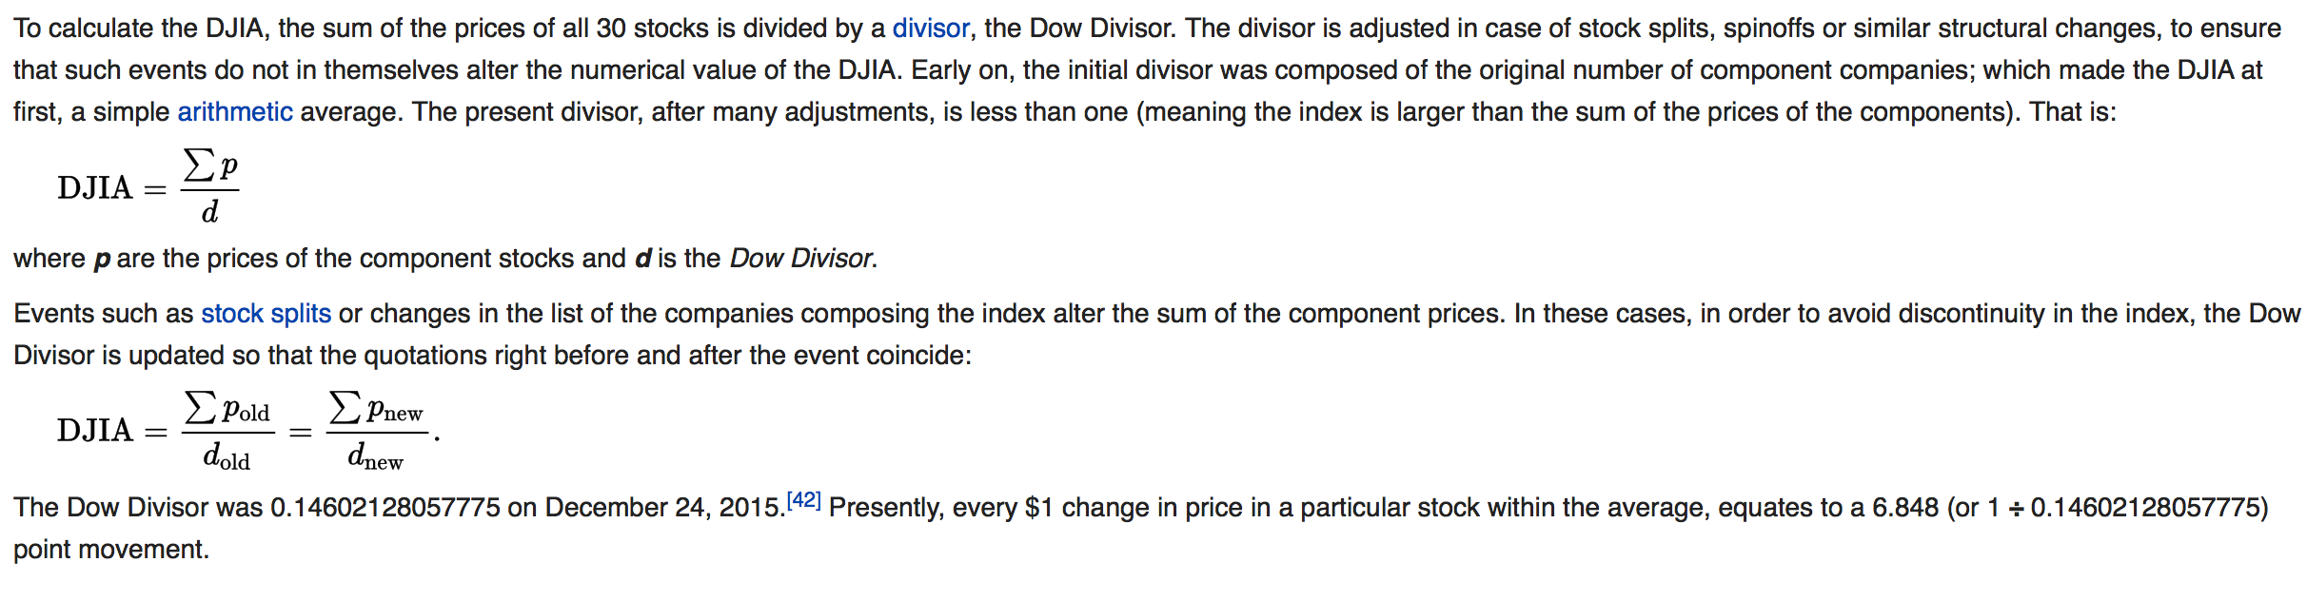

<http://www.investopedia.com/articles/analyst/102501.asp?ad=dirN&qo=investopediaSiteSearch&qsrc=0&o=40186>

S&P 500

Made up of 500 of the most widely traded stocks in the US and represents about 80% of the total value of market

It gives a good indication of the movement in the US marketplace as a whole

It is market weighted or capitalization weighted. Every stock is represented in proportion to its total market capitalization.

Many people consider S&P500 to be a better measure of the market’s movement because two portfolios can more easily be compared when changes are measured in percentages rather than dollar amounts.

Wilshire 500 – total stock market index or total market index

All publicly-traded companies with headquarters in the US with readily available price data are included.

Nasdaq composite index

Market-capitalization-weighted index of all stocks traded on the Nasdaq. Includes some companies that are not based in the US.

Includes many speculative companies and its movement includes performance of technology industry as well as investors’ attitudes toward speculative stocks.

Russell 2000

Market-capitalization-weighted index of 2,000 smallest stocks in the Russell 3000.

Best-known indicator of the daily performance of small companies in the market.

Cryptocurrency index

https://www.coindesk.com/crypto-asset-fund-launches-investable-index-top-30-cryptocurrencies/

A successful index could be used as a shorthand for discussing the cryptocurrency market movements, providing a reference point akin to an equity index.

CAMCrypto30 – designed to mirror the 30 largest cryptocurrencies by market capitalization.

Constructed to resemble the russell2000 and FTSE 100 indices. It is weighted by market cap.

A widget is available for websites to track the index.

The index is rebalanced quarterly as typical with equity indices.

<https://cryptocoincharts.info/indices/info>

price index calculated by all cyprtocurrencies and compare it to profits/loss to well known stock markets.

Formulas are trial and error. Open for input [office@cryptocoincharts.info](mailto:office@cryptocoincharts.info)

<https://coinmarketcap.com/>

most well-known site