Cryptovisor: A Cryptocurrency Advisor Tool

Matthew Baldree, Paul Widhalm, Brandon Hill,

Matteo Ortisi

{mbaldree, pwidhalm, bdhill}@smu.edu,

matteo.ortisi@gmail.com

**Abstract.** In this paper, we present a tool that provides trading recommendations for cryptocurrency using technical indicators to label the data and a stochastic gradient boost classifier to make recommendations. Due to the infancy of the cryptocurrency market and its limited size, the market is volatile, making it difficult for some investors to know when to enter, exit, or stay in a market. A tool is needed to provide investment recommendations for investors. We developed the tool to support three cryptocurrencies, Bitcoin, Litecoin, and Vertcoin, based on their historical price and volume data plus sentiment data to recommend a trading decision for current or past days. This tool is 95.26% accurate with a standard deviation of 0.36% for Bitcoin. We conclude that combining financial technical indicators and sentiment analysis based on momentum in a model, results in a helpful recommendation tool that performs as well or better than a buy and hold trading strategy.

# 1 Introduction

The first cryptocurrency, Bitcoin, based on blockchain technology, is a secure method to make financial transactions that was introduced in 2009 [14]. Bitcoin is a peer-to-peer cryptographic digital currency that was created in 2009 by an unknown person using the alias Satoshi Nakamoto [14]. Bitcoin is unregulated and hence comes withbenefits (and potentially a lot of issues) such as transactions can be made in a frictionless manner – no fees - and pseudo anonymously. Transactions can be purchased through exchanges or can be ‘mined’ by computing/solving complex mathematical/cryptographic puzzles [1].

Since 2009, hundreds of cryptocurrencies have been created and more are continually being created. The long-term asset viability of cryptocurrencies is yet to be understood. The markets are trying to decide whether they are a hedge, safe haven or a real currency like the dollar or yen [4]. Some research has shown that Bitcoin appears to act as a speculative safe haven for investors [4]. Today cryptocurrencies are on over 5,400 cryptocurrency exchanges throughout the world with a total market capitalization of $164 billion [2]. There are over 1,300 cryptocurrencies and growing exponentially with a 29-fold ($537B/$18B) growth rate in 2017. Investors are flocking to cryptocurrencies such as Bitcoin, Litecoin, and Vertcoin where their price have reached all-time highs in 2017 with increases of 18.36-fold ($17,880/$973), 67.63-fold ($304.98/$4.51), and 274.78-fold ($9.48/.03405), respectively. For comparison, the S&P 500 Index took over forty years to achieve the similar growth. Although new cryptocurrencies are constantly entering the market, Bitcoin appears to be entering a more mature phase where its volatility is decreasing [4].

Only recently have mainstream financial institutions like Fidelity begun to give its customers the ability to add cryptocurrencies to their portfolios [3]. Besides the continual development of cryptocurrency products, additional marketplace tools are needed to support this growing marketplace. Cryptocurrencies are so new that even large, stable banks are having a difficult time quantifying the movements and predicting where cryptocurrency is headed next. Some executives are calling Bitcoin a fraud [24].

For investors that do decide to enter these new markets, a common question asked on social media platforms like Reddit is, “When is a good time for me to buy in the market?” Or, the opposite question will be asked, “When is a good time for me to sell out of the market?” To aid both the experienced and lay investor in making a more informed decision and answer these questions, we created a novel cryptocurrency tool, Cryptovisor, that recommends for the investor if she should buy, sell, or hold their investment. This tool is built from financial technical indicators along with social media sentiment analysis to label historical cryptocurrency pricing and volume data for ideal time to buy, sell, or hold the target asset. Labeling the dataset is a trial and error procedure ensuring the data is labeled to produce results as good as a buy and hold trading strategy.

With the labeled dataset, a stochastic gradient boost classifier is used to learn the labeled data and provide future recommendations. The baseline classifier is then iterated by reducing the features until a minimal set is required to yield as good if not better accuracy. For Bitcoin, the required features were reduced from 18 to two with a 1.4% improvement in accuracy to 95.26% with 0.36% standard deviation.

Classifying cryptocurrencies into buy, sell, or hold buckets with minimal data provides for a new tool for investors to group opportunities they might otherwise ignore diversifying their portfolio while maximizing their gains.

The rest of the paper is structured as follows. Section 2 provides background of cryptocurrency. Section 3 provides details about the cryptocurrency market and provides a visualization of the market structure for Bitcoin, Litecoin, and Vertcoin. Section 4 provides background of sentiment analysis. Section 5 describes our Cryptovisor tool. Section 6 details the data used in the research. Section 7 provides the results of our research. Section 8 analyzes the results. Section 9 discusses the ethics. We draw the relevant conclusions in Section 10 and discuss future work in Section 11.

# 2 Cryptocurrency

Cryptocurrency is an asset designed to be used as digital currency. The asset is a chain of digital signatures that exist in binary format secured by cryptography with the right to use [18]. There are two kinds of assets in the cryptocurrency world; i.e., coin and token. Both assets may be acquired and traded on public exchanges and used in the exchange of goods and services. Coins are more general purpose and require more effort to create and support the ecosystem. Tokens run on top of a platform such as Ethereum and are designed for a specific ecosystem such as eSports. The reference cryptocurrency is Bitcoin, the largest and oldest coin, see Fig. 1 for a timeline that includes Litecoin, Vertcoin, Ethereum, and subsequent forks. There are more than 1,300 cryptocurrencies to date.

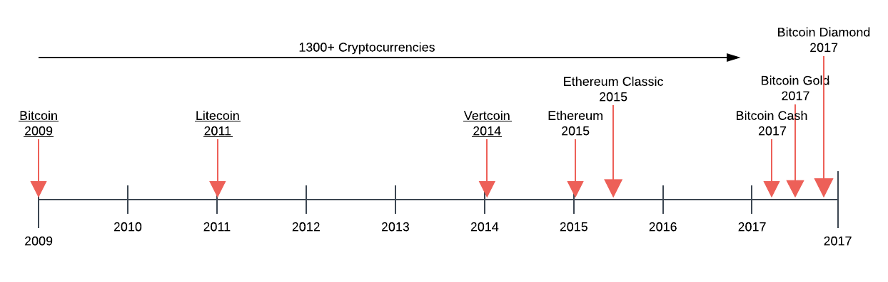

**Fig. 1.** Cryptocurrency timeline.

Since the 1990s, numerous cryptographers and companies have repeatedly attempted to create digital currencies to compete with cash and credit. These attempts failed because their solutions were not substantially better than the current state due to several factors. 1) They relied on cryptographic certificates to tie parties to real-life identities. The hassle to acquire, install and use these certificates lowered the utility of these systems and therefore adoption. 2) They wanted merchants to adopt this new technology as opposed to going directly to consumers. Incumbent solutions are entrenched and have money to defend their marketplace. 3) They solved the “double-spend” problem through a third-party clearinghouse adding cost and time to the process. All these systems still required a network of trust. In the end, these systems added innovation but did not improve the whole user experience [13].

In 2008, after almost two years of development, an anonymous person or group under the alias “Satoshi Nakamoto” released a white paper describing the production of a peer-to-peer electronic cash system named Bitcoin [14]. This system allows irreversible, secure, digital payments directly between parties through a non-trusted network built on cryptographic proof-of-work. Transactions are assembled and hashed by bitcoin nodes or miners that use CPU power to solve cryptographic puzzles for coin and or transaction rewards by adding blocks to the ledger creating the blockchain. Incentivizing, miners to be honest, keeps the network secured and introduces coins to the marketplace. Miners may sell or trade their coins for goods and services and as long as there are 51% honest nodes on the network, the system is secure.

The bitcoin network broadcasts all new transactions to all nodes on the peer-to-peer network. Nodes may come and go as they please and the active nodes collect new transactions into a block and work to solve a computational puzzle or proof-of-work for its block. When a node solves the puzzle, the node will broadcast its block to all nodes on the network. The block will be accepted if all transactions are valid and are not already spent which prevents double-spending. Nodes will compete to work on the next block for a reward by extending the longest ledger. Today there are many derivatives of Bitcoin but the main principles of a decentralized peer-to-peer digital currency network remain the same, see Fig. 2 [14].

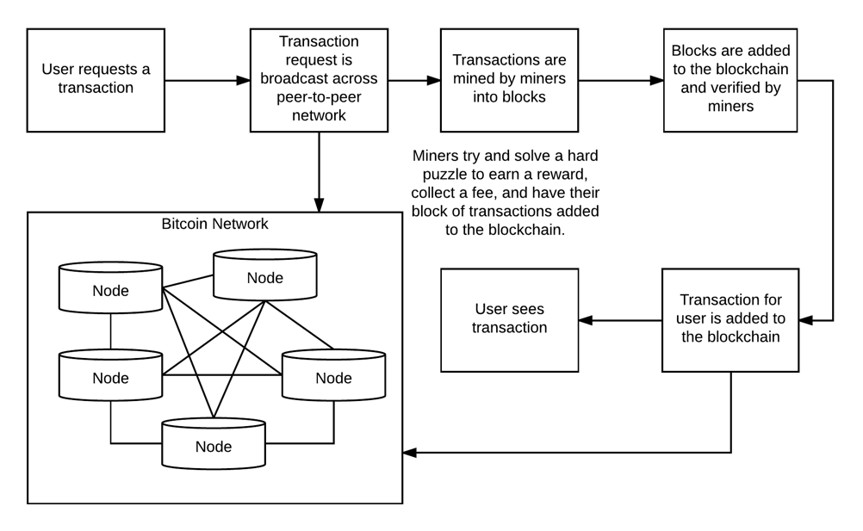

**Fig. 2.** Cryptocurrency workflow.

The process to acquire cryptocurrencies usually entails signing up with an exchange by proving who you are and submitting assets to the exchange to credit your account. Once you have credit, you may buy and sell assets by placing a market order or limit order. A market order authorizes the exchange to make the trade on your behalf. A limit order places the order in an order book waiting for the order’s criteria to be met. Exchanges make money through transaction fees including converting between assets and supporting the inflow and outflow of fiat such as the US dollar. The exchange leverages the trader’s exchange wallet to withdraw and deposit assets. The trader may move their assets off the exchange to other wallets. The trading volume and rules of the exchange can affect asset pricing.

Large purchases on exchanges can run up the price 1% to 10% because the exchange do not have enough liquidity or amount of assets to satisfy the order without bumping up the price. In addition, cryptocurrencies are traded across many exchanges creating less liquidity as opposed to a single exchange. Large trades could exhaust the exchange causing “flash crash” similar to the one experience by GDAX in June of 2017 when a multi-million dollars sell order caused the price of Ethereum to drop 99.9% within a second. The steep drop triggered cascading stop loss orders until the price reached $0.10 within a second. This price volatility is one of the main barriers to adoption [15].

The exchange of digital assets is performed by digital wallets which is an application that supports storing and sending a digital asset such as bitcoin. Wallets can be for a single asset or support multiple assets like Jaxx. Public and private key pairs for your digital asset are stored in the wallet. The public key is the address you use to send and receive assets. The private key is used to claim your assets on the blockchain. Transferring money or digital assets is a transfer of ownership between parties on the public blockchain ledger. After the transaction is sufficiently confirmed, it is essentially permanent. The major security risk of this system is losing your private keys and thereby losing ownership of your assets.

# 3 Cryptocurrency Market

Currently, the cryptocurrency investor’s tools rely solely on past statistics and this is due to the infancy of the cryptocurrency market. There simply has not been the level of analysis on cryptocurrency that is required to bring it to mainstream assets classes.

Most current forecasting techniques utilize univariate time series which model one variable. This approach does not capture other influential factors such as momentum. Due to the highly volatile and unregulated nature of cryptocurrencies, outside factors play an influential role in determining the value of the crypto-coin. We included these factors in our overall analysis to provide a clear picture of what cryptocurrency is and how it can be invested.

In order to better model cryptocurrency, we need to understand how and why it behaves such as it does. One of the main issues with cryptocurrency is that each currency is built somewhat differently. Unlike fiat currency where the units are backed by the government and it has value because the government says it has value, cryptocurrency has value because others who hold the crypto-coin say it has value.

Is there a correlation between fiat and cryptocurrency? In some research, Bitcoin has been found to be negatively correlated with the Yuan and the USD while being positively correlated with the USD/EUR exchange rate [4]. This is part of our model, using various foreign exchange rates to determine their influence on the price of crypto-coin.

Liquidity is one of the major issues with cryptocurrencies. With fiat currency, a large transaction is easily absorbed into the system with little effect on the exchange price. On the contrary, a large transaction for cryptocurrencies will incur heavy fees and cause a large fluctuation in the exchange price of the currency [5]. A set of financially motivated kernels is constructed for the EURUSD currency pair and is used to predict the direction of price movement for the currency over multiple time horizons. Multiple Kernel Learning (MKL) is shown to outperform each of the kernels individually in terms of predictive accuracy [7].

In order to determine whether cryptocurrencies such as Bitcoin can be considered an asset class similar to the world’s government-backed currencies, the cryptocurrency would need to satisfy three questions. Can it be used as a medium of exchange? Can it be used as a unit of comparability between two goods and it must store value over time [4]. Price fluctuations in Bitcoin and other cryptocurrencies are dependent on both internal and external factors[4]. The internal factors are supply and demand but since the supply is deterministic this means that the only internal driver is the demand for Bitcoin. The demand for Bitcoin is determined by the hash rate. External factors affecting the price of Bitcoin is the adoption rate and how it is being used as an investment vehicle. In the short-term, Bitcoin acts as a safe-haven investment and in the long run acts as a hedge [4].

Factor investing is where an investor invest funds in the underlying risk factors that make up an asset class. One of these factors is momentum. The momentum of an asset is looking at the past performance of an asset and using that to determine the future of that asset. The momentum strategy of Jegadeesh and Titman (1993) was able to produce abnormal positive returns [6].

In determining the cryptocurrencies that we use for our model we used each coin’s market capitalization. Market capitalization is a term that has been borrowed from stock markets and inappropriately applied to the crypto space. It is defined as the total value of all shares outstanding of a company. But in crypto land, we have taken to defining market cap as the value of all publicly (not total) available coins or tokens [8]. In our analysis, we use the current standard for market capitalization but also include a percentage showing the coins that are in circulation divided by the total coins outstanding. In addition, we add other financial factors plus sentiment analysis data to determine factors that contribute to an accurate price change forecast.

For those unfamiliar, the Sharpe ratio is a way to normalize returns for the risk that was taken to achieve them, with higher values being better. It is calculated here as the annualized return divided by the annualized volatility, so we are using a zero-risk free rate. Data is from March 17th, 2017 to August 30th, so the major caveat of a small sample size applies to all data in this analysis. A quick note on methodology, when comparing crypto to traditional assets we use the standard 252 trading day annualization factors, and remove weekends and holidays from the data set. When looking at exclusively crypto assets, we use the full 365-day year and 15:00 US Central time as each daily closing price [8].

# 4 Sentiment Analysis

BEFORE YOU GET HERE THERE IS MORE INFORMATION THAT YOU MAY WANT TO HAVE YOUR READER LEARN ABOUT.

There has not been a significant research towards sentiment analysis focused on cryptocurrency market. Instead, we look to a wealth of knowledge gained from the numerous papers focused on sentiment analysis focused on another financial market, the stock market index. “As more and more personal Opinions are made available online, recent research indicates that analysis of online text such as blogs, web pages, and social networks can be useful for predicting different economic trends [17]. As such, sentiment analysis is performed using various data sources/tools such as Twitter, google and yahoo search trends, or message boards/blogs such as Reddit. These studies look for trends from public tools to understand the public sentiment in order to directionally predict the stock market. Similarly, we look to use this public sentiment to predict the cryptocurrency market.

Each of these analyses follows a very similar pattern. First, they seek to gather a consistent data source from the public tool that meets the frequency in which the prediction method requires. These feeds typically come in the form of an API provided by the tool of choice. This makes it somewhat trivial to plug into the tool to capture the transactional data that is provided through the API subscription.

Second, the data retrieved through the APIs is filtered using terms that identify the different exchanges such as names, IPO ticker symbols, or associated businesses. This allows for a much more efficient algorithm process as it only performs further processing on transactions that are relevant to data requirements of the research analysis.

Third, comes the identification of opinion and weighting of each sentiment instance. Now there are various ways to identify and weight each instance, but a common theme is to utilize a lexicon of financial terms to determine whether the opinion/text should be reviewed as positive or negative. This is necessary because as noted, “the Harvard dictionary is not structured for the vocabulary of traders. [16].” Then one can use other attributes provided by the API for the instance such as times searched for search engines such as Google and Yahoo, or the number of followers for the poster for instances gathered from Twitter, Facebook, or bloggers.

Our research focuses on Twitter as our initial source of public opinion based on the amount of sentiment research found for this tool. Many of these analyses found that the opinions provided by the tweeters provided good indicators that could be used by investors trying to determine economic trends. As noted “Twitter has become a major source of information and an effective communication tool for investors and public companies [16].”

# 5 Cryptovisor – A Cryptocurrency Advisory Tool

Cryptovisor is an advisory or recommendation tool for a cryptocurrency investor to query current or past periods for a buy, sell, or hold position regarding a cryptocurrency. The tool is trained on past historical pricing and volume information and labeled for ideal buy, sell, and hold positions based on an algorithm utilizing both leading and lagging financial technical indicators.

A technical indicator is "any class of metrics whose value is derived from generic price activity in a stock or asset [20]." There are two kinds of technical indicators, leading and lagging, that try to predict the future or general price direction of a security by looking at past patterns. Leading indicators signal future events. Lagging indicators follows an event. The importance of a lagging indicator is its ability to confirm that a pattern is occurring. There are many, many indicators. For this paper, two popular indicators, relative strength indicator (RSI) and Bollinger bands (BB), are used to determine a trading strategy [21]. Through trial and error, the indicators were adjusted to fit the pattern of Bitcoin close price for 4-hour resolution. An algorithm was developer to incorporate both indicators to determine a trading strategy of buy, sell, or hold. This strategy was then applied to buy or sell the asset and the result compared to a buy and hold strategy.

The resulting labeled data for 4-hour closing price trading strategy was used to train a stochastic gradient boosting machine learning algorithm [22] to predict buy, sell, or hold strategy based on time series closing price and volume plus derived data. In addition, a feature ranking and example decision tree plots are provided for deeper understanding [23]. Future work in this project would include adding additional technical indicators to determine which ones provide the most value in determining trading strategy, incorporating other cryptocurrency price history to determine if feature importance is the same, automate data acquisition, labeling, and training of algorithm, and develop a webservice to provide trading strategy for today or past days.

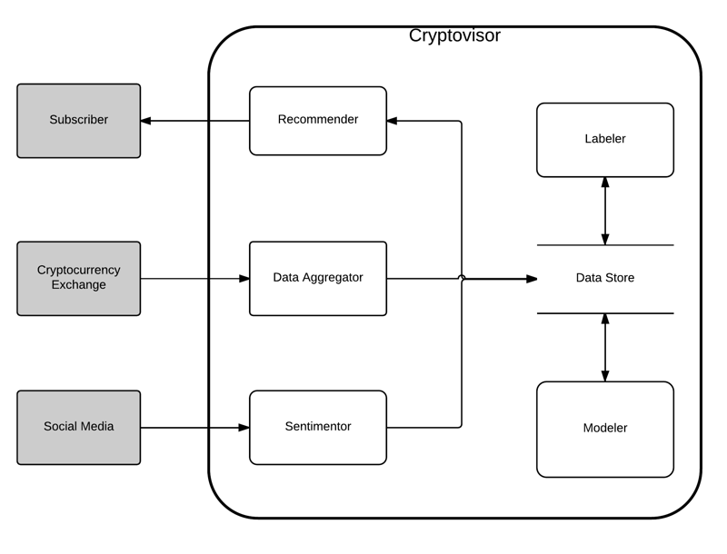

**Fig. 3.** Cryptovisor system diagram.

The tool, *Cryptovisor*, is comprised of six main components, see Fig. 3. This paper focuses on primarily on three components: *labeler*, *sentimentor*, and *modeler*. The *labeler* component reads in the cryptocurrency data and up samples or down samples it appropriately to a 4-hour time period. Then, one and a half years of data is used to generate over 3,000 data points to train a machine learning classifier. Next, Bollinger Bands (BB) are calculated for a 14-day moving average with a standard deviation of 1.8. BB are volatility lines created from a close price moving average (1) and its standard deviation (2). The bands are defined by (3), (4), and (5). N is the number of days to compute the moving average. Next, Relative Strength Indicator (RSI) is calculated for a 14-day period. RSI is a momentum oscillator that measures speed and change of price movements between zero and 100, see (6). N is the average days up closes or down closes. Next, lags are calculated for each attribute and the trading algorithms (7) and (8) are applied. Once the trading signals are generated, the returns are generated and compared with a buy and hold strategy to ensure trading signals yield comparable results. A comprehensive chart is generated to allow for results investigation. Finally, the labeled data plus calculated data is generated.

|  |  |
| --- | --- |
| $\overline{X}= \frac{\sum_{j=1}^{N}{X_{j}}}{N}$. | (**1**) |
| $σ=\sqrt{\frac{\sum_{j=1}^{N}{{(X_{j}-\overline{X})}^{2}}}{N}}$. | (**2**) |
| $BB high=\overline{X}+2σ$. | (**3**) |
| $BB mid=\overline{X}$. | (**4**) |
| $BB low=\overline{X}-2σ$. | (**5**) |
| $RSI=100-[\frac{100}{1+\frac{N_{up}}{N_{down}}}]$. | (**6**) |
| $buy signal= {close}_{lag2}<{BB low}_{lag2} and {close}_{lag1}< {BB low}_{lag1} and {RSI}_{lag1}<30$. | (**7**) |
| $sell signal= {close}_{lag2}>{BB low}_{lag2} and {close}_{lag1}> {BB low}_{lag1} and {RSI}_{lag1}>87$. | (**8**) |

The modeler component reads in labeled data, cleans it, and separates out the features from the labels. A stochastic gradient boost classifier, XGBoost, is then trained with a stratified 5-fold cross validation to determine accuracy. Next, the importance of the features is plotted for examination. Features are then pruned to yield the simplest model without sacrificing accuracy. The simplified model is then used to provide a trading strategy for past and current time period for the cryptocurrency.

# 6 Data

The historical pricing data for Bitcoin on Coinbase exchange was obtained from Kaggle with a one minute resolution from December 1, 2014 to October 19, 2017 [19]. This low-level resolution allowed us to resample it for any desired resolution. For this project, the data was resampled to 4-hours. The For the 4-hour resolution, one and half years of data was used providing 3,036 data points. The raw Bitcoin data in Table 1 is then read by the Labeler component which calculates data in Table 2. Data from table 2 is the read into the Modeler component which fits a model to classify a record as buy, sell, of hold.

**Table 1.** Exchange dataset read into *Labeler* component.

|  |  |
| --- | --- |
| Attribute | Description |
| Timestamp | Data and time of the transaction |
| Open | Open price for the period |
| High | High price for the period |
| Low | Low price for the period |
| Close | Close price for the period |
| Volume BTC | Trade volume of asset for the period |

**Table 2.** Calculated dataset by *Labeler* component.

|  |  |
| --- | --- |
| Attribute | Description |
| Bollinger High | BB mid plus standard deviation |
| Bollinger Mid | BB n-periods moving average |
| Bollinger Low | BB mid minus standard deviation |
| RSI | Relative strength indicator for n-periods |
| Close Lag 1 | Close price for previous period |
| Bollinger High Lag 1 | BB high for previous period |
| Bollinger Mid Lag 1 | BB mid for previous period |
| Bollinger Low Lag 1 | BB low for previous period |
| RSI Lag 1 | RSI for previous period |
| Close Lag 2 | Close price two periods back |
| Bollinger High Lag 2 | BB high two periods back |
| Bollinger Mid Lag 2 | BB mid two periods back |
| Bollinger Low Lag 2 | BB low two periods back |
| RSI Lag2 | RSI two periods back |
| Signal | Buy, sell, or hold indicator |
| Portfolio | Bought or sold asset |
| Trading Return | Trading period return on asset |
| Buy & Hold Return | Buy & sell period return on asset |
| Trading Cum Return | Trading cumulative return on asset |
| Buy & Hold Cum Return | Buy & sell cumulative return on asset |

# 7 Results

With over 3,000 signal points, the Labeler identified half percent of them as sell periods, see Table 3. The Labeler than used the trading signals to build a portfolio and compared its returns with a buy and hold strategy, see Table 4. The difference in Sharpe Ratio return between the two strategies is less than 2% indicating the trading strategy is accurately identifying good buy and sell conditions. The algorithm was adjusted by visualizing the trading signals with the historical close price in Fig. 4. The resulting data from the Labeler was then read into the Modeler to learn the signals through a 5-fold cross validation with a resulting accuracy of 93.97% with a standard deviation of 2.19%. The contribution of the features to classifying the label is shown in Fig. 5. Then the features were pruned to a minimal set yielding an accuracy of 95.26% with a standard deviation of 0.36%. Reducing the features down to volume lag1 and RSI lag1 yielded 1.4% accuracy improvement, see Fig. 6 for the feature importance and Table 5 for interpretation of the feature importance ID’s.

**Table 3.** Labeler signal results.

|  |  |  |
| --- | --- | --- |
| Attribute | Total | Percentage |
| Hold | 2,888 | 95.13% |
| Buy | 130 | 4.28% |
| Sell | 18 | 0.59% |

**Table 4.** Labeler portfolio results.

|  |  |  |
| --- | --- | --- |
| Summary | Trade | Buy & Hold |
| Return | 8.87 | 9.80 |
| Standard Deviation | 0.28 | 0.30 |
| Sharpe Ratio (Rf=0%) | 31.61 | 32.23 |

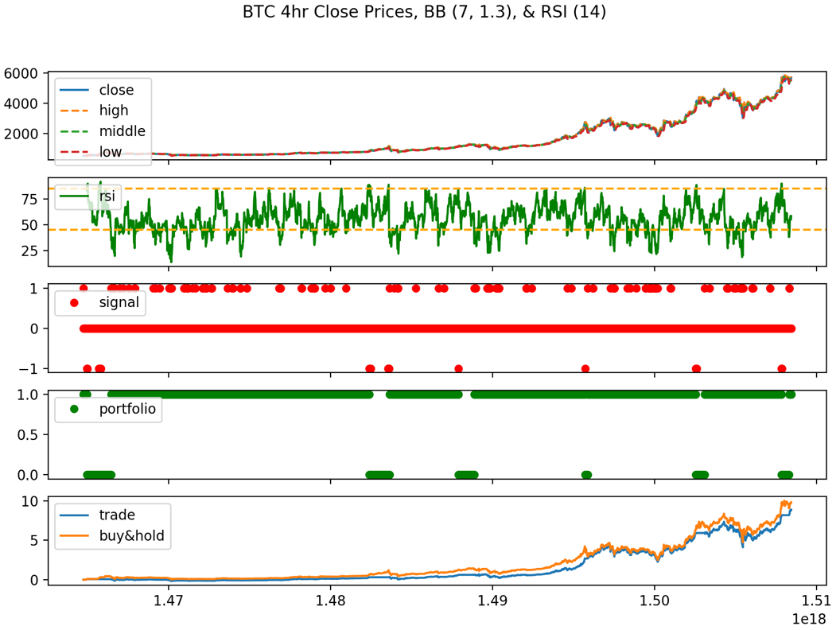

**Fig. 4.** Labeler charts.

**Table 5.** Modeler features.

|  |  |  |
| --- | --- | --- |
| ID1 | ID2 | Feature |
| f0 |  | Close price |
| f1 |  | Volume BTC |
| f2 |  | BB high |
| f3 |  | BB mid |
| f4 |  | BB low |
| f5 |  | RSI |
| f6 |  | Close price prev period |
| f7 | f0 | Volume BTC prev period |
| f8 |  | BB low prev period |
| f9 |  | BB mid prev period |
| f10 |  | BB high prev period |
| f11 |  | Close price two periods back |
| f12 |  | Volume BTC two periods back |
| f13 |  | BB low two periods back |
| f14 |  | BB mid two periods back |
| f15 |  | BB high two periods back |
| f16 | f1 | RSI prev period |
| f17 |  | RSI two periods back |

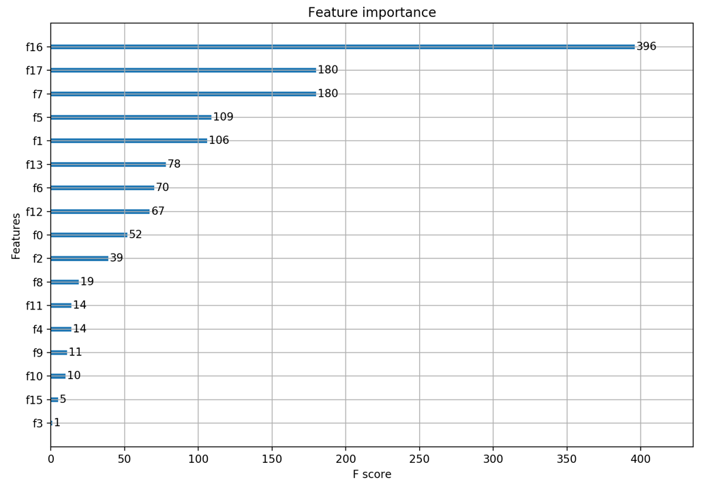

**Fig. 5.** Modeler feature importance considering all features.

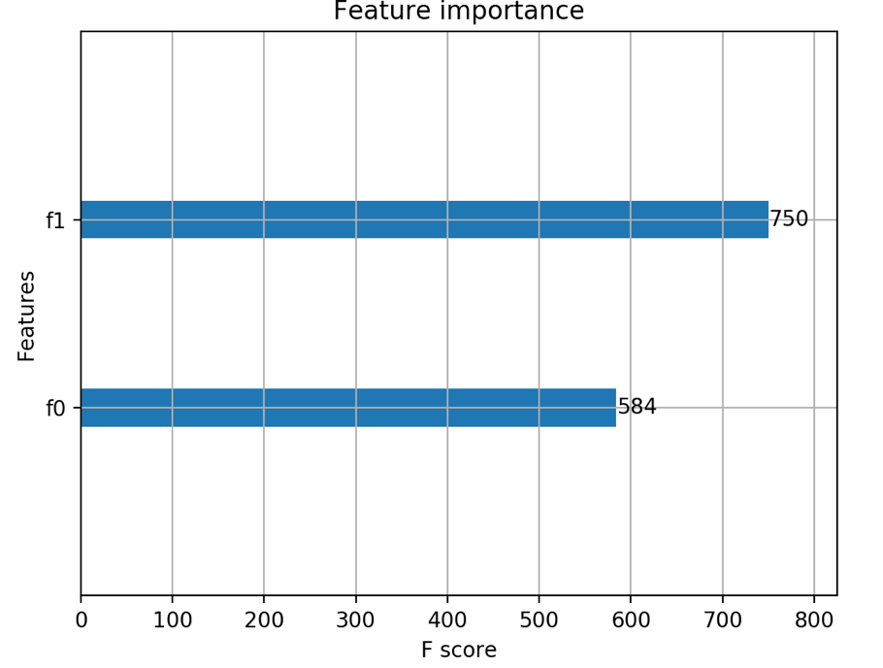

**Fig. 6.** Modeler feature importance with minimal features.

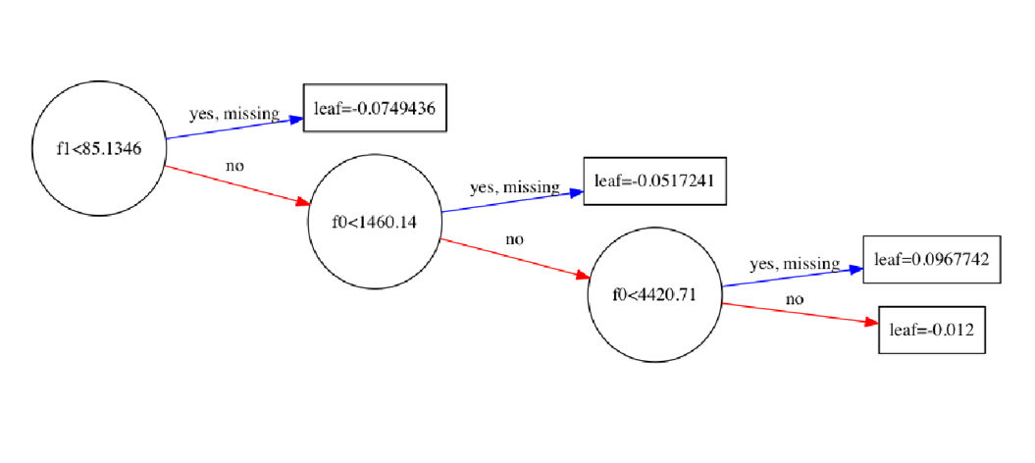

**Fig. 7.** Modeler sample decision tree for minimal features.

# 8 Analysis

# 9 Ethics

cryptocurrencies are financial applications of the blockchain, distributed ledger, technology. As noted in previous research, the adaption of this technology by nature brings the global society into a "new era of openness, decentralization, and global inclusion [9]." Those simple notions are important when trying to understand the issues that the maturing cryptocurrency market are facing as they implicitly inherit the same characteristics of the underlying blockchain technology. Now add the anonymous nature of cryptocurrencies and this sums up one of the primary challenges facing the cryptocurrency market. What does governance/stewardship look like for this open, global, decentralized resource with various levels of transaction anonymity? This collective challenge is our central concern of ethics as it pertains to our research. In this section, we intend to give a better understanding of the ethical concerns of this challenge as well as inform on current efforts to address these concerns.

One organization that has taken notice of this collective challenge is the Financial Action Task Force (FATF). This organization “is an independent inter-governmental body that develops and promotes policies to protect the global financial system against money laundering, terrorist financing and the financing of proliferation of weapons of mass destruction. The FATF Recommendations are recognized as the global anti-money laundering (AML) and counter-terrorist financing (CFT) standard [10].” FATF published its first report in 2013 providing an initial guidance to online alternative currencies. In the report, the organization notes that “given the developing nature of alternate online currencies, the FATF may consider further work in this area in the future [10].” Skip forward a year to the 2014 report, and the organization provides a risk-based approach to the newly classified types of online alternative currencies.

each component of the challenge equation (open, global, decentralized, and anonymous transactions), and evaluate it against the FATF 2014 risk analysis report. Cryptocurrencies are “open” because of their public, decentralized ledgers. “Because the blockchain is massively replicated by mutually-distrustful peers, the information it contains is public [12].” The source code for these currencies are open source meaning they are readily available to the public and the ledgers themselves are maintained by public miners. “No one can hide a transaction, and that makes bitcoin more traceable than cash [15].” This openness is where the ethical risk comes into play. With the “secret sauce” of each cryptocurrency being open it is far easier to reverse engineer to deduce information such as account balances and spending habits of the identities within the blockchain. With this public information, entities could learn about these transactions and try to exploit the market for their gain.

Bitcoin’s network is not hindered by international borders. FAFT who are focused on money laundering and terrorist financing abuse prioritized this characteristic when noting potential risks because cryptocurrencies allow for cross-border payments and funds transfers. In their report, they state, “customer transaction records may be held by different entities, often in different jurisdictions, making it more difficult for law enforcement and regulators to access them”. Today, criminals will locate their business in “jurisdictions with weak AMF/CFT regimes” [16] to money launder. With cryptocurrencies, criminals just need to worry about converting fiat to crypto-coin and onto the network. The distributed ledger allows users to access their funds anywhere as long as they can access the internet.

A decentralized network means there is no central oversight body for cryptocurrencies. The current maturity level of governance/stewardship of this technology is similar to the early days of the internet as noted by the Tapscotts [15]. FATF is concerned that lack of a central “trusted” authority to regulate and generate currencies will lead to exploits.

Anonymous transactions mean “the participants in transactions are not explicitly identified: both the sender(s) receiver(s) are identified solely by a pseudonym, and participants in the system can use many different pseudonyms without incurring any meaningful cost [11].” This capability of the system makes it very challenging for an organization to govern the financial industry from money launderers and terrorists not to mention capital gains tax evaders.

With the growth of the cryptocurrency market, the world governments are evaluating this new system. Some take a wait and see approach. Some shut the doors on the system forbidding it. And, others fully embrace it. Government positions on this new system are various. While governments cannot agree on the use of these early cryptocurrencies as they create new challenges for organizations like FAFT. This currency provides “a powerful new tool for criminals, terrorists, financiers and other sanctions evaders to store illicit funds out of the reach of law enforcement and other authorities [16].”

# 10 Conclusions

# 11 Future Work

# References

1. Shah, D., Zhang, K.: Bayesian regression and Bitcoin. Department of EECS, MIT. (2014)

2. Coin Market Cap. https://coinmarketcap.com.

3. Stern, H: Fidelity Labs Tests Digital Asset Wallet On Fidelity.com. August, 09, 2017. <https://www.fidelity.com/about-fidelity/corporate/fidelity-labs-tests-digital-asset-wallet-on-fidelity.com>

4. Poyser, O.: Exploring the Determinants of Bitcoin’s price, an application of Bayesian Structural Time Series. June 2017.

5. Coin Desk. https://www.coindesk.com/solving-liquidity-challenge-decentralized-exchanges

6. Cazalet, Z., Roncalli, T.: Facts and Fantasies About Factor Investing. October 2014.

7. Fletcher, T., Hussain, Z., Shawe-Taylor, J.: Currency Forecasting using Multiple Kernel Learning with Financially Motivated Features. NIPS 2010 workshop: New Directions in Multiple Kernel Learning (2010).

8. Indexing and Performance in Crypto Assets: Bletchley Indexes. September 8, 2017. <https://www.bletchleyindexes.com/blog/idx_perf_post>

9. Tapscott D., Tapscott A. (2017). Realizing the Potential of Blockchain. A Multistakeholder Approach to the Stewardship of Blockchain and Cryptocurrencies: Whitepaper. Retrieved from World Economic Forum website:

http://www3.weforum.org/docs/WEF_Realizing_Potential_Blockchain.pdf

10. Financial Action Task Force on Money Laundering. FATF report (2014). http://www.fatf-gafi.org/media/fatf/documents/reports/Virtual-currency-key-definitions-and-potential-aml-cft-risks.pdf

11. Meiklejohn, S., Pomarole, M., Jordan, G., Levchenko, K., McCoy, D., Voelker, G. M., & Savage, S.: A fistful of bitcoins. Proceedings of the 2013 conference on Internet measurement conference - IMC '13. doi:10.1145/2504730.2504747

12. Sasson, E. B., Chiesa, A., Garman, C., Green, M., Miers, I., Tromer, E., & Virza, M.: Zerocash: Decentralized Anonymous Payments from Bitcoin. 2014 IEEE Symposium on Security and Privacy. doi:10.1109/sp.2014.36

13. Narayanan, A., et al.: Bitcoin and Cryptocurrency Technologies. Princeton University Press (2016).

14. Nakamoto, S. Bitcoin: A Peer-to-Peer Electronic Cash System. Bitcoin.org (2009).

15. Houser, K.: In the Age of Blockchain, Crytpo Has a Major Problem. Futurism. https://futurism.com/the-age-of-blockchain-crypto-has-a-major-problem (2017).

16. Gholampour, V.: What Can We Learn from Stock Market Tweets? SSRN Electronic Journal (2017). doi:10.2139/ssrn.3041880

17. Smailović, J., Grčar, M., Lavrač, N., & Žnidaršič, M.: Predictive Sentiment Analysis of Tweets: A Stock Market Application. Human-Computer Interaction and Knowledge Discovery in Complex, Unstructured, Big Data, 77-88 (2013). doi:10.1007/978-3-642-39146-0_8

18. Buntinx, JP.: Digital Assets vs Cryptocurrencies. May 17, 2017.

19. Zielak. Coinbase Bitcoin Historical Data. Kaggle, <https://www.kaggle.com/mczielinski/bitcoin-historical-data/data>.

20. Technical Indicator. Investopedia, <https://www.investopedia.com/terms/t/technicalindicator.asp>.

21. Stock Technical Analysis with Python, <https://www.udemy.com/stock-technical-analysis-with-python/>.

22. XGBoost, <https://xgboost.readthedocs.io/en/latest/>.

23. XGBoost with Python, <https://machinelearningmastery.com/xgboost-with-python/>.

24. Monaghan, Angela: Bitcoin is a fraud that will blow up, says JP Morgan boss. https://www.theguardian.com/technology/2017/sep/13/bitcoin-fraud-jp-morgan-cryptocurrency-drug-dealers.