Rabbit holes by the session: dwelling, satiation, and the diversifying feed in donated TikTok histories
Working manuscript scaffold for New Media & Society — Introduction and Findings drafted in full; remaining sections as structured skeletons
Alternative titles: “It just keeps feeding you more”: dwelling and the within-session feed on TikTok · Does lingering shape the feed? Folk theories and observed behaviour in donated TikTok data.

Abstract
Popular and design accounts of TikTok hold that lingering on content drives the recommender to serve more of the same, drawing users into narrowing “rabbit holes.” Drawing on complete, donated TikTok viewing histories from [N] participants, we test this claim directly and characterise the within-session dynamics of engagement and feed composition, treating the viewing session as our unit of analysis and deriving fine-grained content “micro-genres” from large-language-model annotations of each video. Three findings invert the common account. First, contrary to the folk-and-design theory, observable engagement — dwell time, watch-completion, and likes — does not predict the kind of content subsequently served once base-rate persistence is accounted for. Second, within a session engagement wanes (watch-completion and dwell fall; the looping characteristic of a session’s opening fades) while the feed diversifies rather than narrows, drifting modestly back toward the user’s baseline mix; these trends are near-universal across participants yet uncoupled. Third, narrowing “rabbit-hole” sessions are real but constitute roughly one session in four, distributed across nearly all users, rather than a trait of particular people. We argue for reframing the rabbit hole as a session-bound, minority, and engagement-independent phenomenon, and we offer the viewing session — together with donated sequence data and LLM-derived micro-genres — as tools for the empirical study of algorithmic media.
Keywords: TikTok; recommender systems; algorithmic media; folk theories; data donation; rabbit holes; watch time; computational methods

1. Introduction
Ask a regular TikTok user how the app’s “For You” feed works and you will often hear a confident, mechanical account: linger on a few drum-solo clips, or a stand-up bit, or a particular creator, and within minutes the feed obliges with more of the same. The platform encourages this reading. TikTok’s own public descriptions of its recommender foreground “watch time” and replays as primary signals, and a substantial body of journalistic and scholarly commentary treats the For You feed as a paradigmatic engagement-optimising machine — one that learns from your attention and, left unchecked, draws you down ever-narrowing “rabbit holes.” The intuition that dwelling shapes what comes next is, in other words, at once a folk theory held by users and a design story told by the platform, and it underwrites widespread anxieties about algorithmic capture, radicalisation pipelines, and the erosion of user agency.
Yet this account is surprisingly difficult to examine empirically. Recommender systems are proprietary and opaque; their inputs are not observable from the outside; and the feed each user receives is a private, ephemeral stream that disappears as it is scrolled. Most evidence about TikTok’s dynamics therefore comes either from users’ own interpretive accounts — invaluable as folk theory, but not a description of system behaviour — or from sock-puppet audits that probe the system with synthetic accounts rather than real, longitudinal use. What is comparatively rare is the ability to look along an individual’s actual feed over time: to ask, for this person, whether the videos they lingered on are followed by more of the same, and how the character of the feed shifts across a viewing session.
This article does exactly that, using donated TikTok data. [N] participants donated their complete TikTok activity histories through [data-portability mechanism], yielding [≈ millions of] time-stamped video impressions per person — the feed as actually received, in order. We use these traces both to test the folk-and-design theory directly and to characterise the within-session dynamics of engagement and feed composition. To do so we treat the viewing session — a “sitting” with the phone, operationalised as a run of activity uninterrupted by gaps longer than fifteen minutes — as our unit of analysis, and we move beyond coarse content categories by deriving fine-grained “micro-genres” (e.g. stand-up comedy, cat videos, skincare reviews, political commentary) bottom-up from large-language-model annotations of each video.
Three findings follow, and together they invert the common account. First, contrary to the folk theory, how long a user dwells on a video — and whether they watch it to completion or “like” it — does not predict the kind of content the feed subsequently serves, once we account for what is already prevalent in that person’s feed. This null is robust across content categories, creators, micro-genres, and virality, and it holds under a leakage-safe, per-participant evaluation on complete (unsampled) sequences. Second, within a session the feed does not narrow as engagement accumulates; it diversifies. As a sitting progresses, users’ engagement wanes — watch-completion and dwell both decline, and the looping and re-watching characteristic of a session’s opening fade — while the topical diversity of the feed rises, drifting modestly back toward the user’s general baseline mix. These two trends are near-universal across participants but, crucially, uncoupled: sessions in which engagement falls more are not sessions in which the feed diversifies more, so we find no evidence that the system actively diversifies in order to re-engage a fading viewer. Third, the “rabbit hole” is real but mislocated. Narrowing sessions — sittings whose feed concentrates rather than broadens — do occur, in roughly one in four sessions; but almost no participant narrows on average. Rabbit-holing, in these data, is a property of particular sessions distributed across nearly everyone, not a stable trajectory of particular people.
We draw two contributions from this. Conceptually, we argue for reframing the rabbit hole from a deterministic outcome of engagement optimisation — the feed echoing and amplifying your attention until you are captured — to an occasional, session-bound, and engagement-independent pattern that coexists with a more typical dynamic of satiation and diversification. This reframing sharpens a recurring theme in platform studies: the gap between folk and design theories of “the algorithm” and the system’s observable behaviour. Methodologically, we offer the viewing session as a tractable and theoretically meaningful unit for the study of algorithmic media, and we demonstrate an analytic pipeline — donated sequence data, persistent session segmentation, and LLM-derived micro-genres — that lets humanities and social-science researchers turn messy personal feed histories into interpretable findings. Along the way we surface a cautionary lesson about how routine analytic conveniences (here, the down-sampling of sequences for group comparison) can silently destroy the very temporal structure such questions depend on.
We proceed as follows. Section 2 situates the study in work on folk theories of algorithms, the rabbit-hole debate, and engagement optimisation, and motivates the session as a unit. Section 3 describes the donated-data corpus, the session and micro-genre operationalisations, and our analytic strategy. Section 4 presents the three sets of findings. Section 5 discusses their implications for how we theorise algorithmic shaping and user agency, and Section 6 concludes.

2. The algorithm in everyday life: folk theories, rabbit holes, and the feed
Skeleton — ~1,800 words. Three literatures, ending by positing the session as an undertheorised unit. Verify all citations before submission; names below indicate the right bodies of work, not exact references.

2.1 Folk theories and the algorithmic imaginary
- Users hold structured, mechanical theories of how the feed responds to them; these shape behaviour (engage with Bucher on the “algorithmic imaginary”; DeVito on folk theories; Bishop on “algorithmic gossip” among creators; Siles and colleagues on the mutual domestication of recommenders).
- The specific belief at stake — “if I dwell on / engage with X, I get more X” — is both a folk theory and a design narrative the platform actively promotes (watch-time discourse). Frame our RQ1 as an empirical test of this belief, not a debunking of users’ experience.

2.2 Rabbit holes, pipelines, and bubbles
- The rabbit-hole / radicalisation-pipeline / filter-bubble discourse and its public stakes; then the empirical literature that complicates it (Hosseinmardi et al. on YouTube; Munger & Phillips on supply vs demand; Bruns, Are Filter Bubbles Real?).
- Gap in the literature: most evidence is cross-sectional, audit-based, or YouTube-centric; we lack within-feed, longitudinal, per-person evidence on TikTok — which donated histories supply.

2.3 Engagement optimisation and captivation
- Watch-time as the canonical optimisation target; “captivation” and “traps” (Seaver); relevance and recommendation as infrastructural (Gillespie).
- Recommender diversity / exploration–exploitation as a counter-current to pure amplification — sets up our diversification finding.

2.4 The session as a unit of algorithmic experience
- Sessions (“sittings”) are how feeds are actually consumed, yet platform studies rarely theorise them; connect to attention, satiation, and the ephemerality of the scroll. Argue the session is the right grain for our questions.

3. Data and method

3.1 Data donation as method
Our data come from participant donations of TikTok “data download packages” — the personal archives the platform is obliged to provide under data-portability regimes. Each package contains, among other things, a time-stamped log of the videos a user was shown and how they acted on them, which we treat as a record of the For You feed as actually received, in order. Data donation has become an important method for studying otherwise-opaque platforms precisely because it sidesteps the limits of both interview-based and audit-based approaches: rather than asking users to recall or theorise their feed, or probing the system with synthetic accounts, it lets researchers observe real, longitudinal, individual consumption [cite the data-donation methods literature]. Its costs are equally important to state at the outset. Donors are self-selecting and skew toward the digitally literate and research-willing; the archives retain only a bounded window of fine-grained history, so older activity is sparser; and, critically for our purposes, the package records the feed’s outputs but none of the recommender’s inputs or internal state. We design our analyses, and frame our claims, with these boundaries in view.

3.2 Corpus and participants
Our primary corpus comprises complete donated histories from [N = 64] participants [recruited via …, during …], totalling [≈ 2 million] video impressions. For the within-session analyses we additionally analyse an independent second corpus of [N = 27] participants as a replication sample. [Add recruitment, period, compensation, and consent details.] Both corpora are modest in participant count and non-representative; we therefore treat the participant, not the impression, as the unit of analysis throughout, and we foreground individual-level variation rather than population point estimates.

3.3 Operationalising the session
We define a viewing session — a “sitting” — as a maximal run of a participant’s activity in which no two consecutive events are separated by more than fifteen minutes. The threshold is a modelling choice; we selected it after inspecting the distribution of inter-event gaps, which is heavily right-skewed (most consecutive videos are seconds apart, with a long tail of multi-hour and overnight breaks). A shorter threshold fragments a single sitting around ordinary pauses — replying to a message, a brief interruption — while a far longer one merges genuinely separate sittings; fifteen minutes tolerates within-sitting pauses while still breaking at the clearly between-sitting gaps. Sessions are computed once, on each participant’s full, time-ordered activity stream, and a session identifier is attached to every event, so the same segmentation is available to all downstream analyses. (This is distinct from a separate, deliberately short three-minute grouping used only to attach comments and likes to the video they concern; that grouping is internal to data processing and is not a “sitting.”) For the begin→end analyses we restrict attention to sessions of between 12 and 80 annotated videos — long enough to divide meaningfully, while excluding both quick checks and atypical marathon sittings — which yields [≈ 14,800] qualifying sessions in the primary corpus.

3.4 Deriving content micro-genres
A central methodological move is to characterise content at a finer grain than the broad categories (comedy, sport, news, and so on) typical of content analysis. The phenomena users describe — being served more “drum solos,” “stand-up bits,” or a particular aesthetic — live below the level of such categories and above the level of an individual creator. To recover this grain bottom-up, we first annotate every video with a large language model, which returns a structured description (a scene summary, on-screen objects and text, a transcript, and audio and hashtag information). We then assemble a weighted text document per video from these fields and cluster the documents — using a standard term-frequency representation reduced by latent semantic analysis and partitioned with k-means — into roughly 150 “micro-genres.” The resulting clusters are readily interpretable (examples include stand-up comedy, cat videos, skincare reviews, and political commentary) and form the vocabulary in which we measure the feed’s topical composition. Because the clusters are model artefacts, we [report cluster-coherence checks, sensitivity to the number of clusters, and the share of content that is annotated]; we return to their validity in the limitations.

3.5 Measures
From each video impression we derive three measures of engagement: dwell time (the interval to the next logged event, a proxy for time spent on the video), watch-completion (dwell relative to the video’s duration, where values above one indicate re-watching or looping), and whether the user liked the video. We summarise the feed’s composition within any stretch of a session using the Shannon entropy of its micro-genre distribution (higher entropy indicates greater topical diversity) and the share held by the single most-frequent micro-genre (a measure of concentration). We additionally record per-video attributes used in secondary analyses: inferred on-screen gender and ethnicity, model-rated political and sensitivity scores, indicators for advertising, AI-generated content, and trend participation, and platform virality (view counts) and video length.

3.6 Analytic strategy
For the within-session analyses (RQ2, RQ3) we divide each qualifying session into an early and a late third by rank among its annotated videos and compute, for each segment, the measures above. We aggregate to the participant before testing — averaging a participant’s sessions, then treating participants as the sample — so that prolific donors cannot dominate. Group-level effects are reported with percentile bootstrap 95% confidence intervals over participants and Wilcoxon signed-rank tests, and we control the false-discovery rate (Benjamini–Hochberg) across the full grid of measures; decile trajectories show within-session shape. For the prediction analyses (RQ1) we ask whether engagement with a given creator, micro-genre, category, or virality level adds predictive information about subsequent content beyond a baseline that already encodes how prevalent that content is for the user, the time of day, and the position within the session. We evaluate every model with cross-validation that holds out whole participants — so that autocorrelated observations from one person cannot leak between training and test — and report the incremental skill of the engagement-augmented model over the baseline.

3.7 A reflexive note on sequence integrity
One methodological lesson is worth flagging because it is easily, and silently, made. Our analyses initially used a derived dataset that had been date-filtered and down-sampled — to roughly 16 per cent of impressions — for an unrelated group-comparison purpose. Sampling preserves marginal distributions but destroys sequence: with five of every six videos removed, the gaps between surviving impressions balloon and apparent sessions shatter (in our case, the median apparent session fell to two videos). Recomputing every analysis on the complete, intact histories changed the descriptive picture of session structure entirely (median session length of 23 videos) while leaving the substantive conclusions unchanged. The general point is transferable: sequence-dependent questions must be posed on sequence-preserving data, because routine analytic conveniences that are harmless for distributional questions can quietly foreclose temporal ones.

3.8 Ethics
[Participants gave informed consent for the donation and analysis of their histories under approval from …]. Donated histories are richly re-identifying, and LLM annotation entails processing users’ personal viewing content; we therefore [describe storage, access control, de-identification, retention, and any restrictions on data sharing]. [State preregistration and open-materials status.]

4. Findings
We report findings from a primary corpus of [N = 64] participants and, for the within-session dynamics, an independent replication corpus of [N = 27]. Throughout, we aggregate session-level quantities to the participant before testing, so that heavy donors do not dominate, and we control the false-discovery rate across the feature grid.

4.1 Dwelling does not steer the feed
We first test the folk-and-design theory that engagement shapes subsequent content. For each video impression we measured three engagement signals available in donated data — dwell time (seconds before the next logged event, a proxy for time-on-video), watch-completion (dwell relative to the video’s duration), and whether the user “liked” the video — and asked whether higher engagement with a given creator, micro-genre, content category, or level of virality predicted more of that same content in the subsequent feed. To avoid the most common inferential error in sequence data — treating autocorrelated observations from one person as independent — we evaluated every model with grouped cross-validation that holds out whole participants, and we compared each engagement-augmented model against a baseline that already “knows” how prevalent the target content is for that user, the time of day, and how deep into the session the impression falls.
The answer is consistent and, given the strength of the prior, striking: engagement adds essentially nothing. Across all target types and all three engagement signals, the incremental predictive gain over the base-rate baseline was negligible (ΔAUC and ΔR² ≈ 0). Recurrence of content is highly predictable — but from how common it already is in a user’s feed (baseline AUC ≈ 0.66–0.72), not from how the user engaged with it. At the level of individual creators the relationship was, if anything, mildly negative: videos a user liked were less likely to be followed by the same creator (recurrence ≈ 0.08 versus ≈ 0.10 for un-liked videos), consistent with the platform’s well-documented tendency to diversify creators even within a topical interest. The pattern was identical on complete, unsampled sequences and on a sampled subset, ruling out a sequence-thinning artefact (Section 3.7).
Two interpretive cautions matter, and we return to them in the Discussion. First, this is a null about observable engagement: donated dwell time is a forward-delta proxy that conflates attentive watching with pauses and multitasking, and donated histories do not contain the follows, searches, “not interested” taps, or fine-grained re-watch signals that the recommender is known to weight. The result should be read as “the engagement signals available in donated data do not measurably steer subsequent content,” not as “engagement is irrelevant to the recommender.” Second, the dominance of base-rate persistence is itself a substantive finding: feeds are strongly self-similar — what you have been shown is what you will be shown — and that persistence, rather than responsive amplification of your lingering, is the principal structure in these data.

4.2 Over a session, engagement wanes and the feed diversifies
We next turn from prediction to description, asking how engagement and feed composition change within a session. We divided each qualifying session into an early and a late third and compared them. Two robust, near-universal patterns emerge.
First, engagement satiates. Mean watch-completion fell from 1.02 in the early third to 0.89 in the late third (Δ = −0.12; 95% CI [−0.16, −0.08]; declining in 84% of participants), and mean dwell fell from 26.6 to 23.4 seconds (Δ = −3.2s). That early-session completion exceeds 1.0 is itself informative: at the start of a sitting users frequently re-watch and loop videos (dwell exceeds video length), a behaviour that fades as the session continues. The decline is steep early and then plateaus (Figure 1).
Second, and against the rabbit-hole intuition, the feed diversifies. The topical diversity of the served content — the Shannon entropy of its micro-genre distribution — rose from the early to the late third (Δ = +0.044; increasing in 97% of participants), while the share held by the single most-served micro-genre fell (Δ ≈ −0.007). Sessions, in other words, open relatively concentrated and broaden as they go. What is the diversification toward? In part, a regression to the user’s own baseline: the late third’s micro-genre mix sits significantly closer to that participant’s overall feed distribution than the early third’s does (Jensen–Shannon distance 0.120 → 0.113; p < .001), though the effect is small. Sessions thus tend to open on relatively distinctive material and drift back toward the user’s general diet.
Both dynamics are near-universal, which invites a tempting mechanistic story: that the system diversifies the feed precisely to re-engage a viewer whose attention is flagging. Our data do not support it. Within participants, sessions in which completion fell more were not sessions in which diversity rose more (mean within-participant correlation between the two session-level changes ≈ +0.01, n.s.). Satiation and diversification are robust but independent trends, and we are careful not to over-read their co-occurrence as a feedback loop.
A set of smaller, mostly significant shifts fills out the picture: later in a session, videos are slightly longer (+1.2s), somewhat more viral (higher view counts), contain slightly fewer advertisements (−1.3 percentage points), and are marginally less political. Inferred demographic attributes of on-screen subjects (gender, ethnicity), content sensitivity, “trend” participation, and AI-generated content showed no reliable within-session shift.
Crucially, these patterns replicate. An independent second corpus ([N = 27] participants) reproduces them almost exactly — completion −0.15, dwell −3.1s, micro-genre entropy +0.045 (rising in 100% of participants) — which, given the modest participant counts, materially strengthens our confidence that the within-session dynamics are general rather than corpus-specific.
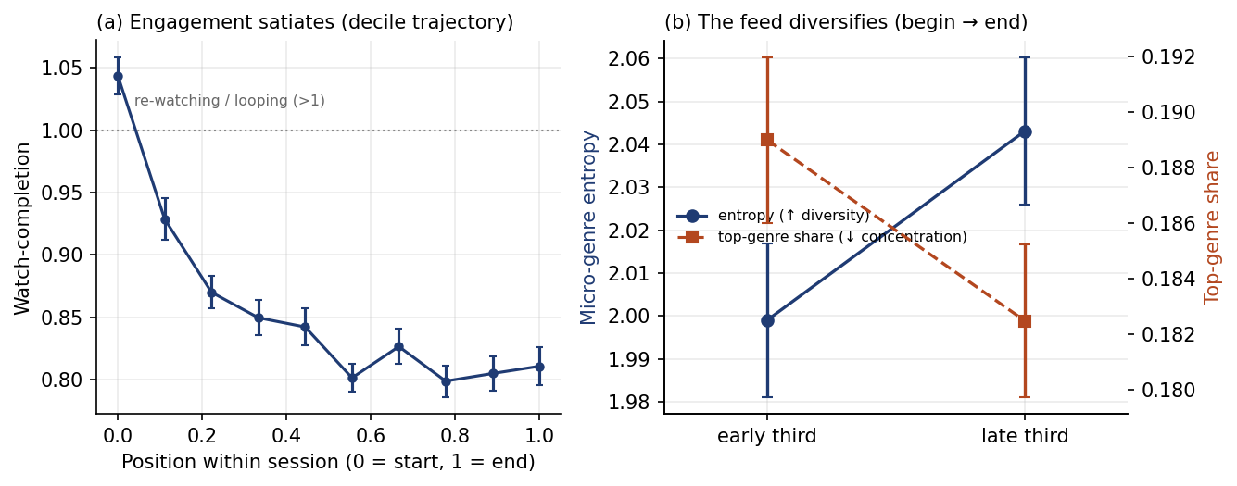
Figure 1. Within-session dynamics (primary corpus, [N = 64]). (a) Watch-completion across position-in-session deciles; values above 1.0 reflect re-watching/looping early in a sitting. (b) Micro-genre entropy rises and top-genre share falls from the early to the late third. Markers: mean ± SEM across participants.

4.3 The rabbit hole is a session, not a person
The aggregate diversification result could mask a subgroup of users who, contrary to the average, narrow into rabbit holes. We therefore examined the distribution of within-session change across participants and across sessions. The two views tell sharply different stories. At the participant level the dynamics are nearly uniform in direction: only 2 of 64 participants narrow on average (show declining micro-genre diversity over their sessions), and the satiation of engagement is similarly near-universal — although its magnitude varies widely (per-participant change in completion ranged from −0.32 at the 10th percentile to +0.04 at the 90th, so a minority even gain engagement over a sitting).
At the session level, however, variation is substantial and the rabbit-hole shape reappears. Roughly one session in four (25%) narrows — its feed concentrates rather than diversifies over the sitting — and 41% show rising rather than falling completion. Because almost no participant narrows on average yet a quarter of sessions do, narrowing cannot be a stable disposition of particular users; it is instead an occasional property of particular sittings, distributed across nearly the whole sample. The rabbit hole, on this evidence, is something most people fall into sometimes, in some sessions — not a trajectory that characterises certain people, or that, once entered, defines a user’s relationship with the feed.
This relocation of the phenomenon — from person to session — is, we suggest, the article’s central empirical contribution, and we develop its implications below.
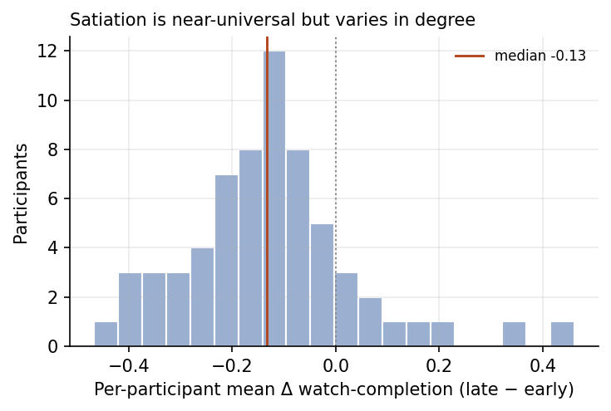
Figure 3. Between-participant variation in satiation. Distribution of the per-participant mean change in watch-completion over a session: the decline is near-universal in direction but varies widely in magnitude.
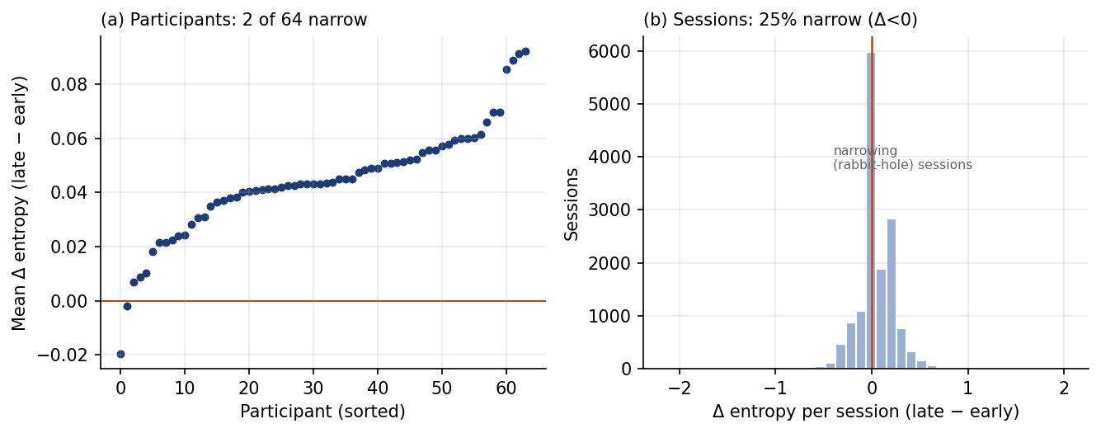
Figure 2. The rabbit hole is a session, not a person. (a) Per-participant mean change in micro-genre entropy (late − early): only 2 of 64 participants narrow on average. (b) Per-session change: ~25% of sessions narrow (Δ < 0). Narrowing is an occasional property of sittings, distributed across nearly all users.

5. Discussion

5.1 Reframing the rabbit hole
Public and scholarly discussion of recommender-driven media has been organised around an image of progressive capture: the feed, optimised for engagement, learns what holds your attention and serves ever more of it, drawing you into a narrowing rabbit hole. Our findings ask for a more differentiated picture on three counts. The dominant within-session dynamic is not narrowing but its opposite — diversification — accompanied by waning rather than escalating engagement; narrowing sessions exist but are a minority, about one in four; and they are a property of sittings, not of people, since almost no participant narrows on average. The rabbit hole, on this evidence, is better understood as an occasional and reversible local episode than as a stable trajectory or a personal fate. This does not deny that intense, narrowing binges happen or that they matter; it relocates them, and it sits alongside a growing body of work that finds the strongest versions of the pipeline and bubble theses difficult to substantiate when feeds are observed directly rather than imagined [cite]. The contribution here is to add the session as the level at which the phenomenon is best identified — and to show that conflating the session and the person can make a common, transient pattern look like a defining individual one.

5.2 Folk and design theories versus observed behaviour
That dwelling shapes the feed is among the most widely held folk theories of TikTok, and it is actively cultivated by the platform’s own account of watch-time as the master signal. Our prediction analyses find no measurable trace of it in the engagement signals donated data afford: once we know how prevalent a kind of content already is for a user, neither how long they dwelt, how fully they watched, nor whether they liked a video improves prediction of what comes next. Why, then, is the belief so robust? Part of the answer is the very session-level variation we document: the memorable cases — the sitting that did spiral into drum solos — are vivid and cognitively available, while the far more common sittings in which lingering changed nothing leave no trace in memory. Part is structural: the dominant pattern in the data, strong base-rate persistence, is experientially indistinguishable from responsive amplification — a feed that keeps showing you what it has been showing you feels like a feed that is responding to you. And part is the platform’s own framing, which offers users a simple, agentive, and flattering account of a system whose actual workings are opaque. The folk theory is, in this sense, experientially grounded but mechanistically mis-specified — a finding that extends work on algorithmic folk theories from how users imagine the system to how those imaginings line up against its observable behaviour.

5.3 Diversification, persistence, and agency
Two of our results bear on long-running debates about agency under algorithmic media. First, the principal structure in these feeds is persistence: what you have been shown strongly predicts what you will be shown, far more than any responsive amplification of your moment-to-moment engagement. This is a different worry from the rabbit hole — less a matter of being pulled somewhere than of being held in place — and it deserves its own conceptual attention. Second, the within-session diversification is open to more than one reading. It is consistent with a recommender that, having exhausted a user’s most predictable interests early in a sitting, explores more widely; it is equally consistent with users themselves seeking variety as a session wears on; and our data, which capture outputs rather than mechanisms, cannot adjudicate between feed-side and user-side accounts. What we can say is that the diversification is not a re-engagement response to satiation: the two trends, though both near-universal, are statistically uncoupled across sessions, which cautions against the tidy functionalist story in which the system diversifies precisely to win back a flagging viewer. Resisting that story is part of taking the data seriously.

5.4 The limits of observable engagement
Our central null must be stated precisely. It is a null about the engagement signals that donated data make visible — dwell, completion, and likes — not a claim that engagement is irrelevant to the recommender. Donated histories do not contain follows, searches, “not interested” responses, shares, or the fine-grained re-watch behaviour the system is understood to weight, and our dwell measure is a coarse forward-delta proxy that conflates rapt attention with a phone left face-up. It remains entirely possible that the recommender responds strongly to engagement signals we cannot see, or to ours at a resolution donated data do not preserve. Establishing that would require richer instrumentation — donation augmented with in-situ logging, or platform cooperation — and is an agenda our method points toward rather than fulfils. The honest summary is that, with the signals a privacy-respecting donation can provide, the popular account of dwelling-driven amplification is not observable, and the feed’s behaviour over a sitting looks more like satiation-plus-diversification than capture.

6. Conclusion
Skeleton — ~500 words.
- Recap the three findings and the reframing. Argue for the session as a unit and for donated-sequence-plus-LLM-annotation as a method for HASS researchers. Future work: other platforms; better dwell measurement; cross-session and longitudinal dynamics (recency-bias permitting); experimental or instrumented donation.

Limitations
- Single platform; observational/correlational. Self-selected donated sample with WEIRD-skew and recency bias in retained histories. Dwell is a proxy (time-to-next-event), not measured attention. Micro-genre clusters are model artefacts requiring validity scrutiny. We observe feed outputs, not the recommender’s inputs or internal state.

Figures and tables
- Figures 1–3 are embedded above (drafts, generated from the primary corpus). Regenerate at journal resolution/format on acceptance; consider adding the replication corpus as a supplementary panel.
- Table 1 (still to produce; appendix/OSF) — Begin→end contrasts for all features: early, late, Δ, 95% CI, FDR-adjusted p; both corpora.

Notes for the author
- Verify every citation; the names in Section 2 mark the right literatures, not exact references.
- Finalise N, recruitment, study period, and the data-donation mechanism throughout (bracketed placeholders).
- Decide naming for the two corpora (e.g. Corpus A / B) and apply consistently.
- Consider preregistration framing for the RQ1 test and an OSF deposit of code (the analysis pipeline) and the contrast table.
- Exact figures used in the draft (primary corpus): completion 1.02→0.89 (Δ−0.12, 84% decline); dwell 26.6→23.4s; entropy +0.044 (97% up); top-share −0.007; JS-to-baseline 0.120→0.113 (p<.001); satiation×diversification corr ≈+0.01 (n.s.); 25% of sessions narrow; 41% rising completion; 2/64 participants narrow on average; Δcompletion p10–p90 −0.32→+0.04. Replication (N=27): completion −0.15; dwell −3.1s; entropy +0.045 (100% up). RQ1: ΔAUC/ΔR²≈0; baseline AUC 0.66–0.72; liked-creator recurrence ≈0.08 vs 0.10.

