FactoryManager
Technical Documentation
Version 0.1.0 — Python 3.12 / PySide6 / PostgreSQL

Table of Contents

1. Project Overview
FactoryManager is a PySide6 desktop application for factory production management. It connects to a PostgreSQL database hosted on Supabase and manages the full production lifecycle: orders, bills of materials, routings, planning, shop-floor tracking, and cost calculation.

1.1 Technology Stack

Layer | Technology | Version
GUI Framework | PySide6 (Qt for Python) | >=6.5
ORM | SQLAlchemy | >=2.0
Database Driver | psycopg2-binary | >=2.9
Database | PostgreSQL (Supabase) | 15+
Migrations | Alembic | >=1.11
Config | python-dotenv | >=1.0
Runtime | Python | 3.12
Packaging | PyInstaller | 6.x

1.2 Project Structure

app.py Entry point — QApplication + LoginDialog + MainWindow
database.py SQLAlchemy engine and SessionLocal factory
db_config.py .env read/write, get_db_url(), test_connection()
models/ SQLAlchemy ORM models
commande.py Commande, LigneCommande
produit.py Assemblage, Composant, Nomenclature, Service, PieceExterne
ressource.py Machine, MatierePremiere, ArretMachine
gamme.py Gamme, Operation, OperationMatiere
production.py OFAssemblage, OrdreFabrication, OperationPlanifiee, Rebut
user.py User (auth + roles)
services/ Business logic layer
of_service.py OF generation from order lines
bom_service.py Bill of materials explosion
planning_service.py Gantt scheduling and shift logic
cout_service.py Cost price calculation
pointage_service.py Operation start/pause/complete
rebut_service.py Scrap recording
ui/views/ PySide6 view files (one per screen)
migrations/ Alembic migration scripts

2. Database Architecture
The database is PostgreSQL hosted on Supabase. Connection parameters are stored in a .env file at the project root and loaded at startup via db_config.py.

2.1 Connection Configuration
The .env file contains:
DB_HOST=db.xxxxxxxxxxxx.supabase.co
DB_PORT=5432
DB_NAME=postgres
DB_USER=postgres
DB_PASSWORD=your_password

The connection URL is assembled by get_db_url() in db_config.py:
postgresql+psycopg2://{user}:{password}@{host}:{port}/{dbname}

2.2 Session Management
All database access uses SQLAlchemy sessions via SessionLocal(). The pattern used throughout the codebase is:
session = SessionLocal()
try:
# queries here
finally:
session.close()

2.3 Key Tables

Table | Model Class | Description
commande | Commande | Customer orders
lignecommande | LigneCommande | Order lines — one assembly per line
assemblage | Assemblage | Finished products
composant | Composant | Manufactured parts
nomenclature | Nomenclature | Bill of Materials (BOM) — parent-child links
gamme | Gamme | Routing — ordered list of operations for a component
operation | Operation | One step in a routing (machine, times, materials)
ofassemblage | OFAssemblage | Assembly production order (one per order line)
ordrefabrication | OrdreFabrication | Manufacturing order — one per component in the BOM
operationplanifiee | OperationPlanifiee | Scheduled instance of a routing operation
machine | Machine | Production equipment
matierepremiere | MatierePremiere | Raw materials
rebut | Rebut | Scrap events
user | User | Application users with role levels

3. Entity-Relationship Diagram
The diagram below shows all 20 tables of the FactoryManager database, grouped by domain, with their columns and relationships. Solid lines indicate mandatory foreign keys; dashed lines indicate optional foreign keys.

Color | Domain
Dark blue (#2C3E50) | Orders — commande, lignecommande
Green (#1A6B4A) | Product catalogue — assemblage, composant, nomenclature, service, piece_externe
Purple (#8E44AD) | Routings — gamme, operation, operationmatiere
Orange (#D35400) | Resources — machine, machineshiftconfig, arretmachine, matierepremiere
Blue (#1F618D) | Production — ofassemblage, ordrefabrication, operationplanifiee, rebut, livraisonpartielle
Gray (#7F8C8D) | Authentication — user

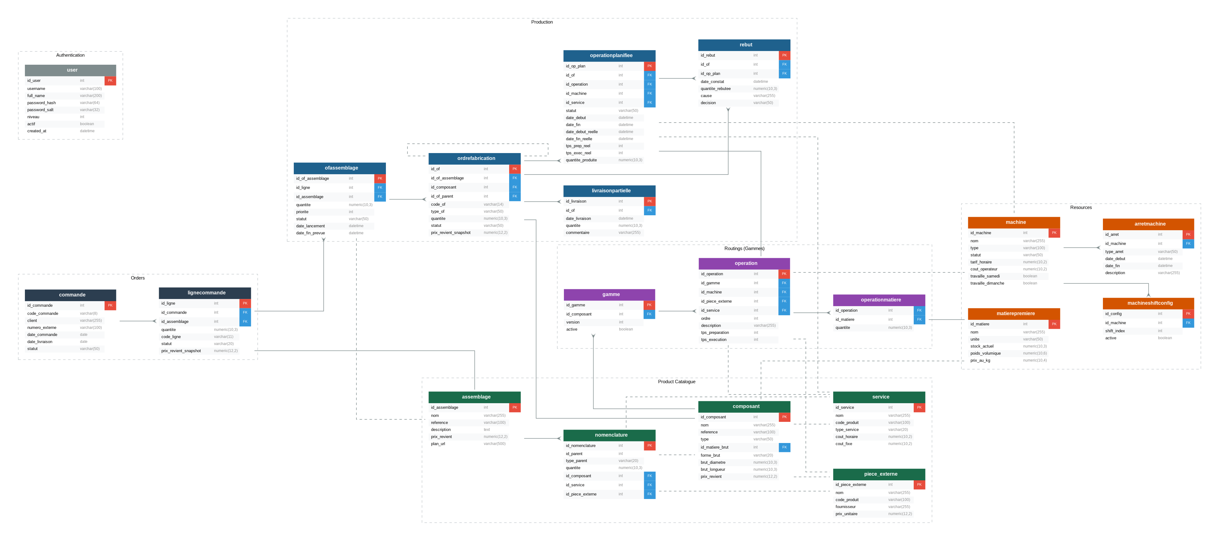
Figure 1 — FactoryManager Entity-Relationship Diagram (v0.1.0)

4. Data Models

4.1 Production Order Hierarchy
The production flow follows this hierarchy:
- Commande (Customer Order)
- └─ LigneCommande (Order Line) — one assembly + quantity
- └─ OFAssemblage (Assembly Order) — one per line
- └─ OrdreFabrication (Manufacturing Order) — one per BOM component
- └─ OperationPlanifiee (Planned Operation) — one per routing step

4.2 OFAssemblage

Column | Type | Description
id_of_assemblage | Integer PK | Auto-increment primary key
id_ligne | FK → lignecommande | Parent order line
id_assemblage | FK → assemblage | Assembly being produced
quantite | Numeric(10,3) | Quantity to produce
priorite | Integer | 1=Urgent, 2=High, 3-4=Elevated, 5=Normal
statut | String | planifie / en_cours / termine / annule
date_lancement | DateTime | Planned start date
date_fin_prevue | DateTime | Planned end date

4.3 OrdreFabrication

Column | Type | Description
id_of | Integer PK | Auto-increment primary key
id_of_assemblage | FK → ofassemblage | Parent assembly order
id_composant | FK → composant | Component being manufactured
code_of | String(14) | Generated code e.g. 2604-001-01-01
quantite | Numeric(10,3) | Quantity to produce
type_of | String | normal / retouche / complement
statut | String | a_planifier / planifie / en_cours / termine / rebute
prix_revient_snapshot | Numeric(12,2) | Cost price at time of OF generation

4.4 OperationPlanifiee

Column | Type | Description
id_op_plan | Integer PK | Auto-increment primary key
id_of | FK → ordrefabrication | Parent manufacturing order
id_operation | FK → operation | Routing operation definition
id_machine | FK → machine | Assigned machine
statut | String | planifiee / en_cours / terminee / rebutee
date_debut_prevue | DateTime | Planned start
date_fin_prevue | DateTime | Planned end
date_debut_reelle | DateTime | Actual start (set when operator clicks Start)
date_fin_reelle | DateTime | Actual end (set when operator clicks Complete)
tps_prep_reel | Integer | Actual preparation time in minutes
tps_exec_reel | Integer | Actual execution time in minutes
quantite_produite | Numeric | Actual quantity produced

5. Service Layer
Business logic is separated from views in the services/ directory.

5.1 of_service.py — OF Generation
Triggered when an order line is released to production. Explodes the BOM recursively, creates one OrdreFabrication per component, and generates OperationPlanifiee records from the component's routing (Gamme).
- generer_of_depuis_ligne(session, ligne) — main entry point
- generer_code_commande(session, date) — generates CMD-YYMM-NNN codes
- generer_code_ligne(code_commande, n) — generates CMD-YYMM-NNN-LL codes

5.2 planning_service.py — Scheduling
Manages the Gantt chart logic. Uses a 3x8h shift system (6h-14h, 14h-22h, 22h-6h).
- recalculer_planning_global(session) — reschedules all a_planifier operations
- deplacer_operation(session, op_plan, new_start, new_machine) — moves a single operation
- valider_deplacement(session, op_plan, new_start, new_machine) — validates before applying
SHIFTS_DEF defines the three shifts. Machine shift availability is stored in machineshiftconfig.

5.3 cout_service.py — Cost Calculation
Calculates the cost price (prix_revient) of a component or assembly. Takes into account:
- Raw material cost — derived from brut dimensions (bar, tube, plate) and material unit price per kg
- Operation costs — machine time costs and service/external part fixed costs
A snapshot of the cost price is stored on each OrdreFabrication at generation time (prix_revient_snapshot).

5.4 pointage_service.py — Operation Lifecycle
- start_operation(session, op_plan) — sets statut='en_cours', records date_debut_reelle
- complete_operation(session, op_plan, tps_prep, tps_exec, qty) — sets statut='terminee'
- rebut_operation(session, op_plan, qty, reason) — records a Rebut event

5.5 bom_service.py — BOM Explosion
Provides recursive BOM explosion used by of_service. Resolves Nomenclature records and returns the flat list of components with quantities adjusted for the production quantity.

6. Authentication & Permissions

6.1 Password Hashing
Passwords are hashed with SHA-256 + a random salt (16 bytes hex). The hash and salt are stored separately in the user table.
def hash_password(password, salt=None):
salt = os.urandom(16).hex() # if not provided
h = hashlib.sha256((salt + password).encode()).hexdigest()
return h, salt

6.2 Permission System
Permissions are evaluated at runtime via User.can(action). The CurrentUser singleton holds the logged-in user for the session.

Action Key | Minimum Level | Screen
production | 1 — Operator | Production Tracking
dashboard | 2 — Coordinator | Dashboard
planning | 2 — Coordinator | Planning, Assembly Orders
scrap | 2 — Coordinator | Scrap
components | 2 — Coordinator | Components
assemblies | 2 — Coordinator | Assemblies
orders | 2 — Coordinator | Orders
machines | 3 — Manager | Machines
materials | 3 — Manager | Materials
services | 3 — Manager | Services
external_parts | 3 — Manager | External Parts
users | 4 — Administrator | Users, DB Config

7. Database Migrations
Alembic is used for schema versioning. The migrations/ directory contains all migration scripts.

alembic upgrade head # Apply all pending migrations
alembic revision --autogenerate -m "description" # New migration
alembic downgrade -1 # Rollback one step

The database URL for Alembic is loaded from the same .env file via db_config.get_db_url(), configured in migrations/env.py.

8. Build & Deployment

8.1 Development Setup
git clone <repo>
cd FactoryManager
python -m venv venv
venv\Scripts\activate # Windows
pip install -r requirements.txt
python app.py

8.2 Standalone Executable
pyinstaller --onedir --windowed --name FactoryManager app.py
The .env file must be placed alongside the executable — it is intentionally excluded from the build to protect credentials.
The build must be performed on the target OS. A Windows build is required for Windows distribution.

8.3 Requirements
PySide6>=6.5.0
SQLAlchemy>=2.0.0
psycopg2-binary>=2.9.0
alembic>=1.11.0
python-dotenv>=1.0.0

9. Code Conventions

Convention | Rule
File naming | Views: *_view.py — Services: *_service.py — Models: domain name
Session handling | Always open SessionLocal() in a try/finally block and close in finally
Permission checks | Always use CurrentUser.can('action') before showing restricted UI
Language | UI labels in English — code comments may be in French (legacy)
Status values | Stored in DB as snake_case strings (e.g. 'a_planifier', 'en_cours')
Code generation | Auto-generated codes follow the pattern YYMM-NNN-LL-CC

