Amateur Chamber Music Society Inc

— Concert —

— Program —

Three Duos
Richard Rodney BENNETT Crosstalk
Alan FRANK Suite
Ernesto CAVALLINI Duo in E minor
clarinets Andrew Kennedy and Brian Martin
20’

— Interval —

SCHUMANN Piano Quintet in E flat major Op44
(1) Allegro brillante (2) In modo d'una Marcia
(3) Scherzo - Molto vivace (4) Allegro ma non troppo
violins George Carrard and Michael Goldstein viola Andrew Kim
cello Robyn Mansfield piano Kian Woo
30’
— Supper —
Concert Organiser: Brian Martin
The manager and volunteer staff of the
Kirribilli Neighbourhood Centre
provide supper (wine, juice, fruit and savouries) and
charge $10 entry ($5 concession/seniors) to cover costs
and to raise funds for the Centre
- Background Notes -
SCHUMANN Piano Quintet in E flat major Op44
Robert Schumann was born in 1810, the son of a bookseller and minor author. Robert was a precocious child – studied piano and latin aged 7, composed his opus 1 aged 12 and, at 15, founded a literary society, a youth orchestra and a “secret society” with radical liberal views. Pressured by his family, he went to Leipzig University at the age of 18 to study law. Instead he spent his time in literary, social and musical activities, the latter notably included playing chamber music by Schubert, and studied piano with Friedrich Wieck. Aged 20, he finally persuaded his family that he should aim to be a pianist and went to live at Wieck’s music school in Leipzig. (This was 1830, a year of civil wars in Europe, in which people successfully forced the establishment of constitutional monarchies.) The piano studies were short-lived as was his formal music theory education – much of his composition technique was self taught, notably by studying Bach, whose works had recently come to prominence as a result of the efforts of Schumann’s contemporary, Mendelssohn, also a resident of Leipzig. At 24 Schumann was founding editor and perceptive leading writer of the New Journal for Music , which built up a wide readership, and led to a doctorate at the University of Jena six year later - Schumann was better known as a writer/editor than as a composer. By the time he was 25, he had written many piano pieces, including Carnaval which, to this day, remains a popular piece in the piano solo repertoire. And he was in love with Wieck’s daughter, Clara, a talented pianist. It was not until his 30th year (1840) that they were finally married, after taking legal steps to overrule the father’s refusal to allow the union.
In the second year of their marriage, Clara went to Copenhagen to give concerts. Schumann missed her dreadfully and later that year wrote his Piano Quintet, which some regard as a small piano concerto for Clara, to be performed at home rather than with an orchestra in a distant town. Although there is some very fancy work for the piano, the strings do much more than accompany the piano, and all instruments have turns at solo parts. The quintet stands out in the 19th century chamber music repertoire, was a model for later works by Brahms and Dvorak, and has always been a favourite with audiences. It is easily assimilated, has a large range of fresh and contrasting musical ideas, and is suffused with Romantic warmth.
In the third movement, the scherzo theme appears three times on either side of two trios. On the day of one of the first performances of the quintet, Clara became ill. Mendelssohn, who sat in for Clara and sight-read the piano part, was very impressed with the work, but suggested that Schumann re-write the second trio – something livelier. Schumann obliged. One cannot help noticing that the liveliness is reminiscent of Mendelssohn’s style, taking it one step further with frequent changes of key. On the subject of reminiscence, is there a reference to Beethoven in the second movement and to Bach in the final allegro? If these references are there, they do nothing to compromise Schumann’s distinctive voice.
Depression had plagued Schumann most of his life and increased with age. He entered an asylum aged 44 and died two years later in 1856.

For information on future concerts, go to the website
http://www.acms-australia.org/ and click on “Concerts” in Navigation panel on the left hand side.
All chamber music players are welcome to join the Amateur Chamber Music Society. If interested, go to the website, click on “Join Us”, download an application form and post to ACMS Membership Secretary, PO Box 584, Balgowlah NSW 2093.

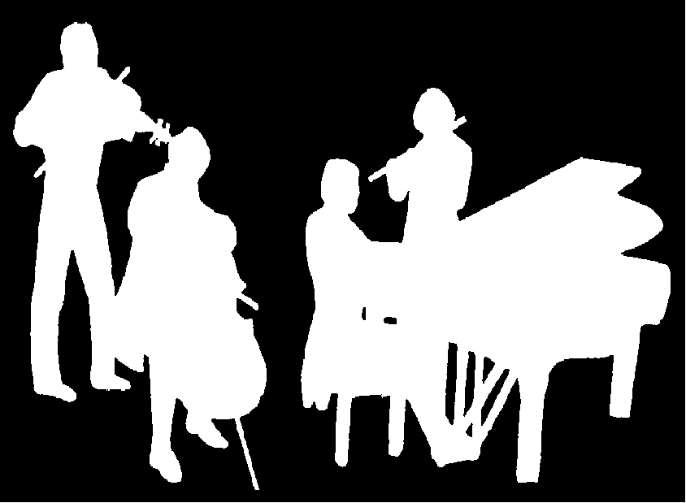
Kirribilli Neighbourhood Centre
16 Fitzroy St Kirribilli tel: 9922 4428
www.KNCsydney.org
Amateur Chamber Music Society
http://www.acms-australia.org/
Chamber Music Concert
5pm Sunday 1 April 2012
16 Fitzroy St Kirribilli

5pm

