Amateur Chamber Music Society Inc

— Concert —
— Program —

Mozart Violin Sonata in Bb, K.372
(fragment; completed by M. Stadler)
Chopin Nocturne Op. 9 No. 2 (arr. Stokes)
Haydn Trio in Eb Hob. XV:10 (arr. Stokes)
Allegro Moderato - Presto

— Interval —
Brahms Sonata No.3 in D Minor Op. 108
Allegro
Adagio
Un poco presto e con sentimento
Presto agitato

Piazzolla Café 1930 (from Histoire Du Tango)
Eesperé Significatio

— REFRESHMENTS (Concert concludes around 6:30pm ) —
Concert Organiser: Nick Stokes
The manager and volunteer staff of the
Kirribilli Neighbourhood Centre
provide light refreshments.
Entry by donation ($10 or $5 concession) - proceeds to the KNC.
- Notes -
Mozart (1756 – 1791) Born Salzburg.
This single movement piece one of many unfinished Mozart works. Completed by Mozart’s friend, Maximilian Stadler.
Today played by Mick and Kian.
Chopin (1810 – 1849) Polish composer.
This short piece one of his most loved tunes. Performed today by Sally and Nick.
Haydn (1732 – 1809) Austrian composer.
This work composed 1785 as part of a commission from his publisher. One of around 40 surviving piano trios. Arranged for modern instruments by Nick Stokes 2012.
Brahms (1833 – 1897) German composer.
This sonata is the last of Brahms’ three violin sonatas. Completed by 1887. Today played by Tracey and Benjamin
Piazzolla (1921 – 1992) Argentinian composer and master of the bandoneón.
This piece part of a set of four pieces representing the development of tango music over the last 100 years.
Played today by Vania & Nick.
Eesperé (1953 - ) Estonian composer.
Studied with Aram Khachaturian. Very much active today producing music with a spiritual dimension.
This final piece played by Vania, Nick & Debra

- Players –
Michael Goldstein – violin
Kian Woo – piano
Sally Cousins - flute
Nick Stokes - guitar
Stephen Harvey – viola
Tracey Tsang – violin
Benjamin Chan - piano
Vania Chan - violin
Debra Leong - cello

For information on future concerts, go to
http://www.acms-australia.org/concerts/.
All chamber music players are welcome to join the Amateur Chamber Music Society. If interested, go to acms-australia.org, click on “Join Us”, download an application form and post to ACMS Membership Secretary, PO Box 584, Balgowlah NSW 2093.

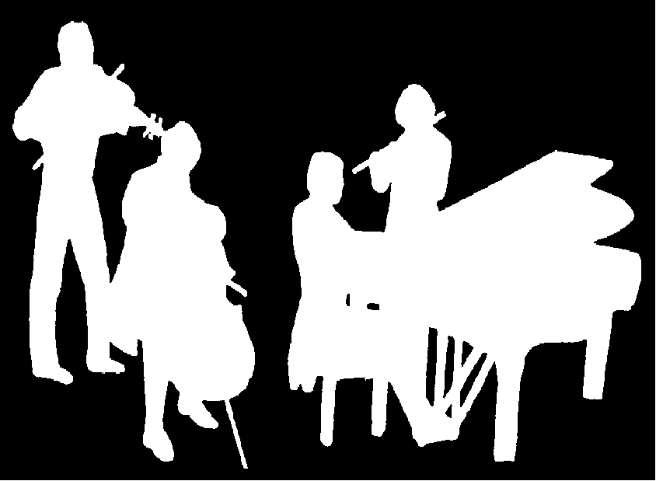
A Concert of Chamber Music
5pm Sunday 5 August 2012
16 Fitzroy St Kirribilli
Kirribilli Neighbourhood Centre
16 Fitzroy St Kirribilli tel: 9922 4428
www.KNCsydney.org
Amateur Chamber Music Society
http://www.acms-australia.org/

5pm

