Amateur Chamber Music Society Inc

— Concert Program —
GOUNOD Le Soir
soprano Susan Butler horn Paula Stokes piano Jane Smith
6'
QUILTER Folk Song Arrangements Part One
(1) Over the Mountains (2) Drink to me Only
(3) My Lady's Garden (4) Ye Banks and Braes
soprano Christine Middleton piano Jane Smith
10'
FARKAS Hungarian Dances from the 17th Century
(1) Intrada (2) Slow dance (3) Shoulder-blade dance
(4) Chorea (5) Saltarello
flute Jim Ranieri oboe Tony Tenney clarinet Paul Williamson
horn Lesley Saddington bassoon Dawn Nettheim
11’
DEBUSSY/ANDINO Songs
(1) Beau Soir (Bourget) (2) Fleur des Bles (Girod)
(3) Mandoline (Verlaine)
soprano Susan Butler flute Richard Tardif
viola Sue Khouri cello Jane Smith
10’
— Interval —
Folk Song Arrangements Part Two
QUILTER (5) The Jolly Miller (6) Ca' the yowes te the Knowes (7) The Ash Grove (8) BRITTEN The Salley Gardens
10'
RAVEL/JONES excerpts from Le Tombeau de Couperin
(1) Prelude (2) Fugue (5) Menuet (4) Rigaudon
flute Richard Tardif oboe Freya Bailes clarinet Lindsay Wanstall horn Paula Stokes bassoon Petrina Slaytor
15’
— REFRESHMENTS —
Concert Organiser: Richard Tardif
The manager and volunteer staff of the
Kirribilli Neighbourhood Centre
provide light refreshments (wine, juice, fruit and savouries) and
charge $10 entry ($5 concession/seniors) to cover costs and to
raise funds for the Centre
- Notes –
FARKAS Early Hungarian Dances
Ferenc Farkas [1905 – 2000] was a 20th Century Hungarian composer, conductor and Professor of Composition at the Franz Liszt Academy in Budapest. He studied with Respighi in Rome. Farkas’s 700 works include orchestral music, chamber music, solo music for a wide range of string, woodwind, brass and keyboard instruments as well as music for film and stage.
RAVEL/JONES excerpts from Le Tombeau de Couperin
While the word-for-word meaning of the title invites the assumption that the suite is a programmatic work, describing what is seen and felt in a visit to the tomb of Couperin, tombeau is actually a musical term popular in the 17th century and meaning "a piece written as a memorial".
The specific Couperin (among a family noted as musicians for about two centuries) that Ravel intended to be evoked, along with the friends, would presumably be François Couperin "the Great" (1668-1733). However, Ravel stated that his intention was never to imitate or tribute Couperin himself, but rather was to pay homageto the sensibilities of the Baroque French keyboard suite. This is reflected in the structure which imitates a Baroque dance suite. Ravel's neoclassicism shines through with his pointedly twentieth-century chromatic melody and piquant harmonies.
When criticised for composing a light-hearted, and sometimes reflective work rather than a sombre one, for such a sombre topic, Ravel replied: "The dead are sad enough, in their eternal silence." [Wikipedia]

For GOUNOD Le Soir, PTO. For QUILTER and BRITTEN Folk Song Arrangements and DEBUSSY Songs, please see attachment.
GOUNOD Le Soir
(Lamartine 1790-1869)
Le Soir
Le soir ramène le silence.  Assis sur ces rochers déserts,  Je suis dans le vague des airs  Le char de la nuit qui s'avance. | The evening brings back silence.  Seated on these deserted rocks,  I am in the waves of breeze from  The chariot of the advancing night.
Vénus se lève à l'horizon;  À mes pieds l'étoile amoureuse  De sa lueur mystérieuse  Blanchit les tapis de gazon. | Venus rises on the horizon;  At my feet, the amorous star  In its mysterious glitter  The carpet of grass pales.
Tout à coup détaché de cieux,  Un rayon de l'astre nocturne,  Glissant sur mon front taciturne,  Vient mollement toucher mes yeux. | Suddenly, a ray of light detaches  From the nocturnal star,  It slides over my silent forehead,  And comes to softly touch my eyes.
Doux reflet d'une globe de flamme,  Charmant rayon que me veux-tu?  Viens-tu dans mon sein abattu  Porter la lumière à mon âme? | Soft reflection of that fiery sphere,  Charming ray, what do you want of me?  Have you come to my battered breast  To bring light to my soul?
Descends-tu pour me révéler  Des mondes le divin mystère?  Ces secrets cachés dans la sphère  Où le jour va te rappeler? | Have you descended to reveal to me  Worlds of divine mystery?  These secrets hidden in the sphere  Where the day goes to recall you?
Viens-tu dévoiler l'avenir  Au coeur fatigué qui t'implore?  Rayon divin, es-tu l'aurore  Du jour qui ne doit pas finir? | Have you come to unveil the future  To the tired heart which implores you?  Divine ray, are you the dawn  Of the day which never has to end?

For information on future concerts, go to the website
http://www.acms-australia.org/ and click on “Concerts” in Navigation panel on the left hand side.
All chamber music players are welcome to join the Amateur Chamber Music Society. If interested, go to the website, click on “Join Us”, download an application form and post to ACMS Membership Secretary, PO Box 584, Balgowlah NSW 2093.

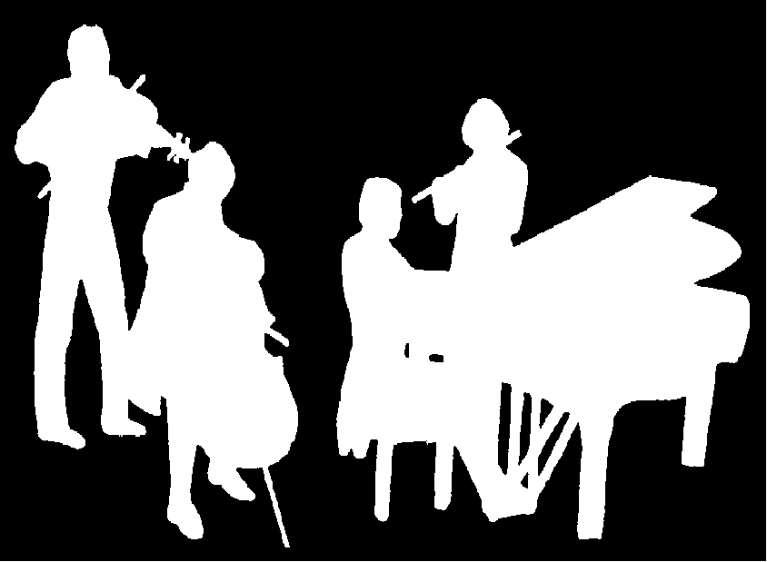
Kirribilli Neighbourhood Centre
16 Fitzroy St Kirribilli tel: 9922 4428
www.KNCsydney.org
Amateur Chamber Music Society
http://www.acms-australia.org/
Chamber Music Concert
5pm Sunday 1 July 2012
16 Fitzroy St Kirribilli

5pm

