Amateur Chamber Music Society Inc

— Concert —
— Program —
BEETHOVEN String Quartet Op18 No2
(1) Allegro (2) Adagio cantabile
(3) Scherzo - Allegro (4) Allegro molto quasi presto
violins Jenny Allison and Judy Mitchell
viola Eve Salinas cello Anne Stevens
25’
BEETHOVEN Sonata in F major Op24 "Spring"
(1) Allegro (2) Adagio molto espressivo
(3) Scherzo - Allegro molto (4) Rondo: Allegro ma non troppo
violin George Carrard and piano Murray Brown
21’
— Interval —
SHOSTAKOVICH Piano Quintet in G Minor Op57
(1) Prelude: Lento (2) Fugue: Adagio (3) Scherzo: Allegretto
(4) Intermezzo: Lento (5) Finale: Allegretto
violins Jenny Allison and Marjery Sherman viola Barbara Robinson
cello Jane Smith piano Marjorie Hystek
30’
— Supper —
Concert Organiser: George Carrard
The manager and volunteer staff of the
Kirribilli Neighbourhood Centre
provide supper (wine, juice, fruit and savouries) and
charge $10 entry ($5 concession/seniors) to cover costs
and to raise funds for the Centre
- Background Notes -

For information on future concerts, go to the website
http://www.acms-australia.org/ and click on “Concerts” in Navigation panel on the left hand side.
All chamber music players are welcome to join the Amateur Chamber Music Society. If interested, go to the website, click on “Join Us”, download an application form and post to ACMS Membership Secretary, PO Box 584, Balgowlah NSW 2093.

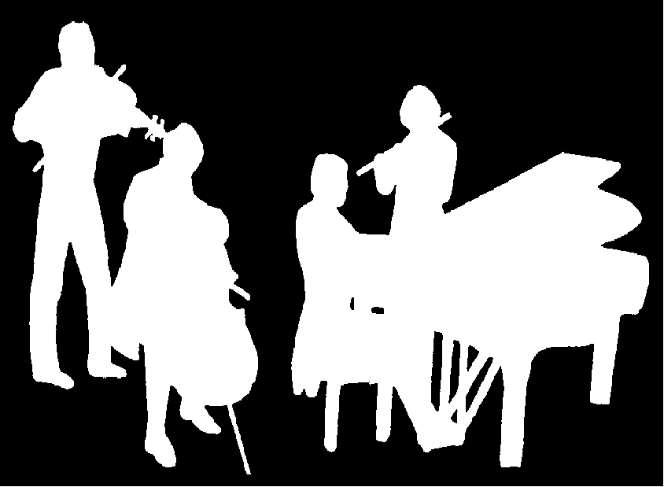
Kirribilli Neighbourhood Centre
16 Fitzroy St Kirribilli tel: 9922 4428
www.KNCsydney.org
Amateur Chamber Music Society
http://www.acms-australia.org/
Chamber Music Concert
5pm Sunday 3 June 2012
16 Fitzroy St Kirribilli

5pm

