Amateur Chamber Music Society Inc
http://www.acms-australia.org/sydney/

— Concert —
5pm Sunday 4 March 2012(first Sunday in March)
Kirribilli Neighbourhood Centre, 16 Fitzroy St Kirribilli
www.KNCsydney.org tel: 9922 4428
— Program —
SCHUBERT String Quartet in G minor OpPosth D173
(1) Allegro con brio (2) Andantino (3) Menuetto - Allegro vivace - and Trio (4) Allegro
violins Inge Courtney-Haentjes and Daniel Bangert
viola Michelle Urquhart cello Steve Meyer
30’
SCHUBERT The Shepherd on the Rock D965
soprano Susan Butler clarinet Lindsay Wanstall piano Ji-Hyun Kim
11’
— Interval —
MOZART Duo in G major K423
(1) Allegro (2 )Adagio (3) Rondo: Allegro
violin Inge Courtney-Haentjes viola Michelle Urquhart
18’
PIAZZOLLA OR OTHER Title
xx movements
violin Inge Courtney-Haentjes piano Anita Zielonka
SPIKE Summer Waltz
flute Peter Scaysbrook clarinet Lindsay Wanstall piano Kris Spike

— Supper —
concert organiser Tony Tenney
The manager and volunteer staff of the Kirribilli Neighbourhood Centre provide supper
(wine juice and savouries) and charge $10 entry donation ($5 concession/seniors)
to cover costs and to raise funds for the Centre.

To get information on future concerts,
(1) go to http://www.acms-australia.org/sydney/
or Google “ACMS chamber music society Australia”
(2) click on “Concerts” in the navigation panel
(3) click on “Concert Programs”, choose date and click on “program”.
All chamber music players are welcome to join the
Amateur Chamber Music Society. If interested, write to
membership@acms-sydney.org
or ACMS Membership Secretary, PO Box 584, Balgowlah NSW 209

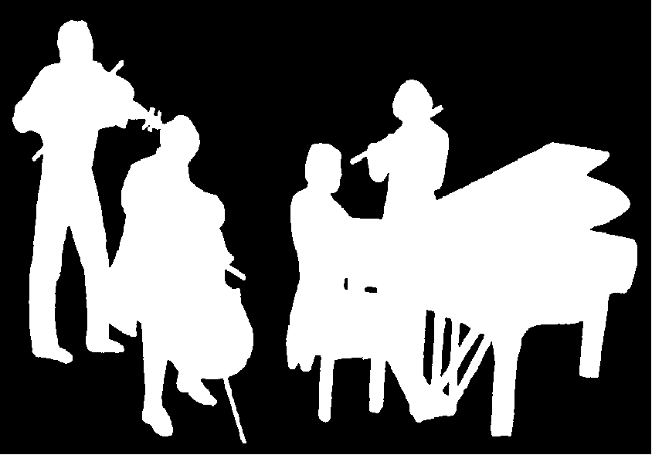
Kirribilli Neighbourhood Centre
www.KNCsydney.org
Amateur Chamber Music Society
http://www.acms-australia.org/
Chamber Music Concert
Sunday 4 March 2012
5pm

