Members of the Amateur Chamber Music Society
present

— Concert —
— Program —
SPIKE Thank You Jack Mundey
flute Cathy Wainwright clarinet Lindsay Wanstall
violin Inge Courtney-Haentjes piano Kris Spike
5’
KATS-CHERNIN Russian Rag
violin Inge Courtney-Haentjes piano Kris Spike
4’
SCHUBERT String Quartet in G Minor Op.Posth D173
(1) Allegro con brio (2) Andantino
(3) Menuetto - Allegro vivace - Trio (4) Allegro
violins Inge Courtney-Haentjes and Daniel Bangert
viola Michelle Urquhart cello Steve Meyer
30’
— Interval —
MOZART Duo in G major K423
(1) Allegro (2 )Adagio (3) Rondo: Allegro
violin Inge Courtney-Haentjes viola Michelle Urquhart
18’
WEBSTER Rhapsody based on Themes from
Bizet’s Carmen
flute Richard Tardif clarinet Lindsay Wanstall piano Ji-Hyun Kim
20’
PIAZZOLA Chiquilin
violin Inge Courtney-Haentjes piano Steve Meyer
KHACHATURIAN Trio (1932)
(1) Andante con dolore - con molto espressione (2) Allegro
(3) Moderato-Presto
clarinet Lindsay Wanstall violin Inge Courtney-Haentjes
piano Kris Spike
15’
– Background Notes –
SPIKE Thank You Jack Mundey
Jack Mundey was a union official who was responsible for saving many beautiful inner Sydney buildings and neighbourhoods from demolition in the 1970s. At the time he was regarded by many people as a villain who was using union power inappropriately to stand in the way of progress but his achievements have now been widely recognised by governments, business and community groups. There is even a street named after Jack in the Rocks and a plaque with a photo showing him being carried away by the police. The power of unions has long since been eroded and it is hard to imagine such a campaign being successful today. Developers once again have free reign and the only thing standing in their way is people of good will and commitment.
SCHUBERT (1797-1828) String Quartet in G Minor Op.Posth D173
This quartet was written when Schubert was 18 but published after his death. It is therefore still following a classical model in the clarity of its structure and style of the movements but nevertheless displays great originality. He wrote the quartet in a week, beginning the day after he completed his second symphony. It is an irony that Schubert died in the year that might have been the turning point in his life as a composer and that his reputation flourished after his death. Publishers who had been unwilling to take the risk of a new composer in Schubert’s lifetime were anxious to find any unpublished unplayed music of which there was a quantity, including this quartet.
Michael WEBSTER (1944 - ) Rhapsody based on themes from Bizet’s Carmen (1990)
Although the combination of a flute, clarinet and piano produces some wonderful sounds, composition for this trio is uncommon. It is presumably for this reason, that the American clarinettist Michael Webster transcribed several works for this group in order to play with his professional flautist wife. This work was arranged in 1990, and is an exciting blend of various themes from Bizet’s famous opera Carmen.
KHACHATURIAN (1903-1978) Trio for Clarinet, Violin and Piano (1932)
Khachaturian was born in Georgia of Armenian parents in 1903 and, aged 18, travelled to Moscow where he learned Russian and began his musical studies as a cellist. Later he entered the Moscow Conservatory, studied composition and, two years before graduating, when he was 29, wrote his Trio for Clarinet, Violin and Piano, which impressed his teachers, including Prokofiev, who arranged a performance in Paris.
The Trio has complex interplays of the three instruments often doing quite different things simultaneously over and above their contrasting sounds, yet amazingly fitting together. The first movement is beautiful, lyrical overlaid with arabesque embellishments that give it a relaxed oriental mood. The second movement opens with a scherzo-like section, presents a second subject that develops into a frenzy before being recast into a grand declamation, and ends with a repeat of the opening bars. The final movement is very folksy and great fun; it opens with a simple Uzbek melody, followed by a section similar to Khachaturian's famous Sabre Dance, followed by a banquet of highly inventive variations on the opening theme, culminating in an exciting presto before coming to rest with a quiet ending.

Amateur Chamber Music Society
Based in Sydney, ACMS brings Amateur Musicians from all over Australia to play Chamber Music for the enjoyment that such playing brings. If you would like to explore the chamber music repertoire, then take advantage of a society that facilitates the organisation of ensembles by providing music, venues and contacts with like-minded amateur musicians. Contact: www.acms-australia.org

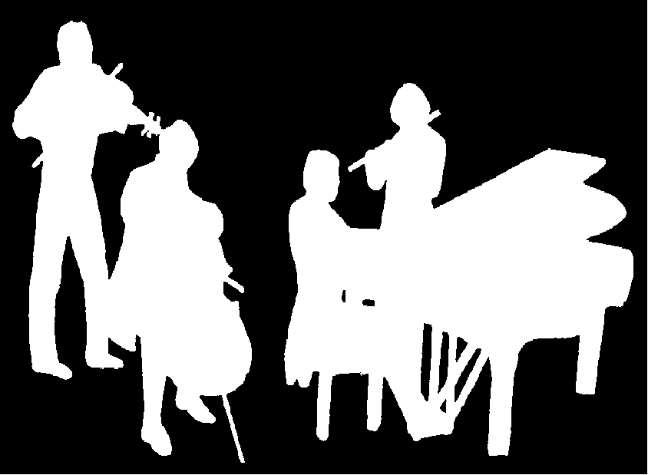
Independent Theatre
http://theindependent.org.au/
Amateur Chamber Music Society
http://www.acms-australia.org/
Chamber Music Concert
2pm Sunday 13 May 2012
269 Miller Street North Sydney

