Amateur Chamber Music Society Inc
http://www.acms-australia.org

— Concert —
5pm Sunday 4 November 2012 (first Sunday in November)
Kirribilli Neighbourhood Centre, 16 Fitzroy St Kirribilli
www.KNCsydney.org tel: 9922 4428

— ProgramME —
FAURÉ Piano Quartet Op.15
(1) Allegro molto moderato (2) Scherzo: Allegro vivo (3) Adagio (4) Allegro molto
violin Jonathan Ell viola Barbara Robinson
cello David Oldroyd piano Christine Edwards
MÜLLER Wind Quintet No.1 in E flat
(1) Larghetto–Allegro (2) Scherzo (3) Larghetto (4) Allegro molto
flute Richard Tardif oboe Tony Tenney clarinet Peter Scaysbrook
horn Lynelle Gullick bassoon Graham Cormack
— INTERVAL —
MENDELSSOHN Piano Trio No.1 in D minor Op.49 First Movement
Molto allegro ed agitato
violin Tracey Tsang cello George Hobbs piano Benjamin Chan
BEETHOVEN Piano Trio Movement in B flat major WoO-39
Allegretto
violin Vania Chan cello David Oldroyd piano Ji-Hyun Kim
HAYDN Piano Trio in G major (Zigeunertrio) Hob XV:25
(1) Allegretto Andante (2) Poco adagio (3) Finale (‘Rondo in the gypsies style’)
violin Vania Chan cello David Oldroyd piano Ji-Hyun Kim
— REFRESHMENTS —
Concert Organiser: David Oldroyd
The manager and volunteer staff of the Kirribilli Neighbourhood Centre provide light refreshments
(wine juice fruit cheese biscuits) and charge $10 entry donation ($5 concession/seniors)
to cover costs and to raise funds for the Centre.

- Note on MÜLLER -
Peter Müller was born on July 28th, 1791 in Kesselstadt near Hanau not far from Frankfurt/Main and died on September 29th, 1877 as the parish priest of Staden in Langen. He studied at the Heidelberg University, became a teacher in Giessen, rector in Gladenbach and a leading music teacher at the seminary in Friedberg. There has been a monument to him since 1889. He wrote music for male choirs, preludes for organ, two string quartets and his well known lieder for youth. He moved to Staden in 1839, where he wrote five quintets and performed several times in Damstadt. His opera "The last days of Pompei" premiered on December 27th, 1853. Muller left many unpublished lieder, a string quartet and another opera, "Claudine von Villa bella" to texts from J.W.v. Goethe. Karl Schmidt published three Wind Quintets, which he had left as manuscripts. The first of these is performed today. (Source: Riemann: Musik-Lexikon)

To get information on future concerts,
(1) go to http://www.acms-australia.org/sydney/
or Google “ACMS chamber music society Australia”
(2) click on “Concerts” in the navigation panel
(3) click on “Concert Programs”, choose date and click on “program”.
All chamber music players are welcome to join the
Amateur Chamber Music Society. If interested, write to
membership@acms-sydney.org
or ACMS Membership Secretary, PO Box 584, Balgowlah NSW 209

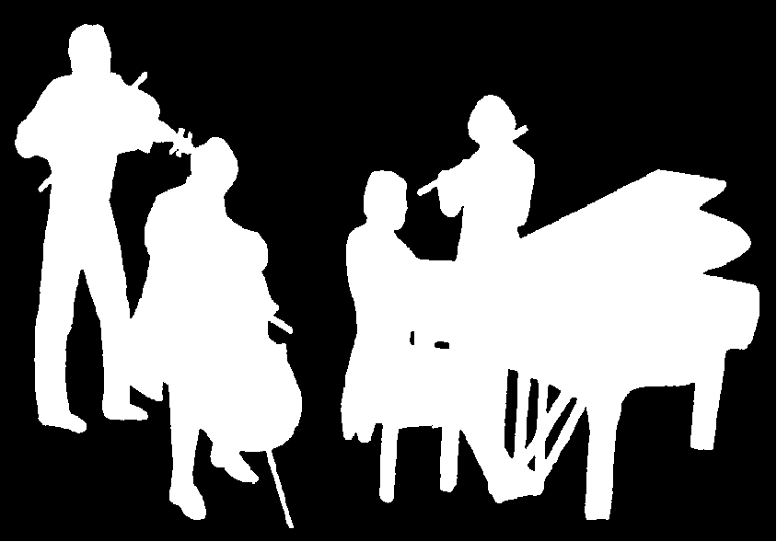
Kirribilli Neighbourhood Centre
www.KNCsydney.org
Amateur Chamber Music Society
http://www.acms-australia.org/
Chamber Music Concert
Sunday 4 November 2012
5pm

