Amateur Chamber Music Society
http://www.acms-australia.org/sydney/
— Concert —
5pm Sunday 7 October 2012 (first Sunday in October)
Kirribilli Neighbourhood Centre, 16 Fitzroy St Kirribilli
www.KNCsydney.org tel: 9922 4428
— Program —
Mainly Schubert
SCHUBERT Impromptu in G flat Op90 No3
piano Murray Brown
xx’
SCHUBERT Four Lieder
(1) xx (2) xx (3) xx (4) xx
mezzo-soprano Jo Burton piano Murray Brown
xx’
— Interval —
SCHUBERT Trio No 2 in E-flat Op100 D979
A selection from the four movements:
(1) Allegro (2) Andante con moto (3) Scherzando (4) Allegro moderato
violin George Carrard cello Robyn Godfrey piano Murray Brown
xx’
— refreshments —
concert organiser Murray Brown
The manager and volunteer staff of the Kirribilli Neighbourhood Centre provide light refreshments (wine juice and savouries) and charge $10 entry donation ($5 concession/seniors)
to cover costs and to raise funds for the Centre
Program Notes
SCHUBERT xx
xx

To get information on future concerts,
(1) go to http://www.acms-australia.org/sydney/
or Google “ACMS chamber music society Australia”
(2) click on “Concerts” in the navigation panel
(3) click on “Concert Programs”, choose date and click on “program”.
All chamber music players are welcome to join the
Amateur Chamber Music Society. If interested, write to
membership@acms-sydney.org
or ACMS Membership Secretary, PO Box 584, Balgowlah NSW 209

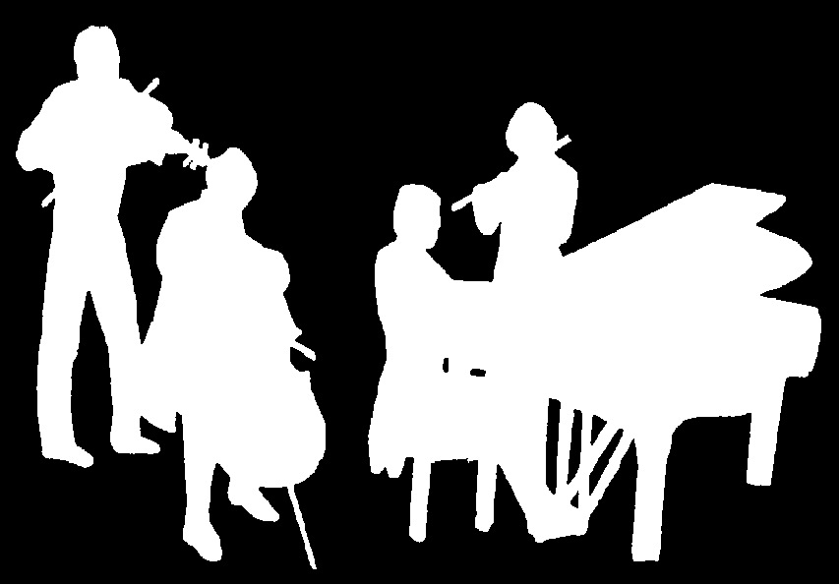
Kirribilli Neighbourhood Centre
www.KNCsydney.org
Amateur Chamber Music Society
http://www.acms-australia.org/
Chamber Music Concert
Sunday 7 October 2012
5pm

