Amateur Chamber Music Society Inc
http://www.acms-australia.org

— Concert —
5pm Sunday 2 September2012 (first Sunday in September)
Kirribilli Neighbourhood Centre, 16 Fitzroy St Kirribilli
www.KNCsydney.org tel: 9922 4428

— Program —
DEBUSSY Movements from Trio in G major
(1) Andantino con moto allegro (3) Andante espressivo
violin Vincent Allen cello Robyn Mansfield piano Kian Woo

Music for Four Clarinets
including DEBUSSY Danse Paul CARR English Post Card
clarinets Andrew Cousins Carolyn LaMotte David LaMotte Peter Scaysbrook
— Interval —
BRAHMS Movements from Sonata in F minor Op120 No1
(3) Allegretto grazioso (4) Vivace
clarinet Andrew Kennedy piano Kris Spike
MARTINU Trio H254
(1) Allegro poco moderato (2) Adagio (3) Allegretto (4) Moderato (poco allegro)
flute Prue Page violin Margery Sherman piano Murray Brown
— REFRESHMENTS —
Concert Organiser: Prue Page
The manager and volunteer staff of the Kirribilli Neighbourhood Centre provide light refreshments
(wine juice fruit cheese biscuits) and charge $10 entry donation ($5 concession/seniors)
to cover costs and to raise funds for the Centre.

To get information on future concerts,
(1) go to http://www.acms-australia.org/sydney/
or Google “ACMS chamber music society Australia”
(2) click on “Concerts” in the navigation panel
(3) click on “Concert Programs”, choose date and click on “program”.
All chamber music players are welcome to join the
Amateur Chamber Music Society. If interested, write to
membership@acms-sydney.org
or ACMS Membership Secretary, PO Box 584, Balgowlah NSW 209

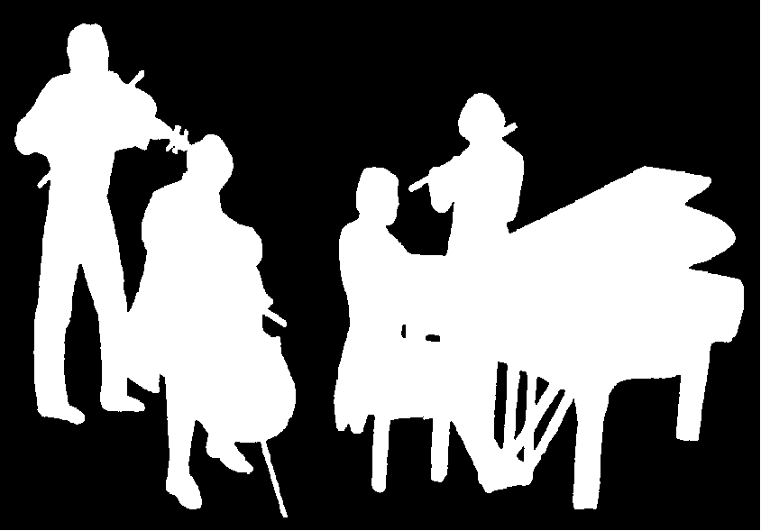
Kirribilli Neighbourhood Centre
www.KNCsydney.org
Amateur Chamber Music Society
http://www.acms-australia.org/
Chamber Music Concert
Sunday 2 September 2012
5pm

