Amateur Chamber Music Society
http://www.acms-australia.org/sydney/
— Concert —
5pm Sunday 7 April 2013 (first Sunday in April)
Kirribilli Neighbourhood Centre, 16 Fitzroy St Kirribilli
www.KNCsydney.org tel: 9922 4428
— PROGRAM —
MENDELSSOHN Sonata in F major (1838)
(1) Allegro vivace (2) Adagio (3) Assai vivace
violin George Carrard piano Christine Edwards
25’
BEETHOVEN Adagio Grazioso from Sonata No16 in G Op31 No1
piano Ivan Foo
13’
— Interval —
MARTINU Trio H300 (1944)
(1) Poco allegretto (2) Adagio
(3) Andante - Allegretto scherzando
flute Richard Tardif cello Robyn Godfrey
piano Kian Woo
21
LISZT Un Sospiro (A Sigh)
piano Ivan Foo
7’
— refreshments —
concert organiser George Carrard
The manager and volunteer staff of the Kirribilli Neighbourhood Centre provide light refreshments (wine juice and savouries) and charge $10 entry donation ($5 concession/seniors)
to cover costs and to raise funds for the Centre
- Notes -
MENDELSSOHN (1809-1847) Violin Sonata in F major (1838)
Felix Mendelssohn was born in Hamburg, Germany, into a distinguished and affluent family of bankers, intellectuals and artists. A child prodigy, he published a piano quartet Op1, with a beautiful slow movement, written when he was thirteen years old. By fourteen he had written 12 sinfonias for strings – one of which was recently recorded by the Australian Chamber Orchestra. At 17 he was in his third year at Berlin University studying philosophy under Hegel and publishing his much loved Overture to Midsummer Nights Dream. A constant stream of work continued throughout his relatively short and very busy life of 38 years. At 26, he moved to Leipzig to take charge of the Gewandhaus Orchestra. There, he met the 25-year-old Schumann, whose family lived there, and they became friends. Seven years later, Mendelssohn helped Schumann with a revision of the scherzo of his celebrated piano quintet. As Gewandhaus director, Mendelssohn championed both historical and modern works - of the former he is particularly well known for reviving interest in the music of Bach.
At 29, he wrote his Sonata in F Major (1838) to be presented today. Mendelssohn did not publish it and it has no opus number, so it is usually defined by the date. Famous violinist Yehudi Menuhin was given a photostat copy of the original manuscript, performed it in 1952 and had it published. No evidence has been found that this sonata was ever played before Menuhin’s “premiere”, except perhaps by Mendelssohn and a friend (or family member) in the year it was written. It was in 1838 that Mendelssohn started work on his famous violin concerto, which he completed six years later. Did Mendelssohn keep the sonata from publication in case he wanted to use some of the ideas in his concerto? In the event there are a few similarities between the concerto and the sonata.
The sonata is an extremely ambitious work, concerto-like for both instruments while remaining true to the form. The result is both coherent and exhilarating. The first movement, Allegro vivace, is fraught with drama from the beginning. The piano begins with a statement of dotted-rhythm sequences moving up. Then the violin takes over the melody while the piano ripples. The two climb and fall as they trade melody and accompaniment back and forth. A reflective Adagio follows. Mendelssohn led a very busy life and busyness is a word that comes to mind especially when playing the last movement Assai vivace – the music scurries along – there is hardly time to breathe!
There are passages in this work that are reminiscent of the sequences of modulations characteristic of Bach.
BEETHOVEN Adagio Grazioso from Sonata No16 in G Op31 No1
Although marked Adagio, (slow tempo), Beethoven embellishes his slow opening theme with variations, which keep the listener wondering what is going to happen next. As usual, what Beethoven does next is just right.
MARTINU Trio H300 (1944)
Martinu has been justly hailed as one of the outstanding Czech composers of the 20th Century. He was a prolific composer, who worked in most of the musical genres; opera, ballet, the symphony, the concerto, choral music, as well as chamber music for various combinations of instruments. Though he drew inspiration from the folk music of the Czech countryside, Bohemia and Moravia, he was cosmopolitan and influenced by the music of Stravinsky and contemporary French composers. His music is marked by simplicity, directness and clarity, as well as a rhythmic drive both athletic and vivacious.
The Trio in F, one of the few of his compositions that he assigned a key signature, was composed in America in 1944. This three-movement work is notable for a wonderful exploitation of tone colour. The opening movement is sprightly, in the French neo-classic manner, yet with hints of Czech folk music. The second movement, an adagio in C minor, is a serene, meditative work in 6/4 time. The third movement opens with a slow solo by the flute, which then perks up and is joined by the other two instruments for a series of episodes in various tempi, textures and moods.

To get information on future concerts,
(1) go to http://www.acms-australia.org/sydney/
or Google “ACMS chamber music society Australia”
(2) click on “Concerts” in the navigation panel
(3) click on “Concert Programs”, choose date and click on “program”.
All chamber music players are welcome to join the
Amateur Chamber Music Society. If interested, write to
membership@acms-sydney.org
or ACMS Membership Secretary, PO Box 584, Balgowlah NSW 209

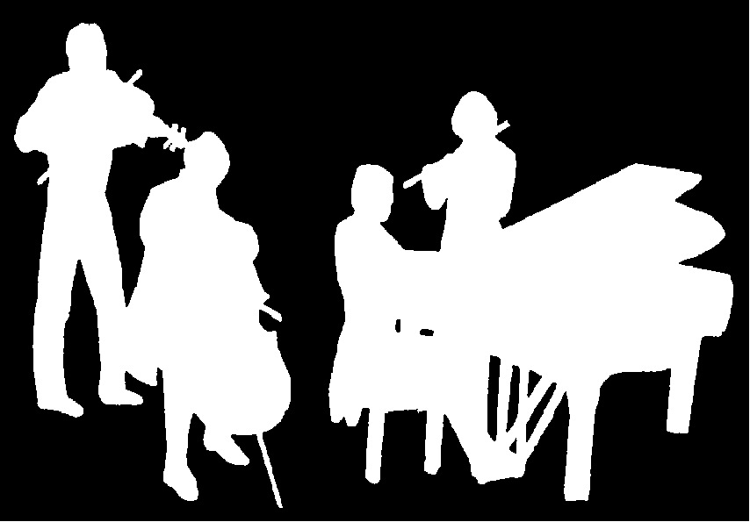
Kirribilli Neighbourhood Centre
www.KNCsydney.org
Amateur Chamber Music Society
http://www.acms-australia.org/
Chamber Music Concert
Sunday 7 April 2013
5pm

In 2009, to celebrate the 200th anniversary of Mendelssohn’s birth, a catalogue MWV (Musikalischen Werke Verzeichnis) was created and the sonata was given the number MWV Q26.
http://www.pristineclassical.com/LargeWorks/Chamber/PACM037.php, http://en.wikipedia.org/wiki/Felix_Mendelssohn, http://www.laphil.com/philpedia/music/violin-sonata-f-major-felix-mendelssohn.

