Amateur Chamber Music Society
http://www.acms-australia.org/sydney/
— Concert —
5pm Sunday 2 June 2013 (first Sunday in June)
Kirribilli Neighbourhood Centre, 16 Fitzroy St Kirribilli
www.KNCsydney.org tel: 9922 4428
— PROGRAMME —
MOZART String Quartet No.17 in B flat K.458 ‘The Hunt’
1. Allegro Vivace Assai
2. Menuetto e Trio
3. Adagio
4. Allegro Assai
Flute - Bruce Lane, Violin – Andrew Thornley
Viola – Marjorie Hystek, Cello – Lye Lin Ho
17”
DVORAK String Quartet No.12 in F major Op.96
‘The American’
- Allegro Ma Non Troppo
- Lento
- Molto Vivace
- Finale: Vivace ma non troppo
Violins – George Carrard, Sonja Mallam Viola – John Keller
Cello – Sharon Maennl
30’
— interval —
SCHUMANN Sonata No.2 in D minor for Violin and Piano Op.121
- Ziemlich Langsam – Lebhaft
- Sehr Lebhaft
- Leise, Einfach
- Bewegt
Violin – Tracey Tsang Piano – Ben Chan
35’
— refreshments —
Concert Organiser – Ben Chan
Programme Notes compiled by Ben Chan
The manager and volunteer staff of the Kirribilli Neighbourhood Centre provide light refreshments (wine juice and savouries) and charge $10 entry donation ($5 concession/seniors)
to cover costs and to raise funds for the Centre
- Programme Notes -
MOZART (1756-1791) String Quartet no.17 in B Flat K.458 “The Hunt”
This quartet belongs to a set of six dedicated to Josef Haydn, referred to as the Haydn Quartets. Although Mozart himself did not give this quartet nickname ‘Hunt’, it draws its name from its 6/8 theme in the first movement, which can be considered to replicate the sound of hunting horns. Playful and good-humoured, the first movement offers surprises in Mozart's creative use of sonata form. The first movement appears almost as a prelude to the two middle movements, which Greenberg believes are the most striking in the quartet. Mozart reverses the expected order of the middle movements, placing the Minuet before the slow movement, the Adagio. The quartet concludes with the Allegro Assai fourth movement, which reprises the cheerful mood of the first movement.
http://www.chambermusicwilliamsburg.org/fineartsNotes.html
DVORAK (1841-1904) String Quartet no.12 in F Op.96 ‘The American’
Dvorak composed his String Quartet No 12 “The American” in his 51st year in the summer of 1893, in Spillville, Iowa USA, where he had relatives. He was there on vacation from his teaching post in New York. It took him three days to write the quartet, but the ideas were probably developing in his mind over a much longer period. With his family (wife and six children) he had arrived in USA a year earlier, at the behest of an American philanthropist, and was to remain there for three years, during which time he greatly influenced American music, was homesick for his native Bohemia, but also produced some of his most famous works, including the Symphony No 9 “From the New World”, the Cello Concerto and of course the “American Quartet”.
The first movement has a quality of simplicity and openness with elements from American and Bohemian folk music. Some have claimed that the theme of the second movement is based on a Negro spiritual, or perhaps on a Kickapoo Indian tune, which Dvorak heard during his sojourn in Iowa. The first violin high entry in the third movement is remarkably similar to an entry that Dvorak made in his notebook (which he always carried) of a bird call, that of the Scarlet Tanager, which he would have heard while fishing in the river near Spillville. The fourth movement of the quartet is reminiscent of the sounds of the railways, which fascinated Dvorak throughout his life.
http://en.wikipedia.org/wiki/String_Quartet_No._12_(Dvo%C5%99%C3%A1k) http://www.classicfm.com/composers/dvorak/guides/antonin-dvorak-trainspotter/

SCHUMANN (1810-1856) Sonata no.2 in D Minor for Violin and Piano Op.121
This work was written in about one week, as a response to Schumann’s lack of enthusiasm for his recent Violin Sonata No.1 in A minor composed immediately prior. The first movement Ziemlich Langsam - Lebhaft (slowly, then lively) is blustery and begins with an introduction in a triple beat then shifts to a lively tempo marking, although mood can be better described as tempestuous with constant dialogue and competition between the two instruments for thematic material. The second movement Sehr Lebhaft (very animated) is in 6/8, with the piano taking the lead, except in the contrasting trio. The third movement Leise, Einfach (simply) includes pizzicato triple-stops, where the violin takes the lead, firstly with a simple pizzicato melody, which develops into a beautiful double stop melody. The fourth movement Bewegt (moving along) is quite fast, with the two instruments again competing for the thematic material. The development explores fairly distant harmonic areas, as well as contrasting textural approaches, but the work ends forcefully.
http://www.allmusic.com/composition/sonata-for-violin-piano-no-2-in-d-minor-op-121-mc0002365802

To get information on future concerts
go to http://www.acms-australia.org/sydney/
(or Google “ACMS chamber music society Australia”)
and click on “Concerts” in the navigation panel

All chamber music players are welcome to join the
Amateur Chamber Music Society. If interested, write to
membership@acms-sydney.org
or to ACMS Membership Secretary, PO Box 584, Balgowlah NSW 2093

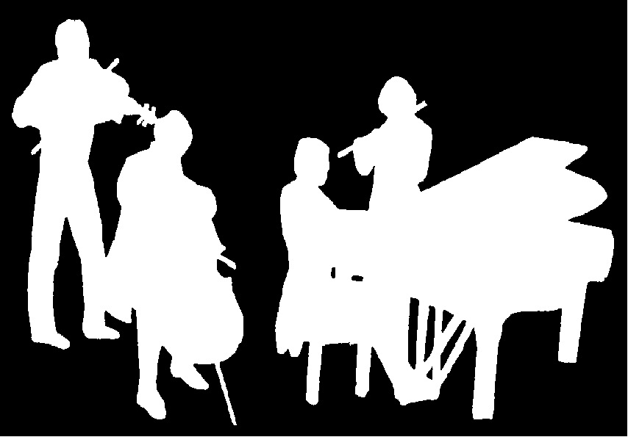
Amateur Chamber Music Society
http://www.acms-australia.org/
at the
Kirribilli Neighbourhood Centre
16 Fitzroy St Kirribilli
Chamber Music Concert
Sunday 2 June 2013
5pm

