Amateur Chamber Music Society
http://www.acms-australia.org/sydney/
— Concert —
5pm Sunday 3 March 2013 (first Sunday in March)
Kirribilli Neighbourhood Centre, 16 Fitzroy St Kirribilli
www.KNCsydney.org tel: 9922 4428
— PROGRAM —
HAYDN Quartet in C major Op20 No2 HobIII:32
(1) Moderato (2) Capriccio: Adagio (3) Minuet: Allegretto
(4) Fuga a quattro soggetti
violins Jenny Allison and Judy Mitchell
viola Eve Salinas cello Anne Stevens
25’
SPIKE Arabesque
flute Prue Page piano Kris Spike
7’
John CARMICHAEL Thredbo Suite (2006)
(1) Air From the High Mountain (2) Nocturne (3) Sleigh Ride to Thredbo
piano Sue Butler flute Richard Tardif
clarinet Lindsay Wanstall
10’
⎯INTERVAL⎯
SHOSTAKOVICH Two Pieces for String Quartet Op36 (1931)
(1) Elegie (2) Polka
violins Sheila Fitzpatrick and Regula Scheidegger
viola Marjorie Hystek cello Jane Smith
10’
DEBUSSY Petite Suite
(1) En Bateau (2) Cortege (3) Menuet (4) Ballet
piano Sue Butler flute Richard Tardif
clarinet Lindsay Wanstall
15’
—refreshments—
concert organiser Jane Smith
The manager and volunteer staff of the Kirribilli Neighbourhood Centre provide light refreshments (wine juice and savouries) and charge $10 entry donation ($5 concession/seniors) to cover costs and to raise funds for the Centre

- Notes -
John CARMICHAEL (1930-) Thredbo Suite (2006)
John Carmichael is an Australian pianist, composer and musical therapist who has long been resident in the United Kingdom. One of his best known works is Concierto Folklorico for piano and string orchestra. His works for piano form much of his musical output, although he composes for many other instruments. His work is described as expressive and lyrical. He composed his Thredbo Suite for flute and piano in 1980 and published a version with the addition of the clarinet in 2006.
It is in three movements. The first, Air from the High Mountain, features a simple melody which is shared between all three instruments. The second movement, Nocturne, is slower and dreamier. The final movement, Sleigh ride to Thredbo, is a lively march. The suite is on a recording by James Galway released in 1988.
DEBUSSY Petite Suite
Debussy's Petite Suite began as a piece for piano, four hands. It has since been frequently arranged, for orchestra and various chamber ensembles, and is much loved as one of Debussy's most appealingly melodic short pieces. In its original form, Petite Suite was first performed on 2 February 1889 by Debussy in collaboration with the pianist-publisher Jacques Durand.
The work has a simple lyricism that contrasts with much of the composer's music from the late 1880's, which was marked by trend-setting harmonies and colours that drew the wrath of contemporary critics for being "too modernistic." The piece in any case is designed to entertain and delight.
There are four separate movements. En bateau, or "In a Boat," the first movement, has an exquisite melody that is accompanied by broken chords that clearly suggest ripples, eddies, and whirlpools in water. Simple though it may be, this movement actually uses one of the signature elements of Debussy's later harmonic style - the whole-tone scale. The next movement, Cortège, reminds the listener of a festival parade, a marching band processing past in an exhilarating rush of musical pageantry. The beautiful Minuet follows, and is pure musical magic. The Suite's most memorable movement, it suggests the musical equivalent of elves at play. In two of its passages, Debussy treats the melody in parallel tenths, creating an eerie, open sound and foreshadowing a compositional technique that he was later to exploit further. The finale Ballet is an energetic, festive dance.

To get information on future concerts,
(1) go to http://www.acms-australia.org/sydney/
or Google “ACMS chamber music society Australia”
(2) click on “Concerts” in the navigation panel
(3) click on “Concert Programs”, choose date and click on “program”.
All chamber music players are welcome to join the
Amateur Chamber Music Society. If interested, write to
membership@acms-sydney.org
or ACMS Membership Secretary, PO Box 584, Balgowlah NSW 209

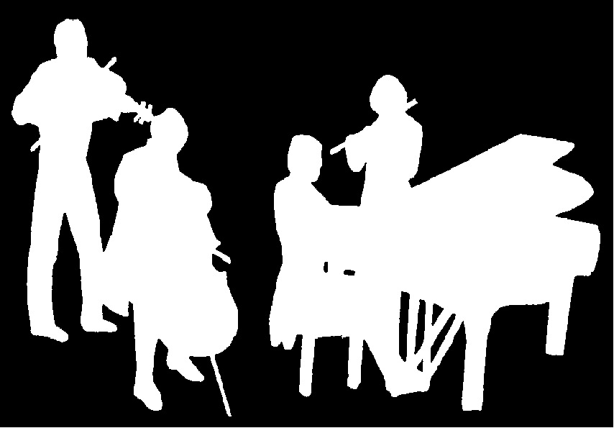
Kirribilli Neighbourhood Centre
www.KNCsydney.org
Amateur Chamber Music Society
http://www.acms-australia.org/
Chamber Music Concert
Sunday 5 March 2013
5pm

