Amateur Chamber Music Society Inc.
http://www.acms-australia.org/sydney/

— Concert —
5pm 2 May 2010 (first Sunday in May)
Kirribilli Neighbourhood Centre, 16 Fitzroy St Kirribilli
www.KNCsydney.org tel: 9922 4428 (5)
— Program —
HAYDN Trio No23 in E flat major Hob15/10 (1785)
(1) Allegro moderato (2) Presto
violin Vania Chan cello Robyn Godfrey piano Nick Stokes
10'
MARTINU Trio H300 (1944)
(1) Poco allegretto (2) Adagio (3) Andante - Allegretto scherzando
flute Alex Chervonsky cello Robyn Godfrey piano Ji-Hyun Kim
21’
— Interval —
MARTINU Promenades H274 (1939)
(1) Poco allegro (2) Adagio (3) Scherzando (4) Poco allegro
flute Alex Chervonsky violin Cameron Hough harpsichord Ji-Hyun Kim
10'
COPLAND Quiet City (1939)
trumpet Pierre-Emmanuel Seguin cor anglais Freya Bailes piano Ji-Hyun Kim
10’
DINICU Hora Staccato (1906)
flute Alex Chervonsky electric guitar Andrew Bell
4’
— Supper —
-------------
Concert Organiser: Alex Chervonsky
The manager and volunteer staff of the Kirribilli Neighbourhood Centre provide supper
(wine juice and savouries) and charge $10 entry donation ($5 concession/seniors)
to cover costs and to raise funds for the Centre

To get information on future concerts,
go to http://www.acms-australia.org/sydney/ and
click on “Concerts” in the navigation panel.
All chamber music players are welcome to join the
Amateur Chamber Music Society.
If interested, write to membership@acms-sydney.org
or ACMS Membership Secretary, PO Box 584, Balgowlah NSW 209

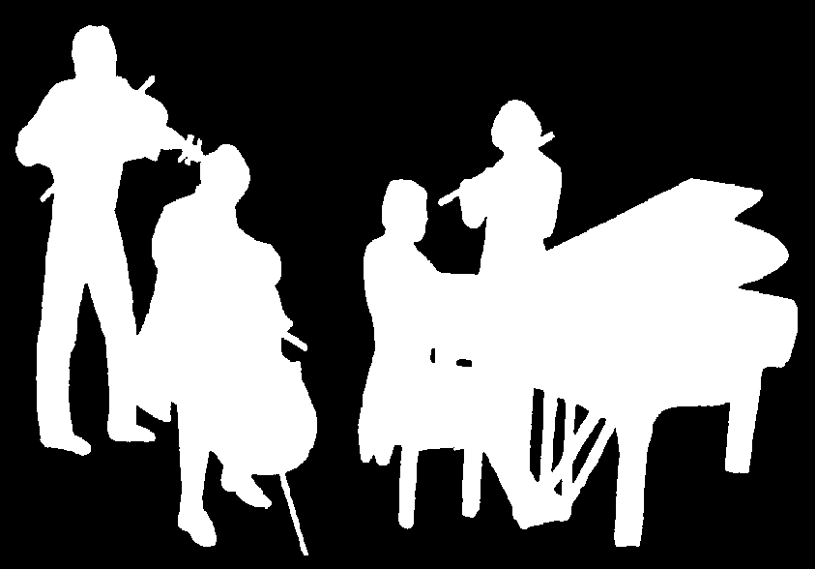
Kirribilli Neighbourhood Centre
www.KNCsydney.org
Amateur Chamber Music Society
http://www.acms-australia.org/
Chamber Music Concert
5pm Sunday 2 May 2010
5pm

