Amateur Chamber Music Society
acms-australia.org
— Concert —
5pm Sunday 3 November 2013 (first Sunday in November)
Kirribilli Neighbourhood Centre, 16 Fitzroy St Kirribilli
www.KNCsydney.org tel: 9922 4428
— PROGRAM —
SCHUBERT Trio in B-flat major D471
Allegro
violin Christine Middleton viola Annie Scrivener cello Jane Grimm
10’
GRIEG Sonata in A Op36
(1) Allegro agitato (2) Andante molto tranquillo (3) Allegro - molto e marcato
cello Robyn Godfrey piano Christine Edwards
30’
— interval —
SCHUBERT Grand Sonata for piano - 4 hands in B flat major
D617 Op30
(1) Allegro moderato (2) Andante con moto (3) Allegretto
Sue Butler and Tomas Drevikovsky
20’
FRANCK Sonata in A major
(1) Allegretto ben moderato (2) Allegro
(3) Recitativo – Fantasia (4) Allegretto poco mosso
violin Tracey Tsang piano Benjamin Chan
25’
— refreshments —
Concert Organiser – Sue Butler
The manager and volunteer staff of the Kirribilli Neighbourhood Centre provide light refreshments (wine juice fruit savouries) and charge $10 entry donation ($5 concession/seniors)
to cover costs and to raise funds for the Centre
SCHUBERT Trio for violin viola and cello D471
Schubert wrote this Trio in 1816 and this is the only complete movement - only a fragment of the second movement exists. We first played together at a self arranged session at the ACMS camp in Wollongong and have been meeting since then. Playing chamber music is a pretty new experience for all of us and we hope you will enjoy this Schubert with the Jannich trio!
GRIEG Sonata in A Op36 for cello and piano
Grieg, the Norwegian composer (b. Bergen 1843) studied in Leipzig but it wasn’t until his return to his homeland following his studies that he began to find hid unique musical voice. He was greatly influenced by Nodraak, the composer of the Norwegian National Anthem who took inspiration from the fjords, sagas and music of his homeland, which led to Grieg developing an interest in studying Norwegian folk music and becoming a leading Nationalist composer. Nevertheless, Grieg wrote that "music which matters, however national it may be, is lifted high above the purely national level.” His music was admired by leading composers of his day including Liszt and Tchaikovsky.
His Cello Sonata is a large scale passionate and dramatic work. The first movement begins with a brooding, agitated theme, which quickly dissolves into a tender second theme more characteristic of Grieg – warmly lyrical, very Norwegian. The movement has a wide emotional range, heightened by the unusual inclusion of a mini cadenza for the cellist.
The lyrical Andante draws its opening theme from an Homage March composed by Grieg as incidental music to a play about King Sigurd Jorsalfar of Norway. (The march was originally scored for four cellos.) There is a stormy middle section before the processional theme returns at the end of the movement.
The final movement begins with a brief recitative-cadenza for solo cello, which ushers in a vigorously rustic folk dance. As in the first movement, the finale traces a huge expressive trajectory. Although the sonata has no known extra-musical program, it creates a strongly narrative impression and represents Grieg at his most intense and passionate.
SCHUBERT Grand Sonata for piano - 4 hands in B flat major
D617 Op30
There is a very large number of duets from Schubert’s pen. The most ambitious are the Fantasy in F minor D940 (an intense work), the Grand Duo D812 and Lebensstürme D947. Most of the duets are less challenging, even quite slight pieces – Marche Militaire D733 is played often by children, and is even the tune of the Sydney Welsh Choir’s signature song.
The Grand Sonata in B flat for 4 hands D617 is not so well known. It does have elements of the traditional sonata form, but it is grand only in comparison to some of the other works. Nevertheless, it has a certain discursive charm, with the frequent modulations so typical of much of Schubert’s music.
FRANCK Sonata in A for violin and piano
Franck’s violin and piano sonata (1886), together with Fauré’s (1876) and Saint-Saëns (1885), have been described as the “cornerstone of the French violin repertoire”.
There is an element of nationalism there, a withdrawal from German culture (Wagner, Brahms) considering the background of enmity between France and Germany (Franco Prussian War 1870-71). Franck was a leader in finding a distinctive French musical flavour. Notwithstanding this, his music shows the influence of Wagner.
Franck presented this sonata to the famous violinist and composer Ysaÿe as a wedding gift in 1886. Ysaÿe premiered it, championed many of Franck’s compositions and contributed to his subsequent fame.
Although Franck was 64 years old when he wrote this violin sonata, it belongs to the group of his most famous works, all written when he was in his 60s. He continually revised his compositions, producing only a few, but all beautifully crafted.
The first movement of this sonata in 9/8 time and can have a serenity reminiscent of the Bach Largo (in 6/8 time), and was conceived this way. However Ysaÿe played it faster, Franck liked it that way, and changed the tempo indication to allegretto. Elements of the opening theme of the first movement reappear in later movements, and whole fragments of the second and third movements reappear in the last movement in different keys, retaining their freshness and contributing to a nostalgic atmosphere.
Franck makes much use of modulation through many keys, emphasising tone colour. Perhaps there is a parallel with his contemporary Van Gough’s emphasis of visual colour.
~~~~~~~~~~
Next concert includes HANDEL Nine German Songs, MOZART Sonata in E-minor K304, and from various composers - Four Antique Italian Songs and baroque carols.
To get information on future concerts
go to acms-australia.org
(or Google “ACMS chamber music society Australia”)
and click on “Concerts” in the navigation panel

All chamber music players are welcome to join the
Amateur Chamber Music Society. If interested, write to
membership.secretary@acms-sydney.org
or to ACMS Membership Secretary, PO Box 584, Balgowlah NSW 2093

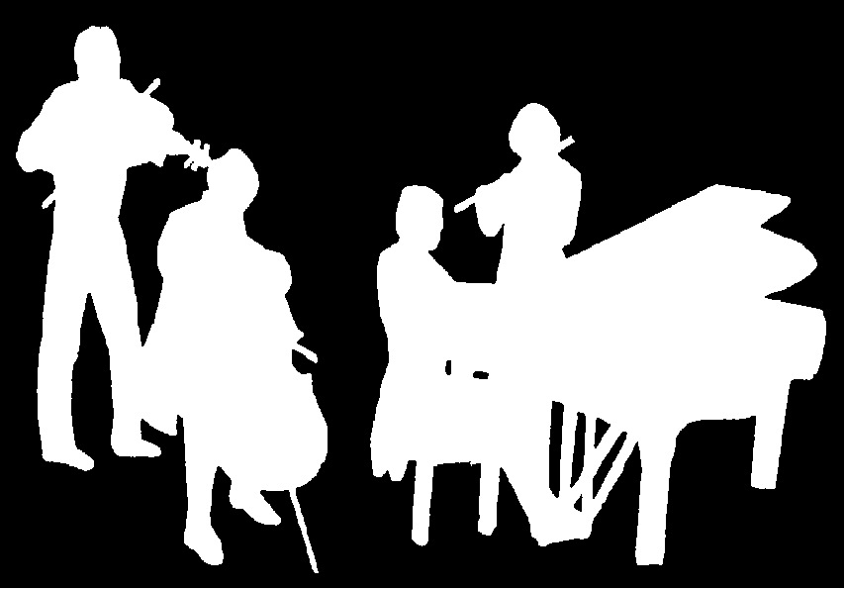
Amateur Chamber Music Society
http://www.acms-australia.org/
at the
Kirribilli Neighbourhood Centre
16 Fitzroy St Kirribilli
Chamber Music Concert
Sunday 3 November 2013
5pm

