Amateur Chamber Music Society
http://www.acms-australia.org/concerts/
— Concert —
5pm Sunday 6 July 2014 (first Sunday in July)
Kirribilli Neighbourhood Centre, 16 Fitzroy St Kirribilli
www.KNCsydney.org tel: 9922 4428
— PROGRAM —
BEETHOVEN Sonata No6 in A major Op30 No1
(1) Allegro (2) Adagio molto espressivo
(3) Allegretto con variazioni
violin George Carrard piano Murray Brown
26’
ZEMLINSKY Trio in D minor Op3, First Movement
Allegro ma non troppo
clarinet Stephanie Whitmont cello Robyn Godfrey
piano Murray Brown
14’
— Interval —
SCHUBERT Piano Quintet in A major
D667 "The Trout”
(1) Allegro vivace (2) Andante (3) Scherzo – Presto
(4) Theme with Variations - Andante (5) Finale - Allegro giusto
violin Stephen Malloch viola Danny Morris
cello Nicole McVicar double bass Mikey Floyd
piano Tomas Drevikovsky
35’
— refreshments —
concert organiser George Carrard

Volunteer staff of the Kirribilli Neighbourhood Centre provide light refreshments (wine juice and savouries) and charge $10 entry donation ($5 concession/seniors)
to cover costs and to raise funds for the Centre
- Notes -
BEETHOVEN (1770-1827) Sonata No6 in A major Op30 No1 (1802)
This sonata for piano and violin is rarely heard in concert performances these days. Considered by its champions to be one of Beethoven's most beautiful chamber works, it requires utmost attention to detail from the performers.
Dedicated to Tsar Alexander I of Russia, it features sudden dynamic contrasts for which Beethoven became so well-known, but the overall character is one of elegance, gentleness, tenderness, and poise.
The piano opens the first movement with a rhythmic motif that seems to be a truncated version of the opening of the earlier “Spring” Sonata No5. The motif also occurs repeatedly as the development section transitions back to the recapitulation. The same occurs again in a much more dramatic form as the opening of Beethoven’s companion Sonata No7 (Op30 No2).
Beethoven was a master of variation. The violin opens the second movement, Adagio, with a simple theme which is repeated twice more, separated by increasingly complex variations of the second subject. The movement has moments of tenderness as well as operatic lyricism and passion which is never overdone.
The last movement, in the form of theme and variations, provides a spirited ending to an elegant sonata. It begins with the theme in the character of a refined German dance, which is followed by six variations. The final variation, Allegro ma non tanto, does not suggest a grand finale with a dramatic climax; rather, the work concludes in an upbeat and contented mood.
(Much of the above adapted from http://www.gotomidori.com/english/musicnote-200302/musicnote46.html.)
ZEMLINSKY (1871-1942) Trio in D minor Op3 (1895)
The musical talent of Vienna-born Alexander Zemlinsky became evident at an early age and already aged 13 he was enrolled in the Conservatory of the Society of the Friends of Music. He was greatly influenced by Brahms, who at the time was serving as President of the Society.
When he showed his Trio in D minor for Clarinet, Cello and Piano to Brahms, Brahms was mightily impressed and immediately recommended that his own publisher Simrock print the work.
Zemlinsky was highly regarded as a teacher and conductor. He gave his contemporary Arnold Schoenberg lessons in counterpoint, the only formal musical instruction the younger man ever received. Like his musical peers in late 19th century Vienna, Zemlinsky fell under the spell of Wagner's Tristan und Isolde and Parsifal. Unlike Schoenberg and the Second Viennese School he stayed with tonality and did not venture into serialism or other innovations of 20th century modernism. He moved from Europe to America in 1938 after the rise of Hitler.
The music of Alexander Zemlinsky has come to the attention of an increasingly wide public over the past quarter-century. Some of his songs have been recorded with those of the better-known Gustav Mahler.
The Trio Op3 shows the influence of Brahms in its formal structure, but the musical language is closer to Wagner. The first movement played tonight is in the full late Romantic style, while still observing the traditional sonata movement form. It takes up almost half of the performance time of the complete work. The trio ranks among his most performed works.
(Adapted eg from http://www.editionsilvertrust.com/zemlinsky-trio-op3.htm. and http://www.naxos.com/catalogue/item.asp?item_code=8.570540)
SCHUBERT (1797-1828) Piano Quintet in A major D667 "The Trout”
Schubert was 22 when he and a group of friends met to play Hummel’s quintet for piano, violin, viola, cello and double bass, a most unusual combination. They wanted something else for the same group, so Schubert wrote this Piano Quintet nicknamed “The Trout” because the fourth movement is a set of variations on his song of the same name. The rising sextuplet figure from the song's accompaniment is used as a unifying motif throughout the quintet, and related figures appear in four out of the five movements – all but the Scherzo. As in the song, the figure is usually introduced by the piano.
The quintet was published 10 years after its first performance, a year after Schubert’s death. Apart from its popularity, the importance of the piece stems mainly from its use of an original and innovative harmonic language and from its expertise in the use of the unusual combination of instruments. Referred to by some as 'the ultimate feel-good piece' it exhibits Schubert's extraordinary ability to introduce one melody after another and provides a joyful conclusion to the concert.
(Adapted from various hits on the internet.)

To get information on future concerts, go to the website
http://www.acms-australia.org/sydney/
(or Google “ACMS chamber music society Australia”)
and click on “Concerts”
All chamber music players are welcome to join the
Amateur Chamber Music Society. If interested, go to the website and click on “Join Us”, or email membership.secretary@acms-australia.org, or write to ACMS Membership Secretary, PO Box 584, Balgowlah NSW 2093

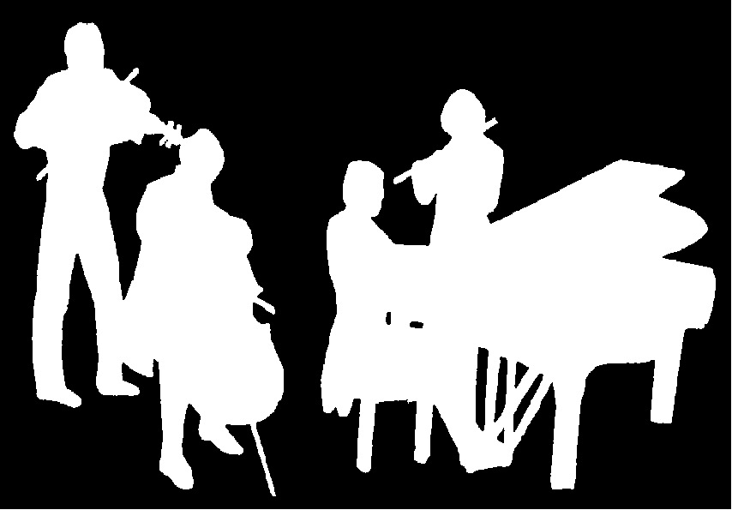
Kirribilli Neighbourhood Centre
www.KNCsydney.org
Amateur Chamber Music Society
http://www.acms-australia.org/
Chamber Music Concert
Sunday 6 July 2014
5pm

