Debussy’s early piano piece Tarentelle Styrienne was first published in 1891 but in 1903 was reissued under the new title Danse, with a few small revisions. This arrangement (1981) for clarinet quartet is by Jean Thilde was also recorded by the Thurston Clarinet Quartet.
SULLIVAN (1842 – 1900) Three Little Maids from School
Sir Arthur Sullivan is best known for his series of 14 operatic collaborations with the dramatist W. S. Gilbert, including such works as 'H.M.S. Pinafore', 'The Pirates of Penzance' and 'The Mikado'. This arrangement for four clarinets by Roderick Ellem is of the well known song from Act 1 of The Mikado, sung by Yum-Yum, Peep-Bo and Pitti-Sing on their return to Titi-pu from school.

Next concert - program includes BACH Two Arias, HANDEL Arias for Two Cellos, SPOHR Six German Songs, a piece by POULENC

The manager and volunteer staff of the Kirribilli Neighbourhood Centre provide light refreshments (wine juice and savouries) and charge $10 entry donation ($5 concession/seniors)
to cover costs and to raise funds for the Centre

To get information on future concerts, go to the website
http://www.acms-australia.org/sydney/
(or Google “ACMS chamber music society Australia”)
and click on “Concerts”
All chamber music players are welcome to join the
Amateur Chamber Music Society. If interested, go to the website and click on “Join Us”, or email membership@acms-sydney.org, or write to ACMS Membership Secretary, PO Box 584, Balgowlah NSW 2093

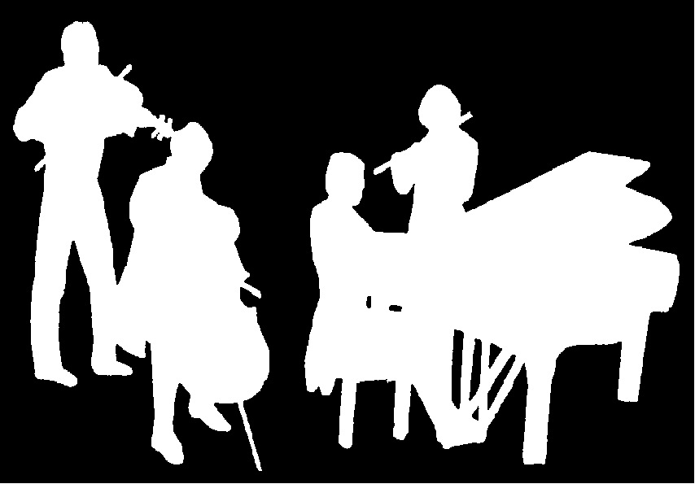
Kirribilli Neighbourhood Centre
www.KNCsydney.org
Amateur Chamber Music Society
http://www.acms-australia.org/
Chamber Music Concert
Sunday 2 March 2014
5pm

Amateur Chamber Music Society
http://www.acms-australia.org/concerts/

— Concert —
5pm Sunday 2 March 2014 (first Sunday in March)
Kirribilli Neighbourhood Centre, 16 Fitzroy St Kirribilli
www.KNCsydney.org tel: 9922 4428

— PROGRAM —
GRUNDMAN Caprice
CARR Five English Postcards
(1) Summer Parade (2) Tea (3) Village Dance
(4) Sunday Afternoon (5) Celebration
Clarinet Quartet: Andrew Cousins David LaMotte
Carolyn LaMotte Peter Scaysbrook
3+15’
HAYDN Trio in A major HobXV:18
(1) Allegro moderato (2) Andante (3) Allegro
violin George Carrard cello Sharon Maennl piano Kian Woo
17’
— Interval —
CUI Five Small Duos Op56
(1) Badinage (2) Berceuse (3) Scherzino (4) Nocturne (5) Valse
flute Richard Tardif clarinet Lindsay Wanstall
piano Ji-Hyun Kim
12’
DEBUSSY Danse
SULLIVAN Three Little Maids
Clarinet Quartet as above
5+2'
— refreshments —
concert organiser Kian Woo

- Notes -
GRUNDMAN (1913 – 1996) Caprice
Claire Grundman composed scores for films, radio, and television, as well as orchestrations for Broadway musicals. He is best known for his many compositions and arrangements for symphonic band but he also wrote a number of works for various chamber ensembles. The Caprice can be played by clarinet choir or clarinet quartet.
CARR (1961 - ) Five English Postcards
Paul Carr is an English classical music composer who has written a number of works, often in a lighter style including concertos for clarinet, oboe, flute, piano and viola. He has also scored several British films and television programmes. The 'Five English Postcards' were composed for the Thurston Clarinet Quartet and consist of five short sketches illustrating traditional English life.
HAYDN (1732-1809) Keyboard Trio in A major HobXV:18
Joseph Haydn’s life was mostly stable compared to that of Mozart and Beethoven. After 30 years as musical director in the court of the Esterházy family, he had become famous throughout Europe and was financially secure. Aged 61, he composed this trio in 1793 between two hugely successful and lucrative visits to London. His life was not entirely a bed of roses because his marriage was not a happy one.
Beethoven and Mozart both had great respect for Haydn and his music, referring to him as ‘Papa Haydn’. Their music went beyond Haydn’s limits in many respects, but it is difficult to find music anywhere in the chamber music repertoire that matches Haydn’s combination of invention and cheerful playfulness exhibited in the last movement of this trio.
CUI (1835 – 1918) Five Small Duos Op56
César Cui was a Russian composer and music critic of French and Lithuanian descent. His profession was as an army officer and a teacher of fortifications. In his musical sideline he is known as a member of The Five, a group of Russian composers under the leadership of Mily Balakirev which also included Mussorgsky, Rimsky-Korsakov and Borodin, dedicated to the production of a specifically Russian type of music. The Five Little Duos (actually for three instruments) are a charming set of short pieces that belie what one might expect of a Russian military man. They are mostly sunny and light in the salon style, although the Nocturne has additional emotional colour.
DEBUSSY (1862-1918) Danse
Along with Maurice Ravel, Claude Debussy was one of the most prominent figures associated with Impressionist music. Embracing non-traditional scales and tonal structures, he is one of the most highly regarded composers of the late 19th and early 20th centuries and is seen as the founder of musical impressionism.

