Jacques IBERT (1890 – 1962) Trois Pieces Breves
In 1919, Ibert won the Prix de Rome at his first attempt, despite his musical studies being interrupted by serving as a naval officer in World War 1. He wrote operas, film music, works for piano, and chamber music. This quintet was written in 1930 and was sadly the only work he wrote for this combination. His musical style has been variously described as festive, gay, lyrical inspired, descriptive, evocative, frivolous, light hearted and humorous.

The manager and volunteer staff of the Kirribilli Neighbourhood Centre provide light refreshments (wine juice and savouries) and charge $10 entry donation ($5 concession/seniors)
to cover costs and to raise funds for the Centre

To get information on future concerts, go to the website
http://www.acms-australia.org/sydney/
(or Google “ACMS chamber music society Australia”)
and click on “Concerts”
All chamber music players are welcome to join the
Amateur Chamber Music Society. If interested, go to the website and click on “Join Us”, or email membership@acms-sydney.org, or write to ACMS Membership Secretary, PO Box 584, Balgowlah NSW 2093

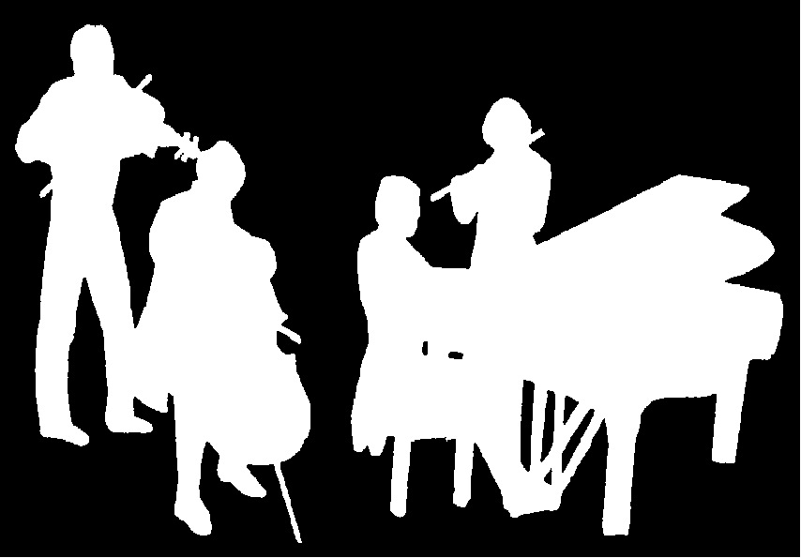
Kirribilli Neighbourhood Centre
www.KNCsydney.org
Amateur Chamber Music Society
http://www.acms-australia.org/
Chamber Music Concert
Sunday 4 May 2014
5pm

Amateur Chamber Music Society
http://www.acms-australia.org/concerts/

— Concert —
5.00pm Sunday 4 May 2014 (first Sunday in May)
Kirribilli Neighbourhood Centre, 16 Fitzroy St Kirribilli
www.KNCsydney.org tel: 9922 4428

— PROGRAM —
WEBER Trio in G Minor Op63
(1) Allegro moderato (2) Scherzo - Allegro vivace
(3) Schäfers Klage - Andante espressivo (4) Finale: Allegro
flute Richard Tardif cello Robyn Godfrey piano Kian Wu
20’
HAYDN Quartet in D major Op64 No5 “The Lark”
(1) Allegro moderato (2) Adagio – Cantabile
(3) Menuetto - Allegretto (4) Finale: Vivace
violins Jenny Allison and Marjorie Hystek
viola Barbara Robinson cello Jane Smith
18’
— Interval —
HUMMEL Trio in A Op78
(1) Introduction - Cantabile (2) Thema - Quasi Allegretto
(3) Variations 1-6 (4) Variation 7 - Finale – Rondo - Vivace assai
flute Ivan Foo cello Jane Smith piano Kris Spike
15’
IBERT Trois Pieces Breves
(1) Allegro (2) Andante (3) Assez lent - Allegro scherzando - Vivo
flute Cathy Fraser oboe Cate Trebeck clarinet Stephanie Whitmont
horn Paula Stokes bassoon Petrina Slaytor
8'
— refreshments —
concert organiser Petrina Slaytor
- Notes -
WEBER Trio in G Minor Op63
The musical reputation of Carl Maria von Weber (1786-1826) rests almost entirely on his famous operas Die Freischutz and Oberon and a few other works such as his clarinet concertos. But Weber’s music by and large is unknown to present day players and listeners, which is a pity since it is uniformly well-written, particularly for wind instruments. Chamber music, however, comprises only a very small part of his oeuvre. There are only three works which qualify as chamber music—his Piano Quartet, his Clarinet Quintet and this work for Flute (or Violin), Cello and Piano.
Weber studied with Michael Haydn (Joseph Haydn’s younger brother) in Salzburg and Abbe Vogler in Vienna, two of the leading teachers of their day. He pursued a career as a conductor and music director holding posts in Breslau, Prague, Berlin and Dresden.
The Op63 Trio was composed in 1819 while Weber was serving as music director in Dresden. In four movements, the first, Allegro moderato, is more moderato than allegro and has an air of melancholy and contemplation. Next comes a short, martial Scherzo. The third movement, The Shepherd’s Lament (Schäfers Klage), is in the tradition of the French Air Pastorale, evocative of a rustic scene with a lonely shepherd, playing a song-like ballad on his flute. The finale, also an Allegro, displays Weber’s gift for melody and invention.
Joseph HAYDN (1732-1809) Quartet in D major Op64 No5 “The Lark”
The Op64 quartets were written in 1790 and they are generally known as the Tost quartets because they were written with Johann Tost, a violinist in Haydn's orchestra, in mind. No5 is known as the "Lark" because of the birdsong-like ornamentation and first violin's singing melody at its opening. However, perhaps not so widely known, it was also known as the "Hornpipe" because of the lively tempo of the last movement. Paul Epstein has said of this quartet that it is "a story, a song, a dance and a party". The second movement, Andante Cantabile, is a lovely song for the first violin with the structure of an aria. The minuet is in traditional form with a contrasting trio and the last Vivace movement is one of bright perpetual motion.
HUMMEL Trio in A Op78
The full title of this piece is Adagio, Variations and Rondo on a Russian Theme. This beautiful work begins with a tender adagio that anticipates the nocturnes of Field and Chopin. The Russian theme is a great melody that is simple yet eloquent and is then given a wide variety of treatment and moods in the seven variations for the combination of piano, flute and cello. The Rondo has an energetic restlessness followed by a sublime, if simple, ending.

