Amateur Chamber Music Society
http://www.acms-australia.org/concerts/
— Concert —
5pm Sunday 2 November 2014 (first Sunday in November)
Kirribilli Neighbourhood Centre, 16 Fitzroy St Kirribilli
www.KNCsydney.org tel: 9922 4428
— PROGRAM —
STAMITZ Quartet Op8 No4
clarinet Lindsay Wanstall violin Jenny Allison
viola Barbara Robinson cello Robyn Godfrey
BEETHOVEN/HERMANN/PAGELS Duet in C major
(1) Allegro commodo (2) Larghetto sostenuto
(3) Rondo- allegretto (vivace)
violin Inge Courtney Hajentes viola Michelle Urquhart
BRIDGE Sonata Op xxx
cello Robyn Godfrey piano Nick Stokes
— refreshments —
concert organiser Jenny Allison
Volunteer staff of the Kirribilli Neighbourhood Centre provide light refreshments (wine juice and savouries) and charge $10 entry donation ($5 concession/seniors)
to cover costs and to raise funds for the Centre
- Notes -
BEETHOVEN/HERMANN/PAGELS Duet in C major
This is the first of a set of three duets are thought today to have been composed by someone other than Beethoven. They have however earned a significant place in woodwind chamber music literature and are still reflected in the Beethoven catalogue. The originals were composed for clarinet and bassoon and first published in parts from 1810-15.
Today the first of the Three Duets will be performed on violin and viola. It has three movements: (1) Allegro commodo- the first melodic theme is introduced by the violin with the viola accompanying in moving quavers. The second theme is introduced by the viola. This movement is in sonata form: theme one, theme two, development and then recapitulation of the two main themes. Both parts are given fairly equal treatment throughout. It is a very positive, joyful movement.
(2) Larghetto sostenuto- the slow second provides a beautiful contrast with the constantly moving energy of first movement. It is in C minor, a beautiful, almost mournful movement with divine harmonies between violin and viola.
(3) Rondo- allegretto (vivace) - in the original key of C major and a similar character to the first, the violin opens with the movements first melodic idea accompanied by the viola. The second melodic idea is then introduced by the viola, and so it goes with the melodies slightly altered and of course developed. The rhythm is also further developed with the introduction of triplet passages, alternating between the violin and viola and then in harmony. There is a brief shift to C Minor prior to its jubilant finale in its original key of C Major.

To get information on future concerts, go to the website
http://www.acms-australia.org/sydney/
(or Google “ACMS chamber music society Australia”)
and click on “Concerts”
All chamber music players are welcome to join the
Amateur Chamber Music Society, which matches players depending on their experience, and has an emphasis on informal playing days and an annual music camp. If interested, go to the website and click on “Join Us”, or email membership.secretary@acms-australia.org, or write to ACMS Membership Secretary, PO Box 584, Balgowlah NSW 2093

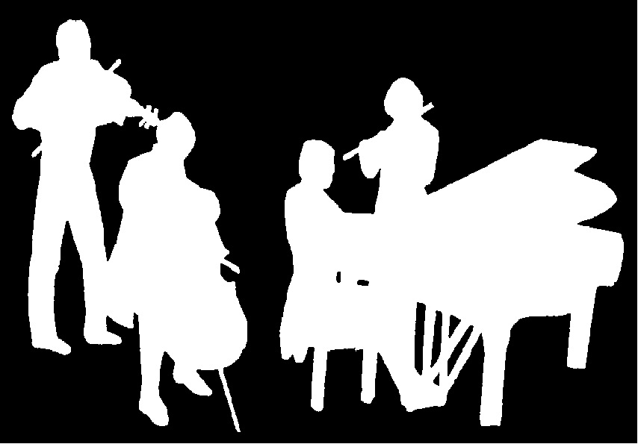
Kirribilli Neighbourhood Centre
www.KNCsydney.org
Amateur Chamber Music Society
http://www.acms-australia.org/
Chamber Music Concert
Sunday 2 November 2014
5pm

