Amateur Chamber Music Society
http://www.acms-australia.org/concerts/
— Concert —
5pm Sunday 7 September 2014 (first Sunday in September)
Kirribilli Neighbourhood Centre, 16 Fitzroy St Kirribilli
www.KNCsydney.org tel: 9922 4428
— PROGRAM —
BEETHOVEN Sonata No1 in D major Op12 No1
(1) Allegro con brio (2) Tema con variazioni
(3) Rondo - Allegro
violin George Carrard piano Christine Edwards
24’
BRAHMS/WEBSTER Hungarian Dance Suite No1
Dance numbers 6, 16, 14, 13, 5, 7
flute Richard Tardif Clarinet Lindsay Wanstall
piano Ji-Hyun Kim
15’
— Interval —
BEETHOVEN Sonata No3 in E-flat major Op12 No3
(1) Allegro con spirito (2) Adagio con molt'espressione
(3) Rondo - Allegro molto
violin Tracey Tsang piano Benjamin Chan
24’

— refreshments —
concert organiser George Carrard
Volunteer staff of the Kirribilli Neighbourhood Centre provide light refreshments (wine juice and savouries) and charge $10 entry donation ($5 concession/seniors)
to cover costs and to raise funds for the Centre
- Notes -
BEETHOVEN (1770-1827) Sonatas Op12 Nos1 and 3
Beethoven’s grandfather, Lodewyck van Beethoven, was from what is now Belgium and moved to Bonn as a young man, where he rose to the position of musical director at the court of the prince-archbishop-elector of Cologne. His mother’s family came from near Bonn. Her ancestry is unknown, but could be mixed considering that the Austrian Empire was multicultural.
Ludwig van Beethoven’s father, Johann, was a tenor, violinist, zither and keyboard player and teacher at the court. He was also an alcoholic and, although he recognised Ludwig’s talent he is said, perhaps under the influence of alcohol, to have accused Ludwig of being an embarrassment to the family if he did not play well.1 There were three boys in the Beethoven family. Ludwig’s brothers were four and six years younger than he.
At the age of 8, Ludwig gave a brilliant keyboard performance in Cologne, after which a group of influential nobles decided to groom him to be Mozart's successor. He was appointed assistant court organist when he was 14, and aged 16, the nobles sent him to Vienna where he had a few lessons from Mozart. After a short time there, he returned to Bonn to support his family as his mother was dying.
After his mother’s death, his father’s drinking problem worsened resulting in half of his pay being turned over to Ludwig for support of his two younger brothers.
At 18, we find Ludwig enrolled at Bonn University.
Aged 21 he went with the electoral orchestra to a town over 300 km away (Mergentheim) by river boat, contributing to his family’s finances by working as a kitchen hand on the boat.
Aged 22 Beethoven went to study with Haydn in Vienna and stayed there for the rest of his life. He soon became established as the finest piano virtuoso there. Over the next six years he published a few works, but after noticing the first signs of his deafness and nearly dying of typhus, he produced, aged 28, works that are still frequently performed today - among them the piano sonata “Pathétique”Op13 and the sonatas for piano and violin Op12.
The Sonatas Op12 were not well received by the critics of the time. It is possible that Beethoven's emphasis on distantly related keys was cause for confusion among his contemporaries.
Op12 No1
The first movement of No1 contains great wealth of material. There are at least three "themes" in a first group, three in a second plus a strong closing theme.
The second movement comprises a theme and variations, but each variation is more adventurous than the previous, taking us on a tour of the outer reaches of Beethoven’s imagination.
The third movement is a rollicking rondo, in which the main theme, built of leaps and arpeggios, returns several times in a variety of guises.
Op12 No3
The first movement keeps both instruments moving incessantly (though never frantically). The development section runs through the themes again, modulating to new keys, stopping short before the coda.
The second movement is a deeply-felt, serene melody that evolves slowly. The violin sings in long lines over a murmuring accompaniment, then trades roles with the piano.
Serenity is banished by the cheerful finale. The primary theme is launched by a repeated-note figure, a musical chuckle that underlies most of what is to follow. Unexpectedly, the middle section falls into the minor mode and hints at some brief, mild conflict between the instruments. This is soon swept away by another surprise, a fugal treatment of the main theme that leads straight into a brief, high-spirited coda.
http://www.allmusic.com/composition/sonata-for-violin-piano-no-3-in-e-flat-major-op-12-3-mc0002663581.
BRAHMS/WEBSTER Hungarian Dances (1869)
The Hungarian Dances are a set of 21 lively dance tunes based mostly on Hungarian themes. They are among Brahms's most popular works, and vary from about a minute to four minutes in length. Only numbers 11, 14 and 16 are entirely original compositions. The others are reputedly based on traditional folksongs. This arrangement for flute, clarinet and piano is by the Webster Trio, faculty members of the Shepherd School of Music at Rice University in Houston.

To get information on future concerts, go to the website
http://www.acms-australia.org/sydney/
(or Google “ACMS chamber music society Australia”)
and click on “Concerts”
All chamber music players are welcome to join the
Amateur Chamber Music Society, which matches players depending on their experience, and has an emphasis on informal playing days and an annual music camp. If interested, go to the website and click on “Join Us”, or email membership.secretary@acms-australia.org, or write to ACMS Membership Secretary, PO Box 584, Balgowlah NSW 2093

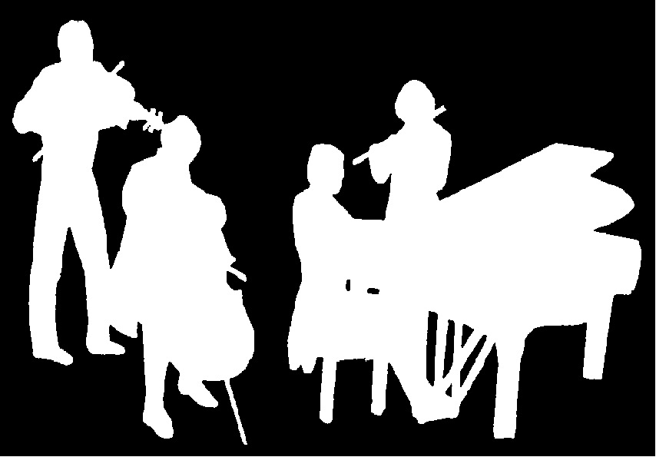
Kirribilli Neighbourhood Centre
www.KNCsydney.org
Amateur Chamber Music Society
http://www.acms-australia.org/
Chamber Music Concert
Sunday 7 September 2014
5pm

http://en.wikipedia.org/wiki/Ludwig_van_Beethoven
http://www.softschools.com/timelines/beethoven_timeline/94/
http://www.allmusic.com/composition/sonata-for-violin-amp-piano-no-1-in-d-major-op-12-1-mc0002451670

