Amateur Chamber Music Society
http://www.acms-australia.org/concerts/
— Concert —
5pm Sunday 12 April 2015 (second Sunday in April)
Kirribilli Neighbourhood Centre, 16 Fitzroy St Kirribilli
www.KNCsydney.org tel: 9922 4428
— PROGRAM —
BRAHMS Piano Quintet in F Minor Op34
(1) Allegro non troppo (2) Andante, un poco adagio
(3) Scherzo: Allegro - Trio
(4) Finale: Poco sostenuto - Allegro non Troppo - Presto, non troppo
violins George Carrard and Sonja Stadnik viola John Keller
cello Sharon Maennl piano Neil Semmler
37’
— Interval —
Three Songs - Music of the ANZACs – 100 Years On
(1) WAINWRIGHT I Wonder …
(2) SILÈSU arr WAINWRIGHT Un Peu d’Amour
(3) HYDE Anzac Threnody
mezzo-soprano Allison Rowlands
flutes Cathy Wainwright and Michael Earl
piano Gail Earl/Cathy Wainwright
15’
POULENC Sextet
(1) Allegro vivace (2) Divertissement: Andantino
(3) Finale: Prestissimo
flute Richard Tardif clarinet Lindsay Wanstall
oboe Adele Haythornthwaite horn Neil O'Donnell
bassoon Petrina Slaytor piano John Hughes
20’
— refreshments —
- Notes -
BRAHMS (1833-1897) Piano Quintet in F Minor Op34
Johannes Brahms’s grandfather was an innkeeper and was comfortably off. Against all advice and because his ability was not outstanding, Johannes’s father was determined to make a career as a musician resulting in a life of poverty. Despite their poverty, the family gave the children as much education as they could afford. Johannes started learning the cello and piano as a child and, when his outstanding natural talent was recognised, he was given piano tuition by the best piano teachers. According to a contemporary, he performed a piano sonata that he either composed or improvised when he was 11 years old.
They lived near the Hamburg waterfront, populated by sailors and prostitutes who frequented sleazy dance halls. As an adolescent as young as 13, Johannes left school and had to contribute to the family income by playing the piano in the dance halls. The pay was a low amount plus alcohol ad libitum. Instead of taking to alcohol, Johannes blotted out the terrible surroundings by reading poetry on his music stand while he was playing the dance music from memory.
In his late teens, Johannes conducted choirs, gave public concerts in Hamburg and, aged 19, he made a concert tour as a pianist. At 20 he was on a concert tour accompanying a violinist during which he met the famous violinist Joachim as well as the composers Liszt and Raff (at Weimar, 300km from Hamburg). Shortly after, with a letter of introduction from Joachim, Brahms met the composer Robert Schumann and his wife, the international performing pianist Clara, and family. They became close friends. Robert praised Brahms so much in the journal that he edited (Neue Zeitschrift für Musik), that Brahms had to work very hard to match his reputation.
In his 20s, Brahms held concurrent positions in the Detmold court and conductor of a ladies choir in Hamburg. During this time he took walks in the forest near Detmold and made drafts of what was to become his Piano Quintet Op34. The first draft was a two-cello-string-quintet, which Joachim and friends performed; they judged that it needed a piano to enhance its dramatic elements. The next draft was for two pianos, Op34a, which is still performed today. Clara Schumann advised that it needed the string sonorities, and Brahms cast it and published it in the final form for piano quintet - he was now 31. Joachim wrote “The quintet is beautiful beyond words a masterpiece of chamber music the like of which we have not seen since the year of 1828 [the date of Schubert’s death].
The quintet succeeds through the balance it strikes between intense individualism of ideas and breadth of organisational plan. It bursts with harmonic and melodic opulence and rhythmic variety. The first movement with its dramatic undertones begins with a simple unison melody of piano, violin and cello, gradually intensifying throughout. It is powerful, majestic and intensely serious. The second movement is the least complex, with its swaying melody—a lyrical song without words, reminiscent of Schubert. The third movement, the Scherzo, with it's swift changes of mood and overwhelming climax; it is rhythmic, insistent, restless, and complex - using a fugue to build to one of the climaxes. In contrast, it is followed by a lyrical, mysterious introduction to the allegro non troppo, which develops folksy elements into an exciting conclusion. A lady who heard Brahms play it told one of Brahms’s biographers, Peter Latham, that Brahms played the allegro non troppo section with great deliberation. Latham writes that most modern combinations play it too fast.
Brahms by Peter Latham (Dent, 1975), The Compleat Brahms edited by Leon Botstein (Norton 1999) http://en.wikipedia.org/wiki/Johannes_Brahms https://www.andrews.edu/~mack/pnotes/2012%20Concerts/sep2212pnotes.html

Three Songs - Music of the ANZACs – 100 Years On
Please see attached sheet.
POULENC (1899-1963) Sextet
This work dates from the period between the World Wars. Composers and critics of a conservative bent were prepared not to like it: composer and critic Florent Schmitt focused on its arbitrariness and vulgarity when he reviewed its premiere in Le Temps. But André Georges, in Les Nouvelleslittéraires, heard it through ears steeped in nationalistic pride: “With Poulenc, all of France comes out of the windows he opens.”
The piano joins a standard wind quintet, which Poulenc employs in a way that capitalizes on its acerbic potential, very much after the taste of Stravinsky in, say, his Octet of 1922–23. But the work is also anchored in the musical mainstream through various references.
In the first movement, the opening scales sweep upward as if they were a curtain opening to reveal a busy stage, though the hustle-bustle does subside for moments of notable sweetness or, following the bassoon’s lead, haunting melancholy.
Poulenc’s neoclassical tendencies are particularly evident in the Mozartean parody of the middle movement. The finale begins as “an Offenbachian gallop” (to quote the cultural historian Wilfred Mellers) and ends, surprisingly, in a coda of reflective solemnity and a touch of grandeur, with shades of Ravel.

concert organiser George Carrard
Volunteer staff of the Kirribilli Neighbourhood Centre provide light refreshments (wine juice and savouries) and charge $10 entry donation ($5 concession/seniors)
to cover costs and to raise funds for the Centre

To get information on future concerts, go to the website
http://www.acms-australia.org/sydney/
(or Google “ACMS chamber music society Australia”)
and click on “Concerts”
All chamber music players are welcome to join the
Amateur Chamber Music Society, which matches players depending on their experience
and arranges informal playing days, an annual music camp, and concerts.
If interested, go to the website and click on “Join Us”, or
email membership.secretary@acms-australia.org, or
write to ACMS Membership Secretary,
PO Box 584, Balgowlah NSW 2093

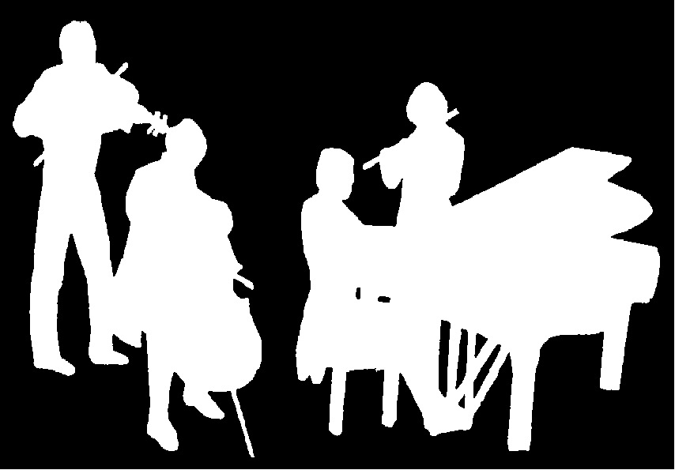
Kirribilli Neighbourhood Centre
www.KNCsydney.org
Amateur Chamber Music Society
http://www.acms-australia.org/
Chamber Music Concert
Sunday 12 April 2015
5pm

