Amateur Chamber Music Society
http://www.acms-australia.org/concerts/
— Concert —
5pm Sunday 5 July 2015 (first Sunday in July)
Kirribilli Neighbourhood Centre, 16 Fitzroy St Kirribilli
www.KNCsydney.org tel: 9922 4428
— PROGRAMME —
BEETHOVEN Sonata No 7 in C minor Op 30 No 2
(1) Allegro con brio (2) Adagio cantabile
(3) Scherzo: Allegro (4) Finale: Allegro - Presto
violin George Carrard piano Murray Brown
25’
DVORAK Piano Quintet Op 81
Dumka Andante con moto
violins Greta Lee and Sarah Allison viola Mark Berriman
cello Ann Kwan piano Patsy Short
15’
- Interval —
BEETHOVEN Sonata in G minor op 5 no 2
Adagio sostenuto e espressivo – Allegro molto più tosto presto
cello Ann Kwan piano Patsy Short
15’
FARRENC Trio Op 45
(1) Allegro deciso (2) Andante
(3) Scherzo - vivace (4) Finale - presto
flute Richard Tardif cello Jane Smith
piano Susan Butler
25’
— refreshments —
- Notes -
BEETHOVEN (1770-1827) Sonata No 7 in C minor Op 30 No 2
Beethoven lived a stormy life in stormy times dominated by the French Revolution and Napoleonic wars. He fell from the high of great public success as a virtuoso pianist and composer to the low of deafness. At the age of 33 he spent six months at the Heiligenstadt resort near Vienna to recuperate from depression, yet he still managed to compose several major works including the second symphony and the three Op 30 sonatas for piano and violin.
The second sonata opens with a sprawling movement shaped by the statement and development of opposing keys and themes, and their harmonic reconciliation. This is music of violent contrast on all levels, which begins softly but ends in fury.
The second movement is characteristic of Beethoven in its singing quality, an aspect of his composition and keyboard-playing that was much admired by contemporaries. It is followed by a cheeky scherzo that includes a trio featuring a canon between the violin and the left hand of the piano which might have won Haydn’s approval. The finale is another turbulent movement, capped with a delirious coda.
One of the hallmarks of Beethoven's style is to wring every implication possible from the smallest gestures, extending them throughout the entire piece.
[adapted from laphil.com/philpedia/music/violin-sonata-c-minor-op-30-no-2-ludwig-van-beethoven]
DVORAK (1841 – 1904) Dumka from Piano Quintet in A major Op 81
The origin of the Dumka is a Slavic vocal folk genre of an improvisational character. A singer performs a narrative ballad, establishing a sad, thoughtful mood, which then introduces brighter sections, but always returns to the original mood. Dvorak used this folk idiom in a number of compositions, as did Tchaikovsky before him.
In this beautiful example from the Piano Quintet, premiered in Prague in 1888, Dvorak builds a movement of contrasting moods, keys and tempi with a strong narrative line, which is passed between all instruments. Dvorak was a viola player so it is not surprising that he gives the opening of the story to that inner voice, although every instrument has a star role to play at some point, making this movement satisfying to play as an ensemble. So consider that five instruments are telling you a story. (Patsy Short)
BEETHOVEN (1770 – 1827) Sonata in C minor Op 5 no 2
Beethoven composed his first two cello sonatas in 1796, while he was in Berlin. He played the piano himself in a performance for the King of Prussia Friedrich Wilhelm II, a keen cellist, to whom they are dedicated. Beethoven received a snuffbox for his reward.
The second sonata has two movements of which we are performing the first. It starts with a slow, spacious introduction and moves into a faster section in sonata form bubbling with energy.
However, at several points the mood of youthful confidence is stopped in its tracks by tonal red herrings, marked by pauses, before the home key of G minor is finally reasserted. This humorous play on the key scheme to confound the listener's expectations pays an audible debt to Haydn. (Patsy Short)
FARRENC (1804-1875) Trio in E minor Op 45
Jeanne-Louise Farrenc was born in Paris into an artistic and bohemian family. From an early age she studied the piano under Moscheles and Hummel and at the age of fifteen her parents allowed her to study composition with Anton Reicha. She married Aristide Farrenc, a flautist, in 1821. They subsequently opened a publishing house which became one of France’s leading music publishers for nearly 40 years.
Her reputation during her lifetime was as a composer, performer (pianist) and a teacher. She wrote numerous chamber music works for different combinations of keyboard, strings and woodwind. She also composed 2 overtures and 3 symphonies, as well as vocal and choral works. However, she wrote no operas, which was required for composers to gain a reputation in France, although she was well regarded by the connoisseurs. The work we are performing today is her Trio for piano, flute and cello, Op 45. It is in four movements.
(Source: womencomposers.org)

concert organiser Patsy Short
Volunteer staff of the Kirribilli Neighbourhood Centre provide light refreshments (wine juice and savouries) and charge $10 entry donation ($5 concession/seniors)
to cover costs and to raise funds for the Centre

To get information on future concerts, go to the website
http://www.acms-australia.org/sydney/
(or Google “ACMS chamber music society Australia”)
and click on “Concerts”
All chamber music players are welcome to join the
Amateur Chamber Music Society, which matches players depending on their experience
and arranges informal playing days, an annual music camp, and concerts.
If interested, go to the website and click on “Join Us”, or
email membership.secretary@acms-australia.org, or
write to ACMS Membership Secretary,
PO Box 584, Balgowlah NSW 2093

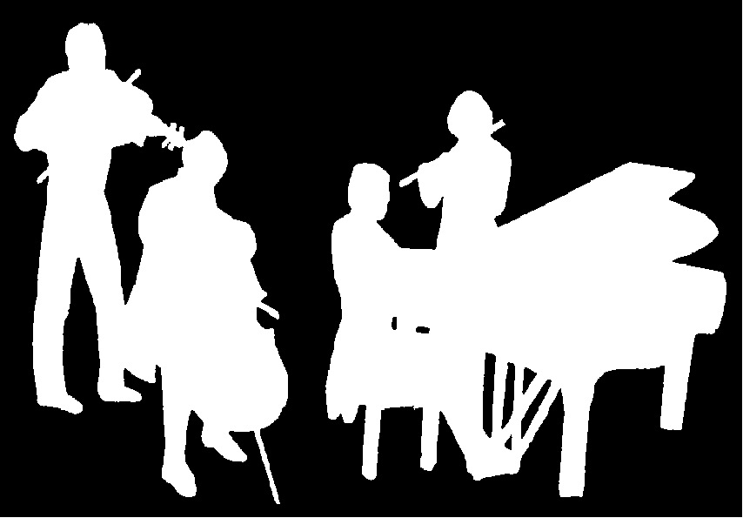
Kirribilli Neighbourhood Centre
www.KNCsydney.org
Amateur Chamber Music Society
http://www.acms-australia.org/
Chamber Music Concert
Sunday 5 July 2015
5pm

