Amateur Chamber Music Society
http://www.acms-australia.org/concerts/
— PROGRAM —
GRIEG Sonata No 3 in C minor Op 45
(1) Allegro molto ed appassionato (2) Allegretto espressivo alla Romanza
(3) Allegro animato
violin George Carrard piano Christine Edwards
25’
Conradin KREUTZER Trio E-flat Op 43
(1) Maestoso - Allegro moderato (2) Andantino Grazioso (3) Rondo
clarinet Lindsay Wanstall bassoon Petrina Slaytor
piano Jennifer MacRitchie
22’
- Interval —
BRAHMS Trio in A minor Op 114
(1 )Allegro (2) Adagio (3) Andantino grazioso (4) Allegro
viola John Keller cello Sharon Maennl piano Neil Semmler
25’

GERSHWIN arr SEMMLER Four Songs
(1) I’ve got rhythm (2) Foggy day
(3) Isn’t it a pity (4) Nice work if you can get it
violin George Carrard viola John Keller
cello Sharon Maennl piano Neil Semmler
15’
— refreshments —

- Notes -
GRIEG (1843-1907) Sonata No 3 in C minor Op 45 (1887)
Grieg wrote three violin sonatas. He completed the first two, Op 8 and Op 13 in 1867 when he was in his early 20s. They have a Norwegian flavour, evoking fjords and mountains. Commenting on them was one of Grieg’s mentors, the Danish composer and musician Niels Gade (1817-1890), assistant conductor to Mendelssohn at Leipzig, later director of the important Copenhagen Musical Society. Gade advised Grieg to write a violin sonata that was “less Norwegian”, to which Grieg retorted that it would be more so. However 20 years later he stated that his outlook had become more cosmopolitan. In the third sonata, the influence of Norwegian folk music appears, but the Norwegian atmosphere does not dominate.
Grieg was able to compose quickly, finishing the first two sonatas in a matter of weeks, but his third sonata Op 45 took him several months to complete. The extra effort paid dividends because this is the most popular of the three, and was also Grieg’s favourite.
Cesar Franck’s only sonata appeared the year before and the influence of the third movement is apparent in the dramatic opening of Grieg’s Op 45. Grieg’s balance between the violin and the piano is more even.
In 1892, Belgian musicologist Ernest Closson wrote that the sonata “must be classed with the most inspired scores ever written … is a marvel of inspiration, intelligence … [had] Grieg composed nothing but this sonata it would suffice to hand his name down to posterity.” In view of this it is hard to understand why this sonata is not as well known as the violin sonatas of Beethoven, Brahms and Franck.
Conradin KREUTZER (1780-1849) Selection from Trio E-flat Op 43
Conradin Kreutzer was a German composer and conductor (not to be confused with the French violinist, conductor and composer Rodophe Kreutzer, to whom Beethoven dedicated his ninth sonata for violin and piano). Conradin started to study law but, aged 24, he pursued his passion for music composition after meeting Haydn in Vienna. Kreutzer moved to Stuttgart in 1811-12 where he had three operas staged. Following this success he became Hofkapellmeister (chief musical director) in Stuttgart, then Kapellmeister in Wurtemburg. The majority of his better known works were operas and in 1840 he was conductor of the Cologne Opera. His best known opera is “The Night Camp in Granada” which was staged for 50 years. The style of Kreutzer’s music is pleasant and similar to that of Weber. His Septet in E flat was performed last year in a Schubert Society concert.
BRAHMS (1833-1897) Trio in A minor Op 114
At the age of 57 Johannes Brahms thought he had finished his work as a composer. A firm believer that one should not write music unless truly inspired, he was feeling exhausted and began setting his affairs in order and writing his will.
But a few months later he visited Meiningen, some 700 km from his residence in Vienna, heard his friend Mühlfeld play a clarinet concerto with the ducal court orchestra, and was newly inspired. He wrote to his friend of 37 years, Clara Schumann, “It is impossible to play the clarinet better than Herr Mühlfeld does.” He then composed four chamber works involving clarinet, all of which are frequently performed today. Among them is the Opus 114, which Brahms himself arranged for viola, cello and piano.
The wistful, somewhat melancholy timbre of the clarinet, and also of the viola, permeates the entire piece with the cello and piano parts also often having an autumnal colour. Some critics unfairly have characterized the Trio as being a bit austere. It would perhaps be more accurate to describe the emotions as being held close to the vest, rather than being grandly expansive. But this very intimacy leads to wonderful byplay between the instruments, as if they are old friends completing each other’s musical thoughts. http://paulthomasonwriter.com/brahms-trio-in-a-minor-op-114-for-piano-clarinet-and-cello/
GERSHWIN (1898-1937) arr SEMMLER Four short pieces
George Gershwin, named after his grandfather Jakov Gershowitz of St Petersburg, was the son of immigrants to America. He lived a usual childhood existence for children of New York tenements - running around with his boyhood friends (mainly in the Yiddish Theatre District), roller skating and misbehaving in the streets. Remarkably, he cared nothing for music until the age of ten. When his parents bought a piano for his brother, Ira, it was George who monopolised it, much to Ira’s relief. His natural talent showed early and from his late teens he got work arranging and composing for piano rolls, musicals, and film. At 26 he wrote his much loved “Rhapsody in Blue” orchestrated by a colleague.
“Nice Work If You Can Get It” and “Foggy Day” were two of nine songs written for the film A Damsel in Distress, lyrics by Ira, sung by Fred Astair. The film was produced in 1937, the year that Gershwin died, aged 39, from a brain tumour. “I’ve Got Rhythm”, a hit, was notably used in a 1930 musical Girl Crazy. Its chord progression, known as the "rhythm changes", is the foundation for many other popular jazz tunes. “Isn’t It A Pity” was written for the musical Pardon My English, which satirises the Prohibition era.
Many of George Gershwin’s songs have made their way into the popular Jazz repertoire as ‘standards’. Unlike improvised jazz, the arrangements are through-composed and intended for chamber or orchestral musicians. Stylistically they are removed jazz for a more Schubertian or even salon-genre sound. Neil believes the inclusion of orchestral instruments allows for richer sounds and smoother melodic lines than piano solo or jazz trio versions.
http://en.wikipedia.org/wiki/George_Gershwin, http://en.wikipedia.org/wiki/I_Got_Rhythm, (https://en.wikipedia.org/wiki/Pardon_My_English
Postscript: George Gershwin’s grandniece, Lisa-ann Gershwin, works for the CSIRO in Tasmania and recently published a book showing how jellyfish are taking over as the sea temperature warms.

concert organiser George Carrard
Volunteer staff of the Kirribilli Neighbourhood Centre porovide light refreshments (wine juice and savouries) and charge $10 entry donation ($5 concession/seniors)
to cover costs and to raise funds for the Centre
To get information on future concerts, go to the website
http://www.acms-australia.org/concerts/
All chamber music players are welcome to join the
Amateur Chamber Music Society, which matches players depending on their experience and arranges informal playing days, an annual music camp, and concerts. If interested, go to the website and click on “Join Us”, or write to ACMS Membership Secretary, PO Box 584, Balgowlah NSW 2093 or email membership.secretary@acms-australia.org

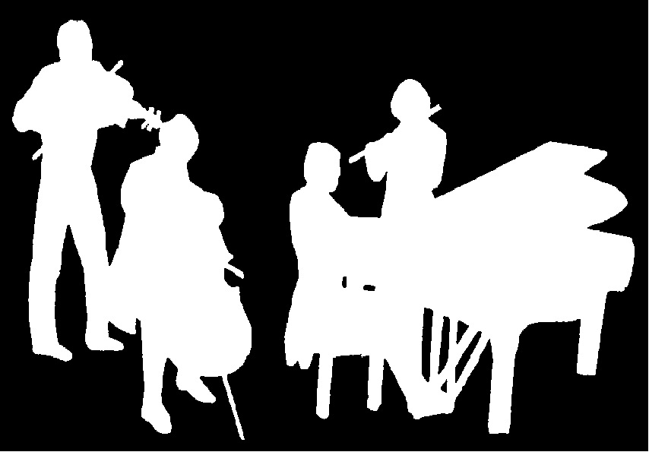
Kirribilli Neighbourhood Centre
16 Fitzroy St Kirribilli - tel: 9922 4428 - www.KNCsydney.org
Amateur Chamber Music Society
http://www.acms-australia.org/
Chamber Music Concert
Sunday 1 November 2015
5pm

